Vivian Ellis

Examining Data Exercise

The following table shows an overview of the metric variables in the HBAT dataset

The MEANS Procedure

| **Variable** | **N** | **N Miss** | **Mean** | **Std Dev** | **Minimum** | **Maximum** |
| --- | --- | --- | --- | --- | --- | --- |
| |  | | --- | | **Prod_Qual** | | **Ecommerce** | | **Tech_support** | | **Complaint** | | **Adv** | | **Prod_Line** | | **Sales_Image** | | **Pricing** | | **Warranty** | | **New_Prod** | | **Ordering** | | **Price_Flex** | | **Del_Speed** | | **Satis** | | **Recommend** | | **Future_Purch** | | **Usage_level** | | |  | | --- | | 100 | | 100 | | 100 | | 100 | | 100 | | 100 | | 100 | | 100 | | 100 | | 100 | | 100 | | 100 | | 100 | | 100 | | 100 | | 100 | | 100 | | |  | | --- | | 0 | | 0 | | 0 | | 0 | | 0 | | 0 | | 0 | | 0 | | 0 | | 0 | | 0 | | 0 | | 0 | | 0 | | 0 | | 0 | | 0 | | |  | | --- | | 7.8100000 | | 3.6720000 | | 5.3650000 | | 5.4420000 | | 4.0100000 | | 5.8050000 | | 5.1230000 | | 6.9740000 | | 6.0430000 | | 5.1500000 | | 4.2780000 | | 4.6100000 | | 3.8860000 | | 6.9180000 | | 7.0200000 | | 7.7130000 | | 58.4000000 | | |  | | --- | | 1.3962793 | | 0.7005164 | | 1.5304568 | | 1.2084032 | | 1.1269428 | | 1.3152850 | | 1.0723198 | | 1.5450553 | | 0.8197382 | | 1.4930479 | | 0.9288398 | | 1.2060035 | | 0.7344372 | | 1.1918393 | | 1.0433048 | | 0.9361057 | | 8.8608776 | | |  | | --- | | 5.0000000 | | 2.2000000 | | 1.3000000 | | 2.6000000 | | 1.9000000 | | 2.3000000 | | 2.9000000 | | 3.7000000 | | 4.1000000 | | 1.7000000 | | 2.0000000 | | 2.6000000 | | 1.6000000 | | 4.7000000 | | 4.6000000 | | 5.5000000 | | 37.1000000 | | |  | | --- | | 10.0000000 | | 5.7000000 | | 8.5000000 | | 7.8000000 | | 6.5000000 | | 8.4000000 | | 8.2000000 | | 9.9000000 | | 8.1000000 | | 9.5000000 | | 6.7000000 | | 7.3000000 | | 5.5000000 | | 9.9000000 | | 9.9000000 | | 9.9000000 | | 77.1000000 | |

The next table shows an overview of the non-metric data in the HBAT dataset

The FREQ Procedure

| **Customer_type** | **Frequency** | **Percent** | **Cumulative Frequency** | **Cumulative Percent** |
| --- | --- | --- | --- | --- |
| **1** | 32 | 32.00 | 32 | 32.00 |
| **2** | 35 | 35.00 | 67 | 67.00 |
| **3** | 33 | 33.00 | 100 | 100.00 |

| **Industry_type** | **Frequency** | **Percent** | **Cumulative Frequency** | **Cumulative Percent** |
| --- | --- | --- | --- | --- |
| **0** | 52 | 52.00 | 52 | 52.00 |
| **1** | 48 | 48.00 | 100 | 100.00 |

| **Firm_size** | **Frequency** | **Percent** | **Cumulative Frequency** | **Cumulative Percent** |
| --- | --- | --- | --- | --- |
| **0** | 49 | 49.00 | 49 | 49.00 |
| **1** | 51 | 51.00 | 100 | 100.00 |

| **Region** | **Frequency** | **Percent** | **Cumulative Frequency** | **Cumulative Percent** |
| --- | --- | --- | --- | --- |
| **0** | 39 | 39.00 | 39 | 39.00 |
| **1** | 61 | 61.00 | 100 | 100.00 |

| **Distribution** | **Frequency** | **Percent** | **Cumulative Frequency** | **Cumulative Percent** |
| --- | --- | --- | --- | --- |
| **0** | 57 | 57.00 | 57 | 57.00 |
| **1** | 43 | 43.00 | 100 | 100.00 |

| **Partner** | **Frequency** | **Percent** | **Cumulative Frequency** | **Cumulative Percent** |
| --- | --- | --- | --- | --- |
| **0** | 55 | 55.00 | 55 | 55.00 |
| **1** | 45 | 45.00 | 100 | 100.00 |

Using PRO UNIVARIATE to gather an in-depth understanding of the metric variable Del_Speed. Del_Speed is the amount of time a product takes to be delivered.

The UNIVARIATE Procedure

Variable: Del_Speed

| **Moments** | | | |
| --- | --- | --- | --- |
| **N** | 100 | **Sum Weights** | 100 |
| **Mean** | 3.886 | **Sum Observations** | 388.6 |
| **Std Deviation** | 0.73443719 | **Variance** | 0.53939798 |
| **Skewness** | -0.4630929 | **Kurtosis** | 0.21812571 |
| **Uncorrected SS** | 1563.5 | **Corrected SS** | 53.4004 |
| **Coeff Variation** | 18.8995673 | **Std Error Mean** | 0.07344372 |

| **Basic Statistical Measures** | | | |
| --- | --- | --- | --- |
| **Location** | | **Variability** | |
| **Mean** | 3.886000 | **Std Deviation** | 0.73444 |
| **Median** | 3.900000 | **Variance** | 0.53940 |
| **Mode** | 4.500000 | **Range** | 3.90000 |
|  |  | **Interquartile Range** | 1.05000 |

| **Tests for Location: Mu0=0** | | | | |
| --- | --- | --- | --- | --- |
| **Test** | **Statistic** | | **p Value** | |
| **Student's t** | **t** | 52.91126 | **Pr > |t|** | <.0001 |
| **Sign** | **M** | 50 | **Pr >= |M|** | <.0001 |
| **Signed Rank** | **S** | 2525 | **Pr >= |S|** | <.0001 |

| **Tests for Normality** | | | | |
| --- | --- | --- | --- | --- |
| **Test** | **Statistic** | | **p Value** | |
| **Shapiro-Wilk** | **W** | 0.981608 | **Pr < W** | 0.1770 |
| **Kolmogorov-Smirnov** | **D** | 0.08352 | **Pr > D** | 0.0852 |
| **Cramer-von Mises** | **W-Sq** | 0.095398 | **Pr > W-Sq** | 0.1312 |
| **Anderson-Darling** | **A-Sq** | 0.572729 | **Pr > A-Sq** | 0.1385 |

| **Quantiles (Definition 5)** | |
| --- | --- |
| **Level** | **Quantile** |
| **100% Max** | 5.50 |
| **99%** | 5.35 |
| **95%** | 4.90 |
| **90%** | 4.75 |
| **75% Q3** | 4.45 |
| **50% Median** | 3.90 |
| **25% Q1** | 3.40 |
| **10%** | 2.95 |
| **5%** | 2.55 |
| **1%** | 1.80 |
| **0% Min** | 1.60 |

| **Extreme Observations** | | | |
| --- | --- | --- | --- |
| **Lowest** | | **Highest** | |
| **Value** | **Obs** | **Value** | **Obs** |
| 1.6 | 84 | 4.9 | 90 |
| 2.0 | 7 | 5.2 | 15 |
| 2.4 | 92 | 5.2 | 48 |
| 2.5 | 98 | 5.2 | 66 |
| 2.5 | 36 | 5.5 | 57 |

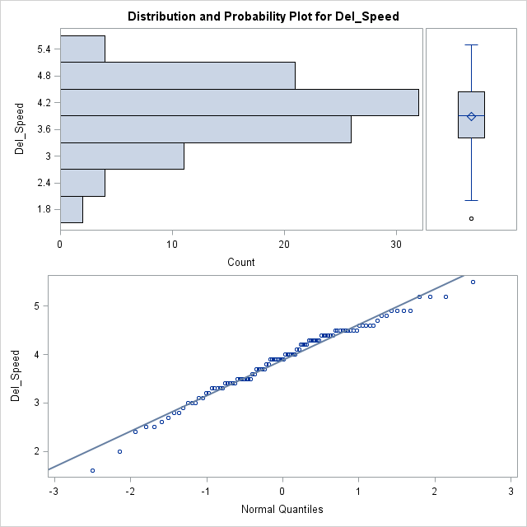

Graphing del_speed against complaint

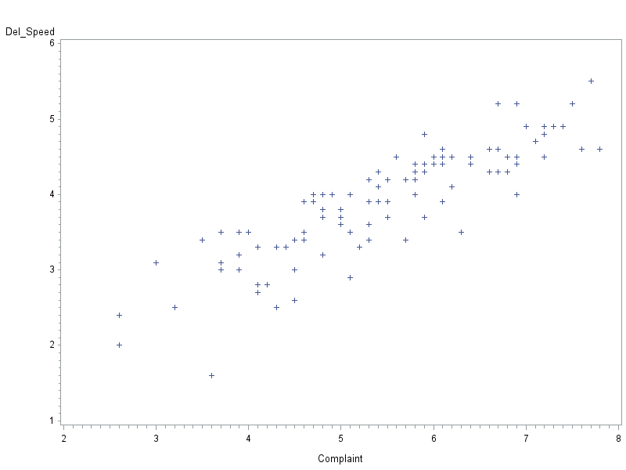

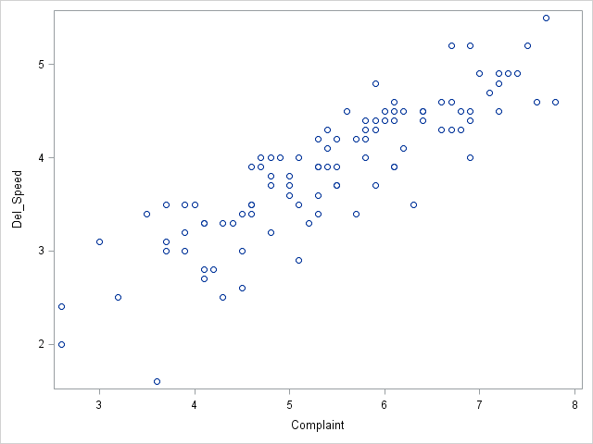

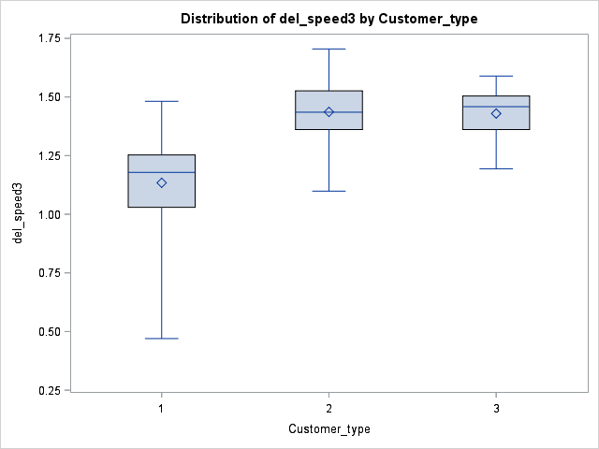

| **Level of Customer_type** | **N** | **Del_Speed** | |
| --- | --- | --- | --- |
| **Mean** | **Std Dev** |
| **1** | **32** | 3.17187500 | 0.61499246 |
| **2** | **35** | 4.24285714 | 0.57306488 |
| **3** | **33** | 4.20000000 | 0.45000000 |

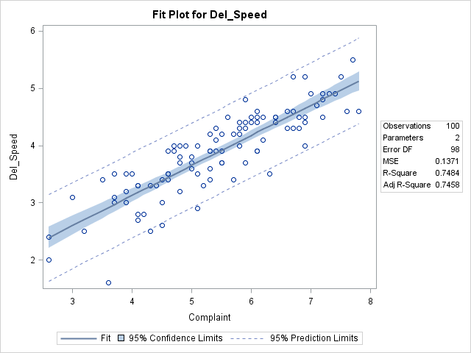

The UNIVARIATE Procedure

Variable: stresid (Studentized Residual)

| **Moments** | | | |
| --- | --- | --- | --- |
| **N** | 100 | **Sum Weights** | 100 |
| **Mean** | -0.0005467 | **Sum Observations** | -0.054672 |
| **Std Deviation** | 1.00593938 | **Variance** | 1.01191404 |
| **Skewness** | -0.7374171 | **Kurtosis** | 0.83259213 |
| **Uncorrected SS** | 100.17952 | **Corrected SS** | 100.17949 |
| **Coeff Variation** | -183995.47 | **Std Error Mean** | 0.10059394 |

| **Basic Statistical Measures** | | | |
| --- | --- | --- | --- |
| **Location** | | **Variability** | |
| **Mean** | -0.00055 | **Std Deviation** | 1.00594 |
| **Median** | 0.13475 | **Variance** | 1.01191 |
| **Mode** | -0.90241 | **Range** | 5.44782 |
|  |  | **Interquartile Range** | 1.24992 |

|  |
| --- |
| **Note: The mode displayed is the smallest of 6 modes with a count of 2.** |

| **Tests for Location: Mu0=0** | | | | |
| --- | --- | --- | --- | --- |
| **Test** | **Statistic** | | **p Value** | |
| **Student's t** | **t** | -0.00543 | **Pr > |t|** | 0.9957 |
| **Sign** | **M** | 8 | **Pr >= |M|** | 0.1332 |
| **Signed Rank** | **S** | 190 | **Pr >= |S|** | 0.5163 |

| **Tests for Normality** | | | | |
| --- | --- | --- | --- | --- |
| **Test** | **Statistic** | | **p Value** | |
| **Shapiro-Wilk** | **W** | 0.965296 | **Pr < W** | 0.0098 |
| **Kolmogorov-Smirnov** | **D** | 0.092466 | **Pr > D** | 0.0348 |
| **Cramer-von Mises** | **W-Sq** | 0.134254 | **Pr > W-Sq** | 0.0399 |
| **Anderson-Darling** | **A-Sq** | 0.786659 | **Pr > A-Sq** | 0.0416 |

| **Quantiles (Definition 5)** | |
| --- | --- |
| **Level** | **Quantile** |
| **100% Max** | 1.828569 |
| **99%** | 1.804846 |
| **95%** | 1.447512 |
| **90%** | 1.205529 |
| **75% Q3** | 0.662281 |
| **50% Median** | 0.134747 |
| **25% Q1** | -0.587635 |
| **10%** | -1.213535 |
| **5%** | -1.963305 |
| **1%** | -2.948643 |
| **0% Min** | -3.619246 |

| **Extreme Observations** | | | |
| --- | --- | --- | --- |
| **Lowest** | | **Highest** | |
| **Value** | **Obs** | **Value** | **Obs** |
| -3.61925 | 26 | 1.45382 | 88 |
| -2.27804 | 81 | 1.47184 | 22 |
| -2.18910 | 19 | 1.49698 | 37 |
| -2.15290 | 20 | 1.78112 | 54 |
| -2.14200 | 15 | 1.82857 | 49 |

