OM增加SequoiaSQL-MySQL的业务创建和卸载
修订记录
2018-06-07 何嘉文 | Init

Story编号和名称
OM增加支持SequoiaSQL-MySQL的业务创建和卸载

Story价值和功能介绍
SAC页面可以创建、卸载SequoiaSQL-MySQL业务。

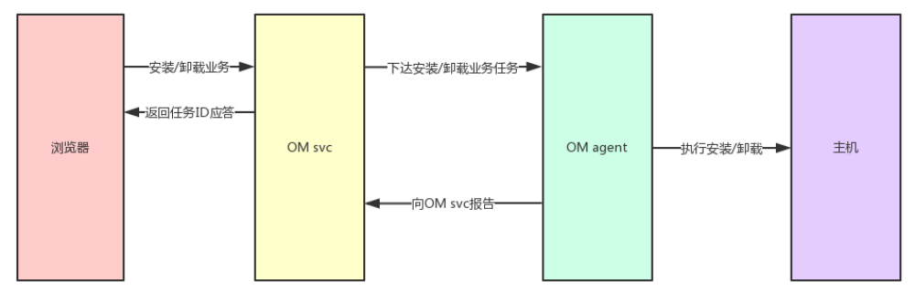

Story 对外功能接口描述
rest接口 | 参数 | 描述
cmd=get business config&TemplateInfo={…} | cmd 命令  TemplateInfo 模板信息 | OM命令。获取业务配置。
cmd=add business&ConfigInfo={ClusterName: xxx, BusinessName: xxxx, ..... } | cmd 命令  ConfigInfo 配置信息 | OM命令。安装业务。
cmd=remove business&  BusinessName=xxxx | cmd 命令  BusinessName 业务名 | OM命令。卸载业务。

接口例子

1. 获取业务配置
请求参数
cmd: get business config
TemplateInfo: {
"ClusterName": "myCluster1",
"BusinessName": "myModule3",
"DeployMod": "",
"BusinessType": "sequoiasql-mysql",
"Property": [],
"HostInfo": [
{
"HostName": "ubuntu-jw-03"
}
]
}

返回值
{
"errno": 0,
"description": "Succeed",
"detail": ""
}
{
"Config": [
{
"HostName": "ubuntu-jw-03",
"InstallPath": "/opt/sequoiasql/mysql",
"dbpath": "/opt/sequoiasql/mysql/database",
"svcname": "3306",
...
}
],
"ClusterName": "myCluster1",
"BusinessName": "myModule1",
"BusinessType": "sequoiasql-mysql",
"DeployMod": "",
"Property": [
{
"Name": "dbpath",
"WebName": "数据路径",
"Type": "path",
"Default": "/opt/sequoiasql/mysql/database",
"Valid": "",
"Display": "text box",
"Edit": "true",
"Desc": "数据存储路径",
"Level": "0",
"DynamicEdit": "false",
"BatchEdit": "false"
},
{
"Name": "svcname",
"WebName": "服务名",
"Type": "string",
"Default": "3306",
"Valid": "",
"Display": "edit box",
"Edit": "true",
"Desc": "本地服务端口",
"Level": "0",
"DynamicEdit": "false",
"BatchEdit": "false"
},
...
]
}

2. 安装业务
请求参数
cmd: add business
ConfigInfo:
{
"ClusterName": "myCluster1",
"BusinessType": "sequoiasql-mysql",
"BusinessName": "myModule1",
"DeployMod": "",
"Config": [
{
"HostName": "ubuntu-jw-01",
"dbpath": "/opt/sequoiasql/mysql/database/",
"port": "3306",
...
}
]
}

返回值
{
"errno": 0,
"description": "Succeed",
"detail": ""
}
{
"TaskID": 22
}

3. 卸载业务
请求参数
cmd: remove business
BusinessName: myModule1

返回值
{
"errno": 0,
"description": "Succeed",
"detail": ""
}
{
"TaskID": 22
}

Story约束和依赖

依赖：
1. 必须先在主机部署sequoiasql-mysql包
2. 配置文件
/sequoiadb/SequoiaDB/web/config/sequoiasql-mysql_config_zh-CN.xml
/sequoiadb/SequoiaDB/web/config/sequoiasql-mysql_config_en.xml
3. 一台主机只能一个mysql实例

Story 简单设计
- 添加服务，run包自动添加
- 生成my.cnf
- 初始化数据路径， /opt/sequoiasql/mysql/bin/mysqld --basedir=/opt/sequoiasql/mysql/ --datadir=/opt/sequoiasql/mysql/data/ --initialize-insecure
- 启动mysql服务

相关模块架构图

* 图中 “蓝色”表示新增，“灰色”表示未修改。

主要操作流程

sac前端后端流程
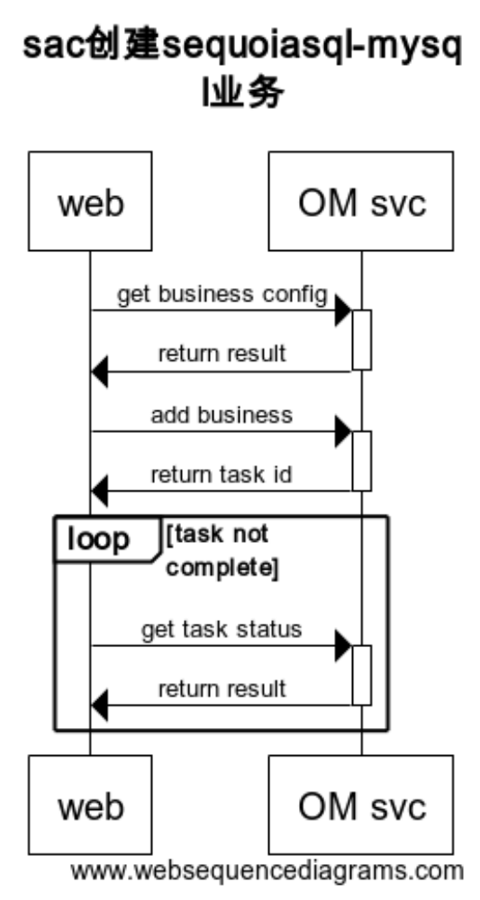

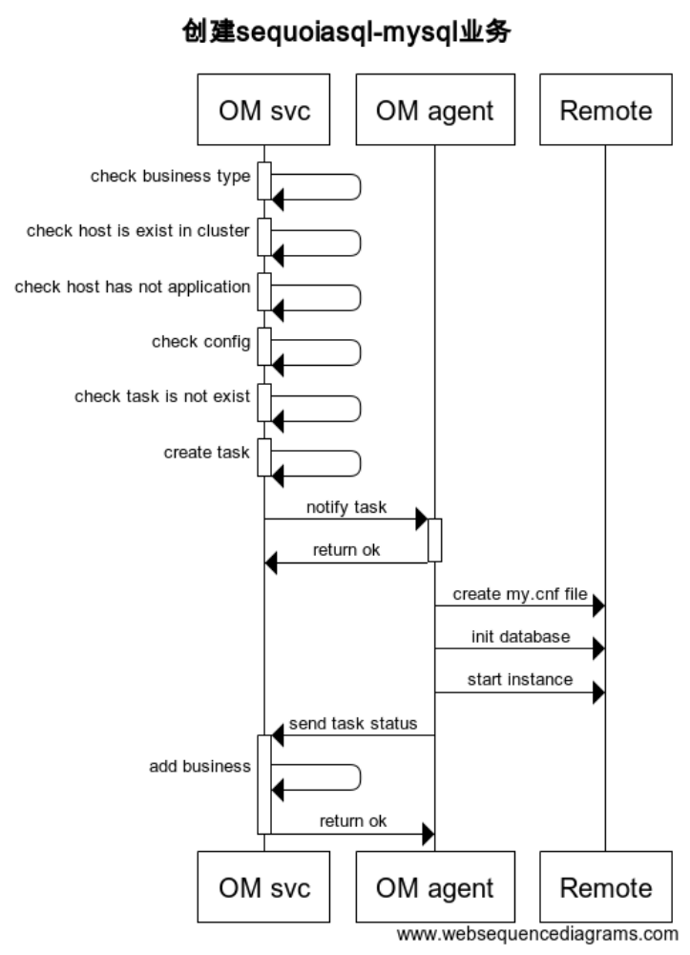
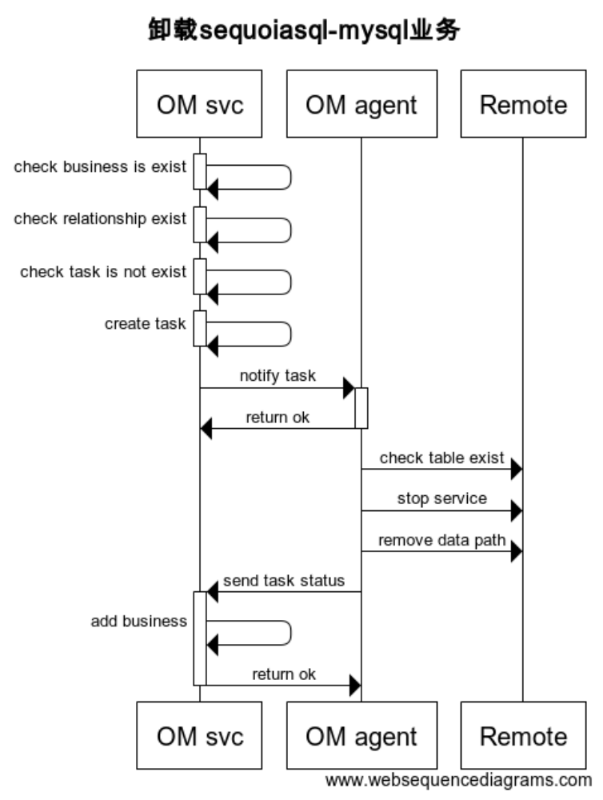

编号 | 异常情况 | 处理方式

遗留问题
说明：该特性中暂时未彻底解决或有待改进优化的问题
编号 | 标题 | 描述
1

验收测试用例
说明: 验收用例是用于表明开发基本功能OK, 满足启动测试最基本需要的一组用例. 验收用例通过,表明开发完成,可启动正式测试;

用例编号 | 用例名称 | 用例操作步骤 | 期望结果
Story.uniondb.mgr.001.001 | 创建DB2 数据源和表,查询DB2数据表 | - 添加DB2 数据源  - 创建表…. | 查询结果与预期相同

Checklist
检查项 | 结论  （NA/N/Y） | 备注
代码是否全部提交SVN，且符合代码规范
原有用例是否全部通过
Story文档是否更新
验收用例是否全部通过
资料是否变更
接口和设计是否通过评审
相关驱动是否变更或添加
周边关联产品或模块是否通知
sdb shell帮助信息是否更新

附件
流程图生成地址：https://www.websequencediagrams.com/
流程图代码：

title sac创建sequoiasql-mysql业务
web->OM svc: get business config
activate OM svc
OM svc->web: return result
deactivate OM svc
web->OM svc: add business
activate OM svc
OM svc->web: return task id
deactivate OM svc
loop task not complete
web->OM svc: get task status
activate OM svc
OM svc->web: return result
deactivate OM svc
end

title 创建sequoiasql-mysql业务
OM svc->OM svc: check business type
activate OM svc
deactivate OM svc
OM svc->OM svc: check host is exist in cluster
activate OM svc
deactivate OM svc
OM svc->OM svc: check host has not application
activate OM svc
deactivate OM svc
OM svc->OM svc: check config
activate OM svc
deactivate OM svc
OM svc->OM svc: check task is not exist
activate OM svc
deactivate OM svc
OM svc->OM svc: create task
activate OM svc
deactivate OM svc
OM svc->OM agent: notify task
activate OM agent
OM agent->OM svc: return ok
deactivate OM agent
OM agent->Remote: create my.cnf file
OM agent->Remote: init database
OM agent->Remote: start instance
OM agent->OM svc: send task status
activate OM svc
OM svc->OM svc: add business
OM svc->OM agent: return ok
deactivate OM svc

title 卸载sequoiasql-mysql业务
OM svc->OM svc: check business is exist
activate OM svc
deactivate OM svc
OM svc->OM svc: check relationship exist
activate OM svc
deactivate OM svc
OM svc->OM svc: check task is not exist
activate OM svc
deactivate OM svc
OM svc->OM svc: create task
activate OM svc
deactivate OM svc
OM svc->OM agent: notify task
activate OM agent
OM agent->OM svc: return ok
deactivate OM agent
OM agent->Remote: check table exist
OM agent->Remote: stop service
OM agent->Remote: remove data path
OM agent->OM svc: send task status
activate OM svc
OM svc->OM svc: add business
OM svc->OM agent: return ok
deactivate OM svc

