OM部署SequoiaSQL-oltp
修订记录
2017-09-05 何嘉文 | Init

Story编号和名称
OM Rest部署增加支持SequoiaSQL-oltp

Story价值和功能介绍
SAC页面可以部署SequoiaSQL-oltp业务

Story 对外功能接口描述
rest接口 | 参数 | 描述
cmd=get business config&TemplateInfo={…} | cmd 命令  TemplateInfo 模板信息 | OM命令。获取业务配置。
cmd=add business&ConfigInfo={ClusterName: xxx, BusinessName: xxxx, ..... } | cmd 命令  ConfigInfo 配置信息 | OM命令。安装业务。

接口例子

1. 获取业务配置
请求参数
cmd: get business config
TemplateInfo: {
"ClusterName": "myCluster1",
"BusinessName": "myModule3",
"DeployMod": "",
"BusinessType": "sequoiasql-oltp",
"Property": [],
"HostInfo": [
{
"HostName": "ubuntu-jw-01"
}
]
}

返回值
{
"errno": 0,
"description": "Succeed",
"detail": ""
}
{
"Config": [
{
"HostName": "ubuntu-jw-03",
"InstallPath": "/opt/sequoiasqloltp",
"dbpath": "/opt/sequoiasqloltp/database",
"svcname": "5432",
...
}
],
"ClusterName": "myCluster1",
"BusinessName": "myModule1",
"BusinessType": "sequoiasql-oltp",
"DeployMod": "",
"Property": [
{
"Name": "dbpath",
"WebName": "数据路径",
"Type": "path",
"Default": "/opt/sequoiasqloltp/database",
"Valid": "",
"Display": "text box",
"Edit": "true",
"Desc": "数据存储路径",
"Level": "0",
"DynamicEdit": "false",
"BatchEdit": "false"
},
{
"Name": "svcname",
"WebName": "服务名",
"Type": "string",
"Default": "5432",
"Valid": "",
"Display": "edit box",
"Edit": "true",
"Desc": "本地服务端口",
"Level": "0",
"DynamicEdit": "false",
"BatchEdit": "false"
},
...
]
}

2. 安装业务
请求参数
cmd: add business
ConfigInfo:
{
"ClusterName": "myCluster1",
"BusinessType": "sequoiasql-oltp",
"BusinessName": "myModule1",
"DeployMod": "",
"Config": [
{
"HostName": "ubuntu-jw-01",
"dbpath": "/opt/sequoiadb/database/data/11820",
"svcname": "11820",
...
}
]
}

返回值
{
"errno": 0,
"description": "Succeed",
"detail": ""
}
{
"TaskID": 22
}

Story约束和依赖

依赖 om svc的deploy package

Story 简单设计

相关模块架构图

* 图中 “蓝色”表示新增，“灰色”表示未修改。

主要操作流程

sac前端后端流程

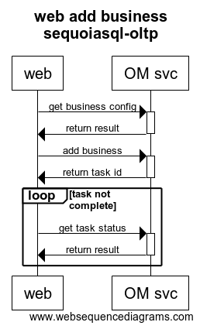

SequoiaSQL-oltp 安装业务
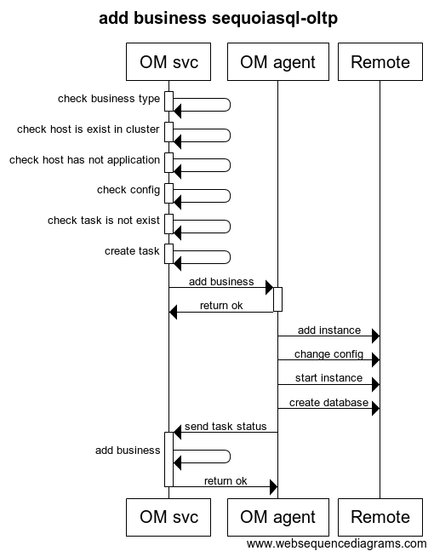

编号 | 异常情况 | 处理方式

遗留问题
说明：该特性中暂时未彻底解决或有待改进优化的问题
编号 | 标题 | 描述
1 | 删除主机没有删除sequoiadb以外的包 | 删除主机会残留其他包

验收测试用例
说明: 验收用例是用于表明开发基本功能OK, 满足启动测试最基本需要的一组用例. 验收用例通过,表明开发完成,可启动正式测试;

用例编号 | 用例名称 | 用例操作步骤 | 期望结果
Story.uniondb.mgr.001.001 | 创建DB2 数据源和表,查询DB2数据表 | - 添加DB2 数据源  - 创建表…. | 查询结果与预期相同

Checklist
检查项 | 结论  （NA/N/Y） | 备注
代码是否全部提交SVN，且符合代码规范
原有用例是否全部通过
Story文档是否更新
验收用例是否全部通过
资料是否变更
接口和设计是否通过评审
相关驱动是否变更或添加
周边关联产品或模块是否通知
sdb shell帮助信息是否更新

附件
流程图生成地址：https://www.websequencediagrams.com/
流程图代码：

title web add business sequoiasql-oltp
web->OM svc: get business configactivate OM svc
OM svc->web: return resultdeactivate OM svc
web->OM svc: add businessactivate OM svc
OM svc->web: return task iddeactivate OM svc
loop task not complete
web->OM svc: get task status activate OM svc OM svc->web: return result deactivate OM svc
end

title add business sequoiasql-oltp
OM svc->OM svc: check business typeactivate OM svcdeactivate OM svc
OM svc->OM svc: check host is exist in clusteractivate OM svcdeactivate OM svc
OM svc->OM svc: check host has not applicationactivate OM svcdeactivate OM svc
OM svc->OM svc: check configactivate OM svcdeactivate OM svc
OM svc->OM svc: check task is not existactivate OM svcdeactivate OM svc
OM svc->OM svc: create taskactivate OM svcdeactivate OM svc
OM svc->OM agent: add businessactivate OM agent
OM agent->OM svc: return okdeactivate OM agent
OM agent->Remote: add instance
OM agent->Remote: change config
OM agent->Remote: start instance
OM agent->Remote: create database
OM agent->OM svc: send task statusactivate OM svc
OM svc->OM svc: add business
OM svc->OM agent: return okdeactivate OM svc

