**Consumer Financial Protection Bureau (CFPB)**

Establishment: The CFPB was created in 2010 through the Dodd-Frank Wall Street Reform and Consumer Protection Act.

Objective: The primary objective of the CFPB is to safeguard consumers by enforcing regulations on financial products and services, ensuring that consumers are not exploited by unfair practices.

Components and Functions

Divisions: The CFPB is structured into several divisions, including Operations, Consumer Education & External Affairs, Legal, Supervision, Enforcement, Fair Lending, and Research, Monitoring, and Regulations. These units collaborate to protect and educate consumers regarding various financial offerings.

Key Insights:

The CFPB was created to safeguard consumers from exploitative financial practices and to promote financial literacy.

Consumers seeking financing for education, retirement, or homeownership can access resources provided by the CFPB.

The CFPB plays a pivotal role in the consumer finance marketplace by providing rules, enforcing them, and enabling consumers to take control of their financial lives.

Role and Responsibilities

Education and Enforcement: The CFPB educates and informs consumers against deceptive financial practices, supervises banks and other financial institutions, and studies data to better comprehend consumers and the financial markets they engage with.

Empowering Consumers: The CFPB's strategic goals include empowering consumers to make informed financial decisions, enforcing regulations against predatory companies and practices, and educating financial institutions about their responsibilities to consumers.

Assistance for Consumers

Financial Guidance: The CFPB offers financial guidance for individuals, including student financial resources for college planning, retirement planning tools and resources, and homeownership assistance with interest rates, monthly payment worksheets, and loan comparison tools.

Filing Complaints: The CFPB's consumer complaint system allows individuals to report issues with financial products or services. The process includes filing a complaint, the CFPB forwarding it to the company involved, and the company responding with a plan to address the issue.

Impact and Engagement

Consumer Complaints: Consumer complaints, which are published in the Consumer Complaint Database, help the CFPB understand the financial marketplace and protect consumers.

Engaging with the CFPB: Consumers should contact the CFPB whenever they encounter issues with financial products or services. The CFPB aims to understand the problem and work towards a resolution.

**Credit or Consumer Reporting:** This category accounts for the largest proportion of complaints, with 1,309,800 complaints, which is a significant increase of 34% compared to the previous year. This suggests that there are issues with the accuracy and timeliness of credit reports, as well as potential errors and inconsistencies in reports, particularly affecting consumers from predominantly minority communities.

**Debt Collection:** The second most common category, with 109,900 complaints, indicates that there are concerns about debt collection practices, including consumers not recognizing the debt being collected. This highlights the need for more transparency and effective communication in debt collection processes.

**Credit Card:** With 70,000 complaints, credit card issues are a significant concern. Complaints in this category are often related to perceived unaffordable and irresponsible lending, as well as administration and customer service problems.

**Checking or Savings:** The 6,450 complaints in this category suggest that there are issues with bank accounts, including fraud and scams, which are a major driver of the increase in current account complaints.

**Mortgage:** Although the number of complaints (2,790) is relatively low compared to other categories, it still indicates that there are issues with mortgage lending and servicing, such as delays in processing and paying insurance claims.

**Money Transfer or Service, Virtual Currency:** The 2,180 complaints in this category suggest that there are concerns about the security and reliability of these services, particularly with regards to fraud and scams.

**Vehicle Loan or Lease:** With 1,770 complaints, this category indicates that there are issues with vehicle financing and leasing, including disputes over charges, fees, and commission.

**Student Loan:** The 12,000 complaints in this category suggest that there are concerns about student loan servicing, including issues with payment processing and customer service.

**Personal Loan:** The 830 complaints in this category indicate that there are issues with personal loan lending and servicing, including disputes over interest rates and repayment terms.

**Prepaid Card:** The 820 complaints in this category suggest that there are concerns about prepaid card services, including issues with fees, charges, and customer service.

**Debt or Credit Management:** The 3,500 complaints in this category indicate that there are issues with debt management and credit counseling services, including disputes over fees and services provided.

**Payday Loan:** The 2,100 complaints in this category suggest that there are concerns about payday lending practices, including high interest rates and predatory lending practices.

**Anti-Money Laundering (AML)**

The primary purpose of money laundering is to conceal the origins of criminal profits.

Money laundering also conceals the origin and destination of money used to fund terrorism. 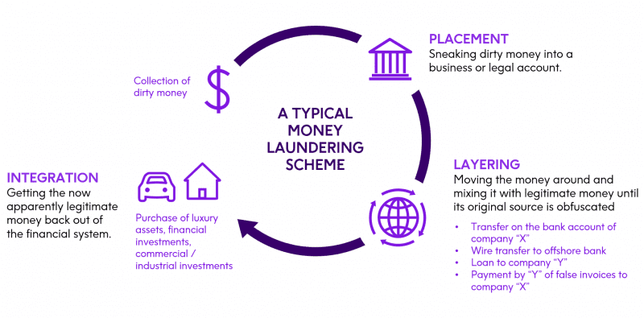

Anti-money laundering (AML) laws, regulations, and procedures are attempts to reduce the ease of hiding criminal profits.

Financial institutions combat money laundering with Know Your Customer (KYC) and customer due diligence (CDD) measures.

Regulatory Framework:

The Financial Action Task Force (FATF) provides the global framework for AML and Combating the Financing of Terrorism (CFT) policies.

The Bank Secrecy Act (BSA), the Money Laundering Control Act, and the Anti-Money Laundering Act are key national laws that require financial institutions to maintain detailed records of financial transactions and report suspicious activities.

AML Compliance:

Banks are required to appoint an AML Compliance Officer, who oversees the entire AML compliance program and serves as a liaison with financial regulators.

Continuous training and a strong compliance culture are essential for maintaining effective AML measures.

AML compliance involves specific operational procedures, including continuous monitoring and timely reporting of suspicious activities.

Biometric Technology Integration:

Biometric technology enhances AML efforts by providing reliable methods for customer identification and authentication, which is critical in the multi-layered approach to AML strategies.

Biometrics can streamline compliance processes, reduce costs, and improve the accuracy of detecting and preventing financial crimes.

Risk-Based Approach:

Banks perform risk assessments and implement Know Your Customer (KYC) and Customer Due Diligence (CDD) procedures to identify and manage potential money laundering risks.

Risk-based approaches help banks focus their efforts on higher-risk customers and transactions.

Penalties for Non-Compliance:

Failure to adhere to AML regulations can result in severe penalties, including fines exceeding $403 billion since 2008.

The cost of non-compliance can be significantly higher than the cost of implementing robust AML programs.

Customer Trust and Financial Stability:

Effective AML measures reassure customers that their financial assets are managed in a system free from corruption and illegal funds, maintaining trust and stability in the financial system.

AML practices help ensure that financial transactions are legitimate and reflective of actual economic activities, supporting economic stability and growth.

International Cooperation:

The US banking system collaborates with international bodies and other countries to combat financial crimes and maintain global financial stability.

These measures are crucial for maintaining the integrity of the US banking system and preventing the infiltration of illicit funds.

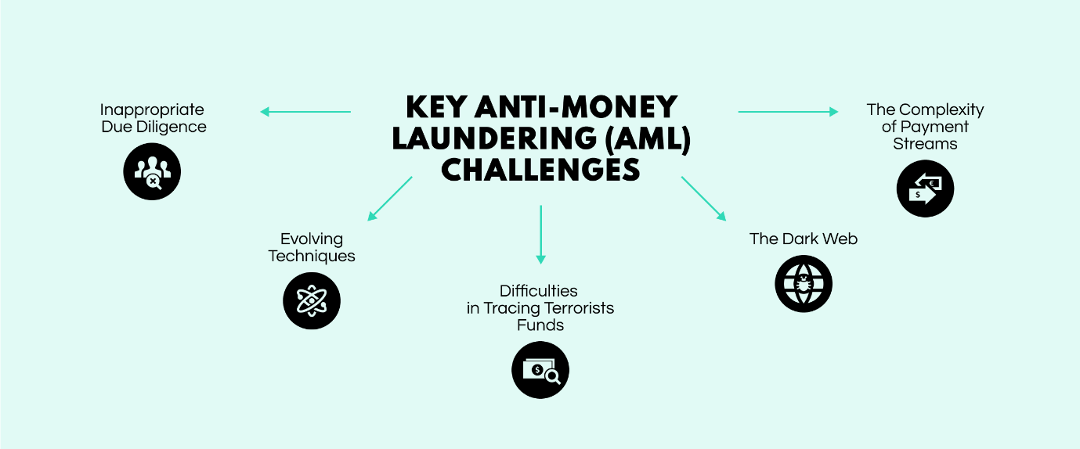

**KYC (Know Your Customer)**

KYC is a critical process in the U.S. banking industry that helps institutions verify the identity of their customers. The primary goal of KYC is to prevent illegal activities such as money laundering, fraud, and terrorist financing.

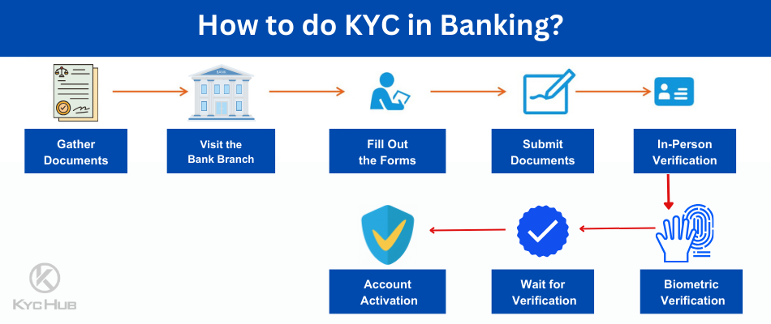

The KYC process in U.S. banks typically involves three main stages:

Customer Identification: Banks must obtain valid identification documents, such as passports or driver's licenses, and verify the customer's address. 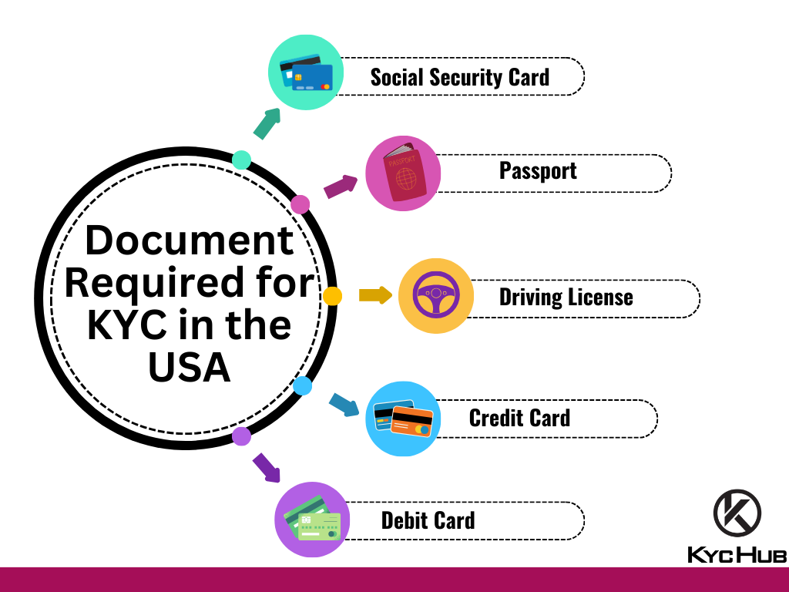

Customer Due Diligence: Banks assess the risk associated with the customer by obtaining information about their financial background, business activities, and source of funds.

Ongoing Monitoring: Banks continuously monitor the customer's transactions and activities to detect suspicious activity. Customer information is regularly updated and re-verified if necessary.

KYC is a legal requirement for U.S. banks to comply with Anti-Money Laundering (AML) laws. The U.S. passed stricter KYC requirements as part of the Patriot Act following the 9/11 attacks.

Failing to meet KYC regulations can result in steep fines and penalties for U.S. banks. KYC helps prevent identity theft, money laundering, financial fraud, and terrorism financing.

To meet KYC requirements, U.S. banks are increasingly adopting technologies like digital identity verification, biometric authentication, and data analytics to streamline their KYC processes. Collaboration between banks and regulatory bodies is also important to share best practices and insights.

**Customer Due Diligence (CDD)**

Throughout the account’s lifetime, financial institutions must conduct customer due diligence (CDD) or maintain accurate and up-to-date records of transactions and customer information for regulatory compliance and potential investigations.

Certain customers may be added over time to sanctions and other AML watchlists, warranting checks for [regulatory risks and compliance issues](https://www.investopedia.com/terms/r/regulatory_risk.asp) on an ongoing basis.7

According to the U.S. Treasury’s [Financial Crimes Enforcement Network](https://www.investopedia.com/terms/f/fincen.asp) (FinCen), the four core requirements of CDD in the United States are:8

* Identifying and verifying the customer’s [personally identifiable information](https://www.investopedia.com/terms/p/personally-identifiable-information-pii.asp) (PII)
* Identifying and verifying the identity of [beneficial owners](https://www.investopedia.com/terms/b/beneficialowner.asp) with a stake of 25% or more in a company opening an account
* Understanding the nature and purpose and compiling [risk profiles](https://www.investopedia.com/terms/r/risk-profile.asp) of customer relationships
* Monitoring suspicious transactions and updating customer information

CDD may try to uncover and counter [money laundering patterns](https://www.investopedia.com/ask/answers/022015/what-methods-are-used-launder-money.asp) such as layering and structuring, also known as “[smurfing](https://www.investopedia.com/terms/s/smurf.asp)”—breaking up large transactions into smaller ones to dodge reporting limits.

For example, financial institutions have instituted AML holding periods that force deposits to remain in an account for a minimum of days before they can be transferred elsewhere.9

If patterns and anomalies indicate money laundering activities, suspicious transactions in U.S. jurisdictions must be reported in [Suspicious Activity Reports](https://www.investopedia.com/terms/s/suspicious-activity-report.asp) (SARs) to relevant financial agencies for further investigation.