Left Overs is not for profit organization working to address food insecurities in increasingly difficult economic times. Grocery stores and restaurants frequently dispose of food products that are close to expiring or not quite right for sale. Left Overs will pick up the food and distribute to registered clients including shelters and food banks. Left Overs’ board of directors feel that they could help reach more people and keep valuable food out of the garbage with an online presence. They have secured government funding and would like to develop a system that allows clients to post extra food that they would like to dispose of or sell and other clients to purchase/pickup the food.
There are many use cases required for the new system. This use case focuses on allowing clients to post the food that they would like to dispose of.
This Systems Use Case diagram identifies the scope of this use case:
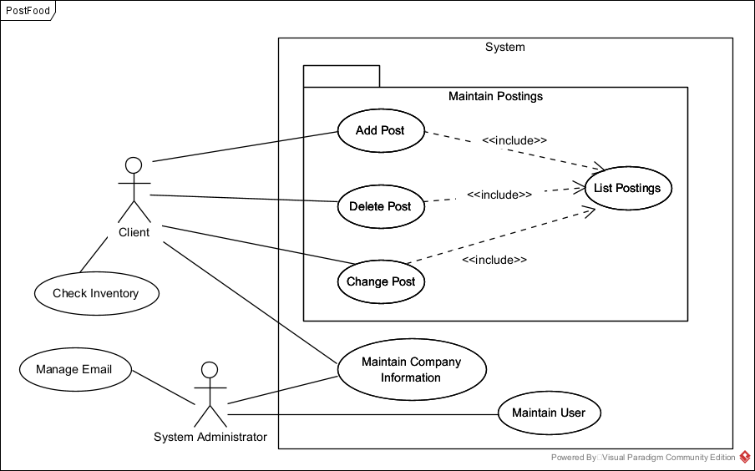
We create our use cases independent of UI/UX, but a basic ‘mockup’ of what we’re describing in our use cases is a handy tool to help the team envision what the use case is about.
Post Food

Client: 999999 XXXXXXXXXXXXXXXX X9X 9X9 (client ID, screen name and postal code)

PostID: 999999999

Post Title: _______________________________________

Description of what is available: ___________________________________

Product Expiry: ____________________________________

Price: _______________________________

Pickup Instructions: __________________________

Pickup Postal Code: ____________________

Activity Diagrams help chart out all of the pathways through this package of logic. Each pathway will result in a Use Case Description.

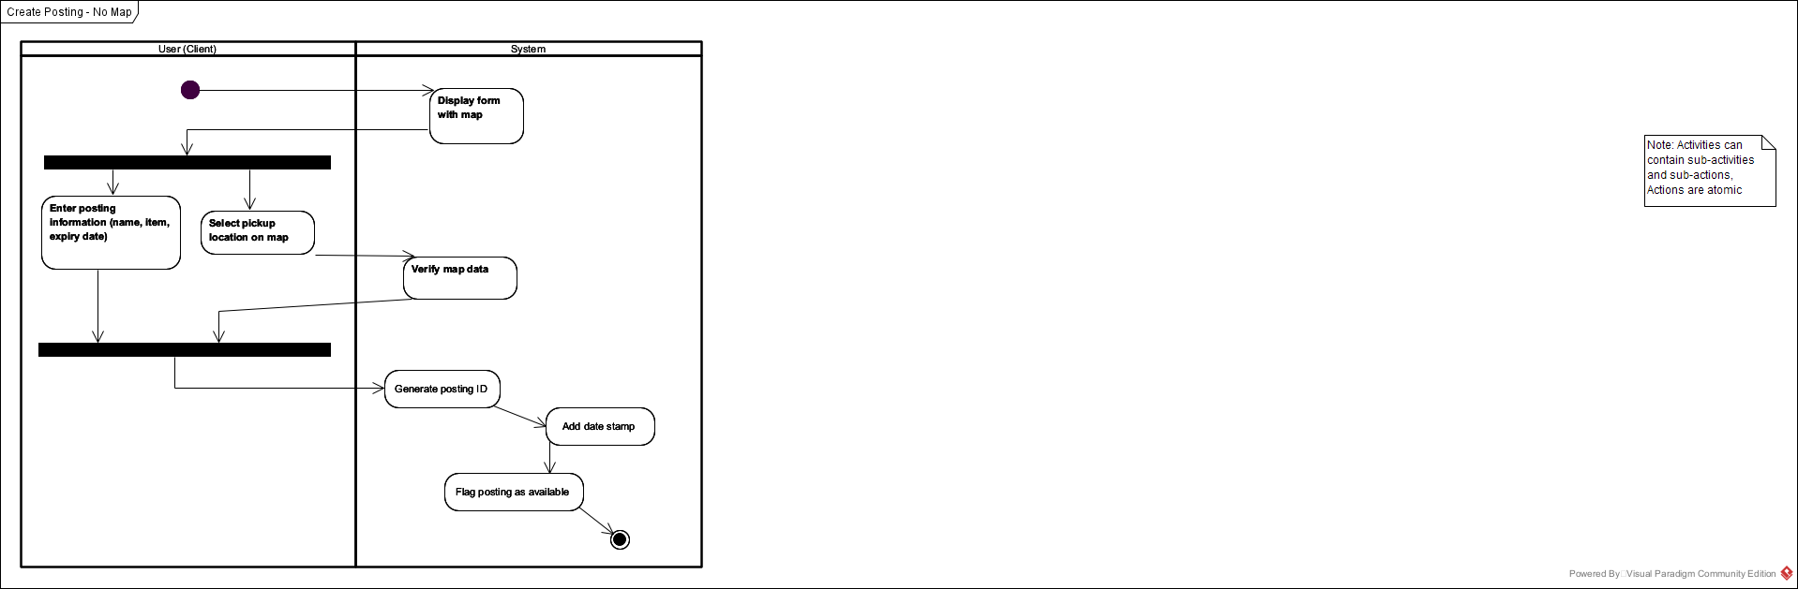

Use Case Definition.
A use case starts with a user story that identifies what user goals for this functionality. A well crafted user story is written from the user’s point of view and identifies what the user wants to do and why they would want to use the functionality. The user story is clear and concise.
Post Food User Story
As a client involved with LeftOvers, I would like to post extra food that I have available. I would like the opportunity to either donate the food or charge a nominal fee.

As stated above, use case descriptions are written for each pathway through the activity diagram. Use case descriptions identify:
- The triggering event for the use case descriptions – they why or when the user would use this functionality.
- A brief description of the scope of the use case description.
- The actors involved in the use case - who will use this functionality
- The preconditions for the use case description, or in other words, where this use case start from.
- The post conditions for the use case description, or how the use case description is supposed to end.
- Any abnormal terminations of the use case description, or how the user will ‘get out’ or abandon the process.

Use Case Name | Add Post
Triggering Event | The client has food that they would like to pass on to another client.
Brief Description | Allows the client to add a post
Actors | Client
Related Use Cases
Preconditions | Client has opened application and sees all of the outstanding posts.
Post Conditions | Post is added to the system and is available for other clients to select and communicate about pickup.
Flow of activities | Actor |  | System
 |  | Selects to add a post | Displays the Post Entry form. Client ID, screen name, and map is displayed.  Prompts for title, description, price, expiry date, pick up instructions.  Allows for override of postal code.
 |  | Enters title, description, price, expiry date, pick up instructions and selects map location | Generates a post id.  Saves the post  Displays a list of outstanding posts
Exception Conditions | - Client chooses to cancel adding the post

