Week 1 – Introduce yourself!
This is an Individual Lab!
Name: | Khanh Vy Tran
Student Number: | 120175245
Where are you from: | Vietnam
What languages do you speak: | Vietnamese, English
Work experience: | I work at Mc Donald
Where did you go to school before this: | I went to Nguyen Thuong Hien highschool in Vietnam
What program are you in? (CPP, CPA, CPAC) | CPAC
How are you doing at school? | - A good student with a fantastic GPA  - A good student, but grades just don’t reflect that  - A student that gets by, because the experience is more important than the numbers
List students in the class that you would like to work with: | Kenneth Co, Judy Nguyen, Vansh Barot
List the students in the class that you don’t want to work with (it happens!):

Lab attendance is mandatory for the first 8 weeks of the course. After that would you prefer to work with a group that meets online or in person? | - Both work for me
What do you like to do outside of school?: | I like to stay home, watch movies, listen to music
Academic Integrity issues will not be tolerated in this course. Complete Seneca’s Academic Integrity module and share the link to your badge  https://cfdev.senecacollege.ca/tl/forstudents/integrityinaction/ | https://factory.cancred.ca/obv3/credentials/333fd44bb740bd64109496c3b51130272e0e221c
Have you started looking for job opportunities? If so, where? | No I have not
What previous jobs have you held? | Only part-time jobs like waitress/crew member
Are you more interested in:  Freelance work? Programmer? Analyst? Project Manager? something else...? | I’m more interested in Analyst and maybe Project Manager
What is your favourite programming language? | C, JavaScript, C++ is harder
What web based platforms (.net, J2EE, JavaScript) have you worked with? | JavaScript
Aside from Visual Paradigm, what non-programming development tools have you used? Do you have a favourite? | Canva is one of my favourite

Using Visual Paradigm, please create a class diagram and a sequence diagram for the following scenario. Copy and paste your diagrams into this document and submit this document and your .vpp file as part of your submission.

Use Case Name | Add Office Booking
Triggering Event | Customer requests booking office space
Brief Description | Allows the Office Manager to add a room booking
Actors | Office Manager
Related Use Cases
Preconditions | Office Manager has opened the Main Menu.
Post Conditions | Room Booking is saved to the database and now can be queried.
Flow of activities | Actor |  | System
 | 1. | Requests to add an office booking | Displays a list of customers including customer name and telephone number. Displays a calendar requesting starting date of the office booking. Displays a list of offices including office name, description, list of features and maximum capacity
 | 2. | Selects a customer, selects a date, selects an office. | Displays a list of office bookings for the week encompassing the selected date.  Displays a list of note taker bookings for the selected week in ‘timetable’ format.  Displays a list of features for the office and prompts for selection  Prompts for office bookings in one hour time slots  Prompts for note taker
 | 3. | Selects time slots, selects whether or not a note taker is required. Selects required office features. | Adds the office booking to the ‘timetable’ format display and prompts to save
 | 4. | Saves the office booking | Saves the office booking and returns to the main menu.
Exception Conditions | - Office Manager chooses to cancel adding the room booking.

Class Diagram:
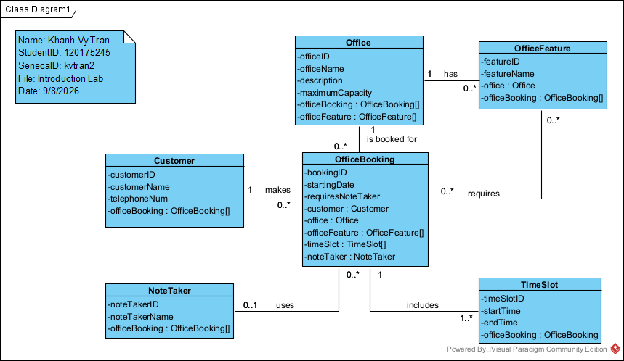

Sequence Diagram:
