Daily Deposit Activity
Backend Setup Guide

What is this activity?
Players can get a bonus on each deposit of the day, up to the number you set (max 10). You set the bonus for each deposit. Players join by ticking the Top-Up Coupon on the deposit page.
Bonus = Deposit amount × Bonus % (never more than the Cap).
Setup in 5 steps
(1) Click Add.
(2) Fill in Basic Info (name, time, status).
(3) Fill in Reward Settings: Monday VIP0 first → Apply to Other Levels → Copy This Day to Other Days.
(4) Fill in Participation Conditions and upload the Content (4 images, title, text).
(5) Click Save. Changes take effect right away.

Remember: Time zone is GMT+8. Each day starts again from Deposit 1 at 00:00. Two activities that are On cannot share any date.

Backend

Backend: Special Activities > Daily Deposit Activity > Activity List
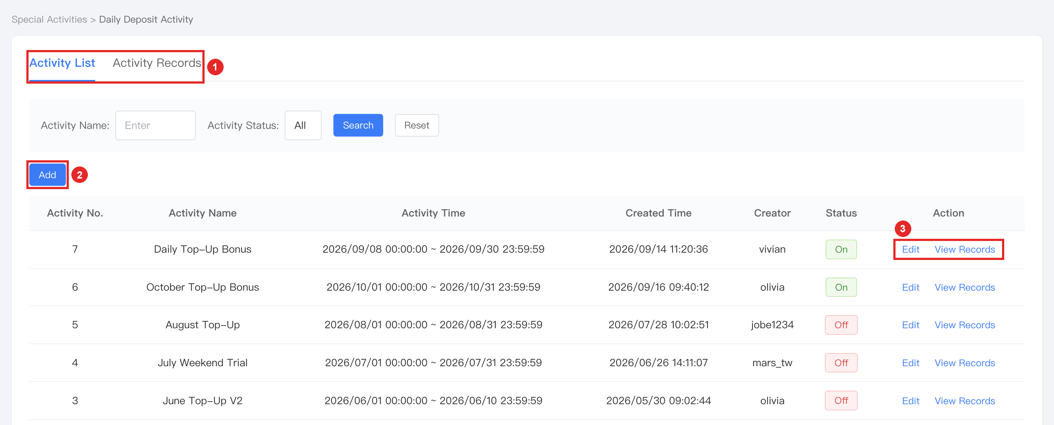
(1) Activity List shows all activities. Activity Records shows every bonus paid.
(2) Add: create a new activity.
(3) Edit: change an activity. View Records: see the records of this activity only.

Backend: Special Activities > Daily Deposit Activity > Add / Edit
1. Basic Info
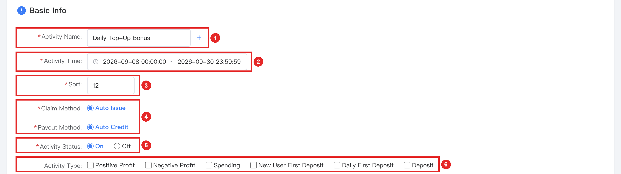
(1) Activity Name: required. Click + to add other languages.
(2) Activity Time: start and end. It cannot share any date with another activity that is On.
(3) Sort: whole number, 0 or above. A bigger number shows higher on the Promotion page.
(4) Claim Method / Payout Method: fixed. Nothing to set.
(5) Activity Status: new activities start as Off. Choose On to go live.
(6) Activity Type: which tab the activity appears in on the Promotion page. Optional.
2. Reward Settings
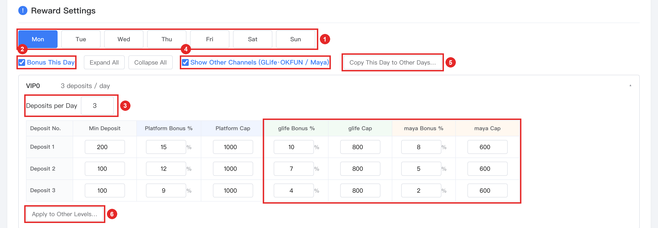
(1) Day tabs: Mon–Sun. Each weekday has its own settings.
(2) Bonus This Day: ticked by default. Untick = no bonus on this weekday.
(3) Deposits per Day: 1–10. The table shows one row per deposit. Each VIP level (VIP0–VIP10) has its own table.
– Each row: Min Deposit, Bonus % (max 100) and Cap. All are required.
(4) Show Other Channels: the glife and maya columns (red box) are hidden by default, but they are still required. Tick it to show and fill them in. Min Deposit is shared by all channels.
(5) Copy This Day to Other Days: copies this day’s VIP0 settings to the days you choose.
(6) Apply to Other Levels: copies VIP0 to the VIP levels you choose.
No bonus on a day: untick Bonus This Day. The tab shows “No Bonus”. Tick it again to bring the settings back.
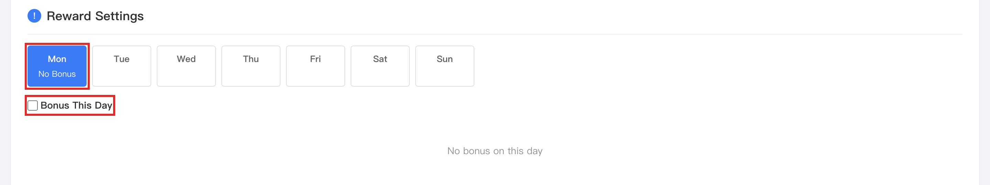
Copy to other days: choose the days, then click Copy to N days.
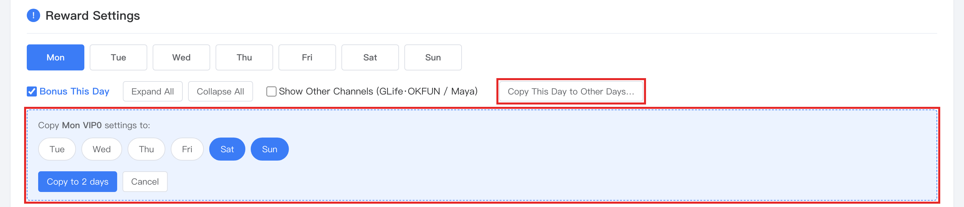
Apply to other levels: all levels are selected by default. Click Apply to N levels. These levels then follow VIP0. To set a level on its own, click Unlink on it.
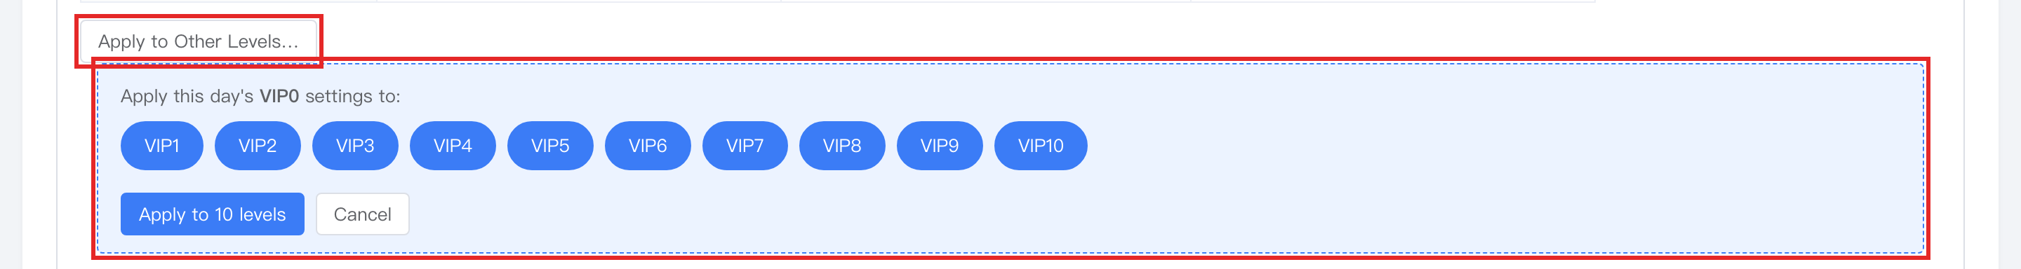
3. Participation Conditions
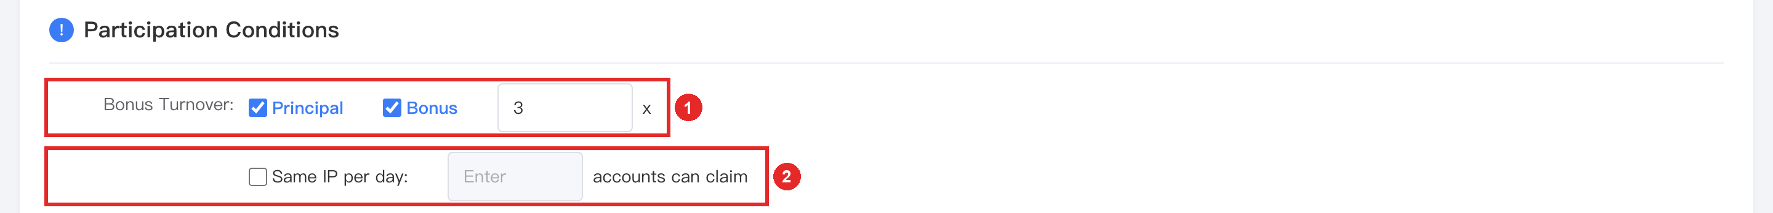
(1) Bonus Turnover: tick Principal and/or Bonus, then enter how many times (x). One setting for all deposits. Optional: if left empty, only the normal deposit turnover applies.
(2) Same IP per day: optional. Limits how many accounts on the same IP can get the bonus each day. Accounts over the limit get no bonus, but the deposit still counts as used.
4. Content, then Save
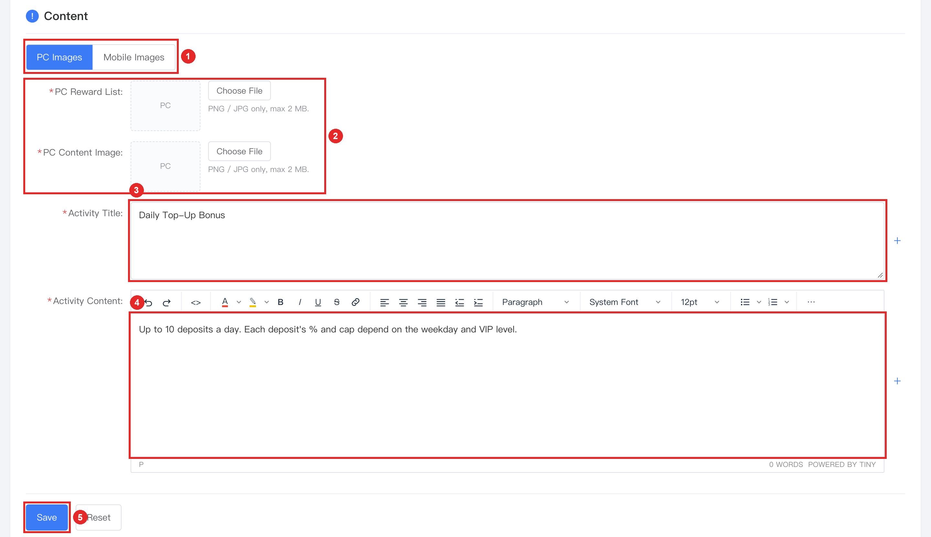
(1) PC Images / Mobile Images: upload on both tabs.
(2) Reward List = card on the Promotion page. Content Image = banner on the Event Details page. PNG/JPG, max 2 MB. All 4 images are required.
(3) Activity Title: title of the Event Details page.
(4) Activity Content: text at the bottom of the Event Details page.
(5) Save: if something is wrong, a red message tells you where. If not, a green success message appears.

Backend: Special Activities > Daily Deposit Activity > Activity Records
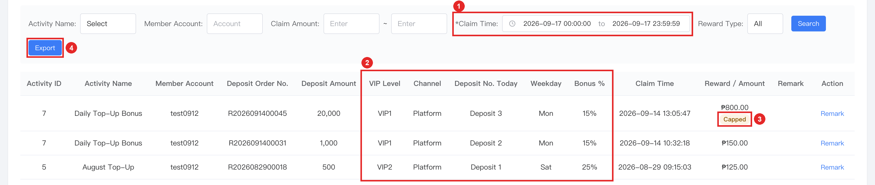
(1) Claim Time is required (default: today).
(2) These columns show how each bonus was worked out: VIP Level, Channel, Deposit No. Today, Weekday, Bonus %.
(3) Capped: the bonus reached the Cap.
(4) Export: download all search results.

Frontend
What players see while the activity is running.

Frontend: Home / Deposit Page / Event Details
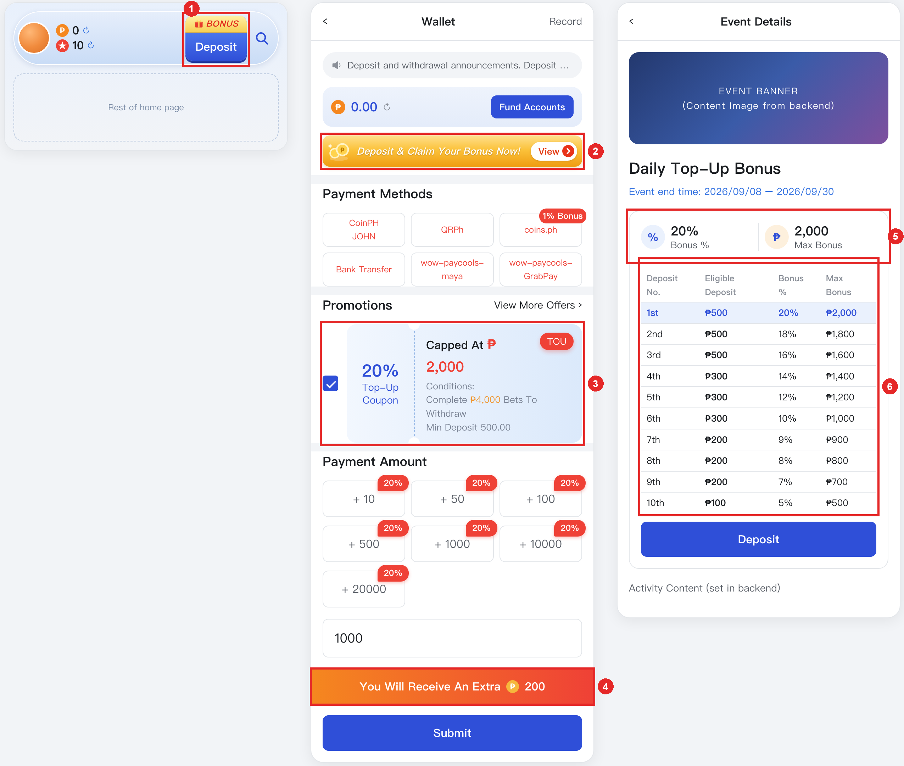
(1) BONUS tag on the Deposit button. It shows when the player has a coupon to use.
(2) Banner “Deposit & Claim Your Bonus Now!”. Tap it to open Event Details.
(3) Top-Up Coupon: shows the bonus for the player’s next deposit. The player ticks it to join. Once submitted, that deposit counts as used, even if the payment fails.
(4) How much bonus the player will get for the amount entered (shows when the coupon is ticked and the amount reaches Min Deposit).
(5) Bonus % and Max Bonus for the next deposit.
(6) Today’s list: one row per deposit, from your Reward Settings. Used deposits turn grey; the next one is highlighted.
5. Where the numbers come from
The player sees one row of your Reward Settings: today’s day tab × the player’s VIP level × which deposit of today it is × the player’s channel.
