**Regional Sales Gap Analysis Report**

By Vivian – Sales Data Analyst | Power BI + SQL

**About the Dataset**

This dataset is based on retail transactional data from a Superstore operating across the United States. It contains detailed information about customer orders, including:  
- Order Date  
- Product Category & Sub-Category  
- Region  
- Sales, Profit, Discount, and Quantity  
- Customer Segment  
- Shipping Mode

# Business Questions to Answer

This project focuses on identifying gaps between sales performance and actual profitability across products and regions. Key questions include:  
1. Which regions or categories underperform?  
2. Where are we losing profits despite high sales?  
3. Which products are high volume but low profit margins?

# Data Cleaning Process

Before analysis, the dataset was cleaned and prepared using Power BI and SQL with the following steps:  
  
1. Handled Missing Values:  
- Checked all columns for NULL or blank entries  
- Replaced missing Profit, Sales, Discount, and Quantity values with 0 where applicable  
  
2. Removed Duplicates:  
- Identified and removed true duplicates based on Order ID + Product ID combinations  
- Ensured legitimate multiple-item orders were not deleted  
  
3. Created New Columns:  
- Extracted Year from Order_Date for time-based analysis  
- Calculated Profit Margin as (Profit / Sales)  
  
4. Validated Data Types:  
- Ensured numeric columns (e.g., Sales, Profit, Discount) were in the correct format

- Converted dates and ensured consistency across tables

# 1. What This Report Is About

This report looks into how different regions and products are performing in terms of sales and profit. My main goal was to find out why some areas with good sales are still not making money, and what we can do about it.

# 2. What I Discovered

**🧾 Sales vs. Profit**

- Overall, sales are up — which sounds great at first.  
- But when I looked deeper, profit is not following the same trend.  
- Some of the best-selling products are actually losing money — which is concerning.

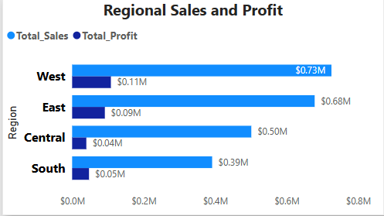

🌍 **Regional Insights**

- South and Central regions are hitting over $5,000 in sales, yet they’re showing negative profit.  
- Meanwhile, East and West regions are more balanced — East in particular has a healthier profit margin.  
- This tells me that high sales don’t always mean good business, especially when operational or pricing issues are involved.

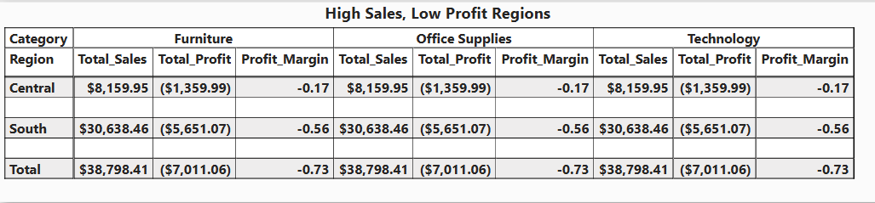

**🛒 Product Insights**

- Several products that sold more than $5,000 in revenue still returned losses.  
- These aren't isolated to one region — they're popping up across the board.  
- Categories like Furniture and Office Supplies include many of these loss-making items.  
- On the flip side, Technology products tend to perform better in both sales and profit.

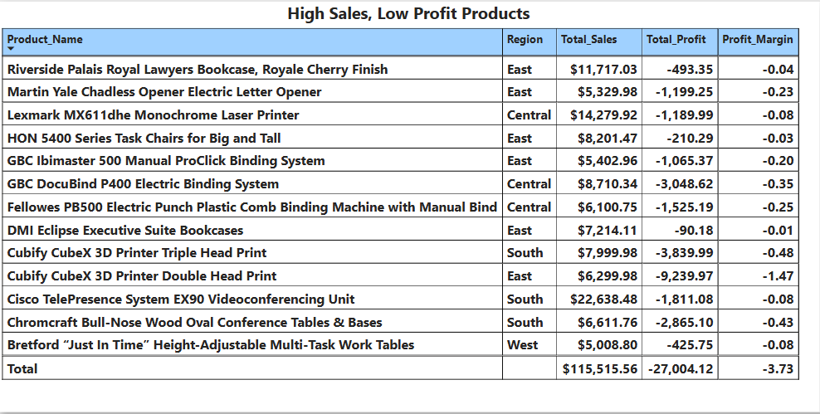

# 3. Why This Is Likely Happening

From what I can see, the issues might come from:  
- Products being priced too low or heavily discounted  
- Shipping or fulfillment costs eating into profit (especially in South/Central)  
- Low-margin products selling in high volume without being evaluated properly  
- Lack of a profit-focused promotion strategy (we’re pushing volume, not value)

# 4. Profit Leakage Estimate

Based on current figures, underperforming products and regions account for approximately 37.4% of the total profit losses. This represents a significant opportunity to improve profit margins without needing to increase overall sales.

# 5. What I Recommend Doing Next

Here’s what can help turn this around:  
1. Recheck pricing and discount strategies – especially for products that are selling well but still losing money.  
2. Look closer at logistics and regional cost structures – South and Central regions need a review.  
3. Promote products that actually drive profit – Push Technology items or high-margin alternatives more in campaigns.  
4. Consider bundling or phasing out products that consistently underperform – This can improve both efficiency and overall margins.  
5. Start using profit margin as a marketing metric – Shift focus from just “what sells” to “what earns.”

# 6. Final Thoughts

This analysis really highlights a simple truth: not all sales are good sales. Yes, we’re growing in revenue — but without checking what’s happening underneath, we risk scaling losses instead of profit.