**Vivian Joseph**

20BCE0777

**Machine Learning LAB DA-1**

**Pre-processing of Data**

**Q1) Create your own dataset - 9 column/ features and minimum 30 samples/rows.**

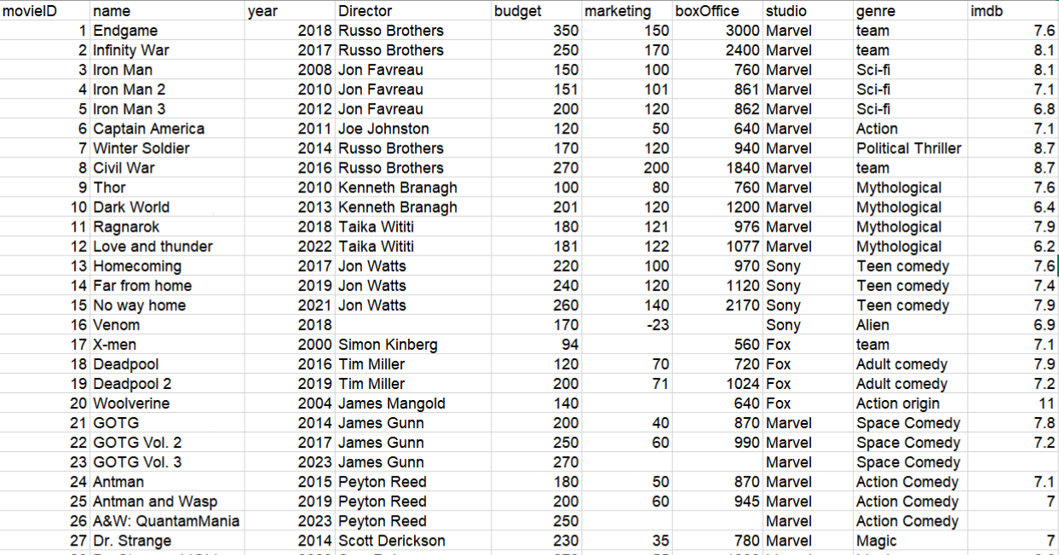

Importing the data into the notebook

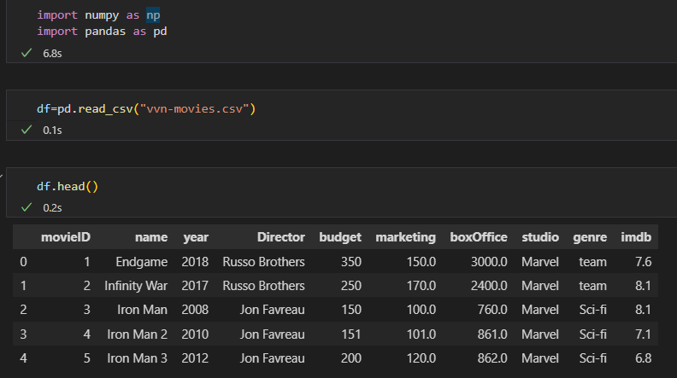

**Q2) Apply Data Manipulation Operations like:**

1. **Insert new sample**

to insert new row:

df=df.append({'movieID':30,'name':'Black Panther','year':2018,'Director':'Ryan Coogler','imdb':8.1},ignore_index=True)

output:



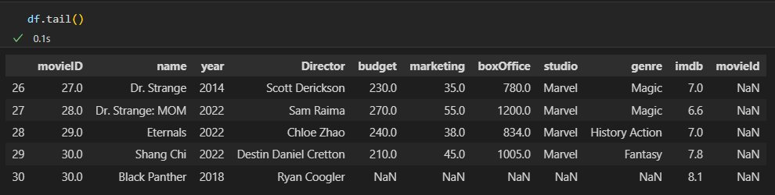

to insert a column:

df.insert(10,"Country","America")

output:

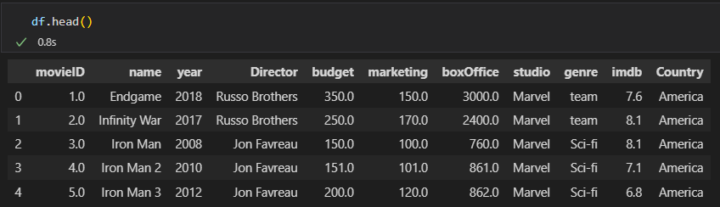

1. **Delete particular sample**

dropping row by row id:

df.drop(29, axis=0, inplace=True)

output:

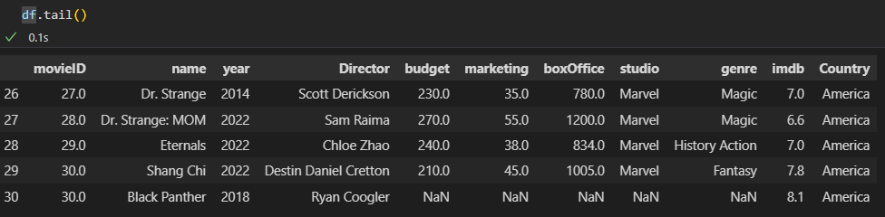

dropping column:

df.drop('movieID', inplace=True, axis=1)

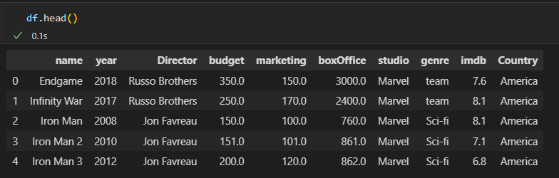

1. **Update particular sample**

To update values at specific sample

df.at[17,'Country']="Canada"

output:

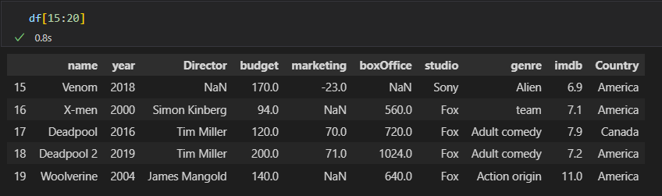

Replacing given values across the data

df.replace("America", "USA", inplace=True)

output:

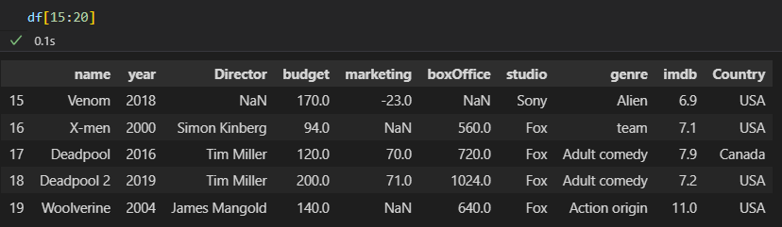

**Q3) Apply Data pre-processing like:**

1. **Find no. of missing values**

Find nan values in each column:

df.isna().sum()

output:

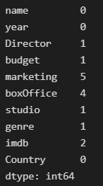

Find total nan values in df

df.isna().sum().sum()

output:



1. **Replace missing values by mean, median and mode operations.**

mean_value=df['marketing'].mean()

df['marketing'].fillna(value=mean_value, inplace=True)

median_value=df['boxOffice'].median()

df['boxOffice'].fillna(value=median_value, inplace=True)

mode_value=df['imdb'].mode()

df['imdb'].fillna(value=int(mode_value), inplace=True)

print(df)

output:

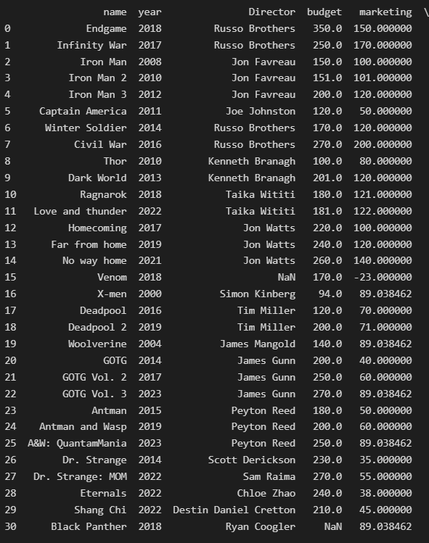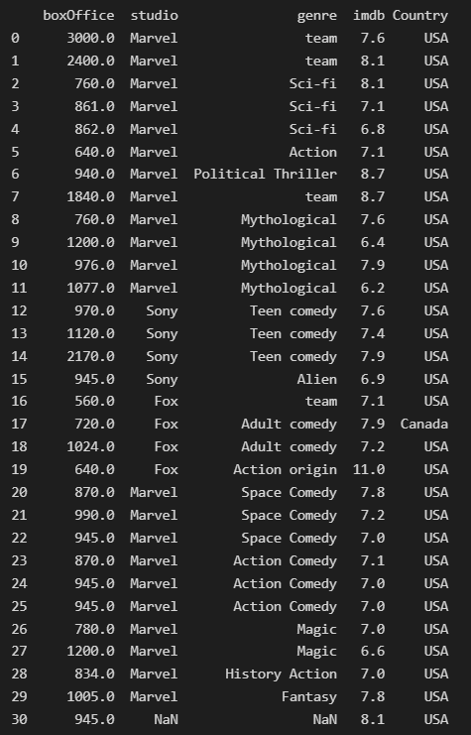

replaced by median replaced by mode



replaced by mean



**c. Apply encoding techniques like**

i. ordinal to categorical

values=['fresh','rotten']

conditions=[(df["imdb"]>8),(df["imdb"]<=8)]

arr=np.select(conditions,values)

print(arr)

df.insert(9,"score",arr)

output:

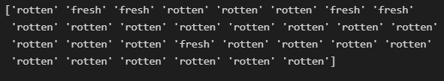

Categorical data 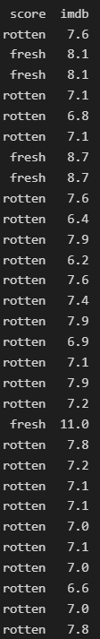 Original numeric data (no categorical data available in dataset)



ii. categorical (text) to categorical (numeric)

df['Country'].replace([0,1], ['USA', 'Canada'], inplace=True)

Output:

Categorical (text) Data 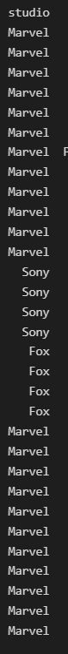 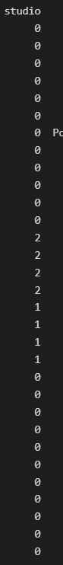 Categorical (numeric) Data



iii. label encoding to binary encoding

df['studio'].replace(['Marvel', 'Fox', 'Sony'], [0,1,2], inplace=True)

label encoding 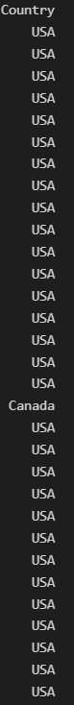 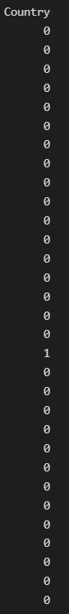 binary encoding



**Q4) Apply Normalization techniques**

**a.Minmax**

df_min_max_scaled = df[['imdb','boxOffice','marketing','budget']]

for column in df_min_max_scaled.columns:

    df_min_max_scaled[column] = (df_min_max_scaled[column] - df_min_max_scaled[column].min()) / (df_min_max_scaled[column].max() - df_min_max_scaled[column].min())

print(df_min_max_scaled)

Output:

Before After MinMax Normalization

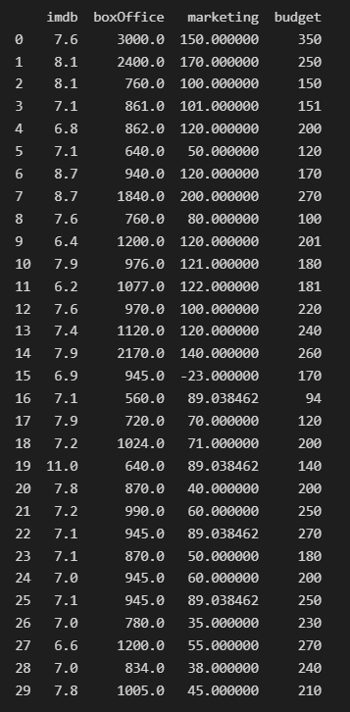 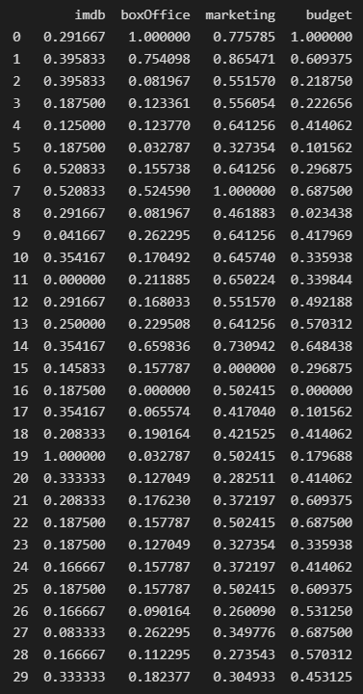

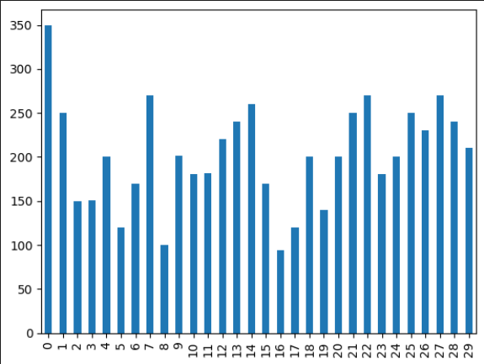 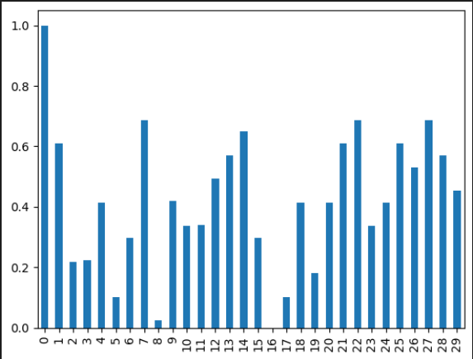

Budget column bar graph (before and after)

b. Standard scaling (according to mean)

df_standard_scaled = df[['imdb','boxOffice','marketing','budget']]

for column in df_standard_scaled.columns:

    df_standard_scaled[column] = (df_standard_scaled[column] - df_standard_scaled[column].mean()) / (df_standard_scaled[column].max() - df_standard_scaled[column].min())

print(df_standard_scaled)

Output:

Before After

 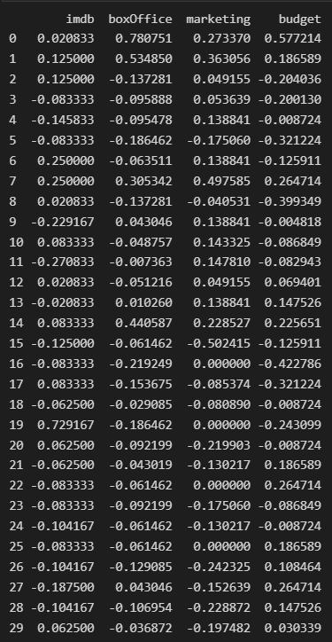

 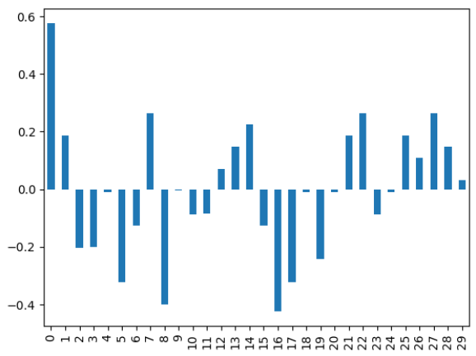

Budget column bar graph (before and after)