**Vivian Joseph**

**(20BCE0777)**

**Machine Learning**

**Lab Da-2**

**Regression Implementation**

**Q1) Create your own dataset for given sample column name (minimum 30 samples).**

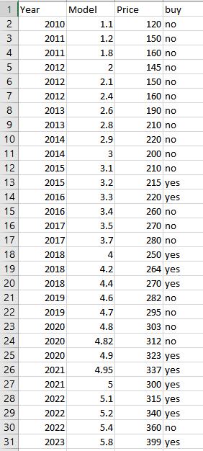 **(make csv file)**



**Q2) Apply linear regression (Hot Code) and visualize the same**

Take the Appropriate variables as target and attributes

X=df[["Year","Model"]]

Y=df["Price"]

Check correlation matrix

correlation_matrix = df.corr().round(2)

sn.heatmap(data=correlation_matrix, annot=True)

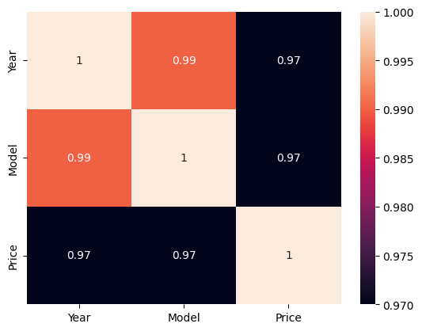

Write a function to fit the line

Price = b0 + b1(year) + b2(Model)

# Taking Price = b0 + b1(Year) + b2(Model)

def linReg(X1,X2,Y):

    N=len(Y)

    X1_square=X1**2

    sig_x1_2= X1_square.sum() - (X1.sum()**2/N)

    X2_square=X2**2

    sig_x2_2= X2_square.sum() - (X2.sum()**2/N)

    X1_X2=X1*X2

    sig_x1x2= X1_X2.sum() - (X1.sum()*X2.sum()/N)

    X1_Y=X1*Y

    sig_x1y= X1_Y.sum() - (X1.sum()*Y.sum()/N)

    X2_Y=  X2*Y

    sig_x2y= X2_Y.sum() - (X2.sum()*Y.sum()/N)

    b1_num=((sig_x2_2)*(sig_x1y)-(sig_x1x2)*(sig_x2y))

    b2_num=((sig_x1_2)*(sig_x2y)-(sig_x1x2)*(sig_x1y))

    denom= ((sig_x1_2)*(sig_x2_2)-(sig_x1x2)**2)

    b1=b1_num/denom

    b2=b2_num/denom

    b0=Y.mean()-b1*X1.mean()-b2*X2.mean()

    return b0, b1, b2

Call the function

b0,b1,b2=(linReg(X["Year"],X["Model"],Y))

We get values for b0,b1,b2

print(b0,b1,b2)





Put values in the line to get any two points on the line (in order to plot later)

print(b0+b1*2010+b2*1)

print(b0+b1*2023+b2*6)





Plot it on a graph to see if the line fits the given data

fig = plt.figure(figsize=(4,4))

ax = fig.add_subplot(111, projection='3d')

x=np.array([2010,2023])

y=np.array([1,6])

z=np.array([120.24,369.21])

ax.scatter(X["Year"],X["Model"],Y, c='r')

ax.plot3D(x,y,z)

plt.show()

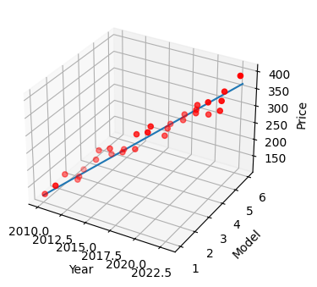(line fits data pretty well)

**Q3) Apply Polynomial regression and visualize the same**

Import relevant functions

from sklearn.preprocessing import PolynomialFeatures

from sklearn.linear_model import LinearRegression

make a function f(x1,x2)= a0+(a1*x1^2 )+(a2*x2^2)+(a3*x)+(a4*y)+(a5*xy) and fit the new features to the given data

poly=PolynomialFeatures(degree=2)

X_poly=poly.fit_transform(X)

reg=LinearRegression().fit(X_poly,df['Price'])

Plot the formed polynomial along with the given data points

fig=plt.figure()

ax=fig.add_subplot(111,projection='3d')

ax.scatter(df['Year'],df['Model'],df['Price'],color='b',marker='o')

x1_pred=np.linspace(df['Year'].min(),df['Year'].max(),100).reshape(-1,1)

x2_pred=np.linspace(df['Model'].min(),df['Model'].max(),100).reshape(-1,1)

x_pred=np.hstack((x1_pred,x2_pred))

y_pred=reg.predict(poly.transform(x_pred))

ax.scatter(x1_pred,x2_pred,pd.DataFrame(y_pred),color='r',marker='o')

ax.set_xlabel("Year")

ax.set_ylabel("Model")

ax.set_zlabel("Price")

plt.show()

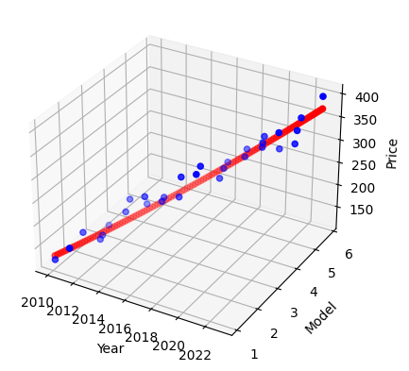

(Polynomial comes close to a straight line but is not exactly linear – as linear line fits the given data very well)

The actual coefficients are as follows:

print(reg.coef_)



**Best fit= degree 1 (linear)**

**Q4) Logistic regression add one attribute(target) user is interested to buy/not buy and visualize the same**

Prepare the data and fit it to the logistic regression function

X=df[['Year','Price']]

Y=df['buy']

clf= LogisticRegression()

clf.fit(X,Y)

coef = clf.coef_[0]

intercept = clf.intercept_[0]

print(coef,intercept)



Visualize the data with the logistic regression line

fig = plt.figure()

ax = fig.add_subplot(111, projection='3d')

x1_min, x1_max = X['Year'].min(), X['Year'].max()

x2_min, x2_max = X['Price'].min(), X['Price'].max()

xx1, xx2 = np.meshgrid(np.linspace(x1_min, x1_max), np.linspace(x2_min, x2_max))

grid = np.c_[xx1.ravel(), xx2.ravel()]

probs = clf.predict_proba(grid)[:, 1].reshape(xx1.shape)

ax.contour(xx1, xx2, probs, levels=[.5], cmap="Greys", vmin=0, vmax=.6)

ax.scatter(df['Year'], df['Price'], df['buy'].map({'yes':1,'no':0}), c='r', marker='o')

ax.set_xlabel('Year')

ax.set_ylabel('Price')

ax.set_zlabel('buy or not')

ax.set_title('Logistic Regression Result Visualization')

plt.show()

