**VIVIAN JOSEPH**

(20BCE0777)

Machine Learning

**Lab DA-5**

Dimensionality Reduction and Unbalanced Data Processing

**PCA:**

import numpy as np

import pandas as pd

import matplotlib.pyplot as plt

import sklearn

from sklearn.metrics import r2_score

from sklearn.model_selection import train_test_split

from sklearn.decomposition import PCA

import seaborn as sn

from sklearn.preprocessing import StandardScaler

**Load the breast cancer dataset:**

from sklearn.datasets import load_breast_cancer

cancer = load_breast_cancer()

X = cancer.data

X=pd.DataFrame(X)

y = cancer.target

**Visualizing the correlations between features**

correlation_matrix = X.corr().round(2)

# annot = True to print the values inside the square

sn.heatmap(data=correlation_matrix, annot=True)

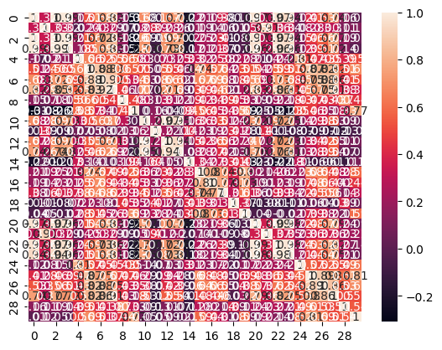

**Total** **30 input features (Clearly, too many features)**

**Training and testing without PCA:**

X_train, X_test, Y_train, Y_test = train_test_split( X, y, test_size=0.30, random_state=30)

from sklearn.linear_model import LinearRegression

from sklearn.metrics import mean_squared_error

lm = LinearRegression()

lm.fit(X_train, Y_train)

# model evaluation for training set

y_train_predict = lm.predict(X_train)

rmse = (np.sqrt(mean_squared_error(Y_train, y_train_predict)))

r2 = r2_score(Y_train, y_train_predict)

print("The model performance for training set")

print("--------------------------------------")

print('RMSE is {}'.format(rmse))

print('R2 score is {}'.format(r2))

print("\n")

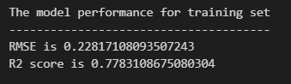

# model evaluation for testing set

Y_pred = lm.predict(X_test)

rmse = (np.sqrt(mean_squared_error(Y_test, Y_pred)))

r2 = r2_score(Y_test, Y_pred)

print("The model performance for testing set")

print("--------------------------------------")

print('RMSE is {}'.format(rmse))

print('R2 score is {}'.format(r2))

# model evaluation for testing set

print(Y_pred.shape)

Y_pred

pd.DataFrame(Y_pred,Y_test)

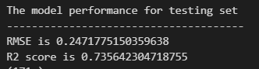



**Test R2 Score with 30 features**

**Applying PCA:**

scaler = StandardScaler()

X_std = scaler.fit_transform(X)

# Initialize PCA model

pca = PCA(n_components=4)



# Fit and transform data

X_pca = pca.fit_transform(X_std)

# Plot the transformed data

plt.scatter(X_pca[:, 0], X_pca[:, 1], c=y+1)

plt.xlabel('PC1')

plt.ylabel('PC2')

plt.title('Iris dataset after PCA')

plt.show()

# Print explained variance ratio

print("Explained variance ratio:", pca.explained_variance_ratio_)

**final shape:**

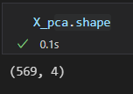

**Training and testing after PCA:**

X_train, X_test, Y_train, Y_test = train_test_split( X_pca, y, test_size=0.30, random_state=30)

lm = LinearRegression()

lm.fit(X_train, Y_train)

# model evaluation for training set

y_train_predict = lm.predict(X_train)

rmse = (np.sqrt(mean_squared_error(Y_train, y_train_predict)))

r2 = r2_score(Y_train, y_train_predict)

print("The model performance for training set")

print("--------------------------------------")

print('RMSE is {}'.format(rmse))

print('R2 score is {}'.format(r2))

print("\n")

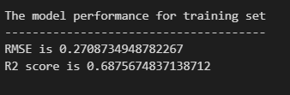

Y_pred = lm.predict(X_test)

rmse = (np.sqrt(mean_squared_error(Y_test, Y_pred)))

r2 = r2_score(Y_test, Y_pred)

print("The model performance for testing set")

print("--------------------------------------")

print('RMSE is {}'.format(rmse))

print('R2 score is {}'.format(r2))

# model evaluation for testing set

print(Y_pred.shape)

Y_pred

pd.DataFrame(Y_pred,Y_test)

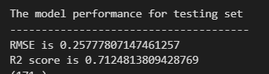



**Test R2 Score with only 4 features**

|  |  |  |
| --- | --- | --- |
| **Number of input Features** | **R2 Score** | **RMSE** |
| **30** input features | 0.735 | 0.247 |
| only **6** input features | 0.712 | 0.258 |

**Clearly, the r2 score is affected barely even after drastically reducing the number of features from 30 to 6.**

**Under-Sampling and Over-Sampling:**

import numpy as np

import pandas as pd

import matplotlib.pyplot as plt

import sklearn

from sklearn.metrics import r2_score

import seaborn as sn

from sklearn.model_selection import train_test_split

from sklearn.linear_model import LinearRegression

from sklearn.metrics import mean_squared_error

**Creating an imbalanced dataset:**

from sklearn.datasets import load_breast_cancer

import numpy as np

breast_cancer = load_breast_cancer()

X = breast_cancer.data

y = breast_cancer.target

# Generate an imbalanced version of the dataset with a 90/10 split

np.random.seed(42)

mask = np.random.rand(len(y)) < 0.9 # 90% of samples in one class

y[mask] = 0 # Assign the first class to the majority of samples

y[~mask] = 1 # Assign the second class to the minority of samples

print("Original class distribution:", np.bincount(breast_cancer.target))

print("Imbalanced class distribution:", np.bincount(y))

target data is highly imbalanced



(504 samples with label 0, 65 samples with label 1)

**Over sample the data:**

# Get the indices of the majority and minority classes

majority_class = np.where(y == 0)[0]

minority_class = np.where(y == 1)[0]

# Randomly select a subset of samples from the minority class

random_indices = np.random.choice(minority_class, size=len(majority_class), replace=True)

# Combine the majority class samples with the randomly duplicated minority class samples

oversampled_indices = np.concatenate([majority_class, random_indices])

X_oversampled = X[oversampled_indices]

y_oversampled = y[oversampled_indices]

# Check the class distribution

print(np.unique(y_oversampled, return_counts=True))

Oversampled Data:



(504 samples with label 0, 504 samples with label 1)

**Under sample the data:**

num_class0 = np.sum(y == 0)

num_class1 = np.sum(y == 1)

# Randomly select a subset of samples from the minority class

random_indices = np.random.choice(minority_class, size=len(majority_class), replace=True)

# Combine the majority class samples with the randomly duplicated minority class samples

oversampled_indices = np.concatenate([majority_class, random_indices])

X_oversampled = X[oversampled_indices]

y_oversampled = y[oversampled_indices]

# Check the class distribution

print(np.unique(y_oversampled, return_counts=True))



(65 samples with label 0, 65 samples with label 1)

**Training and testing for all strategies:**

X_train, X_test, Y_train, Y_test = train_test_split( X, y, test_size=0.30, random_state=30)

lm = LinearRegression()

lm.fit(X_train, Y_train)

# model evaluation for training set

y_train_predict = lm.predict(X_train)

rmse = (np.sqrt(mean_squared_error(Y_train, y_train_predict)))

r2 = r2_score(Y_train, y_train_predict)

print("The model performance for training set")

print("--------------------------------------")

print('RMSE is {}'.format(rmse))

print('R2 score is {}'.format(r2))

print("\n")

Y_pred = lm.predict(X_test)

rmse = (np.sqrt(mean_squared_error(Y_test, Y_pred)))

r2 = r2_score(Y_test, Y_pred)

print("The model performance for testing set")

print("--------------------------------------")

print('RMSE is {}'.format(rmse))

print('R2 score is {}'.format(r2))

# model evaluation for testing set

print(Y_pred.shape)

Y_pred

pd.DataFrame(Y_pred,Y_test)

**For Unbalanced Data:**

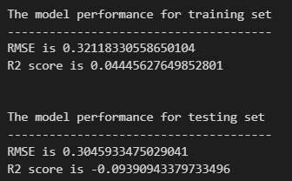

**For Over Sampled Data:**

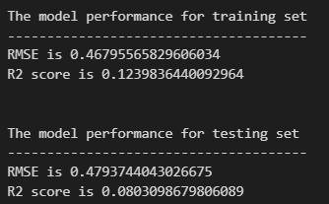

**For Under Sampled Data:**

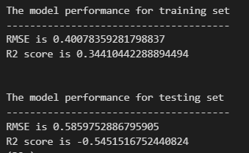

**Clearly, Over Sampling helps improve on the results but under sampling is not very useful in this case**