GDD - M1 Crafting

* Product Owner: Ben Giacobbi
* Technical Lead:
* Producer:

# RACI Matrix

(**R**esponsible **A**ccountable **C**onsulted **I**nformed )

| **Deliverable** | **Product Owner** | **Tech** | **Art** | **Comm** | **Mktg** | **UX/UI** | **Design** | **QA** | **Prod** |
| --- | --- | --- | --- | --- | --- | --- | --- | --- | --- |
|  |  |  |  |  |  |  |  |  |  |
|  |  |  |  |  |  |  |  |  |  |
|  |  |  |  |  |  |  |  |  |  |
|  |  |  |  |  |  |  |  |  |  |
|  |  |  |  |  |  |  |  |  |  |
|  |  |  |  |  |  |  |  |  |  |
|  |  |  |  |  |  |  |  |  |  |
|  |  |  |  |  |  |  |  |  |  |

*Last Modified Date*:

# What This Feature Is

Our priority items for M2 are crafting, resource extraction, and resource searching to round out our primary gameplay look. Because extraction and searching are primary elements of M2, and because we want to complete a first cut of crafting before expanding into module assembly or other additional systems, crafting in M2 will involve toolmaking with the tools involved for extraction and searching.

Essentially, the implementation of this system is our first pass to ensure that basic crafting behavior is complete and bug-free, so that we can begin adding content and developing our demos in a more well-rounded way.

# Crafting Basics

## Components

Each crafting recipe will be represented by a typescript component containing various data about its ingredients, the stat contributions from each ingredient, and sorting information.

The data within each recipe is as follows:

* Identity of Ingredients (resource/object ID)
  + 1-3 ingredients
  + Can have fewer, and very rarely (if ever) just one
  + Ingredient identity can be a higher or lower subclass, and more specific ingredients that fulfill that subclass are okay
* Ingredient contributions (float from 0-1)
  + 9 per ingredient
  + Each ingredient’s three stats can contribute to at least one stat, in some percentage
  + Some ingredients’ stats may not affect anything, in which case it’s “None”
* Result Addressable
  + The recipe holds reference to the completed item’s addressable for display purposes
* Category
  + Whatever item category the result is classified as
* Profession
  + Whatever profession the recipe is governed by
* Other sorting info
  + TBD

A crafting recipe should be easily to replicate and generate. Potentially do an in-game tool?

# UI Basics

## Recipe Book

The primary crafting UI is the Recipe Book, which lists to the player all the recipes they have access to as well as whether or not they are valid to be crafted.

In this first pass, we won’t have any sorting options, as the number of recipes we have available is too low for sorting to matter in the long run. However, we WILL use this opportunity to receive player feedback about how they might like to sort their recipes.

In this first pass, the player essentially has “unlimited” recipe storage, though it will remain bound by any engineer-given limitations for storage (such as the provisional 90 item limit in inventory containers for regular items).

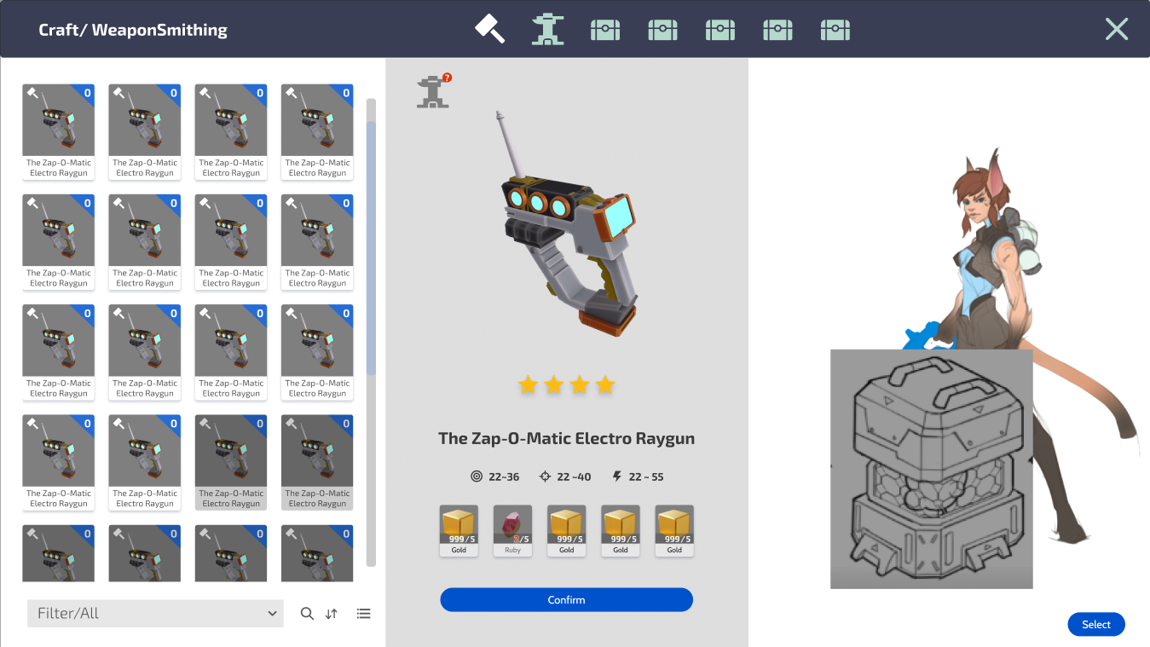

Existing wireframe of the Recipe Book UI. On the left is the recipe list within the profession, in the center is the recipe information, and on the right is a preview.

### Recipe List/Sorting

Recipes are listed in a grid, similar to a regular inventory. Any recipe that is not valid to be crafted is automatically sent to the bottom of the list and is darkened/crossed out, leaving only valid recipes at the top.

For this first pass, recipes will be sorted alphabetically. IN THE FUTURE: Recipes will sort based on some user-specified preferences (such as alphabetical, by type, by ingredients, etc). The player should be able to search in an ingredient and see all recipes that use it, for example, and the player can search for a recipe by name.

Recipes are furthermore sorted by their professions. This is both a useful tool for pagination but also separates the EXP gain from the resulting item, once that system is implemented.

## Crafting Interface

When a craft is inspected, another crafting interface is shown to display the detail of the recipe in higher resolution. The interface allows you to pick from a list of objects in your nearby containers that fulfill the requirements for each component of the recipe.

Per Basic Crafting (GDD Link), even though multiple possible items can fit the criteria for an ingredient, if the recipe calls for multiple, all ingredients used to fill that requirement must be of the same identity. This simplifies the UI greatly, and it will just tell the player that you need at minimum “5 of identical item” to craft.

The craft interface also shows some minimal information for how ingredients contributed to the three stats of the final item. Greater resolution information will be available for advanced players, such as direct percentages.

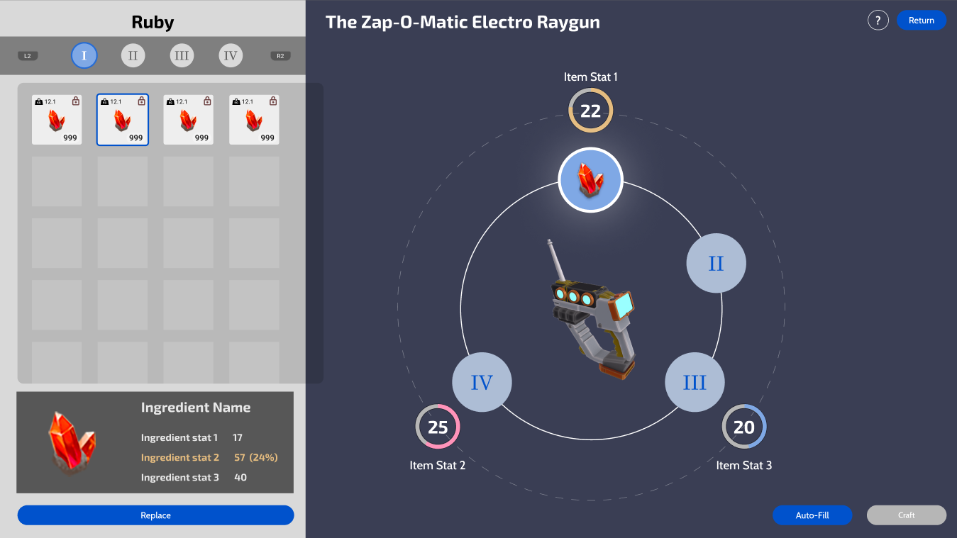

Existing crafting wireframe. The left panel shows the ingredients list and options, while the right displays each of the final crafted item’s stats and how the contributing ingredients influence how close the item can approach its max potential.

## Crafting Result

Upon conclusion of the craft, the player is shown the resulting item and its associated stats. Items do not remember any specific information about the items used to craft them, so the item cannot be inspected for an item history.

IN THE FUTURE: This screen will give players the option to perform Experimentation (link GDD) to expand on the basic crafting process for an item bonus. This system is mostly separate from basic crafting, except choosing to take the item as is forfeits the ability to experiment on it.

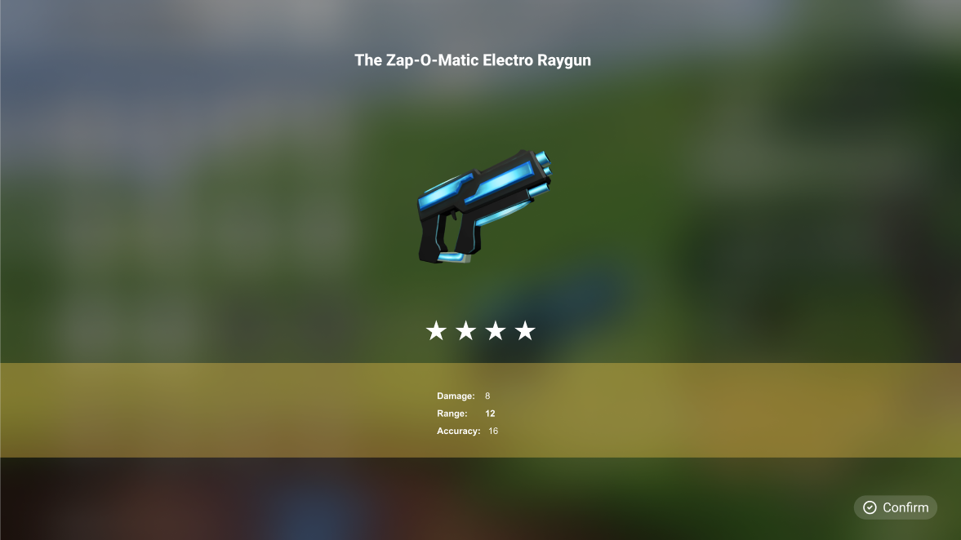’Existing wireframe for craft result. The “stars” show how close the item is to its max potential.

# Items and Materials

Crafting recipes and information lives in json data managed by our editor tools. Actual instanced materials will be tracked in a SQL database.

## Basics

In the underlying system, items are created with respect to subclasses. Each physically represented game item is a subclass of a higher category, such as Iron being a subclass of Ferrous Metal which is itself a subclass of Iron.

Per basic crafting, we have implemented a class hierarchy for items which we will use to create up to two subclass levels from a highest-level type. At this stage, the second subclass will represent the in-game items (such as iron or gold), with no stat variation. IN THE FUTURE, we will have “terminal subclasses”, which are the instanced items subclassed from the second subclass that are populated during worldgen. Prior subclasses can be used to specify recipe requirements, but are not themselves available items

The item database contains the following data

* Stats (1-3)
  + Stats are named, but names do not inherently mean anything. Stats are also indexed
  + Value ranges for these stats (min-max)

If an item is also a resource it contains:

* There’s various CASim data. I could probably also cut this from this document, but it should be called out that our item database either also contains or shares reference to the world resource data.

When an item is generated by resource extraction or combat, it calls to the database to find the ranges for its values, and rolls the values on a bell curve. Low and high extremes are unlikely, and therefore an item with all bad stats or all good stats are EXTREMELY unlikely.

### Resource Items

| Metal > Ferr Metal > **Iron**  Located below the surface of a biome, occasionally in aboveground veins, and near water.  Hardness ()  Shininess ()  Conductivity () | Metal > NF Metal > **Copper**  Located below the surface of a biome, and occasionally in aboveground veins.  Hardness ()  Shininess()  Conductivity() | Metal > NF Metal > **Gold**  Located deep below the surface of a biome, and near surface water.  Hardness ()  Shininess()  Conductivity() | Chem> Rad > **Uranium**  Located extremely deep below the surface. A highly rare and dangerous material.  Hardness ()  Shininess()  Conductivity() |
| --- | --- | --- | --- |
| Edible Animal > Meat > **Raw Herbivore Meat**  Meat drops received from herbivore species. Resources a little HP. | Edible Animal > Meat > **Raw Carnivore Meat**  Meat drops received from carnivore species. Restores a lot of HP. | Rock > Metamorphic Rock > **Gneiss**  Found both on the surface and underground. A common material.  Hardness ()  Workability ()  Flammability () | Rock > Sedimentary Rock > **Limestone**  Found primarily on the surface and by water. A common material.  Hardness ()  Workability ()  Flammability () |
| Rock > Igneous Rock > **Granite**  Found everywhere. A common material.  Hardness ()  Workability ()  Flammability () | Gemstone > Precious > **Ruby**  A rare gem found in various places. Used for high-level crafting recipes.  (Img) | Plant > Edible Plant > **Dozza Berry**  A fruit found high on rarely found Dozza Trees. Replenishes a lot of Stamina. | Plant > Edible Plant> **Trumble Fruit?**  A common fruit found in trees. Replenishes some stamina. |
| Plant > Edible Plant > **Starfruit**  A common fruit found in low-lying bushes. Replenishes some stamina. | Plant > Inedible Plant > **Hard Light Wood**  A common type of wood found in overland trees. | Plant > Inedible Plant > **Soft Dark Wood**  A common type of wood found in overland trees. |  |

### Non-Resource Items

These are items that are not resources, but also do not have any terminal purpose by the player (such as a tool or a crafting station). These were originally called “precursor items”.

The following items were given vaguely sci-fi identities for flavor. The actual identity of these items doesn’t particularly matter, they’re just intermediate steps to provide multiple levels of economy to vertically separate player goals.

| Chrono Power | Drip Core | Basic Wave Guide |  |
| --- | --- | --- | --- |
| (Img) | (Img) | (Img) |  |

### Player-Usable Items

These are items that can be equipped/place/used for some purpose other than crafting.

Per the Resource Extraction from Terrain (GDD) document, each extractor will have two available slots on it. A “Type” module indicating the type of material it can extract, and a “Footprint” module which determines its overall footprint, as well as its focus cost. The remaining variable chassis each have some qualities associated with other modules, but those modules aren’t exposed to players for simplicity and to provide a more obvious “advancement” path in lieu of a proper skill system.

The type modules, when used in a prospector,

The Berry Picker extractors provide basic benefits, but the player can also harvest berries and wood without.

| **Basic Prospector**  Slow harvest speed and low average efficacy. | **Advanced Prospector**  High harvest speed and low average efficacy. | **Ultimate Prospector**  Medium harvest speed and high average efficacy. | **Long-Range Prospector**  (Basic Prospector with Range Module) |
| --- | --- | --- | --- |
| **Depth Prospector** (Basic Prospector with Depth Module) | **Mobile Prospector**  (Basic Prospector with Mobile Module) | **Basic Flora Picker**  Slow harvest speed. Higher efficacy than using hands, | **Advanced Flora Picker**  Medium harvest speed, longer range. |
| **Metal Type Module**  A type module for metals to be used in a prospector. | **Gem Type Module**  A type module for gems to be used in a prospector. | **Stone Type Module**  A type module for stone to be used in a prospector. | **Small Footprint Module**  A footprint module that allows 1x1 |
| **Medium Footprint Module** | Basic Searcher | (Cooking Item 1) | (Cooking Item 2) |
| **Crafting Station (Toolmaking)** | **Crafting Station (Cooking)** |  |  |

# Recipes

# Player Advancement

Players begin M2 with a Basic Prospector, equipped with a Metal Module and a Small Footprint Module.

In this pass, the player has minor advancement along the toolmaking profession. We may not fully establish or expose the profession and skills “system”, but we will still offer a path for players to “level up” their interaction wit hte crafting system and other players.

1. Initially, the crafter creates basic prospectors and one of the non-resource items.
2. Once the player has resources, they can craft advanced prospectors and the other non-resource items, as well as berry harvesters.
3. At this point, the player can offer more of a “service” route to other players with multiple prospector sidegrades. Each sidegrade serves a different purpose and may be useful to different players, leading to requests.
4. Through a combination of trade and self-collection, a crafter can create an ultimate prospector.
5. After this point, the player continues to create ultimate-level harvesters as part of their brand and fulfills other requests, as well as seeks endgame cosmetics.

With a more proper skill system, we will actually gate the player’s ability to craft based on skill points they accumulate by items they sell to other players being used for collection. For now, the gate for crafters is high resource cost encouraging players to help each other with resources they are searching for.

# Requirements

## Required for this pass

# Tech Asks

# Design Asks

# Art Asks

* TBD

# UI/UX Asks

* TBD

# Sound Asks

* TBD

# VFX Asks

# Sign Off

| **Final Approval**  **(right-click to check)** | **Approver** | **Date** |
| --- | --- | --- |
|  | Product Owner (Ben Giacobbi) |  |
|  | Tech (Glen Heide) |  |
|  | Art Director (Valerie Zaroli) |  |
|  | Art (Kevin Burns) |  |
|  | UX/UI (Addison Barnes) |  |
|  | Design () |  |
|  | QA Engineering () |  |
|  | QA Gameplay (Hayley Ancona) |  |
|  | Production (Aiden Wallace) |  |
|  | Marketing () |  |
|  | Community () |  |
|  | Production Director () |  |
|  | EP (Gordon Walton) |  |
|  | Exec/CCO (Raph Koster) |  |
|  | Game Director (David Georgeson) |  |

* Outline some basics for player advancement here in the toolmaking profession
  + In an older spec I did for this, it was just two tools per searching and extracting each
  + Should toolmaking actually be split into multiple professions? Maybe the advancement for toolmaking can actually just be that it unlocks various other tools, because there’s a lot to go around anyway?
    - Searching
    - Extraction
    - Farming
    - Ranching
    - Taming
    - Building
  + Meanwhile Weaponsmithing only has the dedicated weapon types, though those ARE large trees.

**Searching**

* Radius
* Depth
* Specificity
  + Subclass targeted
* Efficacy
* Shareability?
* Convenience?

**Extraction**

* Radius
* Depth
* Specificity
* Efficacy
* Use Range
* Can Use While Moving?
* (Temp Only) Resource Stats?
* Draw Radius (drawing it to you after extracting?)
* Basic:
  + Inspect/Click on Flora/Props
  + Shoot/Kill Creatures
* Intermediate:
  + Basic harvesters leave you stuck in place while harvesting
  + Basic Resource Harvester (Prospector)
    - Harvests inefficiently? Loses resources? Doesn’t really matter in the context of the demo IMO
  + Basic Flora Harvester (Botany?)
    - Has a chance to spoil berries upon harvest?
      * Maybe “spoiled berries” as an item is actually useful for a specific crafting recipe to enforce less vertical integration
    - Maybe one automatically replants bushes that it harvests
* Advanced
  + Advanced Resource Harvester (Prospector)
    - Advanced resource harvesters allow you to harvest while moving
    - Wide version? - Maybe some resources spawn primarily near the surface (Copper? Granite?)
    - Deep version? - Maybe some resources only spawn deeper (Iron, Uranium, Ruby)
    - Long-range One
  + Advanced Flora Harvester (Botany?)
    - Maybe one has just an automatic replanter
* Sidegrades
  + Gold Miner (Harvests gold at better rate?)
  + Gem Miner (Harvests Gems at better rate?)
  + Stone Miner (Increases stone yield at the expense of other valuables)
  + Long-Range Harvester
    - Allows you to harvest a unit from long range, meaning you can avoid enemies more effectively
  + Fruit Harvester
    - Increased fruit yield
  + Wood Harvester
* Bonus
  + Moyai statue?
  + Chair
  + Hat

Having “Searching” be a part of the tree for any individual “harvesting” tool.

Prospecting Chassis

* Basic Prospecting Tool
  + Can harvest “basic” materials above a certain rarity level (> 25%)
* Advanced Prospecting Tool
  + Can harvest “uncommon” materials in a certain rarity range (<25% and >5%)
* Ultimate Prospecting Tool
  + Can harvest “rare” materials below a certain rarity level (<5%)
* Hyper Prospecting Tool
  + Required to harvest “Hyper” materials

Harvesting Modules

* Range Module
  + Short, Medium, Long
* Radius Module
  + Small, Medium, Large, Very Large
* Depth Module
  + Shallow, Deep, Very Deep
* Mobile Module
  + Plant, Portable
* Repel Module
  + Low, High
* Speed Module
  + Slow, Fast, Very Fast