GDD - Experimentation

APPROVED

* Product Owner: Ben Giacobbi
* Technical Lead: Brian Elias
* Producer: Liam Hislop

Major Changes From Previous Version

* First-pass UI is now more defined, giving some basic organization and displays using a wireframe
* Theming is more defined but now later priority
* Implications of skill-boxes and EP are moved to later priority. First priority gives players 4 EP to spend regardless of profession.

# RACI Matrix

(**R**esponsible **A**ccountable **C**onsulted **I**nformed )

| **Deliverable** | **PO** | **Tech** | **Art** | **Comm** | **Mktg** | **UX/UI** | **Design** | **QA** | **Prod** |
| --- | --- | --- | --- | --- | --- | --- | --- | --- | --- |
| Experimentation Mechanics (Value Sets, Chance Rolls, etc) | A | R | I | I | I | I | R | C | I |
| UI Design | A | I | C | I | I | R | C | C | I |
| UI Implementation | A | R | C | I | I | C | C | C | I |
| Data for Value Curves | A | I | I | I | I | I | R | C | I |
| Priority A VFX | A | C | C | I | I | C | I | C | I |
| Priority A SFX | A | C | C | I | I | C | I | C | I |

*Last Modified Date*: 1/31/23

# What This Feature Is

Experimentation is the primary interactive element of our crafting system. Currently, “crafting professions” are divided into both *crafting* (the creation of new items by consuming constituent parts) and *assembly* (the socketing of modules into chassis, which isn’t a permanent, resource-consuming action). Experimentation offers the majority of “play” within our crafting system, and allows experienced crafters to aim for specific results as well as gamble for the highest quality items possible.

Experimentation serves the following purposes:

* Give crafters a level of interactivity beyond “dump resources and press a button”.
* Give crafters a way to specialize for stats they want on their crafted items, while exposing them to a gambling mechanic that results in variation. Luck should play a decent factor in any crafting result.
  + This marginally evens the economic contributions between highest-level and lowest-level players.
  + Players should feel like their choice outweighs the luck element, even if this is not actually true.
* Make it difficult to get the highest-quality stuff. Crafting requires spending resources, skillfully allocating experimentation points, and luck. High-quality stuff may be worth high amounts of money.
* All crafting burns resources, and players’ choices necessarily cost something to feed into our economic loop. In this case, it means a “bad” experimentation results in an item they weren’t hoping for, and that good results are at least common enough to encourage players to repeatedly experiment.
* Make crafting easy enough to page through and complete for people not interested in high-level experimentation and high-level crafters who’ve seen the same menu thousands of times.

This document expands upon the foundation laid in [GDD - Basic Crafting](https://docs.google.com/document/d/10pu9CWcjNBv8kWFyHBsT1p_O-zHOazoP3RCQENzDJSo/edit?usp=sharing).

This system was prototyped using the data described in the document and this website: <https://spinnerwheel.com/>, with the results recorded on paper.

## Related Systems

* [GDD - Basic Crafting](https://docs.google.com/document/d/10pu9CWcjNBv8kWFyHBsT1p_O-zHOazoP3RCQENzDJSo/edit?usp=sharing)
* [GDD - Subclassed Resources](https://docs.google.com/document/d/1jIkY9w3MawVUCt74spVgOF7PzrAHCdIJOD_425MkabM/edit?usp=sharing)
* [GDD - UI Style](https://docs.google.com/document/d/1aIoBa-uMZxCqAP6TrS02O9ZQnID-vAH333IaQsk8FdU/edit?usp=sharing)

# User Stories

A crafter is building a new rifle, and wants to modify the Damage module to get the maximum DPS possible. One of its stats (robustness) prevents it from breaking, but that crafter can’t focus on all three stats at once and thinks Efficiency and Recharge are better suited to his goal. By spending his experimentation points, he’s able to get a lucky roll of a Damage module with massive Efficiency, while the other two stats are about average.

A non-crafter has a few recipes under their belt from a couple of asundry skill boxes they've collected as a consequence of doing other tasks. Out of curiosity, they collect the required materials and craft one of their recipes—during that process, they’re required to spend all their experimentation points to complete the craft, which tells them that they might get something good. Due to pure chance, they receive an extremely powerful item, which they’re able to sell on the market for massive profit. They decide to spec further into crafting to do that again, and learn the nuances of the experimentation system to have a better chance of intentionally getting what they want.

A high level crafter has tons of EP, and bets on the riskiest experimentation option for that stat he’s focusing on, knowing that he’ll probably have enough leftover if things go south. However, his first three rolls go bad, and he struggles to make up the deficit, forcing him to craft again to get another result he likes.

A high-level crafter has been playing the game for almost a year, and has nearly unlocked the final skill box for their crafting skill (weaponsmithing). They have tons of EP to spend, and tend to create really solid modules when they craft, which they can sell at their personal shop to players that arrive on their “home” planet. However, they’ve only managed to make an “ultimate” module with high values in all of its stats a handful of times because they’re betting on so many factors to line up (their total EP, their experimentation choices, and pure luck). The reward for owning a module of that caliber is so great that they keep crafting and feeding the economy, well after unlocking most everything present in their skill of choice.

A mid-range crafter bought a ton of supplies from nearby stores, and rushed to a newly discovered planet when she learned it was filled with an iron type that’s top-tier for weaponsmithing. She goes on a crafting spree, and her experimentation results in one “amazing” weapon among a bunch of “above average” ones. Most of the iron was mined out of the planet in a few days when she next logs in, so she goes on to find another planet to see if she can create more “amazing” weapons.

A mid-level crafter gets her hands on a nigh-perfect set of materials for crafting a specific module, meaning she has the chance of creating a perfect item. She takes some risky bets with her EP knowing she doesn’t have a lot to spend, but unfortunately, rolls negative over and over again, ending up worse than she started. The modules are still great, but she knows it’ll be a while before she can eventually find a similar material again.

# User Flow

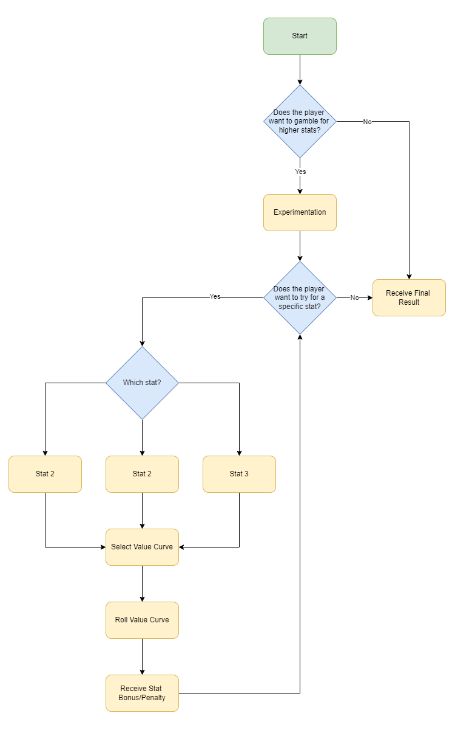

# Vision Items and Motivations

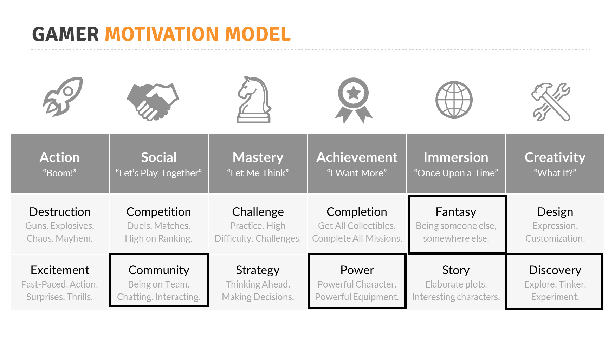

## High and Critical

**Fantasy** - Experimentation creates the feeling of tactile crafting and tinkering, allowing a player to assume the role of a skilled laborer. The purpose of experimentation is to provide a greater level of ownership and creativity than a simple “dump ingredients to craft” system found in other games.

**Completion** - Experimentation allows you to unlock the full range of item stats for craftables, meaning only a skilled crafter can take full advantage of many of the game’s systems and receive the “ultimate” items in the game

## Medium

**Design** - Experimentation allows players to spec into certain stats in any given craft, and attempt to customize their result, although they’re still bound by some luck-based elements.

**Strategy** - Focusing on certain stats during the crafting process, especially when trying to create a top-level item that’s directly usable by the player, may open up strategic options. For example, if experimentation allows the player to push the range of their weapon, they may have new strategies as a long-range sniper using their current equipment.

## Low

**Power** - The rare chance of obtaining super high-quality items can give the player a noticeable power boost, putting them at a competitive advantage with others both in PvE and PvP.

# Basis

Experimentation has been offered in multiple MMOs as an extension of their crafting system. “Experimentation” is a catch-all term for an interactive, choice-based modification to the crafting. The name “experimentation” is a placeholder, as it’s likely that it may not fit visually with our final game crafting skills and their visual representations. Fundamentally, most experimentation systems are gambling games with minor choice-based elements or mercies, meaning a player should expect them to produce junk results some non-insignificant percentage of the time.

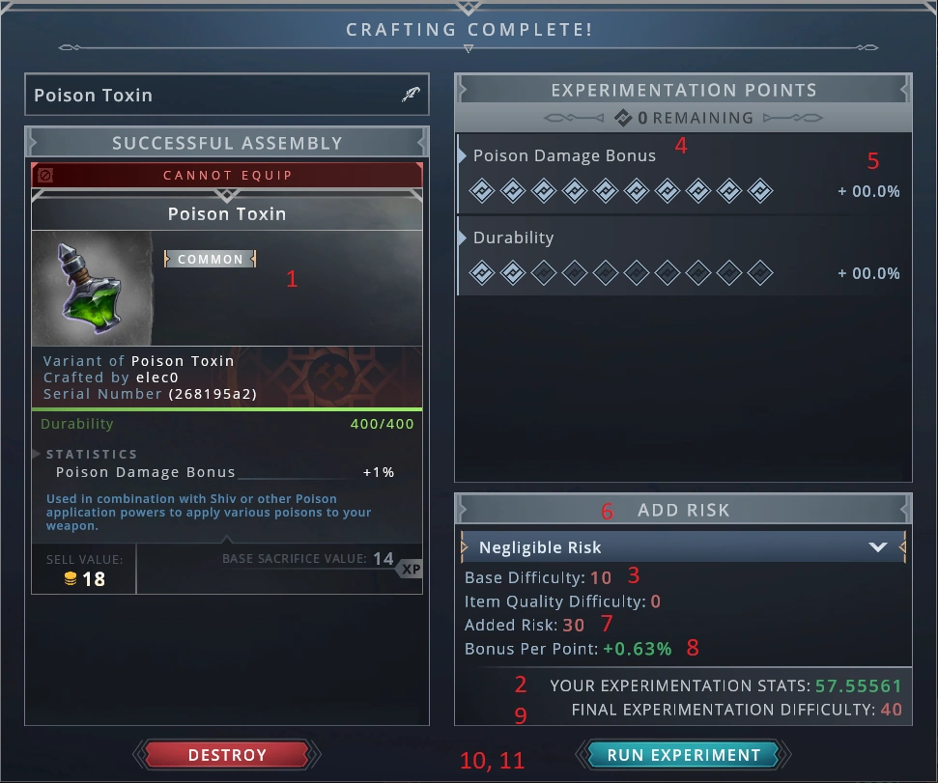

Crowfall’s experimentation page. The UI is very data-focused, and though it does flash with congratulatory feedback for good rolls (success, good success, great success, etc) on each “pip”, it remains a decently uncasual system. While we need to have high granularity in item properties to feed our economy, we likely should steer towards a more casual presentation.

EverQuest 2’s experimentation system, as well as crafting in Final Fantasy XIV, also tend to make their crafting a long process, as the player uses in-game skills to alter results/counter negative reactions until the craft is completed. This makes them much more difficult to multitask with, and requires absolute attention for the duration of the process, which may be less desirable.

For this document, we aim to base experimentation off these previous examples while attempting to simplify the UI, while still maintaining the essential choices that makes this system interesting.

## Experimentation vs Basic Crafting

Both experimentation and basic crafting offer some manner of specialization in the stats of the resulting craft. Since both are random, however, the level of specialization allowed by each part will vary depending on the player experience.

A more savvy crafter, with more connections, requests, and a greater skill at gathering resources, may have an easier time locating items they want. However, it remains true that experimentation is a deciding factor for all players on the usefulness of items for a specific task.

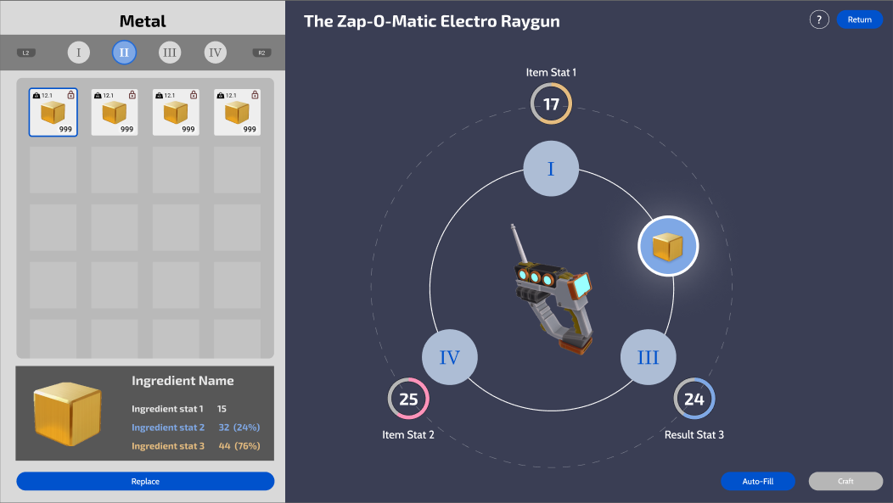

Wireframe for basic crafting. Each stat is shown around the base item, with some consideration added in the future for how ingredients are organized based on affecting each stat. In Priority A, however, stat variance does not occur in basic crafting.

# Priority A

**Only Priority A is being considered for Milestone 1 for first-pass implementing of crafting. Any features and descriptions in Priority B and beyond are not to be considered at this time. Furthermore, experimentation itself is likely to receive more overhauls, so consider most visual/data information to be subject to change.**

Experimentation occurs after the main crafting step has finished. Once the player has completed the initial craft, they can choose to experiment or keep the item outright.

## Main Mechanics

### Basic Values

The value rolled for each stat in basic crafting becomes the **start value** of the experimentation. This value is represented as a percentage of the overall total, rather than a hard value, as various items will have different value ranges.

start_value = (stat - min)/(max - min)

During experimentation, the player can access the entire range of values between **min** and **max**, also represented as percentages (0 and 100%).

### Random Curves

The player can apply a random curve of bonus values to a stat. By default, this curve is entirely 0.

On each bonus curve, the player can pull the max value higher, which shifts the average incrementally. However, pulling the max value higher also replaces the lower values with a “Bomb” negative value, with one bomb added for each tick that the curve is pulled (up to 8).

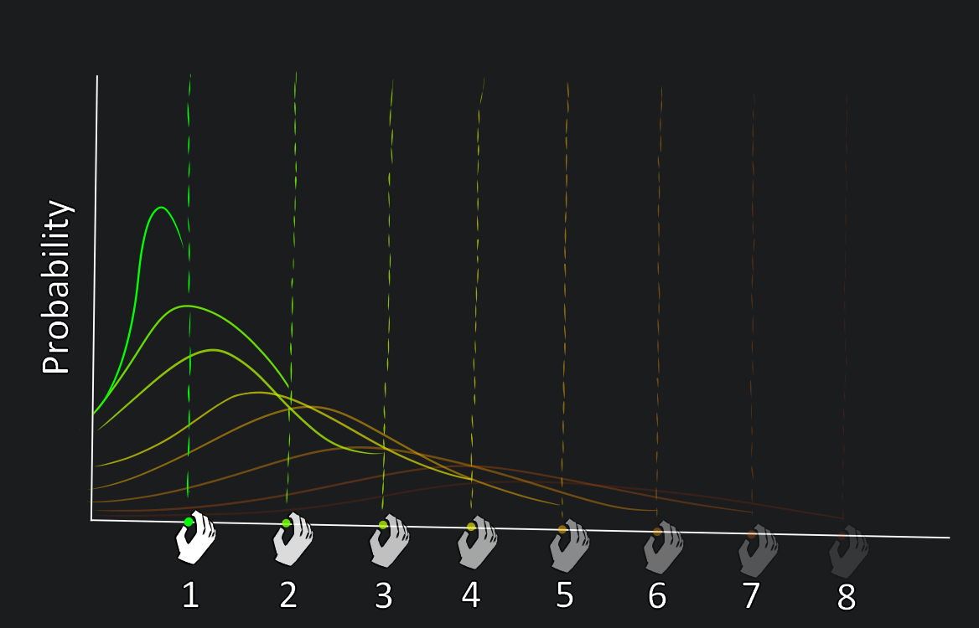

Pulling the curve high for a stat, which shifts the average high…

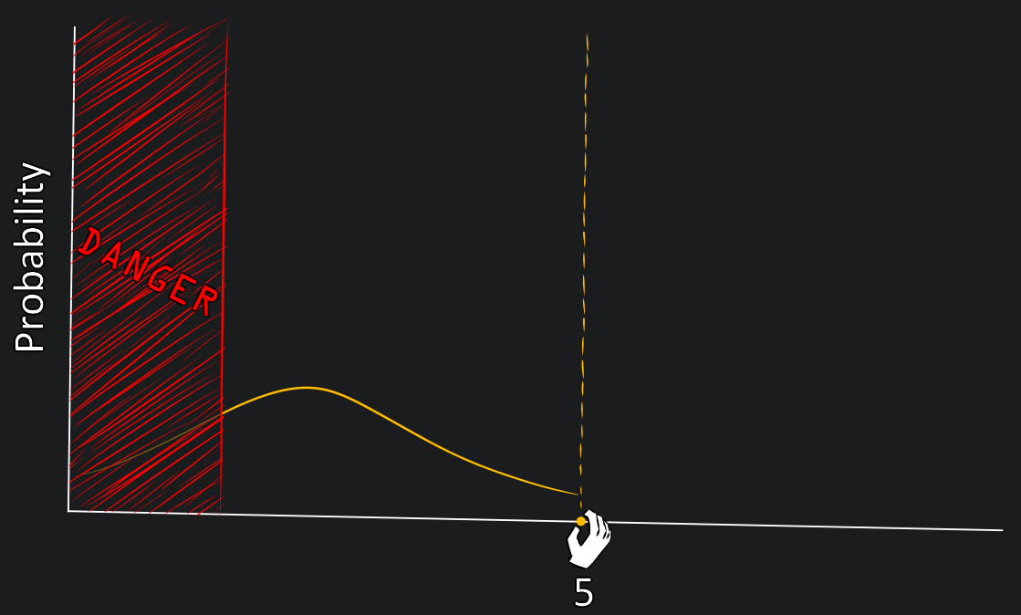

…but adds an increasing chance to land on a bomb, replacing the “lower” values.

The underlying curves are represented by these value sets. These represent percentages of a stat’s overall range:

0 ticks = [0,0,0,0,0,0,0,0,0,0,0,0,0,0,0,0]

1 tick = [-6,0,0,0,0,0,1,1,1,1,1,1,1,1,1,1]

2 ticks = [-6,-6,0,0,1,1,1,1,1,1,1,1,2,2,2,2]

3 ticks = [-6,-6,-6,1,1,1,1,1,1,2,2,2,2,2,3,3]

4 ticks = [-6,-6,-6,-6,1,1,1,2,2,2,2,3,3,3,4,4]

5 ticks = [-6,-6,-6,-6,-6,1,2,2,2,3,3,3,4,4,5,5]

6 ticks = [-6,-6,-6,-6,-6,-6,3,3,3,3,4,4,4,5,5,6]

7 ticks = [-6,-6,-6,-6,-6,-6,-6,4,4,4,5,5,5,6,6,7]

8 ticks = [-6,-6,-6,-6,-6,-6,-6,-6,4,5,6,6,7,7,8,9]

Each of these sets has a sum of 4, and when drawing randomly, they individually approach an average of ~0.25 in an infinite number of trials. However, in the short term, the latter sets tend towards more volatile results.

Note: These values are inherently not final. The values chosen here were based on an expectation that +20 in three stats is “perfect”, and that players will have between 12 and 15 EP at the highest skill level.

### Playing The Game

The player alters the curve for a stat (internally, choosing one of the sets), and then spends 1 EP to roll for a bonus. The player has a set amount of EP with which to play the game which cannot be changed during the game.

The bonus rolled is added to the selected stat, with no modifiers. Therefore:

new_value = random_roll + old_value

If the value would end up below 0%, or above 100%, it is clamped within that range.

The possible range of bonuses is based on the player’s total EP , but it would simply follow the min and max results available across the curves:

min = -6 * total_EP

max = 9 * total_EP

The player rolls each stat individually, and can roll as many times as they want between the three stats until they either run out of EP or choose not to continue. At any point between rolls, they can exit the game, and they can completely ignore certain stats if they want. A player can technically go to the experimentation menu and immediately quit, meaning they gain nothing while losing the option to create a blueprint in the process.

### Strategies

As the player is limited by their EP, their choices in the short term are influenced by their remaining EP and their objectives for each stat.

* If a player wants to nearly guarantee some bonuses for a stat, they can use some of the lower-value sets, which are inherently EP inefficient. This is useful if they care about one specific stat and are willing to throw all their EP into it.
* If a player wants to maximize a stat (or further, maximize multiple stats), they MUST take risks using the higher rolls, in order to potentially save enough EP to make it possible.
* Obtaining a perfect item is nigh impossible without first having a very highly-rated result from basic crafting, and is still difficult anyway, so a player must choose between attempting to shoot for gold by accepting the gamble or switching tactics to a roll that guarantees more success.
* If a stat tanks due to a bad roll, the player can likely recoup those losses with some highly-likely small bonuses from an earlier roll, but it would waste their EP they may use for other stats.

The set the player is using (the appearance of the curve) resets after every roll, encouraging the player to change their choice and reconsider their circumstance.

The sets are designed so that they can and will eventually roll against the player. This is gambling, so while a player has some control over their short-term goals, they must also get lucky to fully succeed in any circumstance.

### Results

Within this system, a player’s “failure” is always on a per-stat basis and relative to their goals. It is difficult to completely fail any given craft and receive an item that is universally worse than what the player started with, in the same way it is very difficult to gain an item that is universally improved.

This system relies on slow movement of goods in our greater economic system to encourage players to accept results they may consider subpar, and to consider the relative value of any stat. A module may have three completely separate stats, and those stats are very valuable for certain roles that its final assembled object will perform.

### Relative Success

As part of our game economy, we attempt to avoid inscribing value on items in the game, and leave players to derive value from their personal experience. However, we still need to apply some top-down reinforcement that players have succeeded in via their experimentation roll.

A crafting “rating” is judged as a percentage change of the start value.

* Failure: < -10%
* Bad: -10% to 0%
* Average: 0% to 6%
* Good: 6% to 14%
* Great: 14% to 18%
* Amazing: > 18%

# Experimentation Points

Experimentation Points (EP) are the key component of the experimentation system, as each roll of a stat costs 1 EP.

A set amount of EP is provided with each experimentation. EP is, in essence, an infinite resource, as its purpose is to provide freedom of choice in the crafting process. However, this amount of EP changes in two ways.

EP is determined by an internal value, which is modified by the number of stats an item has. I.E. if you have 6 EP for 3 stats, you have 4 EP for 2 stats. If this number does not divide cleanly into integers, take the ceiling value.

For this stage, the player starts with 4 EP regardless of craft profession.

# Visuals

The visuals of experimentation inherit the style and organization of basic crafting for better visual continuity. Ideally, the player should understand that this is an extension of crafting.

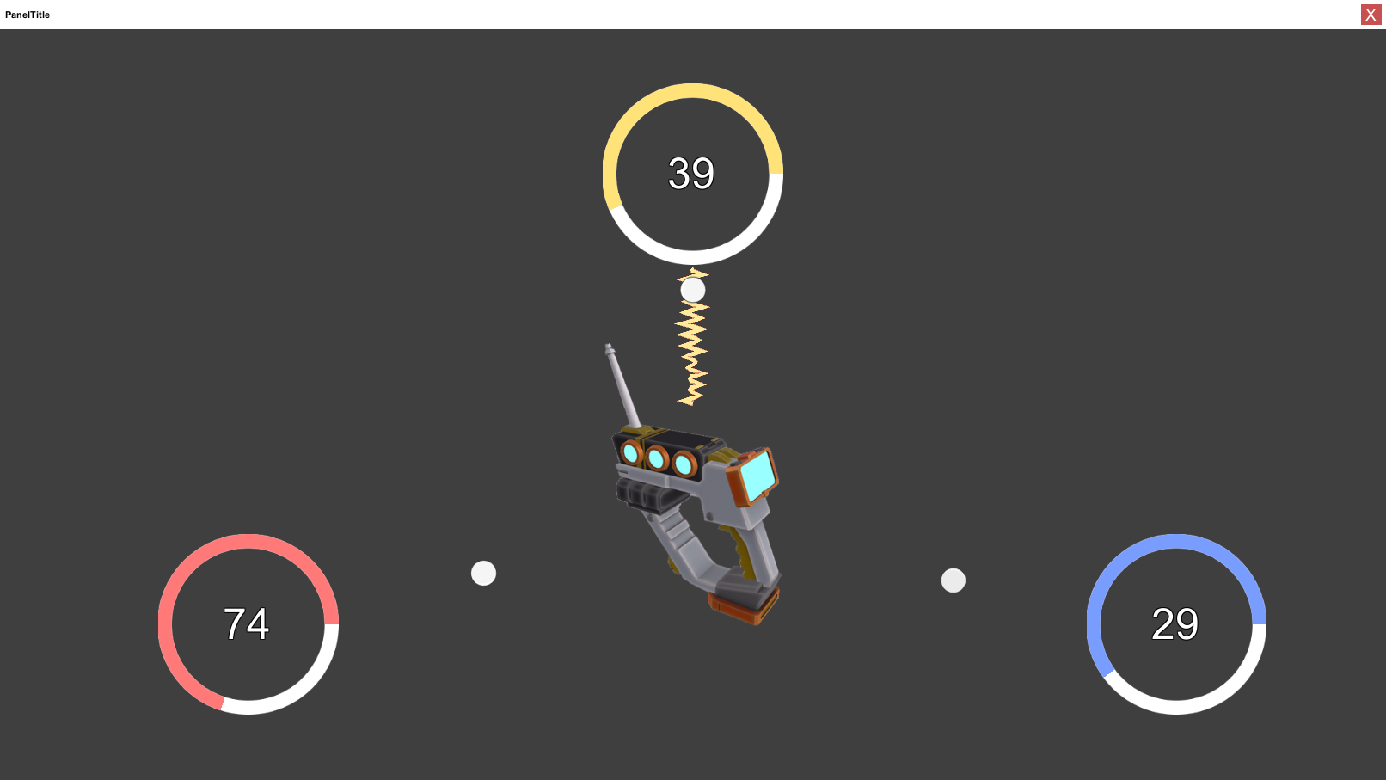

Visualization of experimentation system in a generic style. Each stat is represented by a ring, similar to basic crafting showing stats in a ring or bar.

For this stage, experimentation will use the default styling of our UI components, with the item models consistent from the rest of the inventory. It should have a unique background image like character selection to provide some up-front juice.

This system should be skinnable in the future, replacing background elements and particle effects to better reflect each crafting profession.

### VFX

VFX for experimentation should use gambling-like reinforcement techniques, with high anticipation, satisfying particles, colors, and shapes for success and unsatisfying effects for failure.

Rolling for each stat should play some anticipation, and then success or failure. The final item should also show anticipation and some visual flair for the result, relative to the original stats of the item. Ultimately, the largest fun in this system is anticipating and witnessing the discrepancy between the original stats and the final result, and it should be treated with appropriate fanfare.

However, almost all VFX for this stage is likely to be reconsidered or replaced, so proxies should be used rather than assets prepared for continued use.

## Danger UI/UX

We should aim to show results to the player to make it easier to digest and to reduce self-inflicted frustration. Each set has a visual representation of *danger*, which is the number of bombs contained within the set.

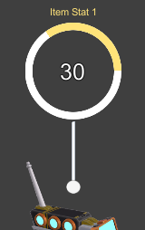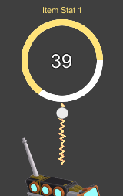

Visual example of danger. In this case, the use of each set is given a line to the item in the center of the craft

Ideally, the player understands that their “danger” is increasing, and therefore receiving a worse result is still the result of luck, rather than the game lying to them about the result they will receive.

We should frame that the benefits from experimentation are listed as a “bonus” on top of the basic crafting result, rather than it being the second half of a two-step process.

# Priority B

## Skill Boxes

The player’s permanent EP for a specific skill increases when more skill boxes are unlocked. If the player has 3 EP in Weaponsmithing, and unlocks another skill box that provides 1 EP, they now have 4 EP for every weaponsmith craft they perform.

By default, all crafters begin with 0 EP. The first point is unlocked with a non-root skill box, and the value of EP provided by each skill box is to be defined in data. EP is a mid-high level crafting function, especially because the added complexity is likely to be a barrier to crafting if introduced to rookie crafters.

### EP Range

Based on the mechanics of the game, it seems reasonable that a player should initially be given about 4 EP when they unlock their first skill box, and that their EP maxes out at 12-15 EP.

This range ensures that an intermediate crafter can, in a very best case, maximize a stat and a half, and continual increases in EP give them more freedom to choose moment-to-moment strategies to recoup losses or go for gold.

## Advanced Information

In addition to the above UX, we will make the underlying probability for the random curves visible to encourage players to participate with a more transparent system.

(Note specifically to SHOW the “curve”, however we may see the whole probability landscape)

For UX purposes, this is hidden by default, and may even be unlocked via a skill box.

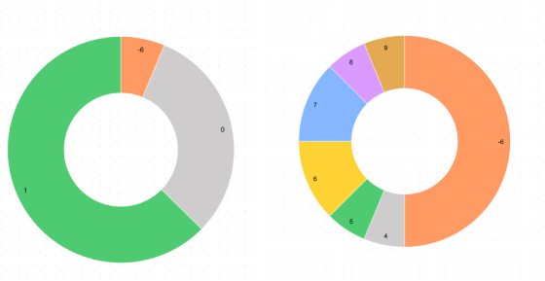

UX suggestion: Show the various results on each curve as a pie chart, which is easily readable. These would not easily fit within the main experimentation visuals.

## Theming

Art should take the approach of making this game skinnable. With the current visual setup of experimentation, the UI elements remain in the foreground and are interacted with as normal, while the background can be filled with images or models that animate and play particles whenever the stats are rolled.

Danger can also be abstracted in various ways. In the cooking example, danger is the raging fire beneath the pan (though this looks like a gas stove, which is explicitly not to be used in-game for environmental message).

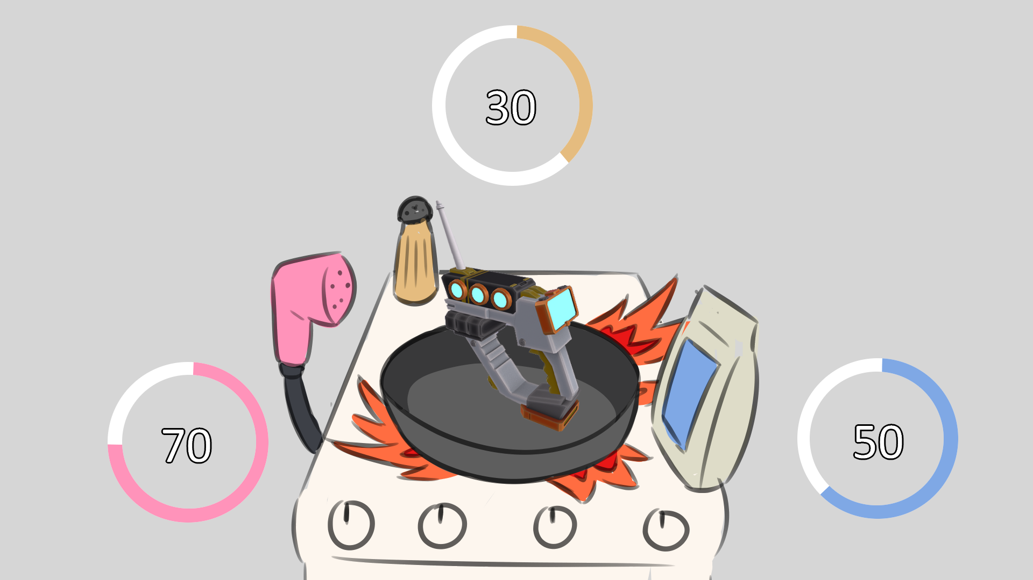

Mockup theming for cooking. In this instance, various tools and spices represent the stats, and could play an animation whenever the stat is rolled. Visual style is obviously not representative of current style, and needs to be more sci-fi.

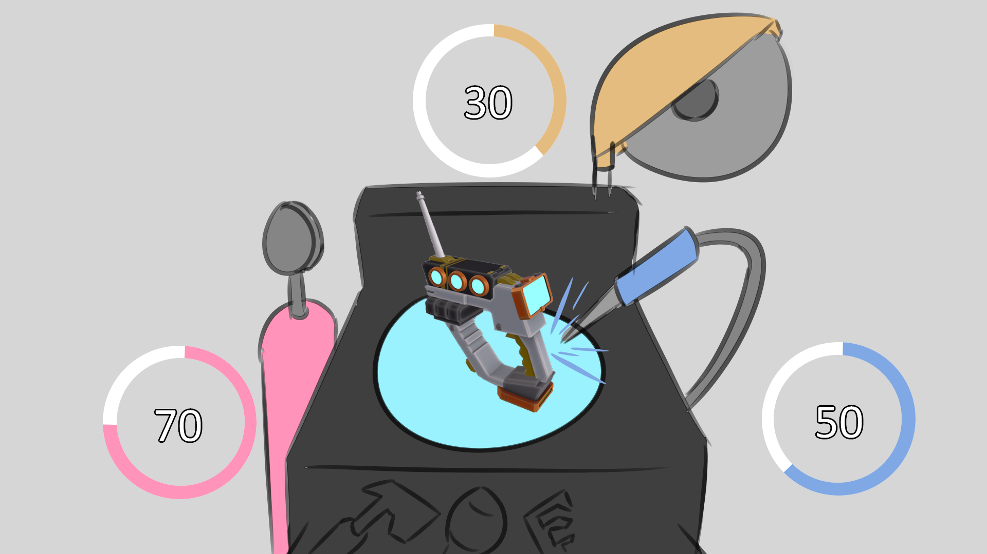

Toolmaking example. A toolmaking station has various options that can be similarly themed.

### Art & VFX

Each theme should have unique VFX and animations for the station/tool that is represented. Some major anticipation and the transition to the final result can be maintained, but the stretch goal is for each skin to have some full tactile animations or movement.

# Priority C

## Crafting Skills

Our game should fully develop the various crafting skills, including toolmaking, cooking, weaponsmithing, etc, to fill out data for crafting unlocks and EP awarded per skill box.

The full list for this is forthcoming.

# Requirements

## Required for this pass

### Priority A

* Experimentation
  + After receiving a set of stats for an initial craft, the player is shown “bonus curves” that they can increase the potential result from while also increasing the risk of negative rolls.
    - The values of the number sets used are exposed to design.
    - New number sets can be added if needed.
  + The player has EP, and 1 EP is spent to roll each bonus curve
    - The player has 4 EP.
* The player can choose to experiment or not after completing a basic craft.
  + Only experimentation can get items at the absolute minimum and absolute maximum of an item’s range.

### Priority B

* Skill box unlock system (from other GDDs)
  + EP is awarded and added to the player
* Experimentation theming
* Additional Art & VFX

### Priority C

* Skill box unlocks (established in another GDD, TBD)
  + Unlocking crafting skill boxes grants EP.

## Not included in this pass

* Stuff about visual feedback? Not much can be accomplished at this time.

# Tech Asks

* Experimentation system
  + Implementation of value sets
    - Rolls randomly when chosen, then applies to a specified stat
  + Skill Box rewards
  + EP system per profession

# Design Asks

* Experimentation data
  + Player EP
    - EP gain per skill box
  + Value sets
    - Average point gain per set
    - Balancing player options
      * Potentially, writing some kind of solver for the probability, to see what we expect high-level players and min-maxers to do when they approach the game
* Crafted item data
  + This is a nebulous ask, but for experimentation to be fully functional, we need to be more informed about the kinds of data we can expect from crafted items. Right now the only known factor is that all stats are between 10 and 100.

# Art Asks

* Dependent on UI Style guide and menu art found in [GDD - UI Style](https://docs.google.com/document/d/1aIoBa-uMZxCqAP6TrS02O9ZQnID-vAH333IaQsk8FdU/edit?usp=sharing).
* Themes per crafting profession
  + Ideally, these don’t require much mechanical redesign of the UI or its interactions.

# UI/UX Asks

* UI wireframes for experimentation
  + Each stat has:
    - Its current value
    - A value curve
      * Can be ticked upwards or downwards between a min and max
    - A representation of danger.
  + Main EP count

# VFX Asks

* VFX for rolls on stats
  + Bad
  + Average
  + Good
  + Great
  + Amazing
* VFX for danger
* Animation for result anticipation - based on Art themes.

# Sound Asks

* TBD

# Sign Off - NOT YET READY FOR APPROVAL

| **Final Approval**  **(right-click to check)** | **Approver** | **Date** |
| --- | --- | --- |
|  | Product Owner (Ben) | 01/31/2023 |
|  | Tech (Brian Elias) | 01/31/2023 |
|  | Art (Brian Youn) | 01/31/2023 |
|  | UX/UI (Yvette Han) | 01/31/2023 |
|  | Design (Greg Costikyan) | 01/31/2023 |
|  | QA Engineering (Andrew Tillinghast) | 01/31/2023 |
|  | QA Gameplay (Hayley Ancona) | 01/31/2023 |
|  | Production (Liam Hislop) | 01/31/2023 |
|  | Marketing (Rick Reynolds) | 01/30/2023 |
|  | Community (Danielle Bartholomew) | 01/30/2023 |
|  | Production Director (Chris Keeling/Liam Hislop) | 01/31/2023 |
|  | EP (Gordon Walton) | 01/30/2023 |
|  | Exec/CCO (Raph Koster) | 01/30/2023 |
|  | Game Director (David Georgeson) | 01/31/2023 |