GDD - Shields

## Process State: Approved

* Product Owner: David Georgeson
* Technical Lead: Abby Suarez
* Producer: Aiden Wallace

| RACI Matrix |
| --- |

(**R**esponsible **A**ccountable **C**onsulted **I**nformed )

| **Deliverable** | **Product Owner** | **Tech** | **Art** | **Comm** | **Mktg** | **UX/UI** | **Design** | **QA** | **Prod** |
| --- | --- | --- | --- | --- | --- | --- | --- | --- | --- |
| **Shield Mechanics** | A | R | C | I | I | I | C | I | I |
| **Chassis Models (functionality)** | A | I | I | I | I | I | R | I | I |
| **Chassis Models (aesthetics)** | A | I | R | I | I | I | C | I | I |
| **Power Rating** | A | I | I | I | I | C | R | I | I |
| **Module Quality** | A | I | I | I | I | I | R | I | I |
| **Modules (functionality)** | A | R | I | I | I | I | R | I | I |
| **Modules (base aesthetics)** | A | I | R | I | I | I | C | I | I |

*Last Modified Date*: —09/13/2022

| What This Feature Is |
| --- |

Shields are an active combat feature where players can deploy barriers to reduce or mitigate incoming damage, versus armor, which is passive defenses tied to the player’s body equipment.

Shields are tools created as part of the Crafting System, meaning their properties are dictated by Modules the player sockets into Chassis objects. The player can customize shields to defend against specific damage types, have certain offensive capabilities, or offer certain bonuses to players and allies. This document will outline both the functions of shields as well as the modules used to define them.

NOTE: This document does not describe the UI/UX of socketing modules into the chassis. That is covered in [GDD - Assembly Interfaces](https://docs.google.com/document/d/1lMeIrNwxIvuTdzMdf-ZaoRY0PTKRUiWyiB5002dDDiU/edit?usp=sharing).

| Related Features |
| --- |

This system depends on:

* **Equipment** - Players need to have tools and the ability to use and swap between them.
* **Crafting System** - Modules for shields will be available to craft through raw materials and precursor objects.

This system interacts with (not all currently implemented):

* **Character Stats** - Shields affect how character stats change in combat (primarily health)
* **PvP** - Strategic decisions in PvP will be influenced by shields and their properties

## 

| User Stories |
| --- |

Bob has a shield in his arsenal when he touches down on a new planet, which turns out to be overrun by Magma Squirrels. After a harrowing encounter that nearly cost him his life, he leaves to search for player markets, finds a module with Heat-type Damage Resistance, and reassembles his shield to better suit the challenge of exploring this new frontier.

Susie is trying to level up her points in crafting and resource collection, so she has filled her loadout with extraction tools to find materials on new planets. However, the planet she just landed on is extremely dangerous and she has been hounded by enemies, so she equips a Reflection shield to discourage attacks on her as she gathers.

While grouping up with some friends, Fred realizes that the group has been constantly slowed by enemy statuses. Taking the role of a healer, he equips a Status Reduction on his shield, as well as loading himself up with consumables, to make sure the group is patched up after creature encounters.

Sky is using an indirect-fire projectile weapon that is much easier to land shots on at long range. However, on planets with swarming enemies, she is constantly surrounded in close range and it’s difficult to deal damage. She equips a small-radius shield with a knockback module to allow her to push enemies back, thereby putting her at optimal distance to use her lobbing weapon.

Campbell’s group is lagging behind him and he gets ambushed by a massive boss monster. Though he has no chance of actually defeating it, he is equipped with three separate shields with unique damage types, and two of them block damage types used by the boss. He is able to hold out by switching shields to block incoming attacks, giving him the time to reconvene with his group and fight on equal ground.

| Vision Items and Motivations |
| --- |

| High and Critical |
| --- |

**Fantasy -** Shields allow players to be more confident in their combat abilities and, in combination with movement options (jumping, jump-jetting, ducking) and actually shooting projectiles out of the sky with your weapons, provides yet another way for the player to deal with incoming attacks and projectiles.

| Medium |
| --- |

**Design** - Like our other assembly-focused systems, players are allowed wide customization in how they create shields, and are allowed to develop niche equipment to suit their personal interests.

**Strategy** - Shields complement the offensive interaction of weapons to give players an array of options in combat. Additional strategy is layered by selecting the main behavior of shields and their damage reduction during crafting and assembly, forcing players to consider whether a shield is useful in a given scenario and if the cost of its use is a valuable expenditure. Additionally, players must balance the total power rating of the shield and how that affects Stamina cost and Cooldown for the shield.

**Excitement** - Shields can be deployed instantly, follow the player, and can encompass allies, allowing players to react quickly in dangerous scenarios to protect themselves and their friends.

| Shield Mechanics |
| --- |

| Hotbar Functions |
| --- |

To deploy a shield, a player selects it via its hotbar (equipped) using the number keys. As long as the player has enough Stamina to trigger the shield, the effect is deployed immediately, Stamina costs are removed, and the player’s currently equipped tool does not change.

You may have up to four shields equipped on your hotbar, if desired. **But you may only have one shield in effect at any given moment.** If you have a shield activated and then activate a second shield, the first one will deactivate immediately and the second one will activate instead.

| Collision |
| --- |

Shields create an enclosed area around the player to block damage. This shield can also block damage for other players if the effect is large enough for them to stand within the shielded area.

Shields can defend against damage from hitscan, projectile shots, and DOT (Damage Over Time) effects.

**NOTE: A shield *does* function against Piercing attacks.**

| Overlapping Shields |
| --- |

#### Although a player can only have one shield, multiple players that activate AoE (Area of Effect) shields can overlap the protections from those shields, creating substantial defenses for their group.

Projectiles heading toward an object protected by multiple shields must deal with each shield successively, in turn, before finally getting to the intended target.

#### 

#### AoE or Delayed Multishot attacks vs. Shields

A “Personal” shield can always defend against AoEs and Delayed Multishot.

A shield with an AoE size greater than “Personal” defends against AoE or Delayed Multishot effects as follows:

| Type of Shield vs **AoE or Delayed Multishot** | **Shield Effect** |
| --- | --- |
| Fortress or Variable shield | Projectile is stopped by the shield if all the damage of the projectile is stopped by the shield’s threshold. Any AoE or Delayed Multishot then occurs outside the shield and the defenders are protected against those effects.  If Projectile is NOT completely stopped, then it penetrates, impacts normally *inside the shield* and the defenders are not protected by the shield against the AoE or Delayed Multishot effects. |
| Reflection shield | The projectile is bounced back toward the attacker without impacting and any AoE or Delayed Multishot effect occurs upon impact at the attack location. |
| Absorption or Catch & Release shield | If the attacking projectile is fully absorbed, then the AoE or Delayed Multishot effect from that projectile *does not trigger.*  If the attacking projectile is only partially absorbed, it still travels to its intended location, does reduced projectile damage to the target, and detonates its AoE or Delayed Multishot effect upon impact and players within the shield are not protected. |

| Chassis Types and Aesthetics |
| --- |

| Chassis Models |
| --- |

Shields have four distinct chassis (small, medium, large, uber) and should visually reflect only the protection type and whichever of the Shield Type modules that are selected.

A shield should not look like a weapon, as many of our other tools are slated to, because they have no firing animation and enable instantly upon pressing a shield button. They are an object that only resides in the player’s inventory and on the hotbar, so visual appearance changes only affect the object’s 2D inventory icon.

| Aesthetics |
| --- |

Shields are seen in-game as force fields extending from the player. They block fire from all directions, so they should appear as spheres. (Although, unless the player is in the air, only a hemisphere will generally be seen as the part of the sphere below ground will not be visible.)

#### Damage Type

Because shields are limited to a single defensive damage type, multiple options are available.

* **Color -** Shields are tinted a unique color for the damage effect type they protect against.
* **Decal -** Shields may have transparent decals on their arc faces with the emblems of each damage type UI icon
* **Unique Texture -** Each shield type has a unique texture overlay

NOTE: In the case of users that are color blind, we need to ensure that the colors selected for damage effects are also supplemented with either Decals or Unique Textures to make those damage types obvious.

It’s more likely that shields will have a combination of these approaches. All of these are possible within the SuperShader or with further development in our VFX system driven by a VFX artist and engineers.

| Shield Modules |
| --- |

The following illustration shows the flow of operations needed for a Crafter to make a Shield object. (NOTE: The diagram itself is a link to the Miro board. Click it to open a new tab and see more detail.)

[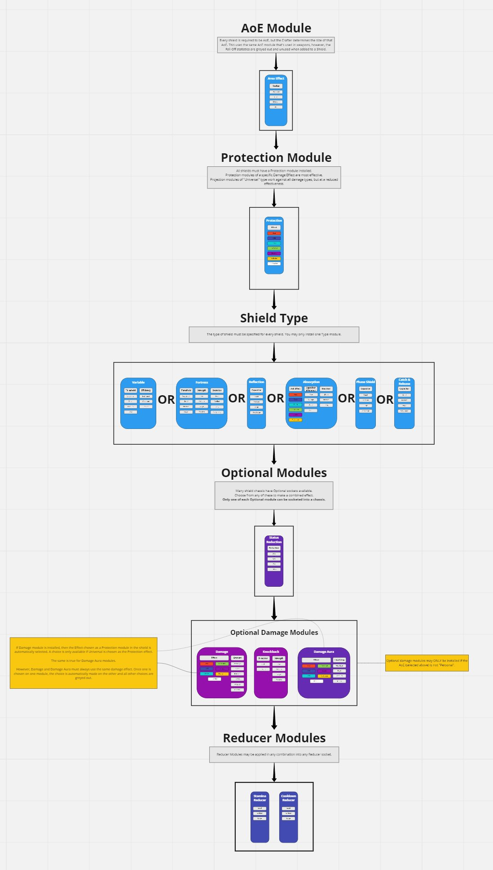](https://miro.com/app/board/uXjVPde_VPc=/?share_link_id=92831476080)

| Shield Chassis Types |
| --- |

There are four shield chassis types: Small, Medium, Large, Uber. They have varying capacities to hold different module types as shown in the following table:

|  | Required | Optionals | Reducers | Inventory Weight |
| --- | --- | --- | --- | --- |
| Small Shield | 3 | 0 | 0 | Very Light |
| Medium Shield | 3 | 1 | 1 | Light |
| Large Shield | 3 | 2 | 1 | Medium |
| Uber Shield | 3 | 3 | 2 | Heavy |

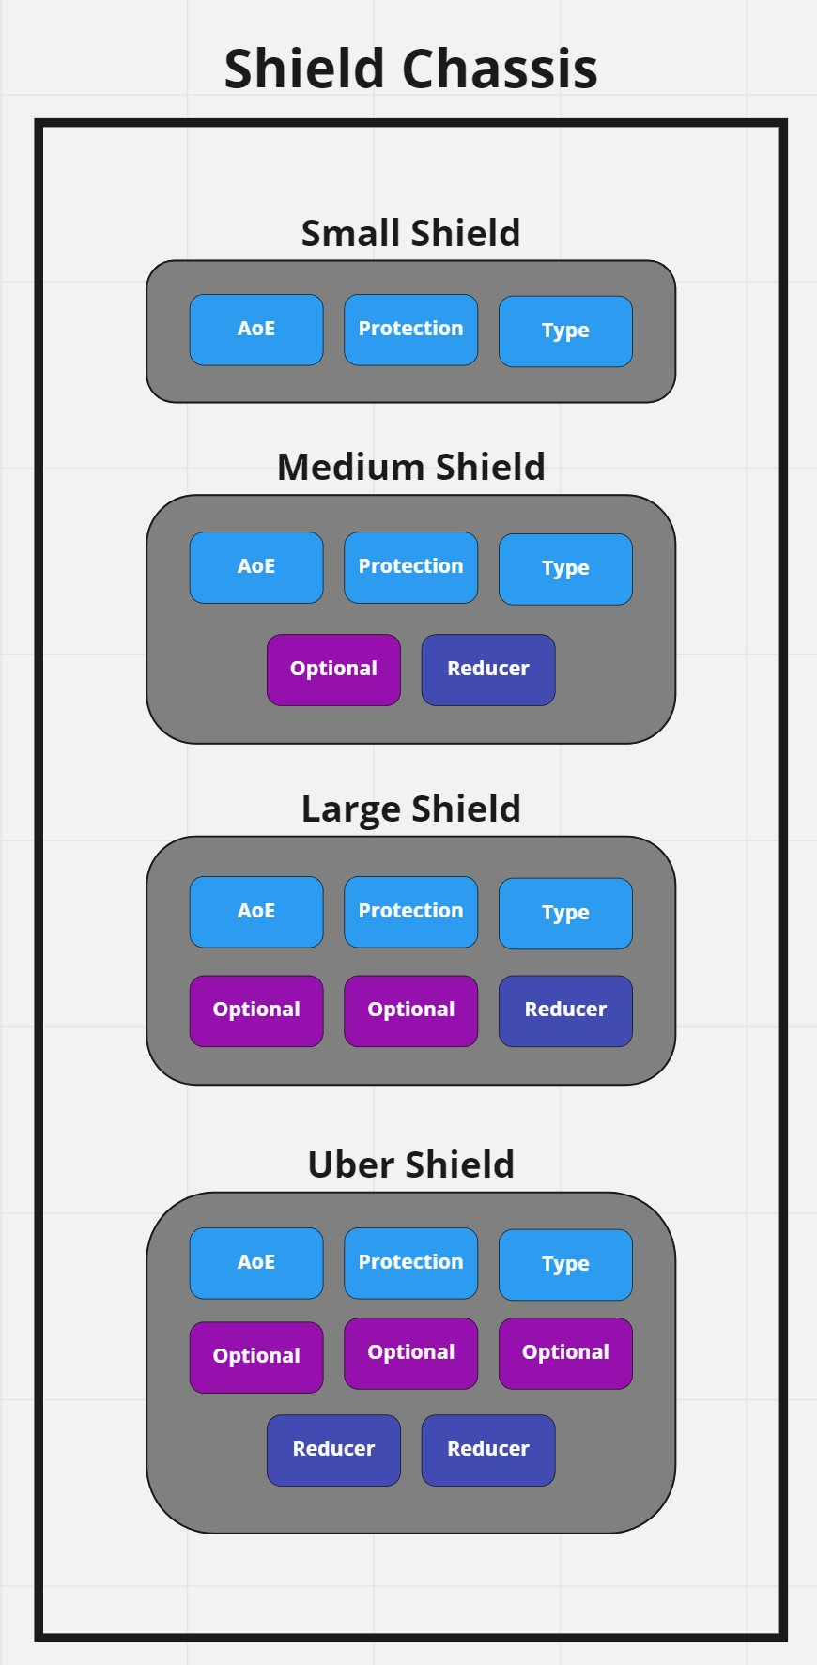

| Power Rating |
| --- |

Each module has a power rating associated that is determined by what it adds to the shield. Add power for all modules together to get a total power rating. The higher the total power rating for a shield, the more Stamina that shield consumes when fired and the longer its cooldown timer.

Therefore, an Uber shield with all possible modules installed is going to cost more Stamina to trigger and have a longer cooldown timer than a Small shield with only the required modules installed.

NOTE: When a shield fails or is deactivated, its cooldown timer begins to count down. The shield cannot be activated again until its Cooldown timer has expired.

* A chassis can have Stamina Reducers installed in any Reducer socket.
* A chassis can have Cooldown Reducers installed in any Reducer socket.
* “Power rating” does not affect any other shield stats.

#### Base Shield Chassis Power Costs

Each of the four shield chassis have a base Power Rating associated with their use. An Uber chassis adds more power to the cost of a shield than a Small chassis.

Additionally, each chassis has several characteristics which can be enhanced via the Experimentation system.

| **Shield Chassis Crafting Characteristics:**  The following elements can be improved by using the Experimentation system when crafting these chassis:  Stat 1 : Increase Chassis Integrity up to 100%  Stat 2 : Enhance overcharge so that that shield’s capacitor is 50% larger and the shield can last longer. (In the case of Variable shields, that results in up to 50% more efficiency instead.)  Stat 3 : Reduce the Power contributed to the weapon by up to 20%. |
| --- |

| Module Quality |
| --- |

Modules can be of various qualities as well. (Depending on crafting rolls, the quality of resources & precursor items used to make them, and the skill of the crafter.) This encourages shield owners to chase the best of the best modules, even when they possess a shield they already like.

Each module has up to three characteristics that can be affected by quality. Those three characteristics are detailed in the module descriptions, below.

Additional information on the process of increasing Module Quality can be found in [GDD - Basic Crafting](https://docs.google.com/document/d/10pu9CWcjNBv8kWFyHBsT1p_O-zHOazoP3RCQENzDJSo/edit?usp=sharing) and [GDD - Experimentation](https://docs.google.com/document/d/1g-T8S9qTHotERudRLP4hoyHiU9p-MZYlXQXWQRp5XAQ/edit?usp=sharing)

| AoE Module (Required) |
| --- |

Every shield must have an AoE module installed.

Choosing the “Personal” AoE size means that the shield only affects the wearer and does not extend its coverage beyond that wearer.

AoEs of greater size can affect allies if they are within the radius and the effects are beneficial (like healing or status removal). AoEs of greater size DO affect enemies whenever the effects would be detrimental (such as damage or knockback).

* Radius
  + Personal, Small, Medium, Large
  + Power cost for Personal is zero. Additional levels of AoE increase power significantly and geometrically.

| **Area Effect Module Crafting Characteristics:**  The following elements can be improved by RNG, resource quality, and using the Experimentation system when crafting this module:  Stat 1 : Increase radius by up to 80% of selected size. (NOTE: A module with “Personal” size selected cannot be pushed on this stat. The stat would not show up during Experimentation.)  Stat 2 : Cooldown reduction (up to a 20% reduction in how much this module adds to the shield’s cooldown timer)  Stat 3 : Stamina cost reduction (up to a 20% reduction in how much this module adds to the shield’s stamina cost) |
| --- |

| Protection Module (Required) |
| --- |

Every module must have a single Protection module installed. The Protection module determines the damage effect against which the shield protects its wearer (and any allies within its AoE).

A Protection module can either protect against a single damage effect (heat, cold, shock, etc.) or it can be set to “Universal” protection instead.

If a shield is set to Universal, then the shield works against all types of incoming damage, but it does so at a much lower level of protection than if a single damage effect is chosen instead. Singular damage protection results in a much higher comparative protection level.

* Protection Effect
  + Heat, Cold, Shock, Corrosive, Kinetic, Radiation, Universal
  + No power cost

| **Protection Module Crafting Characteristics:**  The following elements can be improved by RNG, resource quality, and using the Experimentation system when crafting this module:  Stat 1 : Increase percentage of protection (up to a 15% increase over selected protection)  (no other stats) |
| --- |

| Shield Type Modules (One Required) |
| --- |

Every shield must have a Shield Type module installed. This module defines the type of shield for the player. There are (currently) five kinds of Shield Types available: Reflection, Absorption, Phase, Fortress and Variable.

#### Reflection

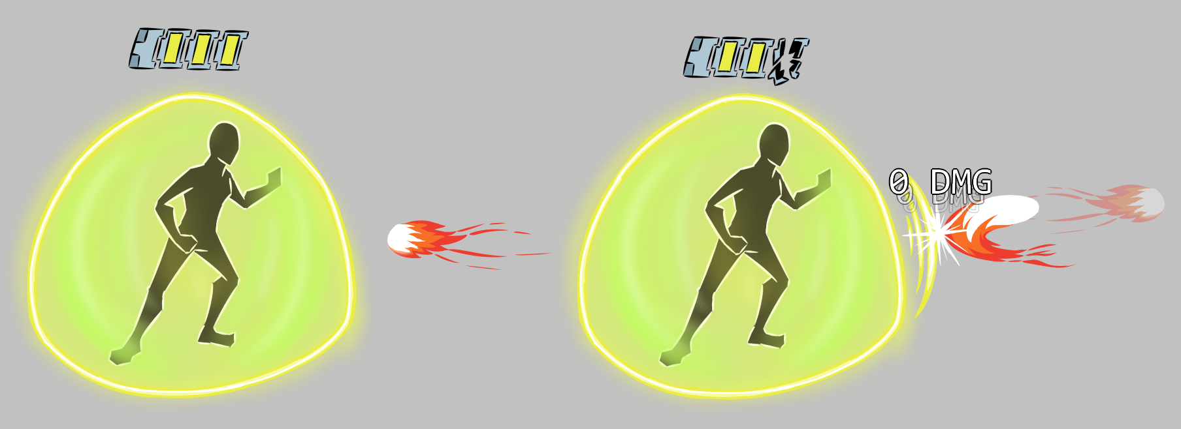

A reflection shield’s capacitor takes a hit for each projectile it reflects, and higher-damage projectiles reduce the capacitor further.

A reflection shield bounces the attack back at the attacker in the same direction that the attack originated but in the opposite direction. A reflected shot does not automatically hit the attacker unless the shot is a Hitscan shot (in which case it *does* automatically hit the attacker).

Indirect shots are bounced back along the same arc that they came in from and should hit the location where they originated.

**Multishot projectiles are handled differently.** When the projectiles from a Multishot or Delayed Multishot weapon impact a Reflection shield, they will not return directly toward the attacker. Instead, they will ricochet off in a logical direction. (The pattern of shots emanates from a point and path that each projectile follows doesn’t make visual sense if it bounces back toward the origin point. Instead, it should bounce off at a 90-degree angle from the original direction it traveled toward the shield’s perimeter. Since there are two potential 90-degree vectors that could be pursued, the angle of bounce should be away from the shield. If a projectile is tracking a line directly from attacker to defender, then that particular multishot projectile should still bounce back toward the attacker.

Reflection works against projectiles 100% of the time*, but the shield can only reflect a set amount of damage back at the attacker. If the amount of damage hitting the shield exceeds the amount remaining in the Reflection module’s capacitor, then the shield fails and the entire shot penetrates through to hit its intended target. (No partial reflection occurs.)

The damage type of the reflected shot is the same as the damage type of the incoming shot.

* NOTE: Any damage caused by anything *other* than projectiles is NOT reflected by this shield. Examples of this are AoE explosions or DOTs that occur outside the shield, but have a radius large enough to hit the player anyway, Damage aura shields with a radius large enough to hit the player, or environmental damage, like heat or cold effects.

* ALSO NOTE: Reflection shields do not work against Piercing attacks. Those attacks go through a Reflection shield as if it wasn’t there. (They phase through the field.)

* Capacitor size
  + Small, Medium, Large, Very Large
  + Power cost is quite high because this effectively stopping 100% of damage while in effect. Power cost goes up with capacitor size.

| **Universal Protection vs Individual Damage Effect Protection**  Only the protected damage type is reflected. Individual damage effect protection results in a capacitor that is more efficient than when Universal damage protection is chosen. This translates into more shots being able to be reflected by the shield before its capacitor is drained and the shield fails. |
| --- |

| **Reflection Module Crafting Characteristics:**  The following elements can be improved by RNG, resource quality, and using the Experimentation system when crafting this module:  Stat 1 : Increase capacitor size (up to 80% increase over selected size)  Stat 2 : Cooldown reduction (up to a 20% reduction in how much this module adds to the shield’s cooldown timer)  Stat 3 : Stamina cost reduction (up to a 20% reduction in how much this module adds to the shield’s stamina cost) |
| --- |

#### Catch & Release

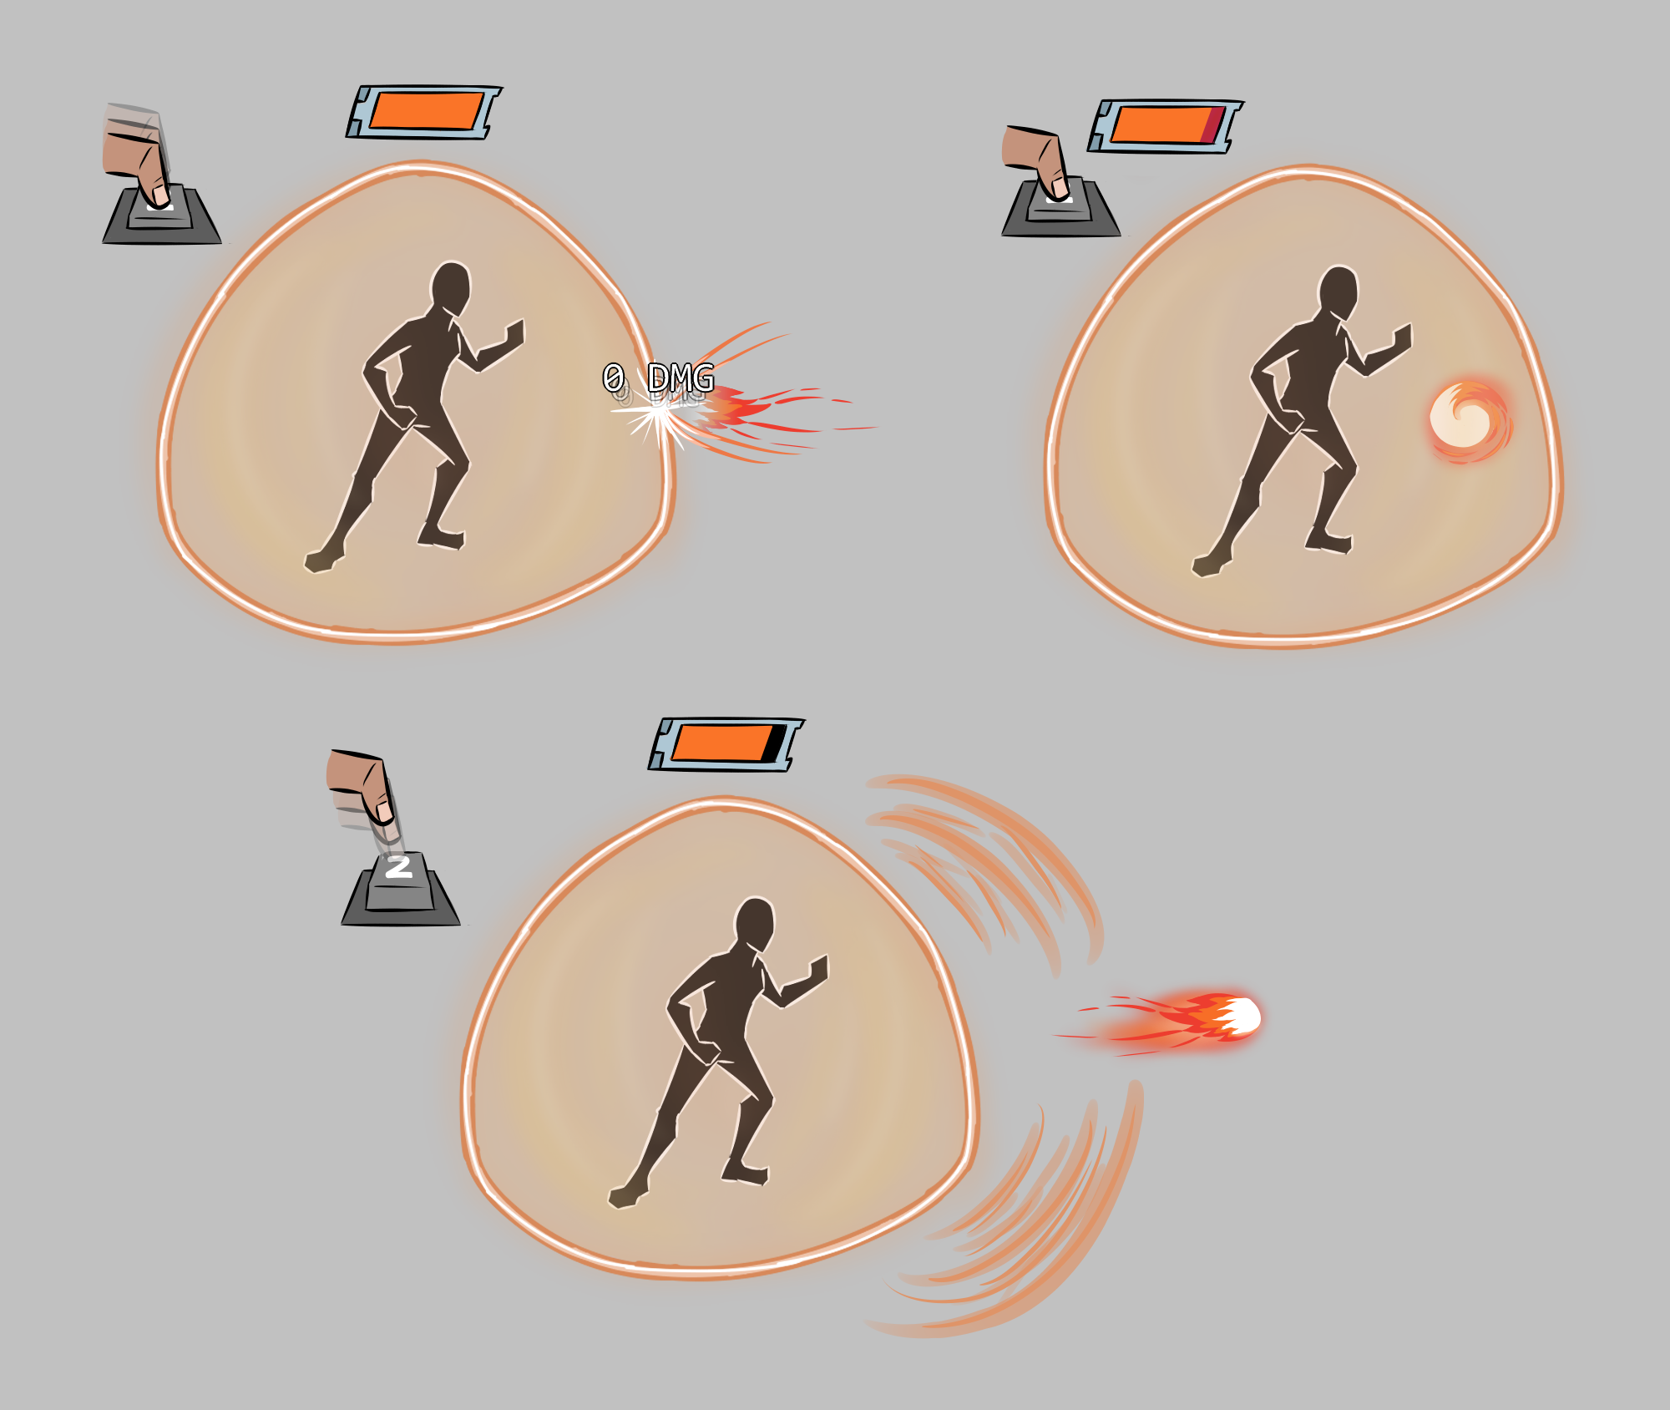

A catch and release shield holds a projectile within its radius until a player chooses to release it by letting go of a key press. It costs energy from the capacitor to capture each projectile.

This shield creates an orb around the player that can be used to trap an incoming projectile, hold it in place, and then give it impetus toward a target of the player’s choice.

When a projectile comes toward the player, the field can wrap around and catch the projectile when it gets to them. When the projectile gets to within 5m of the player, but before it impacts them, the player triggers the Catch & Release field by holding down the number key that triggers their shield. The hostile projectile nearest to the player is then moved into position to the front of the player, hovering approximately one meter in front of them. The projectile stays in that position until the player releases the number key, at which time the field forcibly ejects the projectile toward wherever the player’s mouse cursor is positioned.

(Art note: The projectile should still animate while captured.)

The released projectile becomes a Direct fire projectile (even if it was Indirect before being captured), but maintains all of its other characteristics (speed, size, damage effect, AoE, Delayed Multishot, etc.).

Duration of the field is capacitor based and the size of that capacitor is determined by the crafter. The shield requires energy to capture the projectiles and the size of those projectiles determines how much energy is drained from the capacitor. Larger shots require more energy to capture, so the bigger the incoming damage, the shorter the lifespan of the field.

The Catch & Release field does not protect the player in any way if a projectile is not captured. The Catch & Release field can be used to capture projectiles from any angle as they approach the player, even if the projectile is coming from directly behind the player.

**Larger AoE Aesthetics Note:** Having a larger AoE allows the player to catch projectiles that were headed toward other players. The aesthetic effect should still be that the shield envelops the projectile, while simultaneously slurping it over into position in front of the player that has the shield equipped. When the projectile is released, the shield goes back to full size again.

| **Universal Protection vs Individual Damage Effect Protection**  Only the protected damage type is reflected. Individual damage effect protection results in a capacitor that is more efficient than when Universal damage protection is chosen. This translates into more shots being able to be captured by the shield before its capacitor is drained and the shield fails. |
| --- |

| **Catch & Release Module Crafting Characteristics:**  The following elements can be improved by RNG, resource quality, and using the Experimentation system when crafting this module:  Stat 1 : Increase capacitor size (up to 80% increase over selected size)  Stat 2 : Cooldown reduction (up to a 20% reduction in how much this module adds to the shield’s cooldown timer)  Stat 3 : Stamina cost reduction (up to a 20% reduction in how much this module adds to the shield’s stamina cost) |
| --- |

#### 

#### **Absorption**

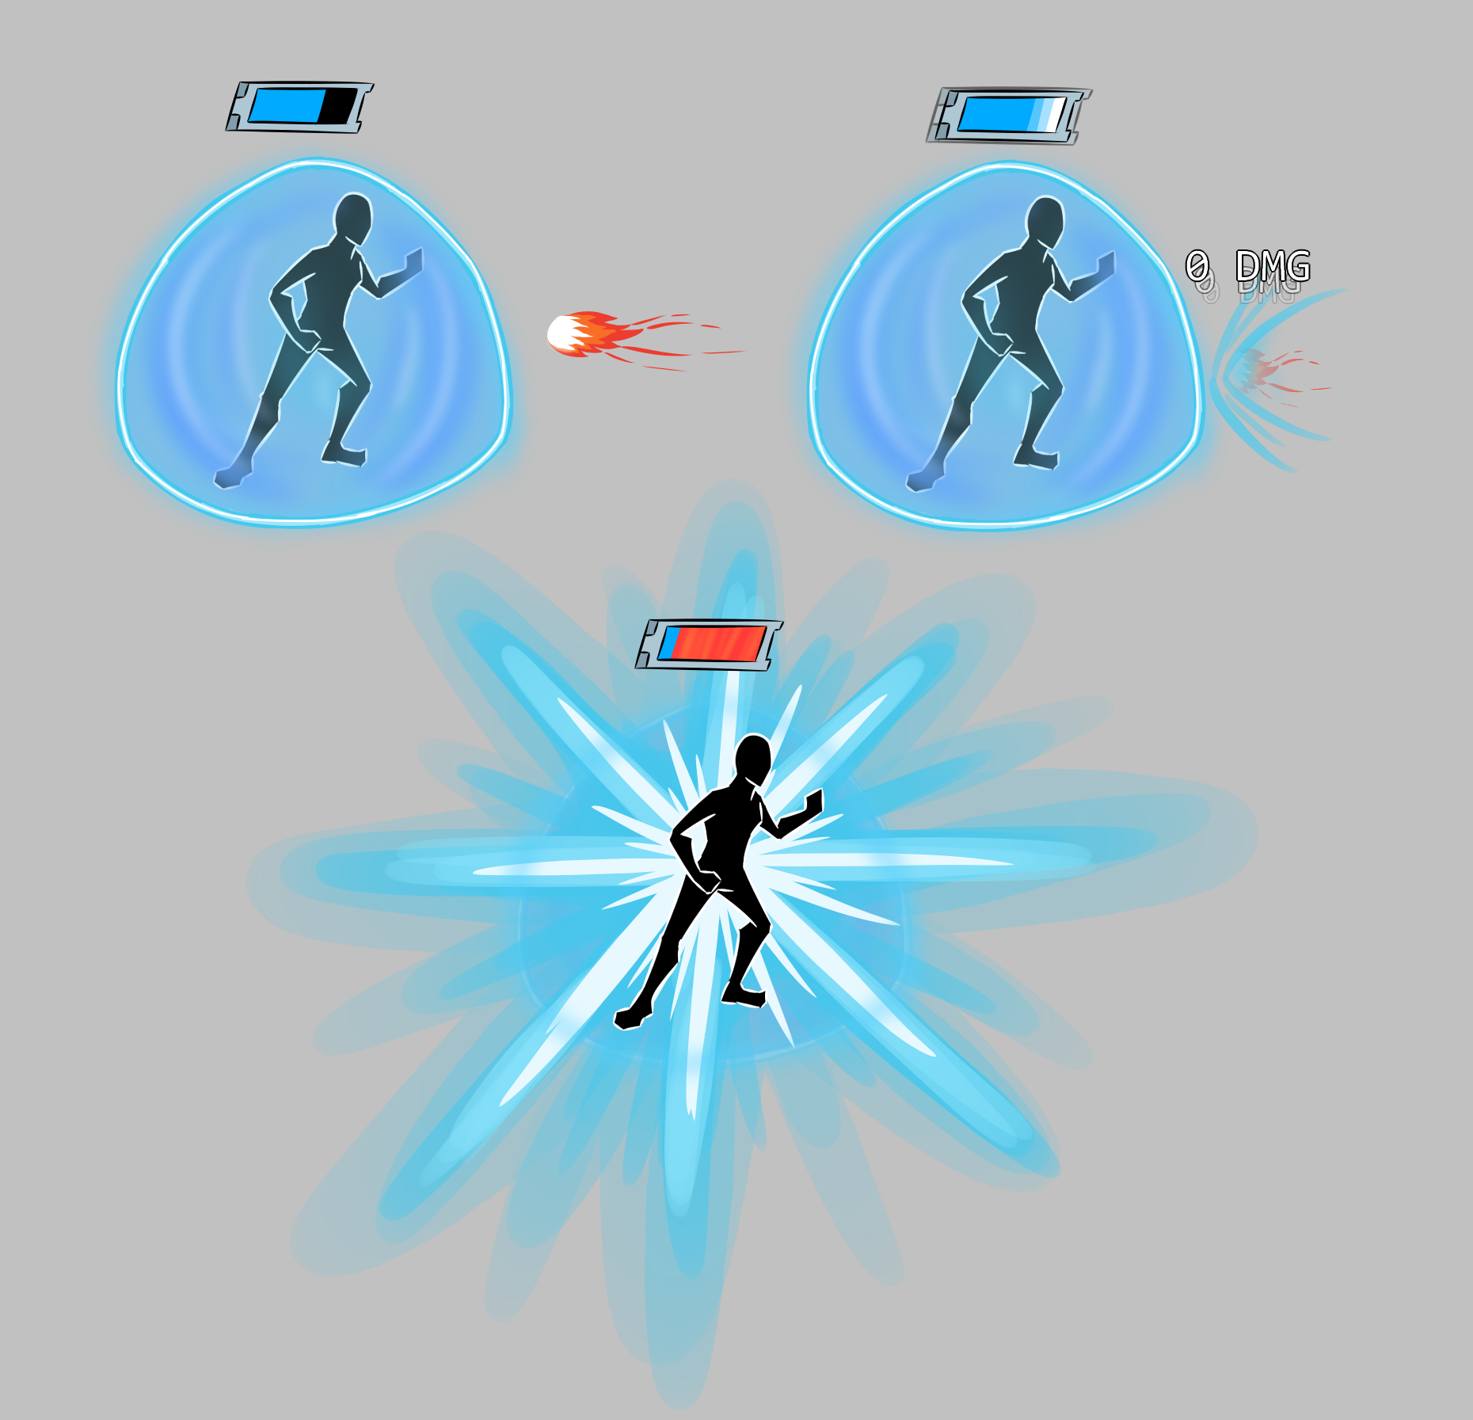

An absorption shield fills its capacitor with damage from projectiles, and then can be released as an AOE explosion. The shield itself is dropped when the capacitor is full.

An absorption field is a bubble of energy connected to a capacitor that the player carries. When the field is hit by attacks, the energy from those attacks flows into the capacitor (instead of hitting the player) and that energy can be released in the form of an explosion by the player. The amount of energy absorbed into the shield’s capacitor is determined by the amount of damage caused by the attack and the Capacitor Efficiency rating of the Absorption module.

The size of the capacitor is the same regardless of any other characteristics chosen. The Efficiency rating only affects how quickly the capacitor becomes filled.

The absorption field has a duration defined. The player can absorb shots, release that energy as an explosion and then continue to absorb more shots thereafter, releasing as many explosions as desired until the field duration has expired.

NOTE: If a capacitor is filled, the field can no longer absorb energy and any attacks hitting the field pass through to potentially hit the intended target instead.

The capacitor can be discharged at any time after it stores one or more points of damage. The energy in the absorption field can be held at max capacity until the player’s shield is eliminated or expires. At that time, any stored energy dissipates harmlessly when the shield drops.

A charged explosion is fired by tapping the shield’s activation (number) key.

When a charged explosion is fired, its AoE size and damage are affected by how much charge is accumulated in the module’s capacitor. The capacitor has three stages and levels of effect:

* 1-49% capacity: Small AoE, Light damage.
* 50-99% capacity: Medium AoE, Medium damage.
* 100% capacity: Large AoE, Massive damage..

The shot uses the “AoE Effect” designated in the Absorption module for damage effect type. The effect is always centered on the player.

UI NOTE: The capacitor needs to be displayed as a UI element to show the current state of charge (how full the capacitor has become).

| **Aesthetic Notes:**   * When the user activates the shield, it pops into place around them. * When a projectile hits the shield, it flares briefly and a bar appears that shows the player the current charge level of the shield’s capacitor. * When the capacitor is fully charged, the shield effect actually *disappears* (to let the player know they are no longer protected), the capacitor bar glows brightly and blinks to attract the user’s attention. * Once the user releases the fully-charged explosion, the absorption shield effect returns as long as the shield still has duration remaining. |
| --- |

* Duration
  + Short, Medium, Long
  + Power increases with duration
* Capacitor Efficiency
  + Poor, Average, Good, Great
  + Power cost increases dramatically as capacitor efficiency increases
* AoE Effect Type
  + Heat, Cold, Shock, Corrosive, Kinetic, Radiation
  + No power effect

| **Universal Protection vs Individual Damage Effect Protection**  Only the protected damage type is absorbed. Individual protection boosts the shield’s capacitor efficiency beyond what is indicated by the module. This translates into a capacitor that fills more rapidly when shots hit the shield and allows the player to fire charged shots more often. |
| --- |

| **Absorption Module Crafting Characteristics:**  The following elements can be improved by RNG, resource quality, and using the Experimentation system when crafting this module:  Stat 1 : Increase capacitor efficiency (up to 80% increase of selected efficiency)  Stat 2 : Cooldown reduction (up to a 20% reduction in how much this module adds to the shield’s cooldown timer)  Stat 3 : Stamina cost reduction (up to a 20% reduction in how much this module adds to the shield’s stamina cost) |
| --- |

#### **Phasing**

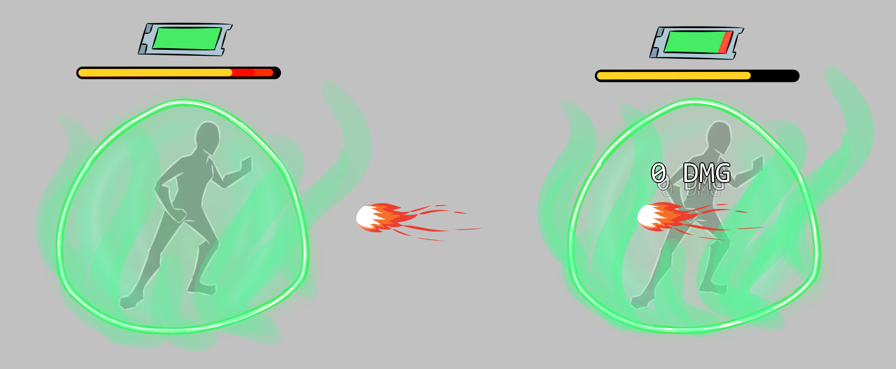

A player spends stamina to activate a phase shield and fill its capacitor, and then projectiles will pass through them at the cost of some of the capacitor’s meter.

The player pours Stamina into a Phase Shield capacitor and sets up a phasing field around them that moves the player and protected allies into a different phase of the world. This field protects them against whatever Protection Effect type was chosen for the shield.

However, projectiles that pass through that field cause disruptions in the field and the energy required to stabilize the field while they pass through is drawn from that capacitor. When enough energy passes through the field, the capacitor is drained and the phase shield deactivates.

“Triggering” the phase shield again (a second key press) turns the shield off so that you can drop back into reality without waiting for the duration to expire.

The shield needs VFX/SFX to keep the user aware that the Phase is in effect.

* Phase Shield Capacitor
  + Small, Medium, Large, Very Large
  + Power cost increases with capacitor size

| **Universal Protection vs Individual Damage Effect Protection**  When individual effect protections are chosen for a phase shield, its capacitor is much more efficient and can more easily stabilize the disruptions caused by the projectiles passing through the field. Universal protection protects against all shots, but requires more power from the capacitor and thus the field won’t last as long. |
| --- |

| **Phasing Module Crafting Characteristics:**  The following elements can be improved by RNG, resource quality, and using the Experimentation system when crafting this module:  Stat 1 : Increase capacitor size (up to 80% increase of selected size)  Stat 2 : Cooldown reduction (up to a 20% reduction in how much this module adds to the shield’s cooldown timer)  Stat 3 : Stamina cost reduction (up to a 20% reduction in how much this module adds to the shield’s stamina cost) |
| --- |

#### 

#### **Fortress Field**

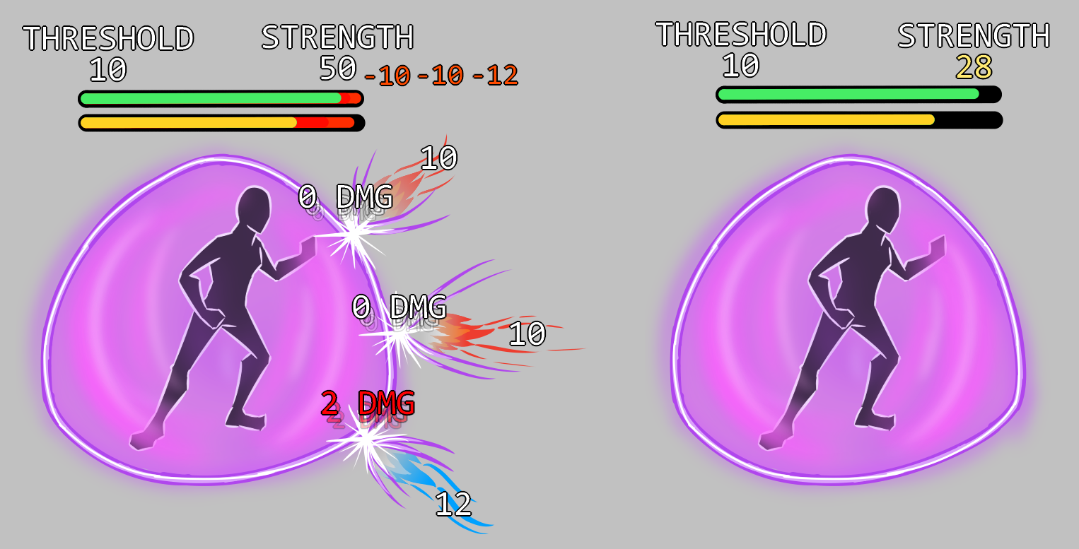

A fortress shield requires a stamina cost to enable, and then individual hits can only deal marginal damage to the player beyond the shield’s threshold value. All damage subtracts from the overall strength value.

A Fortress field consumes a portion of the player’s Stamina when triggered and then lasts for a set duration. When attacks hit the field, the field stops up to a certain maximum amount of that attack’s energy from passing through to hit the protected player. This is known as a damage threshold.

The Fortress field stays up for a set duration *or* until the threshold stops a specified amount of total damage. If either of those situations occurs, the field then drops and the player is unprotected until they raise the field again thereafter.

For example: If a Fortress field has a threshold that stops 10 points of damage, and has a Strength that can endure 50 total points of damage, then if the player is hit by five attacks in a row that do 15 points of damage each, each shot would allow 5 points of damage to penetrate through to the player, but 50 total points of damage would have been stopped by the threshold and the field would stop functioning thereafter.

If a player has a weakened shield, they can opt to drop the shield voluntarily (by pressing the shield’s number key again) and then reactivate it (after the cooldown timer expires) with another chunk of Stamina so that it is a full shield again.

* Threshold
  + Very small, Small, Medium, Large
  + Power cost increases with threshold size
* Duration (number of seconds until shield fails naturally)
  + Very short, Short, Medium, Long, Very Long
  + Power cost increases significantly with duration
* Strength (total damage absorbed before failing)
  + Small, Medium, Large, Massive
  + Power cost increases significantly with strength

| **Universal Protection vs Individual Damage Effect Protection**  Only the protected damage type is affected by the shield's threshold. When a Fortress shield protects against an individual damage effect, each damage point affected by the shield reduces its Strength by a lesser amount. The end result is that such a Fortress shield that protects against an individual damage effect can be hit by a much greater number of shots than a Universal shield. |
| --- |

| **Fortress Module Crafting Characteristics:**  The following elements can be improved by RNG, resource quality, and using the Experimentation system when crafting this module:  Stat 1 : Increase threshold (up to 80% increase of selected threshold)  Stat 2 : Increase strength (up to 80% increase of selected strength)  Stat 3 : Power rating (up to a 20% reduction in how much this module adds to the shield’s stamina cost and cooldown timer) |
| --- |

#### **Variable Shield**

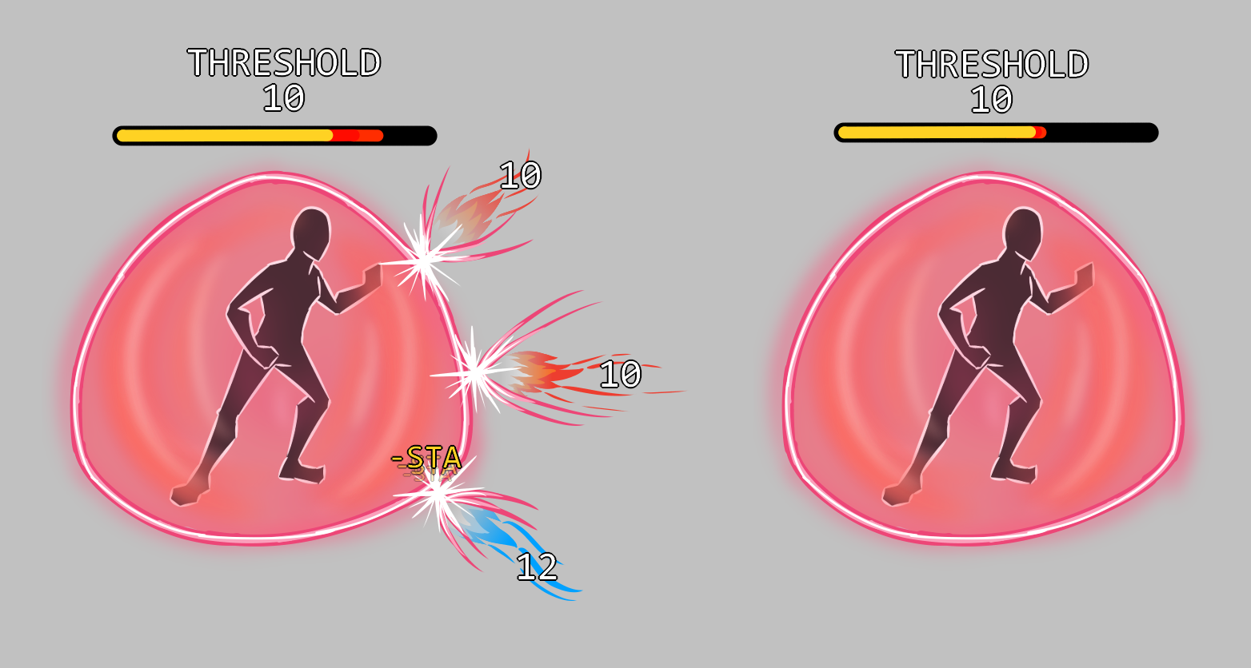

A variable shield trades damage over the threshold for a hit to the player’s stamina. It also passively costs stamina.

A Variable shield is similar in nature to a Fortress field in that it uses a Threshold to stop damage. However, unlike the Fortress field, the Variable shield has no set duration.

Instead, the Variable shield taps into the player’s bio reserve and draws Stamina as needed to stop incoming damage. Additionally, the shield draws a small trickle charge from the player just to remain in existence.

The trickle charge rate is set by design and occurs each second that the Variable shield is running. The shield runs until either the player deactivates the shield (by tapping the shield’s number key again) or they run out of Stamina. In either case, the shield deactivates immediately.

When the shield’s threshold takes damage, points of Stamina are consumed from the player, depending on the Efficiency of the module. The more efficient the module is, the fewer stamina points are drained from the player per point of damage stopped.

* Efficiency
  + Inefficient, Moderately, Efficient
  + Moderate power rating increases as efficiency increases
* Strength (total damage absorbed before failing)
  + Small, Medium, Large, Massive
  + Power cost increases significantly with strength

| **Universal Protection vs Individual Damage Effect Protection**  Only the protected damage type is affected by the shield's threshold. If the Variable shield protects against an individual protection effect, then its efficiency is increased. This results in the player losing less Stamina per damage point inflicted, allowing the player to use the shield longer before running out of Stamina. |
| --- |

| **Variable Module Crafting Characteristics:**  The following elements can be improved by RNG, resource quality, and using the Experimentation system when crafting this module:  Stat 1 : Increase threshold (up to 80% increase of selected threshold)  Stat 2 : Increase efficiency (up to 80% increase of selected efficiency)  Stat 3 : Cooldown timer reduction (up to a 20% reduction in the cooldown timer) |
| --- |

#### 

| Optional Modules |
| --- |

#### **Status Reduction**

This effect occurs when the shield is triggered. Regardless of how long the duration of the shield, the status removal effect only occurs upon shield activation. If the player wants to trigger that effect again, they must deactivate and then reactivate the shield again.

The player, and all allies within its existing AoE, have all statuses reduced in duration by the Reduction value of the module.

Example: If an 8-second Root is on a player and a 25% Status Removal module is activated, the 8-second root has two seconds removed (25% of eight seconds) *regardless of how many seconds remain on the duration*. So if that same 8-second root only had 5 seconds remaining when the 25% Status Reduction module was triggered, then it would be reduced by two seconds, leaving only three seconds remaining before the Root expires.

The player may continue to deactivate and reactivate the shield repeatedly to reduce any Status duration still remaining.

* Reduction
  + 25%, 50%, 75%, 100%
  + Power cost is moderate, increasing with percentage.

| **Status Reduction Module Crafting Characteristics:**  The following elements can be improved by RNG, resource quality, and using the Experimentation system when crafting this module:  Stat 1 : Increase percentage of status reduction duration removal (up to 80% increase of selected threshold)  Stat 2 : Increase efficiency (up to 80% increase of selected efficiency)  Stat 3 : Cooldown timer reduction (up to a 20% reduction in the cooldown timer) |
| --- |

#### 

| Optional Damage Modules |
| --- |

Shields may also have limited offensive capabilities to allow pulse damage, damage auras, and knockback effects. These abilities occur at the same moment the shield is triggered and are Point Blank range, AoE abilities only.

NOTE: If a shield has “Personal” listed as its AoE characteristic, then it *may not* have offensive capabilities installed. (Attempting to add those modules to the shield will result in an error message telling them that the AoE radius must be larger than “Personal”.)

The following offensive modules may be installed in a shield:

* **Damage** (select Effect type and Amount)
  + Pulses once when the shield is activated, doing that amount of damage
* **Knockback** (select Direction and Strength)
  + Pulses once when the shield is activated, doing that amount of damage
* **Damage Aura** (acts as an AoE DOT , select Effect type and Damage per Second).
  + The damage aura lasts as long as the shield does.
  + When Damage Aura (DOT) is applied to a shield, it moves WITH the player. This requires that we have an internal data field that allows us to indicate that the DOT is attached to the player when used as part of a shield. At this time, we are not exposing that data field to the player. It’s just the default way it works with shields.

If any Protection effect type is chosen except Universal, then the damage effect for Damage modules and Damage Aura modules are automatically the same damage type as the Protection effect. (e.g., if the shield protects against Cold damage, then the shield can only create Cold damage.)

The exception is if the Protection effect is “Universal”. In that case, the Damage module and the Damage Aura module must use the same damage effect type. When an effect type is chosen for one module, then it is automatically chosen for the other module and all other options are greyed out.

| **Damage Module Crafting Characteristics:**  The following elements can be improved by RNG, resource quality, and using the Experimentation system when crafting this module:  Stat 1 : Increase amount of damage (up to 80% increase of selected amount)  Stat 2 : Increase efficiency (up to 80% increase of selected efficiency)  Stat 3 : Cooldown timer reduction (up to a 20% reduction in the cooldown timer) |
| --- |

| **Knockback Module Crafting Characteristics:**  The following elements can be improved by RNG, resource quality, and using the Experimentation system when crafting this module:  Stat 1 : Increase amount of knockback (up to 80% increase of selected strength)  Stat 2 : Increase efficiency (up to 80% increase of selected efficiency)  Stat 3 : Cooldown timer reduction (up to a 20% reduction in the cooldown timer) |
| --- |

| **Damage Aura Module Crafting Characteristics:**  The following elements can be improved by RNG, resource quality, and using the Experimentation system when crafting this module:  Stat 1 : Increase efficiency (up to 80% increase of selected efficiency)  Stat 2 : Cooldown timer reduction (up to a 20% reduction in the cooldown timer) |
| --- |

#### 

| Reducers |
| --- |

Like weapons, Shields can also have modules installed to reduce Stamina cost and reduce Cooldown timers. Reduction is applied after all other Power Rating calculations are completed.

#### **Stamina Reducer**

* + Small, Medium, Large
  + Power: Decreases power somewhat
  + Quality increases the Stat reduction of the module.

#### **Cooldown Reducer**

* + Small, Medium, Large
  + Power: No power effect (reduces cooldown but cannibalizes a socket)
  + Quality further reduces the Cooldown reduction of the module.

| **Stamina Reducer Module Crafting Characteristics:**  The following elements can be improved by RNG, resource quality, and using the Experimentation system when crafting this module:  Stat 1 : Increased stamina cost reduction (up to 80% more of selected reduction) |
| --- |

| **Cooldown Reducer Module Crafting Characteristics:**  The following elements can be improved by RNG, resource quality, and using the Experimentation system when crafting this module:  Stat 1 : Increased cooldown timer reduction (up to 80% more timer reduction) |
| --- |

| Base Aesthetics |
| --- |

#### Shield Object

The shield object is never seen in the game world. It is an inventory item that can be equipped onto a hotbar slot, but it is never visually seen on the 3D stage.

#### Modules and Shield Chassis

The basic Shield chassis can still be modified by the modules chosen, but they will only affect the inventory icon for that shield object and thus must be significant outline and color changers or they will not be visible. It is probable that the only change will be the “Shield Type” modules and the protection type that change Shield chassis visuals.

#### Base Shield Aesthetics Needed for Initial Implementation

* A simple sphere that can be sized as needed. It should also be tint-able so it can be color-coded to match the Protection module’s damage protection. Your choice for color on the “Universal” shield.

| Requirements |
| --- |

| Required for this pass |
| --- |

* Shield Mechanics
* Shield Chassis types
* Power Rating
* Module Quality
* All modules, fully functional
* Base Shield aesthetics.

| Not included in this pass |
| --- |

* Final aesthetic versions of chassis design
* Final VFX/SFX for shields.
* The UI/UX of plugging modules into chassis sockets.

| Tech Asks |
| --- |

* Adjustable AoE shield size
* Stacking shield rules
* Damage protection
* Data structure so design can input necessary values for each module type
* Damage over Time (DOT) that moves with the player (AoE point blank DOT)
* Functionality to support:
  + Reflection
  + Absorption
  + Phasing
  + Threshold protection (Variable and Fortress shields)
  + Catch & Release

| Design Asks |
| --- |

* All supporting data needed for the following elements:
  + Shield chassis configurations (small, medium, large, uber)
  + Power ratings
  + Module quality
  + All shield modules (after code mechanics are completed)

| Art Asks |
| --- |

* Concepts for shield chassis configurations
* Base shield aesthetics requested

| UI/UX Asks |
| --- |

* Basic shield effects and planning for final effects (as described under “Chassis Types and Aesthetics”, above).
* None (See [GDD - Assembly Interfaces](https://docs.google.com/document/d/1lMeIrNwxIvuTdzMdf-ZaoRY0PTKRUiWyiB5002dDDiU/edit?usp=sharing) for details instead.)

| Sound Asks |
| --- |

* None (See [GDD - Combat 9: VFX/SFX](https://docs.google.com/document/d/1qeQREwfAHH4caly_7_FhUDeIg6rpY0vgBWX2u3KFpk8/edit?usp=sharing) for details instead.)

| SIGN OFF |
| --- |

| **Final Approval**  **(right-click to check)** | **Approver** | **Date** |
| --- | --- | --- |
|  | PRODUCT OWNER ( David Georgeson ) | 09/23/2022 |
|  | TECH ( Abby Suarez ) | 9/27/2022 |
|  | Art ( Valerie Zaroli ) | 9/26/2022 |
|  | UX/UI ( Addison Barnes ) | 9.26.2022 |
|  | DESIGN ( Greg Costikyan ) | 9/22/22 |
|  | QA Engineering ( Andrew Tillinghast ) | 9/22/22 |
|  | QA Gameplay ( Hayley Ancona ) | 9/23/22 |
|  | PRODUCTION ( Aiden Wallace ) | 9/23/22 |
|  | MARKETING (Rick Reynolds) | 9/22/2022 |
|  | COMMUNITY (Danielle Batholomew) | 09/23/2022 |
|  | Production Director (Chris Keeling) | (Approved by Aiden) |
|  | EP (Gordon Walton) | 9/18/22 |
|  | EXEC/CCO (Raph Koster) | 9/22/22 |