How to create a landlab_dev

There is also a tutorial in https://landlab.readthedocs.io/en/latest/install/index.html but we needed to change the version of numpy and comment one line, because of incompatibility between components. I had previously installed conda in my machine and after all of that, it’s necessary to change the environment in Spyder (or whatever compiler you use).

ls
​will list the stuff from the directory you’re in

git clone https://github.com/landlab/landlab.git
​this will create a copy of the landlab repository in the machine.

cd landlab
​you will then enter in the landlab directory.

nano requirements.in
​comment: #importlib-resources; python_version < '3.12'
​change numpy version to “<2”.

nano pyproject.toml
​in second line, change version of numpy to “<2” too.

cat requirements.in
head pyproject.toml
to check if the changes were done.

conda create -n landlab_dev --file=requirements.in -c nodefaults -c conda-forge --override-channels --file notebooks/requirements.in compilers
that will create a dev environment with all the stuff you need to create your component of mess up with the other components.

conda activate landlab_dev
​that will activate your environment.

pip install -e .
​that will install landlab in the dev environment.

conda env list
​that will list the environments created in the machine.

How to track more than one unit using Concentration Tracker

For the concentration tracker to work (now considering also the ct for diffusion), what I did was to create copies of the component inside the “concentration_tracker” folder (inside components) and change the variable names, then I could instantiate multiple “ctspA”, “ctspB” etc. I don’t know if it’s the most computational efficient way to do it, but it is definitively a way.
Step one, find the landlab components folder (mine was in /Users/viviangrom/landlab/src/landlab/) and replace the ​__init__.py file with the one I am sending, since mine has these copies of the component
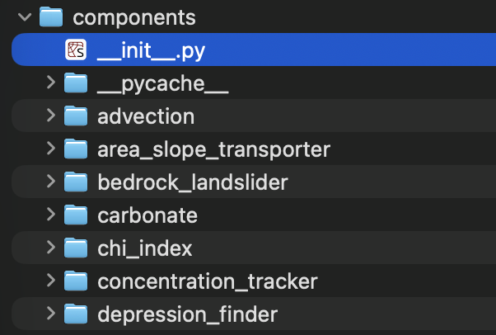

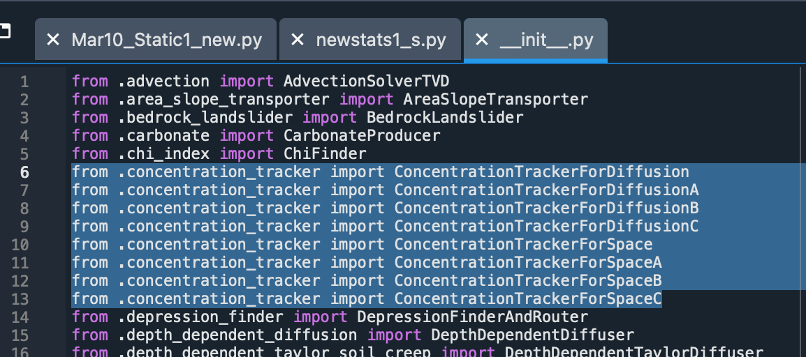

Step two, replace the concentration_tacker folder with the one I am sending.

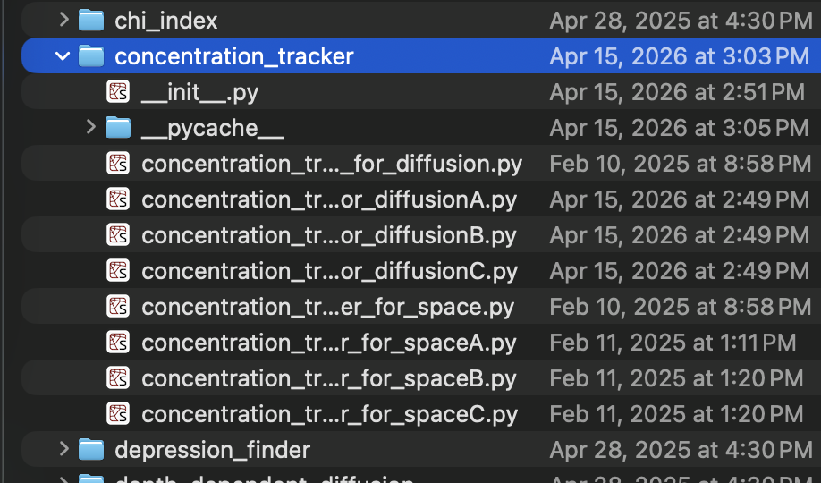

I created an environment with the dev version of landlab, so I would recommend doing the same.

