README

Package recover:

You will receive 6 zip files:

PackOfTrees.zip

Assets(part2).zip

others.zip

Library(part2).zip

Library(part1).zip

releaseVersionTeam02.zip

The result will be

Root file:



Inside “TEAM02”



Inside “releaseVersion”

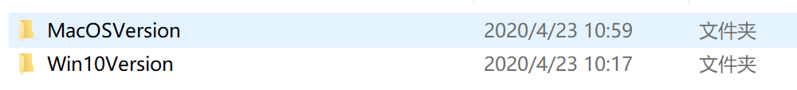

Inside “Team02”

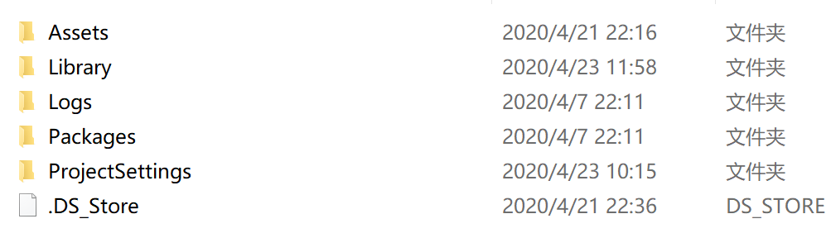

In order to recover to the state above

Step1:

Create an empty file called “TEAM02”

Step2:

Extract all the zip files inside this file

Step3:

Create empty files called “Team02” and “releaseVersion” inside “TEAM02”

Step4:

Create empty files called “Assets” and “Library” inside “Team02”

Step5:

Create an empty file called “PackOfTrees_Vol01” inside the file “Assets”

Step6:

Copy and paste all the files inside “PackOfTrees.zip” into “PackOfTrees_Vol01”

Step7:

Copy and paste all the files inside “Assets(part2)” into “Assets”

Step8:

Copy and paste all the files inside “others” into “Assets”

Step9:

Copy and paste all the files inside “releaseVersionTeam02” into “releaseVersion”

Done!!!!!!

You can also refer to the file’s distribution submitted through Microsoft Forms