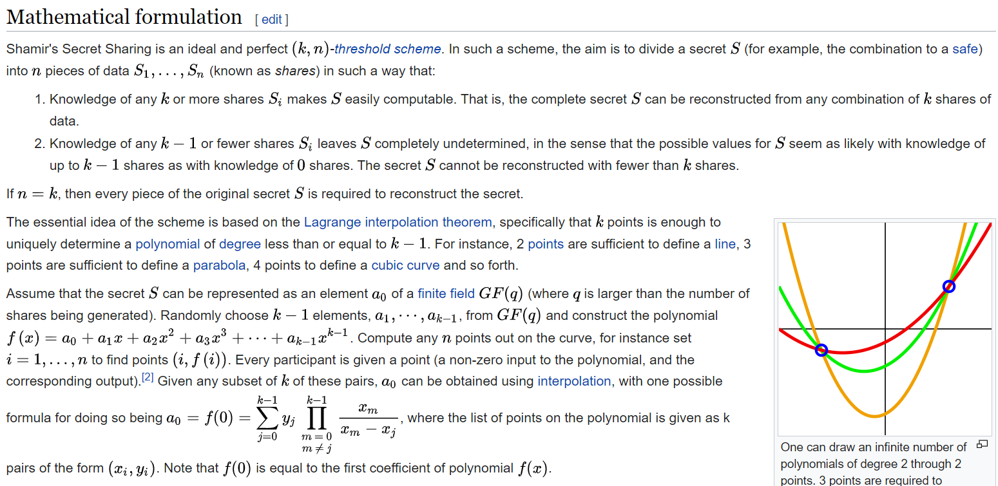

https://en.wikipedia.org/wiki/Shamir's_Secret_Sharing