**QTBCoin User Guide**

**Early Access v.0.11**

**Prerequisite**:

**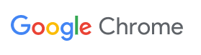***Software:*

1. Google Chrome Browser

Google Chrome Browser is able to support various extensions of Ethereum wallet so that our accounts can be stored.

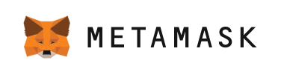

1. MetaMask google extension

MetaMask is an Ethereum Wallet in your browser which enables access to Web3.0, Dapps, NFTs, erc20, tokens, ICO, and other Ethereum related functionalities. For more information, please visit: [The crypto wallet & gateway to Web3 blockchain apps | MetaMask](https://metamask.io/)

*Installation of Google Chrome:*

1. Go to website <https://www.google.com/chrome/downloads/>
2. Download Chrome
3. Install the browser on your computer

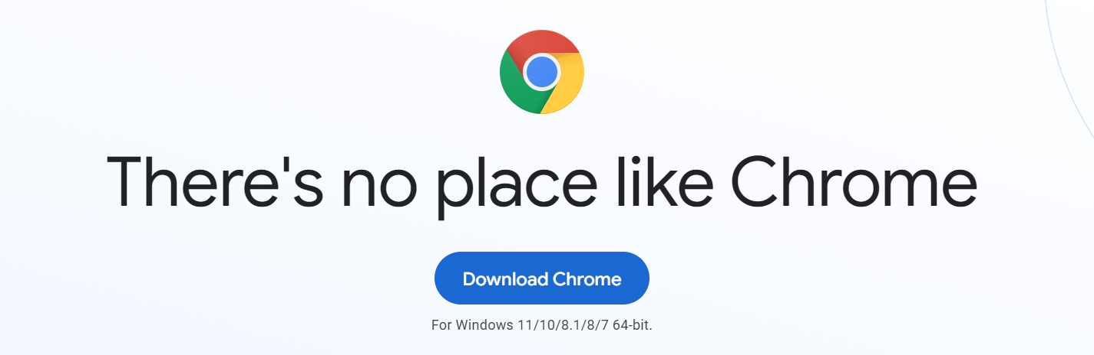

*Installation of MetaMask:*

1. Open the [Chrome Web Store](https://chrome.google.com/webstore) in your Chrome browser
2. Search MetaMask
3. Install the extension to your browser

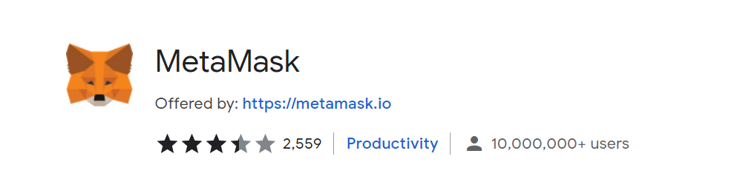

**Configure MetaMask**

1. Follow the step to create a MetaMask account in your local computer.
2. Click the network in the top right corner and click “Add Network”

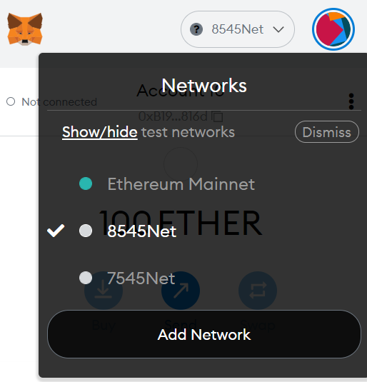

1. Specify the network:
   1. Network name: You can input any name you want. The name will be shown in your Networks section
   2. New RPC URL: <HTTP://98.221.129.176:8545>
   3. Chain ID: 2267
   4. Currency Symbol: ETH
   5. Block Explorer URL(Optional): Leave it blank
2. Click save to save your network specification.
3. Make sure you select the network you just specified in the Network section



Login to the platform and create an account

You may go to http://98.221.129.176/QASTokenApp/login/ or directly enter *qastoken.com* to access the ICO of our QASToken.

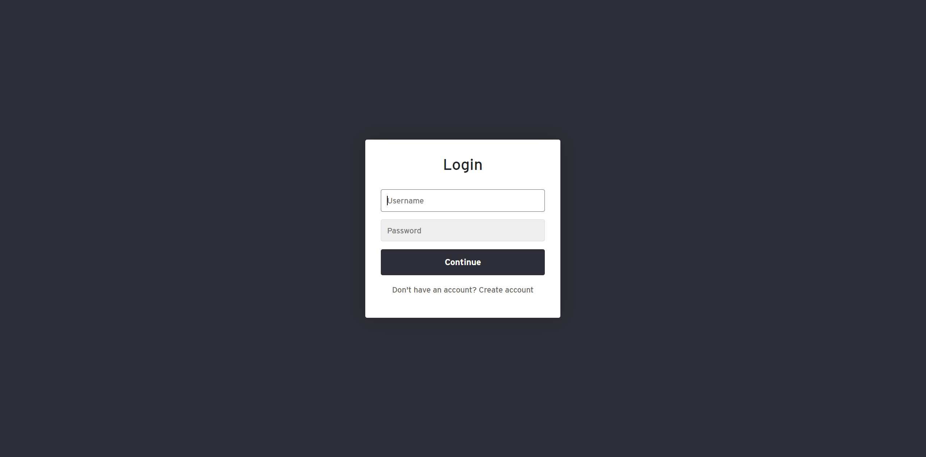

1. You should first create an account in our website by click Create account button.
   1. Please note that you must have a valid ey email address to create an account

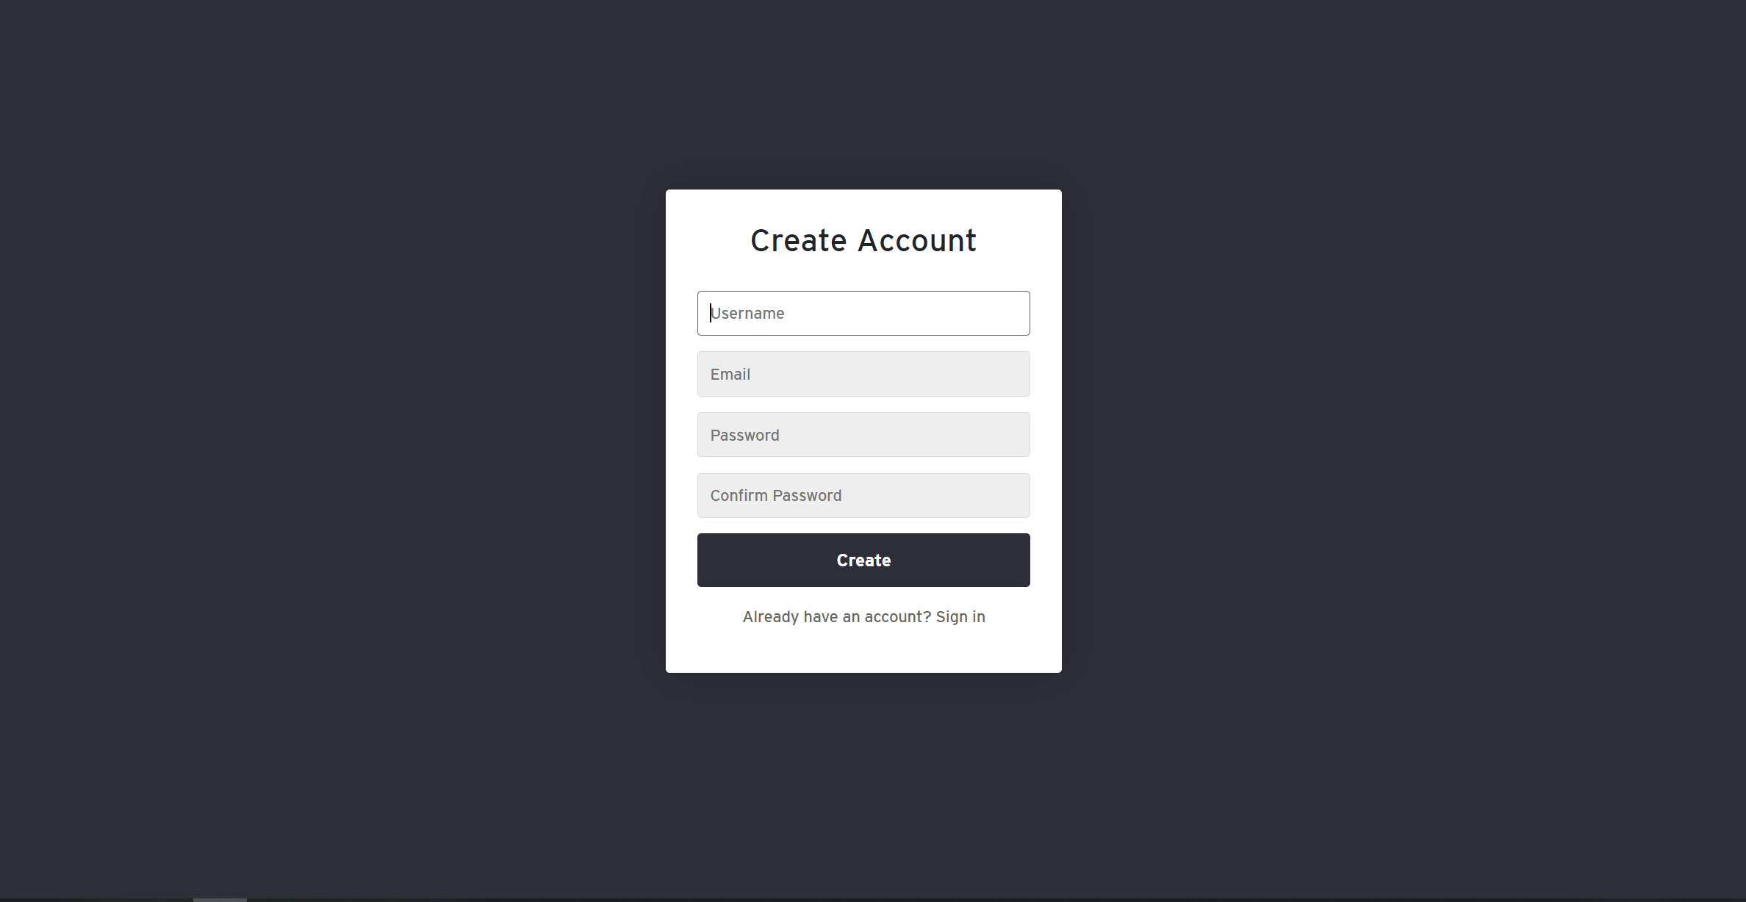

1. Please keep your username and password in a safe place.
2. Once you hit create and everything goes fine, please wait several seconds to have this page shown on your screen.

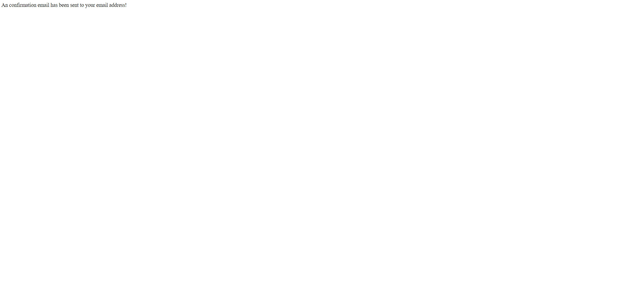

1. In a short while, you will receive an email to verify your email address from qastoken@gmail.com:

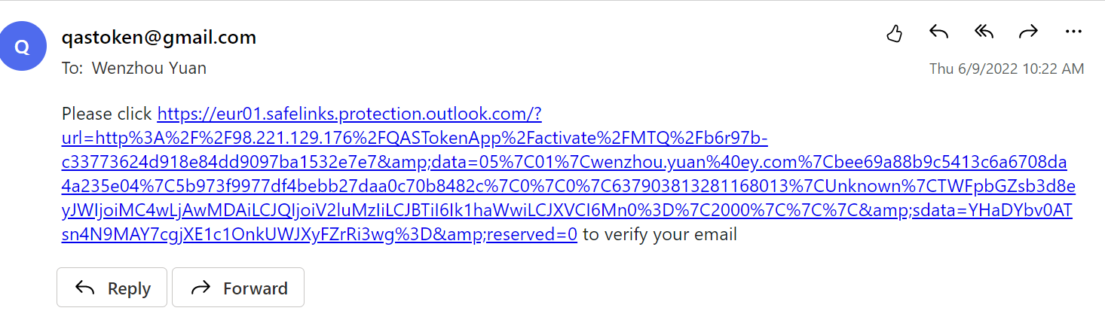

1. Once you click the link, your email will be verified and you will be able to log in to the platform.
2. For the first time of login, you will see the following page:

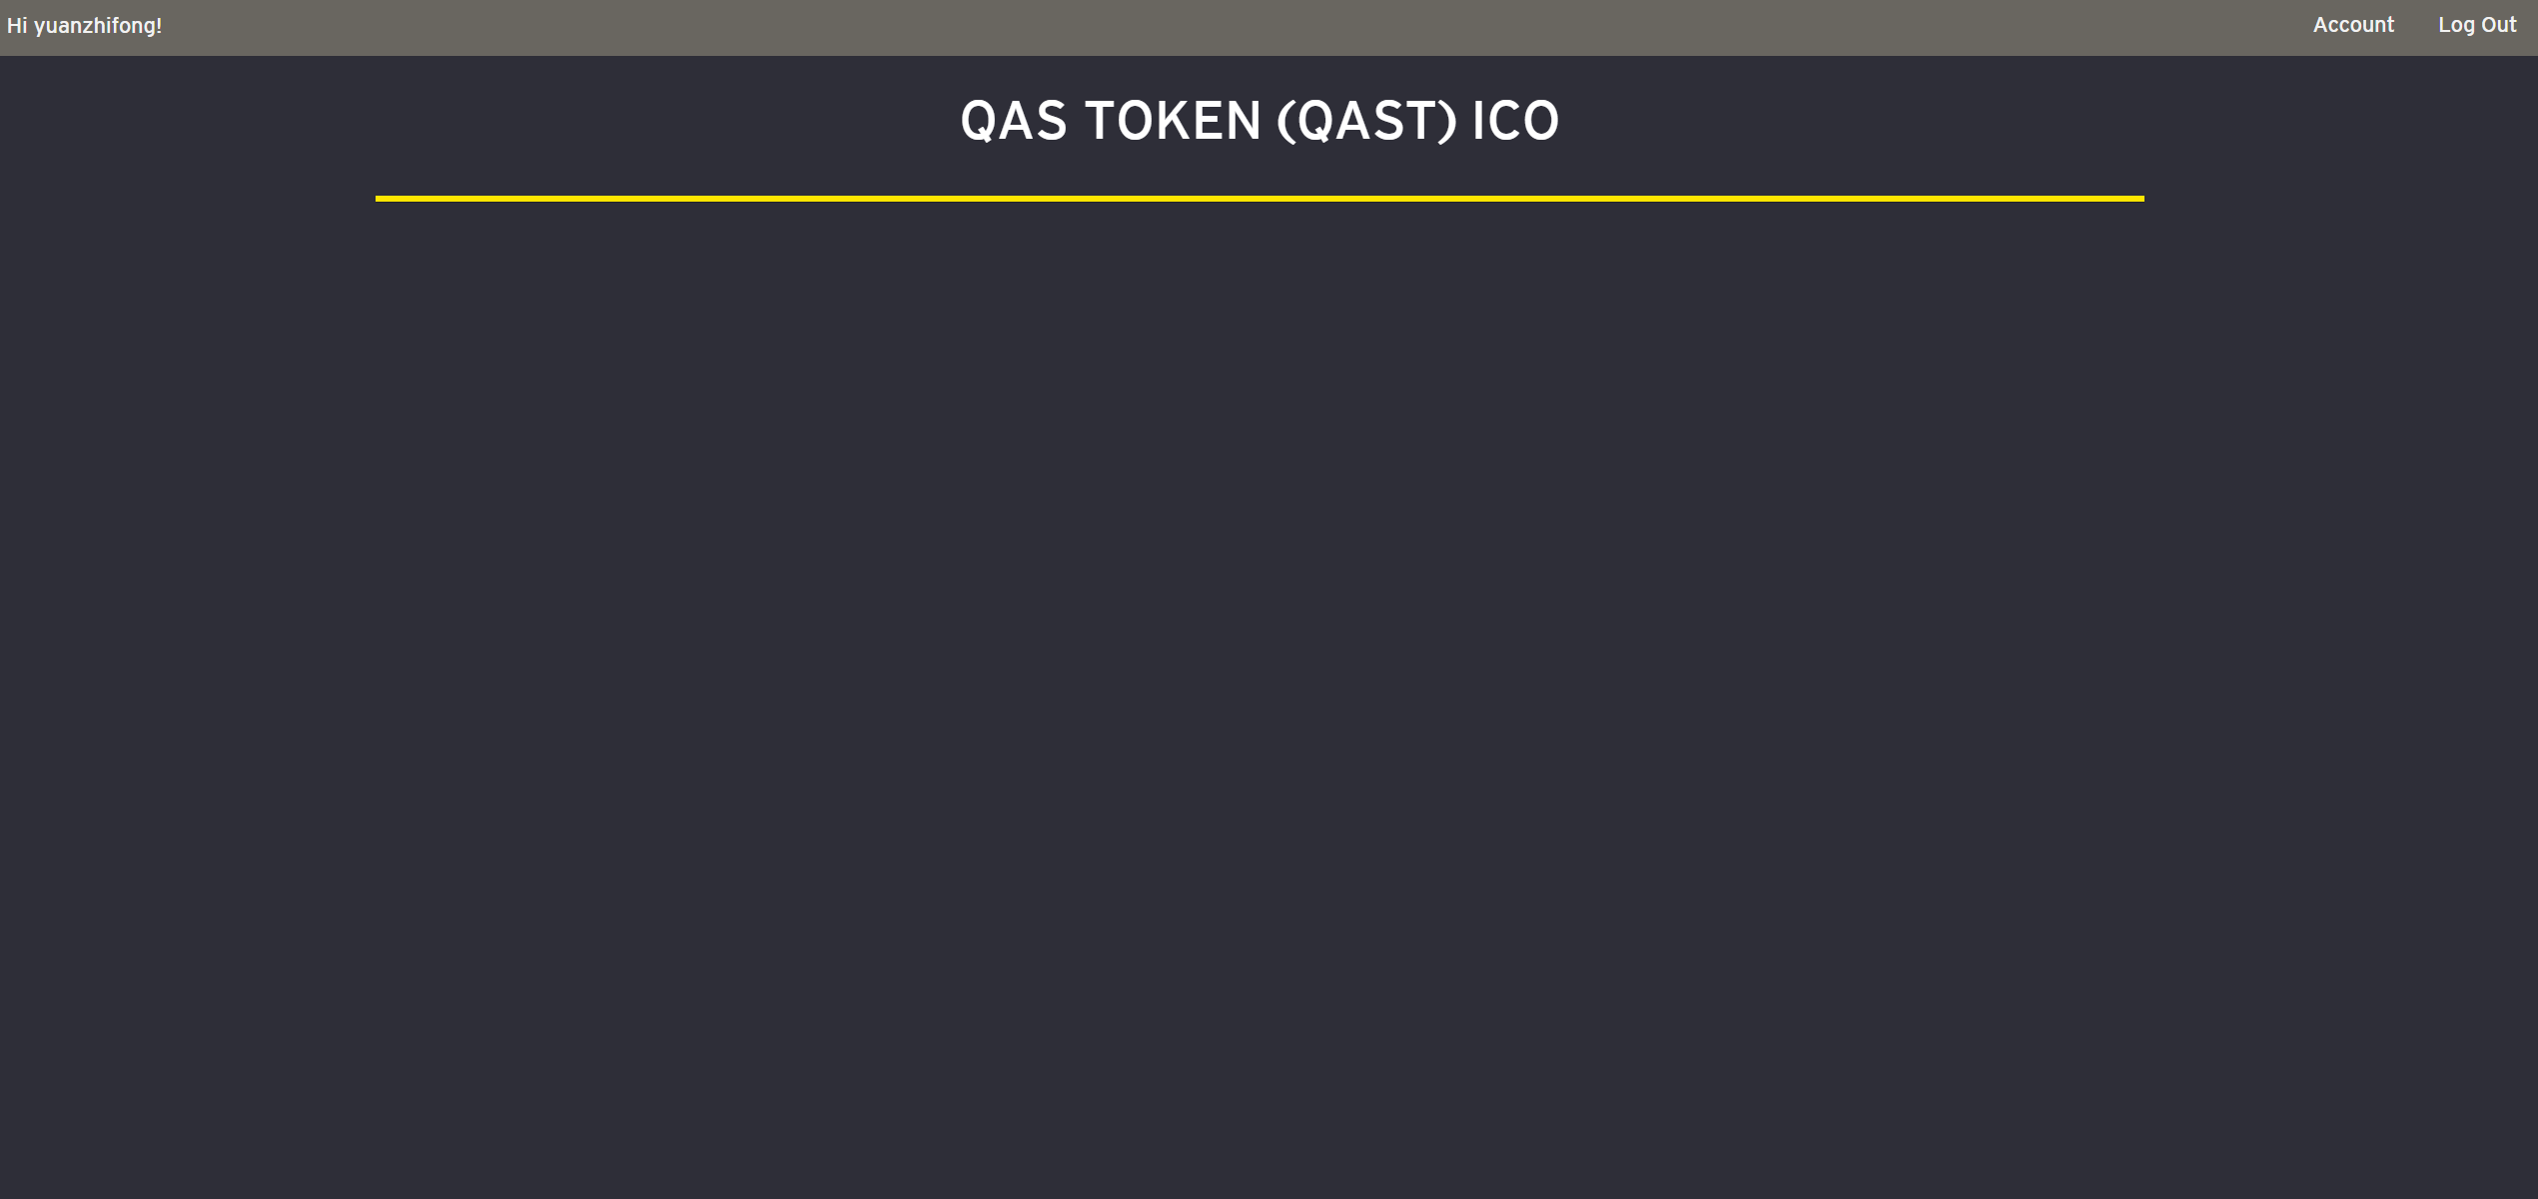

You may see that you cannot access to the content of ICO. This is because your MetaMask wallet does not have any account connected to our private Ethereum blockchain yet. In order to do so, you need to click “Account” in the upper right corner.



1. Click “Generate Key”

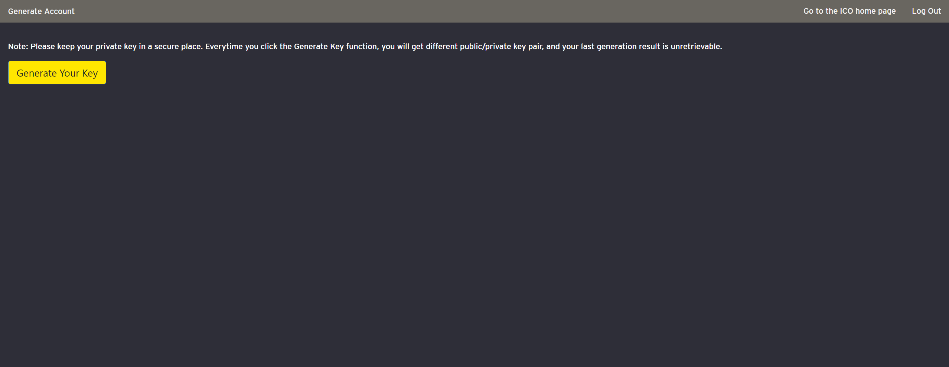

1. You will get a public address and private address shown on the screen. Please definitely keep your private key in a safe and accessible place.
2. If you get a message saying that the system is busy, please wait about 5 seconds and try again. This message means someone else at the same time is requesting an account.
3. Once you get the private key, you can open the MetaMask again and click the upper right circle:

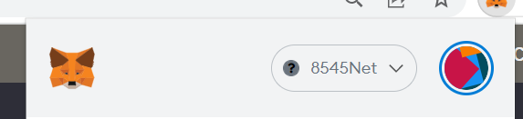

1. Then, click “Import Account”

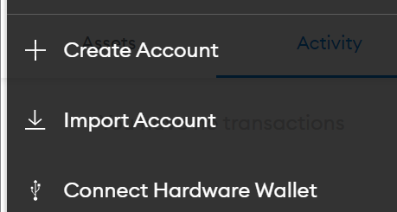

1. Copy and paste your private key in the following:

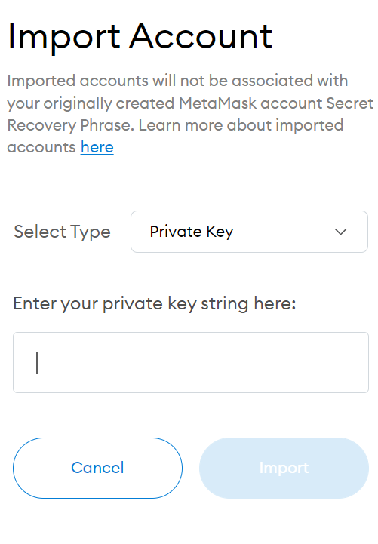

1. Click import to import the account you generated. Your account will have 100 Ether initially.
2. After you have your account in the wallet, you may see that your account is not connected to our platform.

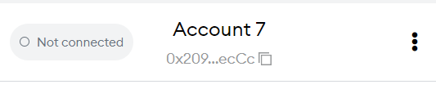

1. To connect to our platform, please first navigate to and stay in the tab of our platform and then open MetaMask plugin and click the three dots on the right and hit connected sites:

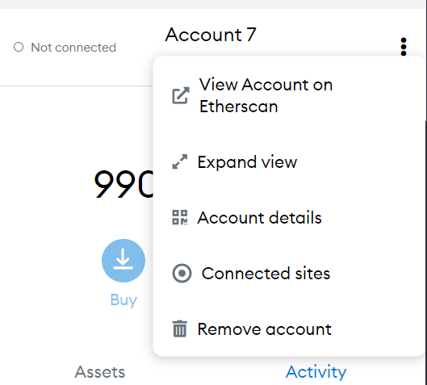

1. Click Manually connect to current site (If there is no “Manually connect”, please refresh your page and try again):

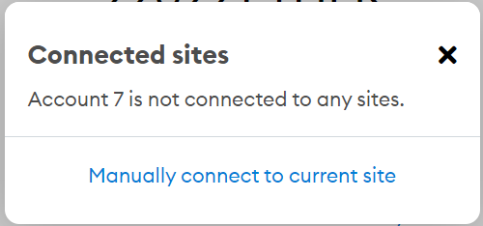

1. Click connect to the site and you will see your account is connected to the site:

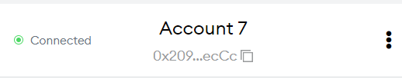

1. Now if you navigate to the ICO home page, you will see the content:

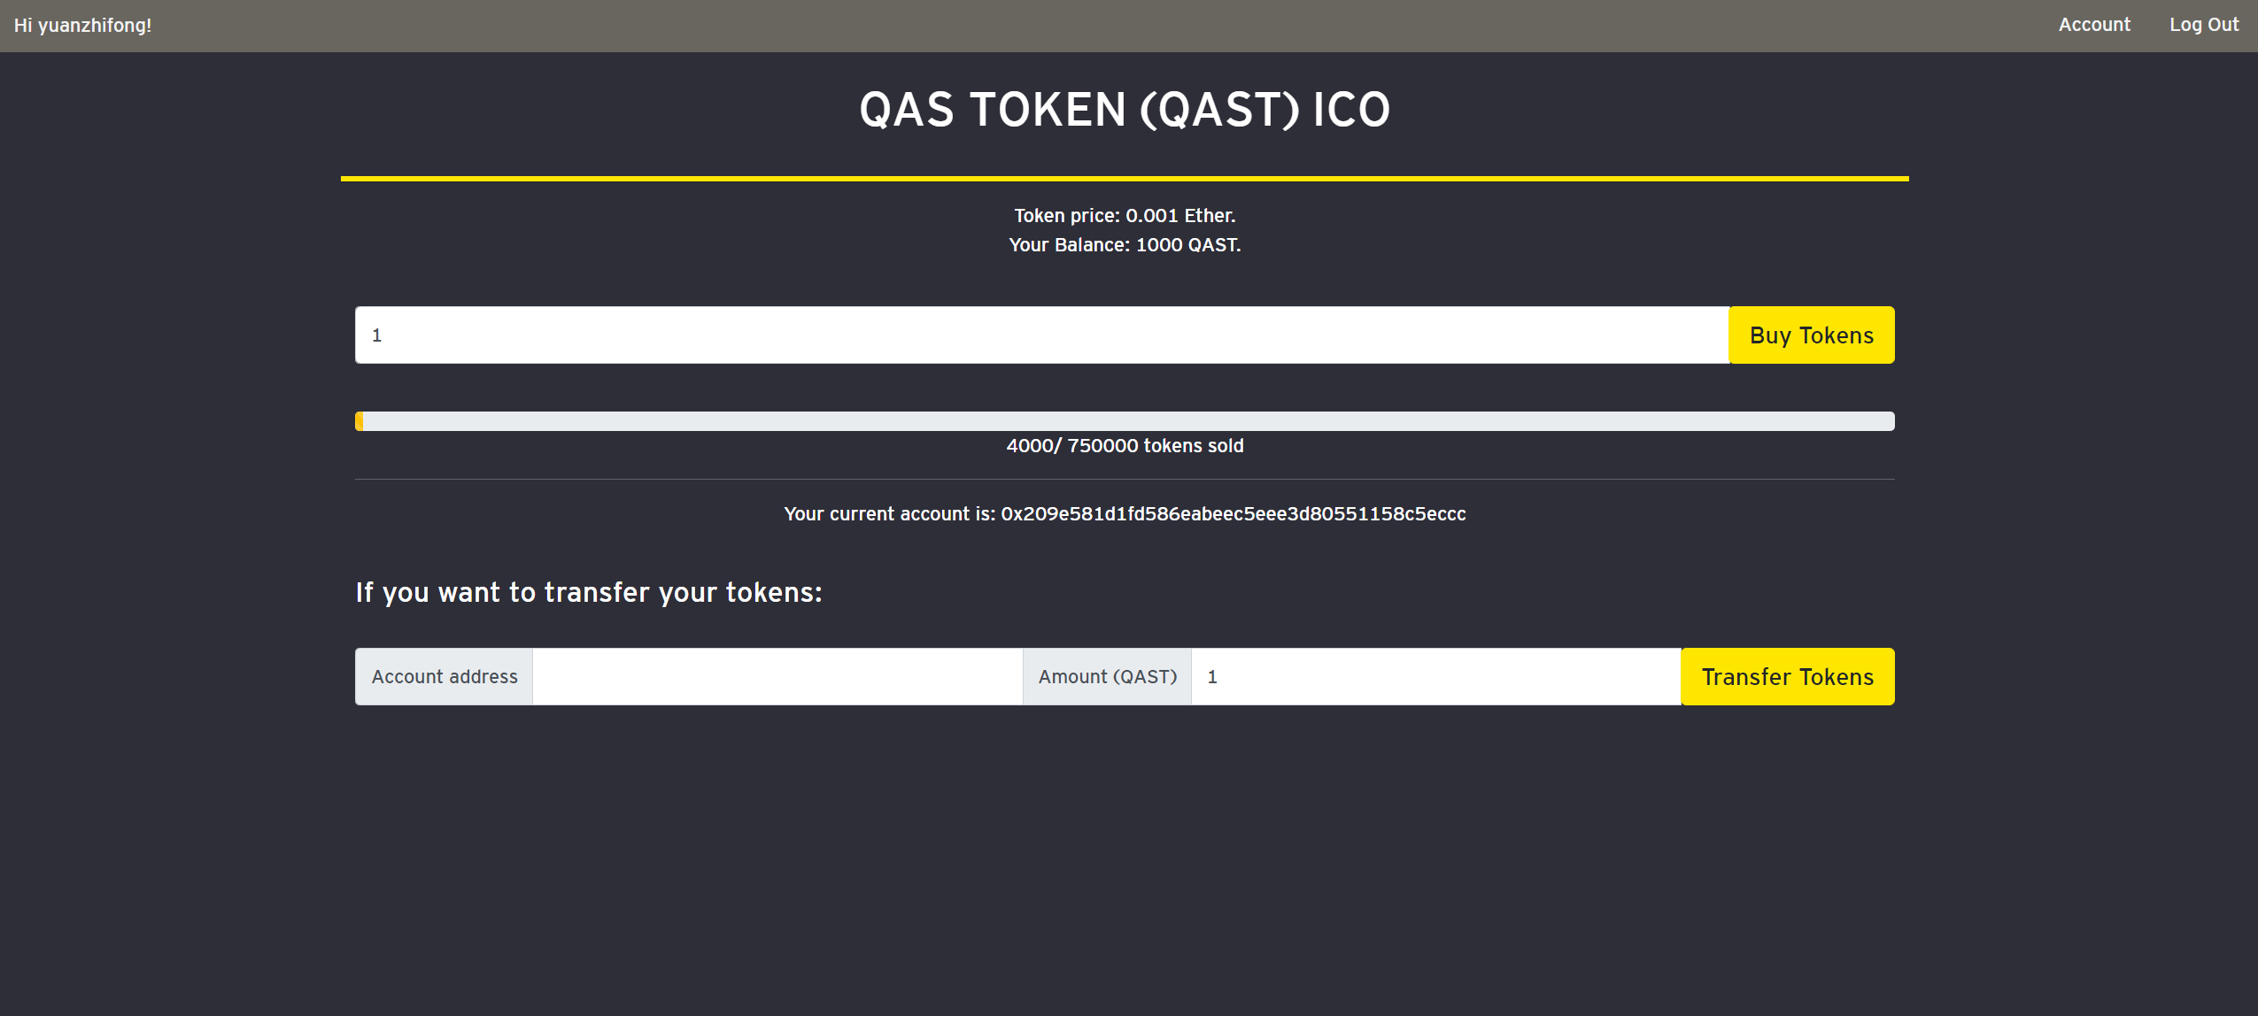

**Platform functionality**

1. Buy Tokens:
   1. You may be able to buy QASTokens from the platform. Our platform will show how many QAST you currently possess and the current Token price.
2. Transfer Tokens:
   1. If you know other people’s public address, you may transfer your QASTokens to their account.