Digital Design and Computer Organization Laboratory UE24CS251A
3rd Semester, Academic Year 2025
Mini Project Report
Name | SRN | Section
Dhawal Pathak | PES1UG24CS151 | 3 ‘C’
Vivian Sobers E | PES1UG24CS901 | 3 ‘C’
Aryan Upadhyay | PES1UG25CS806 | 3 ‘C’

- Problem Statement:

Design and implement a circuit to count the number of ones in a given input data.

- Verilog Code Screenshot
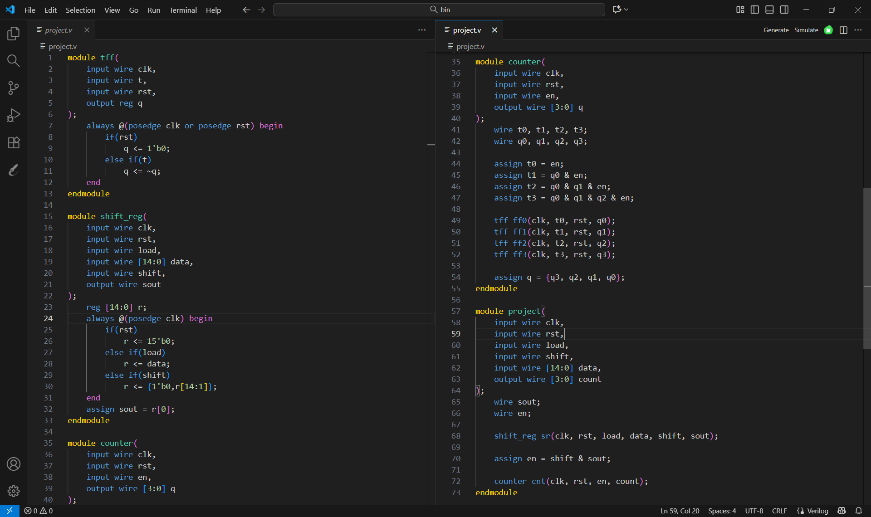
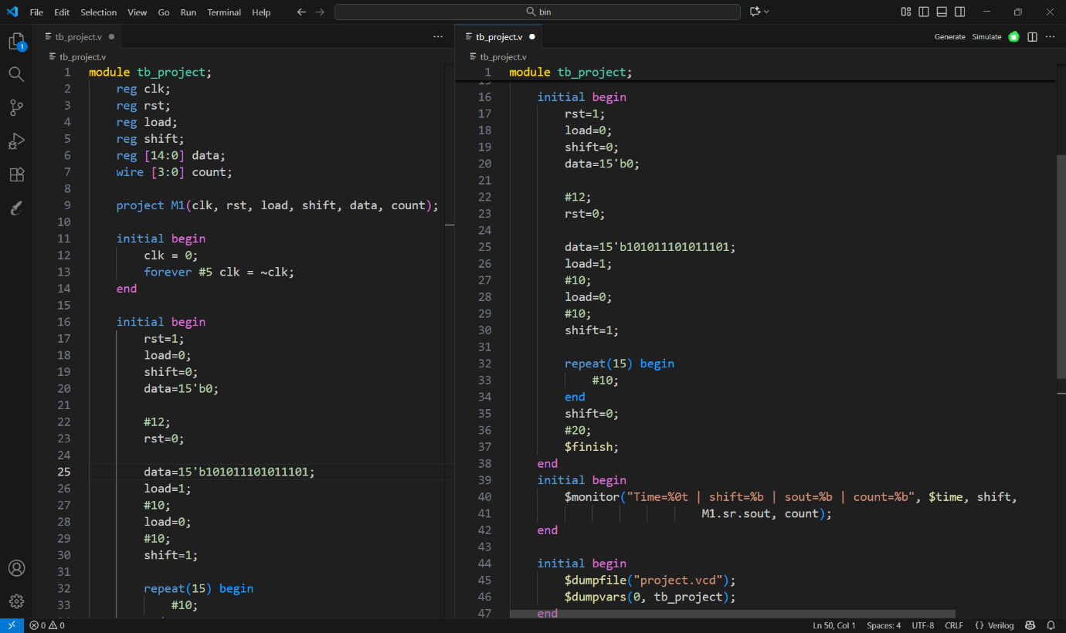
- VVP Output Screen Shot
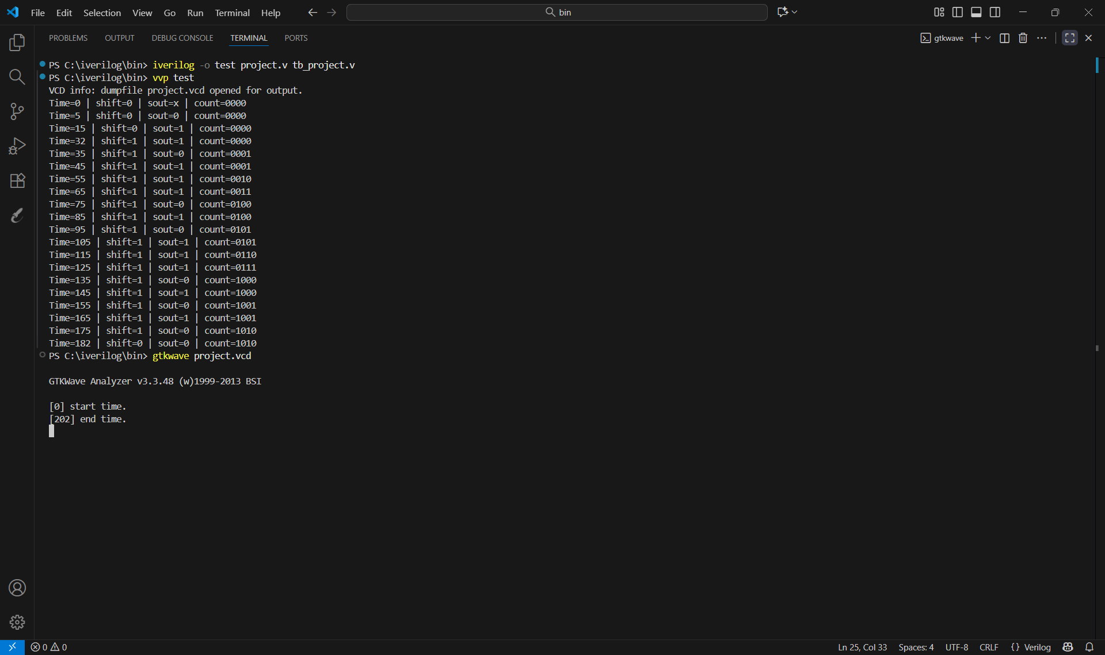
- GTKWAVE Screenshot
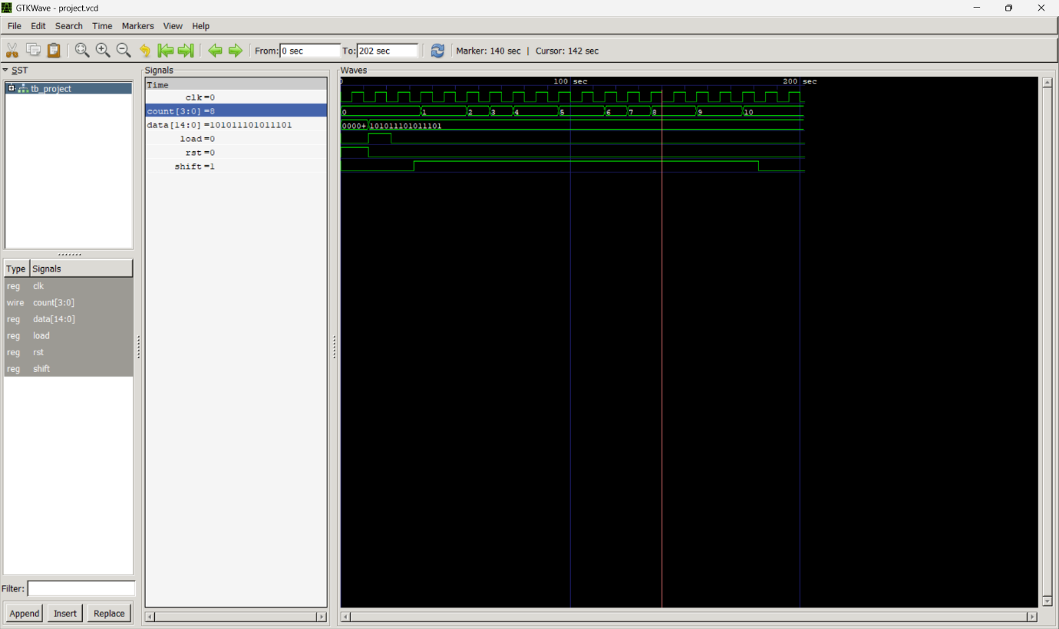

- Logic Circuit
