AFLL PLY Tool Assignment
Name: Vivian Sobers E
SRN: PES1UG24CS901
Class: 3 ‘C’

Syntax Analysis using PLY
1. Language: Javascript
2. Constructs: - Variable declarations - Function definitions - Selective constructs (if/else) - Iterative constructs (for/while) - Array declarations

Constructs Implemented
- Variable Declaration/Instantiation
  - var, let, const keywords
  - With and without initialization
- Function Definition
  - Function declarations with parameters
  - Function body with statements
- Selective Construct
  - if statements
  - if-else statements
  - Nested conditions
- Iterative Construct
  - for loops
  - while loops
- Array Declaration
  - Array initialization with elements
  - Empty arrays

Implementation

Lexer (lexer.py)
The lexer performs lexical analysis by breaking down the input JavaScript code into tokens.
import ply.lex as lex
reserved = {
'var': 'VAR',
'let': 'LET',
'const': 'CONST',
'function': 'FUNCTION',
'if': 'IF',
'else': 'ELSE',
'for': 'FOR',
'while': 'WHILE',
'return': 'RETURN',
'true': 'TRUE',
'false': 'FALSE'
}
tokens = [
'IDENTIFIER', 'NUMBER', 'STRING',
'PLUS', 'MINUS', 'TIMES', 'DIVIDE',
'ASSIGN', 'SEMICOLON', 'COMMA',
'LPAREN', 'RPAREN', 'LBRACE', 'RBRACE',
'LBRACKET', 'RBRACKET',
'GT', 'LT', 'GTE', 'LTE', 'EQEQ', 'NEQ'
] + list(reserved.values())
t_PLUS = r'\+'
t_MINUS = r'-'
t_TIMES = r'\*'
t_DIVIDE = r'/'
t_ASSIGN = r'='
t_SEMICOLON = r';'
t_COMMA = r','
t_LPAREN = r'\('
t_RPAREN = r'\)'
t_LBRACE = r'\{'
t_RBRACE = r'\}'
t_LBRACKET = r'\['
t_RBRACKET = r'\]'
t_GT = r'>'
t_LT = r'<'
t_GTE = r'>='
t_LTE = r'<='
t_EQEQ = r'=='
t_NEQ = r'!='
def t_IDENTIFIER(t):
r'[A-Za-z_][A-Za-z0-9_$]*'
t.type = reserved.get(t.value, 'IDENTIFIER')
return t
def t_NUMBER(t):
r'\d+'
t.value = int(t.value)
return t
def t_STRING(t):
r'\"([^\\\n]|(\\.))*?\"'
return t
t_ignore = ' \t'
def t_newline(t):
r'\n+'
t.lexer.lineno += len(t.value)
def t_error(t):
print(f"Illegal character '{t.value[0]}' at line {t.lineno}")
t.lexer.skip(1)
lexer = lex.lex()
Key Features: - Recognizes JavaScript reserved keywords - Tokenizes identifiers, numbers, strings, and operators - Handles comparison and arithmetic operators - Tracks line numbers for error reporting

Parser (parser.py)
The parser performs syntax analysis using grammar rules defined for JavaScript constructs.
import ply.yacc as yacc
from lexer import tokens
had_error = False
def p_program(p):
'''program : statement_list'''
pass
def p_statement_list(p):
'''statement_list : statement_list statement
| statement'''
pass
def p_statement(p):
'''statement : var_decl
| array_decl
| func_def
| selection
| iteration
| return_stmt
| assignment
| empty'''
pass
def p_var_decl(p):
'''var_decl : VAR IDENTIFIER SEMICOLON
| VAR IDENTIFIER ASSIGN expression SEMICOLON
| LET IDENTIFIER SEMICOLON
| LET IDENTIFIER ASSIGN expression SEMICOLON
| CONST IDENTIFIER ASSIGN expression SEMICOLON'''
pass
def p_array_decl(p):
'''array_decl : VAR IDENTIFIER ASSIGN LBRACKET array_elements RBRACKET SEMICOLON'''
pass
def p_array_elements(p):
'''array_elements : array_elements COMMA expression
| expression
| empty'''
pass
def p_func_def(p):
'''func_def : FUNCTION IDENTIFIER LPAREN param_list RPAREN LBRACE statement_list RBRACE'''
pass
def p_param_list(p):
'''param_list : param_list COMMA IDENTIFIER
| IDENTIFIER
| empty'''
pass
def p_selection(p):
'''selection : IF LPAREN expression RPAREN statement
| IF LPAREN expression RPAREN LBRACE statement_list RBRACE
| IF LPAREN expression RPAREN statement ELSE statement
| IF LPAREN expression RPAREN LBRACE statement_list RBRACE ELSE LBRACE statement_list RBRACE
| IF LPAREN expression RPAREN LBRACE statement_list RBRACE ELSE selection'''
pass
def p_iteration(p):
'''iteration : FOR LPAREN var_decl expression SEMICOLON assignment RPAREN LBRACE statement_list RBRACE
| WHILE LPAREN expression RPAREN LBRACE statement_list RBRACE'''
pass
def p_return_stmt(p):
'''return_stmt : RETURN expression SEMICOLON'''
pass
def p_assignment(p):
'''assignment : IDENTIFIER ASSIGN expression SEMICOLON'''
pass
def p_expression(p):
'''expression : expression PLUS term
| expression MINUS term
| expression GT term
| expression LT term
| expression EQEQ term
| expression NEQ term
| term'''
pass
def p_term(p):
'''term : NUMBER
| IDENTIFIER
| STRING'''
pass
def p_empty(p):
'empty :'
pass
def p_error(p):
global had_error
had_error = True
if p:
print(f"Syntax error at '{p.value}' (line {p.lineno})")
else:
print("Syntax error at EOF")
parser = yacc.yacc()
Grammar Rules: - p_var_decl: Handles variable declarations with var, let, and const - p_array_decl: Handles array declarations - p_func_def: Handles function definitions with parameters - p_selection: Handles if-else statements - p_iteration: Handles for and while loops - p_expression: Handles arithmetic and logical expressions

Main Program (main.py)
The main program provides an interactive menu for testing different JavaScript constructs.
from parser import parser, had_error as parser_had_error
import parser
def verify(code):
print("\n--- Verifying Syntax ---")
parser.had_error = False
parser.parser.parse(code)
if parser.had_error:
print("❌ Syntax errors found.")
else:
print("✅ Syntax is valid! No errors detected.")
def code_input():
print("\nEnter your JavaScript code below.")
print("Type 'exit' on a new line to verify.\n")
code = ""
while True:
line = input("js> ")
if line.strip().lower() == "exit":
break
code += line + "\n"
return code
def main():
while True:
print("JavaScript Syntax Verifier (PLY)")
print("1. Variable declaration/instantiation")
print("2. Iterative constructs (for/while)")
print("3. Selective constructs (if/else)")
print("4. Function declaration")
print("5. Array declaration")
print("6. Combination of all the above constructs")
print("7. Exit")
choice = input("\nEnter your choice: ")
if choice == "1":
code = code_input()
verify(code)
elif choice == "2":
code = code_input()
verify(code)
elif choice == "3":
code = code_input()
verify(code)
elif choice == "4":
code = code_input()
verify(code)
elif choice == "5":
code = code_input()
verify(code)
elif choice == "6":
code = code_input()
verify(code)
elif choice == "7":
break
else:
print("Invalid choice. Please enter a number between 1 and 7.\n")
if __name__ == "__main__":
main()
Features: - Interactive menu-driven interface - Multi-line code input - Real-time syntax verification - Clear success/error messages

Output Screenshots

Screenshot 1: Multiple Test Cases
This screenshot demonstrates various test scenarios including error detection and successful validation.
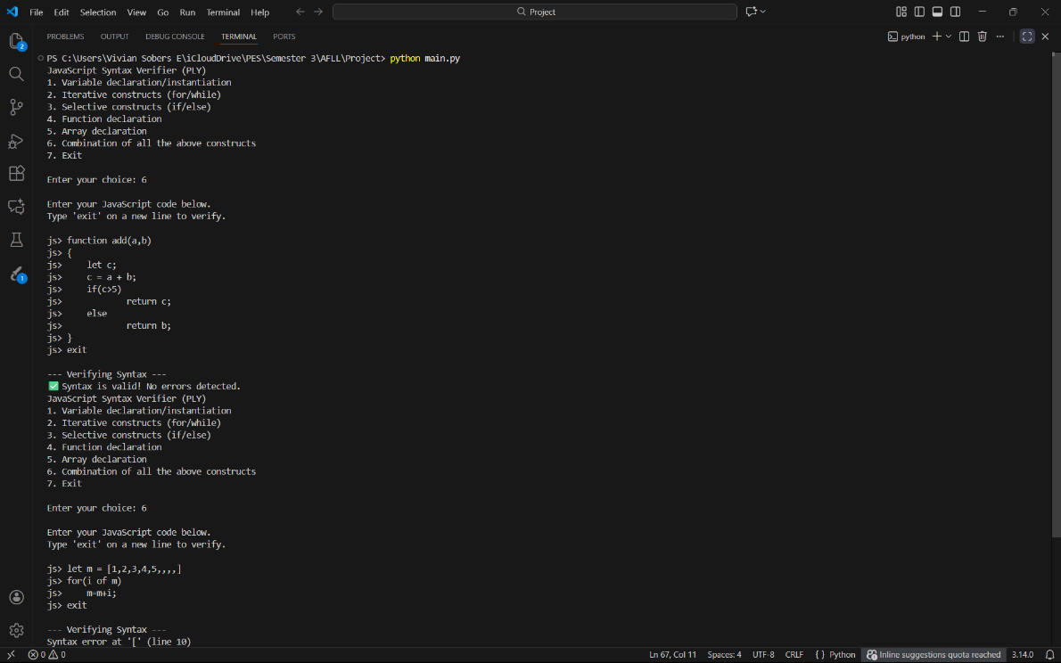

Screenshot 2: Function and Combined Tests
This screenshot shows function definition validation and combination testing.
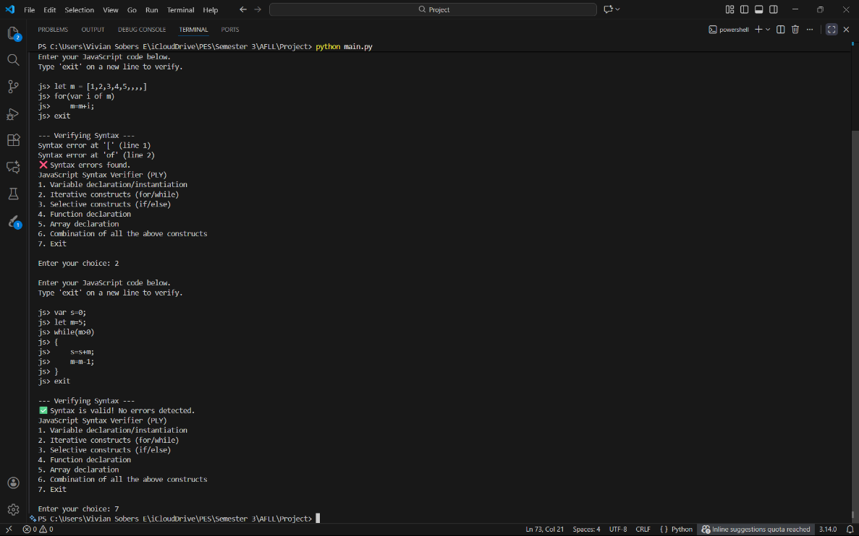

Test Cases
Test Case | Construct | Input | Expected Result | Actual Result
1 | Array Declaration | let m = [1,2,3,4,5,,,,] | Syntax Error | ❌ Error Detected
2 | While Loop | while(m>0) { s=s+m; m=m-1; } | Valid | ✅ Valid
3 | Function Definition | function add(a,b) { ... } | Valid | ✅ Valid
4 | If-Else | if(c>5) return c; else return b; | Valid | ✅ Valid
5 | Variable Declaration | var s=0; let m=5; | Valid | ✅ Valid

