Name: Vivian Sobers E
SRN: PES1UG24CS901
Sec: 3C
NBA Statistics Report
Descriptive Statistics
- Shooting percentages (Fg%, Fg3%, Fg2%, Ft%) display varying levels of spread.
  - Fg% and Ft% approximate normal distributions, with mean (μ) close to league averages and relatively low variance (σ²).
  - Fg3% exhibits higher variance and bimodal tendencies, reflecting specialization between non-shooters and elite three-point shooters.
  - Median Fg3% by position shows Guards consistently outperforming Forwards and Centers.
- Rebounding metrics:
  - Defensive rebounds (Drb) have a higher mean and variance compared to offensive rebounds (Orb), confirming their relative frequency.
  - Both distributions are positively skewed, with Centers and Power Forwards forming upper-tail outliers.
  - Group means confirm: Centers and PFs lead in Orb and Drb, while Guards remain at the lower bound.
- Assists (Ast) show high variance, with Point Guards forming the upper tail of the distribution. The mean is much greater than the median, suggesting a small number of elite playmakers skewing the data.
- Blocks (Blk) and Steals (Stl) are heavily right-skewed, with mode ≈ 0. Their high standard deviation reflects the presence of a few defensive specialists who contribute disproportionately.
- Points (Pts) distribution is also positively skewed, with the mean greater than the median, confirming that a minority of elite scorers elevate the league-wide average.
- Average Points per Position (from group by analysis): SGs and SFs record higher means, while Cs and PFs are lower, reinforcing role-driven scoring differences.

Visualization Results
- Histograms
  - Points, Assists, Block, and Steal show long right tails, confirming skewness.
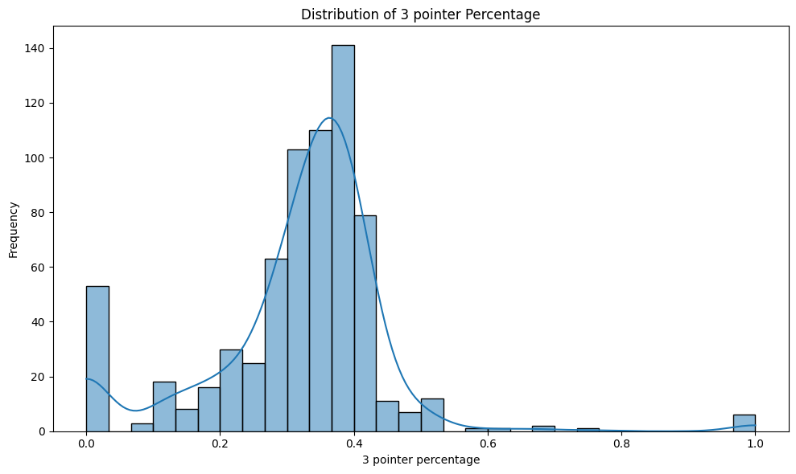
  - Shooting stats (Fg%, Fg2%, Ft%) appear more symmetric, while Fg3% shows a bimodal distribution separating low-volume shooters from elite specialists.
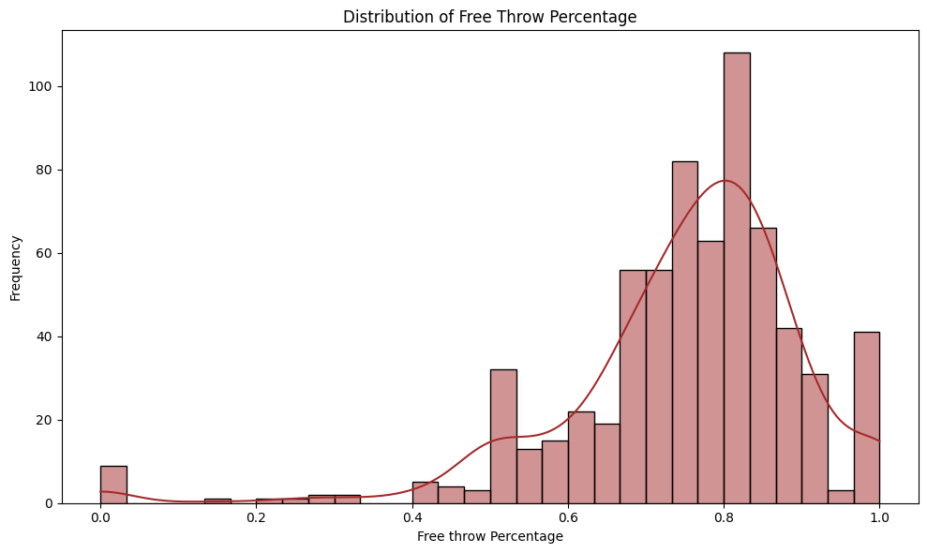

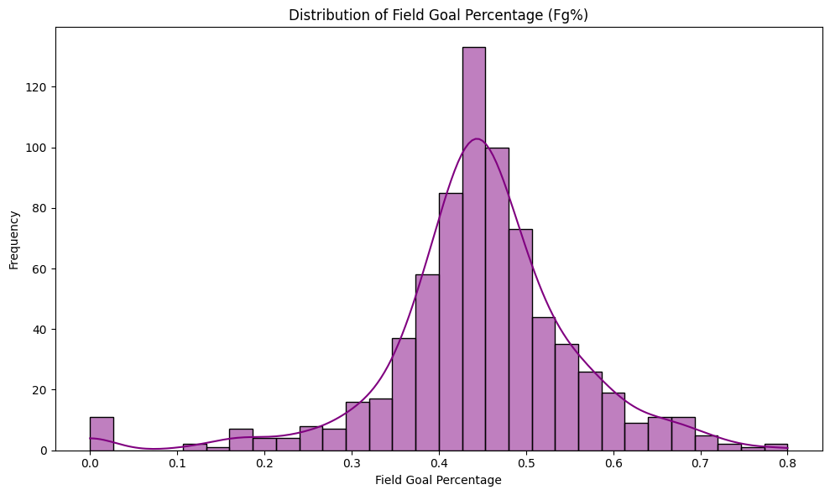
- Boxplots by Position
  - Ast boxplots show Point Guards (PG) with the highest median and narrowest IQR, demonstrating consistent playmaking.
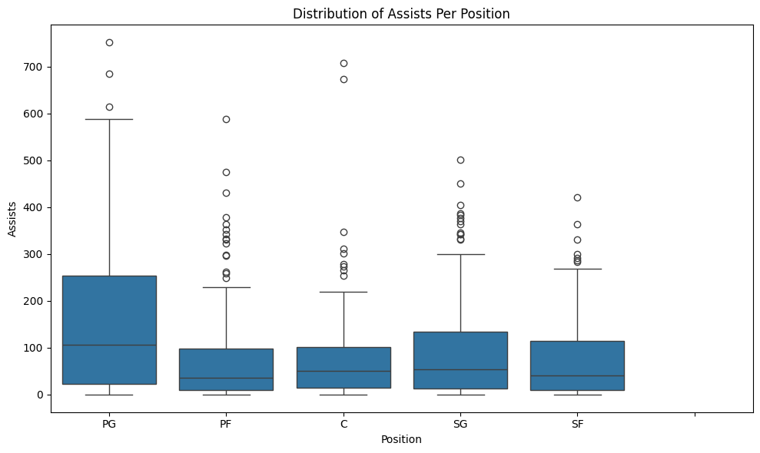
  - Rebounds boxplots highlight Centers (C) and PFs as frequent upper outliers, pulling distributions upward.
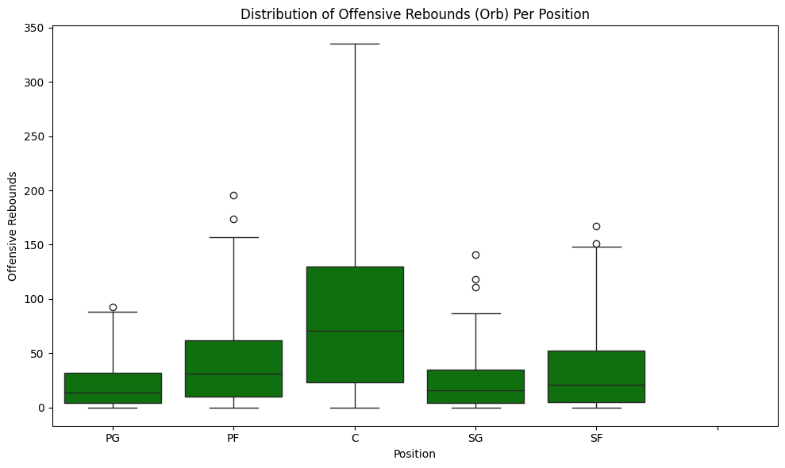
  - Pts boxplots reveal SGs and SFs with wider IQRs, reflecting role-based variability in scoring.
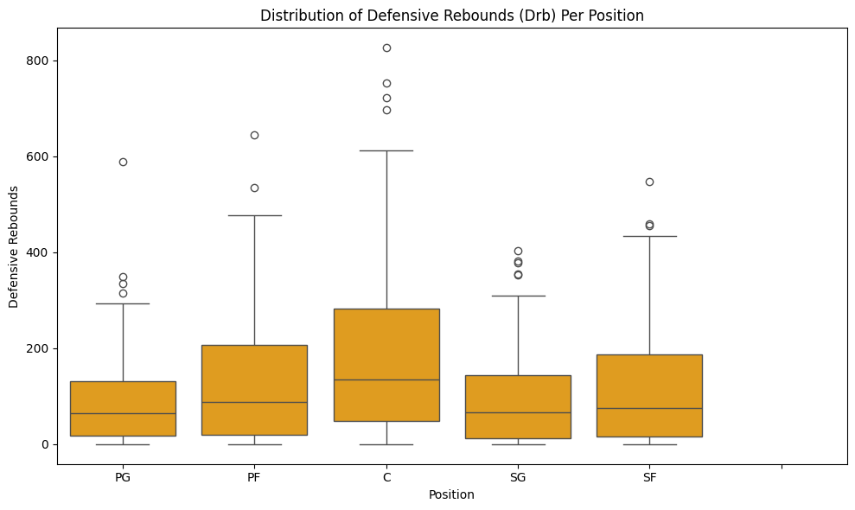
- Correlation Heatmap
  - Strong correlation between Offensive and Defensive rebounds (ρ > 0.7).
  - Moderate correlation between Pts and Fg% (ρ ≈ 0.5).
  - Weak or negative correlation between Ast and Rebounds, confirming positional specialization.
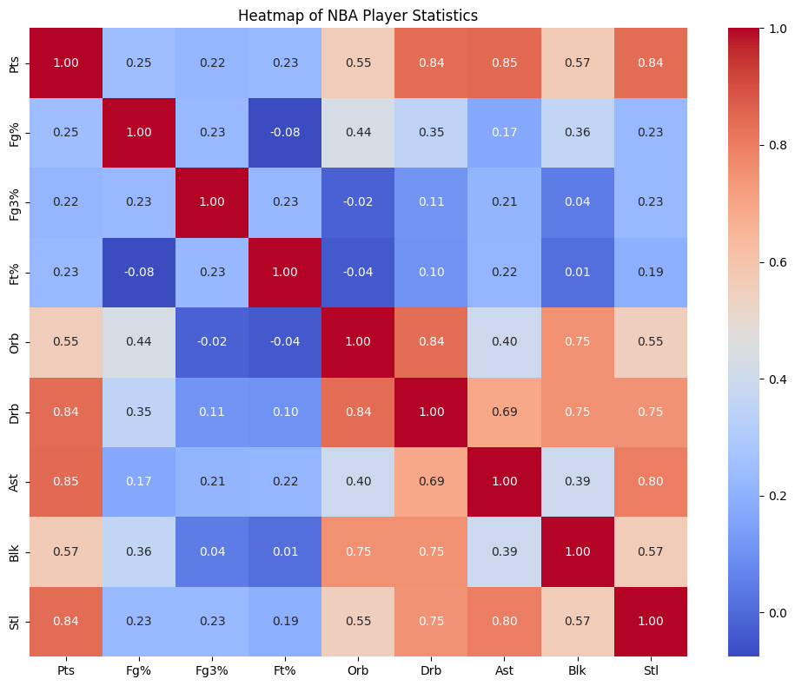
- Scatter Plots
  - Pts vs. Fg%: Positive trend with greater variance among high scorers.
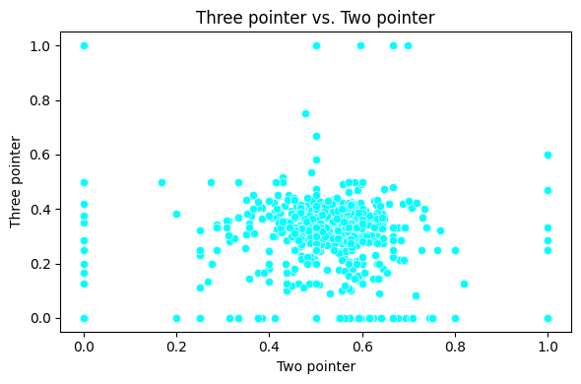
  - Assists vs. Steal: Guards cluster at higher values, confirming their dual perimeter role.
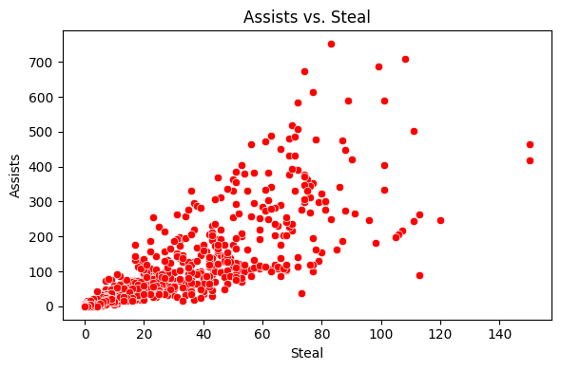
  - Block vs. Defensive Rebounds: Centers dominate the upper-right quadrant, Guards cluster at the origin.
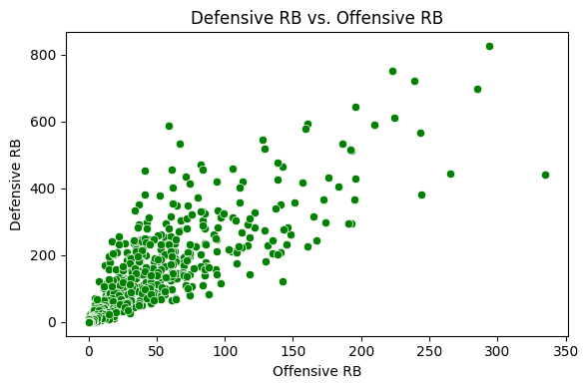
- Density Plots (KDEs)
  - Scoring distributions show clustering at low-to-mid ranges with a distinct upper distribution for elite scorers.
  - Assists density peaks sharply for Guards, showing a high mode at modest assist counts and a long tail from elite playmakers.
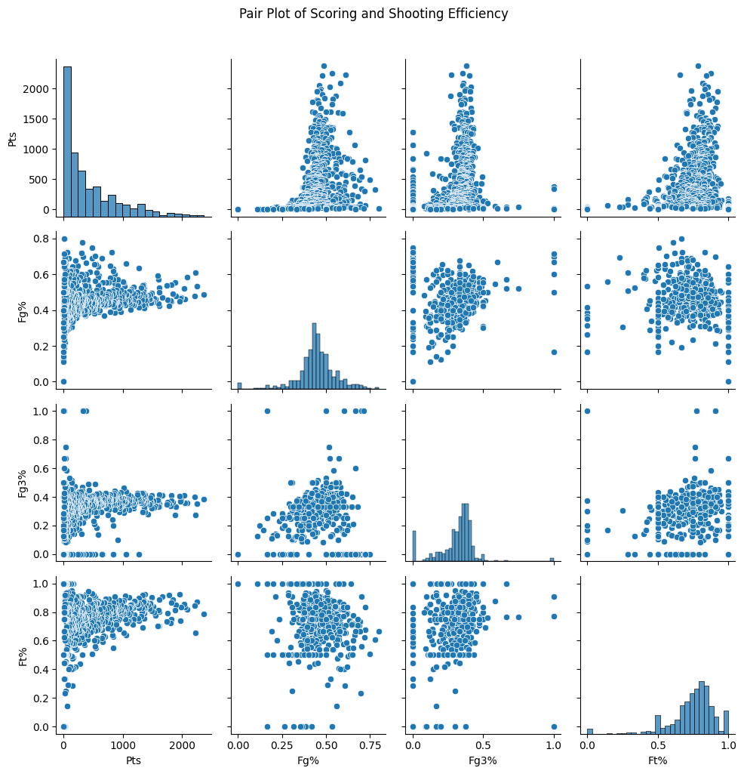
- Bar Chart – Average Points per Position
  - Clear visual separation: SGs and SFs as top scorers, PGs in the middle, PFs and Cs lower. This directly supports descriptive findings.
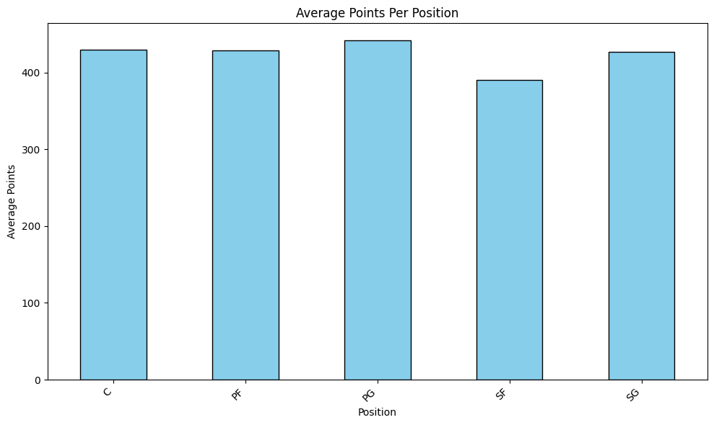
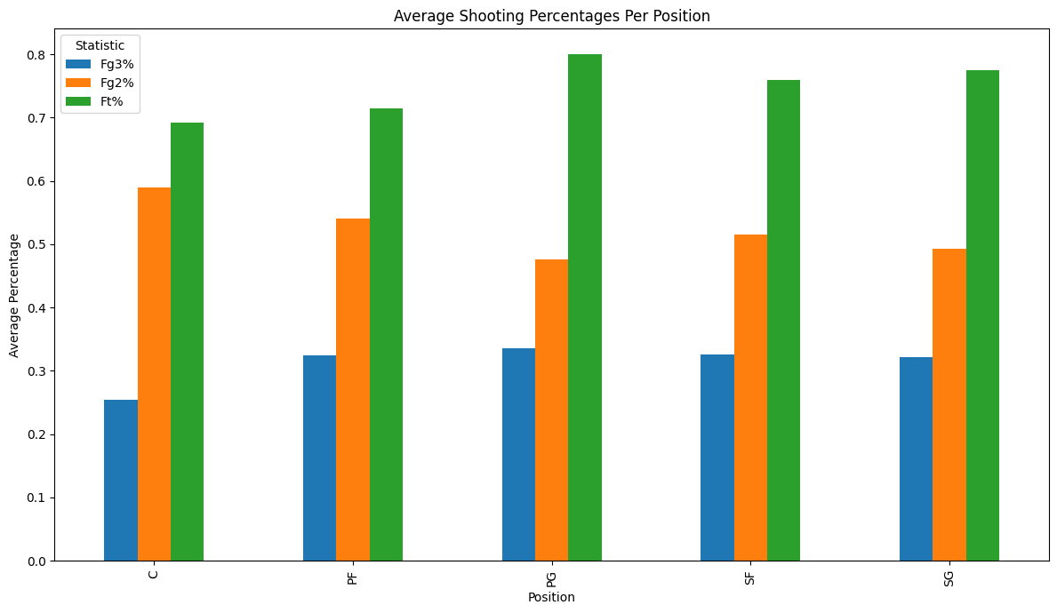

Inferences
- Scoring (Pts):
  - Distribution is positively skewed with μ > median.
  - A small group of elite scorers (SGs, SFs) act as statistical outliers.
- Playmaking (Ast):
  - PGs dominate with the highest μ and relatively small σ, indicating role consistency.
  - Across all players, high variance reflects specialization in playmaking ability.
- Rebounding (Orb, Drb):
  - Cs and PFs have higher μ and σ² in both Offensive Rebound and Defensive rebound, while Guards cluster at the lower bound with low variance.
- Defence (Block, Steal):
  - Blocks: mode ≈ 0 for most players, with Centers as upper-tail outliers.
  - Steals: Guards show higher median and mean, aligning with perimeter defence roles.
- Shooting Efficiency:
  - Fg% and Ft% approximate normal distributions with low σ².
  - Fg3% has high variance, reflecting specialization between non-shooters and sharpshooters.
- Position-Based Roles:
  - Guards (PG/SG): High assists (μ), higher steals (median), low rebounds.
  - Forwards (SF/PF): Balanced across scoring and rebounding, medians near league averages.
  - Centers (C): Highest rebounds (μ, σ²), highest blocks, lowest assists (μ, σ²).

Conclusion
The descriptive statistics and visualizations reveal that NBA player performance metrics are rarely normally distributed; instead, they are characterized by positive skewness, high variance, and positional specialization. Guards dominate in assists and steals, Forwards balance across categories, and Centers specialize in rebounding and rim protection. Correlation analysis validates expected relationships (rebounds–blocks, minutes–points) while confirming trade-offs such as assists vs. rebounding. The average points per position bar chart and median Fg3% per position analysis further strengthen the evidence of role-based statistical separation.

.ipynb File
from bs4 import BeautifulSoup as bs
url = "https://www.basketball-reference.com/leagues/NBA_2024_totals.html"
from urllib.request import Request, urlopen
headers = {'User-Agent': 'Mozilla/5.0'}
req = Request(url, headers=headers)
html = urlopen(req).read()
soup = bs(html, 'html.parser')
player_table = soup.find('table')
player_table = soup.find('table', id='totals_stats')
thead = player_table.find('thead')
column_headers = [th.get_text() for th in thead.find_all('th')]
print(column_headers)
['Rk', 'Player', 'Age', 'Team', 'Pos', 'G', 'GS', 'MP', 'FG', 'FGA', 'FG%', '3P', '3PA', '3P%', '2P', '2PA', '2P%', 'eFG%', 'FT', 'FTA', 'FT%', 'ORB', 'DRB', 'TRB', 'AST', 'STL', 'BLK', 'TOV', 'PF', 'PTS', 'Trp-Dbl', 'Awards']
print(soup.prettify())
Output hidden; open in https://colab.research.google.com to view.
url = "https://www.basketball-reference.com/leagues/NBA_2024_totals.html"
req = Request(url, headers=headers)
html = urlopen(req).read()
soup = bs(html, 'html.parser')
player_table = soup.find('table')
thead = player_table.find('thead')
column_headers = [th.get_text() for th in thead.find_all('th')]
print(column_headers)
['Rk', 'Player', 'Age', 'Team', 'Pos', 'G', 'GS', 'MP', 'FG', 'FGA', 'FG%', '3P', '3PA', '3P%', '2P', '2PA', '2P%', 'eFG%', 'FT', 'FTA', 'FT%', 'ORB', 'DRB', 'TRB', 'AST', 'STL', 'BLK', 'TOV', 'PF', 'PTS', 'Trp-Dbl', 'Awards']
tbody = player_table.find('tbody')
rows = tbody.find_all('tr')
print(f"Found {len(rows)} rows in the table body.")
Found 736 rows in the table body.
player_data = []
for row in rows:
player_info = {}
player_name_tag = row.find('th', {'data-stat': 'player'})
if player_name_tag:
player_info['Name'] = player_name_tag.get_text()
for stat in ['pos', 'fg_pct', 'fg3_pct', 'fg2_pct', 'ft_pct', 'orb', 'drb', 'ast', 'blk', 'stl', 'pts']:
stat_tag = row.find('td', {'data-stat': stat})
if stat_tag:
player_info[stat.replace('_pct', '%').capitalize()] = stat_tag.get_text()
if player_info:
player_data.append(player_info)
print(f"Extracted data for {len(player_data)} players.")
Extracted data for 736 players.
import pandas as pd
player_data_list = []
for row in rows:
player_info = {}
player_name_tag = row.find('th', {'data-stat': 'player'})
if player_name_tag:
player_info['Name'] = player_name_tag.get_text()
for stat in ['pos', 'fg_pct', 'fg3_pct', 'fg2_pct', 'ft_pct', 'orb', 'drb', 'ast', 'blk', 'stl', 'pts']:
stat_tag = row.find('td', {'data-stat': stat})
if stat_tag:
if stat == 'pos':
player_info['Pos'] = stat_tag.get_text()
elif '_pct' in stat:
player_info[stat.replace('_pct', '%').capitalize()] = stat_tag.get_text()
else:
player_info[stat.capitalize()] = stat_tag.get_text()
if player_info:
player_data_list.append(player_info)
columns = [ 'Name','Pos', 'Fg%', 'Fg3%', 'Fg2%', 'Ft%', 'Orb', 'Drb', 'Ast', 'Blk', 'Stl', 'Pts']
df = pd.DataFrame(player_data_list, columns=columns)
display(df.head())
{"summary":"{\n \"name\": \"display(df\",\n \"rows\": 5,\n \"fields\": [\n {\n \"column\": \"Name\",\n \"properties\": {\n \"dtype\": \"number\",\n \"std\": null,\n \"min\": null,\n \"max\": null,\n \"num_unique_values\": 0,\n \"samples\": [],\n \"semantic_type\": \"\",\n \"description\": \"\"\n }\n },\n {\n \"column\": \"Pos\",\n \"properties\": {\n \"dtype\": \"string\",\n \"num_unique_values\": 3,\n \"samples\": [],\n \"semantic_type\": \"\",\n \"description\": \"\"\n }\n },\n {\n \"column\": \"Fg%\",\n \"properties\": {\n \"dtype\": \"string\",\n \"num_unique_values\": 5,\n \"samples\": [],\n \"semantic_type\": \"\",\n \"description\": \"\"\n }\n },\n {\n \"column\": \"Fg3%\",\n \"properties\": {\n \"dtype\": \"string\",\n \"num_unique_values\": 5,\n \"samples\": [],\n \"semantic_type\": \"\",\n \"description\": \"\"\n }\n },\n {\n \"column\": \"Fg2%\",\n \"properties\": {\n \"dtype\": \"string\",\n \"num_unique_values\": 5,\n \"samples\": [],\n \"semantic_type\": \"\",\n \"description\": \"\"\n }\n },\n {\n \"column\": \"Ft%\",\n \"properties\": {\n \"dtype\": \"string\",\n \"num_unique_values\": 5,\n \"samples\": [],\n \"semantic_type\": \"\",\n \"description\": \"\"\n }\n },\n {\n \"column\": \"Orb\",\n \"properties\": {\n \"dtype\": \"string\",\n \"num_unique_values\": 5,\n \"samples\": [],\n \"semantic_type\": \"\",\n \"description\": \"\"\n }\n },\n {\n \"column\": \"Drb\",\n \"properties\": {\n \"dtype\": \"string\",\n \"num_unique_values\": 5,\n \"samples\": [],\n \"semantic_type\": \"\",\n \"description\": \"\"\n }\n },\n {\n \"column\": \"Ast\",\n \"properties\": {\n \"dtype\": \"string\",\n \"num_unique_values\": 5,\n \"samples\": [],\n \"semantic_type\": \"\",\n \"description\": \"\"\n }\n },\n {\n \"column\": \"Blk\",\n \"properties\": {\n \"dtype\": \"string\",\n \"num_unique_values\": 5,\n \"samples\": [],\n \"semantic_type\": \"\",\n \"description\": \"\"\n }\n },\n {\n \"column\": \"Stl\",\n \"properties\": {\n \"dtype\": \"string\",\n \"num_unique_values\": 5,\n \"samples\": [],\n \"semantic_type\": \"\",\n \"description\": \"\"\n }\n },\n {\n \"column\": \"Pts\",\n \"properties\": {\n \"dtype\": \"string\",\n \"num_unique_values\": 5,\n \"samples\": [],\n \"semantic_type\": \"\",\n \"description\": \"\"\n }\n }\n ]\n}","type":"dataframe"}
display(df)
{"summary":"{\n \"name\": \"df\",\n \"rows\": 736,\n \"fields\": [\n {\n \"column\": \"Name\",\n \"properties\": {\n \"dtype\": \"number\",\n \"std\": null,\n \"min\": null,\n \"max\": null,\n \"num_unique_values\": 0,\n \"samples\": [],\n \"semantic_type\": \"\",\n \"description\": \"\"\n }\n },\n {\n \"column\": \"Pos\",\n \"properties\": {\n \"dtype\": \"category\",\n \"num_unique_values\": 6,\n \"samples\": [],\n \"semantic_type\": \"\",\n \"description\": \"\"\n }\n },\n {\n \"column\": \"Fg%\",\n \"properties\": {\n \"dtype\": \"category\",\n \"num_unique_values\": 274,\n \"samples\": [],\n \"semantic_type\": \"\",\n \"description\": \"\"\n }\n },\n {\n \"column\": \"Fg3%\",\n \"properties\": {\n \"dtype\": \"category\",\n \"num_unique_values\": 218,\n \"samples\": [],\n \"semantic_type\": \"\",\n \"description\": \"\"\n }\n },\n {\n \"column\": \"Fg2%\",\n \"properties\": {\n \"dtype\": \"category\",\n \"num_unique_values\": 267,\n \"samples\": [],\n \"semantic_type\": \"\",\n \"description\": \"\"\n }\n },\n {\n \"column\": \"Ft%\",\n \"properties\": {\n \"dtype\": \"category\",\n \"num_unique_values\": 273,\n \"samples\": [],\n \"semantic_type\": \"\",\n \"description\": \"\"\n }\n },\n {\n \"column\": \"Orb\",\n \"properties\": {\n \"dtype\": \"category\",\n \"num_unique_values\": 143,\n \"samples\": [],\n \"semantic_type\": \"\",\n \"description\": \"\"\n }\n },\n {\n \"column\": \"Drb\",\n \"properties\": {\n \"dtype\": \"category\",\n \"num_unique_values\": 294,\n \"samples\": [],\n \"semantic_type\": \"\",\n \"description\": \"\"\n }\n },\n {\n \"column\": \"Ast\",\n \"properties\": {\n \"dtype\": \"category\",\n \"num_unique_values\": 266,\n \"samples\": [],\n \"semantic_type\": \"\",\n \"description\": \"\"\n }\n },\n {\n \"column\": \"Blk\",\n \"properties\": {\n \"dtype\": \"category\",\n \"num_unique_values\": 91,\n \"samples\": [],\n \"semantic_type\": \"\",\n \"description\": \"\"\n }\n },\n {\n \"column\": \"Stl\",\n \"properties\": {\n \"dtype\": \"category\",\n \"num_unique_values\": 103,\n \"samples\": [],\n \"semantic_type\": \"\",\n \"description\": \"\"\n }\n },\n {\n \"column\": \"Pts\",\n \"properties\": {\n \"dtype\": \"string\",\n \"num_unique_values\": 475,\n \"samples\": [],\n \"semantic_type\": \"\",\n \"description\": \"\"\n }\n }\n ]\n}","variable_name":"df","type":"dataframe"}
df.to_csv('nba_player_stats.csv', index=False)
df.info()
<class 'pandas.core.frame.DataFrame'>
RangeIndex: 736 entries, 0 to 735
Data columns (total 12 columns):
# Column Non-Null Count Dtype
--- ------ -------------- -----
0 Name 0 non-null float64
1 Pos 736 non-null object
2 Fg% 736 non-null object
3 Fg3% 736 non-null object
4 Fg2% 736 non-null object
5 Ft% 736 non-null object
6 Orb 736 non-null object
7 Drb 736 non-null object
8 Ast 736 non-null object
9 Blk 736 non-null object
10 Stl 736 non-null object
11 Pts 736 non-null object
dtypes: float64(1), object(11)
memory usage: 69.1+ KB
df.isna().sum()
Name 736
Pos 0
Fg% 0
Fg3% 0
Fg2% 0
Ft% 0
Orb 0
Drb 0
Ast 0
Blk 0
Stl 0
Pts 0
dtype: int64
df['Name']
0 NaN
1 NaN
2 NaN
3 NaN
4 NaN
..
731 NaN
732 NaN
733 NaN
734 NaN
735 NaN
Name: Name, Length: 736, dtype: float64
df.drop(['Name'], axis=1)
{"summary":"{\n \"name\": \"df\",\n \"rows\": 736,\n \"fields\": [\n {\n \"column\": \"Pos\",\n \"properties\": {\n \"dtype\": \"category\",\n \"num_unique_values\": 6,\n \"samples\": [\n \"PG\",\n \"PF\",\n \"\"\n ],\n \"semantic_type\": \"\",\n \"description\": \"\"\n }\n },\n {\n \"column\": \"Fg%\",\n \"properties\": {\n \"dtype\": \"category\",\n \"num_unique_values\": 274,\n \"samples\": [\n \".442\",\n \".378\",\n \".469\"\n ],\n \"semantic_type\": \"\",\n \"description\": \"\"\n }\n },\n {\n \"column\": \"Fg3%\",\n \"properties\": {\n \"dtype\": \"category\",\n \"num_unique_values\": 218,\n \"samples\": [\n \".406\",\n \".111\",\n \".307\"\n ],\n \"semantic_type\": \"\",\n \"description\": \"\"\n }\n },\n {\n \"column\": \"Fg2%\",\n \"properties\": {\n \"dtype\": \"category\",\n \"num_unique_values\": 267,\n \"samples\": [\n \".568\",\n \".583\",\n \"1.000\"\n ],\n \"semantic_type\": \"\",\n \"description\": \"\"\n }\n },\n {\n \"column\": \"Ft%\",\n \"properties\": {\n \"dtype\": \"category\",\n \"num_unique_values\": 273,\n \"samples\": [\n \".838\",\n \".706\",\n \".916\"\n ],\n \"semantic_type\": \"\",\n \"description\": \"\"\n }\n },\n {\n \"column\": \"Orb\",\n \"properties\": {\n \"dtype\": \"category\",\n \"num_unique_values\": 143,\n \"samples\": [\n \"130\",\n \"68\",\n \"31\"\n ],\n \"semantic_type\": \"\",\n \"description\": \"\"\n }\n },\n {\n \"column\": \"Drb\",\n \"properties\": {\n \"dtype\": \"category\",\n \"num_unique_values\": 294,\n \"samples\": [\n \"134\",\n \"293\",\n \"82\"\n ],\n \"semantic_type\": \"\",\n \"description\": \"\"\n }\n },\n {\n \"column\": \"Ast\",\n \"properties\": {\n \"dtype\": \"category\",\n \"num_unique_values\": 266,\n \"samples\": [\n \"57\",\n \"71\",\n \"281\"\n ],\n \"semantic_type\": \"\",\n \"description\": \"\"\n }\n },\n {\n \"column\": \"Blk\",\n \"properties\": {\n \"dtype\": \"category\",\n \"num_unique_values\": 91,\n \"samples\": [\n \"144\",\n \"48\",\n \"87\"\n ],\n \"semantic_type\": \"\",\n \"description\": \"\"\n }\n },\n {\n \"column\": \"Stl\",\n \"properties\": {\n \"dtype\": \"category\",\n \"num_unique_values\": 103,\n \"samples\": [\n \"62\",\n \"30\",\n \"35\"\n ],\n \"semantic_type\": \"\",\n \"description\": \"\"\n }\n },\n {\n \"column\": \"Pts\",\n \"properties\": {\n \"dtype\": \"string\",\n \"num_unique_values\": 475,\n \"samples\": [\n \"23\",\n \"110\",\n \"1956\"\n ],\n \"semantic_type\": \"\",\n \"description\": \"\"\n }\n }\n ]\n}","type":"dataframe"}
df.drop(['Name'], axis=1, inplace=True)
df.head()
{"summary":"{\n \"name\": \"df\",\n \"rows\": 736,\n \"fields\": [\n {\n \"column\": \"Pos\",\n \"properties\": {\n \"dtype\": \"category\",\n \"num_unique_values\": 6,\n \"samples\": [\n \"PG\",\n \"PF\",\n \"\"\n ],\n \"semantic_type\": \"\",\n \"description\": \"\"\n }\n },\n {\n \"column\": \"Fg%\",\n \"properties\": {\n \"dtype\": \"category\",\n \"num_unique_values\": 274,\n \"samples\": [\n \".442\",\n \".378\",\n \".469\"\n ],\n \"semantic_type\": \"\",\n \"description\": \"\"\n }\n },\n {\n \"column\": \"Fg3%\",\n \"properties\": {\n \"dtype\": \"category\",\n \"num_unique_values\": 218,\n \"samples\": [\n \".406\",\n \".111\",\n \".307\"\n ],\n \"semantic_type\": \"\",\n \"description\": \"\"\n }\n },\n {\n \"column\": \"Fg2%\",\n \"properties\": {\n \"dtype\": \"category\",\n \"num_unique_values\": 267,\n \"samples\": [\n \".568\",\n \".583\",\n \"1.000\"\n ],\n \"semantic_type\": \"\",\n \"description\": \"\"\n }\n },\n {\n \"column\": \"Ft%\",\n \"properties\": {\n \"dtype\": \"category\",\n \"num_unique_values\": 273,\n \"samples\": [\n \".838\",\n \".706\",\n \".916\"\n ],\n \"semantic_type\": \"\",\n \"description\": \"\"\n }\n },\n {\n \"column\": \"Orb\",\n \"properties\": {\n \"dtype\": \"category\",\n \"num_unique_values\": 143,\n \"samples\": [\n \"130\",\n \"68\",\n \"31\"\n ],\n \"semantic_type\": \"\",\n \"description\": \"\"\n }\n },\n {\n \"column\": \"Drb\",\n \"properties\": {\n \"dtype\": \"category\",\n \"num_unique_values\": 294,\n \"samples\": [\n \"134\",\n \"293\",\n \"82\"\n ],\n \"semantic_type\": \"\",\n \"description\": \"\"\n }\n },\n {\n \"column\": \"Ast\",\n \"properties\": {\n \"dtype\": \"category\",\n \"num_unique_values\": 266,\n \"samples\": [\n \"57\",\n \"71\",\n \"281\"\n ],\n \"semantic_type\": \"\",\n \"description\": \"\"\n }\n },\n {\n \"column\": \"Blk\",\n \"properties\": {\n \"dtype\": \"category\",\n \"num_unique_values\": 91,\n \"samples\": [\n \"144\",\n \"48\",\n \"87\"\n ],\n \"semantic_type\": \"\",\n \"description\": \"\"\n }\n },\n {\n \"column\": \"Stl\",\n \"properties\": {\n \"dtype\": \"category\",\n \"num_unique_values\": 103,\n \"samples\": [\n \"62\",\n \"30\",\n \"35\"\n ],\n \"semantic_type\": \"\",\n \"description\": \"\"\n }\n },\n {\n \"column\": \"Pts\",\n \"properties\": {\n \"dtype\": \"string\",\n \"num_unique_values\": 475,\n \"samples\": [\n \"23\",\n \"110\",\n \"1956\"\n ],\n \"semantic_type\": \"\",\n \"description\": \"\"\n }\n }\n ]\n}","variable_name":"df","type":"dataframe"}
import pandas as pd
import numpy as np
import statistics as st
print(df['Pos'].value_counts())
df.dropna(inplace=True)
Pos
SG 159
SF 158
PF 150
PG 147
C 121
1
Name: count, dtype: int64
df.isna()
{"summary":"{\n \"name\": \"df\",\n \"rows\": 736,\n \"fields\": [\n {\n \"column\": \"Pos\",\n \"properties\": {\n \"dtype\": \"boolean\",\n \"num_unique_values\": 1,\n \"samples\": [\n false\n ],\n \"semantic_type\": \"\",\n \"description\": \"\"\n }\n },\n {\n \"column\": \"Fg%\",\n \"properties\": {\n \"dtype\": \"boolean\",\n \"num_unique_values\": 1,\n \"samples\": [\n false\n ],\n \"semantic_type\": \"\",\n \"description\": \"\"\n }\n },\n {\n \"column\": \"Fg3%\",\n \"properties\": {\n \"dtype\": \"boolean\",\n \"num_unique_values\": 1,\n \"samples\": [\n false\n ],\n \"semantic_type\": \"\",\n \"description\": \"\"\n }\n },\n {\n \"column\": \"Fg2%\",\n \"properties\": {\n \"dtype\": \"boolean\",\n \"num_unique_values\": 1,\n \"samples\": [\n false\n ],\n \"semantic_type\": \"\",\n \"description\": \"\"\n }\n },\n {\n \"column\": \"Ft%\",\n \"properties\": {\n \"dtype\": \"boolean\",\n \"num_unique_values\": 1,\n \"samples\": [\n false\n ],\n \"semantic_type\": \"\",\n \"description\": \"\"\n }\n },\n {\n \"column\": \"Orb\",\n \"properties\": {\n \"dtype\": \"boolean\",\n \"num_unique_values\": 1,\n \"samples\": [\n false\n ],\n \"semantic_type\": \"\",\n \"description\": \"\"\n }\n },\n {\n \"column\": \"Drb\",\n \"properties\": {\n \"dtype\": \"boolean\",\n \"num_unique_values\": 1,\n \"samples\": [\n false\n ],\n \"semantic_type\": \"\",\n \"description\": \"\"\n }\n },\n {\n \"column\": \"Ast\",\n \"properties\": {\n \"dtype\": \"boolean\",\n \"num_unique_values\": 1,\n \"samples\": [\n false\n ],\n \"semantic_type\": \"\",\n \"description\": \"\"\n }\n },\n {\n \"column\": \"Blk\",\n \"properties\": {\n \"dtype\": \"boolean\",\n \"num_unique_values\": 1,\n \"samples\": [\n false\n ],\n \"semantic_type\": \"\",\n \"description\": \"\"\n }\n },\n {\n \"column\": \"Stl\",\n \"properties\": {\n \"dtype\": \"boolean\",\n \"num_unique_values\": 1,\n \"samples\": [\n false\n ],\n \"semantic_type\": \"\",\n \"description\": \"\"\n }\n },\n {\n \"column\": \"Pts\",\n \"properties\": {\n \"dtype\": \"boolean\",\n \"num_unique_values\": 1,\n \"samples\": [\n false\n ],\n \"semantic_type\": \"\",\n \"description\": \"\"\n }\n }\n ]\n}","type":"dataframe"}
df['Fg3%'] = df['Fg3%'].fillna(df['Fg3%'].mode()[0])
df['Ft%'] = df['Ft%'].fillna(df['Ft%'].mode()[0])
df.isna().sum()
Pos 0
Fg% 0
Fg3% 0
Fg2% 0
Ft% 0
Orb 0
Drb 0
Ast 0
Blk 0
Stl 0
Pts 0
dtype: int64
df.dropna(subset=['Pos'], inplace=True)
for col in ['Pts', 'Fg%', 'Fg3%', 'Fg2%', 'Ft%', 'Orb', 'Drb', 'Ast', 'Blk', 'Stl']:
df[col] = pd.to_numeric(df[col], errors='coerce')
average_pts_per_position = df.groupby('Pos')['Pts'].mean().dropna()
average_pts_per_position.dropna()
display(average_pts_per_position)
Pos
C 429.785124
PF 428.746667
PG 442.102041
SF 390.512658
SG 426.591195
Name: Pts, dtype: float64
df.describe()
{"summary":"{\n \"name\": \"df\",\n \"rows\": 8,\n \"fields\": [\n {\n \"column\": \"Fg%\",\n \"properties\": {\n \"dtype\": \"number\",\n \"std\": 257.25037490996755,\n \"min\": 0.0,\n \"max\": 728.0,\n \"num_unique_values\": 8,\n \"samples\": [\n 0.4475947802197802,\n 0.4465,\n 728.0\n ],\n \"semantic_type\": \"\",\n \"description\": \"\"\n }\n },\n {\n \"column\": \"Fg3%\",\n \"properties\": {\n \"dtype\": \"number\",\n \"std\": 243.82749425076597,\n \"min\": 0.0,\n \"max\": 690.0,\n \"num_unique_values\": 8,\n \"samples\": [\n 0.31699565217391307,\n 0.346,\n 690.0\n ],\n \"semantic_type\": \"\",\n \"description\": \"\"\n }\n },\n {\n \"column\": \"Fg2%\",\n \"properties\": {\n \"dtype\": \"number\",\n \"std\": 255.45533300000326,\n \"min\": 0.0,\n \"max\": 723.0,\n \"num_unique_values\": 8,\n \"samples\": [\n 0.5197206085753804,\n 0.53,\n 723.0\n ],\n \"semantic_type\": \"\",\n \"description\": \"\"\n }\n },\n {\n \"column\": \"Ft%\",\n \"properties\": {\n \"dtype\": \"number\",\n \"std\": 239.1430732850059,\n \"min\": 0.0,\n \"max\": 677.0,\n \"num_unique_values\": 8,\n \"samples\": [\n 0.7497208271787298,\n 0.778,\n 677.0\n ],\n \"semantic_type\": \"\",\n \"description\": \"\"\n }\n },\n {\n \"column\": \"Orb\",\n \"properties\": {\n \"dtype\": \"number\",\n \"std\": 258.34958703933825,\n \"min\": 0.0,\n \"max\": 735.0,\n \"num_unique_values\": 8,\n \"samples\": [\n 39.398639455782316,\n 23.0,\n 735.0\n ],\n \"semantic_type\": \"\",\n \"description\": \"\"\n }\n },\n {\n \"column\": \"Drb\",\n \"properties\": {\n \"dtype\": \"number\",\n \"std\": 326.09538700270105,\n \"min\": 0.0,\n \"max\": 826.0,\n \"num_unique_values\": 8,\n \"samples\": [\n 122.62721088435374,\n 82.0,\n 735.0\n ],\n \"semantic_type\": \"\",\n \"description\": \"\"\n }\n },\n {\n \"column\": \"Ast\",\n \"properties\": {\n \"dtype\": \"number\",\n \"std\": 315.304823148511,\n \"min\": 0.0,\n \"max\": 752.0,\n \"num_unique_values\": 8,\n \"samples\": [\n 99.86530612244898,\n 54.0,\n 735.0\n ],\n \"semantic_type\": \"\",\n \"description\": \"\"\n }\n },\n {\n \"column\": \"Blk\",\n \"properties\": {\n \"dtype\": \"number\",\n \"std\": 257.04602839004696,\n \"min\": 0.0,\n \"max\": 735.0,\n \"num_unique_values\": 8,\n \"samples\": [\n 19.08707482993197,\n 9.0,\n 735.0\n ],\n \"semantic_type\": \"\",\n \"description\": \"\"\n }\n },\n {\n \"column\": \"Stl\",\n \"properties\": {\n \"dtype\": \"number\",\n \"std\": 250.51527048610026,\n \"min\": 0.0,\n \"max\": 735.0,\n \"num_unique_values\": 8,\n \"samples\": [\n 28.16734693877551,\n 20.0,\n 735.0\n ],\n \"semantic_type\": \"\",\n \"description\": \"\"\n }\n },\n {\n \"column\": \"Pts\",\n \"properties\": {\n \"dtype\": \"number\",\n \"std\": 754.4331379081499,\n \"min\": 0.0,\n \"max\": 2370.0,\n \"num_unique_values\": 8,\n \"samples\": [\n 422.9034013605442,\n 244.0,\n 735.0\n ],\n \"semantic_type\": \"\",\n \"description\": \"\"\n }\n }\n ]\n}","type":"dataframe"}
df.groupby('Pos')['Pts'].mean().dropna()
Pos
C 429.785124
PF 428.746667
PG 442.102041
SF 390.512658
SG 426.591195
Name: Pts, dtype: float64
df.groupby('Pos')['Orb'].mean().dropna()
Pos
C 87.545455
PF 42.660000
PG 20.523810
SF 32.778481
SG 23.710692
Name: Orb, dtype: float64
df.groupby('Pos')['Drb'].mean().dropna()
Pos
C 194.206612
PF 134.686667
PG 92.911565
SF 112.797468
SG 94.018868
Name: Drb, dtype: float64
df.groupby('Pos')['Ast'].mean().dropna()
Pos
C 82.016529
PF 80.513333
PG 161.952381
SF 74.379747
SG 99.628931
Name: Ast, dtype: float64
df.groupby('Pos')['Fg3%'].median().dropna()
Pos
0.3660
C 0.2940
PF 0.3450
PG 0.3550
SF 0.3460
SG 0.3585
Name: Fg3%, dtype: float64
df.groupby('Pos')['Stl'].median().dropna()
Pos
C 20.0
PF 17.0
PG 24.0
SF 19.5
SG 20.0
Name: Stl, dtype: float64
std_fg3_pct = df['Fg3%'].std()
print(f"Standard Deviation of Fg3%: {std_fg3_pct:.2f}")
std_stl = df['Stl'].std()
print(f"Standard Deviation of Stl: {std_stl:.2f}")
std_blk = df['Blk'].std()
print(f"Standard Deviation of Blk: {std_blk:.2f}")
Standard Deviation of Fg3%: 0.14
Standard Deviation of Stl: 27.00
Standard Deviation of Blk: 26.71
df['Blk'].var()
713.1994921129186
import matplotlib.pyplot as plt
plt.figure(figsize=(10, 6))
average_pts_per_position.plot(kind='bar', align='center', color='skyblue', edgecolor='black')
plt.title('Average Points Per Position')
plt.xlabel('Position')
plt.ylabel('Average Points')
plt.xticks(rotation=45, ha='right')
plt.tight_layout()
plt.show()
- 

for col in ['Fg%', 'Fg3%', 'Fg2%', 'Ft%']:
df[col] = pd.to_numeric(df[col], errors='coerce')
average_percentages_per_position = df.groupby('Pos')[['Fg3%', 'Fg2%', 'Ft%']].mean().dropna()
display(average_percentages_per_position[1:])
{"summary":"{\n \"name\": \"display(average_percentages_per_position[1:])\",\n \"rows\": 5,\n \"fields\": [\n {\n \"column\": \"Pos\",\n \"properties\": {\n \"dtype\": \"string\",\n \"num_unique_values\": 5,\n \"samples\": [\n \"PF\",\n \"SG\",\n \"PG\"\n ],\n \"semantic_type\": \"\",\n \"description\": \"\"\n }\n },\n {\n \"column\": \"Fg3%\",\n \"properties\": {\n \"dtype\": \"number\",\n \"std\": 0.032535058116974186,\n \"min\": 0.25487096774193546,\n \"max\": 0.3351560283687943,\n \"num_unique_values\": 5,\n \"samples\": [\n 0.3244722222222222,\n 0.32206493506493505,\n 0.3351560283687943\n ],\n \"semantic_type\": \"\",\n \"description\": \"\"\n }\n },\n {\n \"column\": \"Fg2%\",\n \"properties\": {\n \"dtype\": \"number\",\n \"std\": 0.04476061126109731,\n \"min\": 0.4758671328671329,\n \"max\": 0.5898050847457627,\n \"num_unique_values\": 5,\n \"samples\": [\n 0.5406462585034013,\n 0.4921012658227848,\n 0.4758671328671329\n ],\n \"semantic_type\": \"\",\n \"description\": \"\"\n }\n },\n {\n \"column\": \"Ft%\",\n \"properties\": {\n \"dtype\": \"number\",\n \"std\": 0.0443956702512604,\n \"min\": 0.6917304347826088,\n \"max\": 0.8002290076335877,\n \"num_unique_values\": 5,\n \"samples\": [\n 0.7140287769784173,\n 0.7748219178082192,\n 0.8002290076335877\n ],\n \"semantic_type\": \"\",\n \"description\": \"\"\n }\n }\n ]\n}","type":"dataframe"}
import matplotlib.pyplot as plt
average_percentages_per_position[1:].plot(kind='bar', figsize=(12, 7))
plt.title('Average Shooting Percentages Per Position')
plt.xlabel('Position')
plt.ylabel('Average Percentage')
plt.legend(title='Statistic')
plt.tight_layout()
plt.show()
- 
import matplotlib.pyplot as plt
import seaborn as sns
plt.figure(figsize=(10, 6))
sns.boxplot(x='Pos', y='Ast', vert=True, data=df)
plt.title('Distribution of Assists Per Position')
plt.xlabel('Position')
plt.ylabel('Assists')
plt.tight_layout()
plt.show()
- 

import matplotlib.pyplot as plt
import seaborn as sns
plt.figure(figsize=(10, 6))
sns.boxplot(x='Pos', y='Orb', whis=2.0, data=df, color='green')
plt.title('Distribution of Offensive Rebounds (Orb) Per Position')
plt.xlabel('Position')
plt.ylabel('Offensive Rebounds')
plt.tight_layout()
plt.show()
- 
import matplotlib.pyplot as plt
import seaborn as sns
plt.figure(figsize=(10, 6))
sns.boxplot(x='Pos', y='Drb', whis=1.5, data=df,color='Orange')
plt.title('Distribution of Defensive Rebounds (Drb) Per Position')
plt.xlabel('Position')
plt.ylabel('Defensive Rebounds')
plt.tight_layout()
plt.show()
- 
plt.figure(figsize=(6,4))
sns.scatterplot(x='Stl', y='Ast', data=df, color='red')
plt.title("Assists vs. Steal")
plt.xlabel("Steal")
plt.ylabel("Assists")
plt.tight_layout()
plt.show()
- 
plt.figure(figsize=(6,4))
sns.scatterplot(x='Orb', y='Drb', data=df, color='green')
plt.title("Defensive RB vs. Offensive RB")
plt.xlabel("Offensive RB")
plt.ylabel("Defensive RB")
plt.tight_layout()
plt.show()
- 
plt.figure(figsize=(6,4))
sns.scatterplot(x='Fg2%', y='Fg3%', data=df, color='cyan')
plt.title("Three pointer vs. Two pointer")
plt.xlabel("Two pointer")
plt.ylabel("Three pointer")
plt.tight_layout()
plt.show()
- 
import matplotlib.pyplot as plt
import seaborn as sns
plt.figure(figsize=(10, 6))
sns.histplot(df['Fg3%'], kde=True, bins=30)
plt.title('Distribution of 3 pointer Percentage')
plt.xlabel('3 pointer percentage')
plt.ylabel('Frequency')
plt.tight_layout()
plt.show()
- 
import matplotlib.pyplot as plt
import seaborn as sns
plt.figure(figsize=(10, 6))
sns.histplot(df['Ft%'], kde=True, bins=30, color='brown')
plt.title('Distribution of Free Throw Percentage')
plt.xlabel('Free throw Percentage')
plt.ylabel('Frequency')
plt.tight_layout()
plt.show()
- 
import matplotlib.pyplot as plt
import seaborn as sns
plt.figure(figsize=(10, 6))
sns.histplot(df['Fg%'], kde=True, bins=30, color='purple')
plt.title('Distribution of Field Goal Percentage (Fg%)')
plt.xlabel('Field Goal Percentage')
plt.ylabel('Frequency')
plt.tight_layout()
plt.show()
- 
import seaborn as sns
import matplotlib.pyplot as plt
cols_to_plot = ['Pts', 'Fg%', 'Fg3%', 'Ft%']
sns.pairplot(df[cols_to_plot])
plt.suptitle('Pair Plot of Scoring and Shooting Efficiency', y=1.02)
plt.tight_layout()
plt.show()
- 
import seaborn as sns
import matplotlib.pyplot as plt
numerical_cols = ['Pts', 'Fg%', 'Fg3%', 'Ft%', 'Orb', 'Drb', 'Ast', 'Blk', 'Stl']
correlation_matrix = df[numerical_cols].corr()
plt.figure(figsize=(10, 8))
sns.heatmap(correlation_matrix, annot=True, cmap='coolwarm', fmt=".2f")
plt.title('Heatmap of NBA Player Statistics')
plt.tight_layout()
plt.show()
- 

