**docker build -t iris_app_ml .**

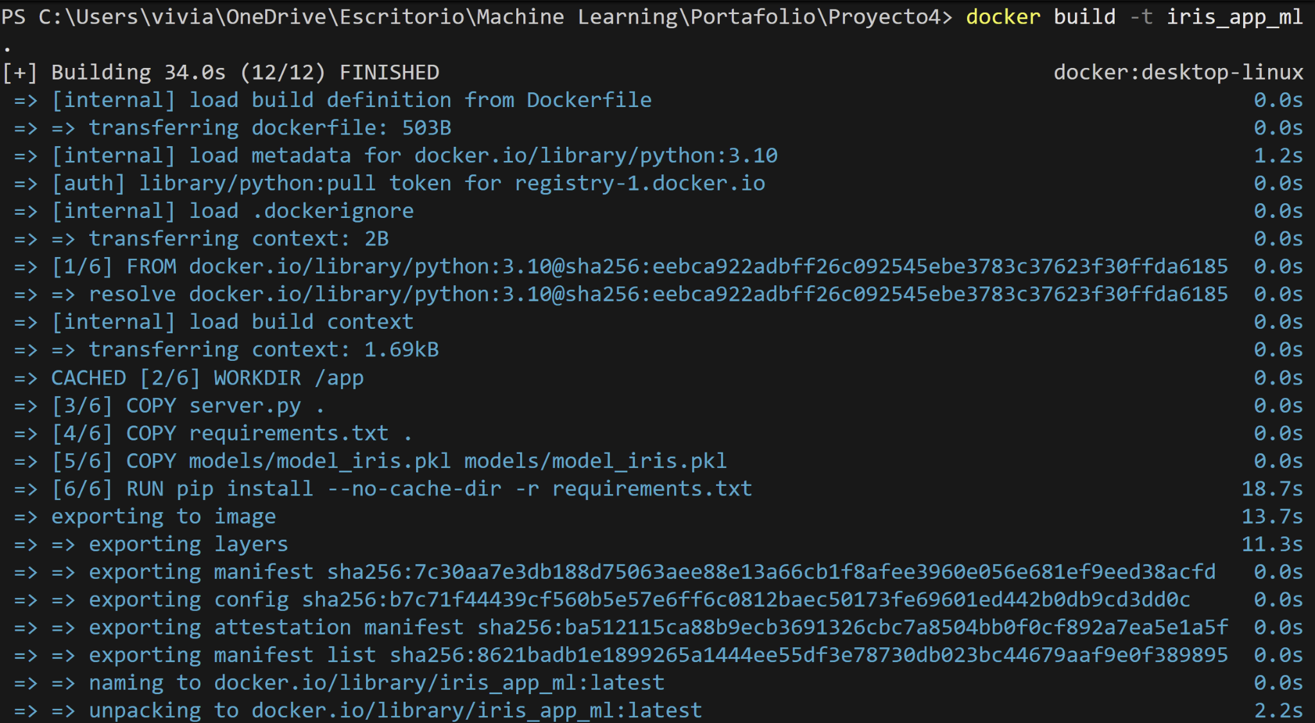

Command to run the docker below, where -p is Port Forwarding (computer port - contanier port):

**docker run -p 5000:5000 iris_app_ml**

