Running the model in the console:

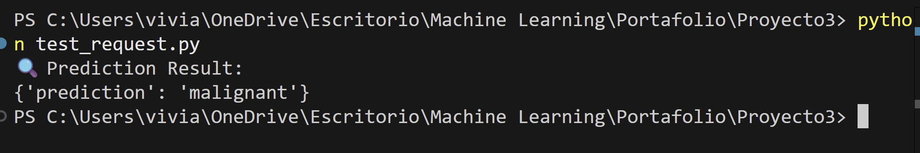

Docker file

Running Docker: **docker build -t breast_cancer_app_ml .**

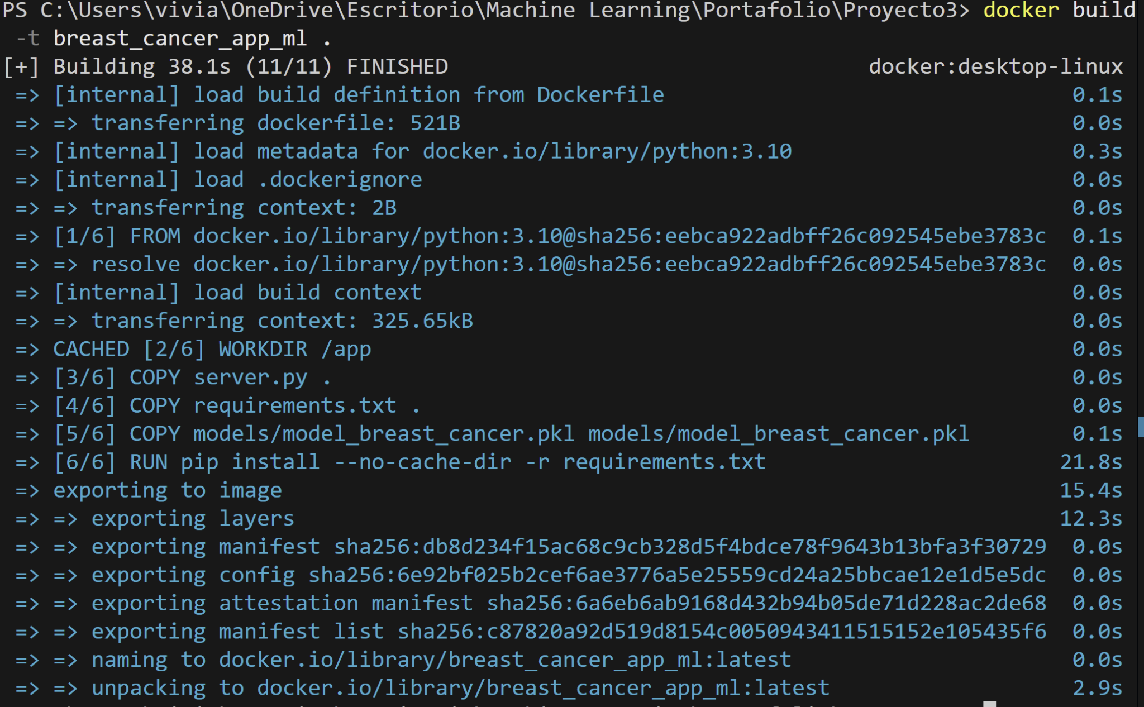

**docker run -p 5000:5000 breast_cancer_app_ml**

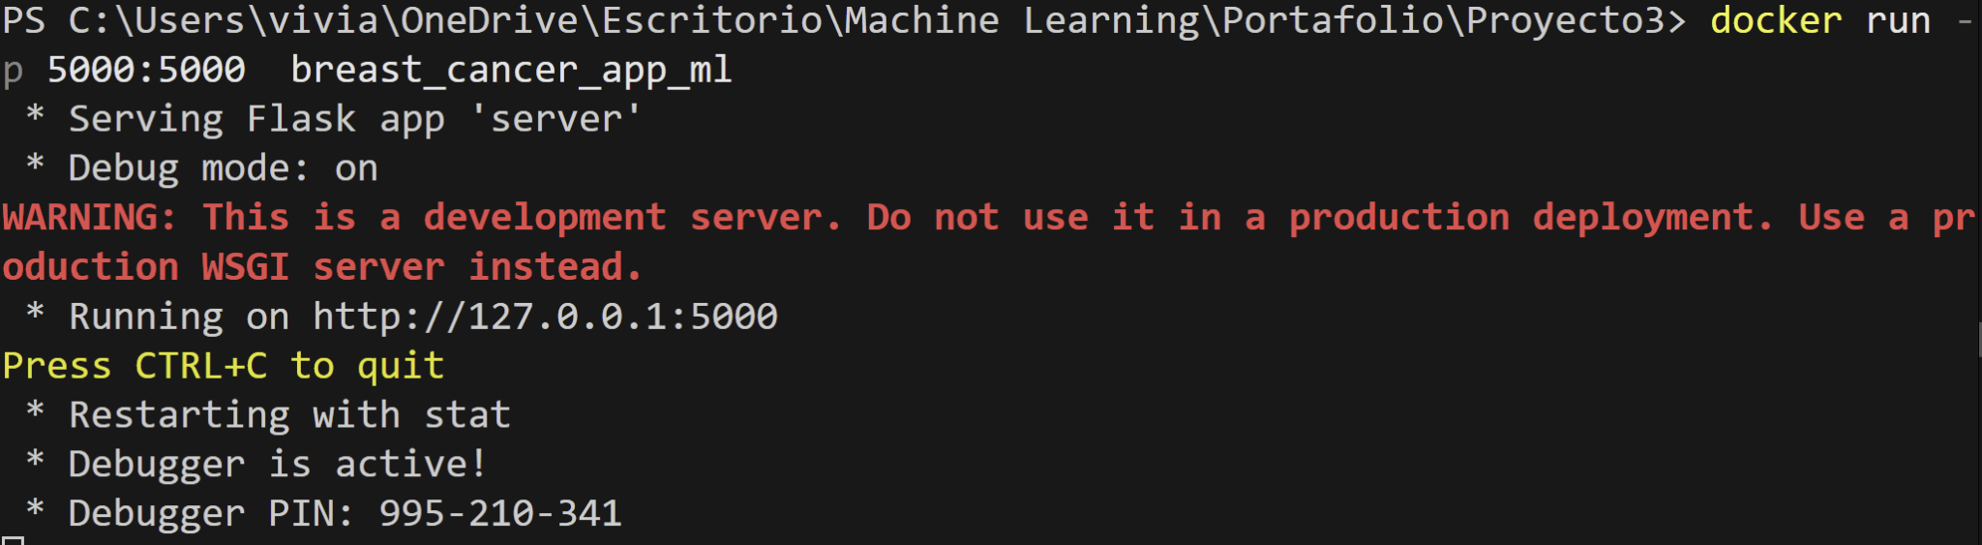

**Docker desk:**

