1. Screenshot of your entry in the github practice repo. Scroll down so your name appears on the list

1. Screenshot of the actual webpage—Please ensure you type the URL address too

<https://kostis-portfolio.netlify.app>

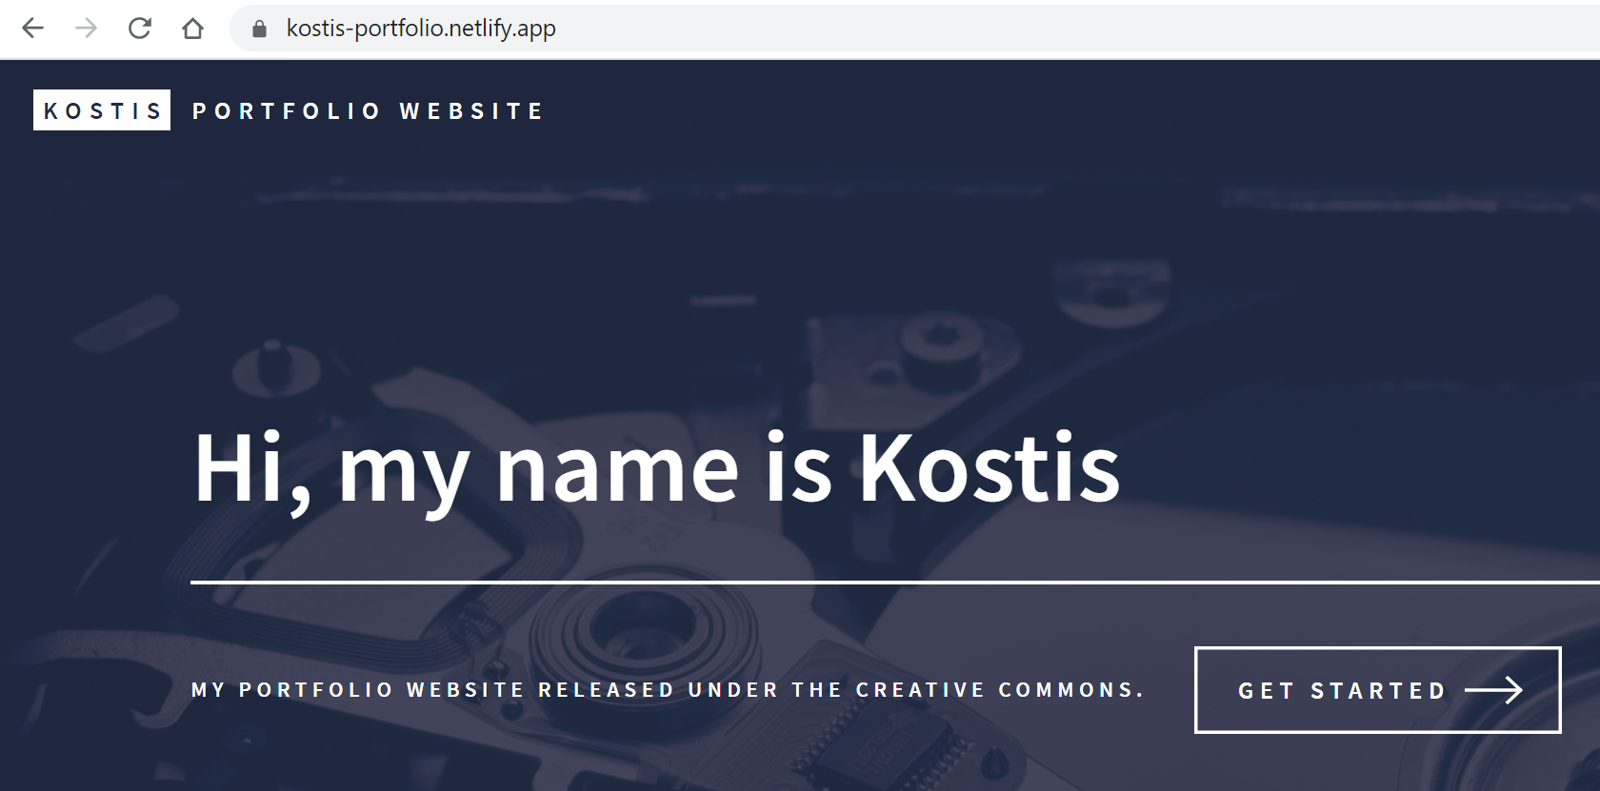

1. Screenshot of your github repo— Please ensure you give the URL Address and that you have made at least 5 commits (16 commits in this example; check under the green ‘Code’ button)

<https://github.com/kostis-christodoulou/my_website>

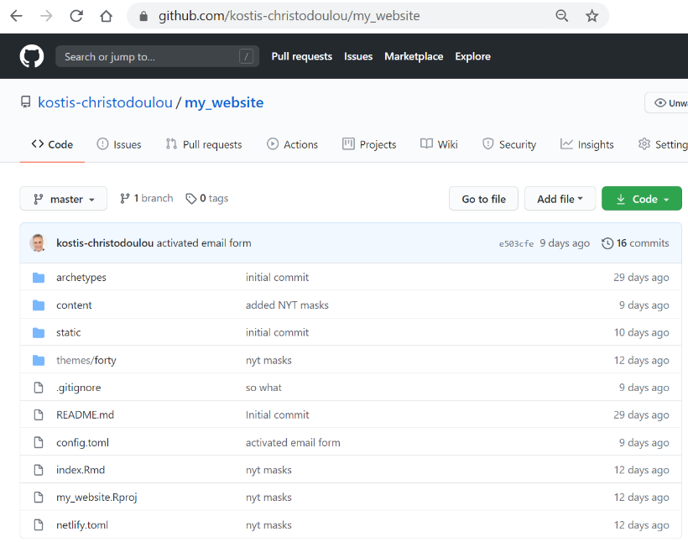

1. Screenshot of your netlify account that shows the history of deployments for your website. Please ensure the URL Address is visible in the screenshot

