--Total sales records
SELECT
COUNT(*)
FROM sales_data;

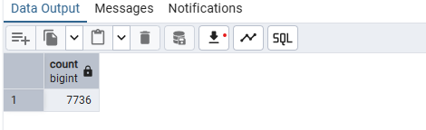

--Date range of the Data
SELECT
Min(order_date) AS MIN_DATE,
Max(ship_date) AS MAX_DATE
FROM sales_data;
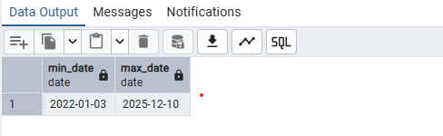

--Distinct customers
SELECT
COUNT(DISTINCT(customer_id))
FROM sales_data;
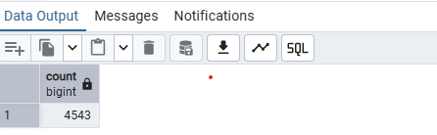

BUSINESS
--Total sales and profit by year
SELECT
EXTRACT(YEAR FROM order_date) AS year,
SUM(s.units * p.unit_price) AS Total_sales,
SUM(s.units * (p.unit_price - p.unit_cost)) AS Total_profit
FROM sales_data AS s
LEFT JOIN products AS p
ON s.Product_id = p.Product_id
GROUP BY 1
ORDER BY 1 ASC

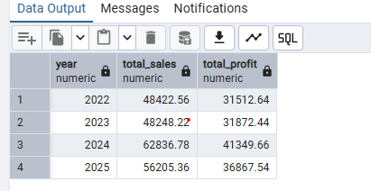

--Monthly sales trends
SELECT
EXTRACT(YEAR FROM s.order_date) AS year,
TO_CHAR(s.order_date, 'MM') as month,
SUM(s.units * p.unit_price) AS Total_sales
FROM sales_data AS s
LEFT JOIN products AS p
ON s.Product_id = p.Product_id
GROUP BY 1,2
ORDER BY 1,CAST(TO_CHAR(order_date,'MM') AS INT) ASC

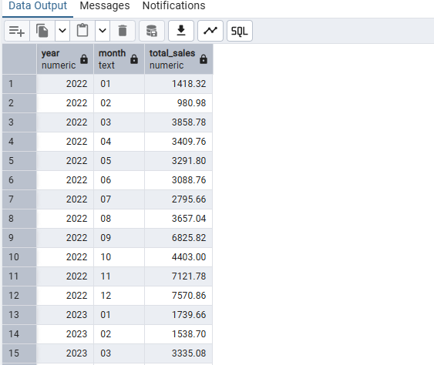

---Sales distribution by division (Chocolate, Sugar, Other)
SELECT
p.division as Division,
SUM(s.units * p.unit_price) AS Total_sales
FROM sales_data AS s
LEFT JOIN products AS p
ON s.Product_id = p.Product_id
GROUP BY 1
ORDER BY 1 ASC

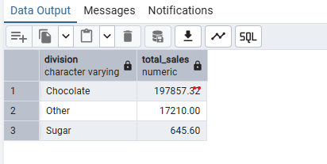

--Top 10 products by revenue and profit
SELECT
p.product_id as Product_id,
p.product_name as Product_name,
SUM(s.units * p.unit_price) AS Total_sales,
SUM(s.units * (p.unit_price - p.unit_cost)) AS Total_profit
FROM sales_data AS s
LEFT JOIN products AS p
ON s.Product_id = p.Product_id
GROUP BY 1,2
ORDER BY 3 DESC
LIMIT 10
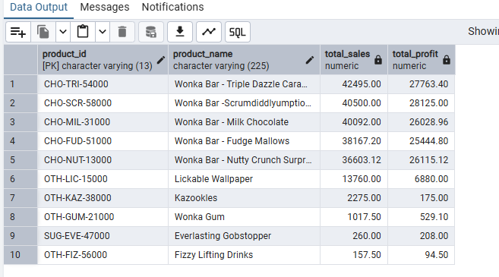

--Customer Lifetime Value analysis (top 20 customers)
SELECT
s.customer_id as Customers,
SUM(s.units * p.unit_price) AS Amount_spent,
COUNT(DISTINCT s.order_id) AS total_orders,
MIN(s.order_date) AS first_order_date,
MAX(s.order_date) AS last_order_date
FROM sales_data AS s
LEFT JOIN products AS p
ON s.Product_id = p.Product_id
GROUP BY 1
ORDER BY 2 DESC
LIMIT 20
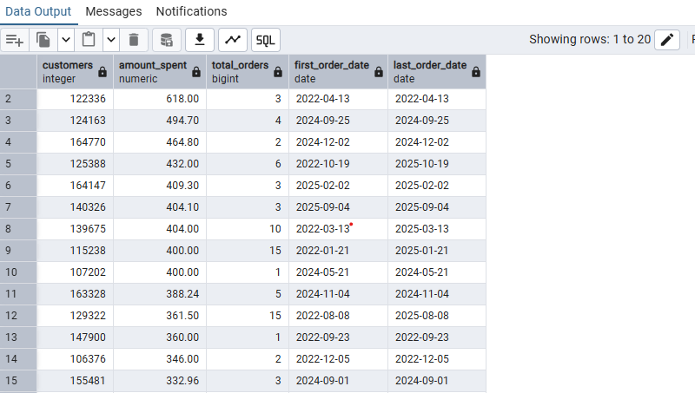

--Product profitability ranking with margins
SELECT
p.product_id as Product_id,
p.product_name as Product_name,
SUM(s.units * p.unit_price) AS Total_sales,
SUM(s.units * p.unit_cost) AS Total_cost,
SUM(s.units * (p.unit_price - p.unit_cost)) AS Total_profit,
TO_CHAR(CAST(
(SUM(s.units * (p.unit_price - p.unit_cost))
/SUM(s.units * p.unit_price) * 100) as DECIMAL(4,2)), 'fm99D00%')AS profit_margin
FROM sales_data AS s
LEFT JOIN products AS p
ON s.Product_id = p.Product_id
GROUP BY 1
ORDER BY (SUM(s.units * (p.unit_price - p.unit_cost))
/SUM(s.units * p.unit_price) * 100) DESC

