|  |
| --- |
| **User Manual** |
| **SIM LIFT** |
| **CSCI321 group GA2** |

Table of Contents

Overview 3

Product overview 3

User manual overview 3

System Requirement 3

Type of Computer 3

User interaction 3

First page 4

Initialization and generate people pattern 4

Input the form then click submit button 5

Make sure the input is valid. 6

Show information and running simulation 7

Read file 8

Simulation run 9

Simulation done 10

Frequently Asked Question 11

# Overview

## Product overview

The efficiency of lifts within a multi-storey building can be a significant factor in determining the efficiency of a business. Sim Lift will help you determine the appropriate number, capacity, type of lifts required in your building.

The lift management system module allows the setting of default floors and setting of rules governing the flow of lifts. The advanced AI module allows for lift management to be automated and adapt to appropriate conditions.

## User manual overview

It is strongly recommended that you read this document before you do any operations. This manual contains detailed information about this software. It will help guide you in how to apply it.

This manual is divided into following main sections: system requirement, user interaction, frequently asked questions.

# System Requirement

## Type of Computer

Windows 7, XP, OSX

# User interaction

This software can be used by user, who wants to determine the appropriate number, capacity of lifts, for example the developer of building.

## First page

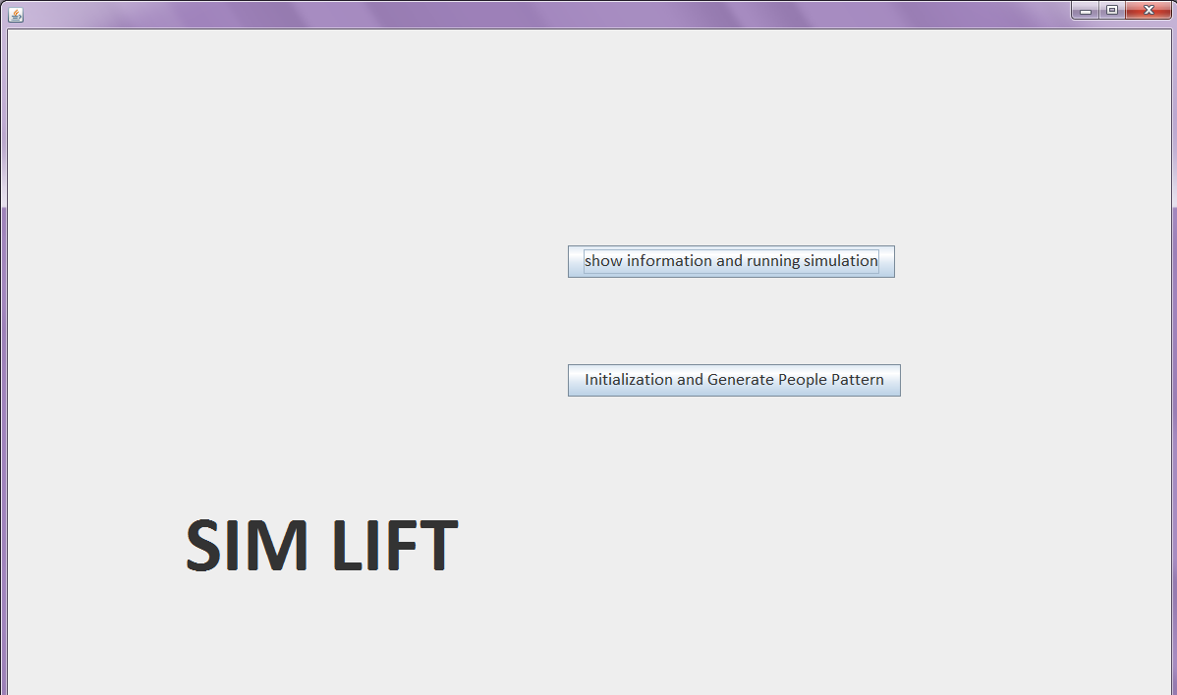

## Initialization and generate people pattern



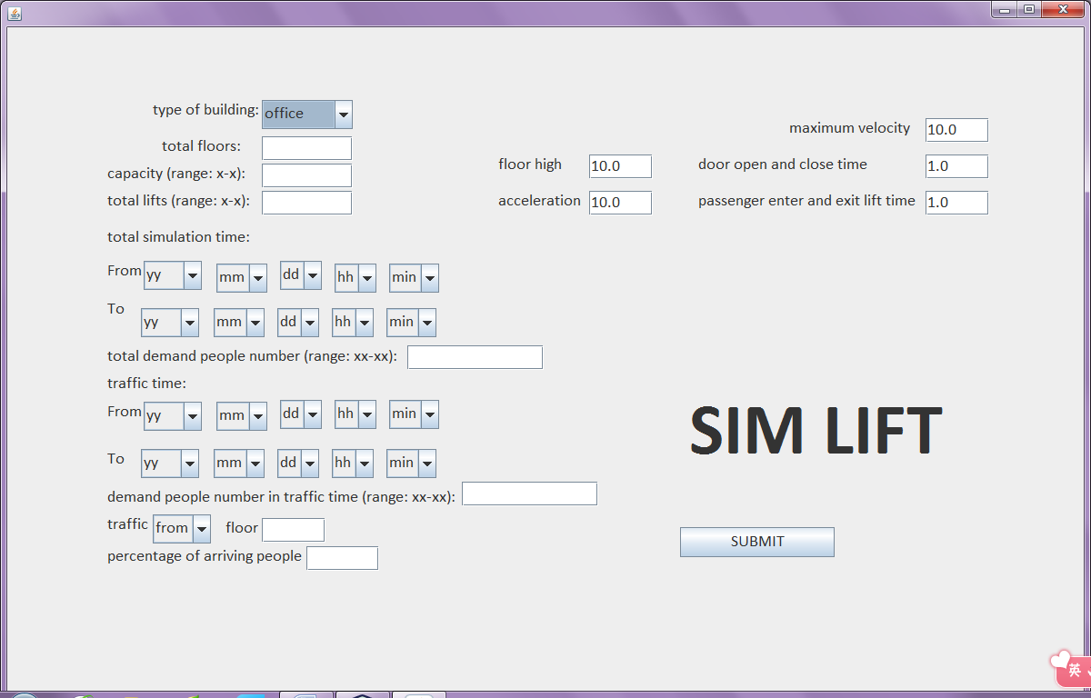

### Input the form then click submit button

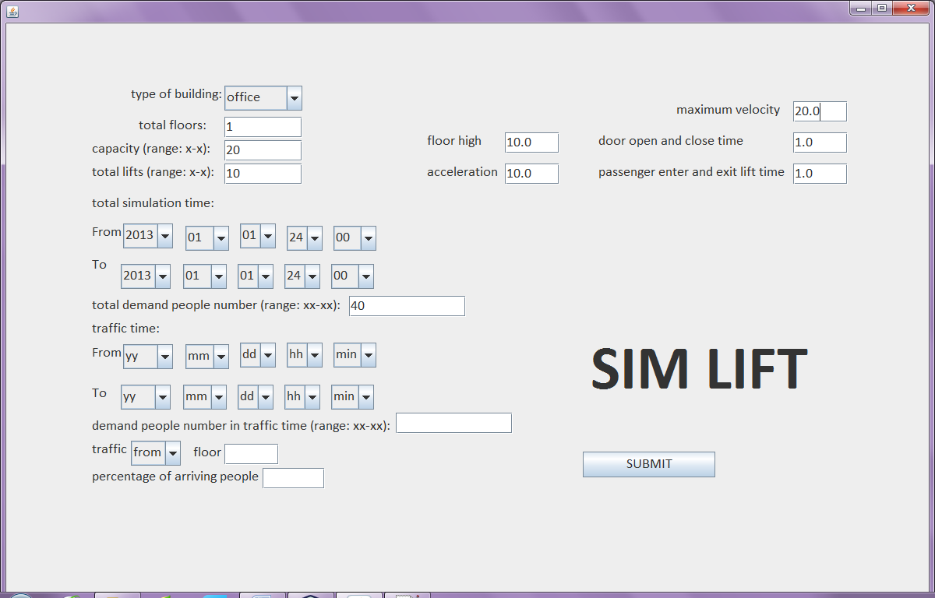

### Make sure the input is valid.

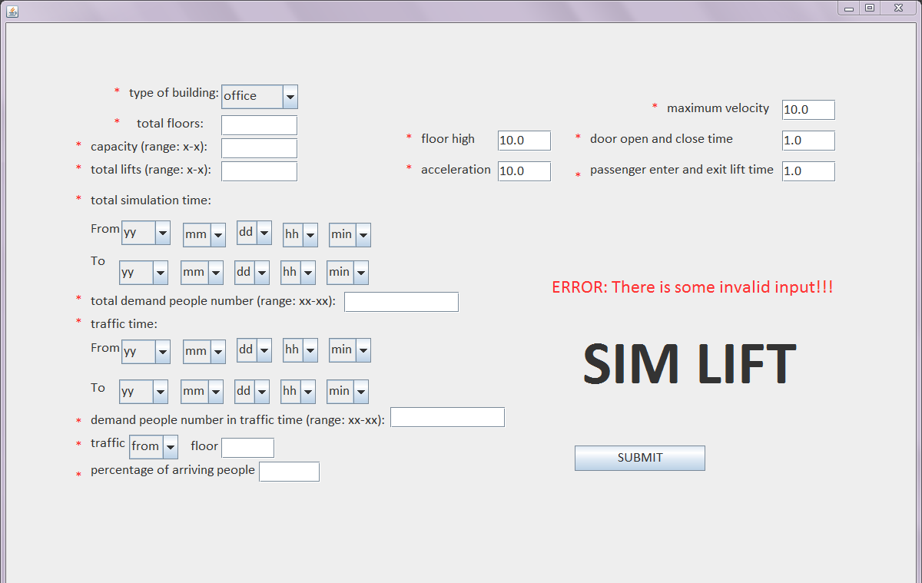Save file

1.png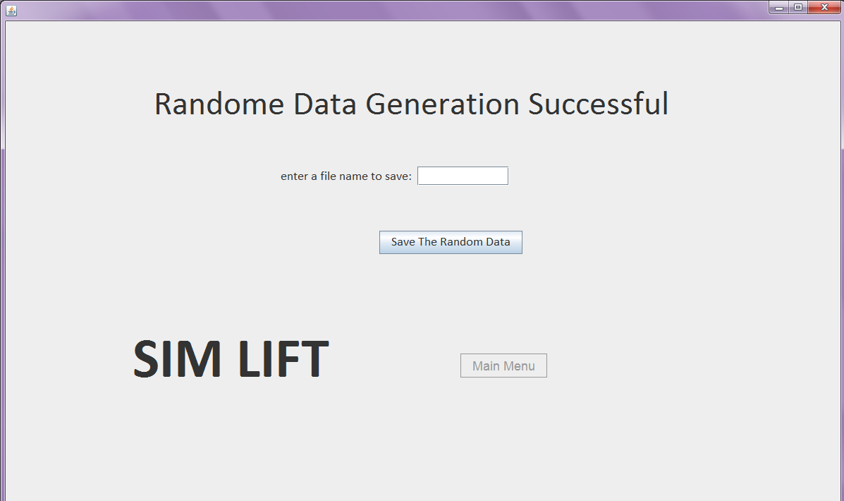

1.png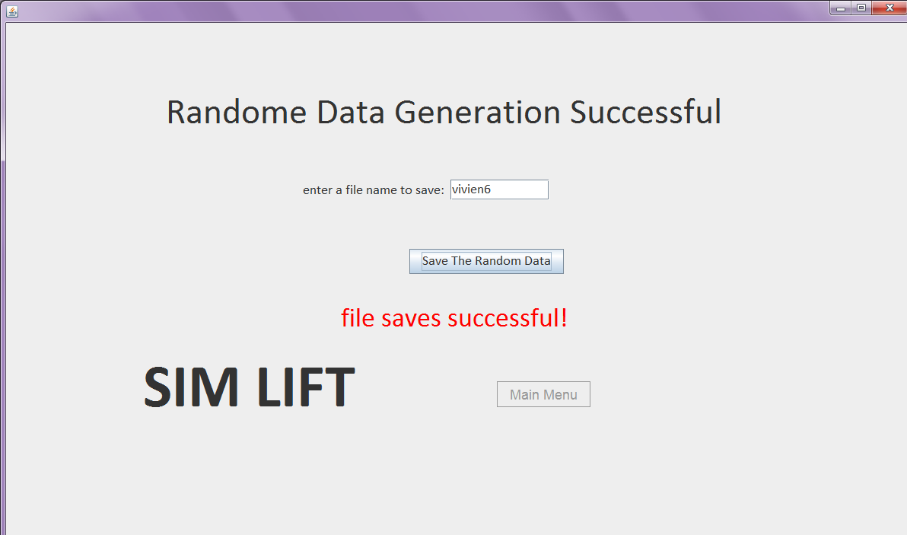

## Show information and running simulation



### Read file

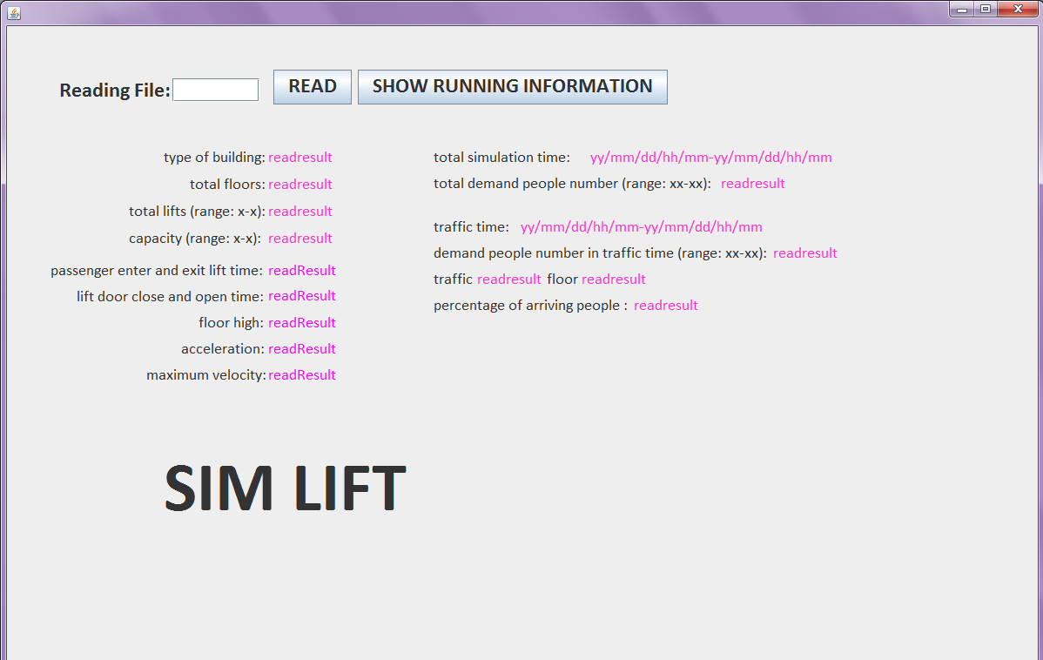

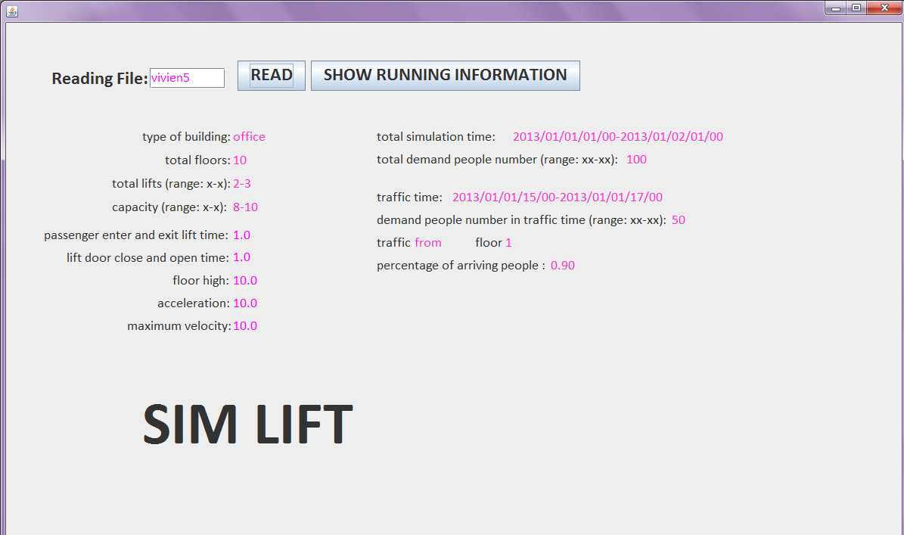

### Simulation run

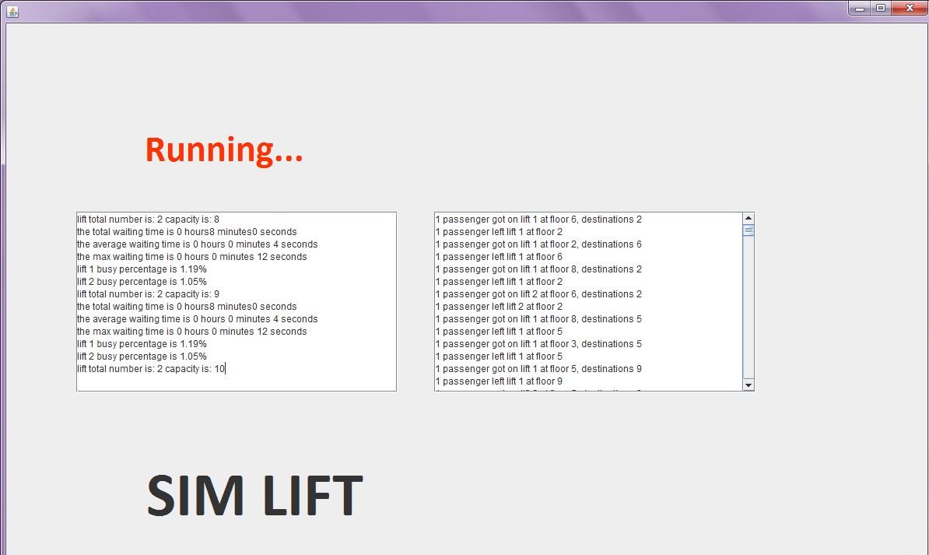

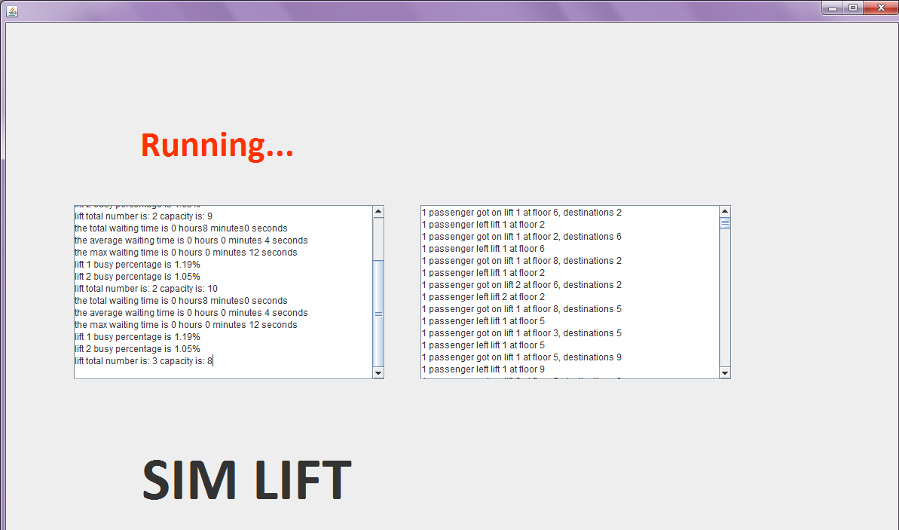

### Simulation done

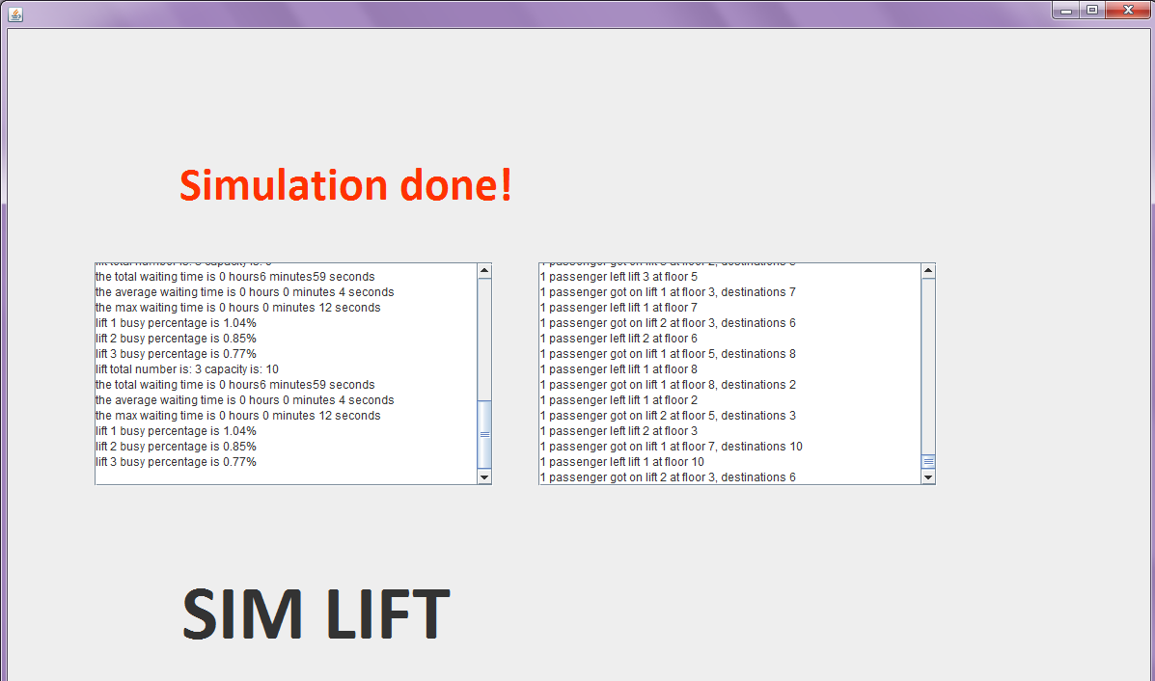

# Frequently Asked Question

* **Q: Who can use this software?**

**A:** The developer of building who wants to build lifts in the building. Sim Lift will give them a good simulation of different properties of lift to help them determine the setting of lift.

* **Q: How Sim Lift is useful for the developer?**

**A:** The Sim Lift will ask user to input a form to generate random people pattern which is similar to the reality. Then the user can simulate with these data to get result. The result includes lift number, lift capacity, total waiting time of demand people, average waiting time of demand people, and busy percentage of lift. So the user can determine the setting of lift from the simulation result.

*By Group GA2 - Yajuan Xu*