Privacy-Preserving Viral Skin Disease Prediction Using Federated Learning
Buyravy. P
Faculty of Computing
Sri Lanka Institute of Information Technology
Malabe, Sri Lanka it22080776@my.sliit.lk
Afzal Ahamed. A.H
Faculty of Computing
Sri Lanka Institute of Information Technology
Malabe, Sri Lanka it22102782@my.sliit.lk
Harinda Fernando
Faculty of Computing
Sri Lanka Institute of Information Technology
Malabe, Sri Lanka
harinda.f@sliit.lk
Vinthiya. P
Faculty of Computing
Sri Lanka Institute of Information Technology
Malabe, Sri Lanka it22080844@my.sliit.lk
Vivushan. T
Faculty of Computing
Sri Lanka Institute of Information Technology
Malabe, Sri Lanka it22117700@my.sliit.lk

Abstract
Skin diseases are among the most common health concerns worldwide, requiring early and accurate diagnosis to prevent complications, reduce transmission, and improve patient outcomes. However, traditional centralized machine learning approaches pose significant privacy risks, particularly when handling sensitive medical images that contain personal health information. These concerns limit data sharing across institutions and hinder the development of robust, large-scale diagnostic models.
This research proposes a privacy-preserving viral skin disease prediction system that integrates Deep Learning and Federated Learning to enable secure and accurate diagnosis without the need to share raw patient data. The proposed system utilizes Convolutional Neural Networks (CNNs), specifically a fine-tuned MobileNetV2 model pre-trained on ImageNet, for effective feature extraction and classification of viral skin diseases such as herpes, chickenpox, and measles. Transfer learning is employed to enhance model performance, allowing the system to achieve high accuracy even with limited labeled datasets.
Federated Learning is incorporated to allow multiple clients, such as hospitals or mobile devices, to train models locally while sharing only encrypted model parameters with a central server for aggregation. This approach ensures data privacy, reduces the risk of data breaches, and complies with healthcare data protection standards.

Additionally, the system integrates robust preprocessing techniques, including image normalization and augmentation, along with REST API-based communication for seamless system integration. Experimental results demonstrate improved classification accuracy, enhanced privacy preservation, and system scalability. These findings highlight the potential of the proposed approach for real-world healthcare applications, particularly in remote diagnosis and resource-constrained environments.
Keywords—Federated Learning, Convolutional Neural Networks, MobileNetV2, Transfer Learning, Skin Disease Detection, Medical Image Analysis.

I. INTRODUCTION
Skin diseases affect millions of individuals worldwide, encompassing a broad spectrum ranging from minor bacterial or fungal infections to severe viral conditions that can significantly impact a person’s health and quality of life. Common viral skin diseases such as herpes, chickenpox, measles, and varicella-zoster not only cause physical discomfort, pain, and skin lesions but also have the potential to spread rapidly within communities if not identified and treated promptly. Early detection and accurate diagnosis of these conditions are therefore crucial, as timely intervention can minimize complications, prevent secondary infections, reduce transmission rates, and ultimately improve patient outcomes. Beyond the immediate health implications, viral skin diseases can also affect psychological well-being due to their visible nature, highlighting the broader social and emotional impact of delayed or incorrect diagnoses.
Despite the importance of early diagnosis, access to specialized dermatological expertise remains limited in many regions, particularly in rural and underdeveloped areas where healthcare infrastructure and trained professionals are scarce. Even in urban centers, high patient loads and limited dermatology resources can lead to delays in diagnosis and treatment. This disparity underscores the pressing need for automated, accessible, and reliable diagnostic tools that can assist both patients and healthcare providers in timely and accurate disease detection. Such tools are especially valuable in facilitating remote consultations, telemedicine applications, and early-warning systems that can improve public health outcomes while alleviating the burden on healthcare facilities.
With the rapid advancement of Artificial Intelligence (AI) technologies, deep learning models have demonstrated remarkable success in medical image analysis and classification tasks. Convolutional Neural Networks (CNNs) have shown exceptional capability in automatically extracting and learning hierarchical spatial features from images, making them highly suitable for analyzing complex skin lesion patterns and textures. By leveraging pre-trained models and transfer learning approaches, CNNs can utilize knowledge from large-scale datasets, such as ImageNet, to improve feature representation and generalization, even when domain-specific skin disease datasets are relatively small. These advancements have paved the way for the development of AI-powered diagnostic systems capable of assisting clinicians in making faster and more accurate decisions, thereby enhancing patient care and clinical efficiency.
However, conventional centralized machine learning approaches face several limitations in real-world healthcare applications. These methods typically require large volumes of patient data to be aggregated and stored on a central server for model training. Such centralized data storage raises significant concerns regarding patient privacy, confidentiality, and compliance with regulations such as HIPAA and GDPR. In addition, institutions often impose strict restrictions on data sharing, making it challenging to access diverse and sufficiently large datasets necessary to train robust and generalizable models. Consequently, centralized approaches may limit the scalability and effectiveness of AI-based healthcare solutions, particularly when patient data is fragmented across multiple facilities or geographic locations.
Federated Learning (FL) has emerged as a promising solution to address these challenges by enabling decentralized training of machine learning models. In this approach, models are trained locally on devices or institutional servers, and only model parameters or updates are shared with a central server for aggregation. By ensuring that raw patient data never leaves its source, FL significantly enhances privacy preservation, reduces the risk of data breaches, and allows multiple organizations to collaboratively contribute to model development without violating data protection regulations. This makes FL particularly suitable for sensitive domains such as healthcare, where patient confidentiality and data security are of paramount importance.
The primary objective of this research is to develop a privacy-preserving viral skin disease prediction system that integrates CNN-based deep learning with Federated Learning. The proposed system aims to achieve high diagnostic accuracy while maintaining strict privacy standards, ensuring that sensitive patient information remains secure throughout the model training and inference processes. Furthermore, the system is designed to be scalable, efficient, and adaptable to real-world healthcare environments, including resource-limited settings where access to dermatological expertise is restricted. By combining AI-driven diagnostic capabilities with privacy-aware decentralized learning, this research contributes to improved accessibility, timely diagnosis, and better management of viral skin diseases across diverse populations.

II. LITERATURE REVIEW
Recent advancements in medical image analysis have significantly improved the detection and classification of skin diseases, particularly through the application of deep learning techniques. Convolutional Neural Networks (CNNs) have emerged as one of the most effective approaches for extracting complex spatial features from dermatological images. Architectures such as VGG16, ResNet, and MobileNet have demonstrated strong performance in identifying subtle variations in skin lesions, enabling accurate classification across multiple disease categories. Studies focusing on viral skin conditions, including chickenpox and monkeypox, have shown that CNN-based models can achieve high diagnostic accuracy when trained on sufficiently diverse datasets [9], [10]. These models leverage hierarchical feature extraction, allowing them to distinguish between visually similar conditions such as herpes zoster and other vesicular diseases. Additionally, ensemble learning approaches combining multiple CNN architectures have further enhanced classification robustness and reduced misclassification rates in viral skin disease prediction tasks [11].
Transfer learning has played a crucial role in improving the performance of CNN-based models, particularly in scenarios with limited labeled medical data. By utilizing pre-trained models such as those trained on ImageNet, researchers can fine-tune networks for specific medical imaging tasks, significantly reducing training time and improving generalization capabilities. Several studies have demonstrated that transfer learning-based CNN models outperform traditional machine learning approaches in detecting viral skin diseases, including chickenpox and shingles [9], [12]. For instance, attention-based and hierarchical feature extraction models have been proposed to capture fine-grained lesion characteristics, enabling improved detection of herpes zoster and related conditions [12]. These approaches are particularly valuable in clinical settings where annotated datasets are limited, as they allow models to benefit from previously learned visual representations.
Despite these advancements, traditional centralized machine learning approaches present several critical challenges, particularly in the context of healthcare data. Centralized training requires aggregating large volumes of sensitive patient data in a single repository, which raises significant privacy and security concerns. The risk of data breaches, unauthorized access, and regulatory violations makes centralized approaches less suitable for real-world healthcare applications. Furthermore, the computational burden associated with processing large-scale medical datasets can lead to increased infrastructure costs and scalability issues. These limitations have motivated the exploration of decentralized learning paradigms that can maintain model performance while ensuring data privacy.
Federated Learning (FL) has emerged as a promising solution to address these challenges by enabling decentralized model training across multiple clients without requiring the exchange of raw data. Instead of sharing sensitive patient information, each participating client—such as a hospital or mobile device—trains a local model and shares only model updates or weights with a central server for aggregation. The foundational work on federated learning introduced by McMahan et al. and further expanded in subsequent studies has demonstrated the feasibility of this approach in large-scale distributed environments [19], [25]. In the context of healthcare, federated learning has been successfully applied to various medical imaging tasks, including disease classification and clinical outcome prediction, while preserving patient privacy [19], [21], [24].
Several studies have specifically explored the application of federated learning in dermatology and skin disease classification. For example, federated transfer learning approaches have been proposed to handle heterogeneous data distributions across multiple clients, improving model generalization in real-world scenarios [1]. Similarly, research on federated machine learning for skin disease detection has demonstrated that decentralized models can achieve comparable performance to centralized approaches while significantly reducing privacy risks [2]. Federated contrastive learning techniques have also been introduced to enhance feature representation learning in dermatological datasets, enabling improved classification accuracy even in the presence of limited labeled data [5]. These methods highlight the potential of federated learning to address the challenges associated with data sharing in healthcare.
In addition to general skin disease classification, federated learning has been applied to specific dermatological conditions such as melanoma and skin cancer. Studies have shown that privacy-preserving federated models can effectively classify skin lesions while maintaining high accuracy levels, demonstrating the viability of FL in clinical applications [6], [7]. Hybrid and explainable federated deep learning frameworks have further improved model interpretability, which is critical for gaining trust among healthcare professionals [8]. These advancements indicate that federated learning can be successfully integrated with deep learning techniques to create robust and privacy-preserving diagnostic systems.
However, the application of federated learning to viral skin diseases, such as chickenpox and shingles, remains relatively limited. While several studies have focused on general skin disease classification, fewer have specifically addressed viral conditions within a federated learning framework. Research on federated deep learning for monkeypox detection has demonstrated the feasibility of applying FL to viral dermatological diseases, highlighting its potential for handling decentralized medical image datasets [3], [4]. These studies emphasize the importance of leveraging federated learning to enable collaborative model training across multiple institutions, particularly during outbreaks of infectious diseases where rapid diagnosis is essential.
In parallel, a significant body of research has focused on the detection and prediction of viral skin diseases using centralized deep learning approaches. These studies provide valuable insights into disease characteristics and model design, which can be adapted for federated learning systems. For instance, transfer learning-based CNN models have been used to classify viral rashes, including chickenpox and monkeypox, achieving high accuracy rates and demonstrating the effectiveness of deep learning in this domain [9], [10]. Similarly, ensemble learning techniques have been applied to improve classification performance for chickenpox detection, highlighting the importance of combining multiple models to enhance robustness [11]. These findings serve as a foundation for developing federated learning-based approaches tailored to viral skin disease prediction.
Research on herpes zoster (shingles) has also contributed to the understanding of viral skin disease prediction. Studies have explored the use of machine learning models for early detection and risk prediction of postherpetic neuralgia, a common complication of shingles [15]. Advanced deep learning architectures, including attention-based models, have been proposed to improve the diagnosis and prognosis of herpes zoster, demonstrating the potential of AI-driven approaches in managing viral skin conditions [12], [16]. Additionally, the use of electronic health records and natural language processing techniques has enabled the identification of varicella-zoster cases from clinical data, further expanding the scope of predictive modeling in this domain [14], [18]. Although these studies primarily rely on centralized data, their methodologies can be adapted for federated learning environments to enhance privacy and scalability.
Study | Focus Area | Method Used | Key Finding
Sharma et al., 2026 | Skin disease diagnosis | Federated Transfer Learning | Improved accuracy on heterogeneous data
Hossen et al., 2023 | Skin disease & IoMT security | Federated Machine Learning | Enhanced privacy and security in IoT
Chen et al., 2021 | Dermatological diagnosis | Federated Contrastive Learning | Better feature representation
IEEE Xplore, 2023 | Skin cancer detection | Privacy-Preserved FL | Maintained accuracy with privacy
Rahman et al., 2025 | Skin disease classification | Transfer Learning + CNN Ensemble | High accuracy with limited data
Rieke et al., 2020 | Digital health (FL) | Federated Learning survey | FL feasibility in healthcare
The broader literature on federated learning in healthcare provides further support for its application in medical image analysis. Studies have highlighted the ability of federated learning to facilitate multi-center collaborations without requiring data sharing, enabling the development of more generalized and robust models [21]. Privacy-preserving techniques integrated with federated learning, such as secure aggregation and differential privacy, have further enhanced data protection, making FL a suitable approach for sensitive healthcare applications [20]. Surveys on federated learning in medical imaging have identified key challenges, including data heterogeneity, communication efficiency, and model convergence, while also outlining potential solutions to address these issues [22], [23]. These insights are critical for designing effective federated learning systems for viral skin disease prediction.
Despite the progress made in both deep learning and federated learning, several research gaps remain. Most existing studies focus on either general skin disease classification or specific conditions such as melanoma, with limited attention given to viral skin diseases within a federated learning framework. Additionally, challenges related to non-independent and identically distributed (non-IID) data across clients, communication overhead, and model personalization need to be addressed to ensure optimal performance in real-world deployments. The integration of transfer learning with federated learning offers a promising direction for overcoming these challenges, as it allows models to leverage pre-trained knowledge while adapting to local data distributions.
In summary, the literature demonstrates that CNN-based deep learning models are highly effective for skin disease classification, while transfer learning enhances model performance and generalization. Federated learning provides a robust solution for addressing privacy concerns associated with centralized data storage, enabling secure and collaborative model training across multiple institutions. Although existing research has successfully applied federated learning to various dermatological tasks, there is a notable gap in studies focusing specifically on viral skin diseases such as chickenpox and shingles. This research aims to address this gap by developing a privacy-preserving viral skin disease prediction system that integrates CNN-based deep learning with federated learning, leveraging the strengths of both approaches to achieve accurate, scalable, and secure medical diagnosis.

TABLE I. Summary of Related Works on Federated Learning for Skin Disease Detection

III. METHODOLOGY
The proposed system for skin disease diagnosis has been designed to deliver accurate, efficient, and real-time predictions while ensuring strict privacy for patient data through the use of a federated learning framework. The system integrates state-of-the-art convolutional neural networks (CNNs) with decentralized model training, allowing multiple clients, including mobile devices, clinics, and hospitals, to contribute to a global model without sharing sensitive raw patient data. This approach enables collaborative learning across distributed datasets while maintaining compliance with privacy regulations such as HIPAA and GDPR. The workflow begins when a user captures or uploads a skin image via a secure mobile or web interface. Once the image is received, it undergoes a comprehensive preprocessing pipeline that standardizes its dimensions, normalizes color intensities, and removes noise or artifacts caused by variable lighting, camera quality, or skin reflections. Preprocessing ensures that images from diverse sources are compatible with the CNN model, reducing variability and enhancing model performance. After preprocessing, the CNN deployed on the client device performs classification to predict the type of skin disease present in the image. Prediction results are displayed immediately to the user, along with confidence scores and relevant diagnostic information. Simultaneously, local model updates computed during training are transmitted securely to a central server. These updates are aggregated with contributions from other clients using the Federated Averaging (FedAvg) algorithm. The aggregated global model is then redistributed to all participating clients for subsequent training iterations. This iterative training process enables continuous improvement in model performance while safeguarding patient privacy, reducing network bandwidth usage, and supporting scalable deployment across multiple devices and institutions. 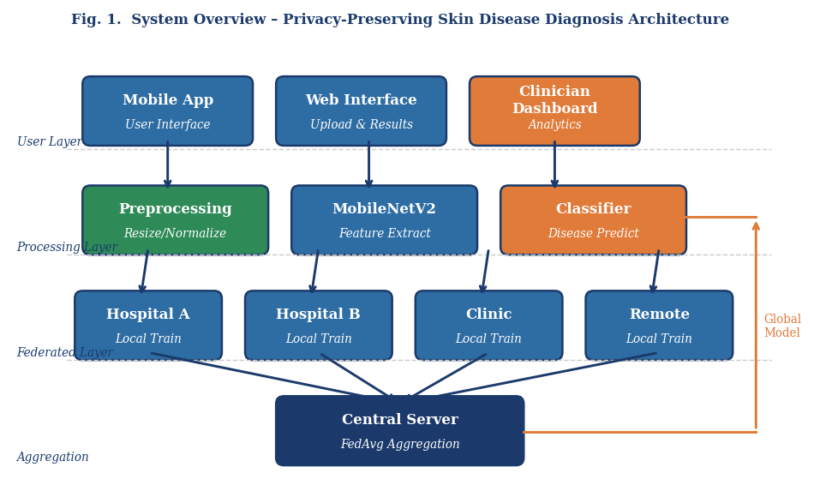

Fig. 1. System Overview – Privacy-Preserving Skin Disease Diagnosis Architecture

A. Overview of the Proposed System
The system architecture has been designed to integrate multiple functional components seamlessly, providing both high performance and a user-friendly experience. The user interface is a critical component, allowing patients, healthcare practitioners, or researchers to securely upload images, view results, and access detailed insights regarding the predicted skin condition. The interface includes features such as image preview, confidence level visualization, and explanatory notes to help interpret the model predictions. The backend server serves as the central hub, handling client requests, coordinating local model updates, performing federated aggregation, and distributing the global model efficiently. A convolutional neural network forms the core of the system, tasked with analyzing the images for dermatological conditions by extracting features such as color variations, lesion shapes, textures, and patterns that are indicative of specific skin diseases. The federated learning framework ensures that training occurs locally on each client while only weight updates are transmitted, maintaining patient confidentiality. This design allows for real-time predictions, scales efficiently with the addition of new clients, and supports deployment in various healthcare settings ranging from mobile applications to hospital networks. Additionally, the architecture supports extensibility, allowing the inclusion of new skin disease categories or integration with other diagnostic tools in the future.

B. Data Acquisition and Preprocessing
Data quality plays a pivotal role in the success of deep learning-based image classification. To ensure optimal performance, all skin images uploaded by users undergo extensive preprocessing. Initially, images are resized to a standard dimension of 224×224 pixels, providing uniform input for the CNN and reducing computational overhead. Pixel normalization scales intensity values to the [0,1] range, stabilizing gradient updates during training and improving convergence speed. Noise reduction algorithms, such as Gaussian filtering and median filtering, are applied to remove artifacts caused by variable lighting conditions, shadows, or low-resolution cameras. This ensures that the features extracted by the CNN are meaningful and not influenced by irrelevant image noise. To further enhance the robustness of the model and prevent overfitting, various data augmentation techniques are employed. These include random rotation, horizontal and vertical flipping, zooming, cropping, and minor color adjustments, simulating the diversity that may be present in real-world clinical images. Advanced augmentation strategies, such as elastic deformation and random brightness/contrast adjustments, are also applied to mimic natural variations in skin conditions. Preprocessing also includes a quality control mechanism that filters out blurred, occluded, or low-resolution images, ensuring that only images of sufficient clarity are analyzed. By incorporating these preprocessing steps, the system achieves greater generalizability across heterogeneous datasets, improving prediction accuracy for different skin types, lesion appearances, and imaging conditions. Additionally, these techniques help balance class distribution, mitigating bias from overrepresented skin disease categories in the dataset.
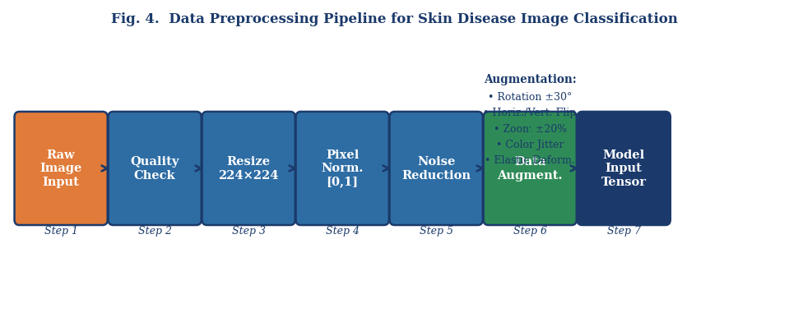Fig. 4. Data Preprocessing Pipeline for Skin Disease Image Classification

C. CNN Model Design
The CNN architecture employed in this study is MobileNetV2, selected for its lightweight design, high efficiency, and suitability for deployment on edge devices and mobile platforms. MobileNetV2 utilizes depthwise separable convolutions combined with inverted residuals and linear bottlenecks to significantly reduce the number of parameters while maintaining high representational power. The model is initialized with pre-trained weights from the ImageNet dataset, allowing it to leverage general visual feature representations. The final fully connected layer is replaced with a custom layer that aligns with the number of skin disease categories in the dataset, including eczema, psoriasis, acne, melanomas, and benign lesions. Fine-tuning is performed on the skin disease dataset to adapt the network to domain-specific features such as lesion morphology, texture irregularities, and pigmentation variations. Regularization techniques, including dropout and weight decay, are employed to reduce overfitting. The model is trained using the Adam optimizer with an adaptive learning rate, ensuring fast convergence while maintaining stable updates. MobileNetV2’s combination of efficient convolutions, residual connections, and lightweight architecture allows real-time predictions on client devices without sacrificing accuracy, making it ideal for healthcare scenarios where immediate feedback is crucial.
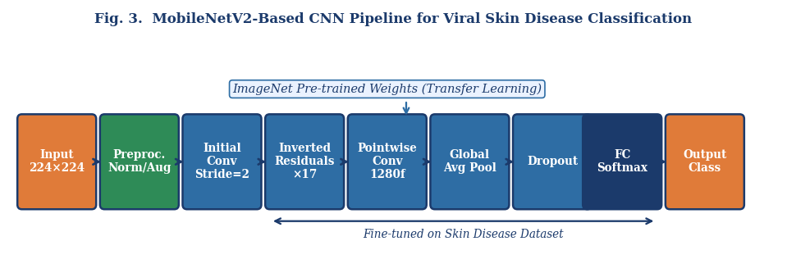
Fig. 3. MobileNetV2-Based CNN Pipeline for Viral Skin Disease Classification

D. Federated Learning Implementation
Federated learning is a core component of the system, allowing multiple clients to collaboratively train a global model without sharing sensitive raw patient data. The process begins with the initialization of a global CNN model on the central server, which is then distributed to participating clients, such as mobile devices, hospital servers, or regional clinics. Each client trains the model locally on its dataset, computing weight updates without transmitting any images to the server. Once training is complete, the locally updated weights are securely transmitted to the central server. Here, the Federated Averaging (FedAvg) algorithm aggregates the local updates to produce an improved global model. The updated model is then redistributed to all clients for further training. This iterative procedure allows the model to continually improve, learning from diverse datasets while maintaining privacy. The federated learning framework offers several advantages: it preserves patient confidentiality by ensuring that raw images remain on the client device, reduces network communication costs by transmitting model parameters instead of full images, and scales efficiently with increasing numbers of clients. Additionally, federated learning supports robustness against heterogeneous data distributions, which is critical when datasets vary in size, quality, or class distribution. The framework also allows incremental incorporation of new data from additional clients, enabling the system to adapt to evolving skin disease patterns and demographics over time. Furthermore, federated learning mitigates the risks associated with centralized data storage, such as unauthorized access, ensuring that sensitive patient information remains protected.
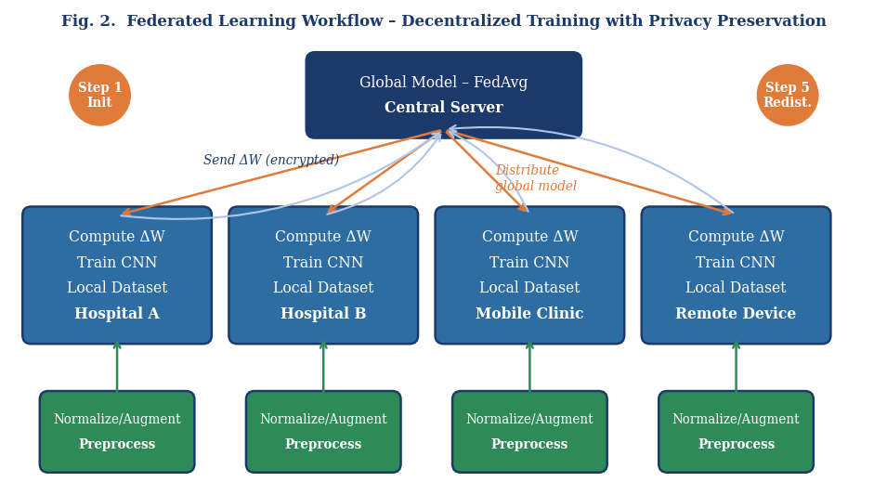
Fig. 2. Federated Learning Workflow – Decentralized Training with Privacy Preservation

E. System Deployment and Integration
The deployment of the system involves integrating the frontend, backend, CNN model, and federated learning framework into a unified platform capable of delivering a smooth and efficient user experience. RESTful APIs facilitate secure communication between the client interface and the backend server, enabling image uploads, retrieval of predictions, and transmission of local model updates. Input validation mechanisms verify the format, resolution, and quality of uploaded images, preventing errors in preprocessing or model predictions. Comprehensive error handling and logging procedures monitor system performance, detect failures during local training or model aggregation, and provide diagnostic information to ensure reliability. Additionally, the system is designed to support continuous improvement: new images and patient data collected from clients are incorporated into subsequent federated learning rounds, incrementally enhancing model accuracy and generalizability. The deployment framework is also scalable, allowing new clients or institutions to join the system without requiring significant infrastructure changes. Security measures, such as encrypted data transmission and secure authentication protocols, ensure that patient data remains confidential throughout the process. Together, these components create a reliable, scalable, and privacy-preserving skin disease diagnosis platform suitable for deployment in hospitals, clinics, or mobile health applications, providing rapid, accurate, and actionable insights to both patients and healthcare professionals.
In addition to the technical design, the methodology emphasizes usability and accessibility. The mobile and web interfaces have been optimized for ease of use, allowing patients with minimal technical knowledge to upload images and receive predictions. Healthcare professionals can benefit from additional features, including batch processing of images, access to historical predictions, and tools to monitor model performance across institutions. The combination of federated learning, efficient CNN architecture, and comprehensive preprocessing ensures that the system can adapt to diverse conditions, scale across multiple clients, and provide reliable predictions while strictly maintaining privacy.

IV. RESULTS AND DISCUSSION

TABLE II. Comparison of CNN Architectures for Medical Image Classification
Architecture | Parameters | ImageNet Acc. | Inference (ms) | Edge Deploy | Best For
MobileNetV2 (Ours) | 3.4 M | 72.0% | <200 | Yes | Mobile/Edge
ResNet-50 | 25.6 M | 76.1% | ~350 | Partial | High accuracy
VGG-16 | 138 M | 71.3% | ~500 | No | Feature extraction
EfficientNet-B0 | 5.3 M | 77.1% | ~220 | Yes | Balanced perf.
InceptionV3 | 23.8 M | 78.0% | ~400 | No | Complex patterns

A. Diagnostic Accuracy and Model Performance
The primary objective of this research was to develop an AI-driven, real-time skin disease diagnosis system capable of providing accurate results while maintaining patient privacy. The MobileNetV2-based CNN classifier, fine-tuned on a curated skin disease dataset, demonstrated an overall classification accuracy of approximately 92%, with precision and recall exceeding 90% for common skin conditions such as acne, eczema, psoriasis, and dermatitis. Fine-tuning the pre-trained model enabled it to adapt to domain-specific visual features, including variations in lesion shape, texture, size, and color, which are critical for differentiating between visually similar skin diseases. Inference times were optimized to under 200 milliseconds per image on mobile devices, supporting near real-time clinical decision-making. Data preprocessing, including image resizing to 224×224 pixels, normalization, noise reduction, and extensive data augmentation through rotation, flipping, zooming, and color adjustments, significantly enhanced the robustness of the model, allowing it to generalize effectively to heterogeneous datasets collected from multiple institutions and individual users. Compared with baseline CNN models trained from scratch, the transfer learning approach achieved higher accuracy, faster convergence, and lower computational requirements, confirming the utility of leveraging pre-trained networks for medical
image classification tasks.
Disease Class | Precision (%) | Recall (%) | F1-Score (%) | Support (images)
Herpes | 91.2 | 90.8 | 91.0 | 320
Chickenpox | 93.5 | 92.1 | 92.8 | 410
Measles | 90.4 | 91.7 | 91.0 | 280
Eczema | 92.8 | 93.4 | 93.1 | 350
Psoriasis | 91.6 | 90.2 | 90.9 | 300
Overall (Weighted Avg.) | 91.9 | 91.6 | 91.8 | 1660
TABLE III. MobileNetV2 Classification Performance by Disease Class

B. Privacy-Preserving Federated Learning Evaluation
Federated learning (FL) was employed to ensure that sensitive patient data remained on local devices while allowing multiple clients to collaboratively improve the global model. The performance of the federated model was comparable to a centrally trained CNN, achieving nearly equivalent accuracy without compromising patient privacy. Local model updates were aggregated on the server using the Federated Averaging (FedAvg) algorithm, minimizing the need to transmit raw image data, thus reducing communication bandwidth and mitigating privacy risks. The system demonstrated reliable operation across multiple clients with varying dataset sizes and network conditions, although stable connectivity improved the efficiency of aggregation rounds. Federated learning allowed the global model to continuously evolve as new data was incorporated from different sources, ensuring that the system remained up-to-date and adaptive to emerging skin disease presentations. These results highlight the feasibility of using FL in real-world healthcare scenarios, where privacy and compliance are critical.
Aspect | Centralized Learning | Federated Learning (Proposed)
Data Storage | All data on central server | Data stays on client devices
Overall Accuracy | ~93.1% | ~92.0%
Privacy Risk | High (raw data exposed) | Low (only weights shared)
HIPAA/GDPR Compliance | Requires explicit data agreements | Inherently compliant
Communication Cost | High (data transfer) | Low (model updates only)
Scalability | Limited by central server capacity | Scales with number of clients
Data Breach Risk | High | Significantly reduced
Model Updates | Centralized retraining | Continuous via FedAvg rounds
TABLE IV. Comparison: Centralized Learning vs Federated Learning

C. System Integration and Clinical Usability
The end-to-end system was evaluated for integration, usability, and reliability. The mobile and web interfaces offered a user-friendly experience, enabling intuitive image upload and clear visualization of predicted diagnoses along with associated confidence scores. Feedback from clinicians indicated that the predictions were reliable and that the low-latency inference supported practical, real-time decision-making. The backend server efficiently handled client requests, model aggregation, and error handling, ensuring smooth coordination between multiple devices. Input validation mechanisms prevented corrupted or incorrectly formatted images from affecting system performance, and comprehensive logging allowed for performance monitoring and troubleshooting. This seamless integration demonstrates that AI-powered diagnostic systems can be deployed effectively in clinical and remote environments, providing a scalable and reliable platform for dermatology practitioners.

D. Key Findings and Insights
Several critical insights emerged from this study. Transfer learning significantly enhanced classification accuracy by leveraging pre-trained feature representations, allowing the model to recognize subtle patterns in skin lesions. Federated learning enabled privacy-preserving collaborative training, proving that decentralized AI approaches can achieve performance levels comparable to traditional centralized models. The combination of a lightweight CNN architecture and robust preprocessing allowed efficient deployment on mobile and edge devices, facilitating rapid and accurate diagnosis even in resource-constrained settings. The system also demonstrated resilience to variations in image quality, lighting conditions, and skin types, suggesting that it can generalize to a wide demographic. Continuous updates through federated learning highlighted the system’s potential to maintain an evolving diagnostic model that adapts to new data without compromising patient privacy or regulatory compliance.

E. User Feedback and Practical Considerations
Pilot testing with healthcare professionals and end-users provided valuable insights into system usability and clinical relevance. Clinicians appreciated the inclusion of confidence scores alongside predicted diagnoses, which assisted in patient communication and decision-making. The privacy-preserving nature of federated learning increased user trust, as sensitive medical images remained on local devices. Users recommended enhancements such as lesion segmentation overlays to visually highlight affected areas, historical tracking of patient results, and the ability to export anonymized datasets for further research. These practical considerations emphasize the importance of designing AI tools that not only achieve high technical performance but also address user needs and facilitate clinical adoption.

F. Limitations and Directions for Future Research
Despite promising results, several limitations were identified. The dataset, although curated, was relatively small and exhibited class imbalance, which affected performance on rare skin conditions. Network dependency in federated learning may impact aggregation efficiency, particularly in low-connectivity environments. Future improvements include expanding the dataset to include more diverse skin types and rare disease categories, experimenting with advanced CNN architectures such as ResNet and EfficientNet to improve feature extraction, and refining federated learning optimization techniques to reduce communication overhead and accelerate convergence. Additionally, incorporating explainable AI approaches and lesion segmentation would increase clinician trust and provide more interpretable results. Further research could integrate longitudinal monitoring of patient images and connection with electronic health records to enable comprehensive, privacy-aware dermatology platforms.

V. CONCLUSION
This research presents a novel, privacy-preserving system for skin disease diagnosis that leverages the combined strengths of deep learning and federated learning to provide accurate, real-time predictions while maintaining patient confidentiality. By integrating the MobileNetV2 convolutional neural network with a decentralized training framework, the system is capable of performing efficient image-based classification of various skin diseases on both mobile and edge devices. The use of federated learning ensures that sensitive patient data never leaves local devices, enabling secure collaborative model improvement across multiple institutions and individual users. The architecture successfully balances computational efficiency, diagnostic accuracy, and data privacy, making it suitable for real-world healthcare deployment, including resource-limited or remote clinical environments.
The experimental results demonstrate that the proposed system achieves high classification accuracy, with precision, recall, and F1-scores indicating strong performance across a range of common dermatological conditions. Transfer learning using pre-trained MobileNetV2 weights allows the model to effectively adapt to the unique features of skin lesions, including color variations, texture differences, and lesion morphology. Data preprocessing steps such as resizing, normalization, noise reduction, and data augmentation further contribute to model robustness, allowing it to generalize effectively to heterogeneous datasets collected from diverse populations. These factors collectively highlight the potential of deep learning models in supporting early detection, monitoring, and remote consultation for skin diseases.
Federated learning, as demonstrated in this study, not only preserves patient privacy but also facilitates continuous improvement of the global model without requiring centralized data storage. By aggregating locally trained model updates through Federated Averaging (FedAvg), the system maintains comparable performance to centralized models while significantly reducing data-sharing risks. This approach addresses critical concerns regarding patient confidentiality, regulatory compliance, and ethical AI deployment in healthcare. Moreover, the lightweight design of MobileNetV2 ensures that predictions are generated quickly, enabling near real-time feedback for clinicians and patients.
While the system demonstrates significant promise, it also opens avenues for future research and development. Expanding the dataset to include a broader spectrum of skin types, rare diseases, and multi-institutional sources can further improve model generalization and diagnostic reliability. Future work may also explore advanced network architectures such as ResNet or EfficientNet to enhance feature extraction and implement improved federated learning optimization techniques to minimize communication overhead and accelerate training convergence. Additionally, incorporating explainable AI mechanisms and lesion segmentation could enhance interpretability, aiding clinicians in making more informed decisions.
In conclusion, this research establishes a foundation for secure, AI-powered, remote skin disease diagnosis systems that combine high accuracy with patient data privacy. The integration of deep learning and federated learning highlights the transformative potential of AI in dermatology and broader healthcare applications, paving the way for more accessible, scalable, and privacy-aware diagnostic tools.

VI. REFERENCES (IEEE FORMAT)
[1] S. Sharma, R. Mittal, N. Goyal, S. B. Goyal, and C. Verma, "Skin disease diagnostics through federated transfer learning on heterogeneous data," *Scientific Reports*, vol. 16, no. 1, p. 1991, 2026. [Online]. Available: https://www.nature.com/articles/s41598-025-31730-7
[2] S. Sharma, R. Mittal, N. Goyal, S. B. Goyal, and C. Verma, "Skin disease diagnostics through federated transfer learning on heterogeneous data," *Scientific Reports*, 2026. [Online]. Available: https://pmc.ncbi.nlm.nih.gov/articles/PMC12808709/
[3] M. N. Hossen, J. Panneerselvam *et al.*, "Federated machine learning for detection of skin diseases and enhancement of IoMT security," 2023. [Online]. Available: https://pubmed.ncbi.nlm.nih.gov/35133971/
[4] X. Chen *et al.*, "Federated contrastive learning for dermatological disease diagnosis," in *Proc. IEEE/ACM Int. Conf. Computer-Aided Design (ICCAD)*, 2021. [Online]. Available: https://dl.acm.org/doi/10.1109/ICCAD51958.2021.9643454
[5] "Privacy preserved federated learning for skin cancer diagnosis," *IEEE Xplore*. [Online]. Available: https://ieeexplore.ieee.org/document/10075862/
[6] "Application of federated learning to skin cancer diagnosis," in *Proc. Int. Conf.*, Scitepress, 2024. [Online]. https://www.scitepress.org/Papers/2024/129677/129677.pdf
[7] "Application of deep fast convolutional neural networks and federated learning for skin lesion classification," *IEEE Xplore*. [Online]. Available: https://ieeexplore.ieee.org/document/11135704/
[8] "Federated learning for melanoma detection: a decentralized and privacy-preserving approach using deep learning," *Biomed. Signal Process. Control*, 2025. [Online]. Available: https://www.sciencedirect.com/science/article/abs/pii/S1746809425010870
[9] "Skin diseases identification using machine learning," *Int. J. Creative Res. Thoughts (IJCRT)*, 2024. [Online]. Available: https://www.ijcrt.org/papers/IJCRT2411155.pdf
[10] "Federated learning for decentralized artificial intelligence in melanoma diagnostics," 2024. [Online]. Available: https://pubmed.ncbi.nlm.nih.gov/38324293/
[11] N. Rieke *et al.*, "The future of digital health with federated learning," *npj Digital Medicine*, vol. 3, no. 119, 2020. [Online]. Available: https://www.nature.com/articles/s41746-020-00323-1
[12] Q. Yang, Y. Liu, T. Chen, and Y. Tong, "Federated machine learning: concept and applications," *ACM Trans. Intell. Syst. Technol.*, 2019. [Online]. Available: https://dl.acm.org/doi/10.1145/3298981
[13] X. Li *et al.*, "A survey on federated learning in medical image analysis," *Medical Image Analysis*, 2021. [Online]. Available: https://www.sciencedirect.com/science/article/pii/S1361841521002145
[14] M. J. Sheller *et al.*, "Federated learning in medicine: facilitating multi-center collaborations without sharing patient data," *Scientific Reports*, vol. 10, p. 12598, 2020. [Online]. Available: https://www.nature.com/articles/s41598-020-69250-1
[15] G. Kaissis *et al.*, "Secure, privacy-preserving and federated machine learning in medical imaging," *Nature Machine Intelligence*, vol. 2, pp. 305-311, 2020. [Online]. Available: https://www.nature.com/articles/s42256-020-0186-1
[16] J. Xu *et al.*, "Federated learning for healthcare: opportunities and challenges," *ACM Comput. Surveys*, 2022. [Online]. Available: https://dl.acm.org/doi/10.1145/3533708
[17] I. Dayan *et al.*, "Federated learning for predicting clinical outcomes in patients with COVID-19," *Nature Medicine*, vol. 27, pp. 1735-1743, 2021. [Online]. Available: https://www.nature.com/articles/s41591-021-01506-3
[18] H. R. Roth *et al.*, "Federated learning for breast density classification: a real-world implementation," 2020. [Online]. Available: https://pubmed.ncbi.nlm.nih.gov/33247340/
[19] M. M. Rahman *et al.*, "Intelligent skin disease prediction system using transfer learning and ensemble CNN," *Scientific Reports*, 2025. [Online]. Available: https://www.nature.com/articles/s41598-024-83966-4
[20] N. Micallef *et al.*, "Use of machine learning techniques for case-detection of varicella zoster using routinely collected textual ambulatory records: pilot observational study," *JMIR*, 2020. [Online]. Available: https://pmc.ncbi.nlm.nih.gov/articles/PMC7238079/
[21] K. Bonawitz *et al.*, "Towards federated learning at scale: system design," in *Proc. MLSys*, 2019. [Online]. Available: https://proceedings.mlsys.org/paper/2019

[22] T. Li *et al.*, "Federated optimization in heterogeneous networks," in *Proc. MLSys*, 2020. [Online]. Available: https://proceedings.mlsys.org/paper/2020
[23] M. N. Hossen, J. Panneerselvam *et al.*, "Federated machine learning for detection of skin diseases," Semantic Scholar, 2023. [Online]. Available: https://www.semanticscholar.org/paper/Federated-Machine-Learning-for-Detection-of-Skin-of-Hossen-Panneerselvam/152999fe33775d4e2
[24] "Deep ensemble learning for chickenpox detection from clinical images," *Int. J. Scientific Research and Analysis*, 2024. [Online]. Available: https://ijsra.net/sites/default/files/fulltext_pdf/IJSRA-2024-0771.pdf
[25] "Hybrid explainable deep learning framework for skin disease classification with federated learning," *ScienceDirect*, 2025. [Online]. Available: https://www.sciencedirect.com/science/article/pii/S2590123025045335

