Frontend Functional Requirements Document
PETZ — Animal Welfare Platform
Role-based modular specification
Version: 2.0
Date: April 2026
Prepared by: PETZ Project Team

Table of Contents
Table of Contents 1
1. Introduction 1
1.1 Purpose 1
1.2 Intended Audience 1
1.3 Scope 1
1.4 Reading This Document 1
2. Setup & Environment 1
2.1 Prerequisites 1
2.2 Repository Layout 1
2.3 Backend Setup 1
2.4 Frontend Setup 1
2.5 Verifying the Stack 1
2.6 Common Setup Issues 1
3. Login Guide — Demo Credentials 1
3.1 Demo Account Matrix 1
3.2 Login Steps (Password) 1
3.3 Login Steps (OTP — Reporter / Adopter) 1
3.4 Quick Role Switching during QA 1
4. Role & Route Map 1
4.1 Public / Unauthenticated 1
4.2 Authenticated — Normal User (Reporter + Adopter) 1
4.3 Authenticated — NGO_REP (and Volunteer) 1
4.4 Authenticated — ADMIN 1
4.5 Authenticated — VET (Hospital Representative) 1
5. Normal User Module (Reporter + Adopter) 1
5.1 Home Page (/) 1
5.2 Authentication 1
5.2.1 Register (Full Account) 1
5.2.2 Login (OTP / Password) 1
5.3 SOS Emergency Reporting 1
5.3.1 SOS Phone Authentication (/sos/auth) 1
5.3.2 OTP Verification (/sos/auth/otp) 1
5.3.3 SOS Report Form (/sos/report) 1
5.3.4 Media Upload (/sos/report/:id/media) 1
5.3.5 Confirmation & Live Status 1
5.3.6 My Reports (/my-reports) 1
5.4 Hospital Discovery & Appointment Booking 1
5.4.1 Hospital Directory (/hospitals) 1
5.4.2 Booking Wizard (/book/...) 1
5.4.3 My Appointments (/appointments) 1
5.5 Adoption — Browse, Apply, Track 1
5.5.1 Browse (/adopt) 1
5.5.2 Pet Detail (/adopt/:id) 1
5.5.3 Application Wizard (/adopt/:id/apply) 1
5.5.4 My Adoptions (/my-adoptions, /my-adoptions/:id) 1
5.6 Profile (/profile) 1
6. NGO Module (NGO_REP + Volunteer) 1
6.1 NGO Dashboard (/ngo/dashboard) 1
6.2 Pet Listings 1
6.2.1 Listings (/ngo/pets) 1
6.2.2 Create / Edit Listing (/ngo/pets/new, /ngo/pets/:id/edit) 1
6.3 Adoption Application Reviews 1
6.3.1 Queue (/ngo/adoptions) 1
6.3.2 Application Review (/ngo/adoptions/:id) 1
6.4 Rescue Operations 1
6.4.1 Rescue Queue (/ngo/queue) 1
6.4.2 Mission Detail (/ngo/missions/:id) 1
6.4.3 SOS Reports by Level (/ngo/sos-reports) 1
7. Vet Module (Hospital Representative) 1
7.1 Current State 1
7.2 Planned Screens 1
7.2.1 Vet Dashboard (planned: /vet/dashboard) 1
7.2.2 Slot Management (planned: /vet/slots) 1
7.2.3 Doctor Management (planned: /vet/doctors) 1
7.2.4 Walk-in Triage (planned: /vet/walk-in) 1
7.2.5 SOS Hand-over Receipt (planned: /vet/sos-handover/:id) 1
8. Admin Module 1
8.1 Admin Dashboard (/admin) 1
8.2 Hospitals (/admin/hospitals) 1
8.3 Rescues (/admin/rescues) 1
8.4 Adoptions (/admin/adoptions) 1
8.5 Appointments (/admin/appointments) 1
9. Cross-Cutting Requirements 1
9.1 Authentication & Session 1
9.2 Role-Based Visibility 1
9.3 Error Handling 1
9.4 Accessibility & Responsive Design 1
9.5 Logging & Telemetry 1
10. Testing & Acceptance 1
10.1 Test Strategy by Module 1
10.2 Smoke Test Checklist 1
10.3 Known Issues Tracker 1
Appendix A — Screenshots Index 1

1. Introduction

1.1 Purpose
This document specifies the functional requirements of the PETZ web application frontend. PETZ is an animal welfare platform that connects citizens, NGOs, hospitals and platform administrators around four core workflows: SOS emergency rescue reporting, veterinary appointment booking, pet adoption, and rescue mission management.
The frontend is built with Angular 19 (standalone components) and consumes a Spring Boot REST API. This FRD is organised by user role so that each module can be tested, evolved and signed-off independently.

1.2 Intended Audience
- QA engineers — to author test cases per module and per role.
- Frontend developers — to map requirements to Angular routes/components.
- Backend developers — to verify role-scoped endpoint contracts.
- Product owners and stakeholders — to validate scope and progress.

1.3 Scope
In scope: every Angular route under petzfrontend/src/app/pages, the navbar, the SOS flow, the adoption flow, and the role-specific portals (Admin, NGO, Vet placeholder, Normal User).
Out of scope: backend service internals, database schema, mobile-app variants, third-party integrations (Firebase Phone Auth, Razorpay, etc.) beyond their UI touchpoints.

1.4 Reading This Document
Sections 5–8 are the role modules. Each role module follows the same template:
- Module overview and access control
- Pages/screens with requirements
- Workflow diagrams (if applicable)
- Status note (working / changes pending)

2. Setup & Environment
This section explains how to run the PETZ application end-to-end locally so testers can reproduce every scenario in the role modules.

2.1 Prerequisites
Component | Required Version
Java JDK | 17 or 21 (Spring Boot 3 requires JDK 17+)
Node.js | 20.x or 22.x LTS (Angular 19 supports Node 20.11+)
npm | 10.x (bundled with Node)
MySQL | 8.0+ (or MariaDB 10.6+)
Maven | 3.9+ (or use the bundled mvnw wrapper)
Git | Any recent version
Browser | Chrome / Edge / Firefox latest

2.2 Repository Layout
Major_Project/
├── petzbackend/ # Spring Boot REST API (port 8081)
├── petzfrontend/ # Angular 19 app (port 4200)
├── PETZ_API_Documentation.md
├── PETZ_FRD.docx # ← this document
└── PETZ_Test_Login_Guide.docx

2.3 Backend Setup
- Create a MySQL database named petz (or any name; update application.properties).
- Update petzbackend/src/main/resources/application.properties with your database username and password.
- From the petzbackend directory, run the application:
cd petzbackend
./mvnw spring-boot:run # macOS / Linux
mvnw.cmd spring-boot:run # Windows
- On first start, the DataSeeder seeds 4 NGOs, 8 hospitals, ~9 adoptable pets, and 9 demo users. The SQL file data.sql also runs and adds Volunteer + Vet demo accounts.
- Backend listens on http://localhost:8081 with base path /api/v1.
⚠ Note: The seed log prints "Default password for all accounts: Petz@1234". Use this for every demo login.

2.4 Frontend Setup
- Install dependencies:
cd petzfrontend
npm install
- Confirm petzfrontend/src/environments/environment.ts points to the backend:
apiBaseUrl: 'http://localhost:8081/api/v1'
serverUrl: 'http://localhost:8081'
- Start the dev server:
npm start # serves on http://localhost:4200
- Open http://localhost:4200 in your browser.

2.5 Verifying the Stack
- Backend health check: GET http://localhost:8081/actuator/health (should return UP).
- Frontend home page should render with the orange PETZ branding and an "EMERGENCY" CTA.
- Login at http://localhost:4200/login with admin@petz.dev / Petz@1234 to confirm end-to-end auth.

2.6 Common Setup Issues
Symptom | Resolution
500 on /api/v1/auth/login | Confirm the database has been seeded and the user table is populated.
CORS error in browser console | Backend must be on 8081 and frontend on 4200 — these origins are pre-configured.
"Invalid Credentials" with seed user | data.sql resets the password each restart; ensure you used Petz@1234 (case-sensitive).
Port 4200 already in use | Run npm start -- --port 4300 to use a different port.
Port 8081 already in use | Edit server.port in application.properties or kill the conflicting process.

3. Login Guide — Demo Credentials
All demo accounts share the same default password (set by the DataSeeder and re-asserted by data.sql on every backend boot):
Default password: Petz@1234

3.1 Demo Account Matrix
Role | Email | Display Name
ADMIN | admin@petz.dev | Platform Admin
NGO_REP | nandita@cupa.org.in | Nandita Krishnan
NGO_REP | geeta@friendicoes.org | Geeta Seshamani
NGO_REP | rahul@bspca.org.in | Rahul Sinha
NGO_REP | priya@pfa.org.in | Priya Menon
NGO_REP (legacy) | ngo@petz.dev | NGO Demo (legacy alias)
ADOPTER | arjun.verma@gmail.com | Arjun Verma
ADOPTER | sneha.iyer@gmail.com | Sneha Iyer
VOLUNTEER | volunteer@petz.dev | Volunteer Demo
VET | vet@petz.dev | Dr. Vet Demo
REPORTER | (any phone) | Created on first SOS via OTP/missed-call

3.2 Login Steps (Password)
Use this for ADMIN, NGO_REP, ADOPTER, VOLUNTEER, VET roles.
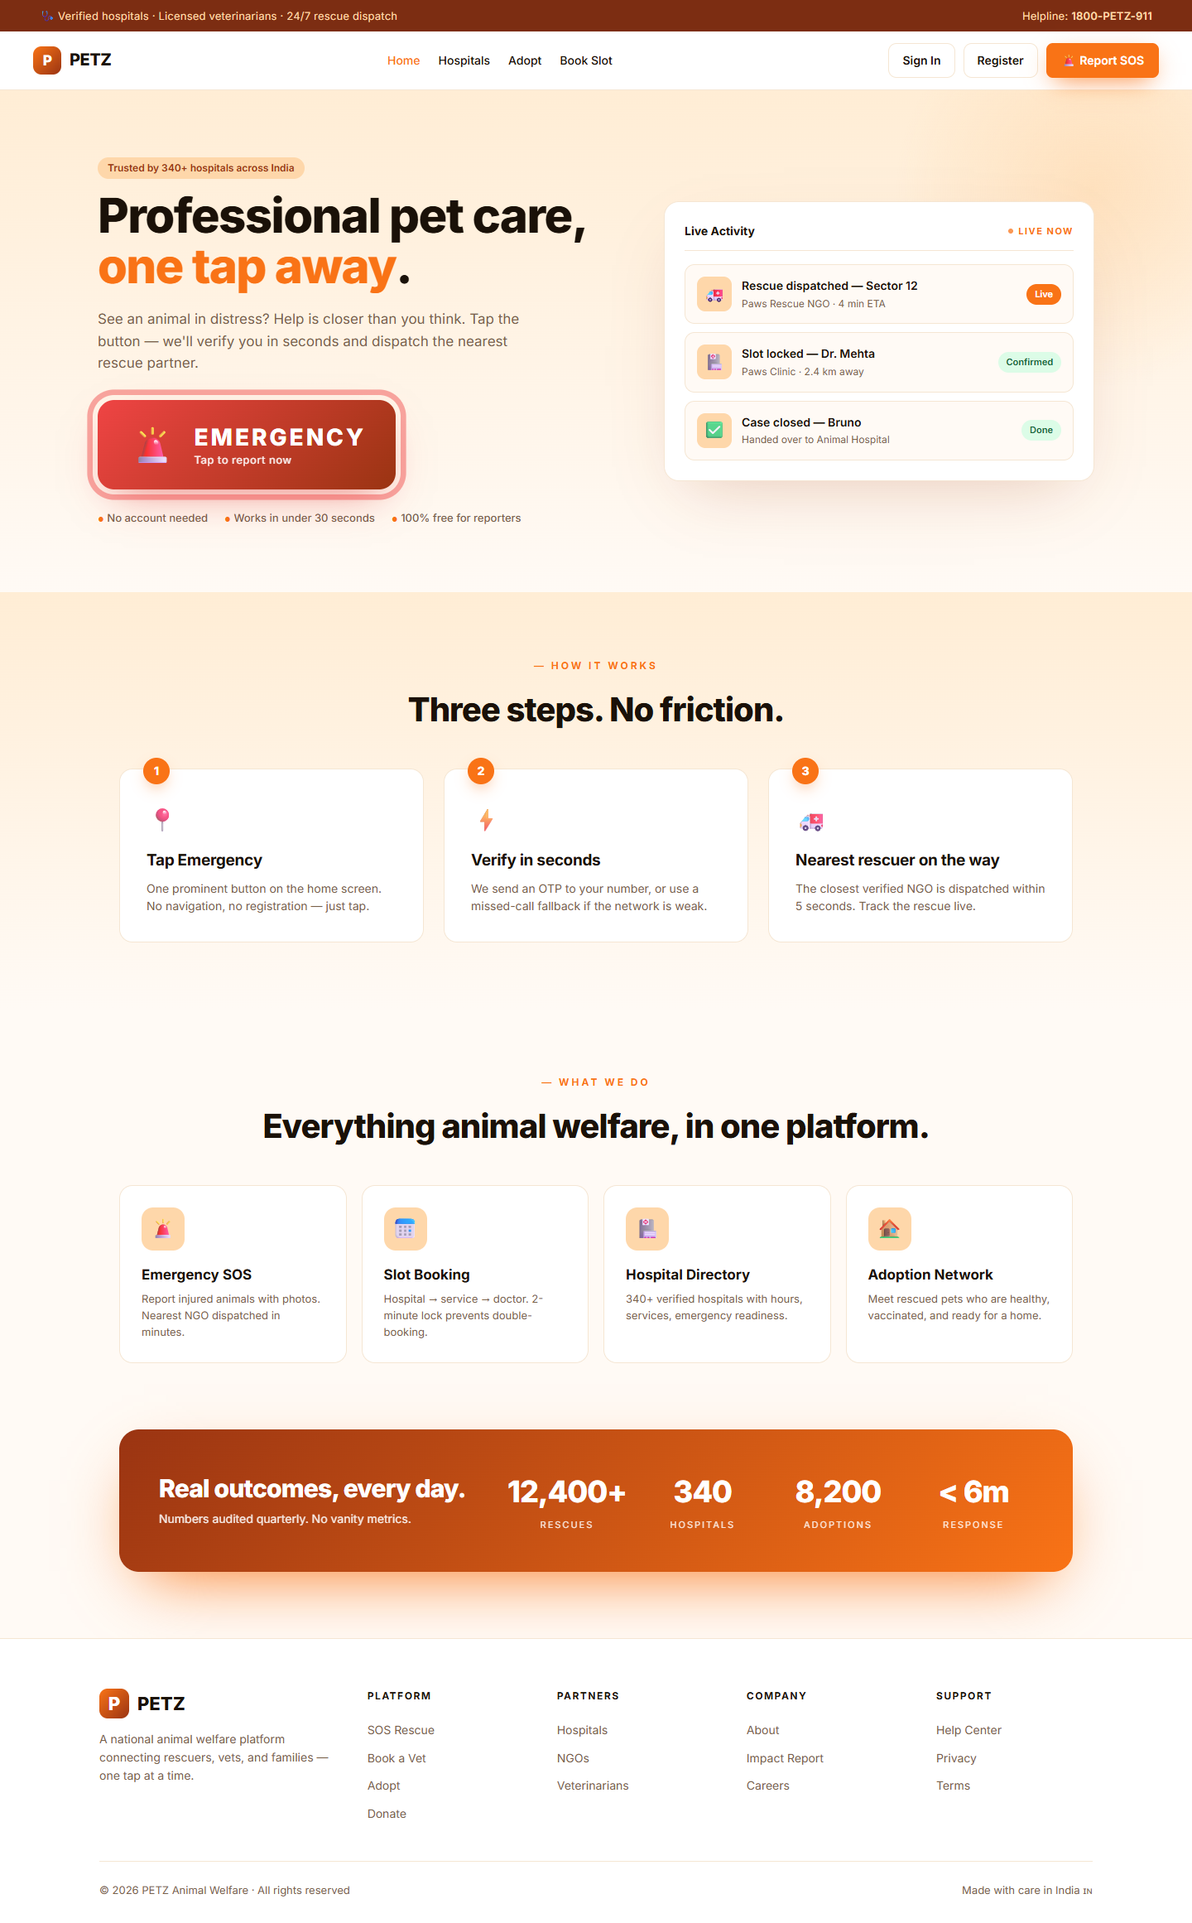
Figure: Home page — entry point for login
- Open http://localhost:4200.
- Click the hamburger icon (top-right) → "Login".
- On the login page, click "Sign in with password instead →" at the bottom.
- Enter email (or phone) and the default password Petz@1234.
- On success the navbar shows the user role and a Profile menu becomes available.

3.3 Login Steps (OTP — Reporter / Adopter)
Used for citizens reporting an SOS or adopters who prefer phone login.
- From the home page click "Login".
- Enter a 10-digit Indian phone number and tap "Send OTP".
- In dev mode, the OTP is logged in the backend console (look for the line "[OTP] phone=..., otp=...").
- Enter the 6-digit OTP and tap "Verify".
- You are redirected back to the home page; the navbar now shows your phone identity.

3.4 Quick Role Switching during QA
Open the browser console while signed in and inspect localStorage.petz.session to read the active accessToken, role, and userId. Logout via the navbar Profile menu (or DevTools: localStorage.removeItem("petz.session"); location.reload()).

4. Role & Route Map
Every Angular route in petzfrontend/src/app/app.routes.ts is mapped to the role(s) that can use it. Routes prefixed with the lock icon below are wrapped in authGuard; the rest are public.

4.1 Public / Unauthenticated
Route | Component / Purpose
/ | home — landing page with EMERGENCY CTA
/login | login — OTP or password sign-in
/register | register — full account creation (adopter)
/hospitals | hospitals — public hospital directory
/adopt | adopt — browse adoptable pets
/adopt/:id | adopt-detail — individual pet profile
/sos/auth | sos-auth-phone — SOS phone entry
/sos/auth/otp | sos-auth-otp — OTP confirmation
/sos/auth/missed-call | sos-auth-missed-call — fallback ring-and-drop verification
/sos/rate-limit | sos-rate-limit — anti-spam page
/sos/success | sos-success — confirmation post-report

4.2 Authenticated — Normal User (Reporter + Adopter)
Route | Component / Purpose
/profile | profile — view & edit account
/my-reports | my-reports — citizen rescue history
/appointments | my-appointments — vet bookings
/sos/report | sos-report — full SOS form (post-auth)
/sos/report/:id/media | sos-report-media — upload photos / videos
/sos/report/:id/confirmed | sos-report-confirmed — confirmation screen
/sos/report/:id/status | sos-status — live mission tracker
/book/... | book-hospital → book-confirm — appointment wizard
/adopt/:id/apply | adopt-apply — multi-step adoption form
/my-adoptions | my-adoptions — list of submitted applications
/my-adoptions/:id | adopt-application-view — adopter-side detail

4.3 Authenticated — NGO_REP (and Volunteer)
Volunteers reuse the NGO portal in this build; their additional field-only screens will be split out in a later iteration.
Route | Component / Purpose
/ngo/dashboard | ngo-dashboard — KPIs and quick links
/ngo/pets | ngo-pets — manage pet listings
/ngo/pets/new | ngo-pet-form — create listing
/ngo/pets/:id/edit | ngo-pet-form — edit listing
/ngo/adoptions | ngo-adoptions — applications queue
/ngo/adoptions/:id | ngo-adoption-review — full review (KYC, decision)
/ngo/queue | ngo-queue — assigned rescue missions
/ngo/missions/:id | ngo-mission — mission detail and status
/ngo/sos-reports | ngo-sos-reports — view SOS by emergency level (NEW)

4.4 Authenticated — ADMIN
Route | Component / Purpose
/admin | admin-dashboard — platform-wide KPIs
/admin/hospitals | admin-hospitals — manage hospital catalogue
/admin/rescues | admin-rescues — live rescue ops + NGO assignment
/admin/adoptions | admin-adoptions — adoption oversight
/admin/appointments | admin-appointments — appointment oversight

4.5 Authenticated — VET (Hospital Representative)
There is no dedicated /vet/* route group at the time of writing. The VET role currently logs into the same shell as a normal user; vet-specific portal screens are slated for the next iteration.

5. Normal User Module (Reporter + Adopter)
A "Normal User" is any non-staff citizen of the platform. Reporters use the SOS path to request rescues; Adopters use the adoption browse-and-apply path; and either role can book vet appointments. Both roles share the same navbar and profile shell — what differs is the data they see ("My Reports" vs "My Adoptions").
⚠ Note: Status: This module is fully working and ready for full functional testing.

5.1 Home Page (/)

Figure: Home page — Reporter entry point
The home page is the landing screen for all unauthenticated users. It is mobile-first and renders a vertical layout with a prominent emergency CTA.
- FR-NU-1.1: Display the PETZ logo, tagline ("Professional pet care, one tap away."), and a large red "EMERGENCY — Tap to report now" button above the fold.
- FR-NU-1.2: Tapping the EMERGENCY button must navigate to /sos/auth even if the user is unauthenticated (citizen-led reporting).
- FR-NU-1.3: A hamburger menu (top-right) exposes Login, Register, Hospitals, and Adopt.
- FR-NU-1.4: Authenticated users see additional menu items: My Reports, Appointments, My Adoptions, Profile.

5.2 Authentication

5.2.1 Register (Full Account)
- FR-NU-2.1: Fields: full name, email, phone (10-digit Indian), password, confirm password.
- FR-NU-2.2: Password must be ≥ 8 chars, contain letters and digits; mismatch on confirm field blocks submit.
- FR-NU-2.3: On success, the user is signed in as ADOPTER and redirected to /.
- FR-NU-2.4: Duplicate email/phone surfaces an inline error from POST /auth/register.

5.2.2 Login (OTP / Password)
- FR-NU-2.5: Default mode: phone OTP — the user enters phone, taps Send OTP, then enters the 6-digit code.
- FR-NU-2.6: "Sign in with password instead →" toggles a password form (used by NGO/Admin/Vet/Adopter).
- FR-NU-2.7: Session is persisted in localStorage under key petz.session.
- FR-NU-2.8: On 401 from any subsequent API call, the user is redirected to /login.

5.3 SOS Emergency Reporting
The SOS path supports unauthenticated reporting via OTP or missed-call verification, then a multi-step form for incident details.

5.3.1 SOS Phone Authentication (/sos/auth)
- FR-NU-3.1: User enters phone → POST /auth/send-otp.
- FR-NU-3.2: Rate-limit response (429) routes to /sos/rate-limit with retry timer.
- FR-NU-3.3: Fallback link: "Use missed call instead" → /sos/auth/missed-call.

5.3.2 OTP Verification (/sos/auth/otp)
- FR-NU-3.4: 6-digit numeric input; Verify calls POST /auth/verify-otp.
- FR-NU-3.5: On success, user is signed in as REPORTER (temporary session) and routed to /sos/report.

5.3.3 SOS Report Form (/sos/report)
- FR-NU-3.6: Required fields: urgency level (CRITICAL / MODERATE / LOW), live latitude+longitude (geolocation API), free-text description.
- FR-NU-3.7: Submit → POST /sos-reports → next route is /sos/report/:id/media.
- FR-NU-3.8: "Use my current location" pulls coordinates via navigator.geolocation; a manual override is allowed.

5.3.4 Media Upload (/sos/report/:id/media)
- FR-NU-3.9: Multi-file picker accepts images and short videos.
- FR-NU-3.10: Each upload calls POST /sos-reports/{id}/media as multipart form-data.
- FR-NU-3.11: "Skip" button is allowed — media is optional but encouraged.

5.3.5 Confirmation & Live Status
- FR-NU-3.12: After media, /sos/report/:id/confirmed shows the assigned mission ID and a "Track" button.
- FR-NU-3.13: /sos/report/:id/status polls the rescue mission and shows REPORTED → DISPATCHED → ON_SITE → TRANSPORTING → COMPLETE timeline.

5.3.6 My Reports (/my-reports)
- FR-NU-3.14: Lists every SOS the signed-in user has ever filed (GET /users/{id}/rescue-history).
- FR-NU-3.15: Each row shows urgency badge (🚨 Critical / ⚠️ Moderate / 🐾 Low), location, date and current status.

5.4 Hospital Discovery & Appointment Booking

5.4.1 Hospital Directory (/hospitals)
- FR-NU-4.1: Lists hospitals with name, services, distance (if geolocation granted), open-now and emergency-ready badges.
- FR-NU-4.2: Filters: emergency-only, open-now, search by name/area.

5.4.2 Booking Wizard (/book/...)
- FR-NU-4.3: Step 1: choose hospital → /book.
- FR-NU-4.4: Step 2: choose service (CONSULTATION, VACCINATION, SURGERY, etc.) → /book/service.
- FR-NU-4.5: Step 3: choose doctor → /book/doctor.
- FR-NU-4.6: Step 4: choose slot (date + time) → /book/slot.
- FR-NU-4.7: Step 5: choose pet (or quick-create) → /book/pet.
- FR-NU-4.8: Step 6: confirm → /book/confirm; on submit, POST /appointments returns the appointment id and routes to /appointments.

5.4.3 My Appointments (/appointments)
- FR-NU-4.9: Lists future and past appointments grouped by status (CONFIRMED, COMPLETED, CANCELLED).
- FR-NU-4.10: Allows cancellation up to 2 hours before slot start; reschedule re-enters the wizard.

5.5 Adoption — Browse, Apply, Track

5.5.1 Browse (/adopt)
- FR-NU-5.1: Grid of adoptable pets (GET /adoptable-pets); filter by species, breed, gender, age, city, vaccinated, special needs, adoption-ready.
- FR-NU-5.2: Sort by newest, distance (if geolocation granted), age.

5.5.2 Pet Detail (/adopt/:id)
- FR-NU-5.3: Renders photo carousel, profile, NGO contact, "Apply to Adopt" CTA (auth required).

5.5.3 Application Wizard (/adopt/:id/apply)
- FR-NU-5.4: Multi-step form: Personal → Lifestyle → Experience → Consent. Each step auto-saves via PATCH /adoption-applications/{id}/{step}.
- FR-NU-5.5: Final submit → POST /adoption-applications/{id}/submit; status moves DRAFT → SUBMITTED.

5.5.4 My Adoptions (/my-adoptions, /my-adoptions/:id)
- FR-NU-5.6: List view shows status badges (Draft, Pending, Under Review, Clarification, Approved, Rejected, Withdrawn).
- FR-NU-5.7: Detail view exposes the timeline + clarification questions; the adopter can answer follow-ups (re-opens to UNDER_REVIEW server-side).
- FR-NU-5.8: "Withdraw" button is shown for any active state and calls POST /adoption-applications/{id}/withdraw.

5.6 Profile (/profile)
- FR-NU-6.1: Read-only fields: role, user ID, created date.
- FR-NU-6.2: Editable: full name, phone, email (subject to backend uniqueness checks).
- FR-NU-6.3: Logout button clears localStorage.petz.session and routes to /.

✓ Module Status — Normal User: Working as expected. Functional testing can be performed against this module without further frontend changes.

6. NGO Module (NGO_REP + Volunteer)
NGO representatives manage pet listings, review adoption applications, and act on rescue missions. Volunteers currently share the same portal — separate volunteer-only screens are deferred.
Login: nandita@cupa.org.in / Petz@1234 (or any NGO_REP from §3.1).

6.1 NGO Dashboard (/ngo/dashboard)
Landing page after NGO login. Shows four KPI cards and a Quick Links grid.
- FR-NGO-1.1: KPIs: Total Listings, Active Pets, Pending Reviews, Approved Adoptions.
- FR-NGO-1.2: "Pending Reviews" count uses status=SUBMITTED on /ngo/adoption-applications.
- FR-NGO-1.3: Quick Links: Manage Pet Listings, Review Applications, SOS Reports by Level (new), Rescue Reports.
- FR-NGO-1.4: Recent applications panel lists up to 5 most recent SUBMITTED applications with adopter and pet name.
⚠ Note: The "+ Add Pet Listing" header button has been removed in v2 in favour of accessing the New Pet form via /ngo/pets → "Add" inside the listings page.

6.2 Pet Listings

6.2.1 Listings (/ngo/pets)
- FR-NGO-2.1: Lists every pet owned by the caller's NGO via GET /ngo/adoptable-pets.
- FR-NGO-2.2: Status filter: LISTED / RESERVED / ADOPTED / ARCHIVED.
- FR-NGO-2.3: Row actions: Edit, Archive (POST /ngo/adoptable-pets/{id}/archive).

6.2.2 Create / Edit Listing (/ngo/pets/new, /ngo/pets/:id/edit)
- FR-NGO-2.4: Required fields: name, species, breed, age (months), gender, location city.
- FR-NGO-2.5: Optional: photos (multipart upload), vaccination flags, special-needs note, adoption-ready toggle.
- FR-NGO-2.6: Submit → POST /ngo/adoptable-pets (create) or PATCH (edit).

6.3 Adoption Application Reviews

6.3.1 Queue (/ngo/adoptions)
- FR-NGO-3.1: Filter chips: All, Pending (=SUBMITTED), Under Review, Clarification, Approved, Rejected.
- FR-NGO-3.2: Cards show adopter, pet, submitted-at date, status chip.
- FR-NGO-3.3: Row click → /ngo/adoptions/:id (detail view).
⚠ Note: In v1 the chip sent status=PENDING to the backend, which returned 500 because the AdoptionApplicationStatus enum has no PENDING value. This has been corrected to send SUBMITTED.

6.3.2 Application Review (/ngo/adoptions/:id)
- FR-NGO-3.4: Shows full application: Personal, Lifestyle, Experience, Consent, KYC documents, history timeline.
- FR-NGO-3.5: Action bar visible only when status is SUBMITTED or UNDER_REVIEW.
- FR-NGO-3.6: Buttons: Start Review (SUBMITTED only), Approve, Ask for Clarification, Reject.
- FR-NGO-3.7: Each KYC document has Verify / Reject toggles per /documents/{docId}/verify.

6.4 Rescue Operations

6.4.1 Rescue Queue (/ngo/queue)
- FR-NGO-4.1: Lists missions assigned to caller's NGO via GET /rescue-missions.
- FR-NGO-4.2: Status filter: DISPATCHED, ON_SITE, TRANSPORTING, COMPLETE, FLAGGED, CLOSED.

6.4.2 Mission Detail (/ngo/missions/:id)
- FR-NGO-4.3: Map / coordinates of incident, ETA, reporter contact, mission audit trail.
- FR-NGO-4.4: Status updater calls PUT /rescue-missions/{id}/status.

6.4.3 SOS Reports by Level (/ngo/sos-reports)
New view (added in v2). Lists all SOS reports across the platform with emergency-level filtering.
- FR-NGO-4.5: GET /sos-reports returns the unfiltered list; the page client-side filters by urgencyLevel.
- FR-NGO-4.6: Filter buttons: All / 🚨 Critical / ⚠️ Moderate / 🐾 Low.
- FR-NGO-4.7: Each card shows urgency badge, current status, report ID, reporter name (if any), reverse-geocoded location, description, reported-at, media count.
- FR-NGO-4.8: Reverse geocoding via Nominatim (OpenStreetMap) — best-effort, falls back to lat/lng.

⏳ Module Status — NGO: Needs to be updated soon — the team will share specifics by tomorrow. Avoid finalising test cases for this module until the next revision lands.

7. Vet Module (Hospital Representative)
The VET role is a hospital-side user — typically a clinic staff member responsible for managing services, doctors, slots, and walk-in records on behalf of a hospital.

7.1 Current State
At the time of writing there are no /vet/* routes in petzfrontend/src/app/app.routes.ts. A vet user (vet@petz.dev) can sign in via password login and reaches the same shell as a normal user. The vet portal screens are scheduled for the next iteration.

7.2 Planned Screens
The screens below are planned but not yet implemented. They are listed so QA, design and backend can pre-align.

7.2.1 Vet Dashboard (planned: /vet/dashboard)
- FR-VET-1.1: Today's appointments, walk-ins, no-shows, top services.
- FR-VET-1.2: Quick links: Manage Slots, Manage Doctors, Walk-In Triage.

7.2.2 Slot Management (planned: /vet/slots)
- FR-VET-2.1: Calendar view per doctor; create / edit / lock slots.
- FR-VET-2.2: Bulk-publish recurring slots.

7.2.3 Doctor Management (planned: /vet/doctors)
- FR-VET-3.1: Add / edit doctors, services, specialisations.

7.2.4 Walk-in Triage (planned: /vet/walk-in)
- FR-VET-4.1: Quick-create a pet record + appointment for an off-the-street patient.

7.2.5 SOS Hand-over Receipt (planned: /vet/sos-handover/:id)
- FR-VET-5.1: Receive an animal arriving from a rescue mission and acknowledge with a hospital handover record.

⏳ Module Status — Vet: Needs to be updated soon — the team will share specifics by tomorrow. The Vet role is currently a hospital representative; the dedicated portal screens are not yet built. Skip vet-specific testing until the next revision.

8. Admin Module
Platform administrators have a global view of every resource: hospitals, NGOs, rescue missions, adoption applications, and vet appointments.
Login: admin@petz.dev / Petz@1234.

8.1 Admin Dashboard (/admin)
- FR-ADM-1.1: Display global KPIs: total hospitals, total NGOs, active rescue missions, pending applications.
- FR-ADM-1.2: Side-bar links to each admin sub-page.

8.2 Hospitals (/admin/hospitals)
- FR-ADM-2.1: Lists every hospital with name, address, services, doctors count, active status.
- FR-ADM-2.2: Actions: Add Hospital, Edit, Activate / Deactivate.

8.3 Rescues (/admin/rescues)
- FR-ADM-3.1: Live table of rescue missions with reporter phone, location, urgency, reported-at, status.
- FR-ADM-3.2: Filter by status (REPORTED, DISPATCHED, ON_SITE, TRANSPORTING, FLAGGED, COMPLETE).
- FR-ADM-3.3: Assign-NGO modal: dropdown of NGOs that have a representative + reason text.
- FR-ADM-3.4: Reverse-geocoded location via Nominatim per row.

8.4 Adoptions (/admin/adoptions)
- FR-ADM-4.1: Read-only oversight of every adoption application across all NGOs.
- FR-ADM-4.2: Add NGO Representative tooling for setting up new NGO logins.

8.5 Appointments (/admin/appointments)
- FR-ADM-5.1: Read-only list of every appointment across all hospitals; filter by status, hospital, date range.

📌 Note — Admin Module: In this module some changes will be made later. The admin and normal-user (Reporter) flows are working fine and testing can be done on these.

9. Cross-Cutting Requirements

9.1 Authentication & Session
- FR-X-1.1: Sessions are stored in localStorage under key petz.session as a JSON blob containing accessToken, role, userId, expiresIn.
- FR-X-1.2: All API calls go through an HttpInterceptor that attaches Authorization: Bearer <accessToken>.
- FR-X-1.3: On 401, the interceptor clears the session and routes to /login.
- FR-X-1.4: authGuard blocks routes flagged canActivate; unauthenticated users are sent to /login with a returnUrl query param.

9.2 Role-Based Visibility
- FR-X-2.1: Navbar menu items vary by role (e.g., NGO_REP sees "NGO Dashboard"; ADMIN sees "Admin").
- FR-X-2.2: Backend re-validates role on every endpoint via @PreAuthorize; the frontend never assumes server trust.

9.3 Error Handling
- FR-X-3.1: Network errors and 5xx responses surface a friendly toast and a "Retry" button on every list page.
- FR-X-3.2: Validation errors (400) bind inline to the offending field where possible.

9.4 Accessibility & Responsive Design
- FR-X-4.1: Mobile-first layout; primary tested viewport is 360 × 780.
- FR-X-4.2: All interactive elements have visible focus rings and aria-label attributes.
- FR-X-4.3: Colour-only signalling is avoided (every status chip pairs colour with a text label or icon).

9.5 Logging & Telemetry
- FR-X-5.1: Console errors are zero on the happy path; QA must report any console.error sightings.
- FR-X-5.2: Network panel: every authenticated call must include the Authorization header.

10. Testing & Acceptance

10.1 Test Strategy by Module
Module | Status / Action
Normal User (Reporter + Adopter) | Working — full functional + regression testing recommended.
Admin | Working for current scope — testing can proceed; expect minor changes later.
NGO (NGO_REP + Volunteer) | Pending update — defer formal sign-off until next revision (ETA: 1 day).
Vet (Hospital Representative) | Pending update — portal not yet built; defer testing.

10.2 Smoke Test Checklist
- Backend up on 8081, frontend up on 4200, login as admin@petz.dev succeeds.
- Home page renders with EMERGENCY CTA in red.
- SOS report flow completes and surfaces a mission ID.
- Adopt browse loads ≥ 1 pet, detail page renders, "Apply" requires login.
- NGO dashboard loads after sign-in as nandita@cupa.org.in (or any NGO_REP).
- Admin → Rescues table renders with at least one row.

10.3 Known Issues Tracker
Issue | Resolution Target
NGO portal lacks volunteer-only screens | Next revision
Vet portal not yet built | Next revision (placeholder routes only)
Admin module — unspecified changes | Later iteration (per stakeholder note)
Some screenshots are pending capture | Captured during QA pass; placeholders marked inline

Appendix A — Screenshots Index
The following images were preserved from version 1 of this FRD. They are reproduced here for cross-reference; placeholders in the role modules will be replaced with role-specific captures during the next QA pass.

Figure: Reference image 1
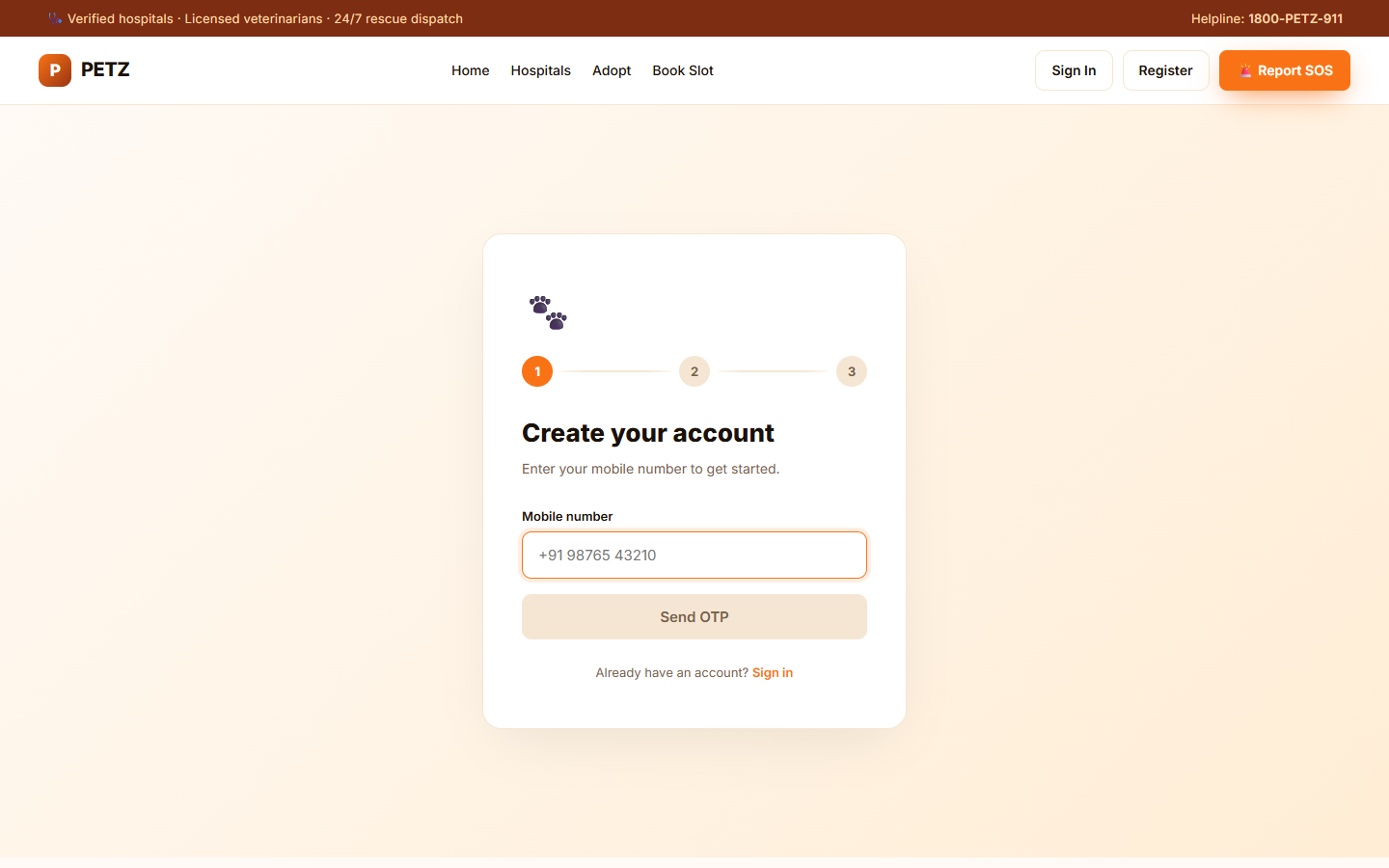
Figure: Reference image 2
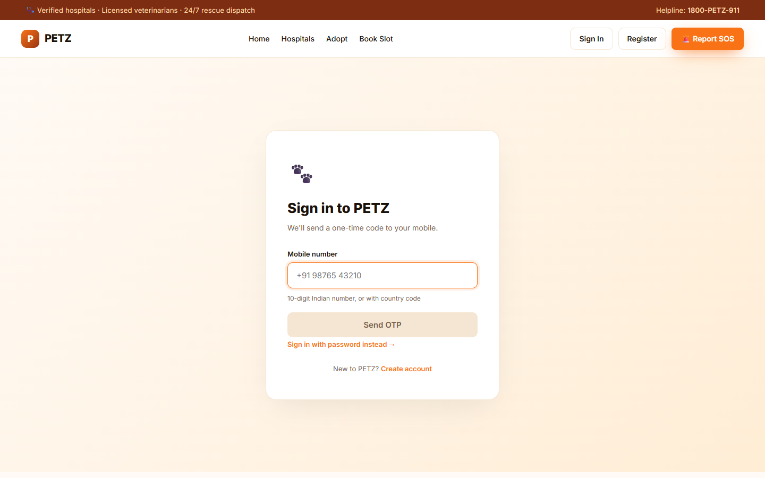
Figure: Reference image 3
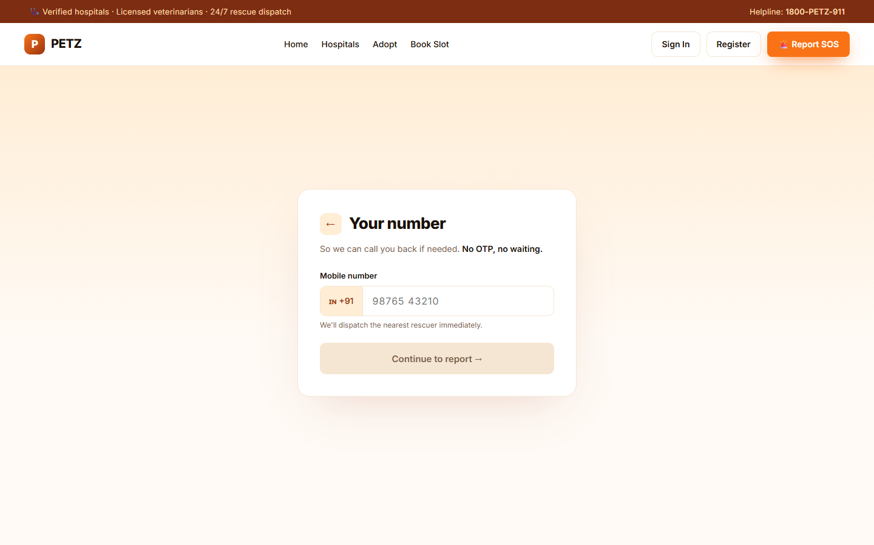
Figure: Reference image 4
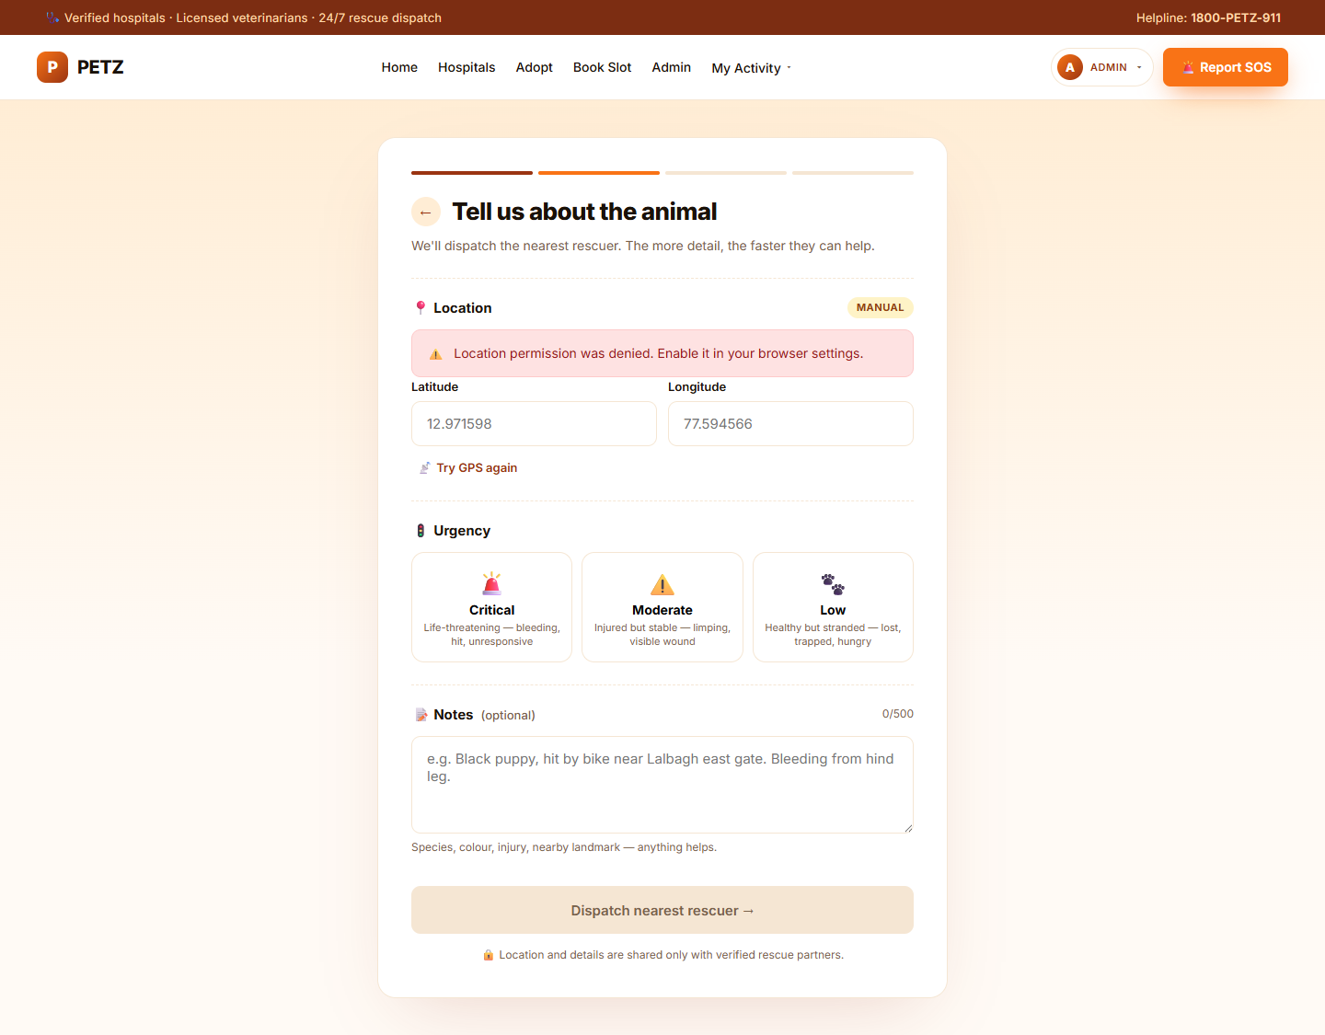
Figure: Reference image 5
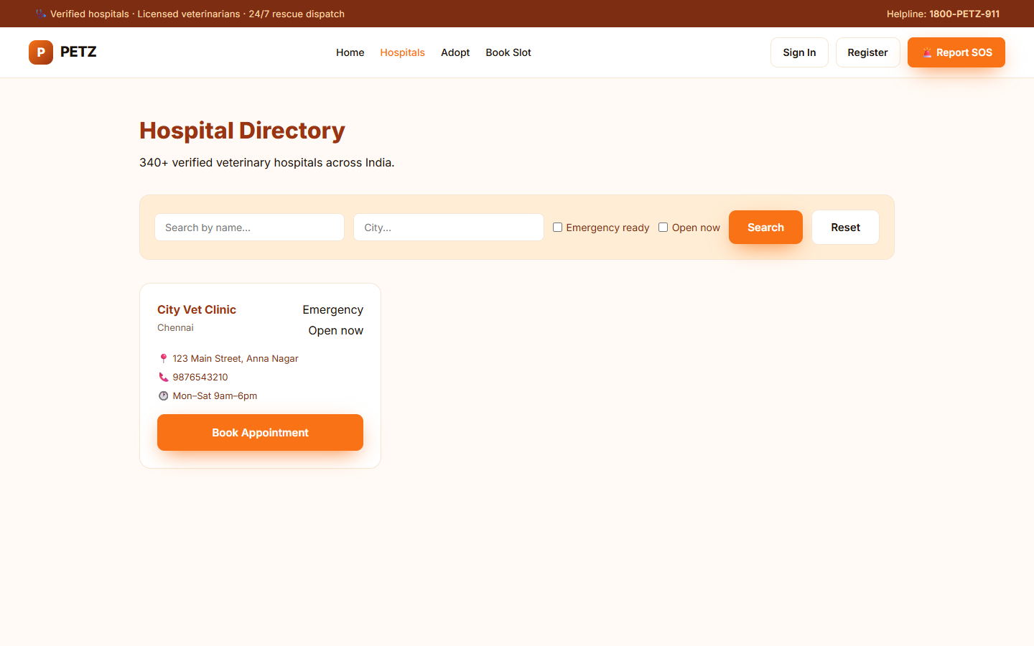
Figure: Reference image 6
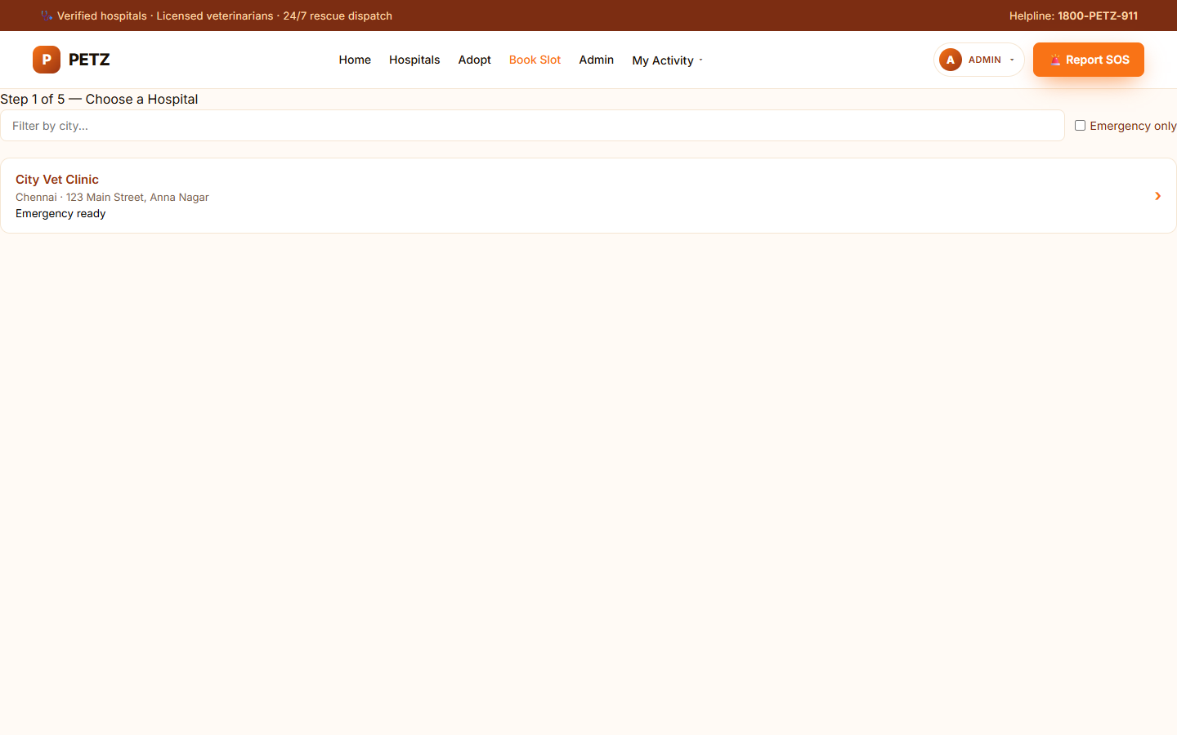
Figure: Reference image 7
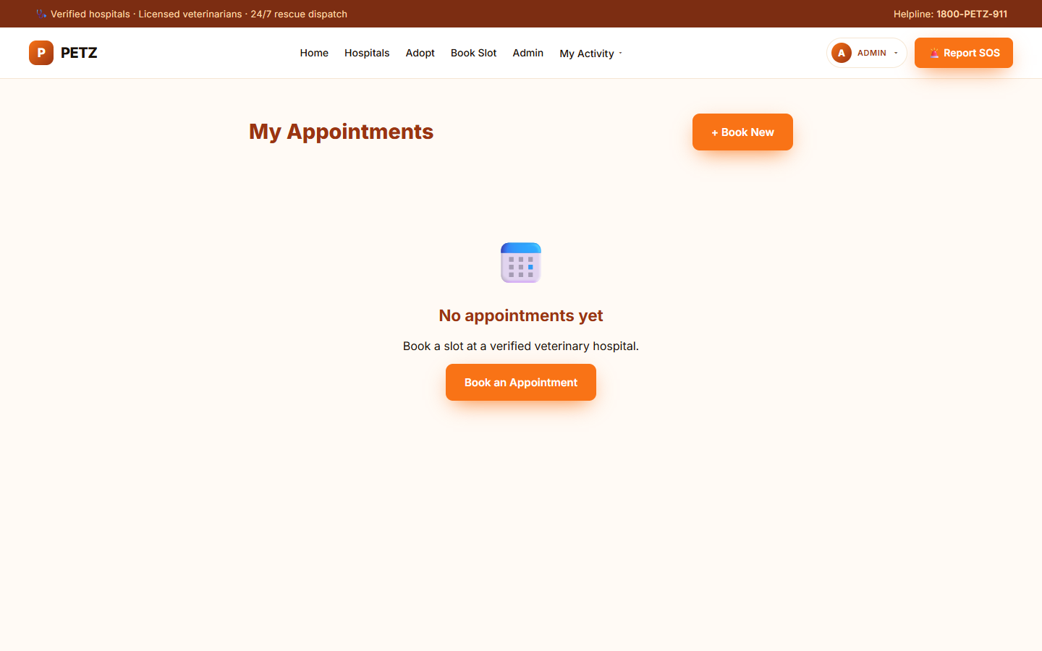
Figure: Reference image 8
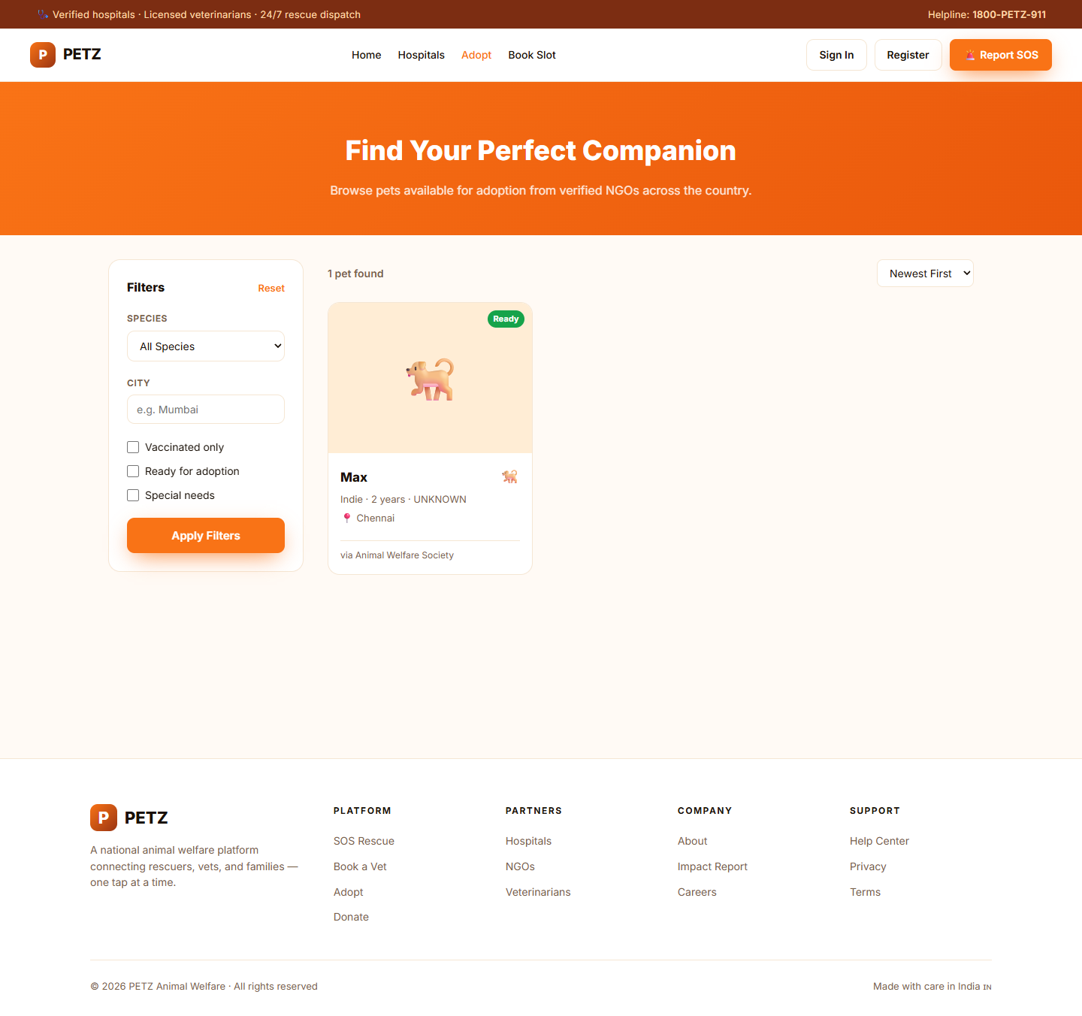
Figure: Reference image 9
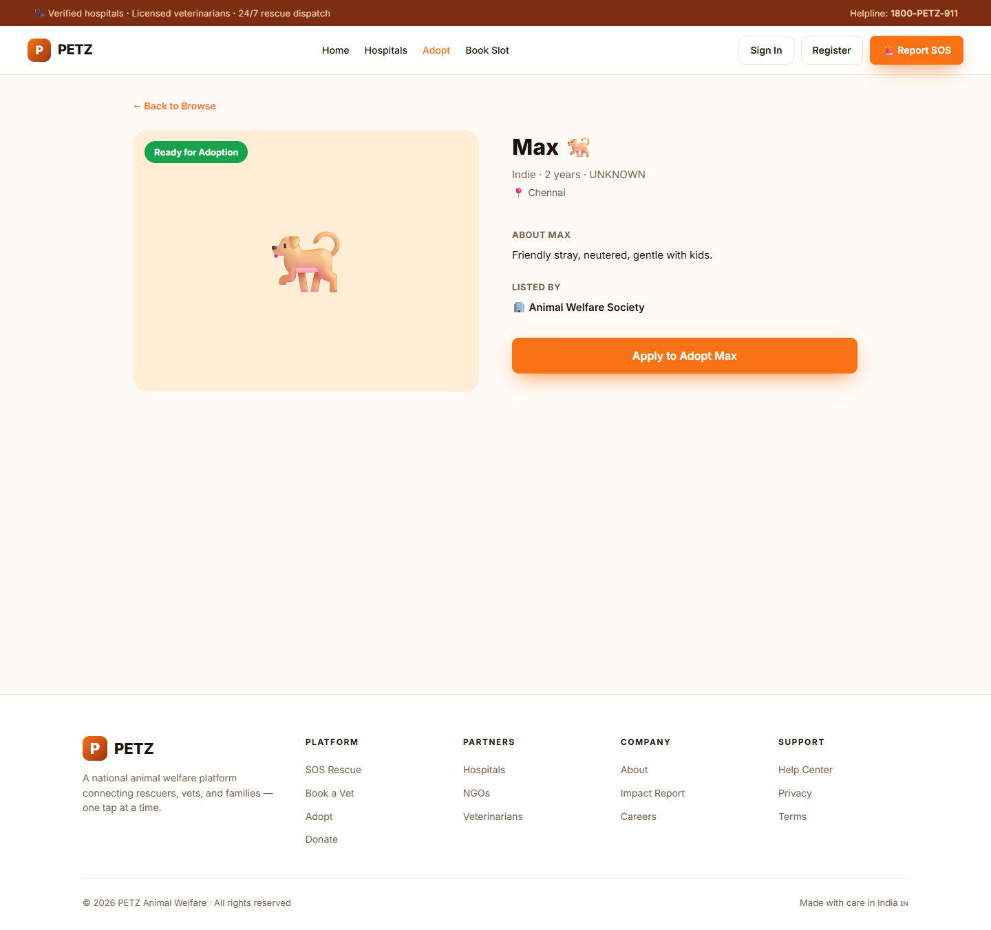
Figure: Reference image 10
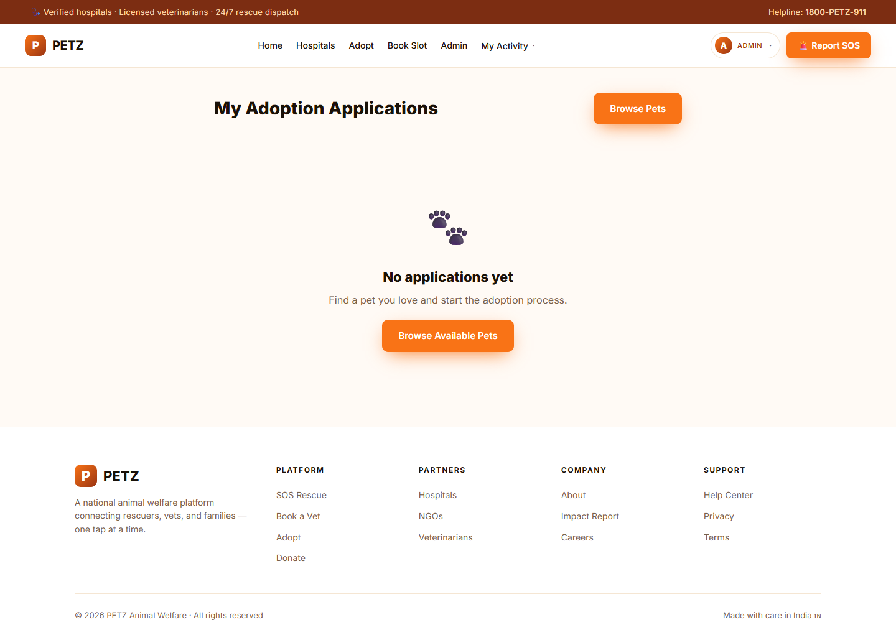
Figure: Reference image 11
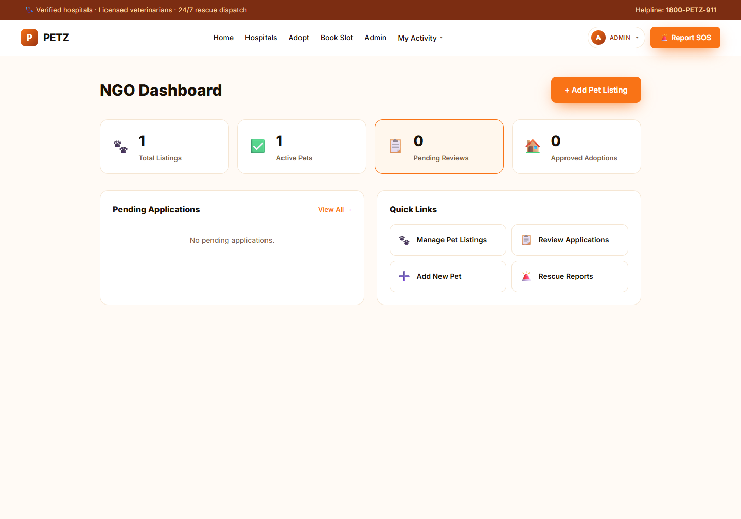
Figure: Reference image 12
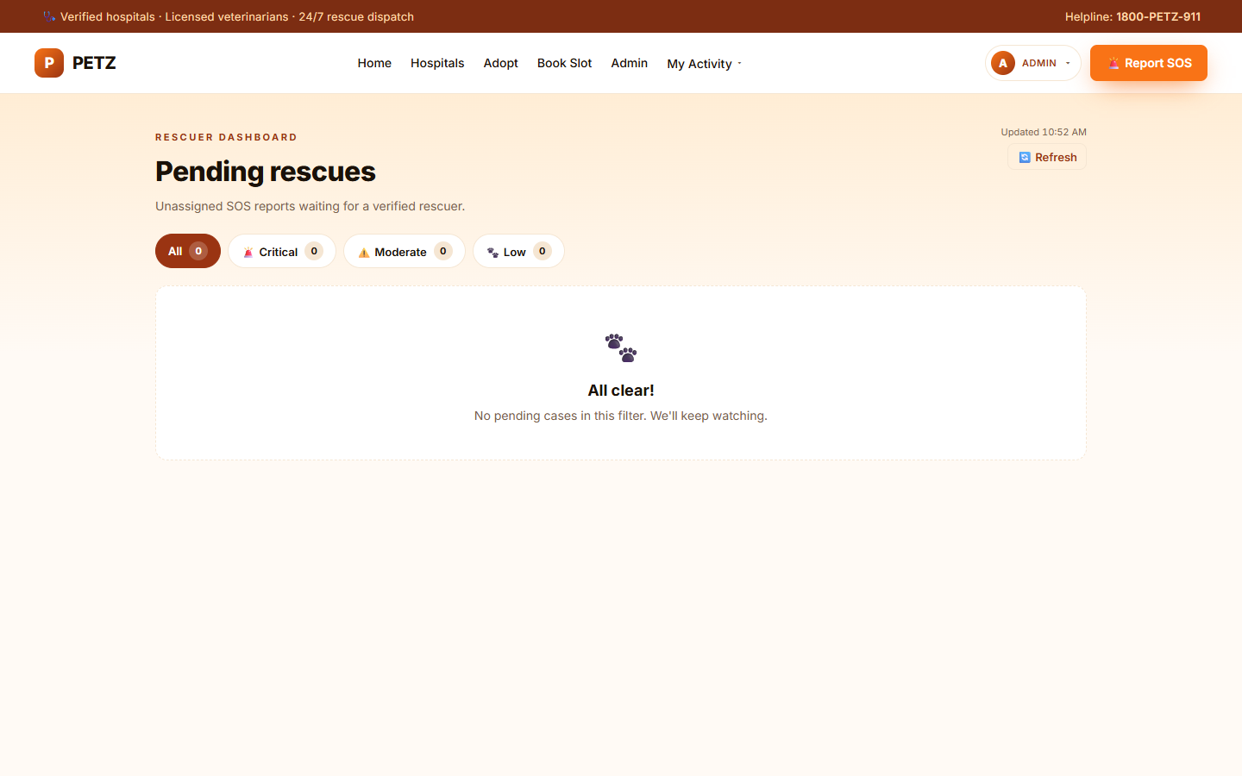
Figure: Reference image 13
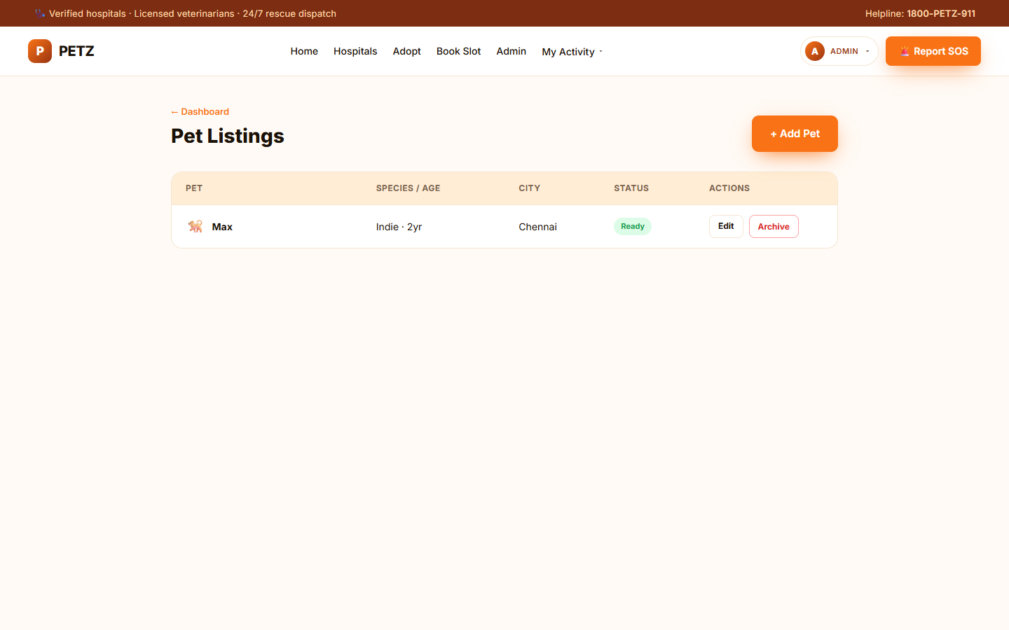
Figure: Reference image 14
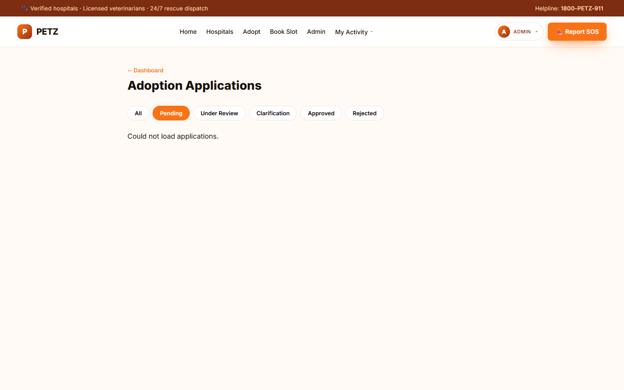
Figure: Reference image 15
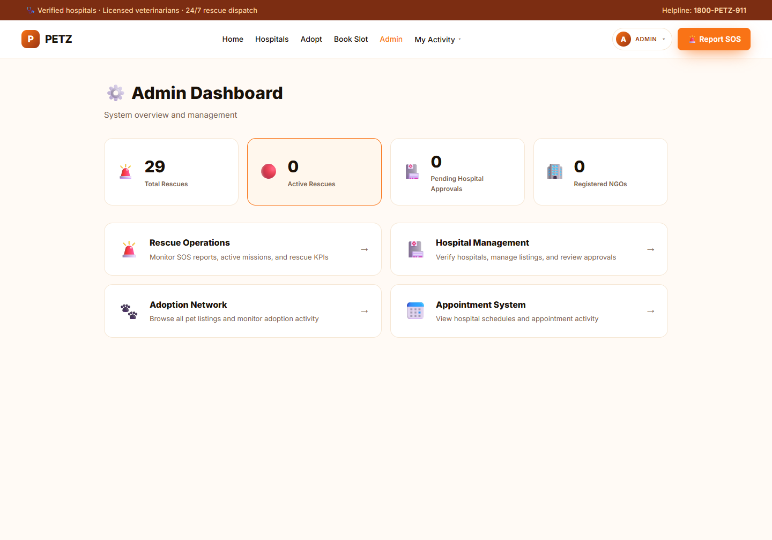
Figure: Reference image 16
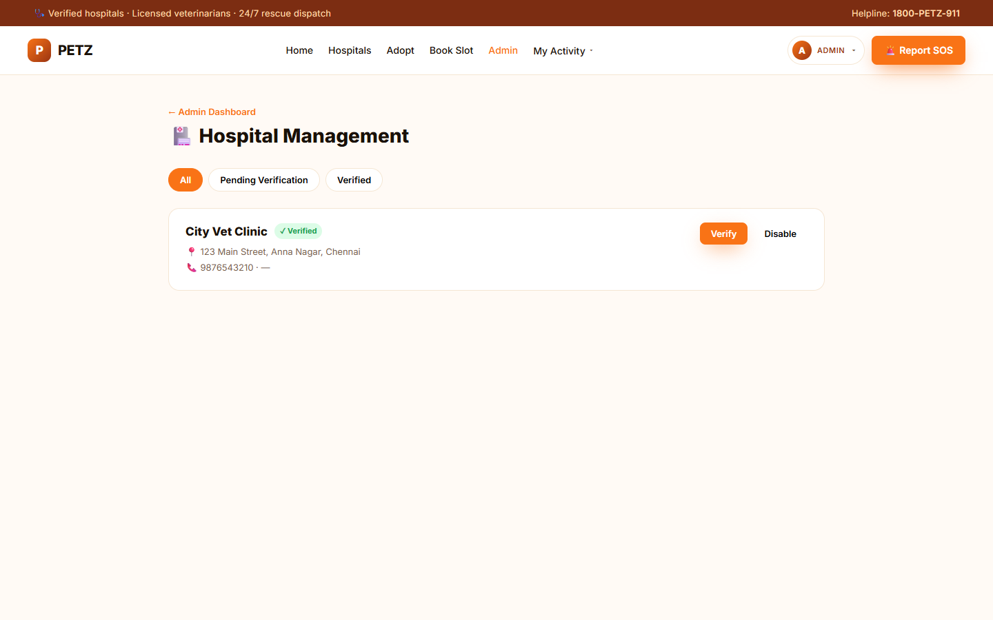
Figure: Reference image 17
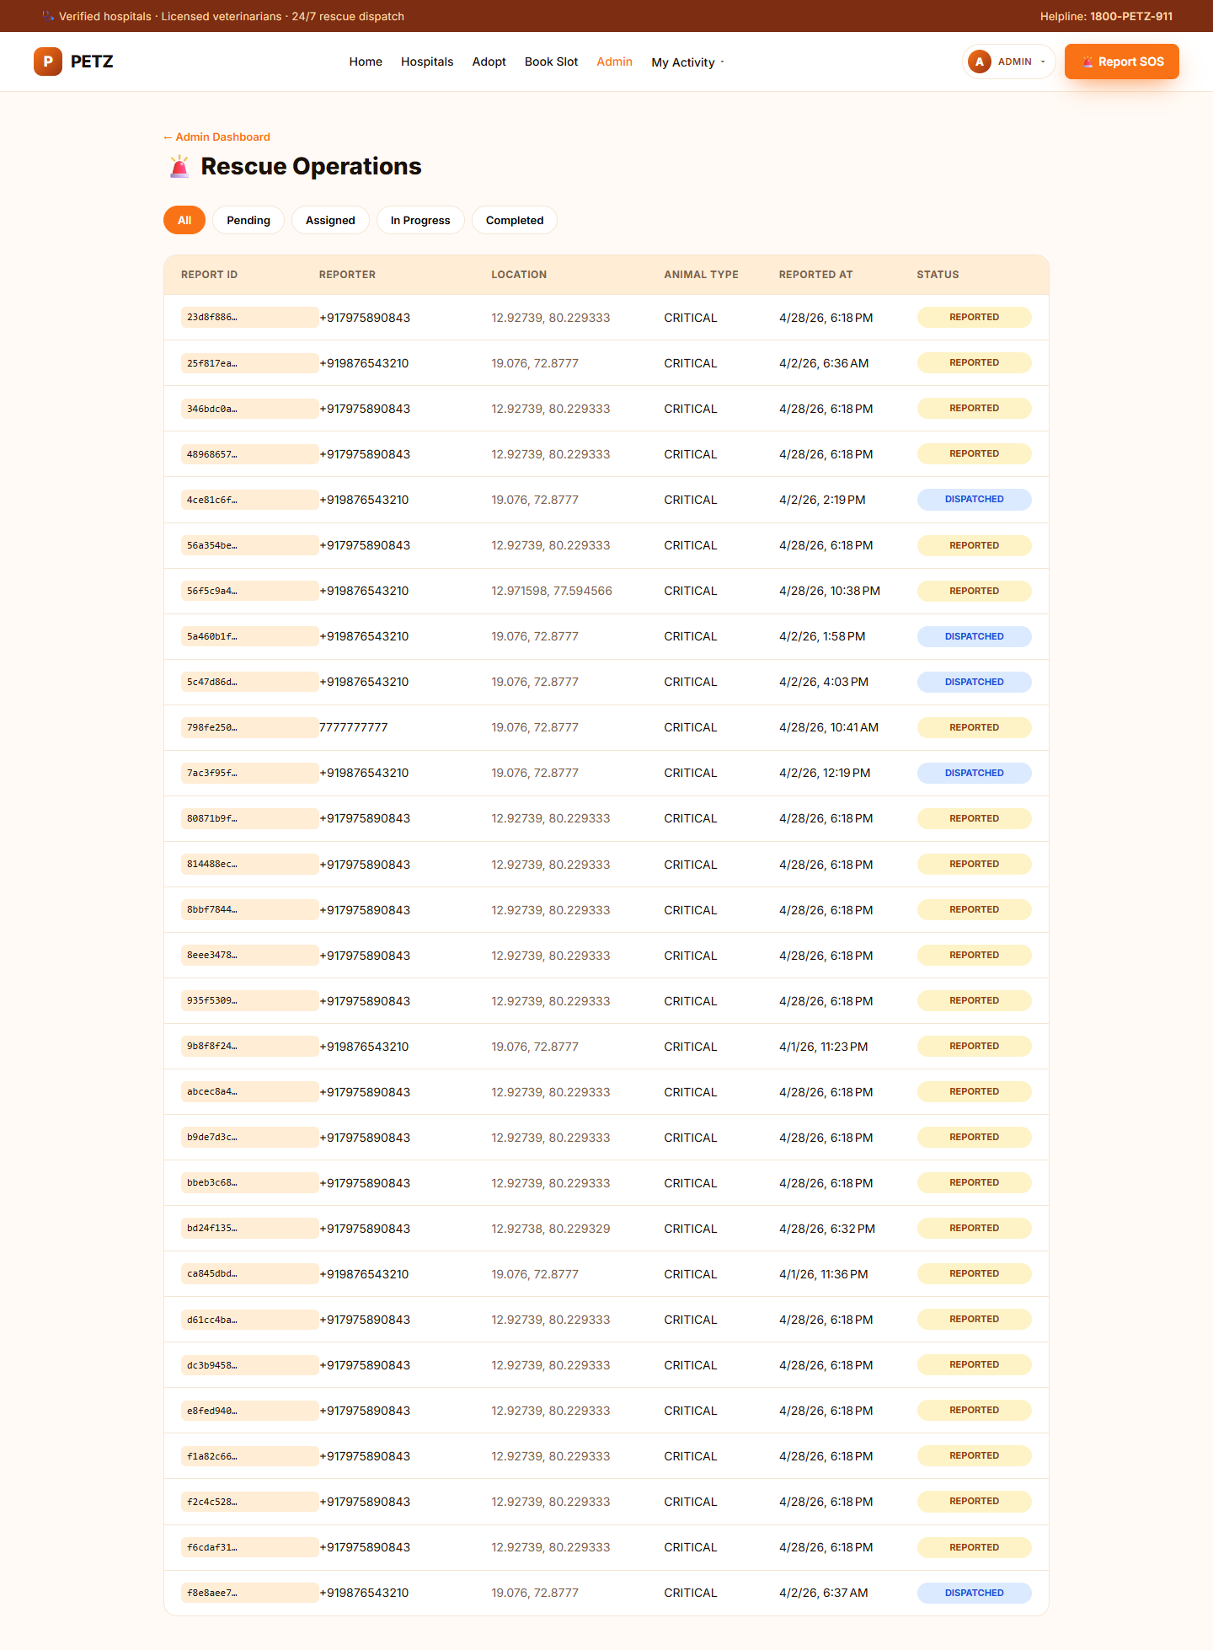
Figure: Reference image 18
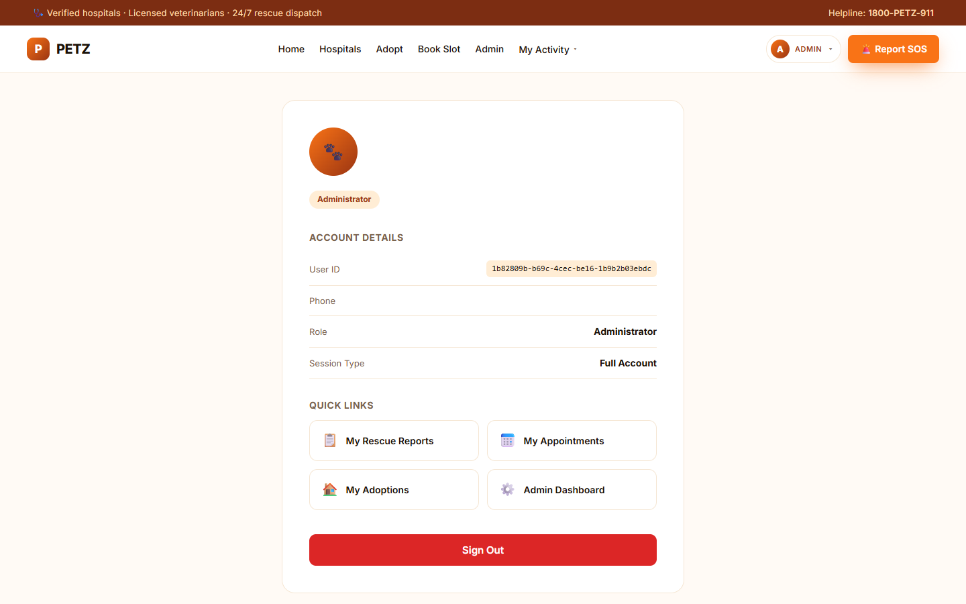
Figure: Reference image 19
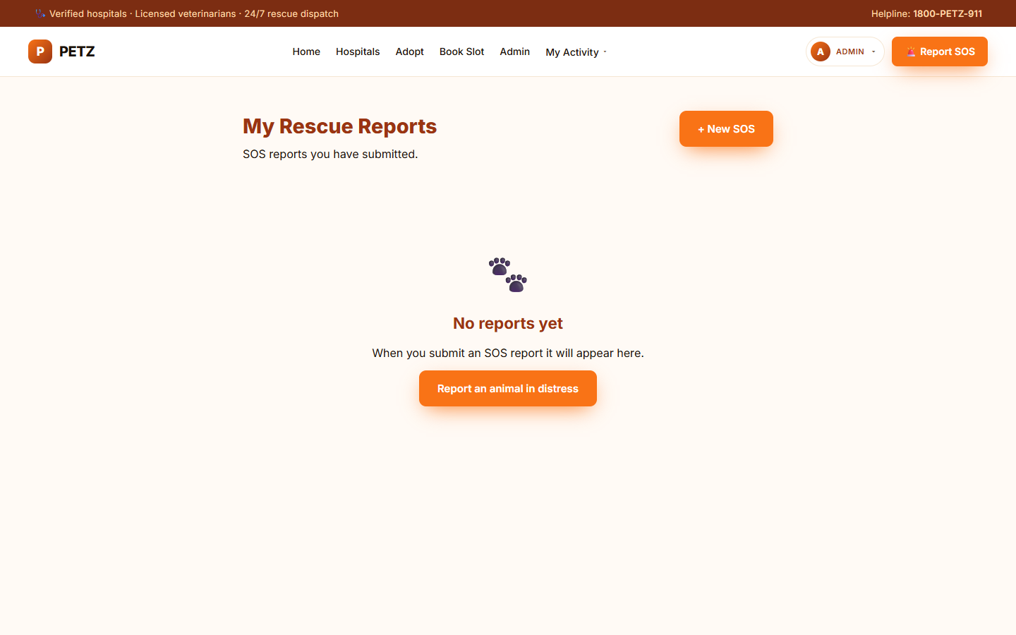
Figure: Reference image 20

