Task9: Launch a t2.micro instance in Mumbai region where ssh can be done only from your IP address with docker and docker-compose installed in it.

Step 1) Launch the t2.micro instance. Note the public IP.

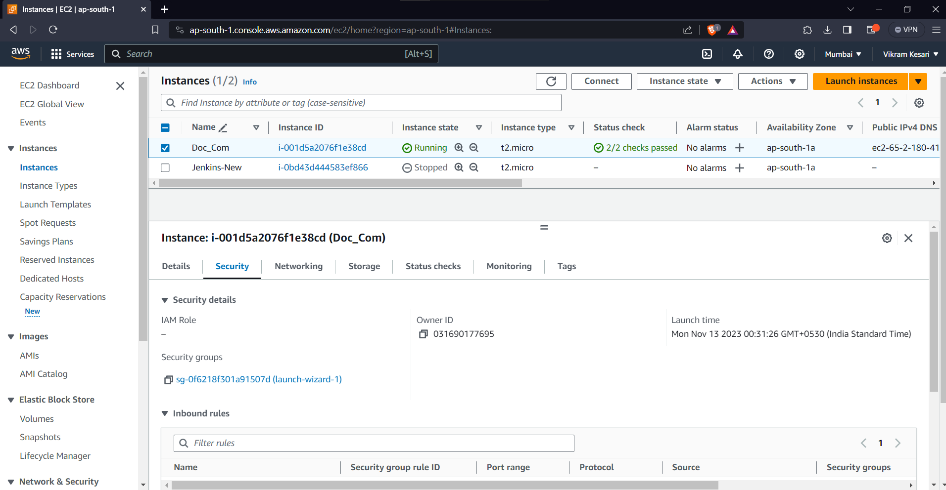

Step 2) Connect the Instance with Remote SSH ( Ex: Mobaxterm.)

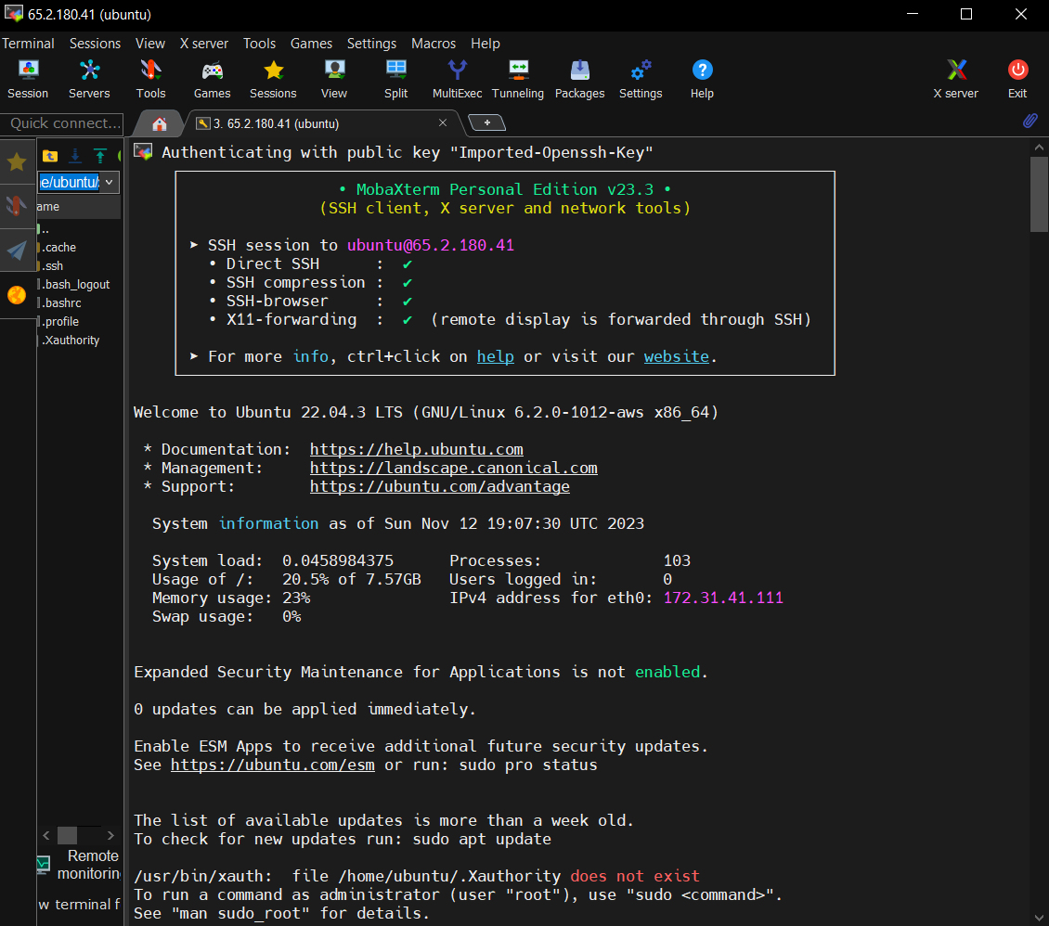

Step 3) # Update the package index

sudo apt update

# Install Docker

sudo apt install -y docker.io

# Start the Docker service

sudo systemctl start docker

# Enable Docker to start on boot

sudo systemctl enable docker

# Add your user to the docker group to run Docker commands without sudo

sudo usermod -aG docker $username

# Log out and log back in to apply the group changes, or run the following command

newgrp docker

# Install Docker-Compose

sudo apt install -y docker-compose

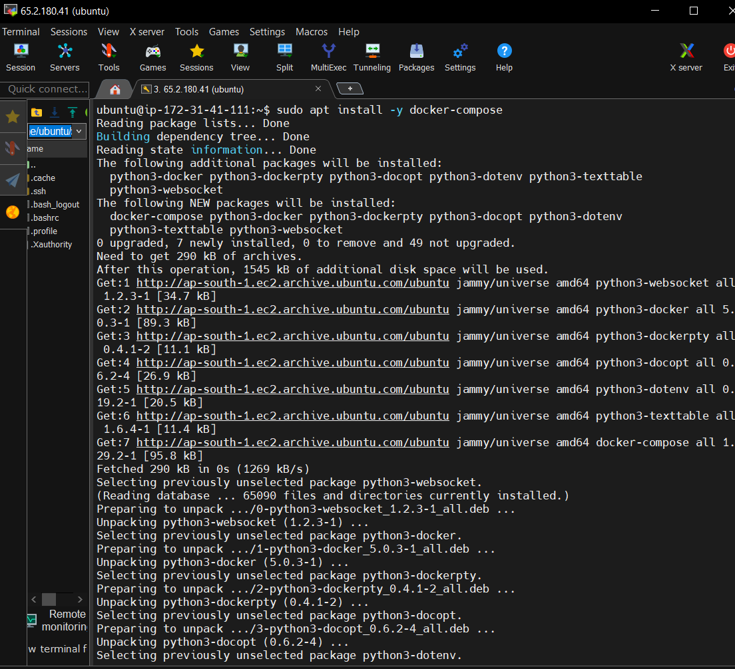

Step4) : Write a Yml file for Ngnix alpine for your web server Images and port number

For example :

nano docker-compose.yml

version: '3'

services:

web:

image: nginx:alpine

ports:

- "80:80"

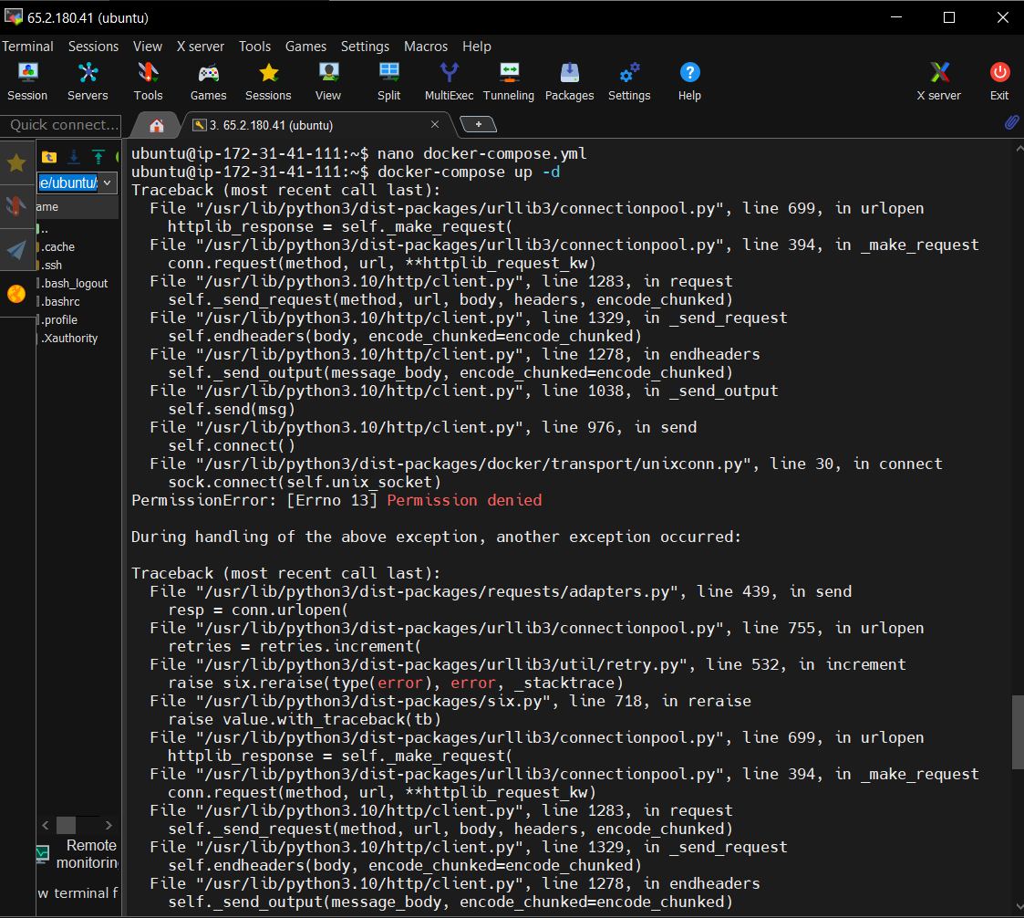

Step 5:

Run the Command:

docker-compose up -d

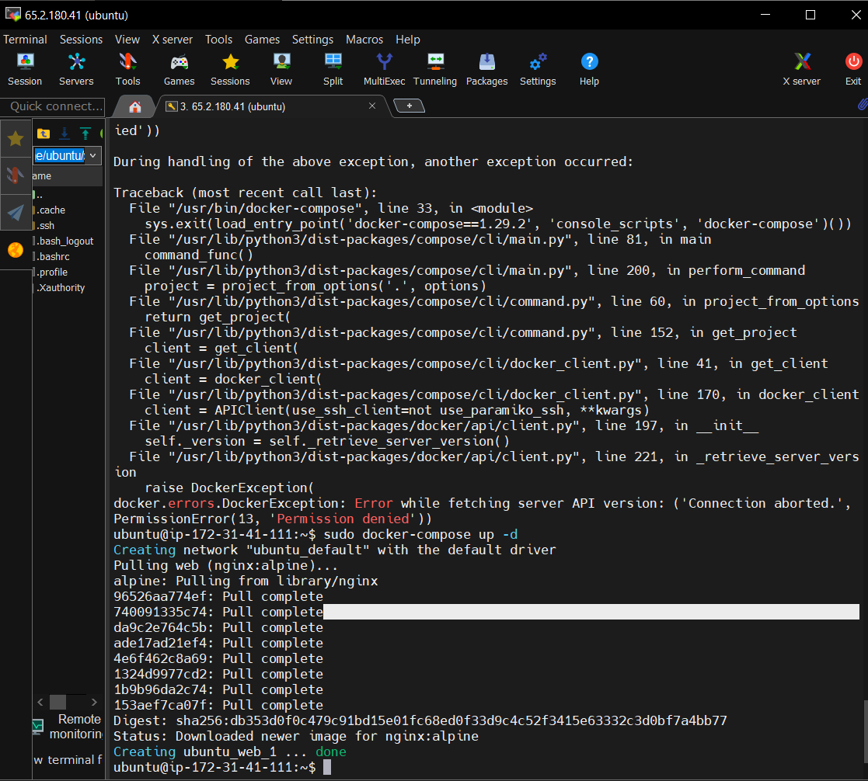

Step6 )

AWS EC2 instance running a simple web application using Docker Compose on Ubuntu Linux. You can customize the docker-compose.yml file to deploy more complex applications or services as needed.

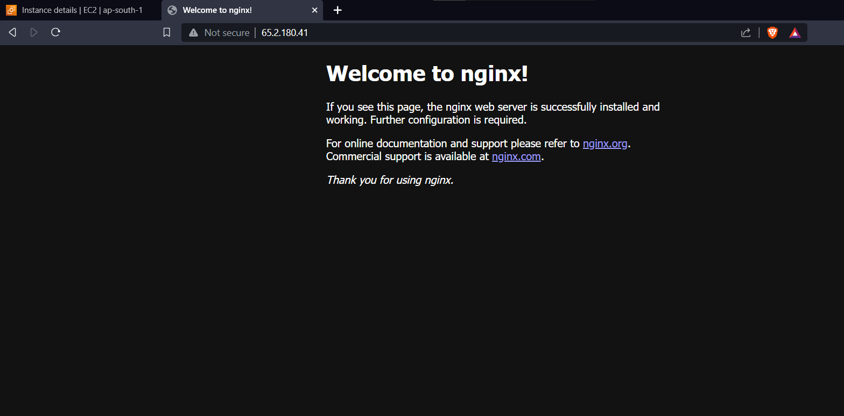

Docker Compose is basically used for isolation and simplified deployment which ultimately leads to easy scaling and port mapping /networking.