5/29/2023

Zanne Smit – ST10072074

ST10082074@vcconnect.edu.za

Read.Me

PROG7311 POE Part 2

Contents

Description 2

Installation 2

Usage 3

LogIn 3

Employees Portal 3

About Page 3

Farmers 4

Products 4

Add Farmer 5

Details 5

Farmers Portal 6

About 6

Products 6

Add Product 7

Details 7

Database 8

# Description

This web application allows farmers and employees to log in once logged in they all sent their respective portals. An employee is able to view all farmers, view a specific farmer's products, add a farmer to the database and view their own details. The farmer's portal allows the farmer to view their products, add a product and view and edit their details. The whole web application has a soft purple theme and is quick and easy to use throughout.

# Installation

You need to unzip the Folder and open it with Visual Studio then find the LogIn.aspx found in the Views folder in Solution explorer and right click the LogIn.aspx and ‘Set as Start Page’.

You will also need to link it to an azure sql database and change the connection string in the web.config file.

Then you can build the application and run it. You will also need to link it to an azure sql database and change the connection string in the web.config file.

# Usage

## LogIn

Both an employee and a farmer are able to log in with an e-mail and password which is checked from the database. And then sent to their respective portals.

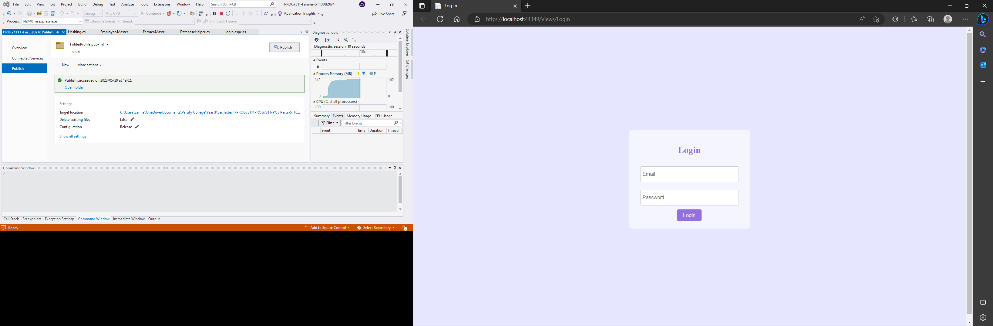

## Employees Portal

Once an employee is in their portal they are able to navigate four different tabs which are: About, Farmers, Add Farmer and Details they are also able to log out which will send them to the login page.

### About Page

The About page is purely just a small amount of details of what the employee portal does in case the employee doesn't know and also has a small empowerment section in case an employee is struggling one day.

### Farmers

The farmer's page is navigable by the farmer's icon in the navigation bar. This page allows the employee to view all farmers in the database and their details it also allows them to add a farmer which will redirect them to the add farmer page as well as select a farmer which will redirect them to the product page of that specific farmer selected.

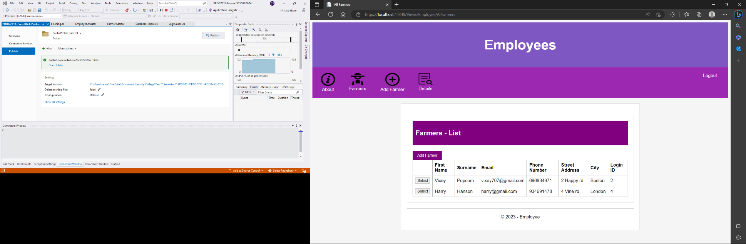

### Products

The products page is populated with the specific selected farmer that the employee selected it will show all the products that the farmer has that is in the database. It allows the employee to filter it by date range or product type and once the employee is done on that page they can click the back button and it will redirect them to their portal.

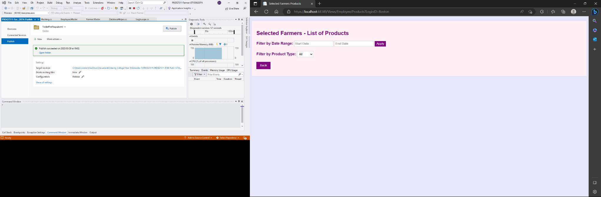

### Add Farmer

The add farmer page allows the employee to add a new farmer and once all the data is correctly entered if not it will display a label error and once the data is entered correctly and the add farmer button is pressed it will be populated to the database in the users table and farmers table and a success label will appear to the employee.

### Details

The details page shows the employees details in case they are unsure about them.

## Farmers Portal

Once the farmer is logged in they will be redirected to the farmer portal where they have the option to navigate through the icons in the navigation bar to the About page, the Products page the Add Products page and the Details page.

### About

This about page is on the farmer's portal where they are able to see what the portal does as well as give a little inspirational bit for the farmer.

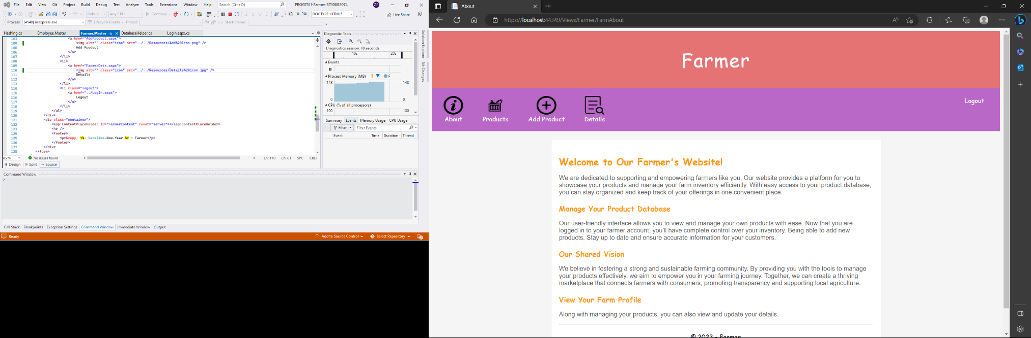

### Products

The farmer's product page will be populated with all the farmers products from all time and will show all product details that are needed for the farmer should they need to view this.

### Add Product

The add product page is for the farmer to add a new product to the database. If they do not enter the data correctly an error message will appear and tell them that they have not entered the correct data. If they do enter the data correctly and click the add product button, the data of the product will be updated to the database and a success message will appear for the farmer.

### Details

The details page is for the farmer to view all their details and should they want to edit their details it will allow them to edit their First Name, Surname, Phone Number, Street Address and City but not their e-mail or login ID as these are vital links to their profiles and accessing all their data

# Database

All Tables and data types

Users Table

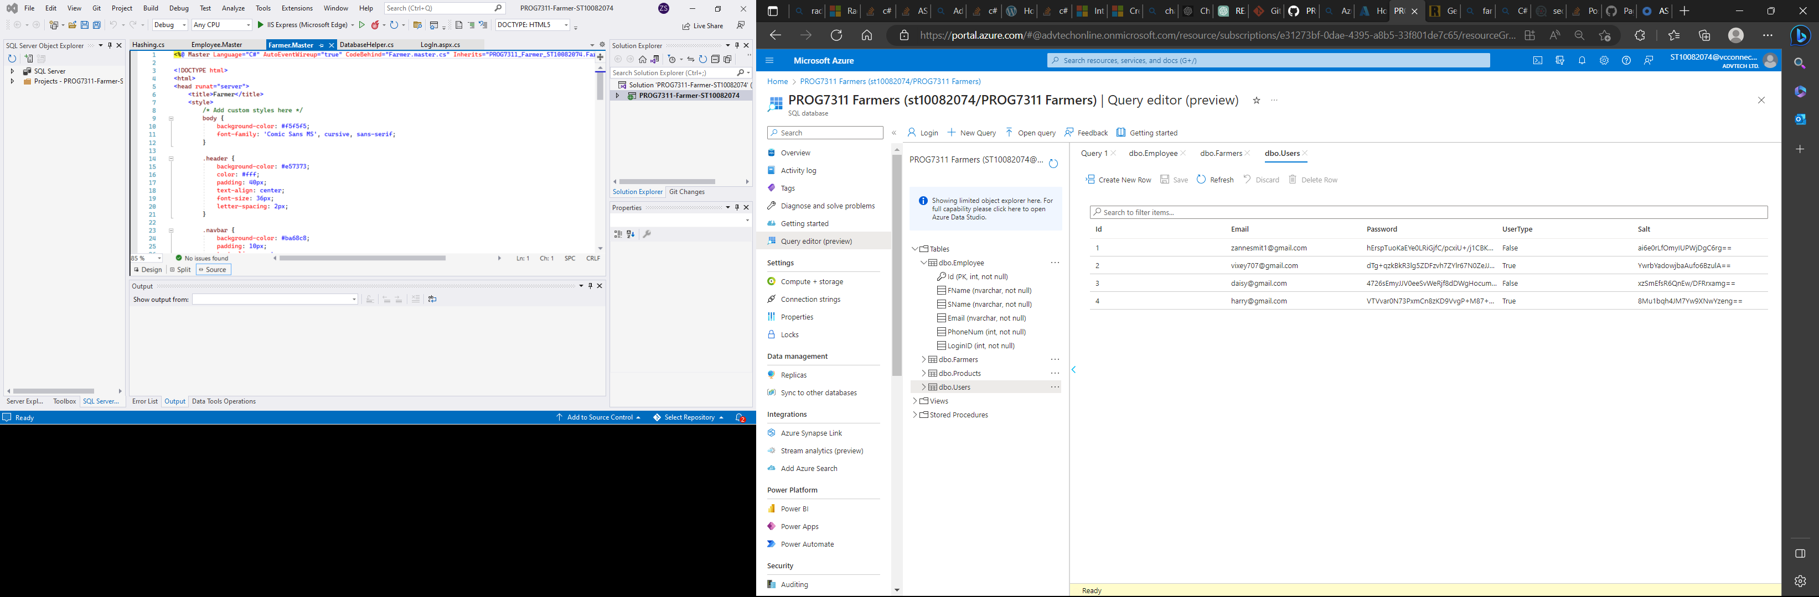

Projects table

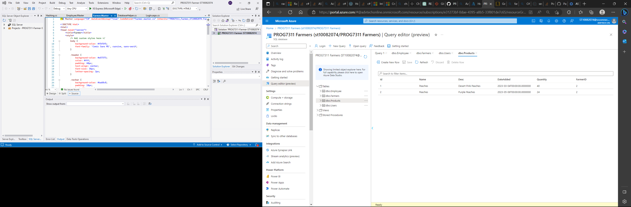

Farmers Table

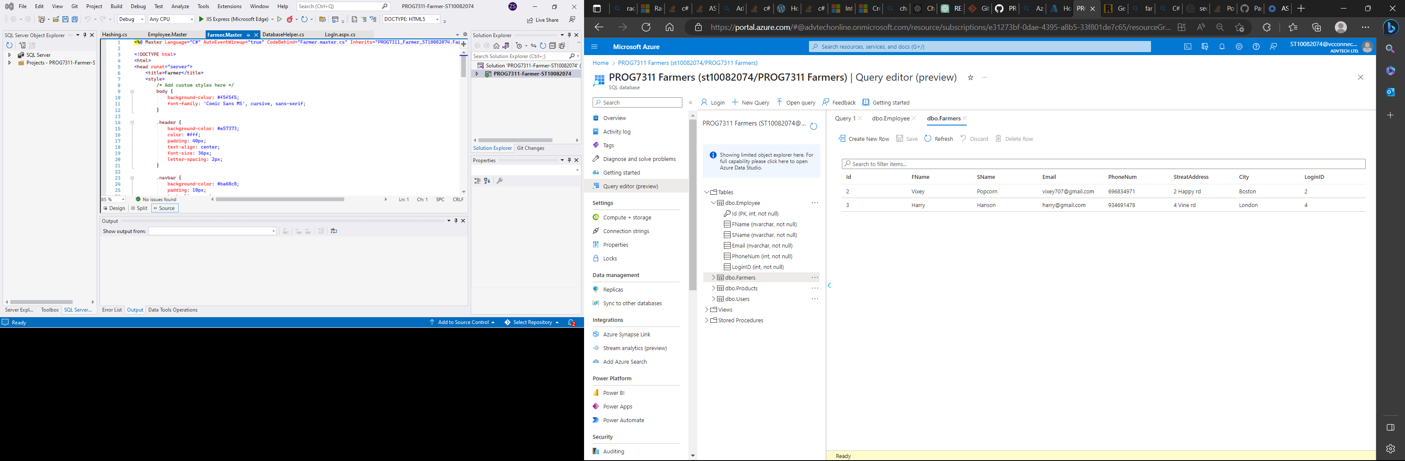

Products table

