- Introduction
This dataset contains real-estate features collected to understand how different property characteristics influence house prices. It is ideal for beginners and intermediate ML practitioners who want to build regression models, perform feature engineering, and apply EDA techniques.

- Problem Statement
Estimating house prices accurately is a challenging task due to multiple influencing factors. Incorrect pricing can lead to financial losses for buyers, sellers, and real estate companies.
Objective:
To build a machine learning model using Linear Regression that predicts house prices based on housing features and evaluates its performance using standard regression metrics.

- Dataset Description
The dataset includes essential attributes such as:
- Area of the house
- Number of Bedrooms
- Number of Bathrooms
- Stories
- Parking availability
- Main road access
- Guest rooms, hot water heating, air-conditioning
- Basement, furnishing status
- And the final target: Price
Dataset Size
- Rows: 545
- Columns: 13
- Type: Mixed (Categorical + Numerical)

- Data Understanding and Exploratory Data Analysis (EDA)
EDA was performed to understand the structure and characteristics of the dataset:
- Used .info() to examine data types and missing values
- Used .describe() to understand statistical distribution
- Visualized correlations between features and house price
Correlation Analysis
A correlation heatmap was generated to identify relationships between numerical variables. Features such as area, bathrooms, and bedrooms showed strong positive correlation with house price.
EDA helped identify important features and guided the preprocessing steps.

- Data Preprocessing
To prepare the dataset for machine learning, the following preprocessing steps were applied:
Handling Categorical Variables
Categorical columns like mainroad, guestroom, basement, and furnishingstatus were converted into numerical format using encoding techniques.
Handling Missing Values
The dataset did not contain significant missing values. Wherever required, numerical missing values were handled using mean imputation.
Feature Selection
- Independent variables (X): All housing features
- Dependent variable (y): price
Train-Test Split
The dataset was split into:
- 80% Training Data
- 20% Testing Data
This ensures that the model is evaluated on unseen data.

- Model Building – Linear Regression
Linear Regression is a supervised learning algorithm used to model the relationship between dependent and independent variables.
Mathematical Representation:
Price=m₁x₁+m₂x₂+...+m_{n}x_{n}+c
Where:
- Price is the predicted house price
- x represents housing features
- m represents coefficients
- c is the intercept
The model was trained using the training dataset from the Jupyter Notebook.

- Model Training and Prediction
• The Linear Regression model was trained using LinearRegression() from sklearn
• After training, predictions were made on the test dataset
• The model learned the relationship between housing features and price

- Model Evaluation
To evaluate model performance, the following metrics were used:
Evaluation Metrics
- Mean Absolute Error (MAE): Measures average prediction error
- Root Mean Squared Error (RMSE): Penalizes larger errors
- R² Score: Measures how well the model explains price variance
Results
- Low MAE and RMSE values indicate good prediction accuracy
- R² score close to 1 shows strong model performance
- The model performs well for linear relationships in the data

- Results and Visualization
9.1 Regression line for predicted price vs actual price

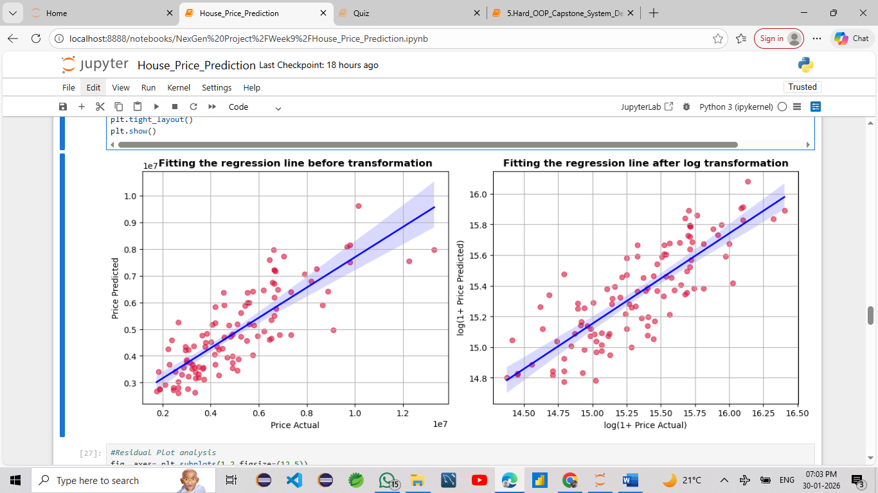
Conclusions from the above plot
1. Before Transformation (Left Plot)
-> A positive linear trend is visible between actual and predicted values.
-> However, the scatter increases at higher prices, indicating heteroscedasticity (non-constant error variance).
-> Many high-priced houses are underpredicted, showing bias in the model.
-> Prediction accuracy drops for extreme values, making the model less reliable on the original scale.

2. After Log(1 + Price) Transformation (Right Plot)
-> The data becomes more linear, and the points align better with the regression line.
-> The spread of residuals reduces significantly — the model errors become more uniform across the price range.
-> The regression fit becomes tighter, improving R², reducing RMSE, and handling outliers more gracefully.
-> The blue confidence band is narrower, showing the model is more confident about its predictions.

  - Residual Plot analysis
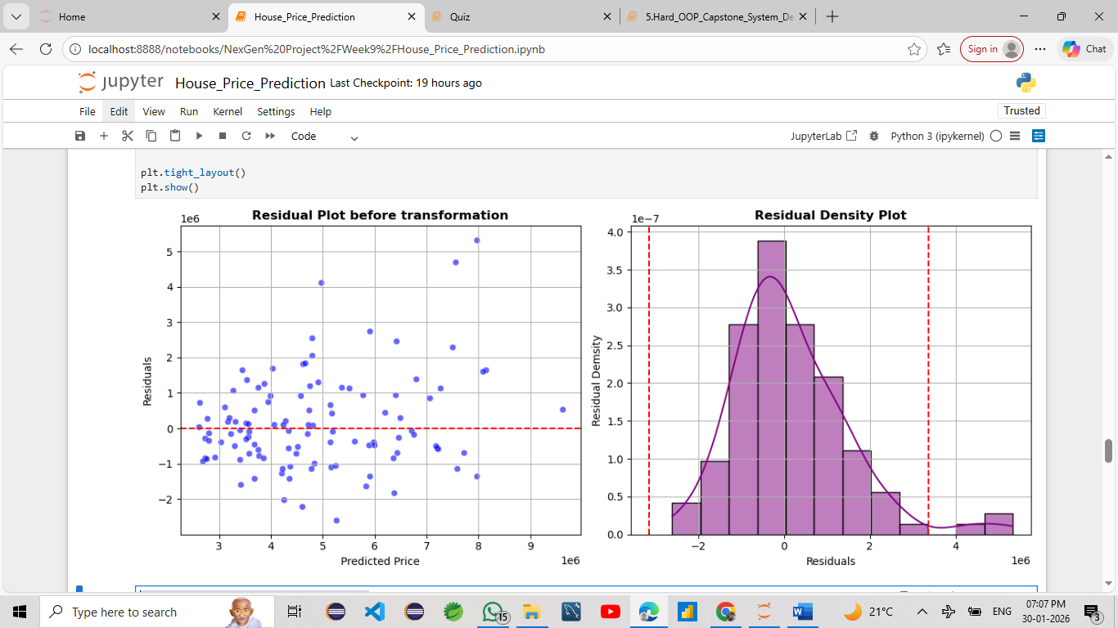
Conclusions from the above plot
1. left plot is Residual Plot Analysis :
-> Linearity assumption is acceptable.
-> Slight heteroscedasticity is present, not severe.
-> A few potential outliers, but not enough to invalidate the model.
2. Right plot is Residual Density Plot :
-> Normality of residuals is fairly acceptable.
-> Minor skew, but not bad enough to demand log transform.
-> Model has decent predictive quality.

  - Box plot of actual vs predicted prices
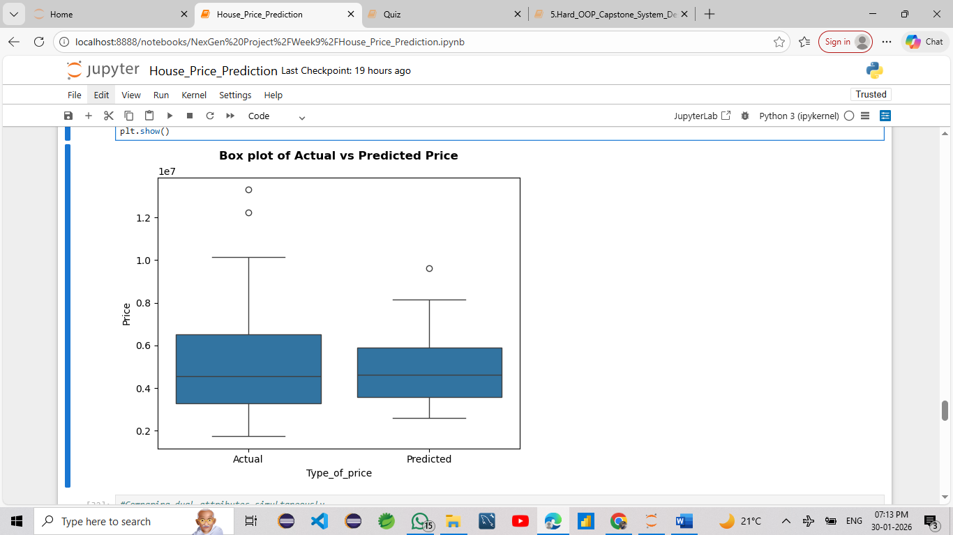
Median Alignment
-> The medians (center lines of boxes) of both actual and predicted prices are fairly close.
-> This means the model is doing a decent job at capturing central tendency.
Predicted Prices Show Less Variability
-> The interquartile range (IQR) of predicted prices is narrower than that of actual prices.
High-Price Properties Underpredicted
-> There are more outliers (above whiskers) on the actual price side — predicted prices fail to reach these extremes.
-> This suggests that high-value homes are being underpredicted, a limitation of linear models when price distribution is skewed.
No Major Underprediction on the Lower End
-> The lower whisker of predicted prices roughly aligns with actual prices.
-> This shows the model is not significantly overpredicting cheaper houses.

  - Pairwise Relation
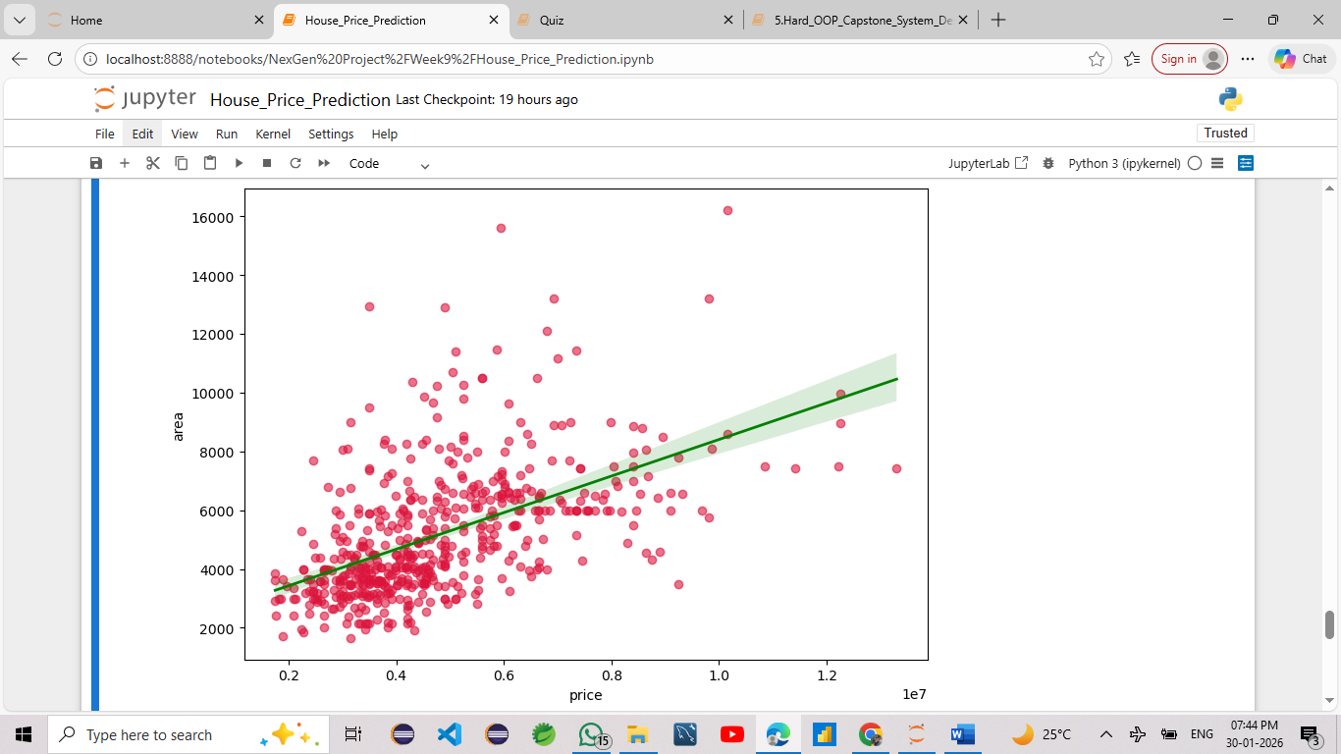
Conclusions from the above plot
-> Trend: As the price increases, area also tends to increase.
-> Spread: There’s moderate dispersion — suggests other features may also influence price.
-> Linearity: Supports the assumption of linearity for linear regression.

  - Heatmap of Feature Correlations

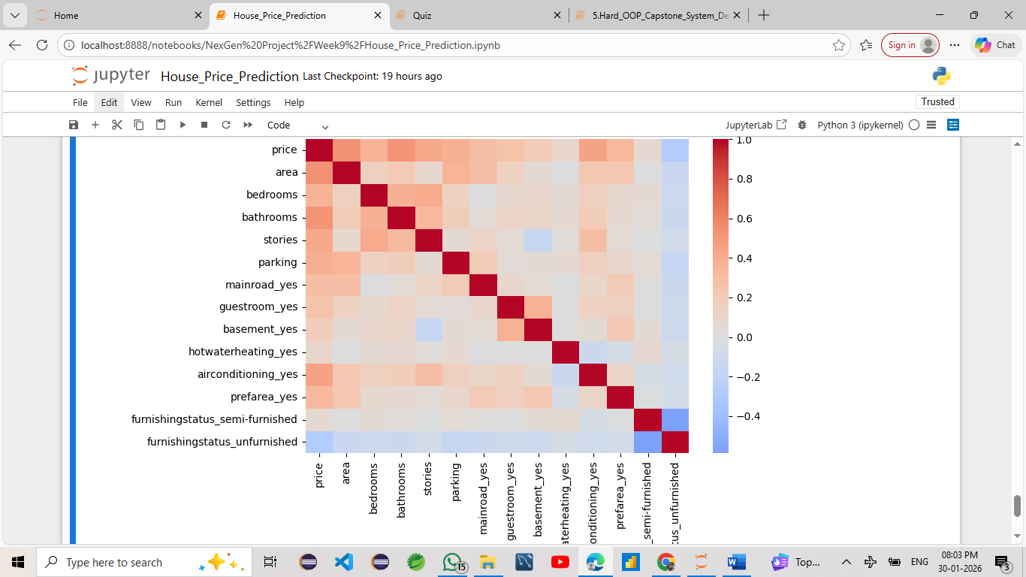
Conclusions
Strong Positive Correlation with price
-> Area shows the strongest positive correlation with price (near 1.0).
-> Larger houses tend to be more expensive.
-> bathrooms, bedrooms, and stories also show moderate positive correlations.
-> More features (rooms, floors) are associated with higher prices.
Weak or No Correlation
-> Features like parking, mainroad_yes, and guestroom_yes show weak to moderate correlation with price.
-> These may not be strong predictors individually, but could help in combination.
Negative Correlation
-> furnishingstatus_unfurnished is negatively correlated with price.
-> Unfurnished houses tend to cost less.
-> Conversely, furnishingstatus_semi-furnished shows a mild positive correlation.
-> Partial furnishing adds some value.

- Business Insights
• Real estate companies can use this model to estimate property prices
• Buyers can compare predicted prices with market prices
• Sellers can set competitive pricing
• The model supports data-driven real estate decisions

- Limitations
• Linear Regression assumes a linear relationship
• Performance may reduce for highly complex or non-linear data
• Model accuracy depends on data quality and feature engineering

- Conclusion
This project successfully demonstrates the application of Machine Learning using Linear Regression for predicting house prices. The complete ML pipeline—from data understanding and preprocessing to model training and evaluation—was implemented using Python. The results show that Linear Regression is effective for house price prediction when strong linear relationships exist in the data.

- Future Scope
• Implement Ridge and Lasso Regression
• Try advanced models like Random Forest
• Include more location-based features
• Deploy the model using a web application

