Barton Malow Field App

Daily Pre-Task Planner (PTP) User Guide
Version 1.0
Published: June 02, 2026
Audience: Foremen, Superintendents, Safety Leads, and Field Operations Stakeholders.
Scope: End-to-end standard PTP flow from sign-in through submission, review actions, export, and closed-state verification.

Table of Contents

PTP Workflow Overview
This guide documents a complete operational PTP lifecycle using captured production-like screens. Where role-dependent approval transitions were not directly exposed in this session, assumptions are explicitly called out.
- Business rule: Required fields block progression until completed.
- Business rule: Signatures are mandatory at crew and foreman review checkpoints.
- Business rule: Dashboard cards and table rows reflect active filters.
- Business rule: Export PDF is available from eligible records (typically closed/review-ready states).

Step 1. Sign In
Goal: Authenticate to the Daily Pre-Task Planner application.
Procedure:
- Open the login page.
- Enter valid credentials.
- Select Sign In to reach the dashboard.
Expected Result: Dashboard loads with summary cards and PTP list.
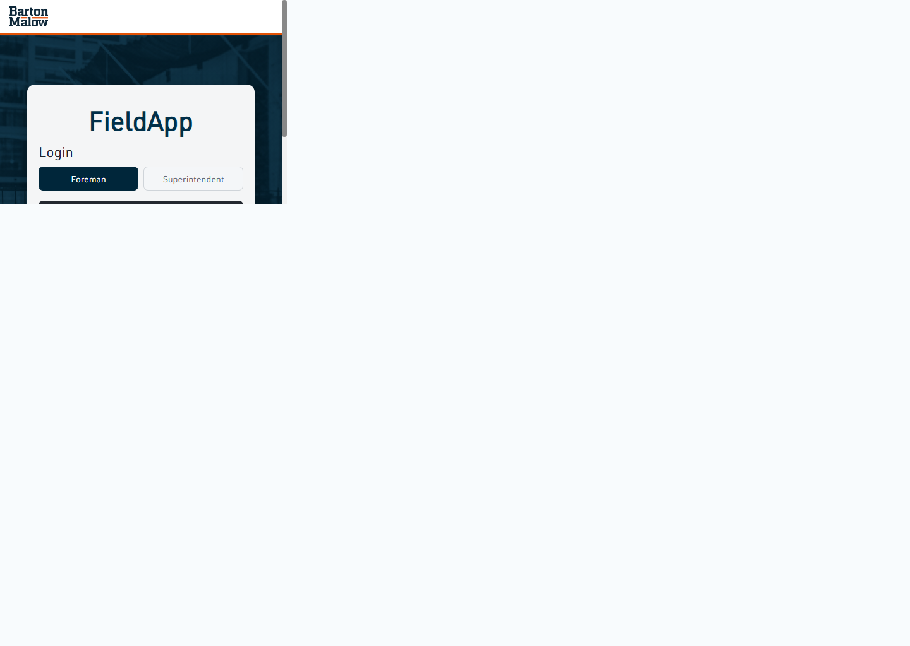
Figure 1: Step 1. Sign In

Step 2. Dashboard and Create New PTP
Goal: Start a new daily PTP process from the dashboard.
Procedure:
- Select Create New PTP.
- Review available start options and click Get Started.
Expected Result: Workflow opens at Activity & Control Measures.
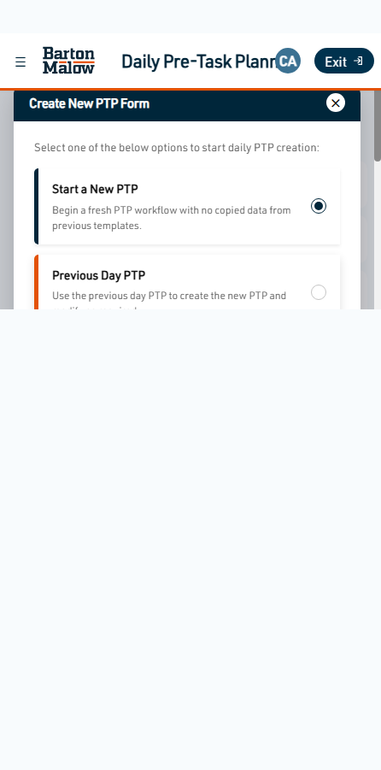
Figure 2: Step 2. Dashboard and Create New PTP

Step 3. Select Project and Enter PTP Details
Goal: Associate the PTP with a project and define the task name.
Procedure:
- Use Select Project / Pick other project site.
- Choose the project and enter Job/Task details.
Expected Result: Required fields validate and Step 1 becomes save-ready.
Figure 3: Step 3. Select Project and Enter PTP Details

Step 4. Activity & Control Measures
Goal: Review hazards and define controls for the work scope.
Procedure:
- Review each activity card.
- Select controls or mark cards as Not Applicable.
- Use Save and Next.
Expected Result: Activity controls save successfully and workflow advances.
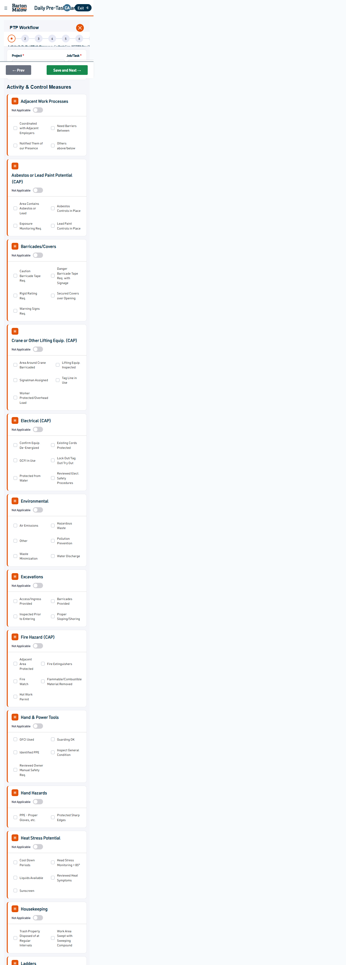
Figure 4: Step 4. Activity & Control Measures

Step 5. Requirements (Permits, Checklists, PPE)
Goal: Capture mandatory requirements before execution.
Procedure:
- Select at least one permit, checklist, or PPE item as applicable.
- Attach permit documents when required.
- Use Save and Next.
Expected Result: Requirements save successfully and workflow advances.
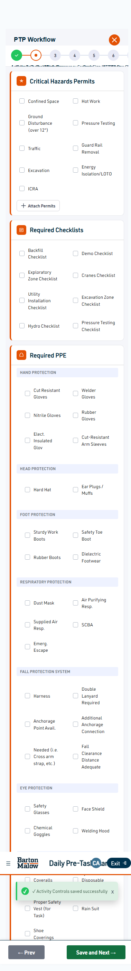
Figure 5: Step 5. Requirements (Permits, Checklists, PPE)

Step 6. Add Work Steps
Goal: Define how work will be performed safely.
Procedure:
- Select Add Work Steps for Each Task.
- Complete required Work Steps and Control Measures fields.
- Save the work step and proceed.
Expected Result: At least one work step appears in the list.
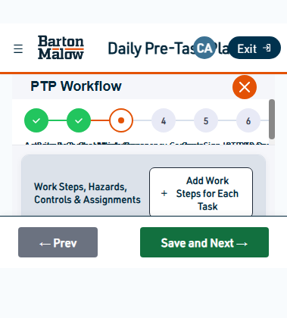
Figure 6: Step 6. Add Work Steps

Step 7. Emergency Contacts
Goal: Confirm emergency communications and muster point.
Procedure:
- Confirm Emergency Action Plan discussion.
- Provide Safety and Superintendent contacts.
- Define Emergency Muster Area and save.
Expected Result: Emergency contacts save successfully and workflow advances.
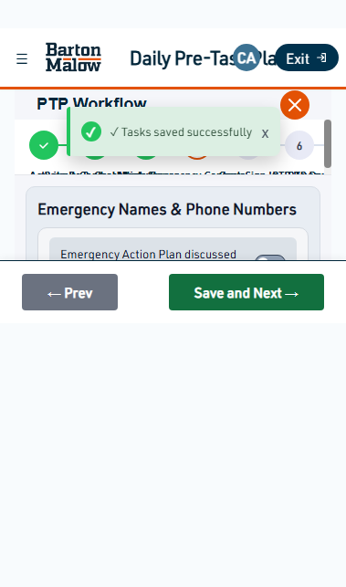
Figure 7: Step 7. Emergency Contacts

Step 8. Crew Sign In
Goal: Add all crew members and capture sign-ins.
Procedure:
- Add each crew member name.
- Open Sign In for each member.
- Provide comments/signature where required and confirm sign-in.
Expected Result: Crew members show Signed-in status.
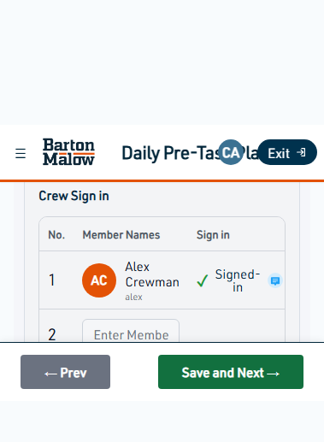
Figure 8: Step 8. Crew Sign In

Step 9. PTP Review and Submit
Goal: Complete foreman review and submit for review workflow.
Procedure:
- Review Foreman Review and PTP Review sections.
- Provide foreman signature.
- Select Submit for Review.
Expected Result: PTP returns to dashboard with Submitted status.
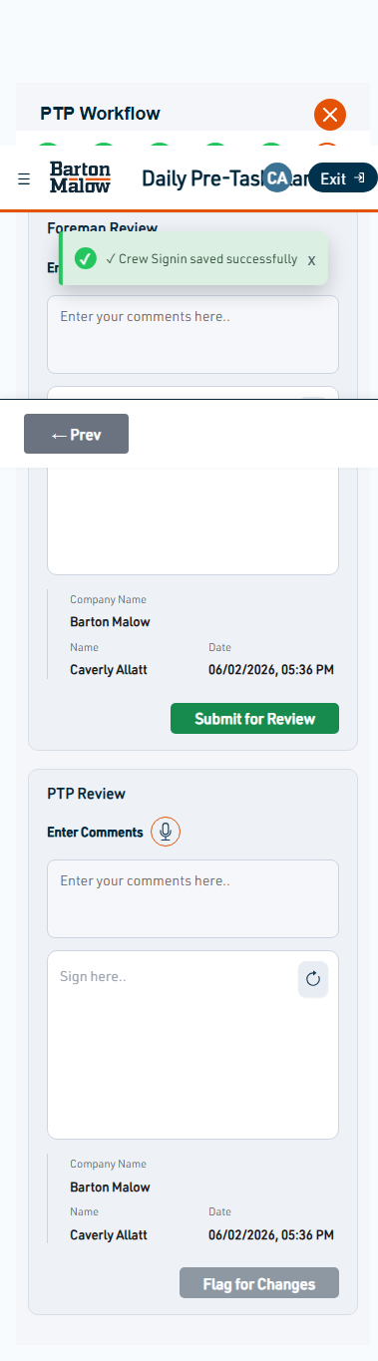
Figure 9: Step 9. PTP Review and Submit

Step 10. Status Updates on Dashboard
Goal: Track lifecycle states after submission.
Procedure:
- Review summary cards: In Progress, Submitted, Reviewed, Flagged, Closed.
- Use filters to locate records by status.
Expected Result: Counts and list rows align with selected filters.
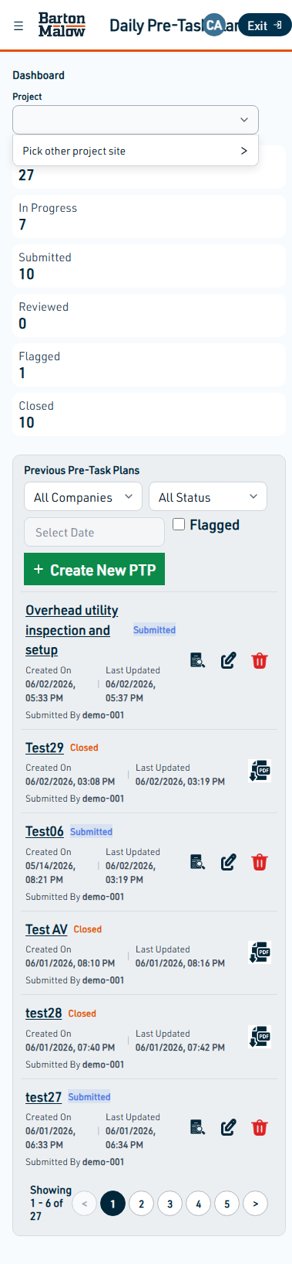
Figure 10: Step 10. Status Updates on Dashboard

Step 11. View PTP
Goal: Open complete read-only PTP details for verification.
Procedure:
- Select Preview from the dashboard list.
- Validate section order and captured signatures.
Expected Result: PTP opens with sections ordered as Hazards, Requirements, Work Steps.
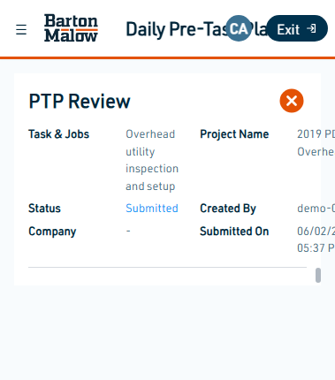
Figure 11: Step 11. View PTP

Step 12. Export PDF
Goal: Generate and download the printable PTP package.
Procedure:
- From a closed/submitted list row, select Download.
- In Export PTP modal, select Download PDF.
Expected Result: PDF file is generated for distribution/audit storage.
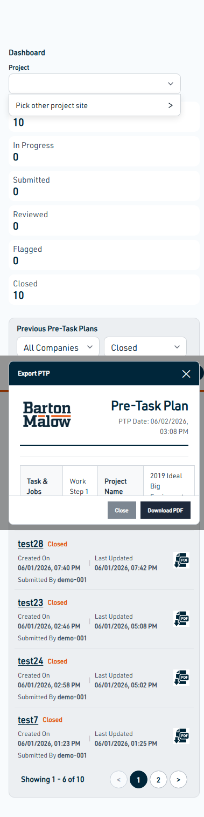
Figure 12: Step 12. Export PDF

Step 13. Close PTP and Verify Closed Status
Goal: Confirm closed records and closure controls.
Procedure:
- Use status filter Closed on dashboard.
- Confirm record appears with Closed badge and export action.
- If exiting an in-progress workflow, confirm close dialog behavior.
Expected Result: Record lifecycle is complete and available under Closed filter.
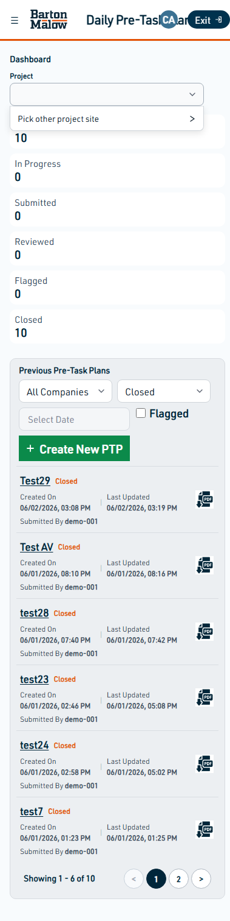
Figure 13: Step 13. Close PTP and Verify Closed Status

Save Draft, Flagging, and Close Behaviors
Observed behavior for draft/close in this environment: closing an in-progress workflow shows a confirmation dialog and warns that unsaved changes will be lost.
Figure 14: Close PTP confirmation dialog
Flagging behavior: if no review comment is provided, the system blocks the action with a validation message.
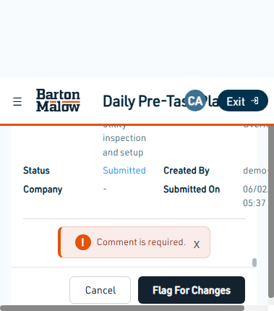
Figure 15: Flag for Changes validation

Common Validation Messages

Validation 1: Project is required
Validation Example 1

Validation 2: All activities must be reviewed
Validation Example 2

Validation 3: Select at least one permit/checklist/PPE
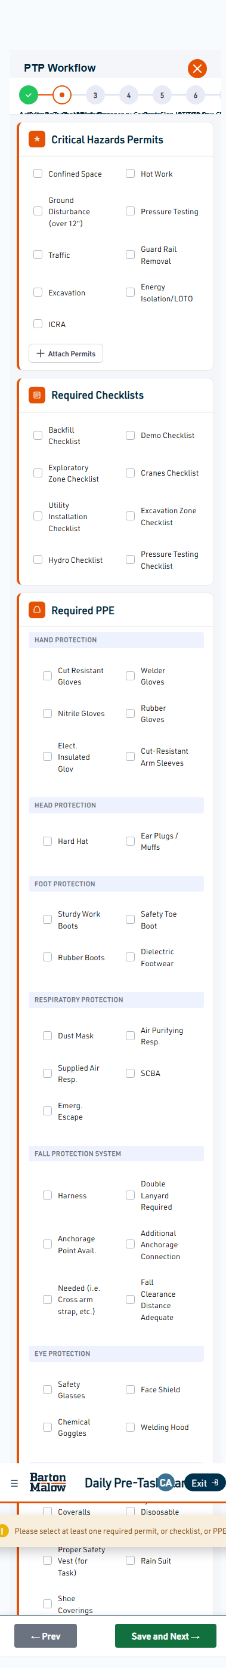
Validation Example 3

Validation 4: Safety/Superintendent required
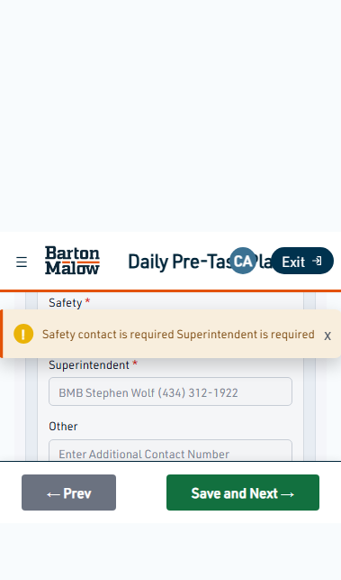
Validation Example 4

Validation 5: Crew signature required
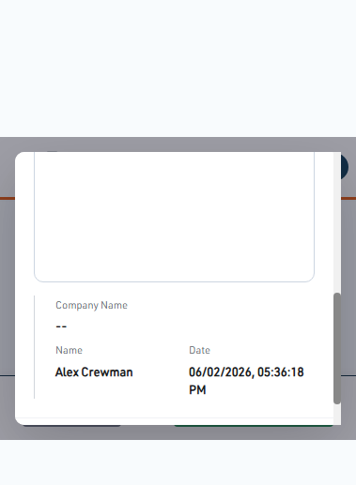
Validation Example 5

Validation 6: Foreman signature required
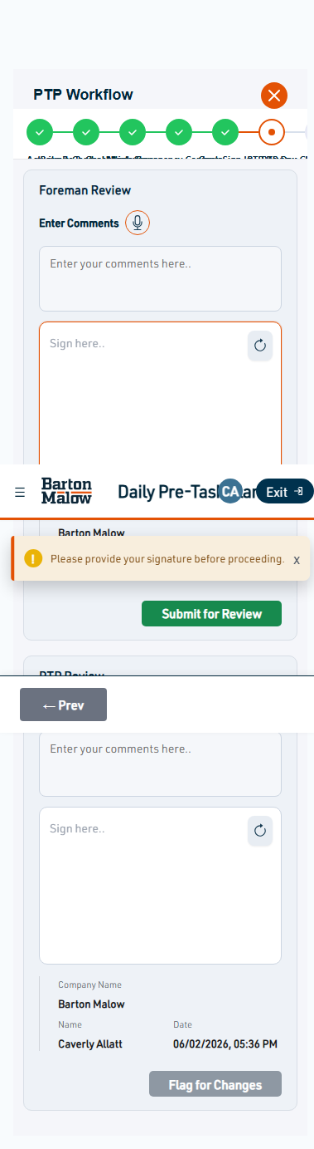
Validation Example 6

Validation 7: Flag for Changes comment required

Validation Example 7

Review and Approval Process
Review Process: Foreman completes signatures and submits the PTP for review. In review-enabled roles, supervisors can inspect details, provide comments, and either approve or flag for correction.
Approval Process (Assumption): After review approval, the record transitions to a close-eligible state and becomes available for final export and historical retrieval.

Figure 16: Review screen used during verification

FAQ

Why can I not proceed to the next step?
Required fields, checklist selections, or signatures are incomplete. Resolve the highlighted validation and retry Save and Next.

Why is Flag for Changes failing?
A review comment is required before a PTP can be flagged.

How do I verify a PTP is closed?
Use the Status filter = Closed on the dashboard and confirm the record appears with closed status and PDF download action.

Troubleshooting
- No records shown: clear project/status filters and refresh the dashboard.
- Signature issues: redraw signature and ensure the signing canvas is visible before submit.
- Export issues: reopen Export PTP modal and retry Download PDF from an eligible record status.
- Unexpected validation: verify all mandatory fields across the current step are populated.

Appendix A - Captured Screens
1. Step 1. Sign In -> 01-sign-in-page.png
2. Step 2. Dashboard and Create New PTP -> 02-dashboard-create-new-ptp-modal.png
3. Step 3. Select Project and Enter PTP Details -> 07-enter-ptp-details-project-selected.png
4. Step 4. Activity & Control Measures -> 03-ptp-workflow-step1-activity-control.png
5. Step 5. Requirements (Permits, Checklists, PPE) -> 09-step2-permits-checklists.png
6. Step 6. Add Work Steps -> 13-step3-work-step-added.png
7. Step 7. Emergency Contacts -> 14-step4-emergency-contacts.png
8. Step 8. Crew Sign In -> 20-step5-crew-signed-in.png
9. Step 9. PTP Review and Submit -> 21-step6-ptp-review.png
10. Step 10. Status Updates on Dashboard -> 25-dashboard-status-updates-and-ptp-list.png
11. Step 11. View PTP -> 23-view-ptp-preview-page.png
12. Step 12. Export PDF -> 27-export-pdf-popup.png
13. Step 13. Close PTP and Verify Closed Status -> 26-closed-status-and-export-pdf-download.png
Additional validation and scenario screens are included in docs/user-guide/screenshots.

