Multithreading Benchmark

Table of Contents
- Introduction
- Fundamental Concepts
- Project Architecture
- Core Components
- Benchmark Tests
- Performance Analysis
- Conclusions
- Technical specs.
- UI Screen Shoots
- References

1. Introduction
This project implements benchmark programs designed to evaluate the performance characteristics of multithreaded applications on modern multicore processors. The project includes several classic parallel computing problems and provides detailed timing analysis to understand scalability limits and thread pool efficiency.

Project Goals
- Measure performance gains from parallelization across different inputs.
- Demonstrate scalability limits as thread count increases.
- Analyze the overhead and efficiency of thread pool implementations.

2. Fundamental Concepts
Processes are independent execution units managed by the operating system. Each process has:
- Its own memory address space
- Separate resources (file descriptors, heap, stack)
- Complete isolation from other processes
Threads are lightweight execution units within a process. Threads share:
- The same memory address space
- Process resources (heap, file descriptors)
- Direct communication through shared memory

The main advantage of threads is efficient parallelism in a single application without the overhead of inter-process communication.

Concurrency means multiple tasks making progress, often by rapidly switching between them on a single core.
Parallelism means multiple tasks executing simultaneously on different cores. This project focuses on true parallelism on multiple CPU cores.

Race Conditions and Synchronization
When multiple threads access shared data, race conditions can occur where the outcome depends on unpredictable thread scheduling. This project uses several synchronization primitives:
std::mutex: Mutual exclusion lock ensuring only one thread accesses critical sections.
std::scoped_lock: RAII-style lock guard that automatically releases the mutex (lock/unlock).
std::condition_variable_any: Allows threads to wait for specific conditions.
std::atomic: Lock-free atomic operations for simple counters.

3. Project Architecture

The project is organized into several modular components:
Array.hpp - Generic array container with random initialization
MatrixParalel.hpp - Matrix data structure supporting parallel operations
ThreadPool.hpp - Worker thread pool implementation
Timer.hpp – High resolution timing utility
Tests.h - Benchmark test class

The implementation follows modern C++20 practices:
- Template based generic programming with concepts
- RAII for resource management
- Move semantics for efficiency
- Type safe interfaces using std::invoke and requires clauses

4. Core Components
Timer Class (Timer.hpp)
The Timer class provides microsecond precision timing with C++20's chrono library using
std::chrono::steady_clock.
This monotonic clock is not affected by system time adjustments making it ideal for performance measurements. The implementation uses:
- steady_clock::now(): Captures high-resolution timestamps
- duration_cast: Converts durations to milliseconds or nanoseconds
- std::variant: Stores either milliseconds or nanoseconds depending on duration (typesafe struct)
The timer automatically selects nanosecond precision for sub-millisecond operations, ensuring accurate measurements for fast operations while maintaining readability for longer tasks.
ThreadPool Class (ThreadPool.hpp)
The thread pool manages a fixed collection of worker threads that process tasks from a shared queue.
Architecture:
- Worker Threads: Created at construction, each runs thread_function() in a loop.
- Task Queue: std::queue<std::function<void()>> holds pending work.
- Synchronization:
std::mutex pool_mutex protects the task queue.
std::condition_variable_any enables efficient thread sleeping/waking.
- Shutdown Mechanism: Uses std::jthread with stop tokens for graceful termination.
Methods:
add_task(Func&& f, Args&&...args)
- Wraps function and arguments in a lambda.
- Uses perfect forwarding to preserve argument categories.
- Thread-safe queue insertion with automatic notification.
thread_function(size_t number, std::stop_token stoken)
- Waits on condition variable for tasks or stop request.
- Processes tasks in FIFO order.
- Exits gracefully when stopped with empty queue.

Need of a TP:
Creating threads is expensive (system calls, stack allocation). Thread pools help by reusing threads across many tasks, reducing overhead from aprox. 50-100 mircroseconds per thread creation to nearly zero per task submission.

Array Class (Array.hpp)
Generic container providing random initialized arrays for benchmark data.
Template Features:
- Concept constraint DefConstructibleOrTrivial ensures type compatibility.
- Constructor overloading for random generation and also initializer lists.
- Deduction guides enable CTAD (Class Template Argument Deduction).
Random Generation:
- std::random_device: Hardware entropy source.
- std::mt19937: Mersenne Twister PRNG (high quality, fast).
- std::uniform_real_distribution / std::uniform_int_distribution: Ensures uniform distribution across ranges.

Matrix Class (MatrixParalel.hpp)
Two-dimensional container optimized for parallel matrix operations.
Storage Strategy:
std::vector<std::vector<T>> _matrix
Row-major storage allows efficient row access and separate column extraction. The get_column() method builds column vectors on-demand for cache-efficient multiplication.
Memory Optimization:
- reserve() pre-allocates memory to avoid reallocations.
- emplace_back() constructs elements in-place.

- Benchmark Tests

Find Min/Max Parallel
Problem: Find minimum and maximum values in a large array using multiple threads.
Algorithm:
- Divide array into nr_threads equal chunks. 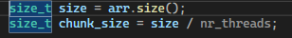
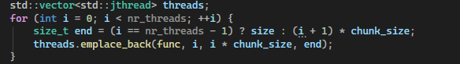
- Each thread finds local min/max in its chunk.
- Threads update global min/max under mutex protection.
- Join all threads and report timing.
Performance Characteristics:
- Work: O(n) - must examine every element.
- Synchronization: Minimal - each thread only locks mutex once for final update.
Scalability Analysis:
With lightweight work per element, this benchmark scales well initially but plateaus around 16-32 threads due to:
- Memory bandwidth saturation (all threads reading different cache lines).
- Lock contention during final updates.
- Diminishing returns when chunks become smaller than cache lines.

Matrix Multiplication In Parallel
Problem: Multiply two matrices A (m×n) and B (n×p) to produce result C (m×p).
Algorithm:
- Pre-compute all columns of matrix B (cache optimization).
- For each element C[i][j]:
Submit task to thread pool.
Task computes dot product of row i from A and column j from B.
- Use custom accumulate_helper iterator for element-wise multiplication and summation.
Implementation Detail:
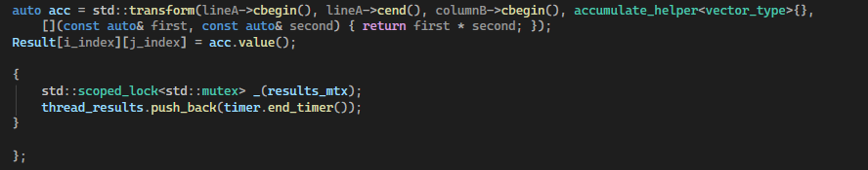

The accumulate_helper class acts as an output iterator that accumulates products, avoiding explicit loops while maintaining clarity.
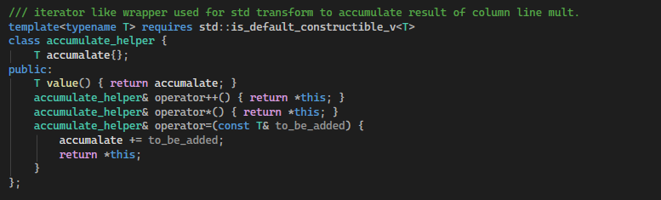
Performance Characteristics:
- Work: O(mnp) - standard matrix multiplication complexity.
- Parallelism: Up to m×p independent tasks (one per result element).
- Bottleneck: Task submission overhead when elements are small.
Scalability:
Matrix multiplication is parallel with excellent scalability properties:
- Each output element is independent.
- No synchronization needed during computation.
- Only mutex for timing results collection.
However, with small matrices, thread pool overhead dominates actual computation. Performance stabilizes when:
- Thread count exceeds available hardware cores (16-32 on typical systems).
- Task queue processing becomes the bottleneck.
- Cache coherency overhead increases.

Parallel Merge Sort
Problem: Sort an array using divide-and-conquer parallelism.
Algorithm:
- Recursively split array until depth reaches max_depth.
- At each level below max_depth, spawn two async tasks for left/right halves.
- Beyond max_depth, continue sorting serially to avoid thread explosion.
- Merge sorted halves in-place using auxiliary array.
Depth Control:
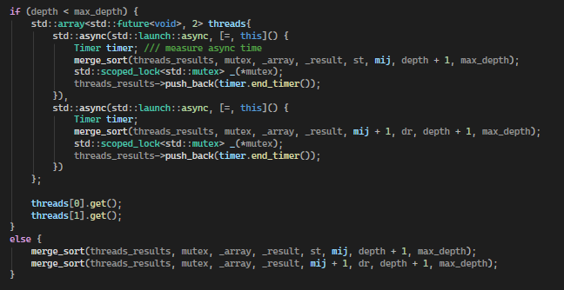
Without limiting parallelism depth, merge sort would create O(n) threads, overwhelming the scheduler. By limiting to depth 4, it creates at most 2^4 = 16 parallel tasks, matching typical core counts.
Performance Characteristics:
- Work: O(n log n) - standard merge sort.
- Memory: O(n) auxiliary space.
Scalability Issues:
Merge sort has limited parallel scalability because:
- The merge step is serial.
- Recursive task creation overhead.
- Diminishing work per task at deep recursion levels.

Monte Carlo Pi Estimation
Problem: Estimate pi by randomly sampling points in a unit square and checking if they fall within the inscribed circle.
Mathematical Basis:
- Circle area = pi*r*r = pi/4 (for radius 0.5).
- Square area = 1.
- Ratio of points in circle to total points is aprox pi/4.
- Therefore: pi is aprox. 4 x (points_in_circle / total_points).
Algorithm:
- Divide iterations (a very large number for a single thread to handle only) into parallel_split_number = nr_threads x 8 chunks.
- Each chunk independently generates random points and counts hits.
- Aggregate all chunk results.
- Calculate pi estimate from total hits.
Why Oversplit by 8x?
Splitting work into more chunks than threads provides:
- Better load balancing (shorter tasks complete first).
- Reduced idle time near completion.
- Smoother thread pool utilization.
Random Number Generation:
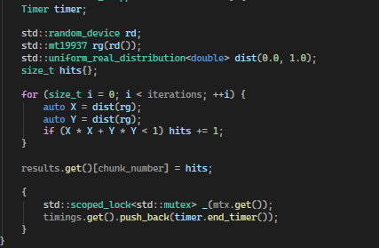
Each thread maintains its own PRNG (pseudo random nr gen) state, avoiding locking issues on a shared generator.
Performance Characteristics:
- Work: O(iterations) - very parallel.
- Convergence: Error decreases as O(1/sqrt(n)).
- Synchronization: None during computation, only final aggregation.
Scalability:
This is the most scalable benchmark because:
- Zero synchronization during computation.
- Independent random number generators per thread.
- Minimal memory access (only local variables).
- Work easily divisible.
Performance scales linearly until hitting hardware thread limits (16-32 threads), then plateaus as no more physical cores are available.

ThreadPool(TP) Benchmark
Problem: Measure thread pool overhead and scalability with synthetic CPU work.
Algorithm:
- Create baseline measurement with 1 thread.
- For thread counts (1, 2, 4, 8, 16, 32...):
  - Submit num_tasks work items.
  - Each performs work_iterations_per_task CPU operations.
  - Measure total completion time.
- Calculate speedup relative to baseline
CPU Work Function:

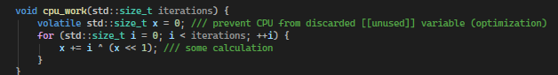
The volatile keyword prevents compiler optimization from eliminating the "useless" computation, ensuring actual CPU work occurs.

Speedup Calculation:
size_t speedup = baseline.first / t.first;
Ideally, speedup equals thread count (linear scaling).
In practice, it plateaus due to:
Amdahl's Law: If fraction “s” of work is serial, maximum speedup is:
Speedup less or equal with 1 / (s + (1-s)/p)
With “p” processors. Even small serial portions (task submission, completion counting) limit scaling.

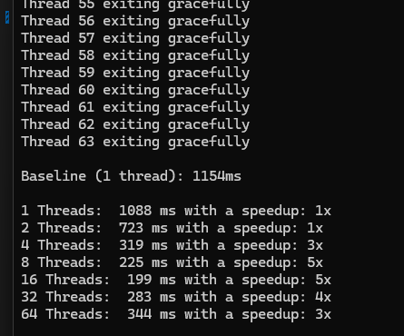
Why Scaling Stops at 16-32 Threads:
- Physical Core Limit: Modern CPUs have 8-32 physical cores.
Hyperthreading provides 16-64 logical cores.
Beyond physical cores, threads share execution units.
- Cache Contention:
L1/L2 caches are per-core.
L3 cache is shared.
More threads = more cache misses.
- Memory Bandwidth:
All cores share memory bus.
Saturates around 16-32 active threads.
- Scheduler Overhead:
OS context switching increases with thread count.
Thread pool queue contention.
- False Sharing:
Threads inadvertently share cache lines.
Causes cache invalidation ping-pong.

6.Performance Analysis

General Scaling Patterns
Across all benchmarks, three phases emerge:
Phase 1: Linear Scaling (1-8 threads)
- Each additional thread provides ~1x speedup.
- Minimal contention.
- Work perfectly partitioned.
Phase 2: Sublinear Scaling (8-16 threads)
- Speedup gains diminish.
- Synchronization overhead becomes visible.
- Cache effects emerge.
Phase 3: Plateau (16-32+ threads)
- No further speedup.
- Hardware limits reached.
- Overhead dominates benefits.

Benchmark-Specific Observations:
Min/Max Finding: Memory-bound, bandwidth-limited.
Matrix Multiplication: Compute-bound, scales well with large matrices.
Merge Sort: Limited by serial merge steps.
Monte Carlo: Near perfect scaling until core exhaustion.
ThreadPool Benchmark: Reveals pure scheduling overhead.

Optimal Thread Count
For CPU-bound tasks, optimal thread count is typically:
optimal_threads = physical_cores x (1 + wait_time / compute_time).
For pure compute (wait_time = 0), this equals physical core count.
The benchmarks confirm this, showing best performance at 8-16 threads on typical desktop CPUs.

7.Conclusions

Key Findings
- Thread pools are essential for avoiding thread creation overhead in task-parallel workloads.
- Memory bandwidth, not cores, often limits scaling for memory-intensive operations.
- Amdahl's Law is real - even tiny serial sections prevent linear scaling.
- Optimal thread count matches physical cores for CPU-bound work, confirming theoretical predictions.
- Problem characteristics matter - super parallel tasks (Monte Carlo) scale better than those with dependencies (merge sort).

Modern C++ Features Used
- C++20 Concepts: Type-safe template constraints.
- C++20 jthread: Automatic thread lifecycle management.
- CTAD: Class Template Argument Deduction for cleaner instantiation.
- Perfect Forwarding: Zero-overhead task submission.
- RAII: Automatic resource cleanup.
Practical Applications
These benchmarks demonstrate patterns applicable to real-world scenarios:
- Image processing: Similar to matrix operations.
- Scientific simulations: Monte Carlo methods.
- Data analytics: Min/max, sorting operations.
- Web servers: Thread pool request handling.

Future Improvements, potential enhancements:
- Work-stealing scheduler for better load balancing.
Current Implementation Problem:
The existing thread pool uses a single shared queue for all tasks. This creates bottlenecks. Every thread must lock the same mutex to get work, causing serialization.
Solution:
Each thread has its own local queue. When a thread runs out of work, it will steal tasks from other threads' queues.

How it works:
When calling add_task() from main thread (or any external thread):
- The scheduler picks a target queue :
  - Round-robin: Distribute evenly across all thread queues.
  - Random: Pick random thread's queue.
  - Least-loaded: Check queue sizes, pick emptiest.
  - Affinity-based: Always submit to same thread's queue (better cache locality).

- Lock that specific thread's queue and insert the task. Compared to current design:
- Current: All tasks go to ONE queue => ONE lock => contention.
- Work-stealing: Tasks distributed across N queues => N locks => much less contention.

- How Worker Threads Consume Tasks:
- Worker thread pulls from its own local queue (no lock needed - it owns the queue).
- Process the task.
- When local queue empty, thread randomly picks another thread and steals from the bottom of their queue (requires lock).
- The owning thread works from top of its queue, stealing one from bottom.

- Adding tasks (from main/external). Still needs locks, but distributed across N queues instead of 1.
- Consuming tasks (by workers): Mostly lock-free. Workers only lock when stealing, not when processing their own work.

Benefits:
- 95% lock-free: Threads only lock when stealing, not for normal work.
- Better cache locality: Threads keep working on related tasks.
- Automatic load balancing: Busy threads lose tasks to idle threads.
- Scalability: No central bottleneck.

- Lock-free data structures: Use of atomics instead of mutexes (lock-free queue).
- GPU acceleration comparison: Compare CPU threading vs CUDA/OpenCL.
- Power consumption analysis: Measure performance-per-watt at different thread counts.

8. Technical Specifications
Language: C++20
Key Libraries: <thread>, <mutex>, <chrono>, <random>, <algorithm> …
Synchronization: Mutexes, condition variables, atomics.
Timing Resolution: Nanosecond precision via std::chrono::steady_clock.
Thread Model: Thread pool with work queue.
Tested Platform: x86-64 multicore processors.

9. User Interface (QT CREATOR) Screen Shots:

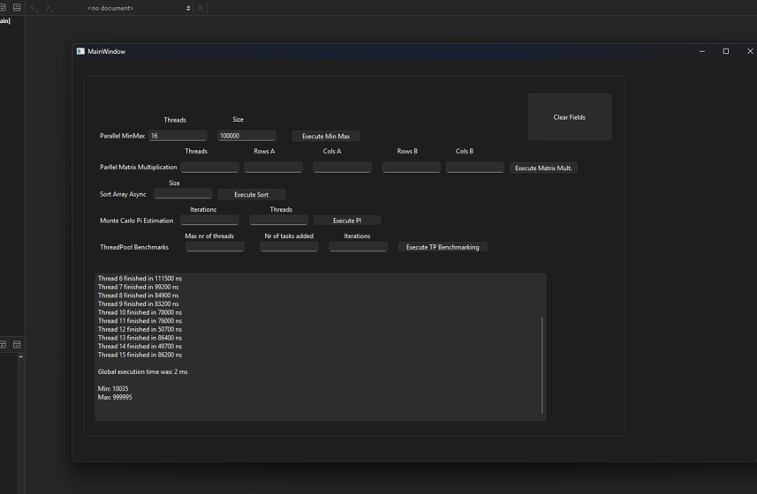
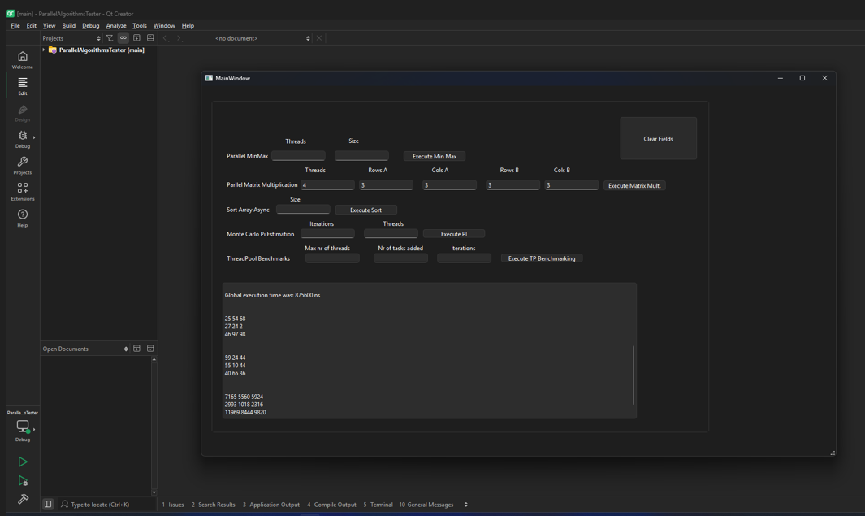
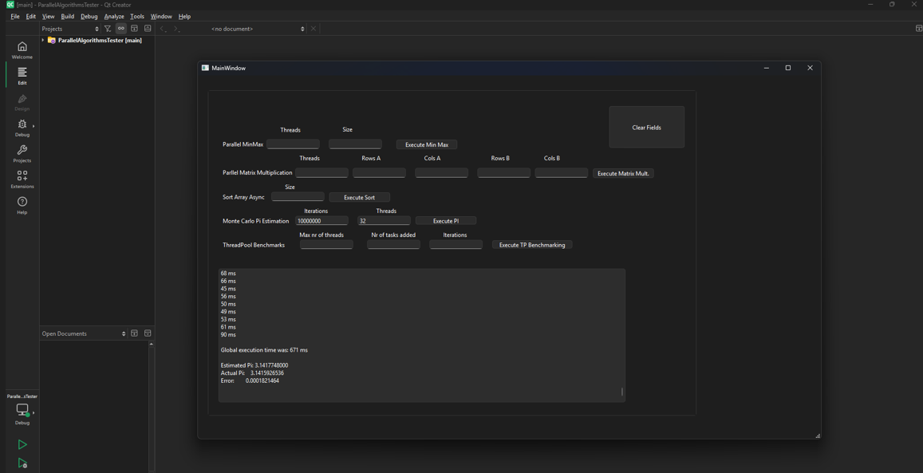
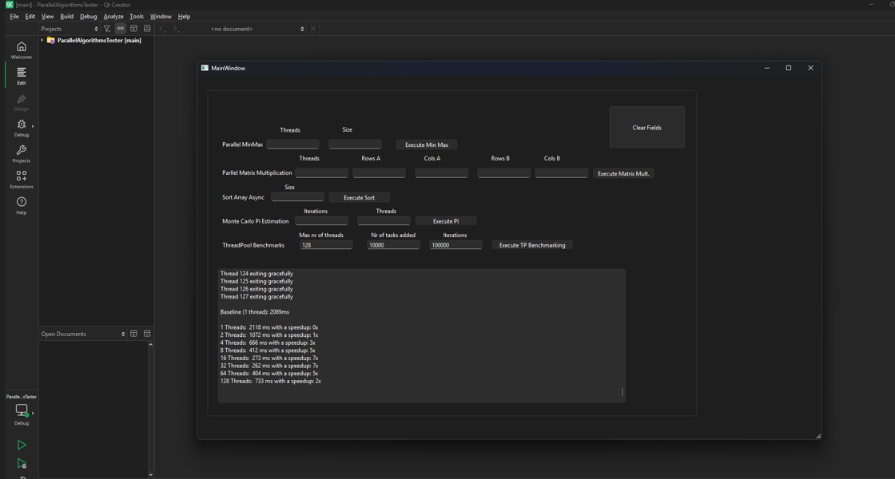

10. REFERENCES
https://cppreference.com
https://cplusplus.com
https://www.learncpp.com
https://www.youtube.com/watch?v=PLURfYr-rdU

