Assignment 3
Software Design
Warehouse Management System
Microservices Architecture with CQRS & Blazor WebAssembly
Author: Virag Raul
Group: 30433

1 Problem Definition
This assignment extends the Warehouse Management System from Assignments 1 and 2 by migrating from a monolithic Blazor Server application to a microservices-based architecture. The domain warehouse inventory, stock tracking, orders, and account management remains unchanged. The goal is to improve scalability, modularity, and maintainability.
Key architectural changes introduced in Assignment 3:
- Decomposition into independent microservices, each with its own database.
- CQRS (Command Query Responsibility Segregation) via MediatR.
- JWT-based authentication shared across all services.
- Blazor WebAssembly replaces Blazor Server as the frontend.
- Template Method pattern for data export; Command pattern for UI actions.
- FluentValidation pipeline for server-side input validation.
- Inter-service HTTP communication for event-driven notifications.

2 Analysis Phase Use Cases & Requirements

2.1 Functional Requirements
All requirements from Assignments 1 & 2 are preserved and extended:
- Users can add, edit, soft-delete, and restore product types (Items).
- NEW: When adding an item whose name matches a previously soft-deleted item, the system restores the old record instead of creating a duplicate.
- Users can add stock units in bulk; each unit receives an auto-generated serial number.
- Users can search stock units by product name or serial number.
- Individual units can be marked as Available, Reserved, Shipped, or Returned.
- Data can be exported as JSON, CSV, or XML via the Template Method export pipeline.
- The system sends email notifications after key operations for the logged-in account.
- Authentication uses JWT tokens; the Blazor WASM client stores the token and attaches it to every API request.
- Role-based access: Visitor (read-only), Seller (inventory ops), Admin (full access).

2.2 Use Cases

UC-1 Login / Register
Actor: Any user
Task: Submit email + password. AccountService validates credentials, returns a signed JWT token.
Result: Token stored in browser localStorage; all subsequent requests carry Authorization: Bearer <token>.

UC-2 Add / Restore Product Type
Actor: Admin, Seller
Task: Submit a new Item name. InventoryService checks for a soft-deleted record with the same name.
Result: If a deleted item exists it is restored (IsDeleted = false) rather than creating a duplicate. Otherwise a new Item is created.

UC-3 Add Stock Units
Actor: Admin, Seller
Task: Select a product type and enter quantity; InventoryService generates serial numbers and creates StockUnit rows.
Result: Stock counter incremented; units searchable by serial.

UC-4 Search Stock
Actor: Admin, Seller, Visitor
Task: Enter a product name or partial serial number.
Result: Filtered list of matching Stock Units returned by a MediatR Query handler.

UC-5 Soft Delete
Actor: Admin
Task: Mark individual stock units or entire Item categories as deleted.
Result: Records hidden via EF query filters; restorable via UC-2.

UC-6 Export Data
Actor: Admin, Seller
Task: Select format (CSV / JSON / XML) and click Export.
Result: InventoryService executes the Template Method export pipeline and returns the file.

UC-7 View Email Notifications
Actor: Admin, Seller
Task: Navigate to account email inbox.
Result: AccountService returns stored AccountEmail records for the logged-in user.

3 Design Phase

3.1 Architecture Overview
The application follows a microservices architecture. Each service is an independent ASP.NET Core Web API project with its own SQL Server database. The Blazor WebAssembly client communicates with services over HTTPS. Services communicate with each other via plain internal HTTP calls (no JWT required for service-to-service).
Service | Responsibility & Database
AccountService | Authentication (login/register), account management, email notifications storage. DB: AccountDb (Accounts, AccountEmails).
InventoryService | Items, StockUnits, Stocks CRUD, soft-delete/restore logic, data export. DB: InventoryDb.
OrderService | Orders, OrderLines, Receipts, ReceiptLines. DB: OrderDb.
NotificationService | Receives WarehouseEvents from other services, calls AccountService to persist email notifications.
Warehouse.Client | Blazor WebAssembly SPA no server-side rendering. Calls each service via typed HttpClient.
Warehouse.Shared | Shared library: DTOs, Commands/Queries, Result<T>, enums, ValidationBehaviour, JwtExtensions, CurrentUser.

3.2 Authentication — JWT Flow
A single shared secret is configured in every service's appsettings.json under CreateJWT:Token. The Warehouse.Shared.Auth library exposes AddSharedJwtAuth() which each service calls once in Program.cs to register JWT Bearer validation. Only AccountService generates tokens; all other services only validate them.
- Client sends login request to AccountService (no token needed).
- AccountService returns a signed JWT string.
- Blazor client stores the token in localStorage via Blazored.LocalStorage.
- JwtAuthStateProvider reads the token and updates the CascadingAuthenticationState.
- AuthTokenHandler (DelegatingHandler) attaches Authorization: Bearer <token> to every outgoing HttpClient call automatically.
- InventoryService / OrderService validate the token using the shared secret — no call to AccountService needed.

3.3 CQRS with MediatR
Every service separates read and write operations into distinct MediatR request types:
Type | Example
Command (write) | CreateItemCommand, UpdateItemCommand, DeleteItemCommand, LoginCommand, RegisterAccountCommand
Query (read) | GetAllItemsQuery, GetItemByIdQuery, GetStockQuery, GetOrdersByCustomerQuery
Pipeline Behaviour | ValidationBehaviour<TRequest, TResponse> — runs FluentValidation before every handler; returns Result.MultipleFails on errors.

Controllers are thin they map the incoming DTO to a Command/Query, call _mediator.Send(), and unwrap the Result<T>

3.4 Result<T> & Validation
All handlers return Result or Result<T> (defined in Warehouse.Shared.Common):
- Result.Success() / Result<T>.Success(value) operation succeeded.
- Result.Fail(msg) system-level error (single message).
- Result.MultipleFails(failures) FluentValidation field errors as Dictionary<string, List<string>>.
The Blazor client inspects IsSuccessful, then renders FieldErrors inline per field or shows ErrorMsg as a banner alert.

3.5 Design Patterns

Template Method Export Pipeline
BaseExporter<T> defines the skeleton: Transform() is abstract; Export() seals the flow. Subclasses implement only the format-specific transformation:
- CsvExporter<T> reflects properties via Type.GetProperties(), builds comma-separated output.
- JsonExporter<T> uses System.Text.Json with WriteIndented = true.
- XmlExporter<T> uses XmlSerializer.
The base class owns the orchestration; subclasses cannot reorder the steps.

Command Pattern Blazor UI Actions
Every button click in the Blazor client constructs a command object (shared DTO) and POSTs it to the backend. The controller maps it to a MediatR IRequest<Result<T>> and dispatches via mediator.Send(). This decouples UI event handling from service logic.

Observer Pattern Event Notification
InventoryService and OrderService publish a WarehouseEvent (containing AccountId, AccountEmail, Action, Description) to NotificationService via HTTP POST after state-changing operations. NotificationService forwards the payload to AccountService's internal endpoint, which persists an AccountEmail record. No JWT is required on internal endpoints.

Strategy (preserved from Assignment 2)
IExportStrategy and concrete ExportCSV / ExportJSON / ExportXML classes are retained inside the Template Method hierarchy as the format-specific Transform() implementations.

Repository / Unit of Work (preserved)
Each service's EF DbContext acts as the unit of work. DbSet<T> properties act as typed repositories. Each service owns only the entities relevant to its bounded context.

3.6 Entity-Relationship Overview (per service)
Service DB | Tables
AccountDb | Accounts (Id, Email, PasswordHashed, AccountType, IsDeleted, CreatedAt), AccountEmails (Id, AccountId FK, EmailContent)
InventoryDb | Items (Id, Name, Description, ReferencePricePerItem, IsDeleted, CreatedAtTime), StockUnits (Id, ItemId FK, SerialNumber, CurrentPrice, Note, Status, IsDeleted), Stocks (Id, ItemId FK, Quantity >= 0)
OrderDb | Orders (Id, CustomerId, SellerId, Status, CreatedAtTime), OrderLines (Id, OrderId FK, StockUnitId, Quantity), Receipts (Id, OrderId FK, Subtotal, Tax, Total, BuyerEmail), ReceiptLines (Id, ReceiptId FK, UnitPrice, LineTotal, Quantity)

4 Implementation Phase

4.1 Tools and Technologies
Technology | Purpose
C# / .NET 10 | Primary language and runtime
ASP.NET Core Web API | Each microservice exposes a REST API
Blazor WebAssembly | SPA frontend runs entirely in the browser
Entity Framework Core | ORM with code-first migrations, per-service DbContext
MediatR | CQRS dispatches Commands and Queries to handlers
FluentValidation | Declarative validation rules, integrated via ValidationBehaviour
AutoMapper | DTO Entity Command mapping
JWT Bearer (Microsoft.AspNetCore.Authentication.JwtBearer) | Stateless authentication shared across all services
Blazored.LocalStorage | Token persistence in the browser
BCrypt.Net | Password hashing in AccountService
SQL Server | Relational database (one per service)
Bootstrap 5 | UI styling for Blazor components

4.2 Solution Structure
- AccountService/ Application/Commands, Application/Queries, Controllers, Infrastructure/DbRepository, Migrations
- InventoryService/ Application/Commands, Application/Queries, Application/Export, Controllers, Infrastructure/DbRepository, Migrations
- OrderService/ Application/Commands, Application/Queries, Controllers, Infrastructure/DbRepository, Migrations
- NotificationService/ Application/Commands, Controllers
- Warehouse.Client/ Pages (Login, Register, Items, Stock, Orders, Export), Auth (JwtAuthStateProvider, AuthTokenHandler), Services (typed API clients)
- Warehouse.Shared/ Common/Result.cs, Common/ValidationBehaviour.cs, Auth/JwtExtensions.cs, Auth/CurrentUser.cs, DTOs/, Enums/

4.3 JWT Authentication — Implementation Detail
Warehouse.Shared.Auth.JwtExtensions.AddSharedJwtAuth(IConfiguration) registers JwtBearer validation using the shared secret. Every service calls this once in Program.cs followed by app.UseAuthentication() and app.UseAuthorization(). AccountService additionally registers JwtTokenGenerator (scoped) which produces tokens on successful login.
The Blazor client uses AuthTokenHandler (DelegatingHandler) registered on every named HttpClient. After login, JwtAuthStateProvider.NotifyLogin(token) saves the token to localStorage and signals CascadingAuthenticationState to re-evaluate, updating AuthorizeView components and @attribute [Authorize] pages immediately.

4.4 Soft-Delete & Restore Logic (New in Assignment 3)
When CreateItemCommandHandler receives a new item name, it first queries InventoryDb for an existing record matching that name with IsDeleted = true. If found, the handler sets IsDeleted = false, clears DeletedAtTime, updates LastModifiedTime, and returns the restored item's DTO. If not found, a new Item row is inserted. This prevents duplicate catalogue entries and preserves historical serial numbers linked to the original item.

4.5 Inter-Service Communication
Service-to-service HTTP calls use named HttpClients registered without the AuthTokenHandler (no JWT). Internal endpoints are not decorated with [Authorize]. The notification flow is:
- InventoryService or OrderService handler completes a write operation.
- Handler resolves IHttpClientFactory.CreateClient("NotificationService") and POSTs a WarehouseEvent containing AccountId, AccountEmail, Action, and Description.
- NotificationService handler receives the event and POSTs { AccountId, AccountEmail, Content } to AccountService's /api/account/internal/save-email endpoint.
- AccountService persists an AccountEmail row. No JWT validation occurs on internal endpoints.

4.6 User Manual

Login
Navigate to /login. Enter email and password. On success the navbar updates to show the current user's email and role. Field-level validation errors from the server are displayed inline beneath each input.

Register
Navigate to /register. Admin users see an Account Type selector; non-admins always register as Customer. Password confirmation is validated server-side by FluentValidation.

Items
Items list: displays all active product types. Admin and Seller can create items — if a deleted item with the same name exists, it is restored automatically. Admin can soft-delete items.

Stock Units
Search by product name or partial serial. Add stock by selecting a product and entering a quantity. Change unit status via dropdown.

Export
Select a format (CSV / JSON / XML) from the dropdown and click Export. The file is generated server-side via the Template Method pipeline and downloaded by the browser.

Email Inbox
Accessible by Admin and Seller. Shows all notification emails stored for the logged-in account.

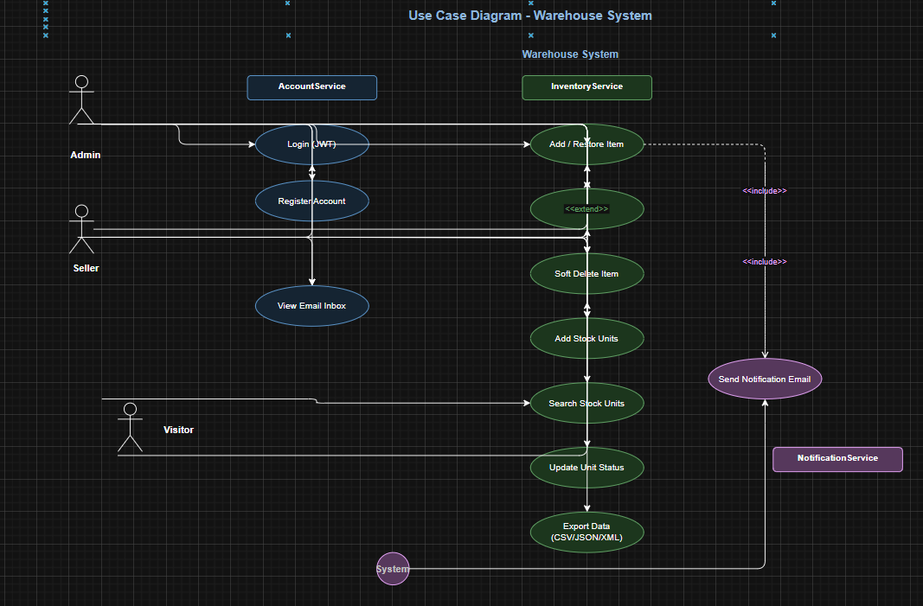

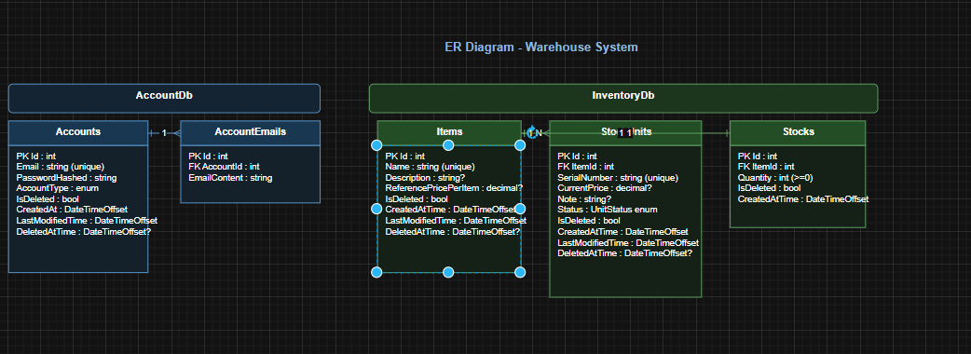
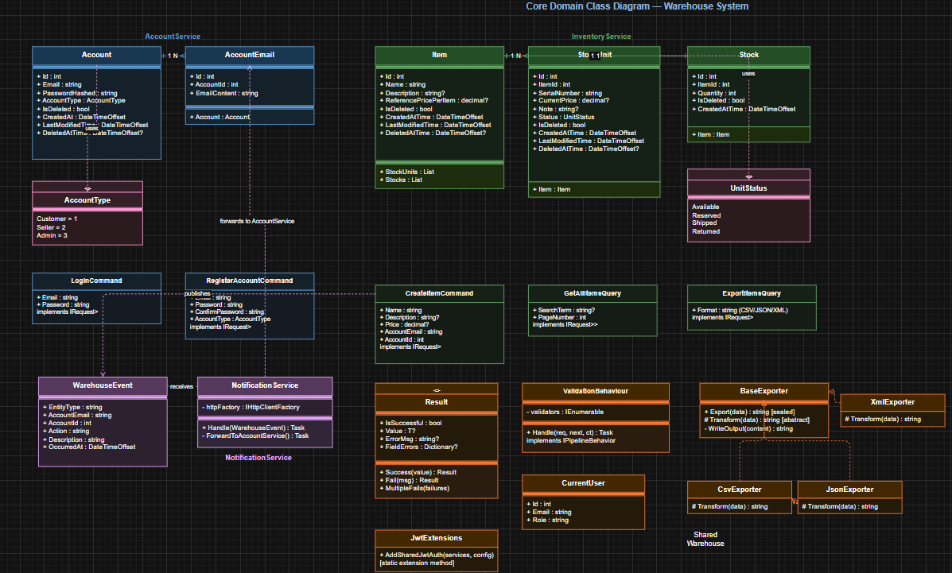
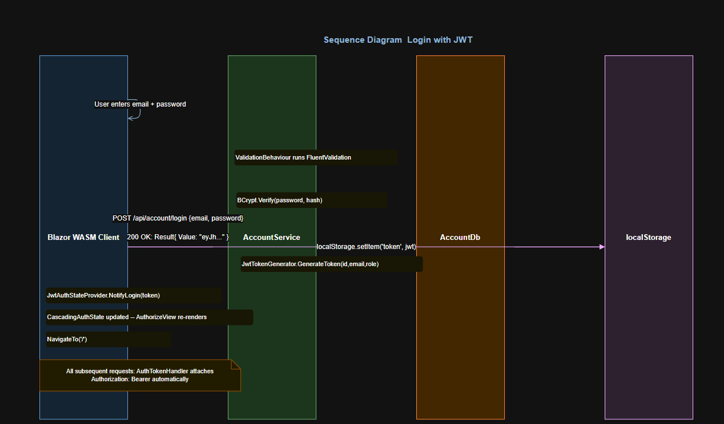

5 Testing and Validation

5.1 Unit Tests
Each service includes an xUnit test project. Tests use Moq to mock repository dependencies and verify both Command and Query handlers in isolation.
Test | What it verifies
CreateItemCommandHandler — new item | Calls repository.AddAsync once; returns Success with ItemDto.
CreateItemCommandHandler — restore deleted | When a soft-deleted item with the same name exists, sets IsDeleted=false; does NOT call AddAsync.
GetItemByIdQueryHandler — found | Returns Success<ItemDto> with correct fields.
GetItemByIdQueryHandler — not found | Returns Fail with appropriate error message.
LoginCommandHandler — valid credentials | Returns Success<string> containing a non-empty JWT.
LoginCommandHandler — wrong password | Returns Fail without throwing an exception.
RegisterAccountCommandHandler — duplicate email | Returns Fail; does not persist a second account.
ValidationBehaviour — invalid command | Returns MultipleFails with FieldErrors; handler is never invoked.

5.2 Manual Integration Tests
Scenario | Expected Result
Login with valid credentials | JWT returned; navbar shows email; protected pages accessible.
Login with wrong password | 400 Bad Request; error message displayed on login page.
Register with mismatched passwords | Field error shown under Confirm Password; no account created.
Create item with duplicate deleted name | Item restored; no duplicate row in DB.
Add 3 stock units to an item | 3 StockUnit rows created with unique serials; Stock.Quantity += 3.
Export items as CSV | File downloaded; headers and rows match current Items data.
Access /admin page as Seller | 403 Forbidden; redirected to Not Authorized page.
Notification after item creation | AccountEmail row created in AccountDb for the logged-in user.

