C# Lesson one

Hello, my name is kieran, I am going to take you through the basics of the programming language c#.

Here is a script I have just written

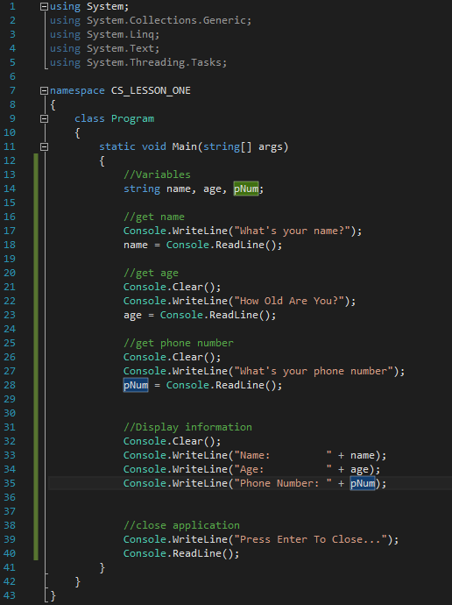

Its ok if you do not understand any of that because in this lesson that is what you are going to learn to do, or something similar

Getting Started With C#

The first thing to know is that this is a console application, meaning that it will run only in the console of your computer (and no you can’t run cmd commands in this console, so don’t try, thanks)

So, open visual studio, hit “File > New > Project” give it a name, make sure you have console application selected with C#, it should look something like this

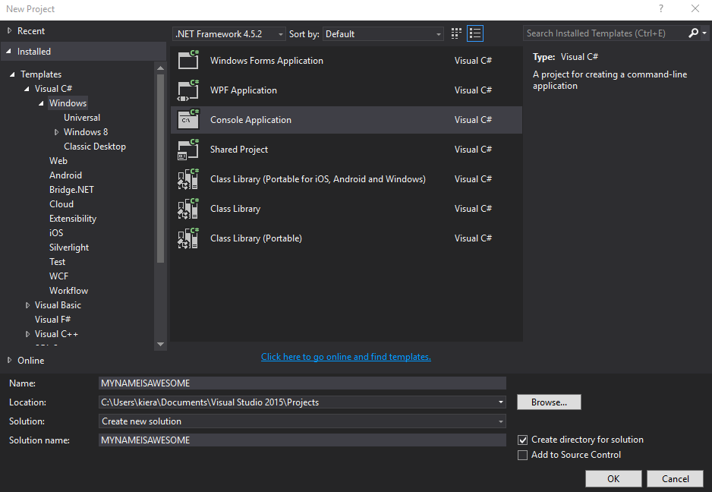

Once you have that opened, visual studio will create a bunch of code for you so that when you start coding you don’t have to do it in zeros and ones.

Once your document has loaded, you can start adding code

The Fun Begins

Ok, so you have a C# application loaded and you don’t have a clue what your doing, that’s fine.

Follow these simple steps and you can create your first program in minutes