**MIS 6308 – System Analysis and Project Management**

**“HR360”**

**GROUP 3**

Surya Raja Harshitha Achanta

Arun Chakravarthi Ravichandran

Vignesh Rajasekaran

Contents

**Executive Summary** 3

**Problem Statement** 4

**Business process model using BPMN for the key business processes** 7

**Use Case Diagram** 8

**Use Case Description** 9

**Context Diagram for the proposed system** 15

**Data Dictionary** 16

**Class Diagram** 18

**Sequence Diagram** 19

**Functional Specification Document for the proposed system** 22

**Interface design** 24

**Database design** 29

**Complete Class Diagram** 32

**Software Design:** 33

**Meeting Overview:** 39

# **Executive Summary**

The planned cloud-based platform HR360 is intended to automate and streamline HR procedures while connecting with the departments of learning and development, research and development, and finance. The platform would include several innovative functions that are not present in current HR management systems.

HR process management can be time-consuming and error-prone, which lowers productivity and efficiency. By offering a comprehensive and integrated HR management solution that automates and simplifies numerous HR activities, HR360 seeks to solve this issue. To build an all-encompassing and well-rounded HR management system, the platform would interface with other departments including learning, development, and finance.

The platform would have several capabilities, including automated performance management, extensive employee training and development programs, and administration of pay and benefits. The platform's features could be altered to meet the unique requirements of each company.

The main goal of HR360 is to increase the efficacy and efficiency of HR processes, which will boost output, reduce costs, and improve business outcomes. The platform would eliminate errors, save time, and offer a cost-effective solution for HR management by automating and streamlining HR procedures. Through the platform's integration with other departments, an integrated HR management system would be created, facilitating improved internal coordination and communication.

Training and assistance for the platform's users would be a part of the development and implementation of HR360, assuring the platform's usability and accessibility. The platform would be cloud-based, enabling remote access, and obviating the requirement for on-site infrastructure.

In conclusion, HR360 is a suggested cloud-based platform aimed to automate and expedite HR procedures, connecting with other departments to build a thorough and well-rounded HR management system. Users of the platform would receive training and support, and the platform's features would be adaptable to each organization's unique needs. The platform would raise the efficacy and efficiency of HR procedures, which would boost output, reduce expenses, and improve company results.

# **Problem Statement**

**The Problem**

HR departments are accountable for various duties, including hiring, training and development of employees, salary and benefits, and performance management. These procedures sometimes have a high error rate, which lowers production and efficiency. Additionally, manual processes are time-consuming, which detracts from the completion of other crucial business tasks. To automate and streamline their HR procedures, businesses are constantly looking for innovative solutions.

**Objectives**

The main goal of the suggested solution, "HR360," is to provide an automated and streamlined cloud-based platform for HR activities. A comprehensive and well-rounded HR management system would be created by integrating the platform with other departments, including learning and development, research and development, and finance.

**Scope**

The project's scope would include developing and implementing the "HR360" platform. The platform would include functions for hiring, staff training and development, pay and benefits, and performance management. To build a complete and well-rounded HR management system, the platform would also interface with other departments including learning and development, research and development, and finance. The scope would also cover user assistance and training.

Several HR procedures, including the following streamlined and automated procedures are:

1. Recruitment: The software would automate every step of the hiring process, from publishing open positions to tracking and vetting applicants.
2. Employee development and training: The platform would offer a thorough training program for staff members, complete with online courses and virtual training sessions.
3. Payroll, benefits administration, and employee self-service would be automated by the platform in compensation and benefits.
4. Goal setting, performance monitoring, and feedback would all be automated by the platform for performance management.

To build a complete and integrated HR management system, the suggested platform would also integrate with other departments. For instance, the platform would interact with the learning and development division to offer staff a thorough training program. To automate payroll and benefits administration, it would also interface with the financial department.

**Business Needs**

Several business requirements would be met by the suggested solution, including:

1. Enhanced productivity and efficiency: By automating and streamlining HR procedures, the platform would cut down on errors and free up time, enhancing productivity and efficiency.
2. Wide-ranging HR management: By linking with other departments, the platform would develop a comprehensive HR management system, enabling greater coordination and communication throughout the firm.
3. Cost-effective HR management solution: By eliminating the need for manual processes and cutting down on errors, the platform would offer a cost-effective HR management solution.

# **Business process model using** **BPMN for the key business processes**

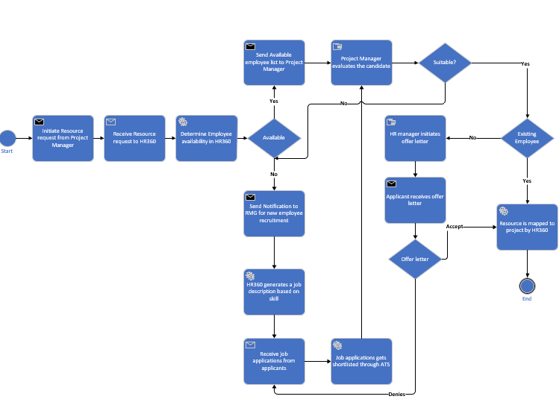

# **Use Case Diagram**

# **Use Case Description**

**Use Case Name: Sign In**

Primary Actor: Employee

Brief Description: Employee will be able to log in to the System.

Trigger: Login button is clicked

**Normal Flow of events:**

1. The employee opens the HR360 portal.

2. User presses the sign-up button

3. User signs in using the exiting username.

4. User enters the password.

**Exception Flow:**

Flow 1:

1. If the credentials are wrong the user is asked to re-enter the credentials.

Flow 2:

1. If the credentials are correct the user is navigated to the homepage.

**Use Case Name: Raise resource request.**

**Primary Actor**: Project Manager

**Brief Description**: The user will be allowed to raise a resource request against a project requirement.

**Trigger**: Clicking on the raise request button

**Normal Flow of events**:

1. User navigates to the resource management tab from the home page.

2. User clicks on the raise resource request button

3. User selects the project and the skills required for the position.

4. User submits the request.

**Use Case Name: Search and select a resource.**

**Primary Actor**: Project Manager

**Brief Description**: The user will be allowed to select a resource and map to the project based on skill set.

**Trigger**: User submitting the resource request.

**Normal Flow of events**:

1. User submits a resource request at the portal

2. The available resources matching the skill set and requirements are displayed.

3. User is allowed to select the resources and map them to the project.

**Exception Flow:**

Flow 1: If the requested resource is not available a request is raised to hire a new employee for that position.

**Use Case Name: Job Application Process.**

**Primary Actor**: Job Applicant

**Brief Description**: Any person who wants to apply for a job for the posted job vacancy.

**Trigger**: User clicks submit job application button

Normal Flow of events:

1. User navigates through the job portal

2. User selects the job title to view the description.

3. User is allowed to fill in the required details and attach a resume along with the details

4. User shall click the submit job application button

**Exception Flow**:

1. If the submit job application button is clicked without the required fields, then the user is given an error message.

**Use Case Name: Onboarding**

**Primary Actors**: Job Applicant, Project Manager, HR Manager

**Brief Description**: User shall be able to onboard and be mapped into the project.

**Trigger**: Accepting/Rejecting the offer

**Normal Flow of events:**

1. User is notified about the offer details.

2. User will be able to accept / reject the offer issued by the HR.

3. User shall upload required documents.

4. User is onboarded and mapped to the project.

**Exception Flow**:

1. If the user rejects the offer letter new job applicants are considered for an interview process.

**Use Case Name: Track Finances.**

**Primary Actor**: CEO/CFO

**Brief Description**: The user shall be able to view the finance reports.

**Trigger**: User clicking the finance reports / finance dashboard tab.

**Normal Flow of events:**

1. User navigates through the home page

2. User selects the finance dashboard tab.

3. User can click on various filters to view the data accordingly

4. User can perform analytics on the data

**Use Case Name: Hiring**

**Primary Actor**: Resource Manager

**Brief Description**: The user will be able to hire resources.

**Trigger**: The user clicks the hire resource button from the HR tab.

**Normal Flow of events:**

1. User navigates through the homepage.

2. User opens the HR tab by clicking on it.

3. User can initiate a hiring process against a resource request.

**Include:** The background verification takes place as soon as the employee hiring process is started.

**Use Case Name: Update profile.**

**Primary Actor**: Employee

**Brief Description**: The user shall update the personal and skill information.

**Trigger**: User clicks the update profile button on the dashboard.

**Normal Flow of events:**

1. User navigates through the home page

2. User selects the update profile tab

3. User can update the personal and other related information on the relevant tabs.

4. User clicks on the save button to update the data

**Use Case Name: Apply for leave.**

**Primary Actor**: Employee

**Brief Description**: The user shall apply for leave/day off.

**Trigger**: The user clicks the LMS portal.

**Normal Flow of events:**

1. User navigates through the home page

2. User selects the leave management system tab from the dashboard.

3. User can click on the ‘Apply Leave’ button.

4. User selects the date for which he applies leave

5. User selects the category of leave.

6. User can type the reason for leave.

7. User can also attach files for proof from the same portal.

8. User clicks on Submit button to submit the leave.

**Extend**

Once the submitted leave request is approved it is reflected in the team calendar where the other team members are notified about the absence.

**Use Case Name: Project Planning**.

**Primary Actor**: Project Manager

**Brief Description**: Planning the project with respect to time and cost.

**Trigger**: The user clicks the project planning tab

**Normal Flow of events:**

1. User navigates through the homepage.
2. User clicks on the project planning tab
3. User creates a new project.
4. User creates a Gantt chart and sprint plan for the project
5. User saves the milestones.
6. User maps the resources to the project
7. User saves the project.

# **Context Diagram for the proposed system**

# **Data Dictionary**

**Data** **Associated with Use Case Name: Sign in**

Email id = Data element

Password = Data element

Email = [Verify | Don’t Verify]

**Data** **Associated with Use Case Name: Raising Resource request.**

Email id = Data element

Password = Data element

Email = [Verify | Don’t Verify]

**Data** **Associated with Use Case Name: Raising Resource request.**

Resource Request id = Data element

Request type = [Internal | External | Any]

Hiring Type = [Fresher | Lateral]

Priority = [High | Medium | Low]

Project ID = Data element

Employment Type = [Permanent | Contract | Intern]

Start Date = Data element

End Date = Data element

**Data** **Associated with Use Case Name: Search and select a resource.**

Status = [ Draft | Submitted | Approved | In process | Closed]

Skill set = Data element

Start Date = Data element

End Date = Data element

Description = Data element

Duration = End date + Start date

Total resource = Data element

Created by = Data element

Approver = Data element

**Data** **Associated with Use Case Name: Job Application Process**

Salutation = [ Mr. | Mrs. | Ms.]

First Name = Data element

Last Name = Data element

Nationality = Data element

National Id = Data element

Resume = Attachment

HR Admin = Data element

**Data** **Associated with Use Case Name: Update profile.**

Effective Date = Data element

Current Project = Data element

Relationship Type = Data element

Education details = Data element

Certificate details = Data element

HR documents = Attachments

**Data** **Associated with Use Case Name: Apply for Leave**

Leave date = Data element

Leave type = [Leave | Sick Leave | Flexi Holiday | Bereavement Leave | Paternity Leave | Loss of Pay]

Compensation off = Data element

Team calendar = Data element

# 

# **Class Diagram**

# 

# **Sequence Diagram**

1. **Sequence Diagram for Login:**

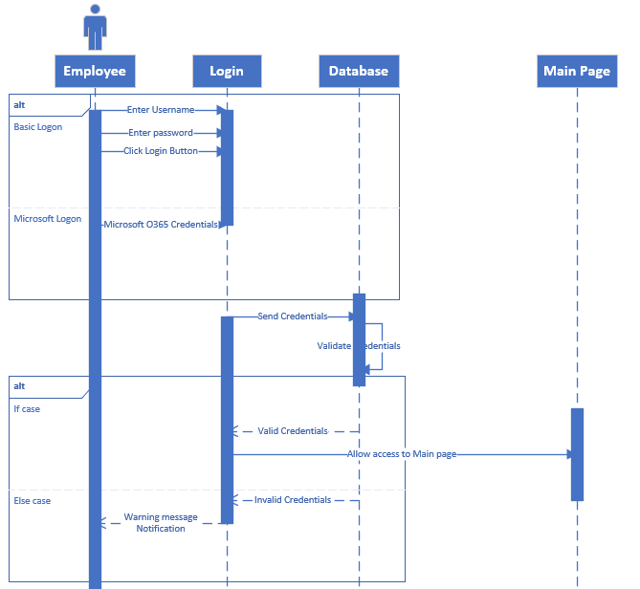

1. **Sequence Diagram for Project Management:**

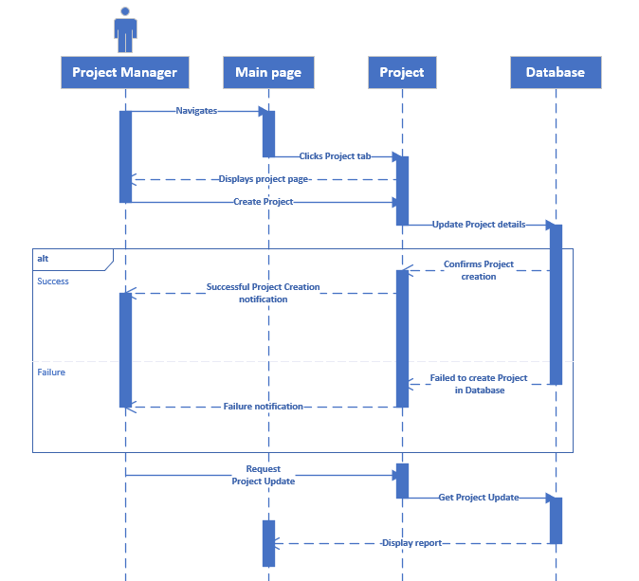

1. **Sequence Diagram for HR Central Page:**

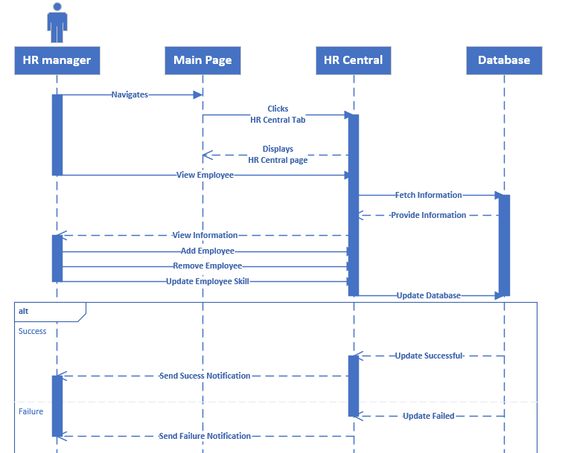

# **Functional Specification Document for the proposed system**

**Features:**

* Recruitment Management
* Employee Training
* Compensation and Benefits
* Performance Management
* Customization Flexibility

**Tasks:**

Step 1: Analyse current HR management system to identify the gaps and opportunities.

Step 2: Develop an initial prototype of the proposed system – HR360

Step 3: Test on a few samples and redefine the data model.

Step 4: Develop the fully functional version of HR360.

Step 5: Conduct Technical, Functional and User Acceptance Testing.

**Deliverables:**

* Fully functional Customizable HR360 platform.
* Training sessions and user documentation.
* Ongoing support and maintenance.

**Risks:**

* Initial market penetration due to existing HR systems.
* Integration with the existing non-HR systems might be time-consuming.
* Real time issues while developing the platform.

**Assumptions:**

* Innovative and customized solution.
* Integration of different models like HCM, P2P, CRM, PMS, EMS etc.
* Each customer's unique needs and requirements are met with the customization option.

**Deadlines:**

|  |  |
| --- | --- |
| Prototype Development | 8 weeks |
| Testing on samples | 3 weeks |
| Final Platform Development | 40 weeks |
| Testing | 8 weeks |
| Launch | 4 weeks |

# **Interface design**

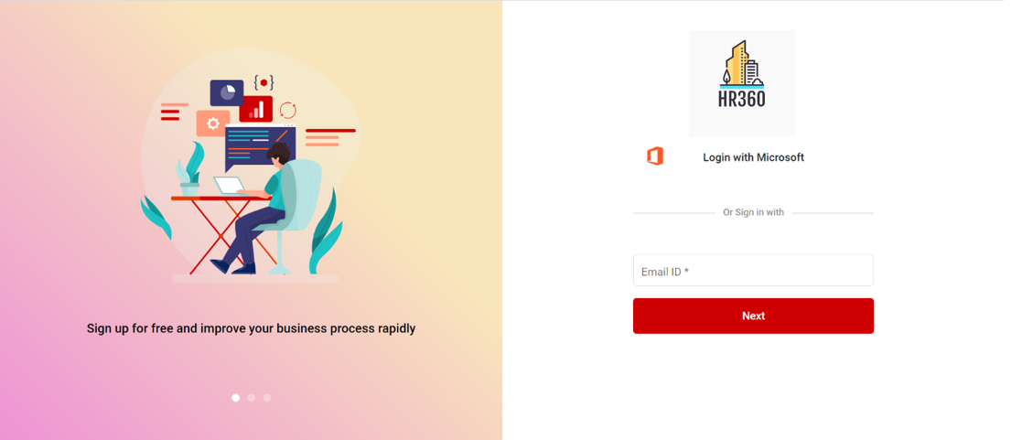

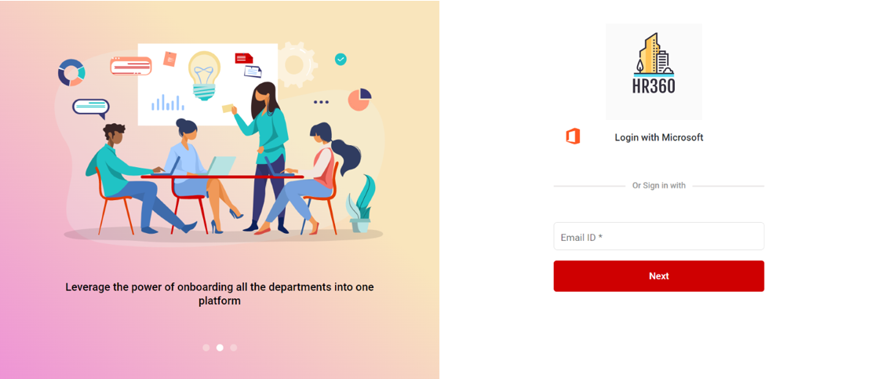

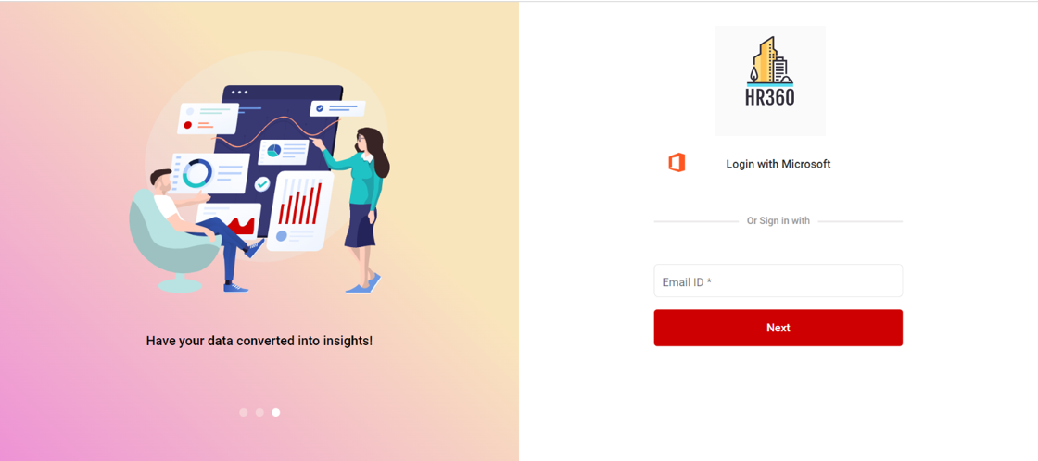

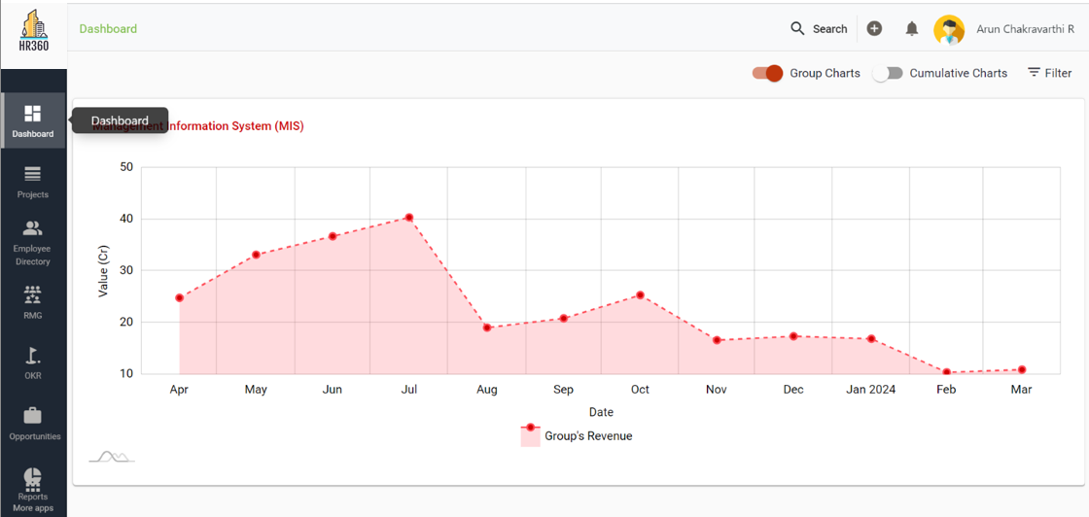

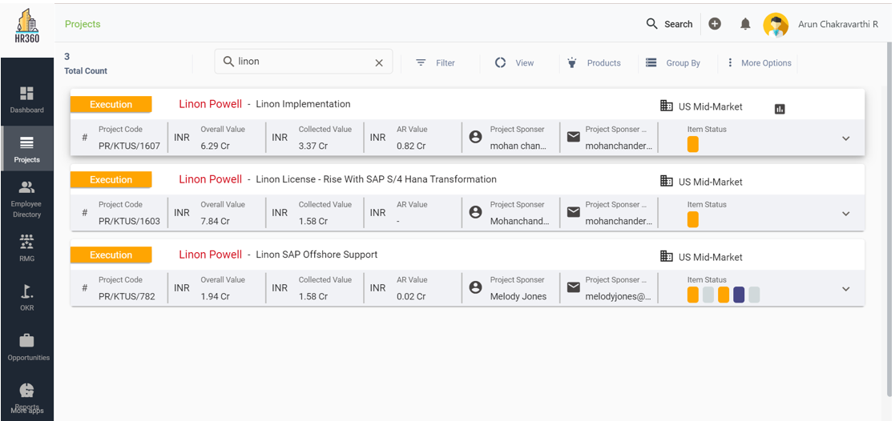

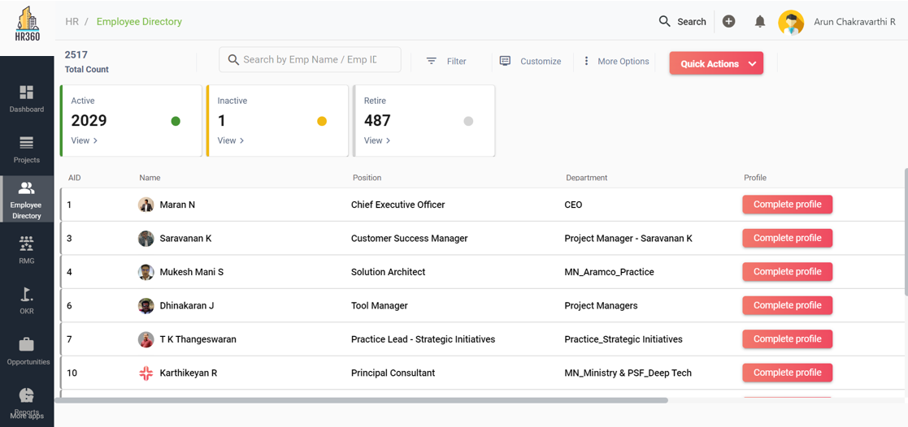

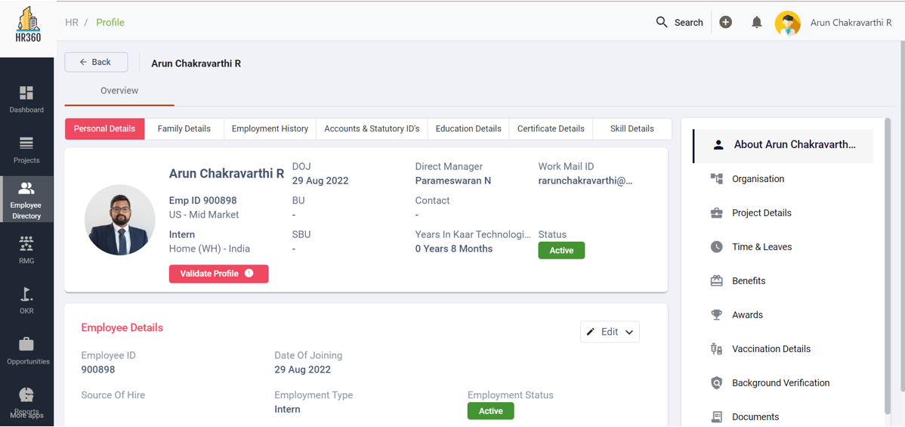

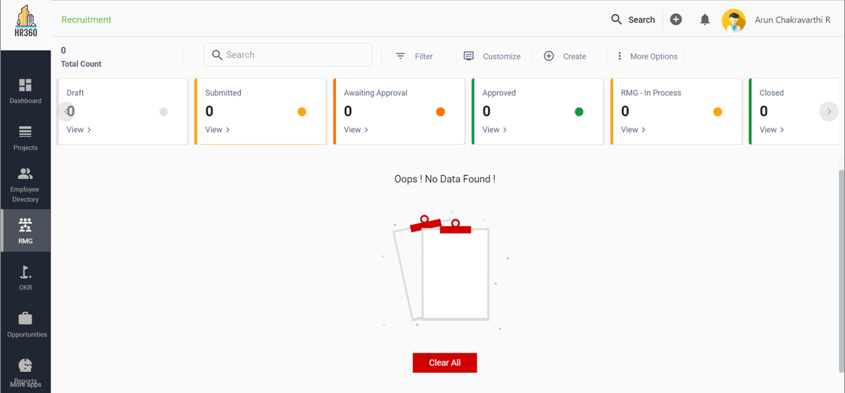

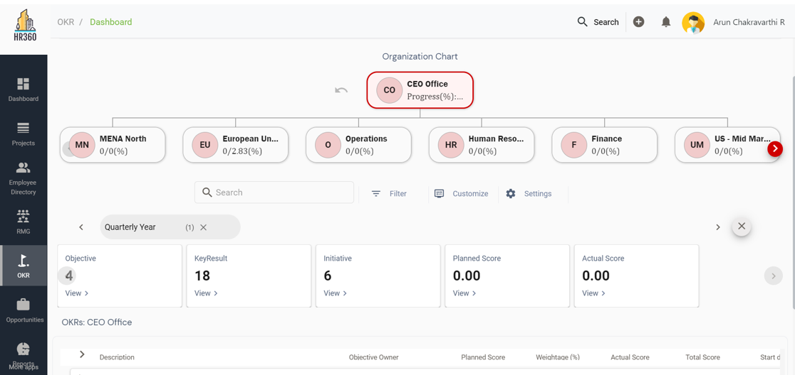

# **Database design**

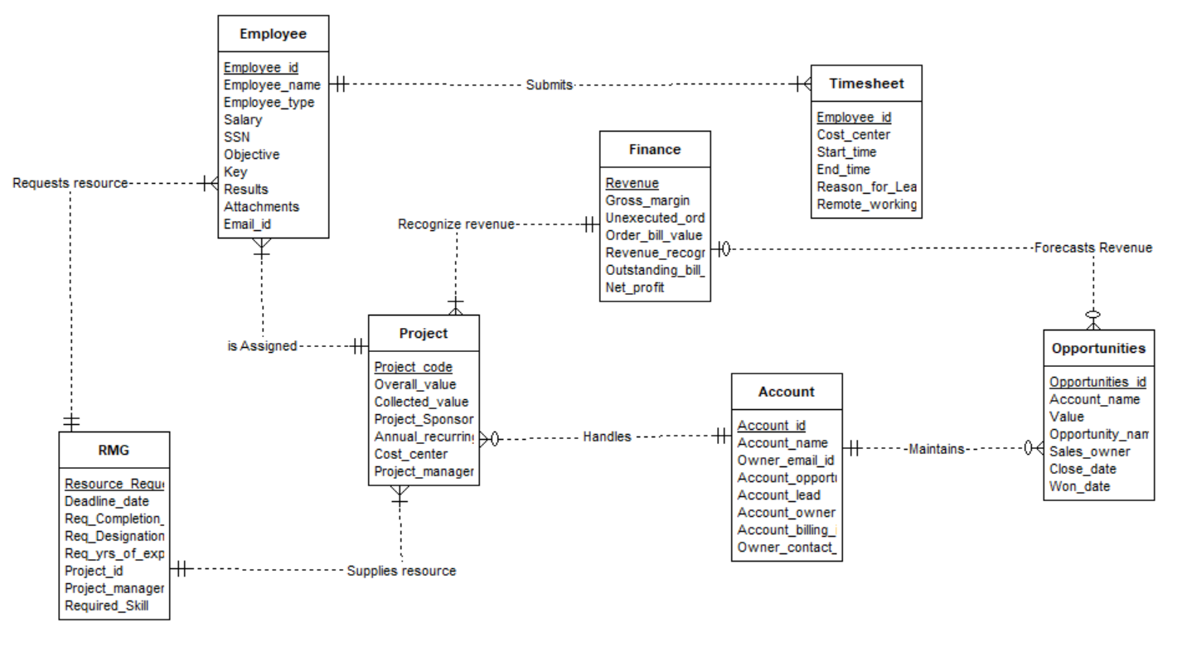

**Table: Employee**

**Constraints:**

Primary key constraints/Integrity constraints: EMPLOYEE_ID and attributes EMPLOYEE_NAME AND EMAIL_ID should be NOT NULL.

Unique Constraint: Primary Key EMPLOYEE_ID should be unique.

**Table: Project**

**Constraints:**

Primary key constraints/Integrity constraints: PROJECT_CODE and attributes COST_CENTER AND PROJECT_MANAGER should be NOT NULL.

Unique Constraint: Primary Key PROJECT_CODE should be unique.

**Table: RMG**

**Constraints:**

Primary key constraints/Integrity constraints: RES_REQ_ID and attributes PROJ_ID AND REQ_SKILL should be NOT NULL.

Unique Constraint: Primary Key RES_REQ_ID should be unique.

**Table: Finance**

**Constraints:**

Primary key constraints/Integrity constraints: TRANSACTION_ID and attributes REVEUE should be NOT NULL.

Unique Constraint: Primary Key TRANSACTION_ID should be unique.

**Table: Timesheet**

Constraints:

Primary key constraints/Integrity constraints: EMPLOYEE_ID and attributes COST_CENTER should be NOT NULL.

Unique Constraint: Primary Key EMPLOYEE_ID should be unique.

**Table: Opportunities**

**Constraints:**

Primary key constraints/Integrity constraints: OPPORTUNITIES _ID and attributes SALES_OWNER should be NOT NULL.

Unique Constraint: Primary Key OPPORTUNITIES _ID should be unique.

**Table: Accounts**

**Constraints:**

Primary key constraints/Integrity constraints: ACCOUNT_ID and attributes OWNER_CONTACT should be NOT NULL.

Unique Constraint Primary Key: ACCOUNT_ID should be unique.

# **Complete Class Diagram**

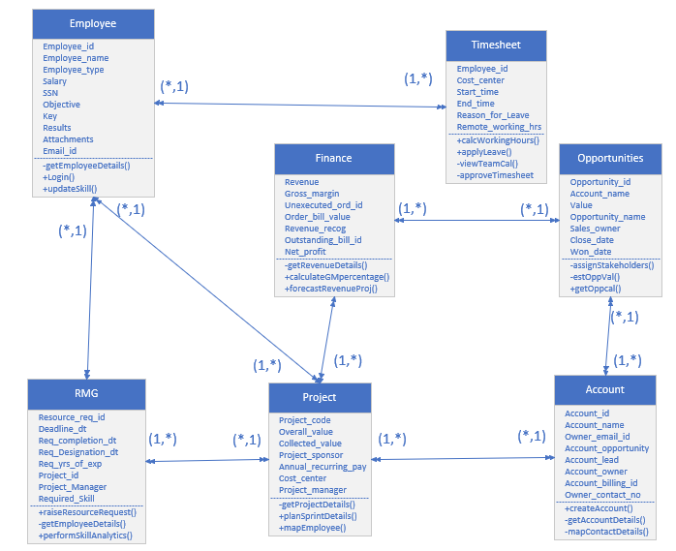

# **Software Design:**

**Method: Login**

Class: Employee

Clients: Every individual User

Associated Use cases: Sign-in

Pre- Condition: Username and Password should not be Null or Must have a Microsoft Account.

Post- Condition: Validate credentials and Provide Access

Type of value returned: Boolean

Logic:

* Username and password are the two required parameters.
* The method verifies that if one or both username and the password is null. The method will fail and return false.
* The method will determine whether the user has a Microsoft Account and if the username and password are not null.
* If the user has a Microsoft Account, it will continue to verify that the username and password entered are correct and match those on file.
* The method will return true, indicating that the user can log in successfully, if the credentials are correct and match.
* The method will return false, and the user won't be allowed to log in if the credentials are invalid or don't match.

**Method: updateSkill**

Class: Employee

Clients: Resource Manager

Associated Use cases: Update Profile

Pre- Condition: Enhanced Skill set or new recognized certifications

Post- Condition: Update the employee database

Type of value returned: Boolean

Logic:

* Either a widely recognized certification or the employee's expanded skill set are two parameters that are considered by the method.
* It verifies whether the employee has supplied a new recognized certification or an improved skill set. If not, the method will return false.
* It will update the employee's profile in the employee database if they have either of those parameters.
* Once the employee's profile has been correctly updated, the method will return true.

**Method: planSprintDetails**

Class: Project

Clients: Project manager

Associated Use cases:

Pre- Condition: Exiting project

Post- Condition: Detailed time and effort plan is saved in the database

Type of value returned: Boolean

Logic:

* The method's input parameters are the quantity of resources, the project's priority, and the budget allotted.
* It determines whether the project is already in the database. If not, the method will return false.
* If the project already exists, the procedure will make a detailed time and effort plan for the project, referred to as the Sprint Plan, using the given parameters.
* The Sprint Plan will then be saved in the project database.
* Once the Sprint Plan is successfully saved in the database, the method will return true.

**Method: raiseResourceRequest**

Class: RMG

Clients: Project Manager

Associated Use cases: Raise Resource Request

Pre- Condition: Demand for a resource in a project, identifying the skill set, duration of the project.

Post- Condition: Notifying the project manager the details of the resource with matching skill set.

Type of value returned: Resource Request ID

Logic:

* The method accepts the project ID, the necessary skill set, and the project duration as input parameters.
* It adds a new resource request with a special resource request ID to the resource request database.
* It searches the resource pool database for individuals who have the necessary skill set and are available for the project's duration.
* It notifies the project manager of any matched resources, together with information about their names, skill sets, and availability, if one or more are discovered.
* If no matching resources are discovered, it modifies the resource request in the database to reflect the lack of any matching resources.
* The resource request ID is returned by the method.

**Method: getRevenueDetails**

Class: Finance

Clients: CEO and CFO

Associated Use cases: Revenue Recognition

Pre- Condition: Validate if the authorized person is either CEO or CFO.

Post- Condition: Display detailed analysis report of the revenue.

Type of value returned: Report.

Logic:

* The method requires the authorization credentials of the person who wants to access the revenue details as the input parameter.
* By using this method, it can be confirmed if the CEO or CFO is the authorized person.
* If the credentials are true, the method pulls the revenue information from the revenue database.
* It uses the analysis of the revenue data to provide a thorough report that contains information like revenue by client, revenue by region, revenue by product line, and revenue trends over time etc.

**Method: ForecastRevenueProj**

Class: Finance

Clients: CEO, CFO, Project Manager and Resource Manager

Associated Use cases: Forecast and Analysis

Pre- Condition: The company’s previous years revenue information along with planned vs actual revenue information

Post- Condition: Report to display the revenue predictions

Type of value returned: Report

Logic:

* The input parameter of the method is the company's previous year's revenue data as input, which includes overall revenue, revenue by product line, revenue by client, and revenue by location and information on the company's expected vs. actual revenue for the current year.
* It predicts the future revenue trends for the company as a whole using statistical analytic techniques like regression analysis, time-series analysis, and machine learning algorithms.
* It produces a report that shows expected revenue for the company overall, revenue projections for individual product lines, individual customers, individual geographic regions etc.
* The study also provides analysis and insights on the company's revenue trends, including information on the product lines most likely to experience growth, the most lucrative clients, and the most promising geographical areas.

**Method: applyLeave**

Class: Timesheet

Clients: Employee

Associated Use cases: Apply Leave

Pre- Condition: Apply leave according to the category of leaves – Sick leave, planned leave, LOP, Flexi Leaves, earned leaves, Bereavement Leave, Maternity/ Paternity Leave etc. and the number of leaves left in the current year.

Post- Condition: Notification of the leave application sent to the respective manager and update leave balance.

Type of value returned: Leave Request ID

Logic:

* Verify the input parameters, such as the leave type, duration, start date, and end date.
* Verify that any significant project deliverables or deadlines do not conflict with the desired leave dates.
* Create a leave request ID, then enter the information in the timesheet database for the employee.
* Based on the approved leave request, update the employee's leave balance.
* Send a request for permission to the appropriate manager.
* Update the employee's timesheet database with the status of the leave request if the request is authorized.
* Return the Leave Request ID.

# **Meeting Overview:**

**Meeting 1:**

Date: 01/28/2023

Time: 11AM to 1PM

Attendees: Surya Raja Harshitha Achanta, Arun Chakravarthi Ravichandran, Vignesh Rajasekaran

Project Activities:

* Introduction to each other
* Discussion about the course

Actions Assigned:

|  |  |
| --- | --- |
| Possible ideas for the deliverables | Team |
| Going through relevant materials | Team |

Follow-ups for the next meeting:

* Project Ideas with pros and cons.

Timeline:

* Planned: 1 day
* Execution: 1 day

Deadline: 02/08/2023

**Meeting 2:**

Date: 02/08/2023

Time: 11AM to 1PM

Attendees: Surya Raja Harshitha Achanta, Arun Chakravarthi Ravichandran, Vignesh Rajasekaran

Key Points:

* Discussion of each project idea
* Identifying Pros and cons of each idea.

Actions Assigned:

|  |  |
| --- | --- |
| Research on existing system. | Team |
| Possible outcome of the proposed system. | Team |

Follow-ups for the next meeting:

* Existing system cons.
* Final Project Ideas with pros and cons and outcomes.

Timeline:

* Planned: 2 days
* Execution: 1 day

Deadline: 02/10/2023

**Meeting 3:**

Date: 02/11/2023

Time: 11AM to 1PM

Attendees: Surya Raja Harshitha Achanta, Arun Chakravarthi Ravichandran, Vignesh Rajasekaran

Key Points:

* Final Project idea – HR360
* Unique Solutions for the proposed system

Actions Assigned:

|  |  |
| --- | --- |
| Scope | Harshitha |
| Unique features | Vignesh |
| Improvement ideas | Arun |

Follow-ups for the next meeting:

* Final Project Proposal
* Problem statement

Timeline:

* Planned: 3 days
* Execution: 2 days

Deadline: 02/03/2023

**Meeting 4:**

Date: 02/18/2023

Time: 11AM to 1PM

Attendees: Surya Raja Harshitha Achanta, Arun Chakravarthi Ravichandran, Vignesh Rajasekaran

Key Points:

* Final Project Proposal
* Deep research on the possible outcomes of the proposed system

Actions Assigned:

|  |  |
| --- | --- |
| Problem statement | Harshitha |
| Business Needs | Arun, Vignesh |

Follow-ups for the next meeting:

* Learn BPMN Model.

Timeline:

* Planned: 3 days
* Execution: 2 days

Deadline: 02/24/2023

**Meeting 5:**

Date: 02/25/2023

Time: 11AM to 1PM

Attendees: Surya Raja Harshitha Achanta, Arun Chakravarthi Ravichandran, Vignesh Rajasekaran

Key Points:

* Discussion about the BPMN Model.
* Discussion on how it can be implemented on HR360.

Actions Assigned:

|  |  |
| --- | --- |
| Finalize BPMN Model | Team |
| Research on Context Diagram | Team |
| List out the different modules that can be covered under HR360. (Revised) | Arun |

Follow-ups for the next meeting:

* BPMN Model
* Context Diagram

Timeline:

* Planned: 3 days
* Execution: 2 days

Deadline: 03/03/2023

**Meeting 6:**

Date: 03/04/2023

Time: 11AM to 1PM

Attendees: Surya Raja Harshitha Achanta, Arun Chakravarthi Ravichandran, Vignesh Rajasekaran

Key Points:

* Learn and discuss use case diagrams.
* Discuss the actors and use cases in HR360

Actions Assigned:

|  |  |
| --- | --- |
| List out the actors and use cases in HR360 | Harshitha |
| Use case descriptions | Arun |
| Finalize the Use case Diagram | Vignesh |

Follow-ups for the next meeting:

* Final use case diagram
* Learn about sequence Diagrams

Timeline:

* Planned: 3 days
* Execution: 2 days

Deadline: 03/10/2023

**Meeting 7:**

Date: 03/25/2023

Time: 11AM to 1PM

Attendees: Surya Raja Harshitha Achanta, Arun Chakravarthi Ravichandran, Vignesh Rajasekaran

Key Points:

* Discuss about class diagrams
* Finalize the attributes and methods

Actions Assigned:

|  |  |
| --- | --- |
| Attributes and methods | Arun, Harshitha |
| Finalize Classes | Vignesh |
| Mapping | Team |

Follow-ups for the next meeting:

* Research on sequence Diagrams

Timeline:

* Planned: 3 days
* Execution: 2 days

Deadline: 03/30/2023

**Meeting 81:**

Date: 04/01/2023

Time: 11AM to 1PM

Attendees: Surya Raja Harshitha Achanta, Arun Chakravarthi Ravichandran, Vignesh Rajasekaran

Key Points:

* Discuss the data dictionary
* Implement the sequence diagrams for HR360

Actions Assigned:

|  |  |
| --- | --- |
| Sequence Diagram 1 | Arun |
| Sequence Diagram 2 | Vignesh |
| Sequence Diagram 3 | Harshitha |

Follow-ups for the next meeting:

* Finalize Sequence Diagrams.
* Start the draft of the final project document.

Timeline:

* Planned: 3 days
* Execution: 3 days

Deadline: 04/07/2023

**Meeting 9:**

Date: 04/08/2023

Time: 11AM to 1PM

Attendees: Surya Raja Harshitha Achanta, Arun Chakravarthi Ravichandran, Vignesh Rajasekaran

Key Points:

* Initial draft of the final project documentation
* Discussion about the functional specification document

Actions Assigned:

|  |  |
| --- | --- |
| Prototype of HR360 | Team |
| Discuss the database design | Team |
| Finalize the functional specification Document | Harshitha |

Follow-ups for the next meeting:

* Working on the prototype
* Sample data
* Finalize the database design

Timeline:

* Planned: 3 days
* Execution: 3 days

Deadline: 04/14/2023

**Meeting 10:**

Date: 04/15/2023

Time: 11 AM to 1 PM

Attendees: Surya Raja Harshitha Achanta, Arun Chakravarthi Ravichandran, Vignesh Rajasekaran

Key Points:

* Finalize the database design
* Discussion on the software design

Actions Assigned:

|  |  |
| --- | --- |
| Complete Software Design | Arun, Vignesh |
| Complete Class Diagram | Harshith |

Follow-ups for the next meeting:

* Finalize the project report

Timeline:

* Planned: 7 days
* Execution: 9 days

Deadline: 04/29/2023

**Meeting 11:**

Date: 05/06/2023

Time: 11AM to 1PM

Attendees: Surya Raja Harshitha Achanta, Arun Chakravarthi Ravichandran, Vignesh Rajasekaran

Key Points:

* Final Project Report

Actions Assigned:

* Final review of the project and submission - Team

Timeline:

* Planned: 2 days
* Execution: 2 days

Deadline: 05/08/2023