**INSIGHTSTREAM**

**Navigate the News Landscape** (React Application)

* **Team Details:**

|  |  |
| --- | --- |
| **Team Leader** | **EMAIL ID** |
| JAYASURYA V | jayasurya1525@gmail.com |

|  |  |
| --- | --- |
| **Team Members** | **EMAIL ID** |
| VIGNESH S | vigneshselva2910@gmail.com |
| SANJAY K | sanjay2004112@gmail.com |
| RATHISH R | rathish7018@gmail.com |
| MAITHERYAN R | rmaitheryan@gmail.com |

**Introduction to Insight Stream: Navigating the News Landscape**

In today’s rapidly evolving world, staying informed is both a necessity and a challenge. With an overwhelming flow of information from countless sources—ranging from traditional media outlets to social platforms—navigating the news landscape can feel like an insurmountable task. This is where Insight Stream steps in. Our platform is dedicated to offering a curated, thoughtful approach to the way we consume news, providing clarity in an era of information overload.

Insight Stream is designed to help individuals, organizations, and communities make sense of the most important stories shaping our world. By filtering out the noise and emphasizing accuracy, depth, and relevance, we aim to empower our users with the tools they need to understand the world in a more meaningful way. We do this by offering expert analysis, real-time updates, and multimedia content that explores the underlying context of breaking news.

With Insight Stream, users are not just passive consumers but active participants in the way they engage with current events. We bridge the gap between raw data and insightful understanding by distilling complex stories into digestible formats, offering diverse perspectives that challenge assumptions and encourage critical thinking.

In a world where news can be fragmented and sensationalized, Insight Stream stands as a reliable and trusted partner in making informed decisions. Whether it’s global politics, technological advancements, or social issues, we help you navigate through the noise and get to the heart of the matter—so you can be better informed, empowered, and prepared for what’s ahead. **InsightStream: Revolutionizing How We Consume and Understand News**

In an era marked by an abundance of information and an ever-expanding variety of news sources, staying informed has never been more challenging or crucial. With traditional news outlets competing against digital media, social platforms, and user-generated content, the quality and reliability of news are often compromised. At InsightStream, we recognize the struggle to navigate through this maze of information and aim to offer a solution—providing clarity, insight, and context to the world’s most pressing issues.

**What is InsightStream?**

InsightStream is a platform designed to provide users with an informed and balanced perspective on current events. Whether you're an individual seeking to stay up-to-date, a professional looking for reliable industry insights, or a curious mind trying to understand the complexities of the modern world, InsightStream serves as your trusted guide through the global news landscape.

Our platform doesn’t just focus on breaking news but seeks to dive deeper, offering rich analysis and meaningful discussions about the stories that matter. We aim to bridge the gap between raw information and real understanding, ensuring that you are not only informed but also capable of making well-rounded, thought-out decisions based on that information.

**Features of InsightStream:**

**News from API Sources:** Access a vast library of global news spanning various categories and interests, ensuring a well-rounded coverage of current affairs.

**Visual News Exploration:** Discover breaking stories and explore different news categories through curated image galleries, enhancing the visual appeal of news discovery.

**Intuitive Design**: Navigate the application seamlessly with a clean, modern interface designed for optimal user experience and clarity in information presentation.

**Advanced Search Feature:** Easily access news articles on specific topics through a powerful search feature, providing users with tailored news content based on their interests.

**Why Choose InsightStream?**

In a time when misinformation and sensationalism often dominate the news cycle, InsightStream stands out as a reliable and objective source of information. Our mission is to equip our users with the tools they need to navigate an increasingly complex world, not only by keeping them informed but also by promoting understanding, empathy, and engagement.

Through curated, diverse, and well-researched content, InsightStream doesn’t just tell you the “what” of current events; it explores the “why” and the “how.” We provide context that helps users grasp the broader implications of global stories, making sure that you’re not just consuming news, but actively learning from it.

In addition to its editorial focus, InsightStream is built with user experience in mind, offering a clean, user-friendly interface and seamless navigation across devices. Whether you're accessing the platform on your computer, tablet, or smartphone, InsightStream ensures a smooth, consistent experience.

**A Future-Oriented Approach**

As technology continues to evolve, so does the media landscape. InsightStream stays at the forefront of innovation, constantly adapting its features and tools to offer a dynamic news experience. Whether it's utilizing artificial intelligence for better story recommendations or expanding multimedia content options, InsightStream is committed to enhancing how you engage with news in the future.

**Scenario-Based Introduction to InsightStream**

It’s a typical morning. You wake up, grab your phone, and immediately check the news. Headlines flood your screen, some sensational, others clickbait, and most, you feel, leave you with more questions than answers. As you scroll through, you find stories from sources you trust, but there are also unfamiliar outlets with conflicting information. You feel overwhelmed, unsure of where to turn for clarity.

This chaotic news landscape is a reality for many today. With an overabundance of /information constantly vying for your attention, it’s difficult to know what’s true, what’s relevant, and what’s worth your time. But what if there was a way to break through the noise—an approach that not only gives you timely updates but also offers expert insights, context, and a variety of perspectives, helping you make sense of it all?

Welcome to **InsightStream**, where navigating the news landscape is no longer a daunting task.

**The Problem: Information Overload and Misinformation**

Imagine you’re trying to follow the latest political debate, but every outlet presents a different angle. One outlet reports on a policy proposal with excitement, while another suggests it’s doomed to fail. Then, a third source provides a completely contradictory opinion, offering no real context for its conclusions. You're left with a confused, fragmented understanding of what’s really going on.

This situation is common in today’s media environment, where news is rapidly produced, distributed, and consumed. The rise of social media platforms and digital outlets means news stories can be distorted, manipulated, or oversimplified for clicks and engagement. While breaking news is important, it’s equally crucial to understand the *why* behind the headlines and how they impact our lives and society. But with so much noise, it’s easy to lose sight of the bigger picture.

**The Solution: InsightStream**

Enter InsightStream. Imagine having a trusted guide in this information maze, one that helps you sift through the noise and offers clear, accurate, and meaningful insights into the stories that shape our world. Let’s paint a picture of how InsightStream can transform your news consumption.

It’s late afternoon now, and you’re catching up on the news after a busy day. Instead of mindlessly scrolling through a barrage of headlines, you open InsightStream. The platform’s clean and user-friendly interface welcomes you, offering a personalized feed based on your interests—whether that’s global politics, environmental news, or technology trends. You quickly notice that the stories here are different: well-researched, curated, and free of sensationalism.

You tap on a story about a new climate policy being introduced in a major country. Instantly, you’re presented with more than just a headline. InsightStream doesn’t just give you the facts; it breaks down the issue in depth, offering historical context, expert commentary, and analysis of the policy’s potential impact. A climate scientist explains the long-term effects, while an economist discusses how the policy will affect the economy. In just a few minutes, you’ve gained a comprehensive understanding of the story, not just the surface-level details.

Moreover, InsightStream gives you the opportunity to view the topic from various viewpoints. You can read opinions from different political perspectives or hear from international experts. If you’re uncertain about something, you can easily engage with the community through live discussions or Q&A sessions with professionals. The more you explore, the more you realize how InsightStream is designed to not only inform you but also to help you think critically about the information you encounter.

**A Day in the Life of InsightStream**

Let’s rewind to earlier in the day when you first woke up. Imagine you had opened InsightStream, instead of diving into the typical news spiral. You would have been greeted with curated, reliable news articles, not just breaking headlines. Each story would have included thoughtful analysis and diverse perspectives, offering a richer, more nuanced understanding of the issues at hand.

The platform uses advanced algorithms to recommend news tailored to your preferences, ensuring that you stay informed on topics that matter to you. But it’s not just about the headlines—it’s about the context. InsightStream helps you understand the *why* and *how* behind every major news event, making sure you never feel lost in the noise again.

As the day goes on, you receive real-time updates on developing stories. But rather than rushing to consume every new article, InsightStream helps you filter out the irrelevant or sensational pieces, focusing on what’s truly important. Through multimedia content like videos, podcasts, and interactive infographics, the platform keeps you engaged while enhancing your understanding.

**Technical Architecture for InsightStream**

The technical architecture of InsightStream is designed to support the platform’s core functionality: delivering curated, insightful, and timely news with an emphasis on accuracy, context, and personalized user experiences. The architecture is built to handle large-scale data processing, real-time updates, diverse content formats, and high user engagement while maintaining performance, scalability, and security.

Below is an overview of the key components and services that make up InsightStream’s technical architecture:

**1. User Interface (UI) / Front-End Layer**

**Technologies:**

* **Web**: React.js or Angular for fast, dynamic, and responsive web pages.
* **Mobile**: React Native or Flutter for cross-platform mobile applications (iOS & Android).

The UI layer is designed to provide users with an intuitive, seamless experience for interacting with news stories, analysis, videos, and multimedia content. This layer handles:

* **Personalized Feed**: Displaying news content based on user preferences and behavior.
* **Interactive Features**: Allowing users to engage with live discussions, expert Q&As, comment sections, and opinion polls.
* **Multimedia Content**: Integration with video players, podcasts, and interactive infographics.
* **Real-Time Notifications**: Alerts for breaking news or updates on followed stories.
* **Responsive Design**: The UI is fully responsive and adjusts dynamically to fit different devices (desktop, tablet, mobile).

**2. Content Aggregation Layer**

**Technologies:**

* **Web Scraping**: BeautifulSoup, Scrapy, or custom APIs to gather news articles from a wide range of trusted sources (news websites, blogs, social media).
* **News APIs**: Integration with third-party APIs (such as NewsAPI, New York Times API, or Reuters API) for additional news sourcing.
* **RSS Feeds**: Collecting updates from various reliable sources.

The content aggregation layer is responsible for collecting and curating content from multiple sources. It continuously monitors the web, pulling in news stories, blog posts, and other relevant data based on predefined rules. These sources are filtered and categorized according to relevance and reliability before being presented to users.

**3. Content Management System (CMS) and Moderation**

**Technologies:**

* **CMS**: WordPress, Contentful, or a custom-built CMS.
* **Moderation Tools**: AI-driven content moderation using tools like AWS Rekognition, Google Cloud Vision, or custom text classifiers based on NLP (Natural Language Processing).

This layer allows the editorial team to curate, categorize, and review the content being presented to users. Articles, videos, and other types of media are reviewed and organized in the CMS for easy publication. Automated moderation tools also help ensure that content is free from harmful misinformation and inappropriate material before it is posted.

**4. Personalization & Recommendation Engine**

**Technologies:**

* **Machine Learning Algorithms**: Collaborative filtering, content-based filtering, and deep learning algorithms.
* **Frameworks**: TensorFlow, PyTorch, Scikit-Learn.
* **Data Stores**: Elasticsearch for fast and scalable searching and indexing.
* **User Behavior Tracking**: Google Analytics, custom event tracking, or Mixpanel.

The recommendation engine personalizes the user experience by analyzing individual behavior, preferences, and interaction history. This engine suggests content based on factors like:

* **User Interests**: Identifying which topics (e.g., politics, technology) the user engages with most.
* **User Behavior**: Analyzing reading patterns, clicks, shares, and engagement to recommend relevant articles, videos, and podcasts.
* **Trending Content**: Highlighting popular or relevant stories that match a user’s interests.
* **Dynamic Content Updates**: Continuously adjusting recommendations based on real-time user data.

**5. Backend Services and APIs**

**Technologies:**

* **Backend Frameworks**: Node.js (Express.js), Python (Flask/Django), or Java (Spring Boot).
* **Microservices Architecture**: Each service is encapsulated in independent microservices (e.g., news aggregation, notifications, user profiles).
* **GraphQL**: For efficient and flexible data fetching.
* **REST APIs**: Exposing various backend functionalities to interact with the front end.

The backend services layer handles the core logic for the platform:

* **News Aggregation**: Fetching and processing incoming news stories from various sources.
* **User Profiles**: Storing user preferences, past interactions, and engagement data.
* **Authentication & Authorization**: Managing user logins, registrations, and secure access.
* **Real-Time Notifications**: Sending alerts for breaking news or story updates.

This service layer can be designed using microservices architecture, where each service operates independently, allowing for flexibility, scalability, and easier maintenance.

**6. Real-Time Data Processing and Updates**

**Technologies:**

* **Event Streaming**: Apache Kafka or AWS Kinesis for real-time data processing.
* **WebSockets**: For real-time user interactions and updates.
* **Caching**: Redis or Memcached for improving performance.

This layer is responsible for handling and processing real-time news updates and user interactions. For example, as soon as a breaking news event occurs, it is processed and pushed to the relevant channels using event-driven architectures. WebSockets allow users to see live discussions, comments, and new updates immediately. The caching layer ensures quick retrieval of frequently accessed data.

**Project Goal for InsightStream:**

The primary goal of **InsightStream** is to revolutionize the way individuals consume and engage with news. The platform aims to navigate the overwhelming landscape of information by providing users with personalized, insightful, and reliable content that cuts through the noise. InsightStream seeks to create a space where users can not only stay informed with up-to-date news but also gain a deeper understanding of stories through expert analysis, diverse viewpoints, and interactive features.

In essence, the goal is to deliver a comprehensive news experience that empowers users to make sense of complex issues, stay well-informed, and engage meaningfully with the content they consume.

**Project Objectives for InsightStream:**

1. **Provide a Personalized News Experience:**
   * Leverage machine learning and behavioral analytics to curate a personalized news feed for users, based on their preferences, reading habits, and interests.
   * Deliver customized content recommendations, including articles, videos, and podcasts, to ensure that users stay engaged with the topics they care about most.
2. **Ensure High-Quality, Reliable Content:**
   * Aggregate news from multiple trusted, authoritative sources (e.g., Reuters, NewsAPI) to ensure accuracy and reliability.
   * Implement a robust content moderation system to avoid misinformation and ensure that the content is both relevant and factual.
3. **Empower Users with Expert Insights and Diverse Perspectives:**
   * Integrate expert opinions, in-depth analysis, and diverse viewpoints alongside news articles to provide context and a deeper understanding of the stories.
   * Offer content from various political, social, and cultural perspectives to promote critical thinking and balanced views.
4. **Facilitate Real-Time Engagement:**
   * Enable real-time updates and notifications to keep users informed on breaking news events and ongoing developments.
   * Provide interactive features such as live chats, Q&A sessions with experts, and discussions that allow users to engage with the content and community.
5. **Promote Thoughtful News Consumption:**
   * Design an intuitive and distraction-free interface that encourages users to read and engage with content in a meaningful way.
   * Incorporate tools like content filters and news categorization to help users easily navigate through the wealth of information available.
6. **Scalable and Secure Platform:**
   * Build a scalable backend infrastructure that can handle large amounts of real-time content updates and user interactions.
   * Ensure that the platform is secure, protecting user data through encryption and secure authentication mechanisms (OAuth, JWT).
7. **Improve User Retention and Engagement:**
   * Use analytics to track user behavior, predict trends, and continuously optimize content recommendations.
   * Incorporate gamification features (e.g., badges, achievements, polls) to increase user engagement and retention over time.
8. **Promote Transparency and Trustworthiness:**
   * Ensure that all news content is traceable, with clear sources and citations, fostering a sense of trust and credibility.
   * Educate users on how to differentiate between trustworthy news sources and unreliable content.

**Key Features of InsightStream**

**1. Personalized News Feed**

* **Customizable News Recommendations**: Based on user behavior, preferences, and reading history, InsightStream curates a personalized news feed. This ensures that users are always presented with relevant content tailored to their interests, whether it's politics, technology, entertainment, or any other topic.
* **Dynamic Filtering**: Users can filter news by categories, topics, or regions to quickly access content that matters most to them.

**2. Real-Time Updates and Alerts**

* **Breaking News Notifications**: Users receive immediate alerts for breaking news, ensuring they stay up-to-date with the latest developments.
* **Live Updates**: Continuous stream of live updates on ongoing events, sports, and real-time news broadcasts directly on the platform.

**3. Expert Insights and Analysis**

* **In-Depth Articles and Commentary**: Beyond standard news articles, InsightStream provides expert commentary, analysis, and op-eds on important issues, offering deeper context and diverse viewpoints.
* **Expert Panels and Guest Contributions**: Regular contributions from subject-matter experts, industry leaders, and analysts that help users understand the broader implications of news events.

**4. Diverse Perspectives**

* **Multiple Viewpoints**: InsightStream offers content from various political, social, and cultural perspectives, encouraging users to explore multiple sides of an issue and develop a well-rounded view.
* **Curated Multi-Source News**: News stories are sourced from different regions, outlets, and viewpoints, helping combat the rise of echo chambers and bias in media.

**PRE-REQUISITES**:

Here are the key prerequisites for developing a frontend application using React.js:

* **Node.js and npm**:

Node.js is a powerful JavaScript runtime environment that allows you to run JavaScript code on the local environment. It provides a scalable and efficient platform for building network applications.

Install Node.js and npm on your development machine, as they are required to run JavaScript on the server-side.

* + Download: <https://nodejs.org/en/download/>

Installation instructions: <https://nodejs.org/en/download/package-manager/>

* **React.js**:

React.js is a popular JavaScript library for building user interfaces. It enables developers to create interactive and reusable UI components, making it easier to build dynamic and responsive web applications.

Install React.js, a JavaScript library for building user interfaces.

* + Create a new React app:

npx create-react-app my-react-app

Replace my-react-app with your preferred project name.

* + Navigate to the project directory:

cd my-react-app

* + Running the React App:

With the React app created, you can now start the development server and see your React application in action.

* + Start the development server:

npm start

This command launches the development server, and you can access your React app at http://localhost:3000 in your web browser.

* **HTML, CSS, and JavaScript**: Basic knowledge of HTML for creating the structure of your app, CSS for styling, and JavaScript for client-side interactivity is essential.

* **Version Control**: Use Git for version control, enabling collaboration and tracking changes throughout the development process. Platforms like GitHub or Bitbucket can host your repository.

• Git: Download and installation instructions can be found at:

<https://git-scm.com/downloads>

* **Development Environment**: Choose a code editor or Integrated Development Environment (IDE) that suits your preferences, such as Visual Studio Code, Sublime Text, or WebStorm.

* + - Visual Studio Code: Download from <https://code.visualstudio.com/download>
    - Sublime Text: Download from <https://www.sublimetext.com/download>
    - WebStorm: Download from [https://www.jetbrains.com/webstorm/download](https://www.jetbrains.com/webstorm/download%20)

To install and run the Application project from google drive:

Follow below steps:

* **Get the code:**
  + Download the code from the drive link given below: <https://drive.google.com/drive/folders/1tDoSwd-1I3HsPJ9_92MnZTUtteeda-hL?usp=sharing> **Install Dependencies:**
  + Navigate into the cloned repository directory and install libraries:

cd news-app-react npm install

* **Start the Development Server**:
  + - To start the development server, execute the following command:

npm start

**Access the App:**

* + - Open your web browser and navigate to [http://localhost:3000](http://localhost:3000/).
    - You should see the applications homepage, indicating that the installation and setup were successful.

You have successfully installed and set up the application on your local machine. You can now proceed with further customization, development, and testing as needed.

**Project structure:**

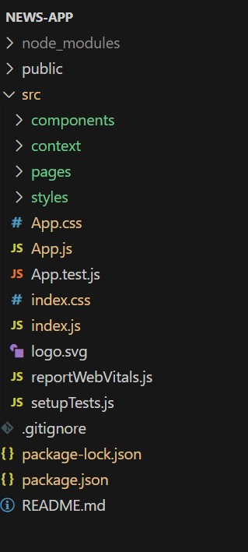 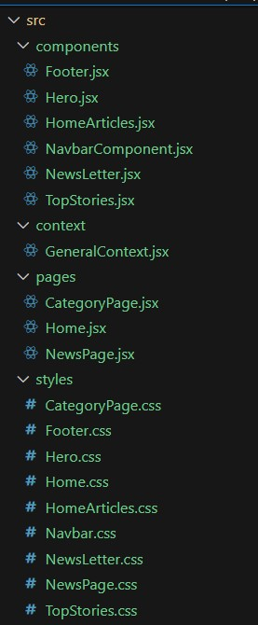

In this project, we’ve split the files into 4 major folders, *Components, Context, Pages and Styles.* In the pages folder, we store the files that acts as pages at different URLs in the application. The components folder stores all the files, that returns the small components in the application. The context Api will be coded in the context folder. All the styling css files will be stored in the styles folder.

**Project Flow:**

**Project demo:**

Before starting to work on this project, let’s see the demo.

Demo link:<https://drive.google.com/file/d/1i8y09FiMk7QM0akH3my10OBWqXH-8dNh/view?usp=sharing> Use the code in:

<https://drive.google.com/drive/folders/1tDoSwd-1I3HsPJ9_92MnZTUtteeda-hL?usp=sharing> **Milestone 1: Project setup and configuration.**

* **Installation of required tools**:

To build InsightStream, we'll need a developer's toolkit. We'll use React.js for the interactive interface, React Router Dom for seamless navigation, and Axios to fetch news data. For visual design, we'll choose either Bootstrap or Tailwind CSS for pre-built styles and icons.

Open the project folder to install necessary tools. In this project, we use:

* + React Js o React Router Dom o React Icons o Bootstrap/tailwind css
  + Axios

* For further reference, use the following resources o <https://react.dev/learn/installation> o <https://react-bootstrap-v4.netlify.app/getting-started/introduction/> o <https://axios-http.com/docs/intro> o <https://reactrouter.com/en/main/start/tutorial>

**Milestone 2: Project Development**

* Setup the Routing paths

Setup the clear routing paths to access various files in the application.

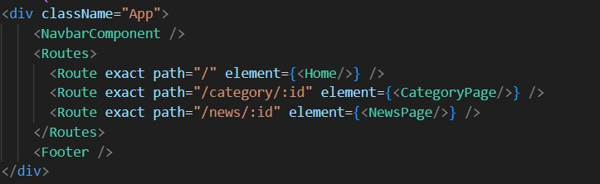

* Develop the Navbar and Hero components
* Code the popular categories components and fetch the categories from ***newsapi***.
* Also, add the trending news in the home page.
* Additionally, we can add the component to subscribe for the newsletter and the footer.
* Now, develop the category page to display various news articles under the different categories.

**Important Code snips:**

**Fetching Top/Trending news**

With the API request, we fetch the trending news articles.

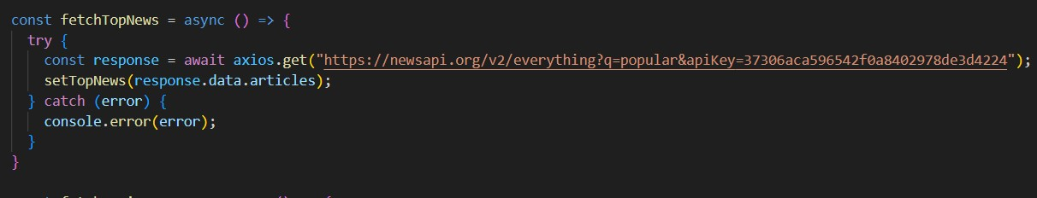

The code snippet shows a function written in Python called fetchTopNews that fetches news articles from an API. Here's a breakdown of the code:

*Async function fetchTopNews:*

The code defines an asynchronous function named fetchTopNews. An asynchronous function is used to handle asynchronous operations, such as making API requests that take time to complete.

*try...catch block:*

* + The try...catch block is used to handle the API request.
  + The try block contains the code that attempts to fetch data from the API using axios.get.
  + axios is an external Python library for making HTTP requests. If you don't already use Axios in your project, you'll need to install it using a package manager like pip.
  + The .get method makes a GET request to the specified URL.

*API URL:*

The URL used in the API request is

'[https://newsapi.org/v2/everything?q=popular&apiKey=37306aca596542f0a840297 8de3d4224](https://newsapi.org/v2/everything?q=popular&apiKey=37306aca596542f0a8402978de3d4224)'.

This is likely a specific API endpoint that returns popular news articles. You might need to replace this URL with the actual endpoint you want to use depending on the API you're using. Replace '37306aca596542f0a8402978de3d4224' with a placeholder instructing users to replace it with their own API key.

*Error Handling (catch block):*

The catch block handles any errors that might occur during the API request. If there's an error, it's logged to the console using console.error(error).

*Setting State (then block not shown):*

The .then method (not shown in the code snippet) is likely used to process the fetched data after a successful API request.

In this case, it likely updates a state variable named topNews (based on the function name fetchTopNews) with the fetched news articles. This state variable might be used to display the news articles in a user interface.

**Fetching news by search/category**

With the specific category or search keyword, we use API request to fetch all the news articles related to that.

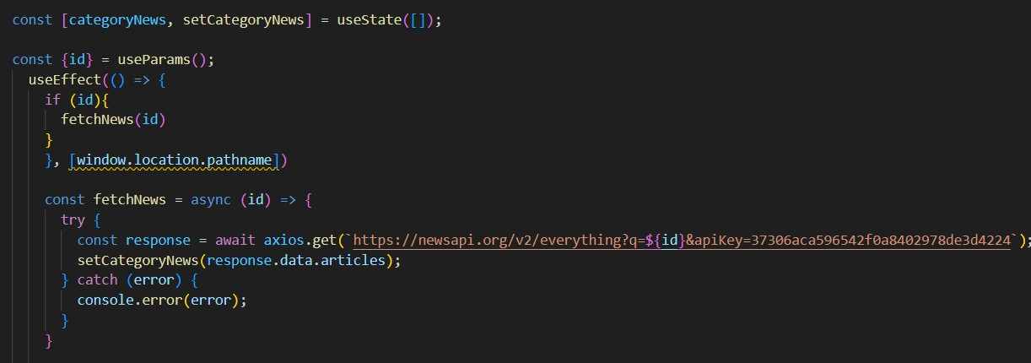

The code snippet shows a function called get_news_articles that fetches news articles from a news API. Here's a breakdown of the code:

*Imports:*

The code starts by importing the requests library. The requests library is a popular Python library for making HTTP requests. If you don't already have it installed in your project, you can install it using pip install requests.

*API Key:*

The line API_KEY = 'YOUR_API_KEY' defines a variable named API_KEY and assigns it a placeholder value 'YOUR_API_KEY'. You should replace this with a placeholder instructing users to replace it with their own API key obtained from the news API provider they want to use.

*Function Definition (get_news_articles):*

The code defines a function named get_news_articles that takes two parameters:

* query: This parameter is likely a string representing the search query for news articles.
* source: This parameter is likely a string representing the news source (e.g., 'bbc-news', 'cnn').

*Building the API Request URL:*

The line url = f'https://newsapi.org/v2/everything?q={query}&apiKey={API_KEY}' constructs the URL for the API request using a formatted string literal (f-string).

The URL includes the following parts:

* Base URL: https://newsapi.org/v2/everything
* Query parameters:
* q: This parameter is set to the query argument passed to the function.
* apiKey: This parameter is set to the API_KEY variable, which should contain the user's API key.

*Making the API Request (requests.get):*

The line response = requests.get(url) sends a GET request to the API URL constructed earlier. The requests.get function from the requests library is used to make the HTTP request. The response from the API is stored in the response variable.

*Error Handling (try...except block):*

* The try...except block is used to handle potential errors during the API request.
* The try block contains the code that attempts to fetch data from the API using requests.get(url).
* The except block handles any exceptions that might occur during the request, such as network errors or invalid API responses. In this case, it prints an error message to the console using print(f'Error fetching news articles: {e}').

**Project Execution:**

After completing the code, run the react application by using the command “npm start” or “npm run dev” if you are using vite.js

Here are some of the screenshots of the application.

**Hero components**

In the hero component, the trending news articles are displayed. It is to highlight them. Apart from that, the search bar is also available to search for various articles and categories.

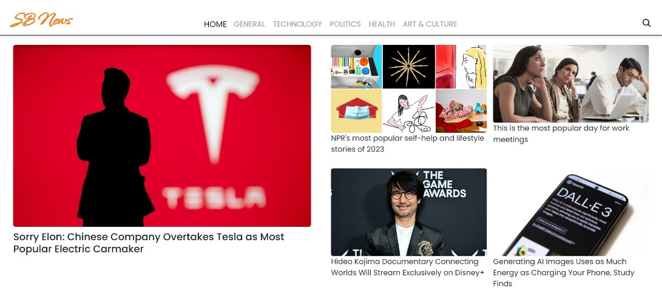

**Popular categories**

In the hero component, the trending news articles are displayed. It is to highlight them. Apart from that, the search bar is also available to search for various articles and categories.

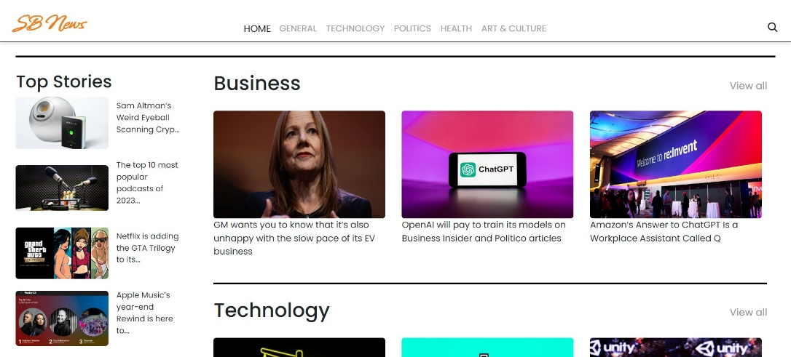

**Newsletter**

Staying informed is key! This section would act as a magnet for users who want to stay up-to-date on the latest news. A brief signup form with an email field would be presented, along with a clear call to action button like "Subscribe Now" or "Get Daily News Updates." With a simple click, users can join the InsightStream community and receive curated news delivered straight to their inbox.

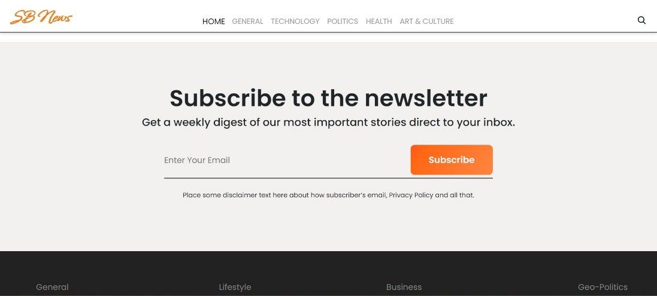

**Category/Search result page**

Finding the news you crave is effortless with InsightStream. This page displays a neatly organized list of articles matching your chosen category or specific search query. Each entry would provide a clear headline, a concise summary, and if available, an image to give you a quick glimpse into the story. To further refine your exploration, filters or sorting options might be available. Imagine narrowing down results by date, source, keyword, or other relevant criteria to pinpoint exactly what you're looking for.

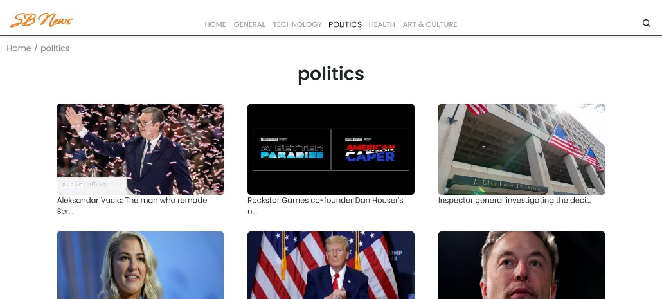

**Redirected Article page**

This is where you dive deep! The article page proudly displays the complete news story, retrieved directly from the original source. To keep you engaged and exploring related topics, the page might also suggest additional articles based on the current story. These suggestions can open doors to a world of interconnected information, allowing you to become a well-rounded news connoisseur.



Project Demo link:

[https://drive.google.com/file/d/1i8y09FiMk7QM0akH3my10OBWqXH-8dNh/view?usp=shari ng](https://drive.google.com/file/d/1i8y09FiMk7QM0akH3my10OBWqXH-8dNh/view?usp=sharing)

Top of Form

Bottom of Form