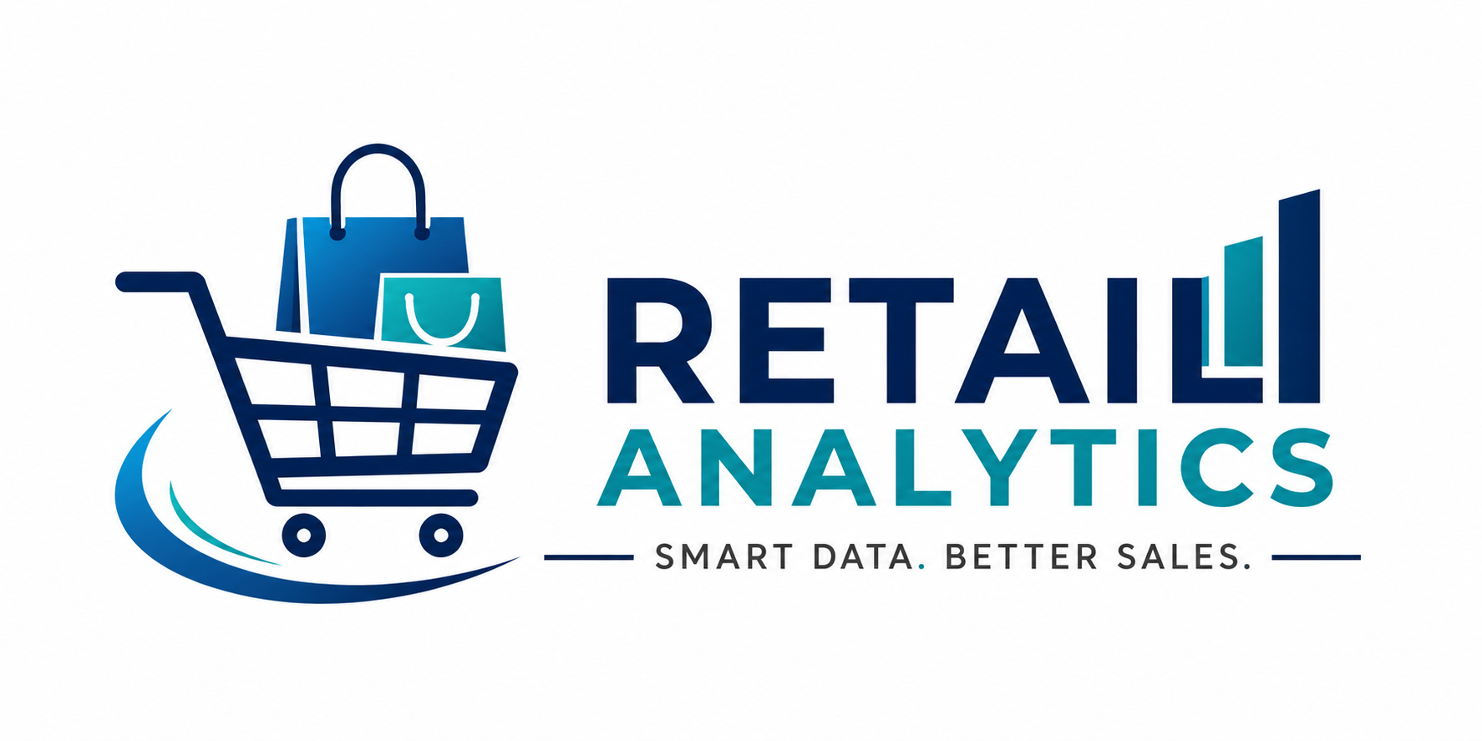
AZURE RETAIL SALES ANALYTICS
WHERE TO START • WHAT TO LEARN • WHY IT MATTERS • HOW TO BUILD IT
A practical study guide based on the complete project workflow

INDEX
No. | Section | Focus
01 | How to Use This Guide | Project mindset
02 | Prerequisites | What to learn first
03 | Learning Roadmap | Recommended sequence
04 | Business Problem | Questions before tools
05 | Source Data & SQL | Profiling and validation
06 | Azure Fundamentals | Cloud building blocks
07 | ADLS Gen2 | Storage layer
08 | Azure Data Factory | Ingestion and orchestration
09 | Databricks | Processing platform
10 | PySpark & Spark SQL | Transformations
11 | Medallion Architecture | Bronze / Silver / Gold
12 | Delta Lake | Reliable tables
13 | Data Quality | Investigate and resolve issues
14 | Gold Star Schema | Fact/dimension modeling
15 | Power BI & DAX | Semantic model
16 | Dashboard Storytelling | Business insights
17 | Validation | Reconciliation
18 | Interview Preparation | Questions and answers
19 | Practice Checklist | Hands-on exercises
20 | LinkedIn Sharing Guide | Professional presentation

1. How to Use This Guide
Use this manual as a learning path, not a memorization sheet. Learn one layer, implement it, validate it, and then move forward.
Core mindset
Do not start with Power BI. Start with the business question and the data. A dashboard is the final layer of a data pipeline.

Five questions to ask at every stage
- What problem are we solving?
- What data do we need?
- What can go wrong?
- Why are we transforming it?
- How will we prove the result is correct?

2. Prerequisites — What Should I Know First?
Topic | Minimum knowledge | Why
SQL | SELECT, JOIN, GROUP BY, CTE, windows | Profiling and validation
Data Modeling | Keys, grain, facts, dimensions | Prevent double counting
Python | Basic syntax and data structures | Foundation for PySpark
Power BI | Loading, relationships, basic DAX | Final reporting layer
Cloud | Storage, compute, authentication | Understand Azure
Statistics | Average, %, trend | Interpret metrics
Do not wait for mastery
Learn the minimum SQL and modeling concepts, then learn Azure and Databricks through the project.

3. Recommended Learning Roadmap
Stage | Focus | Output
1 | SQL + Data Modeling | Understand source data
2 | Azure Fundamentals | Understand resource roles
3 | ADLS Gen2 | Create landing/storage
4 | ADF | Build ingestion
5 | Databricks | Understand compute/workspace
6 | PySpark + Spark SQL | Transform data
7 | Delta + Medallion | Build Bronze/Silver/Gold
8 | Gold Star Schema | BI-ready model
9 | Power BI + DAX | Semantic model
10 | Validation + Storytelling | Trust + insights
Recommended order
Understand the data → build the pipeline → transform → model → visualize → validate → explain.

4. Start With the Business Problem
For this retail project, the main questions were sales performance, product/customer drivers and salesperson performance.
Question | Data Needed | Analysis
How much are we selling? | SalesAmount, Date | Sales KPIs/trend
Which regions perform best? | Region, SalesAmount | Regional comparison
Which products drive sales? | Product, Category, SalesAmount | Product analysis
Who are valuable customers? | Customer, SalesAmount | Customer analysis
Who drives sales? | Salesperson, Territory, SalesAmount | Salesperson analysis
Can we trust the numbers? | All layers | Validation

Why?
Business questions determine the required grain, measures, dimensions and dashboard design. Technically correct visuals can still answer the wrong question.

5. Source Data & SQL — The Foundation

What to learn
- Schema and grain
- Primary/foreign keys
- JOINs
- GROUP BY
- CTEs
- Window functions
- NULL handling
- Duplicates
- Profiling

Why?
SQL lets us inspect the source before building the pipeline. It creates baseline numbers for later reconciliation.
SELECT Region, COUNT(*) AS Record_Count,
SUM(SalesAmount) AS Total_Sales
FROM source_sales
GROUP BY Region;
SELECT COUNT(*) AS Zero_Quantity_Records,
SUM(SalesAmount) AS Sales_From_Zero_Quantity
FROM source_sales
WHERE Quantity = 0;
Benefits
Find anomalies early, understand grain, prevent incorrect joins and create reconciliation baselines.

6. Azure Fundamentals — Understand the Building Blocks
Service | Role | Benefit
Resource Group | Organizes resources | Management boundary
ADLS Gen2 | Cloud storage | Durable scalable storage
ADF | Ingestion/orchestration | Repeatable movement
Databricks | Transformation | Distributed processing
Key Vault | Secrets | Security
Power BI | Reporting | Business consumption
Storage vs compute
ADLS is storage. Databricks compute is processing. ADF is orchestration. Separating responsibilities makes the architecture easier to scale and troubleshoot.

7. ADLS Gen2 — the Storage Layer

What to learn
- Storage account
- Hierarchical namespace
- Containers
- Paths
- Access control
- Raw vs processed zones

Why?
ADLS decouples ingestion from processing. Data can be landed once and reprocessed repeatedly without returning to the original source.

Benefits
- Durable landing zone
- Replay/reprocessing
- Centralized cloud storage
- Separation of storage and compute

8. Azure Data Factory — Ingestion & Orchestration

What to learn
- Linked services
- Datasets
- Copy Data
- Pipelines
- Triggers
- Parameters
- Monitoring
- Integration Runtime
CSV Source → ADF Linked Service → Dataset → Copy Data → ADLS Gen2

Why?
ADF gives us controlled, monitored and repeatable ingestion. It handles movement and orchestration while Databricks handles transformation.

Benefits
- Scheduling
- Monitoring
- Failure visibility
- Repeatable ingestion

9. Azure Databricks — The Processing Layer

What to learn
- Workspace
- Notebook
- Compute
- Spark
- PySpark
- Spark SQL
- Catalog/schema
- Delta tables
Term | Meaning
Apache Spark | Distributed data-processing engine/framework
PySpark | Python API for Spark
Spark SQL | SQL interface for Spark
Python → PySpark → Spark Engine → Distributed Processing

Why?
Databricks provides a collaborative environment for scalable transformations, Delta tables and analytics engineering.

10. PySpark & Spark SQL — Transform the Data

What to learn
- DataFrames
- select/withColumn
- filter
- groupBy/agg
- join
- when/otherwise
- dropDuplicates
- cast
- date functions
- windows
df = df.withColumn("Region", trim(upper(col("Region"))))
df = df.dropDuplicates(["LineItemID"])
sales_by_region = (df.groupBy("Region")
.agg(sum("SalesAmount").alias("Total_Sales")))

Why?
These transformations turn inconsistent source data into reliable analytical data while preserving business meaning.

Benefits
- Consistent reporting
- Cleaner joins
- Reliable aggregations
- Reusable logic

11. Medallion Architecture — Bronze, Silver, Gold
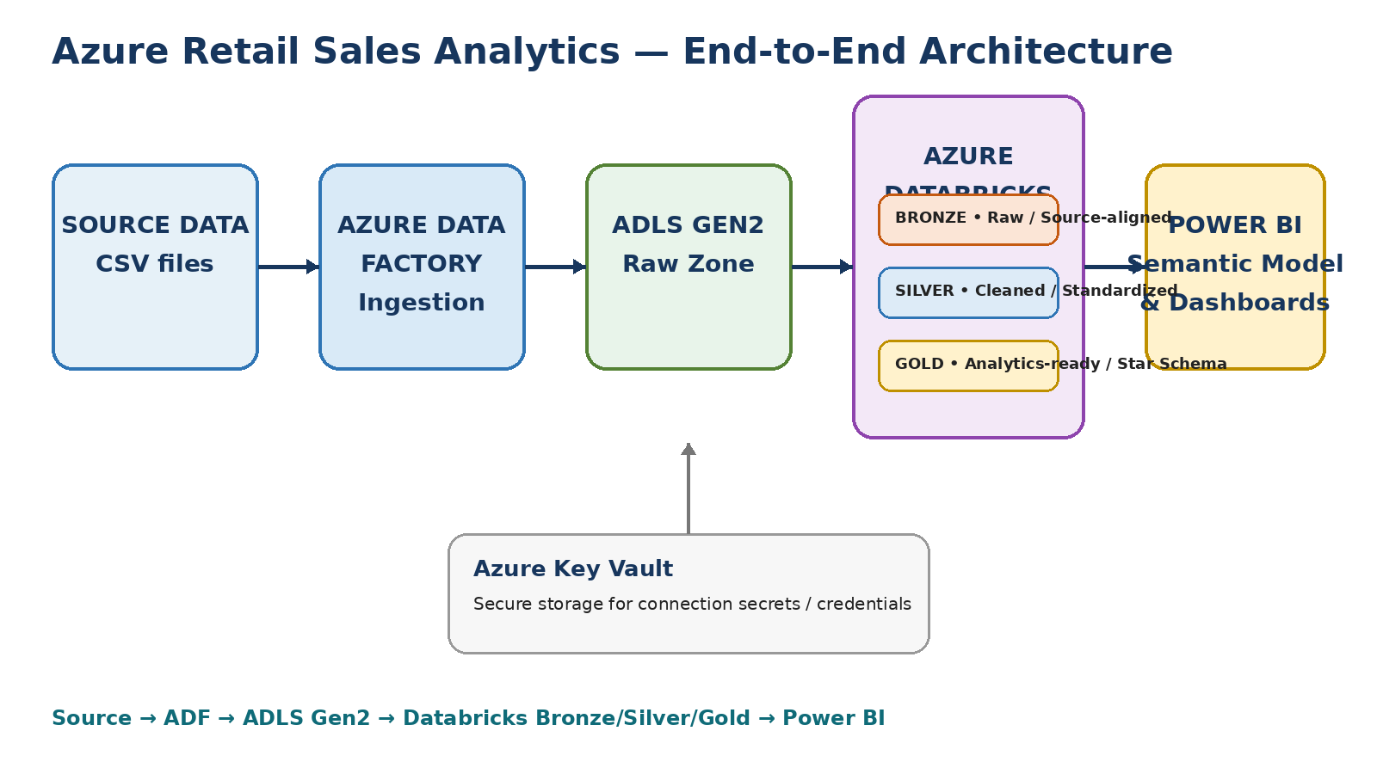
Figure 1. Project architecture with Medallion layers.
Layer | Purpose | Typical work
Bronze | Raw/source-aligned | Ingest and retain traceability
Silver | Clean/standardize | Types, case, nulls, duplicates, business rules
Gold | Analytics-ready | Facts, dimensions and BI measures
Mental model
Bronze = What arrived. Silver = What we trust. Gold = What the business uses.

12. Delta Lake — Reliable Tables

What to learn
- Delta format
- ACID transactions
- Schema enforcement
- Schema evolution
- MERGE
- Version history concepts

Why?
Delta adds reliability and table-management capabilities on top of cloud object storage, making analytical pipelines safer and more maintainable.

Benefits
- Reliable writes
- Schema control
- Incremental processing
- Better table management

13. Data Quality — The Most Important Engineering Habit
Do not assume source data is clean. This project found real inconsistencies that could have produced misleading dashboard results.
Issue | Found | Why it matters | Action
Region case | South/south/SOUTH | Splits totals | Standardize
Category case | office supplies/Office Supplies | Splits totals | Standardize
Zero quantity | 0 with ₹275,000 sales | Inflates revenue | Investigate/remove
Missing salesperson | 3 NULL rows | Breaks analysis | UNASSIGNED
Dimension integrity | Potential unmatched keys | Wrong relationships | Validate joins

Zero-quantity investigation
LineItemID = LI000421
Quantity = 0
UnitPrice = 55,000
SalesAmount = 275,000
The record was traced back to Bronze and confirmed as a source issue. After remediation, the final dataset became 1,988 line items and ₹42,724,680 in sales.
Key lesson
A beautiful dashboard with incorrect numbers is worse than no dashboard. Data quality protects business decisions.

14. Gold Layer & Star Schema
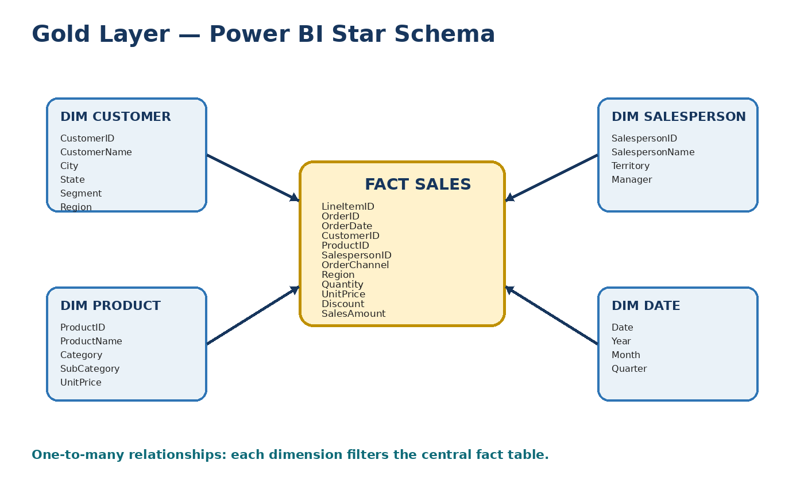
Figure 2. Gold-layer star schema.
Table | Purpose
fact_sales | Sales measures at order-line grain
dim_customer | Customer attributes
dim_product | Product/category attributes
dim_salesperson | Salesperson/territory/manager
dim_date | Calendar and time intelligence

Why star schema?
It simplifies analytical filtering, reduces ambiguity and maps naturally to Power BI.
Most important modeling question
What does one row in the fact table represent? In this project: one LineItemID / order line.

15. Power BI — Semantic Model, DAX & Reporting
- Open Power BI Desktop
- Get Data → Azure Databricks
- Enter Server Hostname and HTTP Path
- Authenticate
- Choose Import mode
- Load the five Gold tables

Relationships
dim_customer[CustomerID] 1 ─── * fact_sales[CustomerID]
dim_date[Date] 1 ─── * fact_sales[OrderDate]
dim_product[ProductID] 1 ─── * fact_sales[ProductID]
dim_salesperson[SalespersonID] 1 ─── * fact_sales[SalespersonID]

Core DAX
Total Sales = SUM(fact_sales[SalesAmount])
Total Orders = DISTINCTCOUNT(fact_sales[OrderID])
Total Quantity = SUM(fact_sales[Quantity])
Average Order Value = DIVIDE([Total Sales], [Total Orders])

Time intelligence
Sales YTD = TOTALYTD([Total Sales], dim_date[Date])
Previous Year Sales = CALCULATE([Total Sales], SAMEPERIODLASTYEAR(dim_date[Date]))
Sales YoY % = DIVIDE([Total Sales]-[Previous Year Sales], [Previous Year Sales])
Why?
The semantic model turns engineering tables into reusable business measures that respond to slicers and report context.

16. Dashboard Storytelling — Build Pages With Purpose
Page | Business question | Content
Sales Overview | How is the business performing? | Sales, orders, quantity, AOV, trend, region, category, channel
Product & Customer | What drives sales? | Category, subcategory, Top-N products, customers, segments, matrix
Salesperson Performance | Who drives sales? | Top salespeople, territory, manager, contribution, performance matrix

Design principles
- Avoid repeating KPIs
- Use meaningful slicers
- Keep colors consistent
- Match chart to question
- Keep executive page simple
- Use detail on analytical pages
- Sort time chronologically

17. End-to-End Validation
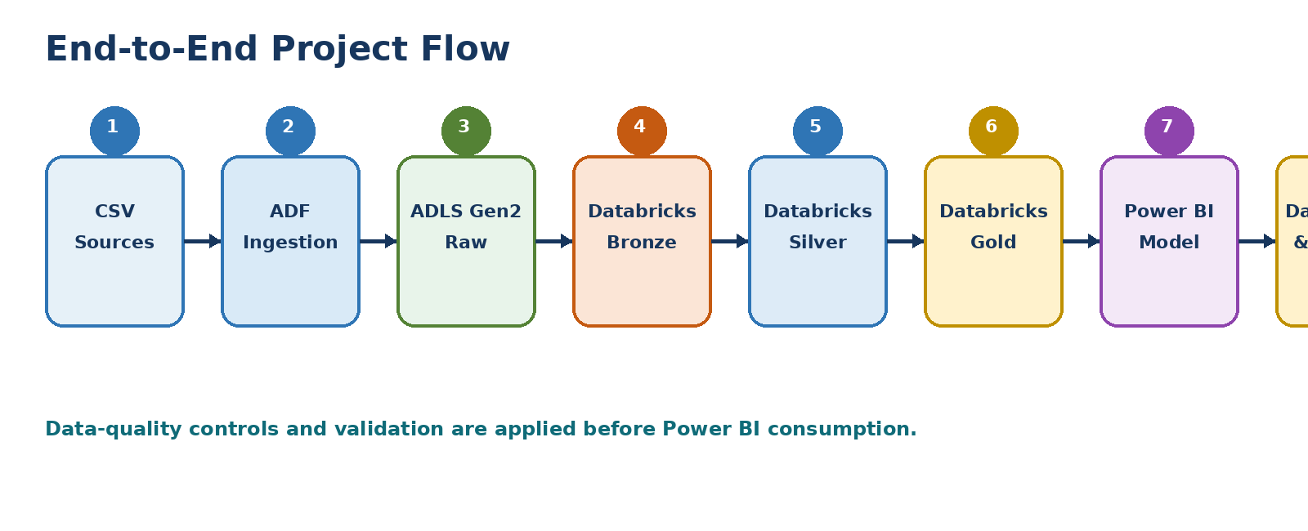
Figure 3. End-to-end project flow.
Metric | Validated result
Line Items | 1,988
Orders | 799
Quantity | 5,959
Sales | ₹42,724,680
First Order Date | 2026-01-01
Last Order Date | 2026-07-31
Unmatched Customers | 0
Unmatched Products | 0
Unmatched Salespersons | 0

Validation sequence
- Validate source
- Validate Bronze
- Validate Silver rules
- Validate Gold grain
- Validate relationships
- Reconcile Gold
- Load Power BI
- Reconcile Power BI KPIs

18. Interview Preparation
Question | Strong answer
Why Medallion? | Separates raw, cleaned and analytics-ready data for traceability and maintainability.
Why Databricks? | Distributed processing, PySpark/Spark SQL, Delta and collaborative notebooks.
Spark vs PySpark? | Spark is the engine/framework; PySpark is the Python API.
Why ADLS? | Scalable cloud storage and separation of storage from compute.
Why ADF? | Ingestion, orchestration, scheduling and monitoring.
Why star schema? | Simple, business-friendly analytical filtering with clear relationships.
What is fact grain? | One row per LineItemID/order line.
How did you handle bad data? | Profile, investigate, apply explicit rules, then validate.
Why Import mode? | Suitable for this reporting dataset and portfolio use case.
How did you validate Power BI? | Reconciled Power BI KPIs to Databricks Gold totals and checked relationships.

19. Hands-On Practice Checklist
Practice | Done? | What you should explain
Profile source | ☐ | Counts, nulls, duplicates, anomalies
Build ADLS landing | ☐ | Storage vs compute
Build ADF pipeline | ☐ | Linked service, dataset, copy activity
Create Bronze | ☐ | Traceability
Clean Silver | ☐ | Types, case, duplicates, business rules
Run quality checks | ☐ | Evidence of trust
Build Gold schema | ☐ | Grain, keys, dimensions
Validate Gold | ☐ | Reconciliation
Connect Power BI | ☐ | Databricks endpoint, Import
Create relationships | ☐ | 1:* and filter direction
Write DAX | ☐ | Measures vs columns
Build dashboards | ☐ | Business questions
Explain architecture | ☐ | 2–3 minute end-to-end walkthrough

Mini-project challenge
After completing the guided project, intentionally introduce one data-quality issue into a copy of the source and verify that your validation layer detects it. This teaches more than repeating only the happy path.

