**PHILOSOPHY + ENGINEERING**

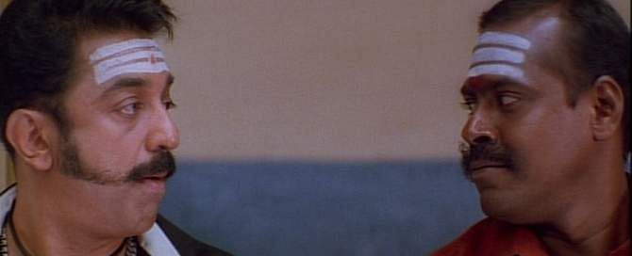

**ENGINEERING\***

\***PHILOSOPHY**

**PHILOSOPHY OF ENGINEERING**

**ASSIGNMENT – 1**

**NAME:**  VIJAYAN V

**REGISTRATION NUMBER:** RA2211004010572

1. **STAGES OF ERA:**

* Prehistory
* Ancient
* Medieval
* Renaissance
* Enlightenment
* Modern
* Postmodern

**PRE – HISTORY ERA**

* It refers to the period before recorded history.
* It covers the time from the earliest human existence to the invention of writing.
* During this time, early humans developed tools, hunted for food, and formed communities.
* Prehistoric humans evolved over time into different species such as homo erectus, Homo sapiens.
* This era is estimated to have started 2.6 million years ago.
* The transition from prehistory to history is marked by the invention of writing systems, such as cuneiform, hieroglyphics, and others.

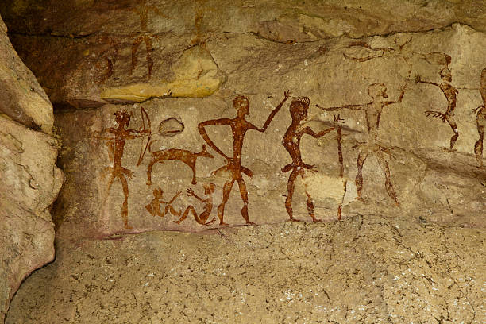

**ANCIENT ERA**

* The ancient era refers to the time period from the beginning of recorded history to the fall of the Western Roman Empire in 476 CE.
* It was characterized by the development of early civilizations such as the Sumerians, Egyptians, Greeks, and Romans.
* Ancient societies developed systems of writing, religion, governance, and law.
* The ancient era saw many important innovations such as the wheel, irrigation systems and the first legal codes.
* Many ancient cultures made significant contributions to fields such as philosophy, mathematics, astronomy, and art.
* The ancient era was also marked by wars and conquests, with powerful empires such as the Roman and Persian Empires dominating large parts of the world.

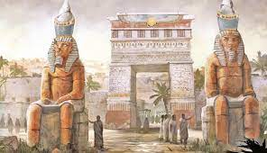

**MEDIEVAL ERA**

* The medieval era, also known as the Middle Ages, lasted from the 5th to the 15th centuries.
* It was characterized by the fall of the Roman Empire and the rise of feudalism in Europe.
* The medieval period was marked by the growth of Christianity and the Catholic church, which played a significant role in shaping the culture and politics of Europe.
* The medieval era saw the development of castles, chivalry, and Gothic architecture.
* The Black Death, a devastating pandemic of bubonic plague, swept through Europe in the 14th century, killing millions of people.
* The medieval era also saw the Crusades, a series of wars fought by Christian Knights to recapture the Holy Land from the Muslims.
* The end of the medieval era was marked by the Renaissance, a time of great culture, artistic, and scientific achievements.

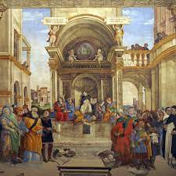

**RENAISSANCE** **ERA**

* The Renaissance was a cultural and intellectual movement that began in Italy in the 14th century and lasted until 17th century.
* It marked a transition from the medieval period to the modern era.
* The Renaissance was characterized by a revival of interest in classical learning and culture, as well as rediscovery of ancient Greek and Roman texts.
* The period was significant development in **Art, Architecture, Science and Philosophy.**
* Artists such as Leonardo da Vinci, Michelangelo, and Raphael made lasting contribution to western art.
* The Renaissance was also a time of exploration and discovery, with voyages to the New World and the circumnavigation of the globe.
* It was a period of significant social and political change of feudalism and the rise of nation-states.

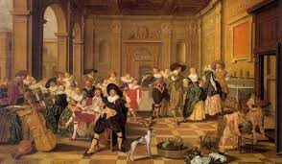

**ENLIGHTENMENT ERA**

* The Enlightenment era was an intellectual and cultural movement that look place in Europe from the late 17th century to the 18th century.
* It was characterized by a focus on reason, science and individualism, and rejection of traditional authority and dogma.
* The Enlightenment produced a number of influential thinkers and writers, such as John Locke, Jean Jacques Rousseau, Immanuel Kant, and Voltaire.
* The ideas of the Enlightenment had a profound impact on political, social, and economic systems, leading to the development of modern democracy, human rights, and the scientific method.
* The Enlightenment was also marked by significant advance in technology, including the Industrial Revolution, which brought about sweeping changes to the way goods were produced and distributed.
* The Enlightenment has been seen as a key turning point in Western history, paving the way for modernity and shaping the way for modernity and shaping the modern worlds as we know it today.

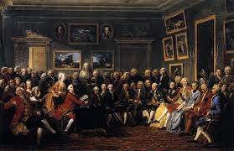

**MODERN ERA**

* The modern era began in the late 18th century and continues to the present day.
* It is characterized by rapid technological advancements, industrialization, and globalization.
* The modern era saw the growth of democracy and the decline of monarchies and colonial empires.
* The 20th century was marked by two World Wars and the Cold War, as well as significant scientific and technological innovations such as the computer, the internet, and space exploration.
* The modern era has seen the rise of globalization and the growth of international trade and commerce.
* It has also been characterized by ongoing debates over social, economic, and political issues, including incoming inequality, climate change, and the role of government in society.

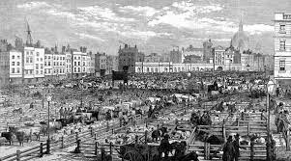

**POST – MODERN ERA**

* The post modern era is a term used to describe the culture, economic, and social conditions that emerged after World War II, around the mid – 20th century.
* It is characterized by a rejection of grand narratives, absolute truth claims narratives, and universal principles.
* The postmodern era is marked by a fragmented and pluralistic society, where multiple perspectives, identities, and culture practices coexist.
* The concept of the postmodern era is associated with development is art, literature, and architecture, characterized by experimentation, irony, and the deconstruction of traditional forms.
* Postmodernism also reflects changes in the way we understand and experience reality, influenced by developments in communication and information technologies.
* The postmodern era has been marked by a rejection of Enlightenment ideals and the rejection of the idea of progress.
* It has been characterized by ongoing debates over issues of cultural identity, social justice, and globalization.

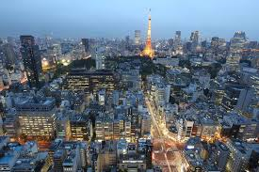

1. **RELATION BETWEEN ARTS, SCIENCE, MATHEMATICS ENGINEERING AND TECHNOLOGY**

**ARTS:**

Arts is a diverse range of human activity, and resulting product, that involves creative or imaginative talent expressive of technical proficiency, beauty, emotional power, or conceptual ideas.

The are two types of arts:

* Motivated
* Non – Motivated

**SCIENCE:**

Science is a systematic endeavour that build and organizes knowledge in the form of testable explanations and predictions about the universe.

Now a days, each and every happening need scientific reason or explanation.

**MATHEMATICS:**

Mathematics is an area of knowledge that includes the topics of number, formulas and related structures, shapes, and the spaces in which they are contained, and quantities and their changes.

Growth of Mathematics from ancient era have act as a backbone of engineering.

**TECHNOLOGY:**

Technology is the application of knowledge for achieving practical goals in a reproducible way. The word technology can also mean the product resulting from such efforts, including both tangible tools such as utensils or machines, and intangible ones such as software. Technology plays a critical role in science, engineering, and everyday life.

**ENGINEERING:**

Engineering is the use of Arts, Science, Mathematics, Technology to design and build machines, structure, and other items, including bridges, tunnels, road, vehicles, and buildings. The discipline of engineering encompasses a broad range of more specialized field of engineering, each with a more specific emphasis on particular areas of applied mathematics, applied science, and types of application.

**RELATIONSHIP OF STEAM:**

The relationship between arts, science, mathematics, engineering, and technology is interdependent and complementary.

Arts use elements of science and technology to create works of expression and beauty. Science relies on mathematics principles to describe and explain natural phenomena, while mathematics provide the language and tools used by engineers to design and build technological systems. Engineering and technology apply scientific and mathematical concepts to create practical solutions and products. All five fields overlap and influence each other, contributing to human advancement and cultural expression.