Artificial intelligence

**Phase 3 : DEVELOPMENT PART 1**

**Chatbot in Python:**

The Development of the Chat bot is nothing by added or by attaching various and more question with answer from the datasets that were given previously.

The chatbot development may be developed by many other ways and by more interesting ways to give up an idea.The idea might be created by enrolling the user to the Chatbot to produce more user .If more users are experienced a Chatbot the cahtbot will experience more number of questions if the question is valid or useful the asked question is added/ uploaded to the main database such that the questions to be answered.

**PROGRAM FOR CHATBOT DEVELOPMENT**

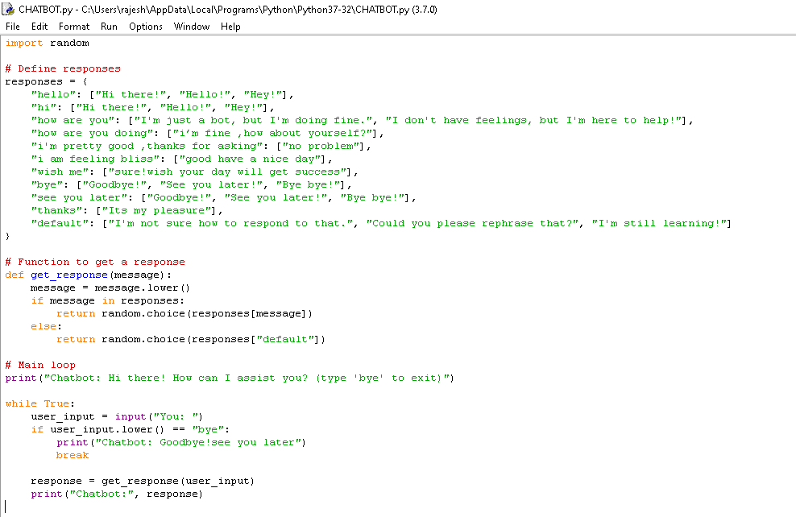

SAMPLE OUTPUT FOR SAMPLE PROGRAM

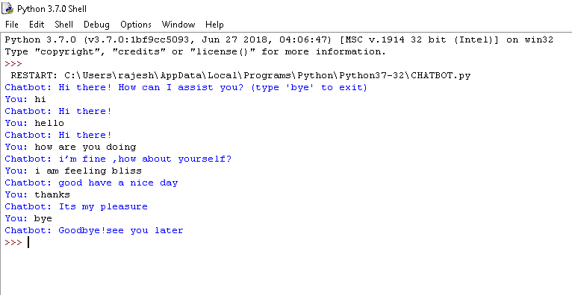

Done by:

S.Rajeshwaran

S.Rajesh

B.Vijay

M.Karuppaiah

N.Mohamed Idrish