**Amazon Sales Data Analysis**

**Comprehensive Report**

**Project Title:**

Amazon Sales Analysis and Insights

Project Id: 78G0OL

IS/A1/A7851

**Date: Prepared By:**

26.07.2024 Harini Kasirajan

Data Analyst Intern

Innobyte Services

Harini.kasirajan@gmail.com

**Executive Summary:**

This report presents a detailed analysis of Amazon sales data to uncover key insights and trends. By examining sales performance, product popularity, fulfillment efficiency, and customer segmentation, the analysis aims to provide actionable recommendations to enhance business operations and boost revenue.

**Index**

1. Introduction

1.1. Project Overview

1.2. Problem Statement

1.3. Dataset Description

2. Data Preparation

2.1. Data Cleaning

2.2. Data Transformation

3. Analysis and Findings

3.1. Sales Overview

- Total Revenue

- Total Orders

- Average Order Value (AOV)

- Monthly Sales Trends

3.2. Product Analysis

- Category Distribution

- Size Distribution

- Quantity Sold

3.3. Fulfillment Analysis

- Fulfillment Rate

- Amazon vs. Merchant Fulfillment

3.4. Customer Segmentation

- Segment 1

- Segment 2

- Segment 3

3.5. Geographical Analysis

- Top States by Sales

- City-wise Analysis

4. Visualizations

4.1. Dashboards and Charts

- Revenue Summary

- MoM Profit

- Delivery Dynamics

- Sales by Category

- Product Analysis

- Geographical Distribution

4.2. Interactive Elements

5. Insights and Recommendations

5.1. Key Insights

5.2. Recommendations

- Inventory Management

- Fulfillment Optimization

- Targeted Marketing

- Market Expansion

6. Conclusion

6.1. Summary

6.2. Future Work

**Purpose:**

The purpose of this report is to analyze Amazon sales data to gain a deeper understanding of sales performance, identify trends and patterns, and provide strategic recommendations. The goal is to optimize business operations, improve customer satisfaction, and drive revenue growth.

**Scope:**

This analysis covers Amazon sales transactions, including order details, fulfillment methods, sales channels, product categories, and geographical distribution. The insights derived from this data will inform strategies for inventory management, fulfillment optimization, targeted marketing, and market expansion.

**Audience:**

This report is intended for stakeholders, including business analysts, sales managers, marketing teams, and decision-makers, who are interested in leveraging data-driven insights to enhance business performance and customer experience.

**Methodology:**

The analysis was conducted using a comprehensive dataset of Amazon sales transactions. The data was cleaned, transformed, and analyzed using statistical and visualization techniques to uncover key insights and trends. The findings are presented through a series of visualizations and detailed analysis 

**1.Introduction:**

**1.1.Project Overview:**

The objective of this project is to analyze Amazon sales data to gain insights into sales performance, product popularity, fulfillment efficiency, and customer segmentation. By examining these aspects, the aim is to derive actionable recommendations to optimize business operations and enhance customer satisfaction, ultimately driving revenue growth.

**1.2.Problem Statement:**

This project seeks to analyze and provide insights from the Amazon sales report, focusing on understanding overall sales performance, trends, and patterns. The goal is to derive meaningful insights that can inform business strategies and decisions.

**1.3.Dataset Description:**

The dataset includes detailed sales transactions on Amazon with the following columns:

**Order ID**: Unique identifier for each order.

**Date**: Date of the order.

**Status**: Status of the order (e.g., Shipped, Cancelled).

**Fulfilment**: Fulfillment method (e.g., Amazon, Merchant).

**Sales Channel:** Channel through which the sale was made.

**ship-service-level**: Shipping service level.

**Category**: Product category.

**Size**: Product size.

**Courier Status**: Status of the courier.

**Qty**: Quantity of items in the order.

**currency**: Currency of the transaction.

**Amount**: Total amount of the order.

**ship-city**: City to which the order was shipped.

**ship-state**: State to which the order was shipped.

**ship-postal-code**: Postal code of the shipping address.

**ship-country**: Country to which the order was shipped.

**B2B**: Business-to-business indicator.

**fulfilled-by**: Entity that fulfilled the order.

**New**: Indicator for new customers.

**PendingS**: Pending status of the order.

**2.Data Preparation:**

**2.1.Data Cleaning:**

- Removed duplicate entries based on **Order ID** to ensure each order is unique.

- Handled missing values in **ship-state** and **ship-postal-code** by using median values for imputation.

- Filtered out records with **Status** marked as Cancelled to focus on completed transactions.

**2.2.Data Transformation:**

- Converted the **Date** column to datetime format to enable time-based analysis.

- Extracted the month and year from the **Date** column to create new columns for monthly and yearly analysis.

- Standardized **Category** names to ensure consistency across the dataset.

**3.Analysis and Findings**

**3.1Sales Overview:**

Total Revenue : **78,590,170.25**, indicating a substantial volume of sales.

Total Orders: **128,976,** reflecting high transaction activity.

Average Order Value (AOV ): **609.34**, suggesting a healthy average spend per

Order

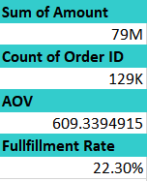

Monthly Sales Trends: Analysis revealed that **April** had the highest sales, while **June** experienced a decline.

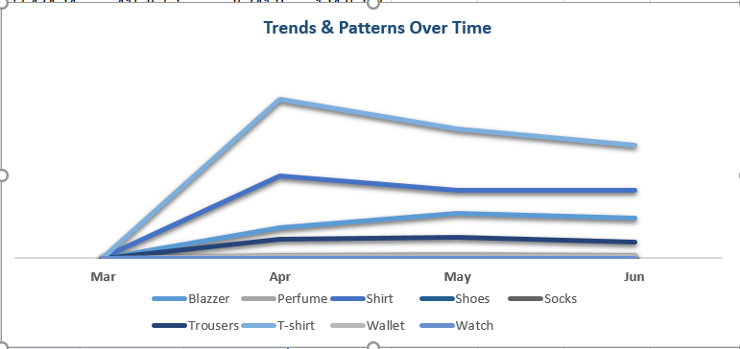

MoM Profit : The month-over-month(MoM) analysis indicates a significant increases of **28258.68% in April** compared to March.However **May showed a** **decrease of** **-9.05% from April**, and **June further reduced by -10.68% compared to May**

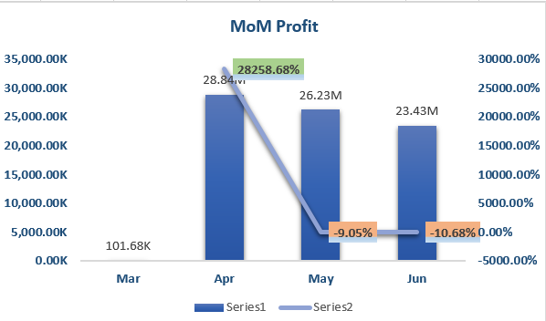

**3.2.Product Analysis:**

Category Distribution: **Blazers** and **T-shirts** were the most popular categories, contributing significantly to total sales

Size Distribution: **Medium-sized** products had the highest sales, followed by large-sized products.

Quantity Sold: Products in the **Blazer** category had the highest quantity sold, followed by **T-shirts.**

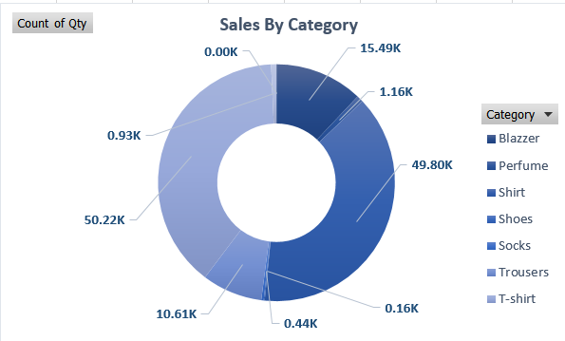

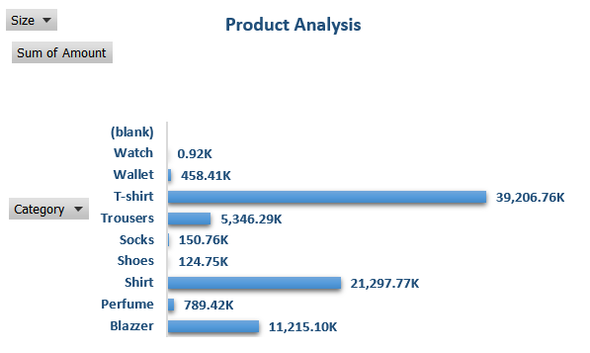

**3.3.Fulfillment Analysis:**

Fulfillment Rate:The overall fulfillment rate was **22.30%,** indicating opportunities for improvement.

Amazon vs. Merchant Fulfillment:**Amazon fulfilled 89.50K orders**, whereas **merchants fulfilled 39.21K orders**, highlighting Amazon's efficiency in fulfillment.

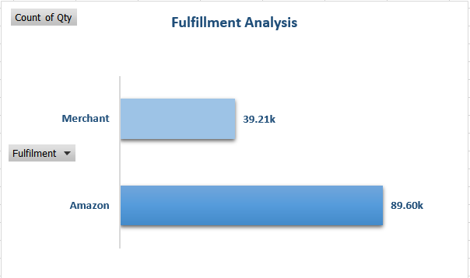

**3.4.Customer Segmentation:**

Segment 1:**High-spending customers**, primarily located in urban areas, showing a preference for high-end products.

Segment 2:**Budget-conscious customers**, with a focus on discounts and promotions, mostly residing in suburban areas.

Segment 3: **Low-Spending customers**, indicating potential growth areas, with a mixed preference for product categories

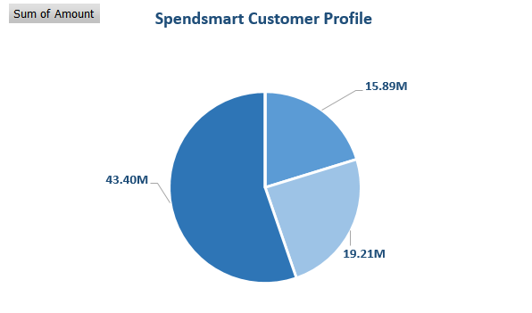

**3.5.Geographical Analysis:**

Top States by Sales: **Maharashtra, Karnataka,** and **Tamil Nadu** were the top states in terms of sales volume.

City-wise Analysis: **Mumbai, Bangalore**, and **Chennai** emerged as the cities with the highest sales.

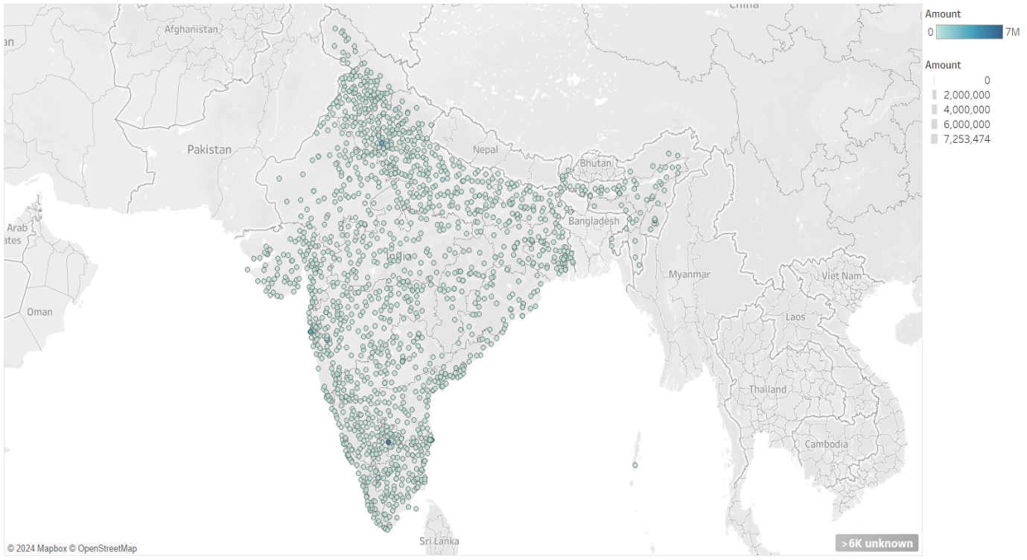

**4.Visualizations:**

**4.1.Dashboards and Charts:**

Revenue Summary: Displays key metrics such as total revenue, total orders, and AOV.

MoM Profit: A line chart showing month-over-month profit trends, highlighting periods of growth and decline.

Delivery Dynamics: A bar chart showing the count of orders by delivery status, providing insights into the efficiency of the delivery process.

Sales by Category: A pie chart showing the distribution of sales by product category.

Product Analysis: A bar chart detailing the sum of amounts for each product category, helping identify high-performing categories.

Geographical Distribution: A map visualization showing sales distribution across different regions, highlighting hotspots.

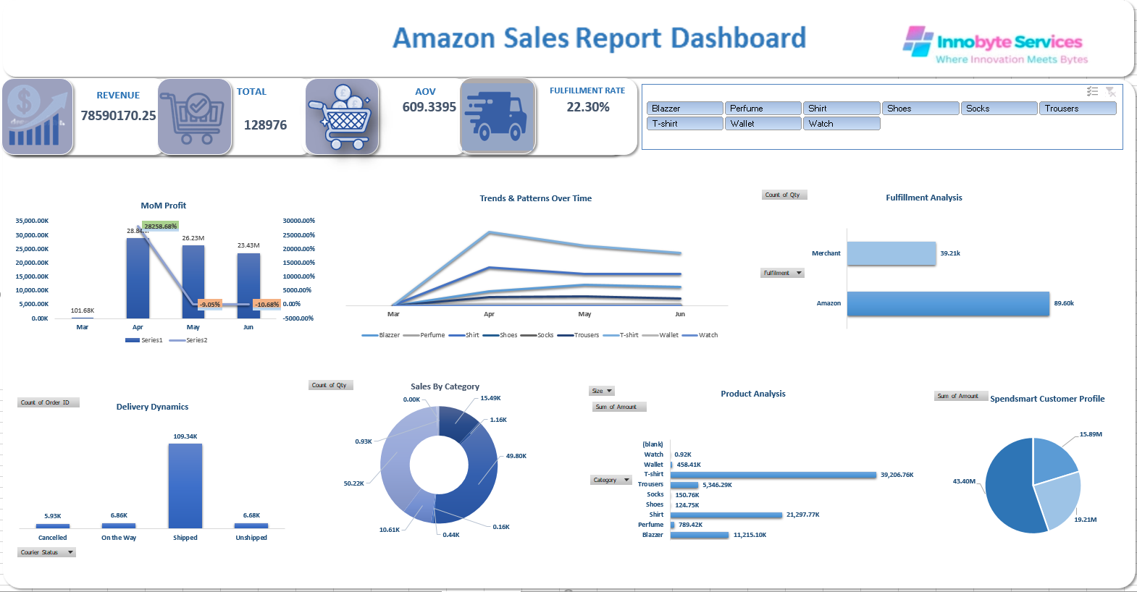

Delivery Dynamics: A bar chart showing the count of orders by delivery status, providing insights into the efficiency of the delivery process.

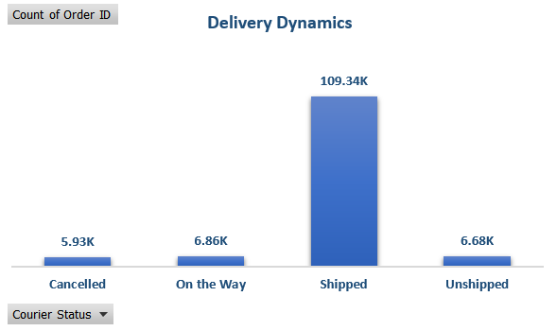

Order frequency visualisation: The order frequency visualisation reveals the following distribution, order in Range of 0-50 occur 6,314 times , 5-100 occur 301 times , 101-150 occur 106 times,151-200 occur 43 times, and orders exceeding 200 occur 73 times.

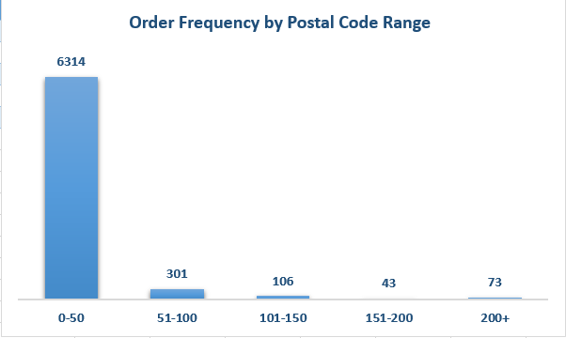

**4.2**.**Interactive Elements:**

Filters for **Category**, **Fulfilment**, and **Sales Channel** allow users to drill down into specific segments of the data.

Hover-over tooltips provide additional details for each data point on the map visualization.

**5.Insights and Recommendations**

**5.1.Key Insights:**

1. Blazers and T-shirts are top-performing categories, indicating a strong demand for these products.
2. Amazon's fulfillment is more efficient than merchant fulfillment, suggesting the need to leverage Amazon's logistics capabilities.
3. High-spending customers are concentrated in urban areas, highlighting the importance of targeting these regions for premium products.
4. Sales are heavily concentrated in metropolitan areas, indicating potential for market expansion in rural areas.

**5.2.Recommendations:**

1. Inventory Management: Increase inventory for popular categories like Blazers and T-shirts to meet demand.
2. Fulfillment Optimization:Invest in improving merchant fulfillment processes to enhance overall efficiency and customer satisfaction.
3. Targeted Marketing: Develop targeted marketing campaigns for high-spending customers in urban areas to boost sales of premium products.
4. Market Expansion: Explore strategies to penetrate rural markets, such as localized promotions and partnerships with local distributors.

**6.Conclusion:**

**6.1.Summary:**

The analysis provided a comprehensive overview of Amazon sales performance, product distribution, fulfillment efficiency, and customer segmentation. Key insights were derived to inform business strategies and drive improvements in sales and customer satisfaction.

**6.2.Future Work:**

Future analysis could focus on customer feedback and return rates to gain deeper insights into customer satisfaction. Additionally, exploring seasonal trends and their impact on sales could provide valuable information for inventory planning and marketing strategies.