Impact Metrics
Team Name: TBD

Abstract
This project presents a comprehensive, multi-granular analysis of India's air quality using five years (2015–2020) of daily and hourly observations collected from over 230 monitoring stations across 26 cities. The dataset spans a wide range of criteria pollutants, including particulate matter (PM2.5, PM10), nitrogen oxides (NO, NO₂, NO_{x}), sulfur dioxide (SO₂), carbon monoxide (CO), ozone (O₃), ammonia (NH₃), and volatile organic compounds(Benzene, Toluene, Xylene), along with corresponding Air Quality Index (AQI) values and AQI Bucket according to CPCB guidelines. A gap-aware imputation framework was applied to address missing station records. Pollution hotspots, seasonal trends, and inter-pollutant correlations were examined to infer dominant emission sources. Station performance was audited to assess monitoring reliability, and exposure-based impact metrics were developed to evaluate public health risk. Findings were finally integrated into an interactive, policy-oriented dashboard.

Preprocessing
We opened the CSV files to manually view and study the provided data. We developed a rough idea of the entries and their nature. Different imputation strategies were employed for city and station data as well as hourly and daily observations.

S. No. | Data File | Imputation Strategy | Explanation
1. | station_day | - Forward/Backwards Fill for the days where a non-null value exists within 2 days.  - Station Monthly Median for remaining NULL values having at least one non-null value in that month.  - City Monthly Median for remaining NULL values having at least one non-null value in that month.  - City Seasonal Median for remaining NULL values having at least one non-null value in that season.  - The remaining NaN values were flagged and excluded from further analysis. | - Forward/Backwards Fill preserves the local trend, assuming no drastic change from day to day.  - Station Monthly Median is the next best estimate if a short-term trend is not available.  - Assuming intra-city monthly air quality patterns are similar, using City Monthly Median provides a broader context.  - As a last resort, City Seasonal Median was used to capture the macro-seasonal trend.  - Imputing remaining gaps could have introduced bias, so they are flagged as missing.
2. | city_day | - Forward/Backwards Fill for the days where a non-null value exists within 5 days.  - City Monthly Median for remaining NULL values having at least one non-null value in that month.  - City Seasonal Median for remaining NULL values having at least one non-null value in that season.  - The remaining NaN values were flagged. | - Since city-level data is much more stable than station-level data, the window for forward/backward fill is increased.  - To protect the aggregate integrity, the imputation layers are reduced in size.
3. | station_hour | - Only the primary pollutants were considered for imputation.  - Linear Interpolation for gaps less than 4 hours.  - For gaps of length 5-12 hours, the previous day's mean.  - Long gaps were flagged(more than 18 hours of missing data). | - Over very short periods, air quality changes are assumed to be smooth.  - A gap of over 18 hours is not imputed to protect data quality.
4. | city_hour | Same strategy as station_hour. | --

For each of the data sheets, the AQI values and buckets were recalculated after imputations using the CPCB standards.

Hotspot Identification
The objective of the analysis focused primarily on a descriptive analysis of the processed data, yielding several key insights.
Station Hotspots:
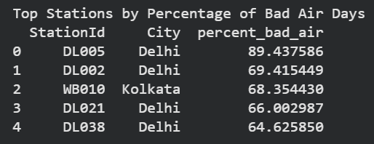
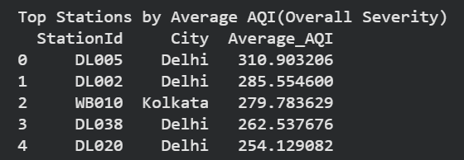

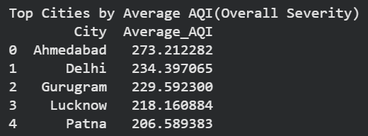
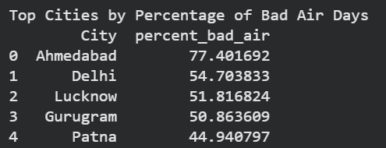
City Hotspots:
A significant observation emerged from the city-level daily observations: The reported CO concentration values in Ahmedabad were consistently registered far above the acceptable thresholds set by CPCB. We strongly suspected that this was a result of faulty sensor readings rather than a genuine atmospheric condition.

To ensure the integrity of the overall AQI assessment, the AQI and its corresponding category were recalculated, excluding CO sub-indices.
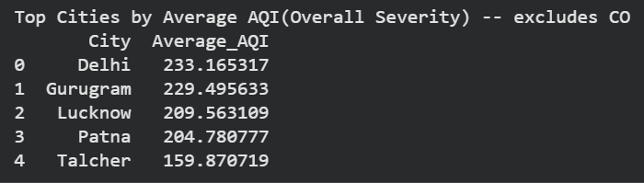
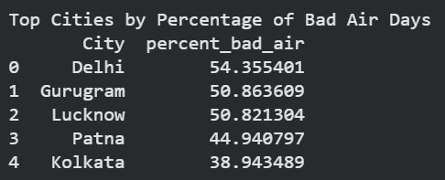
Upon removal of the anomalous CO data, Ahmedabad immediately dropped out of its position among the 'Most Polluted Cities' identified in the initial, unadjusted ranking. This confirmed the outsized and likely erroneous influence of the CO sensor on the city's reported air quality profile.
We next identified the Top Contributing Pollutant(on average) for each city:
- Out of the 26 cities, 11 cities were found to have PM2.5 as the most critical pollutant, including Ahmedabad, Delhi, and Gurugram.
- The remaining 15 cities had PM10 as the top contributing pollutant, including Bengaluru, Mumbai and others.
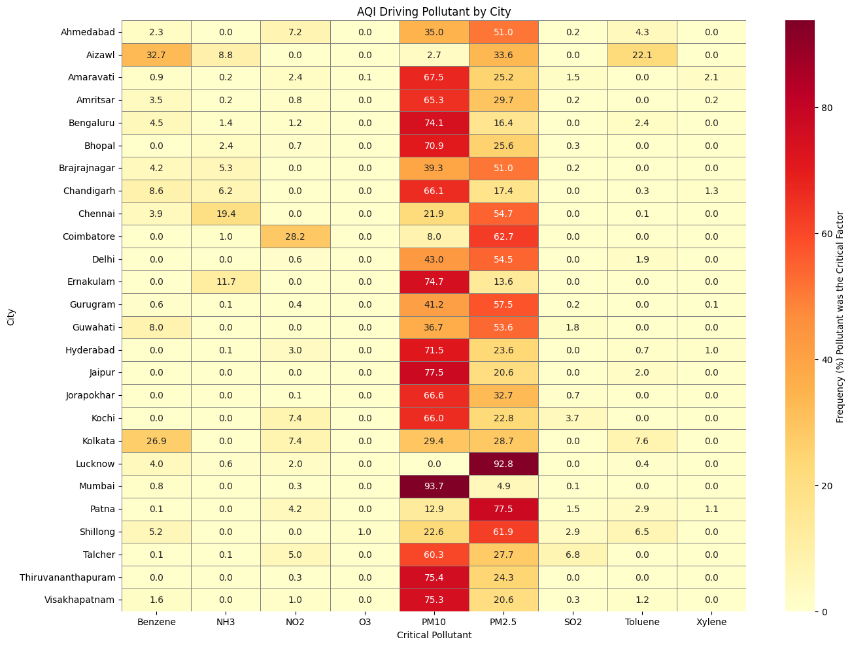
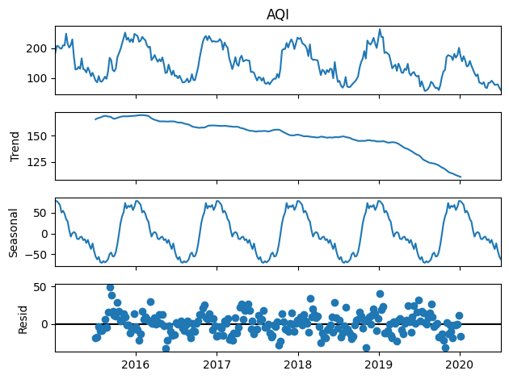
To dissect the underlying temporal patterns in AQI, Seasonal Decomposition using an additive model was performed.

Peak Seasonal Month: January (Average deviation from trend: +70.16 AQI)
Through Seasonal Month: August (Average deviation from trend: -66.60 AQI)

Finally, to demonstrate the deterioration in AQI with major fireworks, a spike-baseline analysis was performed for Diwali 2019 and New Year 2019.

Diwali 2019 | New Year 2019
Avg PM2.5 during spike: 91  Avg PM2.5 during baseline: 83  Percentage increase over baseline: 9.64% | Avg PM2.5 during spike: 130  Avg PM2.5 during baseline: 120  Percentage increase over baseline: 8.33%
Avg PM10 during spike: 132  Avg PM10 during baseline: 122  Percentage increase over baseline: 8.20% | Avg PM10 during spike: 195  Avg PM10 during baseline: 183  Percentage increase over baseline: 6.56%
Avg NO₂ during spike: 34  Avg NO₂ during baseline: 32  Percentage increase over baseline: 6.25% | Avg NO₂ during spike: 47  Avg NO₂ during baseline: 44  Percentage increase over baseline: 6.82%

Pollutant Correlation & Source Attribution

To understand how changes in one pollutant concentration relate to others, a Pearson Correlation Matrix was computed across the primary set of air quality parameters.
We used K-Means Clustering to group cities based on their pollution profiles, which were created by calculating five summary statistics (mean, median, standard deviation, maximum, and 90th percentile) for six key pollutants (PM2.5, PM10, NO2, SO2, CO, and O3) in each city. The Elbow Method, applied to the inertia curve, indicated that the optimal number of clusters was K = 11. The final K-Means model successfully segmented the cities into 11 distinct clusters.
The results aligned mainly with physicochemical expectations:
- A high positive correlation(0.846) was observed between PM2.5 and PM10.
- A slight negative correlation between SO₂ and NH₃ (due to their chemical reactivity).

Furthermore, cities were grouped into 11 clusters based on their pollution profiles.
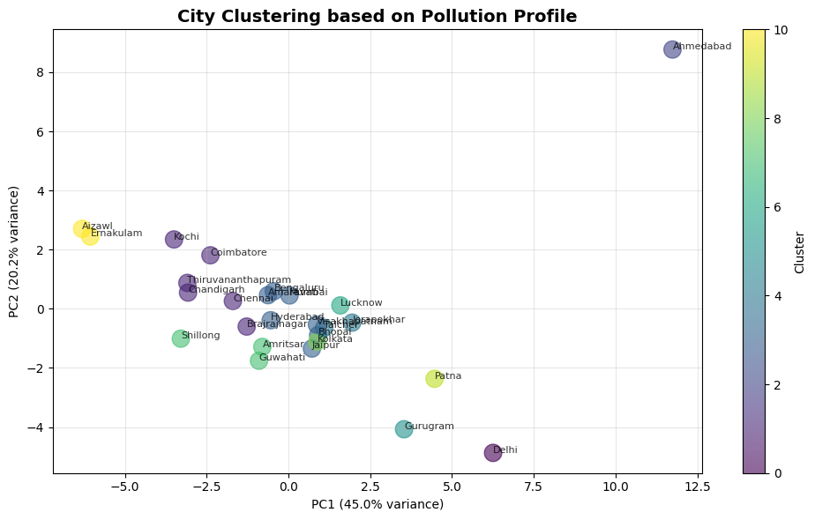

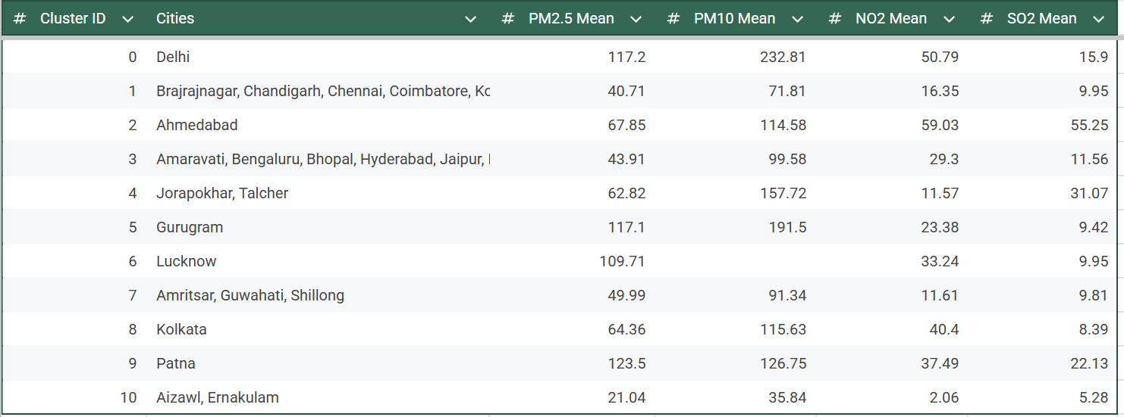

Source-specific marker pollutants were used to identify the pollution sources (Industrial, Vehicular, and Seasonal). We generated a binary score for each pollution type by comparing its daily value against a statistical threshold.

Score Type | Characteristic Pollutants | Threshold
Industrial Score | High SO₂ and NO_{x} | Both > City-specific 75th percentile
Vehicular Score | High NO₂ and CO | Both > City-specific 75th percentile
Winter Score | High PM2.5 | PM2.5​ > (Median×1.5) and (Season is 'Winter')
Summer Score | High PM10 and O₃ | PM10​ > (Median × 1.3) OR O₃​ > (Median × 1.3) and (Season is 'Summer')
Monsoon Score | High SO₂ | SO₂​ > (Median × 1.2) and (Season is 'Monsoon')
Post-Monsoon Score | High PM2.5 | PM2.5​ > (Median × 1.6) and (Season is 'Post-Monsoon')

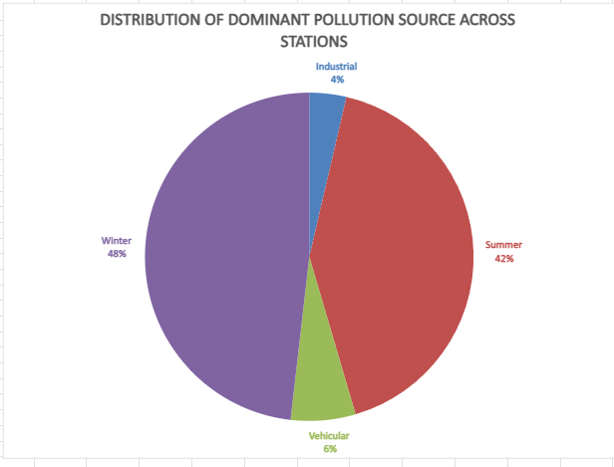

Station Performance & Data Quality Audit:
To gain a rough idea of the entries and their nature, we manually reviewed the provided CSV files. We observed:
- Blank rows - Contiguous and isolated rows of either blank data or NULL entries
- Partially filled rows - For some records, some columns were left empty
- Duration - Although the problem statement mentions that the data spans 5 years, the stations had different net durations that seldom spanned the complete 5 years.
- Long continuous streaks of 0 - Some columns, e.g. Benzene, CO, etc., had contiguous streaks of NULL readings across several hours
- Data Range - We observed high variation in the data values, suggesting that some extreme and thus invalid entries may exist.
- Continuity in timestamps - For each station, we observed the given timestamps, which appeared to be exhaustive and continuous, with a 1-hour gap always present. [We later tested this using code, and indeed they were continuous]
- AQI - Several records had no readings but still reported an AQI, which is a clear red flag, as the subindices of the given pollutants determine the AQI.
We also referred to CPCB data to determine quality standards and ideal ranges of the pollutants.
Finally, we decided on our strategy and metrics:
Completeness
- Completeness refers to the percentage of the dataframe that is actually present. It helps us find coverage and missing data.
- Defined as: Total Readings / Expected Readings.
- Total Readings - Actual number of values reported by the sensors
- Expected Readings - Total number of cells that were to be filled
- The calculations were done for each pollutant, for each season and for each station in a nested manner.
Validity
- Validity refers to the extent to which the given data is factually correct and relevant. This helps us to do a quality check on the data.
- Defined as: Valid Readings / Total Readings.
- Total Readings - Actual number of values reported by the sensors
- Valid Readings - Readings that meet the already set validation checks
- This was calculated for each pollutant, for each season and for each station in a nested manner.
- Validity checks used:
  - All values should be positive
  - PM2.5 is a subset of PM10. Therefore, PM2.5<PM10
  - NO and NO₂ are a subset of NO_{x}. Therefore, NO+NO₂<NO_{x}
  - CPCB data shows the calculation for AQI and the breakpoints for each pollutant. We use that to verify the AQI calculation.
  - There was no direct data regarding extreme upper bounds for each pollutant, so we used the CPCB data for AQI and scaled the extreme breakpoint 2-4x to get an empirical upper bound. Then, we checked each reading.
Operational Period
- The Operational Period refers to the actual hours the station was operational (uptime). It helps measure efficiency and also monitor outages.
- Measured as: 1-(non-operational hours/total hours).
- Total hours - total hours considered
- Non-operational hours - total hours with blank entries (NULL or NaN values)
- This calculation was performed for each season and station in a nested manner.
Reliability
- Here, we calculate and assess the reliability, dependability, and trustworthiness of each station.
- Measured as a weighted average of completeness%, validity% and uptime%.
- The weights were empirically determined to assign an appropriate value to the parameters. Uptime is the least important (0.2) while Completeness and Validness are higher (0.4, 0.4).
- This calculation was performed for each season and station in a nested manner.
Data Summary
Season-wise:
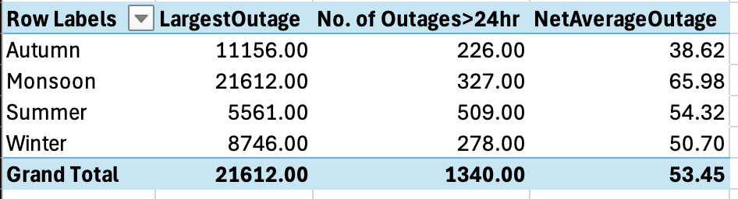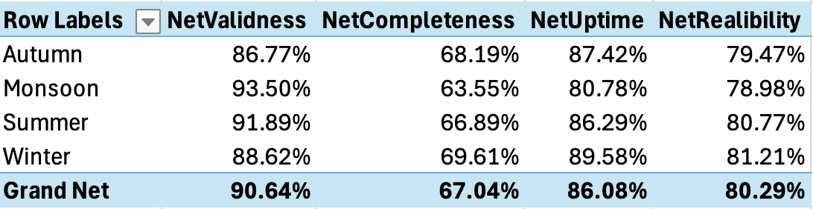
State-wise:
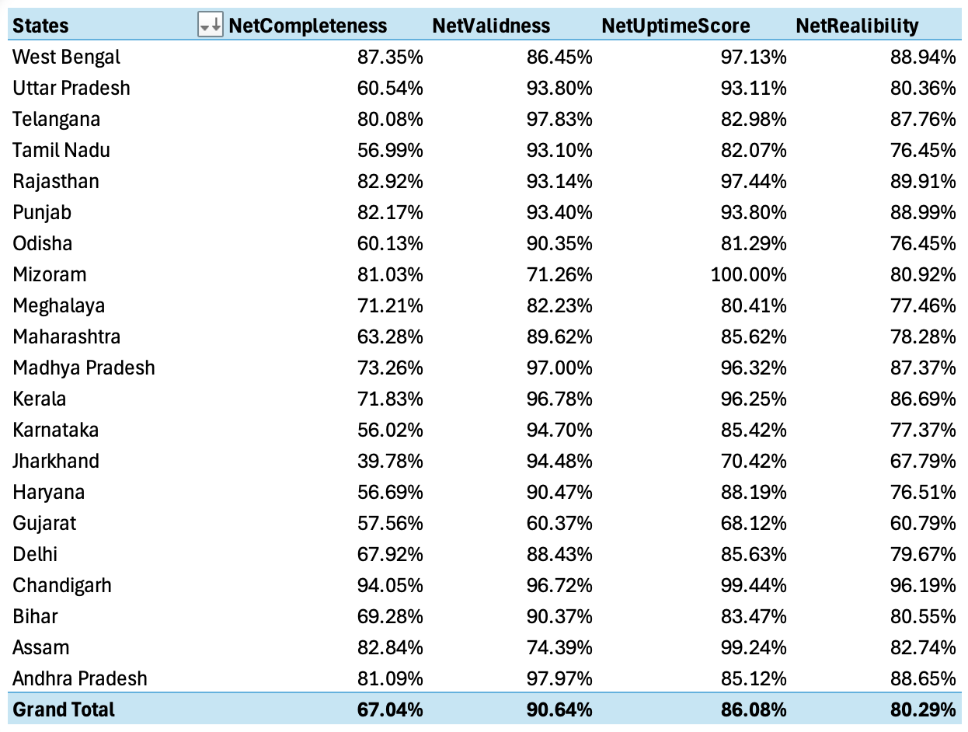
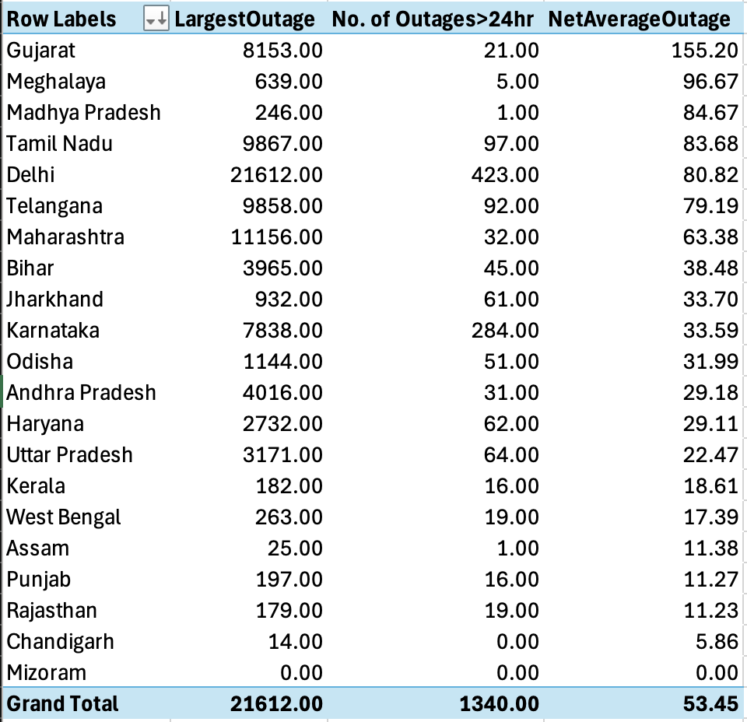

Pollutant-wise:
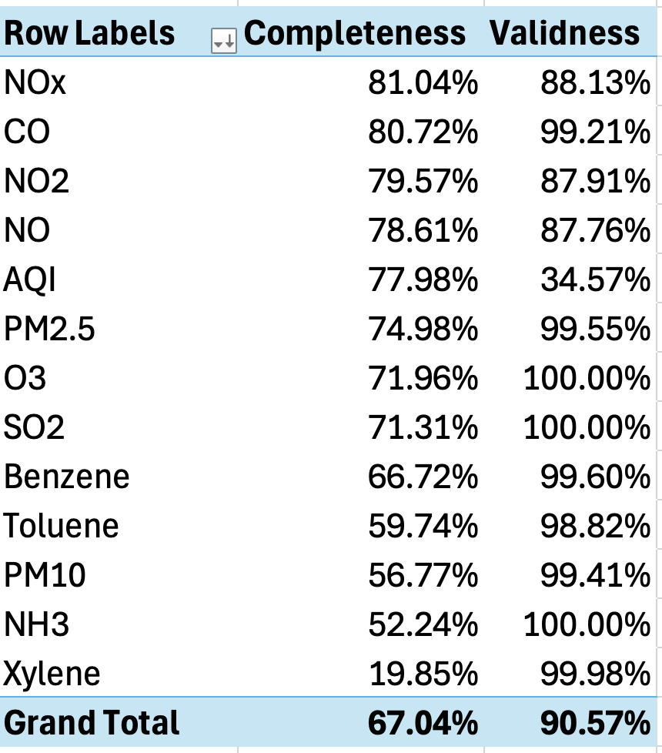

Our thoughts from the pre-processing were verified, because we can clearly see that the data was highly corrupted and showed several missing fields:
- Season-wise:
  - The net reliability scores across the seasons are more or less the same.
  - An approximate 80% reliability, which seems average.
  - However, we see an interesting case with Monsoon, where the readings are the most accurate, but there were a lot more outages, resulting in the lowest reliability.
  - You can observe the absurd lengths of outages in the Autumn and Monsoon. This arose due to a particular station becoming dormant for an extended period and then being reactivated.
  - Though Monsoon has a greater average length of outages, summer has a higher number of ‘days-long’ outages.
  - In all 4 seasons, completeness is sub-standard and needs overall upgrades.
- State-wise:
  - There is considerable variation when discussing state-wise data.
  - Some states are performing well, for example, Chandigarh, Rajasthan and Punjab. All three showed excellence in the metrics, with Chandigarh having the highest Completeness and Uptime Scores, and ultimately, the highest Reliability.
  - Others that should definitely be flagged include Gujarat, Jharkhand, and Tamil Nadu. Inferior metrics, with Gujarat having the least Validness, Uptime Scores and ultimately, Reliability.
- Pollutant-wise:
  - AQI calculations were inaccurate, primarily due to the presence of numerous rows with no readings but an AQI value assigned nonetheless.
  - Several sensors are clearly inadequate and backward, as the completeness of pollutants like Toluene, NH3, and Xylene (0.2 is utterly unacceptable) is unsatisfactory.
  - While others demonstrate adequate validity, the chosen limits were empirical and very liberal, requiring further analysis.
- In the metadata, several stations are held dormant.
Strategies to improve India’s air monitoring network:
- Better power management and delivery will increase uptime, especially during monsoons.
- Upgrade of sensors to increase sensitivity and expand the range of pollutants, such as toluene and NH3, that can be detected.
- Increase funds for poorly performing states, such as Haryana, Jharkhand, and Tamil Nadu, and impose stronger checks and balances over them.
- Renovate the dormant stations, such as those in Madhya Pradesh (with only one active station), or build new ones to ensure better coverage of the Indian landscape.
- Better data management services are needed, as the data obtained is highly unsatisfactory.
- Regular sensor recalibration and inspections are performed to ensure greater accuracy and increased validity. (e.g. CO in Ahmedabad)

Impact Metrics & Public Health Analysis
We used the WHO-recommended levels for calculating the City Exposure & Intensity metrics across city-level datasets(using hourly and daily data, respectively).
The defined metrics are:
$Intensity = Annual Average Concentration of a Pollutant$
Exposure = $\frac{Number of Exceedance Days}{Total Days}$
Risk Score = $Intensity× (1 + Exposure)$
$ΔR = \% Change in Risk Score(YoY)$

For identifying Vulnerable Populations, we mapped exposure levels to age groups based on the WHO and medical research.

Age Group | Conditions
Children & Infants | Developing respiratory systems and higher breathing rates.
Elderly (65+) | Weakened immune systems, pre-existing conditions.
Pregnant Women | Fetal development risks, pregnancy complications.
Asthma & Respiratory Patients | Exacerbation of existing conditions.
Cardiovascular Patients | Increased heart attack and stroke risk.
Outdoor Workers | Extended exposure duration.

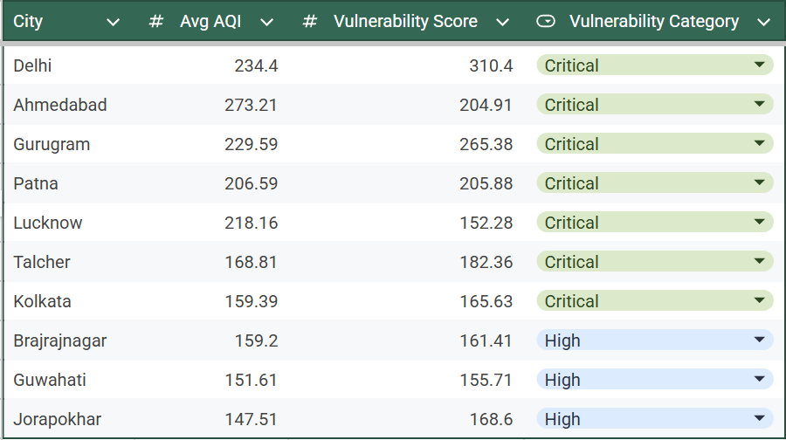

Using the calculated Risk Scores, the cities with the Largest YoY improvement and deterioration were identified:
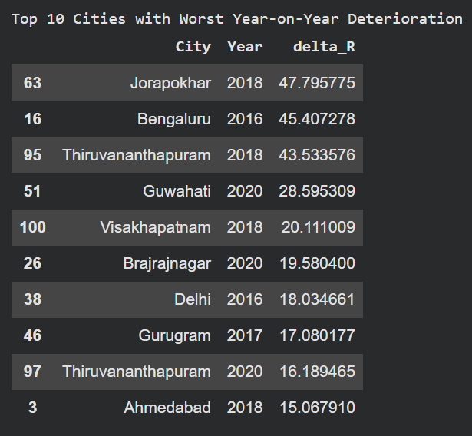
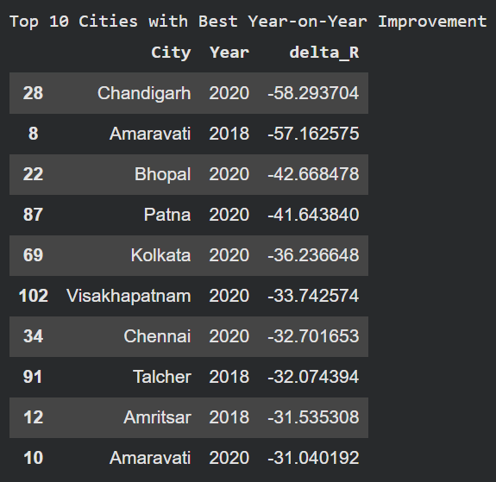

Finally, we ranked the years based on the number of cities that demonstrated improvement in that year.
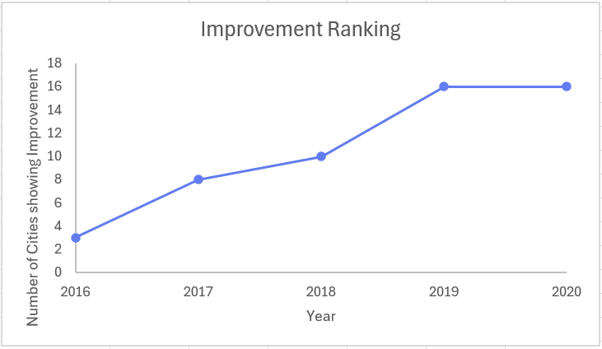

Conclusion
The analysis highlighted clear pollution hotspots, strong seasonal effects, and consistent relationships between key pollutants, helping to link observed patterns to likely emission sources. A review of station performance also revealed essential gaps in monitoring coverage. Overall, the results demonstrate how existing air-quality data can be utilised more effectively to understand exposure risks and support more informed, evidence-based air-quality planning, without relying on complex predictive models.

Credits
Vanshika Kataria (kataria.vanshika08@gmail.com)
Akshara Jain (jainakshara108@gmail.com)
Aayush Agarwal (agar.aayush@gmail.com)

