Tab 1

Station Performance Report
~Deliverable 3

Table of Contents
- Overview
- Pre-Processing
- Completeness
- Validity
- Operational Period
- Reliability
- Data Summary
- Insights
- Recommendations
- Bibliography

Overview
This document serves as our audit report, verifying the quality and validity of the provided data. We worked on the dataset ‘station_hours.csv’ to identify coverage gaps, patterns of missing data, non-operational periods, and the reliability of various stations. In subsequent sections, we describe the chosen metrics. For transformation and analysis, we used Pandas in the Google Colab environment, and for visualisation, we used PivotTables in MS Excel. Both files are attached to the Bibliography. We prepared the data to view metrics station-wise, state-wise, pollutant-wise, and temporally (we implemented a logic to classify by seasons). Finally, we prepared summaries and presented them here.

Pre-Processing
We opened the CSV files to manually review and study the data. We have a rough idea of the entries and their nature. We observed:
- Blank rows - Contiguous and isolated rows of either blank data or null entries
- Partially filled rows - For some records, some columns were left empty
- Duration - Although the problem statement states that the data span 5 years, the stations had different net durations that seldom spanned the full 5 years.
- Long continuous streaks of 0 - Some columns, e.g. Benzene, CO, etc., had contiguous streaks of null readings across several hours
- Data Range - We observed high variation in the data values, suggesting that some entries may be extreme and thus invalid.
- Continuity in timestamps - For each station, we observed the timestamps, which appeared to be exhaustive and continuous, i.e., with a gap of 1 hour. [We later tested this using code, and indeed they were continuous]
- AQI - Several records had no readings but still reported an AQI, which is a clear red flag, as the subindices of the given pollutants determine the AQI.
We also referred to CPCB data to determine quality standards and ideal ranges of the pollutants.
Finally, we decided on our strategy and metrics:
- Completeness
- Validity
- Actual Operational Periods and Outages
- Reliability Score

Completeness
- Completeness refers to the percentage of the dataframe that is actually present. It helps us find coverage and missing data.
- Defined as: Total Readings / Expected Readings.
- Total Readings - Actual number of values reported by the sensors
- Expected Readings - Total number of cells that were to be filled
- The calculations were performed for each pollutant, each season, and each station in a nested manner.

Validity
- Validity refers to the extent to which the given data is factually correct and relevant. This helps us to do a quality check on the data.
- Defined as: Valid Readings / Total Readings.
- Total Readings - Actual number of values reported by the sensors
- Valid Readings - Readings that meet the already set validation checks
- This was calculated for each pollutant, for each season and for each station in a nested manner.
- Validity checks used:
  - All values should be positive
  - PM2.5 is a subset of PM10. Therefore, #PM2.5<#PM10
  - NO and NO2 are a subset of NOx. Therefore, #NO+#NO2<#NOx
  - CPCB data shows the calculation for AQI and the breakpoints for each pollutant. We use that to verify the AQI calculation.
  - There was no direct data regarding extreme upper bounds for each pollutant, so we used the CPCB data for AQI and scaled the extreme breakpoint 2-4x to get an empirical upper bound. Then, checked each reading.

Operational Period
- The Operational Period refers to the actual hours the station was operational (uptime). It helps measure efficiency and also monitor outages.
- Measured as: 1-(non-operational hours/total hours).
- Total hours - total hours considered
- Non-Operational hours - total hours with blank entries (null or NaN values)
- This calculation was performed for each season and station in a nested manner.

Realibility
- Here, we finally calculate and find how reliable, dependable and trustworthy each station is.
- Measured as a weighted average of completeness%, validity% and uptime%.
- The weights were empirically determined to assign an appropriate value to the parameters. Uptime being the least important (0.2) while, Completeness and Validness being higher (0.4,0.4).
- This calculation was performed for each season and station in a nested manner.

Data Summary

Season-wise:
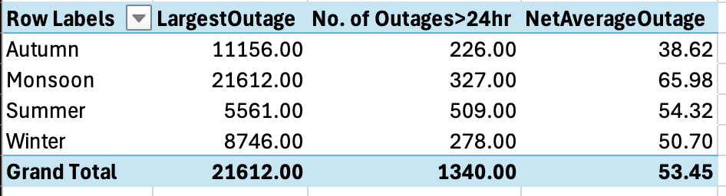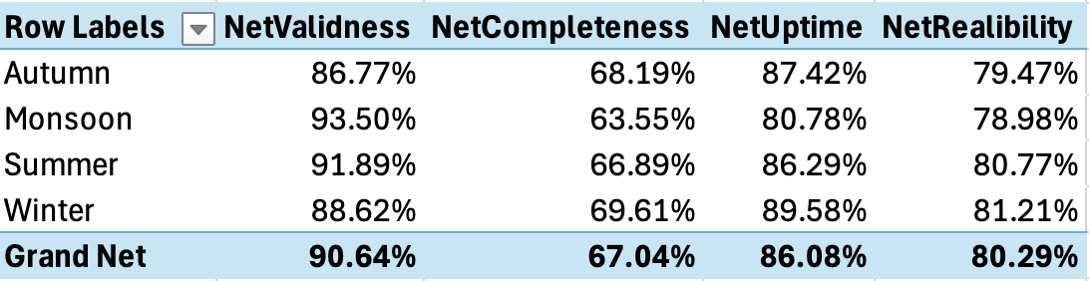

State-wise:
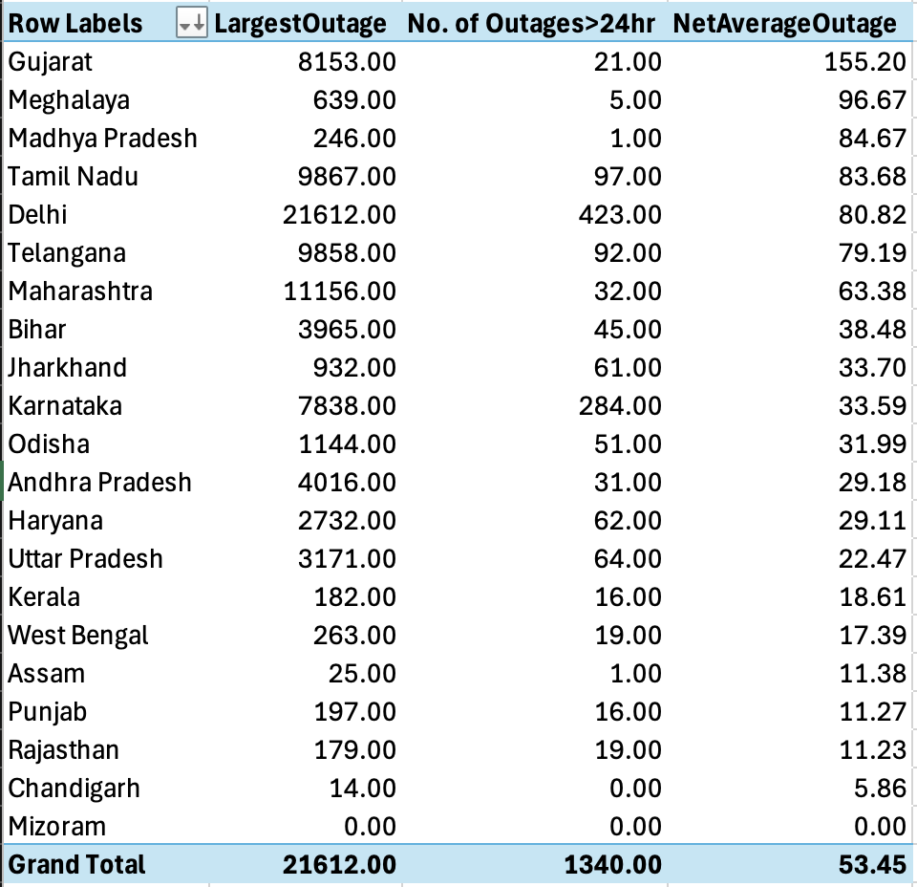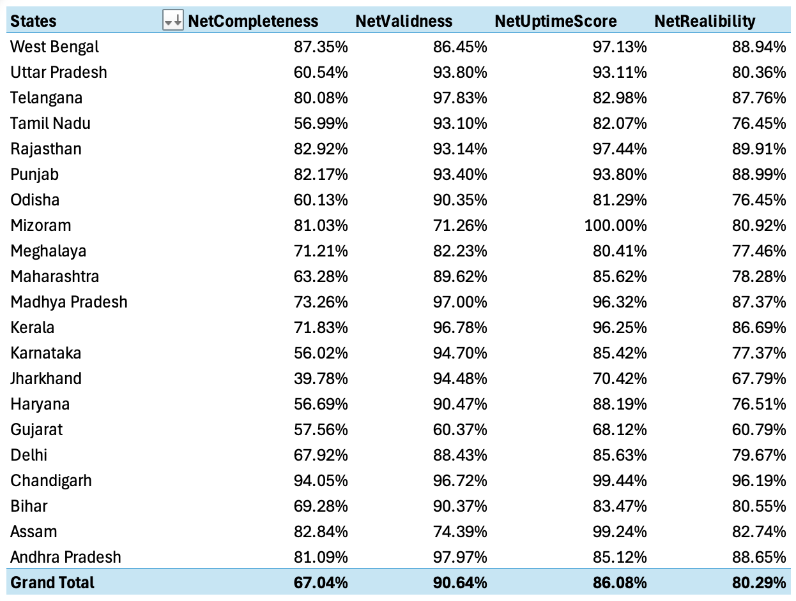

Pollutant-wise:
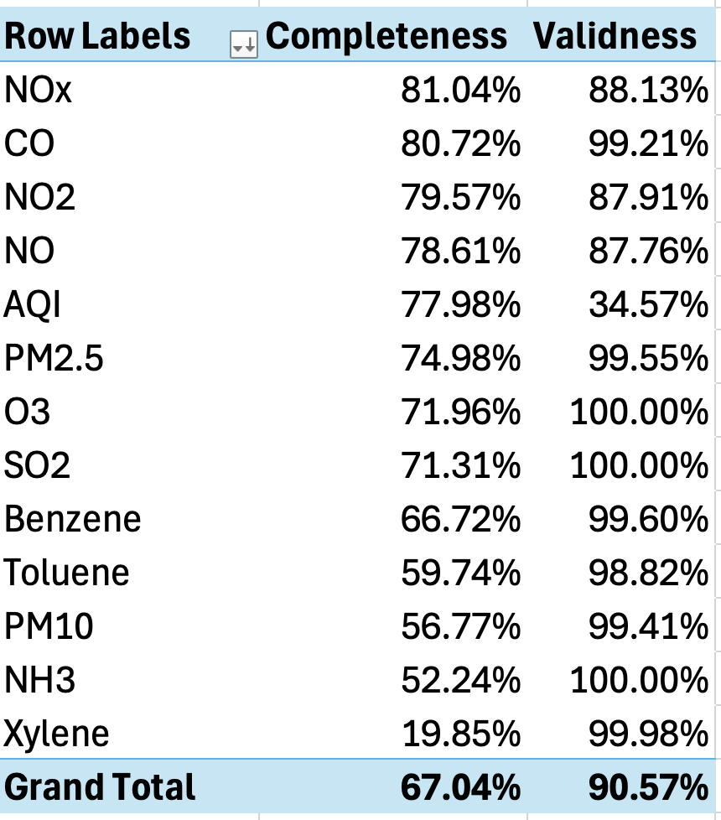

Insights
Our thoughts from the pre-processing were verified, because we can clearly see that the data was highly corrupted and showed several missing fields:
- Season-wise:
  - The net reliability scores across the seasons are more or less the same.
  - An approx 80% reliability, which seems pretty average.
  - However, we see an interesting case with Monsoon, where the readings are the most accurate, but there were a lot more outages, resulting in the lowest reliability.
  - You can observe the absurd lengths of outage in the Autumn and Monsoon. This arose due to a particular station becoming dormant for an extended period and then being reactivated.
  - Though Monsoon has a greater average length of outages, summer has a higher number of ‘days-long’ outages.
  - In all 4 seasons, completeness is sub-standard and needs overall upgrades.
- State-wise:
  - There is considerable variation when discussing state-wise data.
  - Some states are performing well, for example, Chandigarh, Rajasthan and Punjab. All three showed excellence in the metrics, with Chandigarh having the highest Completeness and Uptime Scores and ultimately, Reliability.
  - Others that should definitely be flagged include Gujarat, Jharkhand, and Tamil Nadu. Very poor metrics, with Gujarat having the least Validness and Uptime Scores and ultimately, Reliability.
- Pollutant-wise:
  - AQI calculations were inaccurate, primarily due to the presence of numerous rows with no readings but an AQI value assigned nonetheless.
  - Several sensors are clearly inadequate and backward, as the completeness of pollutants like Toluene, NH3, and Xylene (0.2 is utterly unacceptable) is unsatisfactory.
  - While others show adequate validness, the limits chosen were empirical and very liberal and required further analysis.
- In the metadata, several stations are held dormant.

Strategies to improve India’s air monitoring network:
- Better power management and delivery will increase uptime, especially during monsoons.
- Upgrade of sensors to increase sensitivity and expand the range of pollutants, like Toluene, NH3 etc. that can be detected.
- Increase funds for poorly performing states, such as Haryana, Jharkhand, and Tamil Nadu, and impose stronger checks and balances over them.
- Renovate the dormant stations, like in Madhya Pradesh (only one active station) or build new ones to ensure better coverage of the Indian landscape.
- Better data management services are needed, as the data obtained is highly unsatisfactory.
- Regular sensor recalibration and inspections to ensure more accuracy and increase validity.

Bibliography
- Drive Link: https://drive.google.com/drive/folders/1YNNHAKfnB-OOT_-0UJFxCdH7H5c9RXG1?usp=sharing
- CPCB references:
https://cpcb.nic.in/displaypdf.php?id=bmF0aW9uYWwtYWlyLXF1YWxpdHktaW5kZXgvQWJvdXRfQVFJLnBkZg==
https://cpcb.nic.in/openpdffile.php?id=UmVwb3J0RmlsZXMvMTI5OF8xNjI4NjY0MzY3X21lZGlhcGhvdG8yMDg3NS5wZGY=
https://cpcb.nic.in/openpdffile.php?id=UHVibGljYXRpb25GaWxlLzk5OV8xNzM1NjIyNTA0X21lZGlhcGhvdG8xNjkzMC5wZGY=

