Proactive Elderly Safety System
@page { size: A4; margin: 0.72in 0.78in 0.72in 0.9in; }
body { font-family: "Times New Roman", serif; font-size: 11pt; line-height: 1.2; color: #111; }
p { text-align: justify; margin: 0 0 7pt 0; }
h1 { font-size: 16pt; text-align: center; color: #1f4e79; page-break-before: always; margin: 0 0 18pt 0; }
h2 { font-size: 13pt; color: #1f4e79; margin: 14pt 0 6pt 0; }
h3 { font-size: 11pt; margin: 10pt 0 5pt 0; }
.cover { text-align: center; page-break-after: always; }
.cover p { text-align: center; margin: 10pt 0; }
.front { page-break-after: always; }
.center { text-align: center; }
.small { font-size: 9pt; }
.fig { text-align:center; page-break-inside: avoid; margin: 9pt 0 14pt 0; }
.fig img { max-width: 6.1in; max-height: 6.5in; }
.phone img { max-height: 5.7in; max-width: 3.2in; }
.caption { text-align:center; font-style:italic; font-size:9pt; }
table { width:100%; border-collapse:collapse; margin:7pt 0 12pt 0; font-size:9pt; page-break-inside:auto; }
th,td { border:1px solid #555; padding:4px; vertical-align:top; }
th { background:#dce6f1; text-align:center; }
tr { page-break-inside:avoid; }
ul,ol { margin-top:3pt; }
.toc li { margin: 6pt 0; }
.note { background:#eef4f8; border-left:3px solid #1f4e79; padding:7pt; }
.sig { margin-top:34pt; }

VISVESVARAYA TECHNOLOGICAL UNIVERSITY
YENEPOYA INSTITUTE OF TECHNOLOGY
Thodaar, Moodbidri, Karnataka
DEPARTMENT OF COMPUTER SCIENCE AND ENGINEERING
(Affiliated to Visvesvaraya Technological University, Belagavi)
PROJECT REPORT
PROACTIVE ELDERLY SAFETY SYSTEM FOR PRE-IMPACT FALL ANTICIPATION USING TEMPORAL REASONING
Submitted in partial fulfillment of the requirements for the degree of
BACHELOR OF ENGINEERING
COMPUTER SCIENCE AND ENGINEERING
Academic Year 2026â€“2027
Under the guidance of
Mrs. Anupama K
Department of CSE
Submitted by
Prajwal (4DM23CS093)
Praveen M Pawar (4DM23CS094)
Vinay V S (4DM23CS125)
Vivek Sathish Poojary (4DM23CS126)

CERTIFICATE
This is to certify that the project report entitled â€œProactive Elderly Safety System for Pre-Impact Fall Anticipation Using Temporal Reasoningâ€ is a record of project work carried out by Prajwal (4DM23CS093), Praveen M Pawar (4DM23CS094), Vinay V S (4DM23CS125), and Vivek Sathish Poojary (4DM23CS126), in partial fulfillment of the requirements for the award of the Bachelor of Engineering degree in Computer Science and Engineering of Visvesvaraya Technological University, Belagavi, during the academic year 2026â€“2027.
The project work is carried out under the guidance of Mrs. Anupama K, Department of Computer Science and Engineering, Yenepoya Institute of Technology, Moodbidri.
Guide signature: ____________________ HOD signature: ____________________
Principal signature: ____________________ Date: ____________________
Names and designations not present in the supplied evidence have been left blank for the department to complete.

DECLARATION
We declare that this project report titled â€œProactive Elderly Safety System for Pre-Impact Fall Anticipation Using Temporal Reasoningâ€, submitted in partial fulfillment of the requirements for the degree of Bachelor of Engineering in Computer Science and Engineering, is based on the project work carried out by our team under the guidance of Mrs. Anupama K. The report presents the implementation and evidence available in the project repository and dossier. Wherever the work of others has been referred to, it is acknowledged in the references.
Prajwal (4DM23CS093): ____________________
Praveen M Pawar (4DM23CS094): ____________________
Vinay V S (4DM23CS125): ____________________
Vivek Sathish Poojary (4DM23CS126): ____________________

ACKNOWLEDGEMENT
We express our sincere gratitude to our guide, Mrs. Anupama K, Department of Computer Science and Engineering, for her guidance and feedback during the project. We thank the faculty and staff of Yenepoya Institute of Technology for their support and the institution for providing an environment in which we could develop and evaluate this prototype.
We also acknowledge the authors and maintainers of the datasets, libraries, tools, and research works cited in this report. The project evidence and evaluation records used here are preserved in the accompanying repository dossier.

ABSTRACT
Falls are a major safety concern for older adults. This project presents a camera-based research prototype that analyzes pose and motion over time to issue an early balance-loss warning and confirm a possible fall. The pipeline combines MediaPipe PoseLandmarker, YOLOv8 furniture context, a 72-dimensional kinematic feature vector, a compact temporal convolutional and GRU classifier, and an M4 finite-state engine. A role-based Expo application and alert gateway represent the response workflow.
The deployed M3 model uses 15 samples at 25 Hz and 72 features, with 78,529 parameters and an ONNX export. At threshold 0.15, the saved Le2i validation evaluation reports precision 1.0000, recall 0.9592, and F1 0.9792 over 118 windows. On the out-of-distribution GMDCSA24 Subject 4 split, it reports precision 0.1821, recall 0.6995, and F1 0.2890 over 7,648 windows. In a separate 37-clip replay ablation, full M3 plus rules produced Tier 1 warnings on 17/17 Fall clips and Tier 2 events on 11/17 Fall clips; 5/20 ADL clips also produced Tier 2 events. These results show a working prototype and expose substantial false-alarm and generalization limits. Device delivery and real-world safety performance have not been established.
Keywords: fall anticipation, pose estimation, temporal modeling, finite-state machine, elderly safety, alert escalation.

TABLE OF CONTENTS
1. Introduction
1. Literature Survey
1. Problem Statement and Objectives
1. Proposed System and Architecture
1. Requirements Analysis
1. System Design and Implementation
1. Results, Testing and Discussion
1. Conclusion and Future Work
1. References
1. Appendices
Use Wordâ€™s navigation pane to move between numbered headings. Page numbers are generated by the Word/PDF layout and are not manually estimated in this contents list.

LIST OF FIGURES
1. System architecture
1. Pose skeleton during walking
1. Pre-fall warning interface
1. Confirmed fall interface
1. Bed/rest-surface frame without active alert
1. Replay dashboard
1. Mobile application screen captures

LIST OF TABLES
1. Functional and non-functional requirements
1. M2 72-dimensional feature layout
1. M4 states, transitions, thresholds and timers
1. M3 model metrics at threshold 0.15
1. Round 3 ablation results
1. Subject 4 Fall.csv timing and replay results
1. Test summary
1. Software and benchmark environment
1. Dataset sizes

CHAPTER 1 â€” INTRODUCTION

1.1 Background
A fall-monitoring system should recognize a developing balance loss, distinguish it from ordinary movement, and communicate a confirmed event. A single-frame classifier can confuse bending, sitting, exercise, or lying on furniture with a fall. This project therefore combines pose-derived kinematics, temporal classification, furniture context, and timed state transitions.

1.2 Problem statement
The project addresses the design of a prototype that processes video frames, estimates body pose and motion, emits an early warning when fall-like motion is detected, confirms a possible fall only when the person remains down, and records an alert episode for a caregiver-facing application.

1.3 Objectives
• Estimate human pose and selected furniture context from video.
• Build normalized pose and motion features for temporal inference.
• Combine M3 probability and interpretable kinematic rules in M4.
• Use recovery and down-duration checks to suppress transient false alarms.
• Represent warning, emergency, and escalation handling through the gateway and mobile interface.
• Evaluate model metrics and clip-level ablations with recorded evidence.

1.4 Scope and limitations
This is a prototype evaluated using stored datasets, local clips, replay runs, and software tests. It is not a clinical device or validated unattended monitoring service. Subject 4 contains 17 Fall and 20 ADL clips, and the saved model evaluation shows a large precision reduction out of domain. Ground-truth CSV intervals do not include a separate point-valued impact timestamp, so a warning-to-annotated-impact lead time cannot be calculated from the available annotations.

CHAPTER 2 â€” LITERATURE SURVEY

2.1 Pose-based fall analysis
Pose estimation provides body landmarks that can be transformed into posture and motion measurements. BlazePose and MediaPipe provide efficient landmark estimation suitable for prototyping. Pose-based methods can be affected by occlusion, camera placement, lighting, and partial visibility.

2.2 Temporal reasoning
Fall anticipation depends on how posture changes over time. Temporal convolutional layers capture local feature changes, while a gated recurrent unit (GRU) summarizes sequence context. The project uses a 15-frame feature window, sampled at 25 Hz, followed by a two-layer GRU.

2.3 Dataset and evaluation considerations
Le2i is used for the in-domain validation result. GMDCSA24 Subject 4 is evaluated as an out-of-distribution clip set. Clip-level ablation results measure whether the complete alert lifecycle emits event types on each of 37 clips. Window-level model metrics and clip-level alert counts answer different questions and should not be conflated.

2.4 Design rationale
The prototype uses a hybrid decision path: M3 provides a learned probability, while M4 retains explicit velocity and tilt rules. A finite-state machine separates warning from confirmation and long-lie escalation. Furniture context suppresses alerts when the person is plausibly resting on a bed or couch.

CHAPTER 3 â€” PROBLEM STATEMENT AND OBJECTIVES

3.1 System problem
Given a video stream, determine whether observed motion is ordinary activity, a developing balance loss, a self-recovered event, or a sustained fall-like event; then produce an episode-linked alert suitable for the application workflow.

3.2 Functional objectives
1. Acquire frames and estimate pose landmarks.
1. Detect chair, couch, and bed context.
1. Construct a 72-dimensional feature vector and sequence window.
1. Compute M3 fall probability and M4 kinematic predicates.
1. Track warnings, recovery, confirmation, post-fall monitoring, and long-lie state.
1. Group event updates under an episode identifier and route configured notifications.

3.3 Evaluation questions
The evaluation asks whether the saved M3 model separates positive and negative windows on the recorded splits, how each of three runtime configurations changes clip-level event coverage, and whether the supplied low-light manual clip corresponds to a validation clip. Results are reported with the split sizes and limitations.

CHAPTER 4 â€” PROPOSED SYSTEM AND ARCHITECTURE

4.1 System overview
The system is organized into M1 perception, M2 feature extraction, M3 temporal inference, M4 decision logic, an alert gateway, Firestore integration, and a React Native/Expo client. In the replay evidence, the pipeline runs on stored clips. Firestore and alert sinks can be intercepted for replay; the presence of an Expo notifier in code does not prove device delivery.
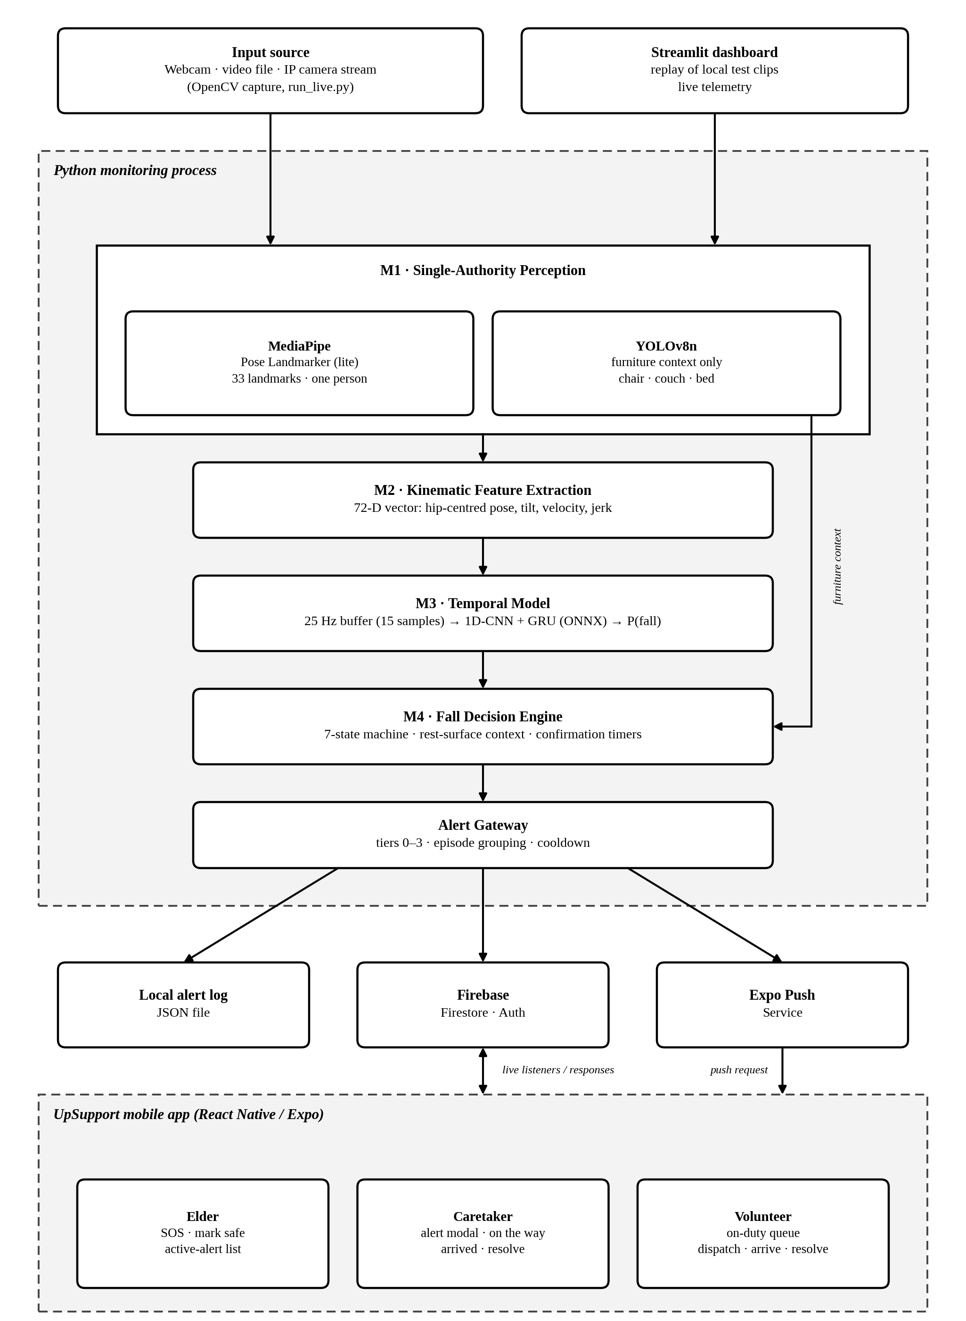
Figure 4.1. Supplied project system architecture.

4.2 M1 â€” Perception
M1 uses MediaPipe Tasks PoseLandmarker Lite float16 with 33 pose landmarks and a minimum pose confidence of 0.5. YOLOv8n retains COCO classes 56 (chair), 57 (couch), and 59 (bed). Chair maps to a seat context; couch and bed map to a rest-surface context. The recorded configuration runs furniture detection every 15 frames, uses a two-frame hold override, a 0.4 confidence threshold, and 120-frame furniture memory.

4.3 M2 â€” Kinematic representation
The 72-dimensional vector contains 33 normalized landmark coordinate pairs (66 values) plus six motion features. Landmark coordinates are hip-centred and divided by torso length. Motion features use torso-normalized per-second units as implemented in the project.
Dimensions | Feature | Description
0â€“65 | 33 landmark x,y pairs | Hip-centred normalized coordinates
66 | Trunk tilt | Radians
67 | Hip-centre vertical velocity | Vertical motion
68 | Hip-centre horizontal velocity | Horizontal motion
69 | Shoulder-centre vertical velocity | Upper-body motion
70 | Centre-of-mass vertical velocity | Body-centre motion
71 | Hip-centre jerk magnitude | Change in acceleration magnitude

4.4 M3 â€” Temporal model
The model consists of Conv1d 72â†’64 (kernel 3, padding 1), BatchNorm1d, ReLU; Conv1d 64â†’64 (kernel 3, padding 1), BatchNorm1d, ReLU; a two-layer GRU (input 64, hidden 64, batch-first, dropout 0.3); final time step; Dropout 0.3; Linear 64â†’32; ReLU; and Linear 32â†’1 logit. It has 78,529 parameters, takes input (batch, 15, 72), uses a 25 Hz sample cadence, and is exported as an ONNX model of 317,947 bytes. The 15 samples span 0.56 seconds between endpoints.

4.5 M4 â€” State machine
The seven declared states are STAND_WALK, PRE_FALL, CONFIRMING, FALL_IMPACT, POSE_LOST_WHILE_FALLEN, POST_FALL_MONITOR, and LONG_LIE_ALERT. FALL_IMPACT is declared as a state name and also used as an alert type; the normal confirmed path transitions from CONFIRMING to POST_FALL_MONITOR.
Transition or decision | Implemented condition
STAND_WALK â†’ PRE_FALL | Valid pose and not rest-suppressed; M3 probability > 0.40 OR downward hip velocity > 1.2 with trunk tilt > 35Â°. Warning cooldown must have elapsed (2.0 s). A low-probability already-horizontal posture is gated.
PRE_FALL â†’ CONFIRMING | Invalid pose while not rest-suppressed, or impact predicate: probability > 0.70 OR tilt > 60Â°, jerk > 1500, and downward velocity > 1.2.
PRE_FALL â†’ STAND_WALK | Valid tilt < 30Â° sustained for 1.0 s, or the 1.5 s pre-fall latch expires; emits self-recovery cancellation.
CONFIRMING â†’ STAND_WALK | Reliable, physically plausible upright recovery sustained for 1.0 s (tilt < 35Â°, |vertical velocity| â‰¤ 12, jerk â‰¤ 20,000), or valid rest-surface context.
CONFIRMING â†’ POST_FALL_MONITOR | Down evidence (invalid pose or valid tilt â‰¥ 45Â°) accrues to the confirmation window: 2.5 s normally, 1.3 s when downward velocity > 2.0.
POSE_LOST_WHILE_FALLEN â†’ STAND_WALK | Valid tilt < 30Â° sustained for 1.0 s.
POSE_LOST_WHILE_FALLEN â†’ LONG_LIE_ALERT | Down monitor reaches 180 s without recovery.
POST_FALL_MONITOR â†’ STAND_WALK | Valid tilt < 30Â° sustained for 1.0 s.
POST_FALL_MONITOR â†’ LONG_LIE_ALERT | Down monitor reaches 180 s without recovery.
LONG_LIE_ALERT â†’ STAND_WALK | Valid tilt < 30Â° sustained for 1.0 s.
Other M4 limits include a 2.0 s warning cooldown, a 1.5 s PRE_FALL latch, 2.5 s standard confirmation, 1.3 s fast confirmation, recovery tilt 30Â°, confirmation-upright tilt 35Â°, confirmation-down tilt 45Â°, recovery maximum |vy| 12, maximum jerk 20,000, and long-lie duration 180 s. The `lost_recent_tilt` threshold is 45Â° but is recorded as unused in the dossier.

4.6 Alert gateway
Tier | Meaning | Events
0 | Informational/auto-cancel | SELF_RECOVERY_CANCELLED
1 | Pre-impact warning | PRE_FALL_WARNING
2 | Emergency event | FALL_IMPACT, POSE_LOST_WHILE_FALLEN, MANUAL_SOS
3 | Escalated prolonged lie | LONG_LIE_ALERT; volunteer escalation
Episode grouping uses one alert record keyed by episode ID. A warning creates the episode record; impact, pose-lost, cancellation, and long-lie events update that record. The gatewayâ€™s default duplicate-event cooldown is 5 seconds; M4 warning cooldown is 2 seconds. The configured Firestore/Expo path submits records and push requests. Expo acceptance is asynchronous and does not establish handset delivery. Default notifiers are mock Expo and mock Twilio; Twilio is not a live SMS/voice integration in the recorded path.

CHAPTER 5 â€” REQUIREMENTS ANALYSIS

5.1 Functional requirements
ID | Requirement
FR1 | Read video frames and estimate human pose landmarks.
FR2 | Detect furniture context and distinguish rest surfaces.
FR3 | Build a normalized 72-D feature sequence and infer fall probability.
FR4 | Generate early warning, recovery cancellation, confirmation, and long-lie events.
FR5 | Group event updates by episode and write through configured sinks.
FR6 | Provide elder, caretaker, and volunteer application roles and screens.

5.2 Non-functional requirements
• Expose event and model behavior in inspectable logs and replay evidence.
• Use timed confirmation to reduce transient posture false alarms.
• Keep project code modular across perception, features, inference, decision, and alerting.
• Protect personal records through authenticated application access and Firestore rules.
• Do not claim real-time, device delivery, or clinical performance without measured evidence.

5.3 User roles and software
Roles in the mobile client are elder, caretaker, and volunteer. The app uses Expo approximately 51.0.0, React Native 0.74.5, React 18.2.0, and Firebase JS SDK ^10.12.0. Authentication paths include email/password and Google; user profile data is stored in Firestore, with AsyncStorage for an onboarding draft.

CHAPTER 6 â€” SYSTEM DESIGN AND IMPLEMENTATION

6.1 Firestore data model
Collections identified from the rules and application include `users`, `alerts`, `sos_alerts`, and `volunteer_directory`. User documents include identity, contact, role, authentication provider, setup/on-duty state, linkage/pairing fields, room location, Expo tokens, and timestamps. Alert documents include alert/episode identifiers, elder identity/name, room location, event type, status, tier, fall probability, posture, furniture context, assigned caretaker, acknowledgement, volunteer escalation, escalation timer, timestamp, and warning timestamp. Mobile adds response/event objects and resolution metadata. Volunteer-directory documents include uid, name, Expo token, on-duty state, and update time. No live production document is included as evidence.

6.2 Mobile application
Registered screens include authentication and setup (Login, Signup, RoleSetup, VerifyEmail, ForgotPassword, SetupFailed); elder screens (ElderHome, SOS, CancelAlert); caretaker screens (CaretakerHome, CaretakerAlert, ActiveResponse, AlertHistory, ElderDetails, ManageResidents); and volunteer screens (VolunteerHome, VolunteerDispatch).
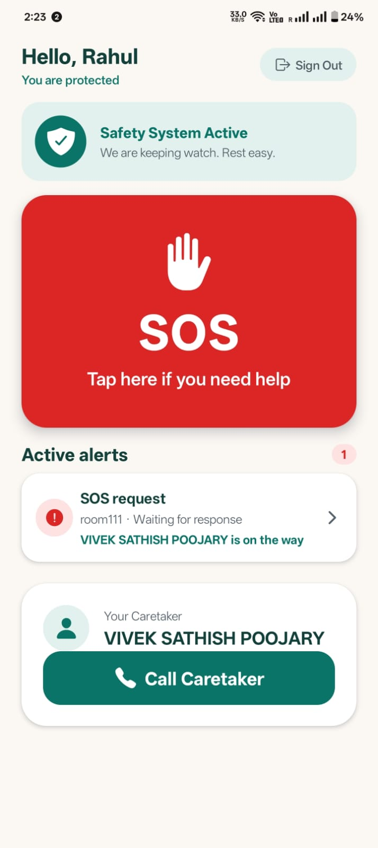
Figure 6.1. Supplied mobile application screen.
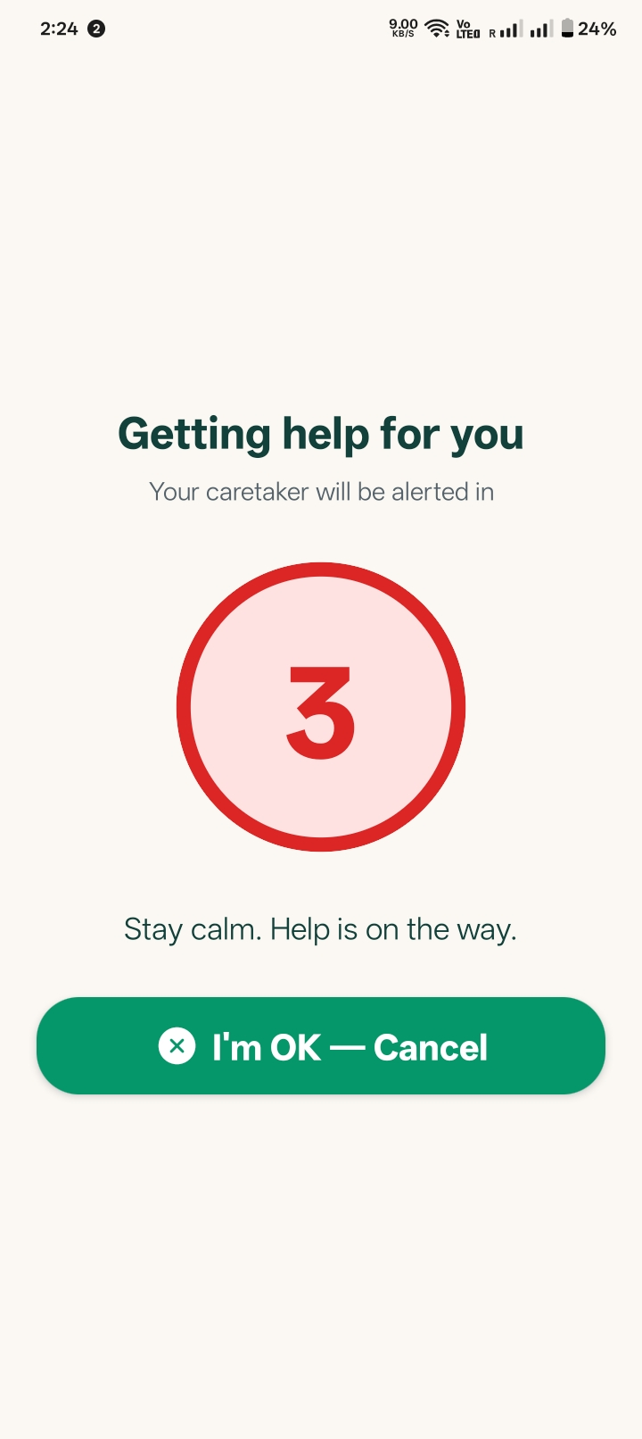
Figure 6.2. Supplied mobile application screen.
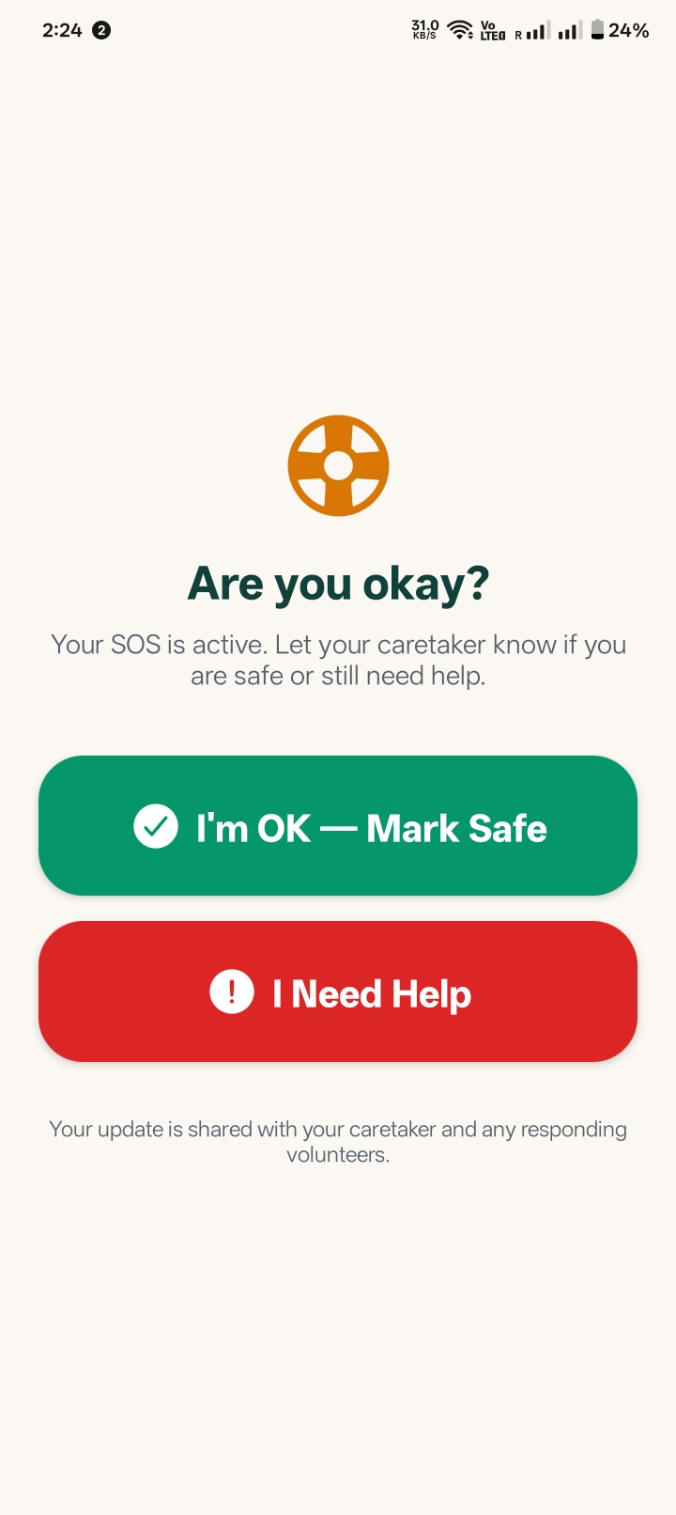
Figure 6.3. Supplied mobile application screen.
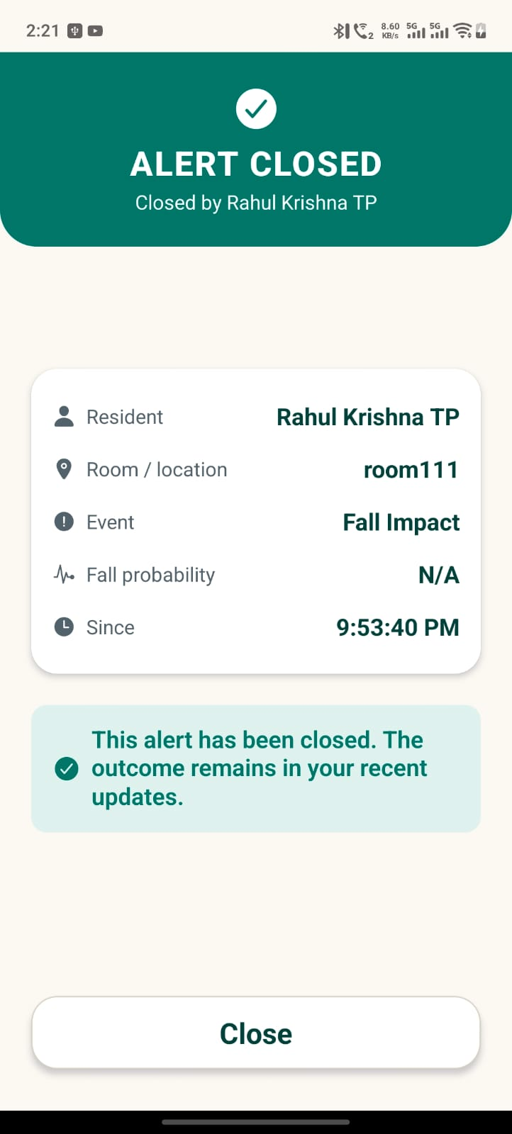
Figure 6.4. Supplied mobile application screen.

6.3 Test evidence
The saved Jest output reports 4 suites passed, 60 tests passed, and 0 snapshots. Suite files are `authFlow.test.js`, `alertResponses.test.js`, `emailActionLinks.test.js`, and `alertPush.test.js`. The saved console output does not provide per-file test counts (NOT FOUND). The test suite was not rerun for this report.

CHAPTER 7 â€” RESULTS, TESTING AND DISCUSSION

7.1 M3 model metrics
The metrics below are from `models/m3_metrics.json`. Threshold 0.15 is the deployed threshold and is used for the primary comparison.
Split | Windows (positive) | Threshold | Precision | Recall | F1 | Confusion TP/FP/FN/TN | ROC-AUC
Le2i validation | 118 (49) | 0.15 | 1.0000 | 0.9592 | 0.9792 | 47 / 0 / 2 / 69 | 0.9965
GMDCSA24 Subject 4 | 7,648 (802) | 0.15 | 0.1821 | 0.6995 | 0.2890 | 561 / 2,519 / 241 / 4,327 | 0.7576
Model provenance records the saved evaluator as `evaluate_m3.py`, which selects 812 Le2i windows (116 falls) from a shared 24,135-window train array, then evaluates on Le2i validation and GMDCSA Subject 4. The evaluation is not evidence that the current checkpoint was trained on the full mixed-source array.

7.2 Round 3 clip ablation
Each configuration processed the same 37 Subject 4 clips (17 Fall and 20 ADL). Counts are videos with each event at least once.
Configuration | Fall Tier 1 / 17 | Fall FALL_IMPACT / 17 | Fall any Tier 2 / 17 | ADL Tier 1 / 20 | ADL Tier 2 / 20
Full M3 + rules | 17 | 10 | 11 | 15 | 5
Rules only (M3 probability forced to 0) | 14 | 8 | 8 | 10 | 5
M3 only (kinematic entry rules disabled at runtime) | 16 | 9 | 10 | 15 | 4
Full M3+rules trigger-path capture found 37 probability and 19 kinematic PRE_FALL entries; 46 probability and 7 kinematic pending-impact transitions; confirmed FALL_IMPACT alerts were preceded by 8 probability and 7 kinematic transitions. Full-run event fields matched the preceding 37-clip run for all clips.
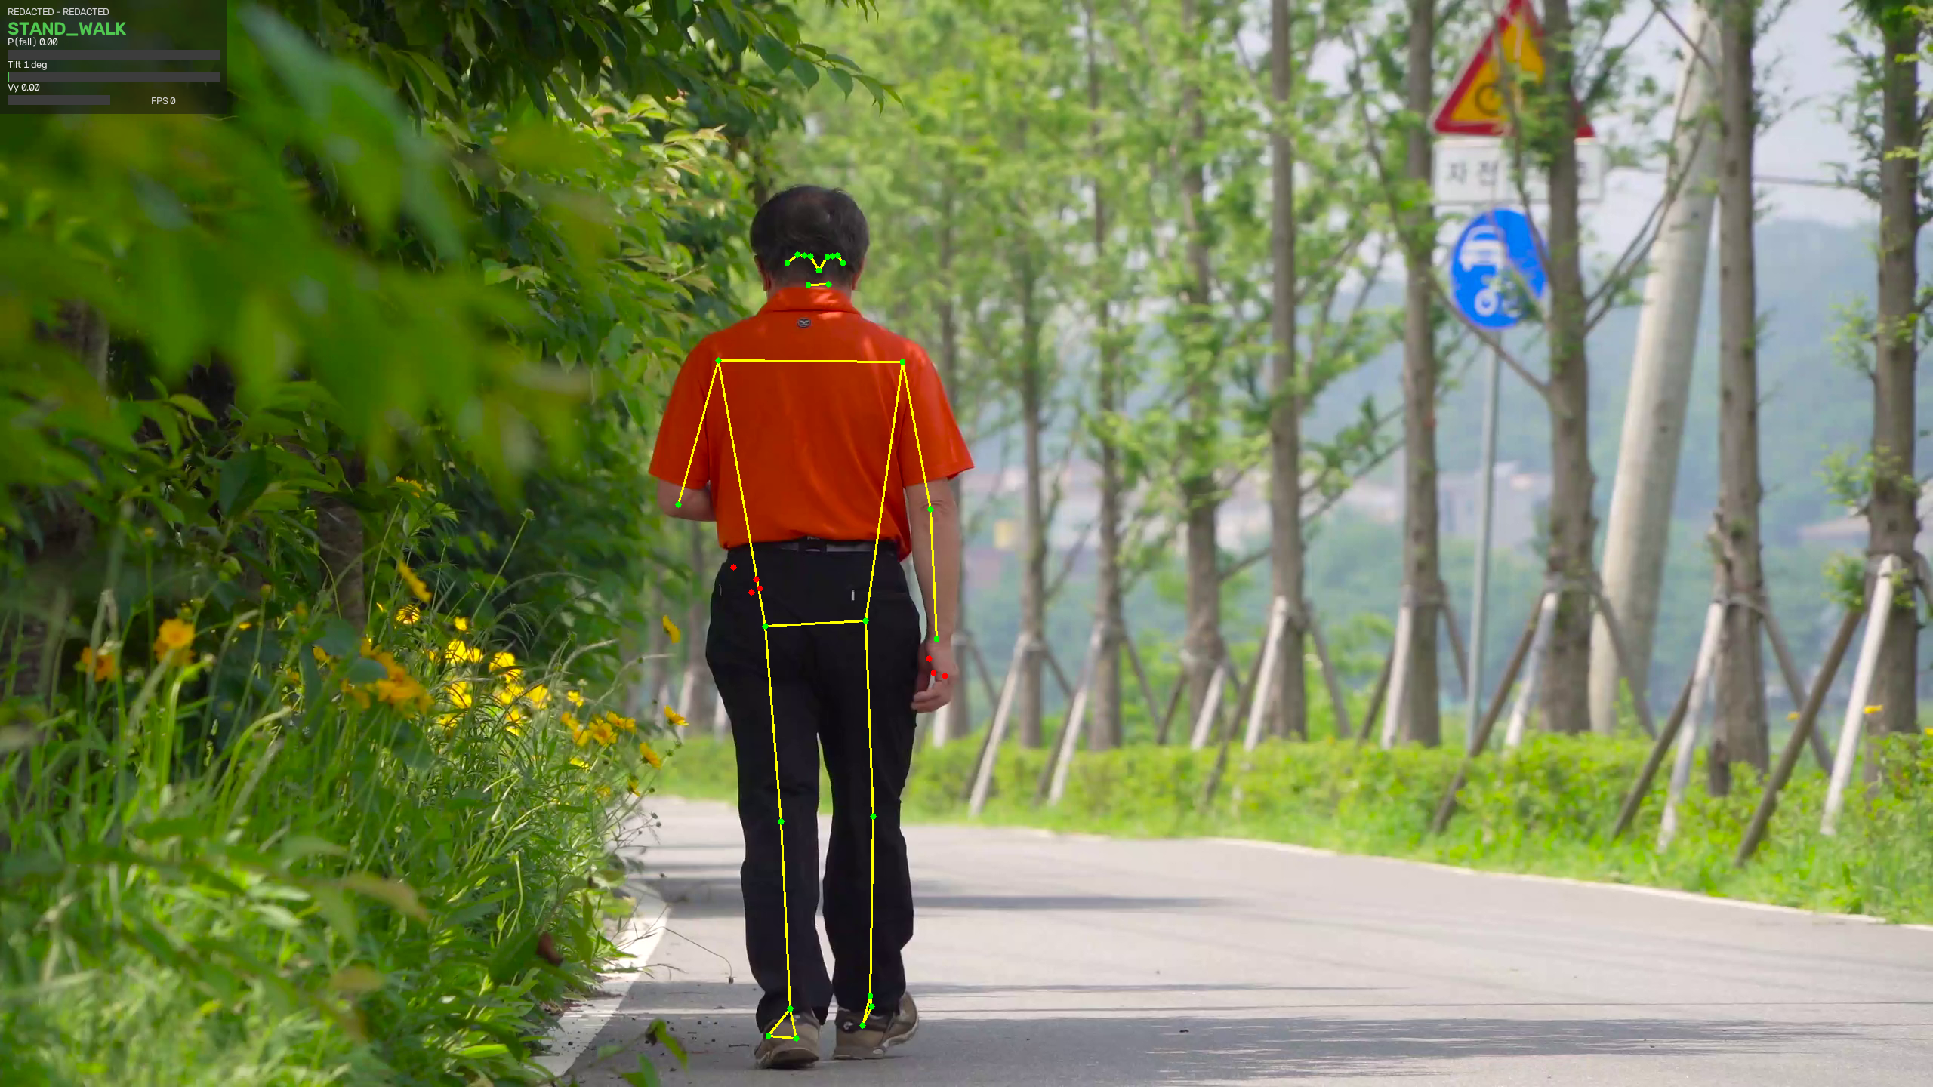
Figure 7.1. Pose skeleton during a walking clip.
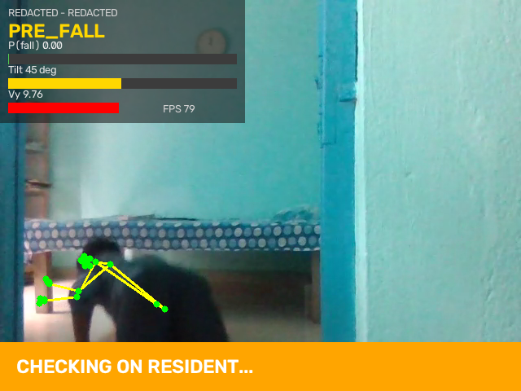
Figure 7.2. Pre-fall warning evidence.
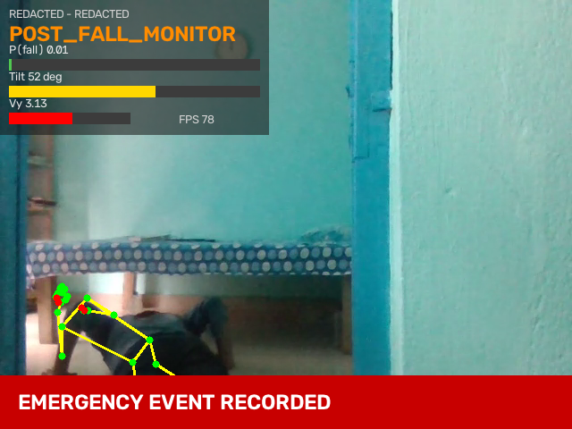
Figure 7.3. Confirmed fall evidence.
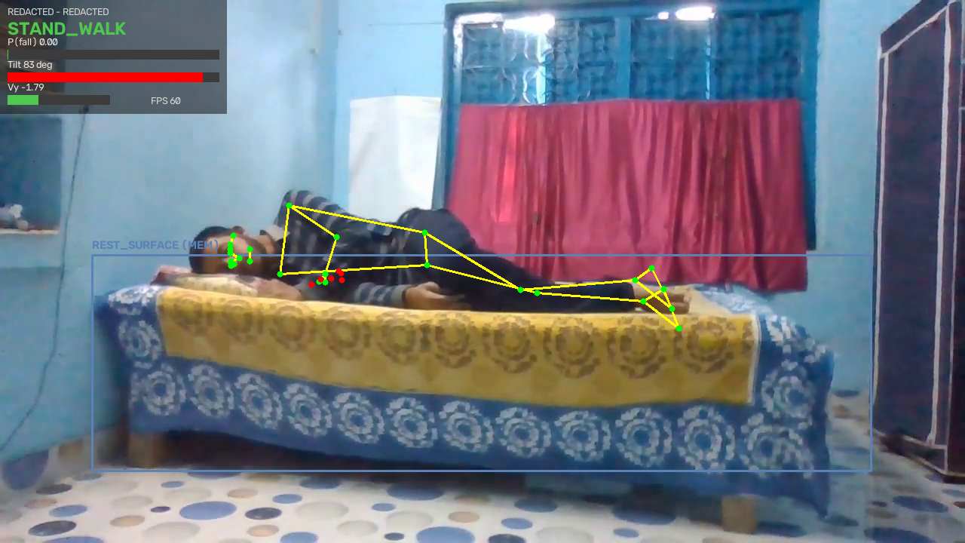
Figure 7.4. Bed/rest-surface frame without an active alert.
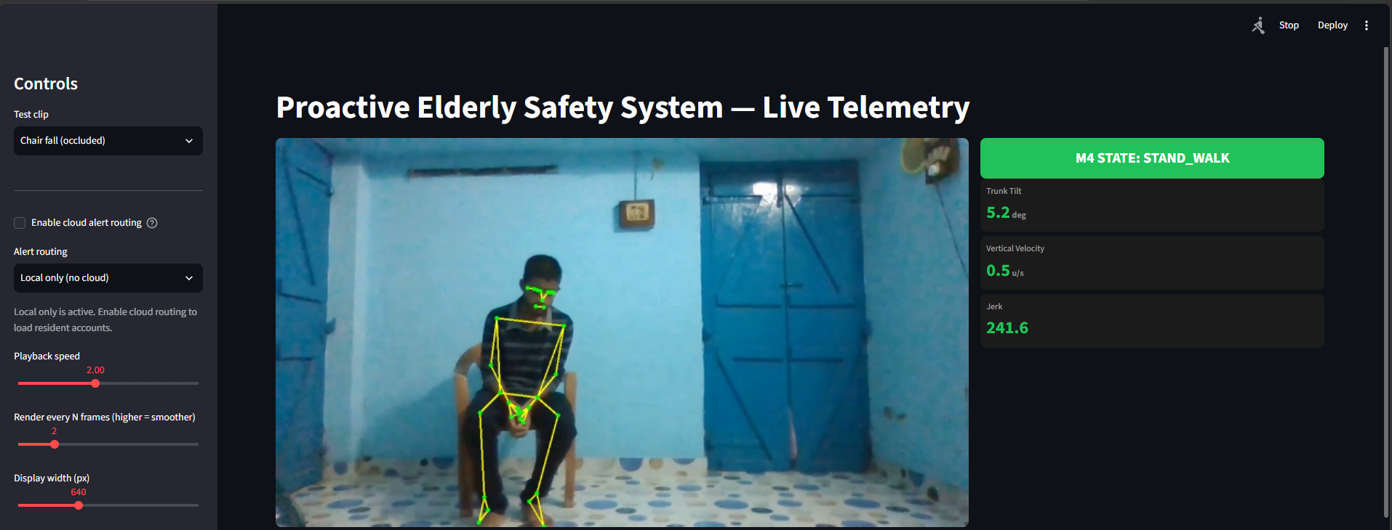
Figure 7.5. Replay dashboard capture with lower identity table cropped.

7.3 Timing evidence
The Fall.csv `Falling[...]` bounds are interval annotations in seconds. Their starts are fall onset and their ends are labeled interval endpoints; the CSV has no separate point-valued impact time. FPS values are from saved replay metadata. `FALL_IMPACT` values are detector event times and are not substituted for annotated impact ground truth. Therefore lead_s is NOT FOUND for all clips.

7.4 Interpretation
The Le2i validation result is strong on a small validation set. Subject 4 performance falls substantially, particularly precision, and the clip ablation includes five ADL clips with Tier 2 events in the full configuration. These findings motivate subject-disjoint evaluation, false alarms per hour, wider lighting/camera testing, and alert delivery testing. The prototype must not be represented as production-ready fall detection.

CHAPTER 8 â€” CONCLUSION AND FUTURE WORK

8.1 Conclusion
The project integrates pose estimation, furniture detection, normalized kinematics, a temporal neural model, finite-state confirmation, alert episode management, and role-specific mobile screens. Saved evidence documents the model metrics, 37-clip ablation, Jest summary, screenshots, and implementation settings. The hybrid pipeline demonstrates a complete research prototype, while the out-of-distribution precision and ADL Tier 2 events show that its alerts require further validation.

8.2 Future work
• Evaluate subject-disjoint data and report false alarms per hour.
• Calibrate on varied lighting, viewpoints, occlusion, clothing, furniture, and mobility aids.
• Measure end-to-end latency and throughput on the intended monitoring hardware.
• Verify Firebase deployment, push receipt, locked-phone presentation, acknowledgement, and escalation on real devices.
• Add camera-offline monitoring, privacy controls, retention settings, and deployment documentation.
• Conduct supervised usability and safety evaluation with older adults and caregivers.

REFERENCES
[1] Q. Chu et al., â€œIntention-guided cognitive reasoning for egocentric long-term action anticipation,â€ arXiv:2508.01742v2, 2025.
[2] A. Furnari and G. M. Farinella, â€œStreaming egocentric action anticipation: An evaluation scheme and approach,â€ arXiv:2306.16682v1, 2023.
[3] O. Flor-Unda et al., â€œA comparative overview of technological advances in fall detection systems for elderly people,â€ Sensors, vol. 25, 7423, 2025.
[4] V. Bazarevsky et al., â€œBlazePose: On-device real-time body pose tracking,â€ arXiv:2006.10204, 2020.
[5] E. Alam et al., â€œGMDCSA-24: A dataset for human fall detection in videos,â€ Data in Brief, 2024.
[6] G. Jocher, A. Chaurasia, and J. Qiu, â€œUltralytics YOLOv8,â€ software, 2023.
[7] S. Santhosha et al., â€œA survey on temporal reasoning and long-term action anticipation,â€ team reference document, Yenepoya Institute of Technology, 2026.
[8] Visvesvaraya Technological University, Major Project Report Reference Format, supplied 2026â€“2027 PDF.

APPENDIX A â€” SUBJECT 4 FALL TIMING
Clip | FPS | Onset s | Annotated impact s | End s | First warning s | FALL_IMPACT s | Lead s | Confirmed Tier 2 s
01 | 29.8443 | 1.8 | NOT FOUND | 4 | 2.0439 | NOT FOUND | NOT FOUND | NOT FOUND
02 | 29.8922 | 1.5 | NOT FOUND | 2 | 2.9774 | NOT FOUND | NOT FOUND | NOT FOUND
03 | 29.8261 | 1.7 | NOT FOUND | 6 | 2.3469 | 4.4927 | NOT FOUND | 4.4927
04 | 29.8630 | 1.2 | NOT FOUND | 4 | 1.6408 | 4.1858 | NOT FOUND | 4.1858
05 | 29.8260 | 2.7 | NOT FOUND | 7 | 2.8499 | 4.4257 | NOT FOUND | 4.4257
06 | 29.8550 | 1.1 | NOT FOUND | 6 | 1.4068 | 3.2825 | NOT FOUND | 3.2825
07 | 29.8174 | 2.4 | NOT FOUND | 6 | 1.7104 | 4.3934 | NOT FOUND | 4.3934
08 | 29.8840 | 2.3 | NOT FOUND | 6 | 2.4428 | 6.1906 | NOT FOUND | 6.1906
09 | 29.8398 | 2.3 | NOT FOUND | 6 | 2.5469 | 5.6636 | NOT FOUND | 5.6636
10 | 29.8563 | 2.2 | NOT FOUND | 5 | 2.0096 | NOT FOUND | NOT FOUND | NOT FOUND
11 | 29.8150 | 1.2 | NOT FOUND | 4 | 1.4422 | NOT FOUND | NOT FOUND | NOT FOUND
12 | 29.8357 | 1.5 | NOT FOUND | 4 | 1.8434 | NOT FOUND | NOT FOUND | NOT FOUND
13 | 29.8396 | 0.3 | NOT FOUND | 5 | 0.5362 | 2.0778 | NOT FOUND | 2.0778
14 | 29.9072 | 0.8 | NOT FOUND | 5 | 1.0700 | 2.5746 | NOT FOUND | 2.5746
15 | 29.9002 | NOT FOUND | NOT FOUND | NOT FOUND | 2.1405 | NOT FOUND | NOT FOUND | NOT FOUND
16 | 29.8355 | 3.2 | NOT FOUND | 7 | 2.5138 | NOT FOUND | NOT FOUND | 6.3683 (POSE_LOST_WHILE_FALLEN)
17 | 29.8726 | 2.8 | NOT FOUND | 6 | 2.9793 | 5.6908 | NOT FOUND | 5.6908
Values are rounded to four decimals for layout; full precision and raw inputs remain in `docs/dossier/12_report_inputs.md`. The `Fall.csv` header is File Name, Length (seconds), Time of Recording, Attire, Description, Classes. The CSV intervals are seconds, not frames.

APPENDIX B â€” DATASETS AND ENVIRONMENT
Dataset/source | Recorded size | Use
Le2i | 812 training windows (116 positive); 118 validation windows (49 positive); video count NOT FOUND | In-domain training subset and validation
GMDCSA24 | 4 subjects, 160 clips in total (S1 32, S2 48, S3 43, S4 37) | Subject 4 out-of-distribution evaluation and clip ablation
Subject 4 | 17 Fall, 20 ADL | 7,648 evaluation windows; 802 positive
Local manual clips | 10 MP4 (5 fall-named, 2 walk, 3 GMDCSA samples) | Manual replay and feature source
Shared training arrays | 24,135 windows: GMDCSA S1 5,255; S2 9,923; S3 7,645; Le2i 812; local 500 | Feature dataset provenance
Environment item | Recorded value
Host | Windows 11 Home; Intel Core i5-13450HX; NVIDIA RTX 3050 Laptop GPU 6 GB; approximately 16 GB RAM
Python | 3.12.10
mediapipe / onnxruntime | 1.0.1 / 1.30.0
opencv-python / ultralytics | 5.0.0.93 / 8.4.165
firebase-admin | 7.7.0
Expo / React Native | ~51.0.0 / 0.74.5
Recorded ONNX CPU timing: mean 0.0952 ms, median 0.0943 ms, p95 0.1104 ms across 1,000 iterations. This is model inference timing only, not end-to-end camera-to-alert latency. The FPS benchmark environment fields were not captured in the original FPS report; host details above are the available recorded machine snapshot.

APPENDIX C â€” KNOWN LIMITATIONS AND UNTESTED ITEMS
• Locked-phone push receipt and device delivery confirmation not verified.
• Firebase deployment and real device behavior not verified.
• Always-on inference host, camera connectivity, supported CCTV URLs/codecs, and camera-offline alerts not validated.
• Mobile vision/capture, real SMS, and iOS automatic calling are untested; Twilio is mock.
• GPS, multi-person identity, hardware wearables, cloud video storage, log retention/TTL, and sensitivity settings are not implemented or not verified.
• Dashboard is local fixed-clip replay; Python and mobile alert writers are separate.
• Python runtime dependencies are unpinned; 720p/30 comments are not enforced; M1 tracker hold defaults differ from the runtime override; `lost_recent_tilt` is unused.
• Emergency URI is hardcoded as `tel:911`; no video retention policy is recorded.
• Le2i validation has 118 windows; Subject 4 out-of-distribution precision is 0.1821 at threshold 0.15; five ADL clips emitted a Tier 2 event under full M3+rules.

APPENDIX D â€” REPOSITORY STRUCTURE
Two levels deep; transient build and cache folders omitted.
.
â”œâ”€â”€ analysis/
â”œâ”€â”€ dashboard/
â”œâ”€â”€ data/
â”‚ â”œâ”€â”€ manual_test_videos/
â”‚ â”œâ”€â”€ processed_features/
â”‚ â””â”€â”€ raw_datasets/
â”œâ”€â”€ docs/
â”‚ â”œâ”€â”€ dossier/
â”‚ â””â”€â”€ modules/
â”œâ”€â”€ functions/
â”œâ”€â”€ logs/
â”œâ”€â”€ mobile_app/
â”‚ â”œâ”€â”€ android/
â”‚ â”œâ”€â”€ assets/
â”‚ â”œâ”€â”€ modules/
â”‚ â”œâ”€â”€ plugins/
â”‚ â””â”€â”€ src/
â”œâ”€â”€ models/
â”‚ â””â”€â”€ candidate_25hz/
â”œâ”€â”€ output/
â””â”€â”€ src/

