**ANNEX 1: UPGRADE OPTIONS FOR HEALTH SENSE PLAN**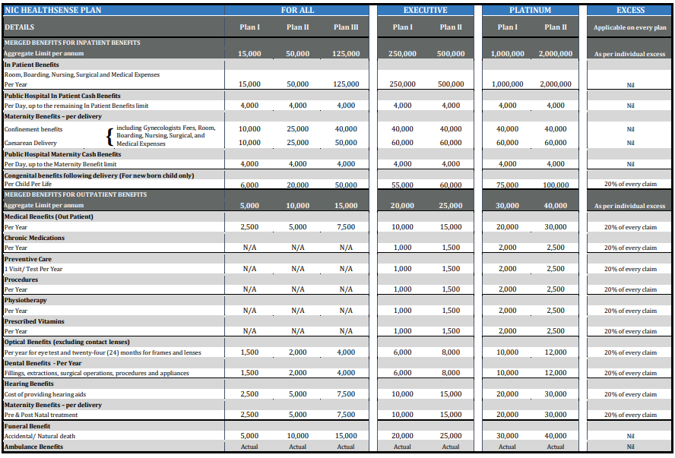

**ANNEX 2: UPGRADE OPTIONS FOR CATASTROPE COVER**