Project ID: 26

B. Tech. Project
“HierarchIQ”
AI-powered industrial PDF-to-hierarchical product intelligence.
CA4 Progress Report – October 2026
Under the Guidance of
Dr. Aniket Shahade Prof. Mayur Gaikwad
Group Members
Sehajdeep Singh Sikka | 23070126119
Vidish Mistry | 23070126146
Manan Khanna | 23070126156

DEPARTMENT OF ARTIFICIAL INTELLIGENCE & MACHINE LEARNING

Table of Contents
1. Names of all the group members and their work distribution 3
2. Introduction 3
3. Problem Statement 3
4. Objectives of the Project 4
5. Literature Review 5
6. Gap in the Research Technology Methodology 6
7. Description of the proposed solution 6
8. Requirement Analysis 7
9. Technology Stack 9
10. Design 10
11. Development Implementation 12
12. Testing and Debugging 14
13. Project plan and progress 16
14. Project Outcome 18
15. Conclusion 18
16. References 19

1. Names of all the group members and their work distribution
Member and PRN | Continuing role | CA4 work distribution
Sehajdeep Singh Sikka  23070126119 | Data pipeline, PDF preprocessing and OCR integration | Multi-page rendering and OCR integration; page-wise artifacts and preprocessing workflow.
Manan Khanna  23070126156 | Semantic block detection and hierarchy reconstruction | Cross-page heading hierarchy; context chunks, LLM extraction and product relationships.
Vidish Mistry  23070126146 | Testing, schema design and documentation | Canonical and final catalog schemas; regression testing, output review and CA4 documentation.

2. Introduction
Industrial companies have mountains of product data stored as PDF catalogs. They define families, models, varieties, dimensions, materials, compatibility, and so on – almost all of this in unstructured free text format optimized for human viewing, not for consumption by a computer. Moreover, each company pretty much reinvents the document structure when creating the catalog, meaning each vendor’s PDF pretty much looks different to its competitors’, making direct downstream consumption difficult for enterprise systems.
Why are the root causes more or less the same within the industry? Catalogs are simply disorganized PDFs, many manufacturers’ have their own version of a document standard, no Family- to -Model-to-Variant structure is embedded into the document at all, and you will probably not find an abundance of labeled data available to train a supervised model. The business impact, as you may guess, is equally predictable. It costs engineers far more to manually transcribe a catalog than it is worth, product spec discovery can consume days, and the same product may be listed multiple ways in your various internal databases, often not tied to PLM, ERP or inventory solutions.
The solution I would suggest to implement would be an AI pipeline, to read the PDF catalogue of an industry product and reconstruct the product hierarchy within the PDF; and extract out the essential attributes (e.g. Specifications, size, material used, what else is it compatible with), etc, and to form a final, standardized output as a JSON output. The pipeline would integrate OCR, document layout understanding, information extraction and LLM in order to create an end output that could indeed support an enterprise infrastructure rather than a flat, basic text based dump. Such a system would undoubtedly find many uses among manufacturing, industry automation, PLM and PIM systems as well as in ERP systems, supply chain and/or inventory management systems, all of which intrinsically require structured product information for optimal use.

3. Problem Statement
Industrial product information is primarily stored in unstructured PDF catalogs, which makes it difficult for machines to understand product relationships, specifications, and hierarchy. Different manufacturers follow different document formats, which results in inconsistent and non-standardized product data across the industry. This project aims at automatically reconstructing the product hierarchy and extracting product attributes like specifications, dimensions, material, compatibility in a structured JSON format. In terms of industry problem as defined by Dassault Systemes it asks: how to transform large industrial PDF catalogs into structured product portfolio hierarchy that ranges over models, variants, sellable item and attributes in a database persistent format. The input is large industrial pdf catalog files, the output will be in a hierarchy like: Portfolio, Product Family, Model, Variant, Sellable Item, Option or Accessory. These will be linked with respective attributes and their relation:

3.1 Use Case
An example of an application would be having a manufacturer with around 300 catalogues PDFs regarding pumps, seats, actuators, or vehicle accessories. The sales, engineering, and service team members in such a company cannot know which model or configuration can be sold, which means that what is needed in this case is to ingest those catalogues and create a hierarchical portfolio tree in the database. For example, companies such as Honda and Toyota have published their product and parts catalogues according to the model and variant details, which means that this is the hierarchy that should be generated from the catalogues.

4. Objectives of the Project
- Automatic reconstruction of the product hierarchy (Portfolio -> Family -> Model -> Variant -> SKU) in the unstructured industrial PDF catalogues.
- Automatic extraction of the structured product metadata such as specifications, sizes, materials, compatibility in the JSON format.
- Creation of the modular solution that utilizes the combination of OCR, layout analysis, inter-page context aggregation, and LLM reasoning, but doesn't rely on any single technology.
- Creation of the rules-based validation process that will allow filtering inconsistent attributes, duplicate SKUs, incorrect hierarchy relations, etc. before proceeding to the next step.
- The output must be ready to use in PLM, ERP, PIM and other knowledge graph databases like Neo4j, not just another research paper.
- Helping engineers spend their valuable time not on searching through the catalogues but on working on product development.

5. Literature Review
The common thread running through all of these papers is quite simply the fact that there have been significant advances made in the field of layout-aware transformers and OCR-based pipelines. There is one area where it seems that something was missing, which is the 'last mile', namely converting the layout and detected text into a product hierarchy.

5.1 Literature reviewed
Paper | Year | Approach / Technology | Research Gap
Engineering Queryable Industrial Product Knowledge Bases (Mohammed et al.) | 2026 | Enterprise product knowledge extraction from technical documents using OCR, NLP, knowledge graphs and LLMs | No automatic hierarchy reconstruction or validation
DocLLM (Wang et al.) | 2024 | Layout-aware generative language model using transformer and spatial embeddings | No product hierarchy generation
DocHieNet (Xing et al.) | 2024 | Hierarchical document structure parsing using a hierarchical transformer | Not evaluated on industrial product catalogs
MultiDocFusion (Shin et al.) | 2025 | Cross-page context fusion for long documents using hierarchical chunking and LLMs | Focuses on retrieval, not product hierarchy
Document Intelligence in the Era of LLMs (Wang et al.) | 2025 | Survey of modern Document AI using LLMs and vision-language models | No end-to-end industrial implementation
Visually Rich Document Content Understanding Survey | 2025 | Multimodal document understanding survey using LayoutLM and transformers | Limited focus on engineering catalogs
Engineering Diagram Digitisation Review (Jamieson et al.) | 2024 | Processing engineering drawings using OCR, CNN and vision transformers | Does not address product relationships
GeoLayoutLM (Luo et al.) | 2023 | Spatial-aware document understanding via a graph and layout transformer | No hierarchy or knowledge graph generation
LayoutLMv3 (Huang et al.) | 2022 | Unified multimodal document encoder based on a vision transformer and OCR | No enterprise product modeling
DocFormer (Appalaraju et al.) | 2021 | Multimodal transformer for documents based on a vision transformer | Generic document understanding only

5.2 Additional literature review

CatalogBank — Bank and Herber (2024)
CatalogBank provides industrial catalog data and a semi-automatic annotation tool for engineering system design. It is directly relevant to the project’s Thorlabs and McMaster-Carr samples. Its contribution is data and annotation support; a complete catalog-to-portfolio pipeline remains a separate engineering task. CA4 uses catalog samples to inspect page structure, while a vendor-separated ground-truth evaluation is still required.

DocLayNet — Pfitzmann et al. (2022)
DocLayNet introduces 80,863 human-annotated document pages across 11 layout classes. Its document diversity makes it useful for testing layout robustness beyond a single catalog template. Layout labels alone do not identify model, sellable-item or accessory relationships. The project should evaluate block detection separately from business hierarchy reconstruction.

PubLayNet — Zhong et al. (2019)
PubLayNet supplies large-scale document layout annotations derived from scientific articles. It supports layout model development but differs from dense engineering catalogs containing part numbers and specification tables. For HierarchIQ, it is a potential layout benchmark rather than evidence that industrial product extraction is accurate.

TableFormer — Nassar et al. (2022)
TableFormer models table structure with transformers and separates structural recognition from cell-content handling. It highlights the importance of preserving cell relationships, especially in complex tables. The current project parses HTML, Markdown and raw tables without expanding merged cells; merged headers and missing cells therefore belong in the next test suite.

OCR-free document understanding — Kim et al. (2021)
The Donut approach directly maps document images to structured output, reducing dependence on a separate OCR stage. This offers an alternative for future comparison with the modular OCR pipeline. It has not been integrated into HierarchIQ; comparison would need the same catalog pages, target schema and extraction metrics.

PaddleOCR 3.0 — Cui et al. (2025)
The technical report describes the PaddleOCR 3.0 family, including PP-StructureV3 document parsing. This is the closest methodological reference for the implemented OCR and layout stage. The project uses a pretrained parser and adapts its output into semantic blocks; it does not train or fine-tune the OCR model.

5.3 Implications for the project
The added literature supports three evaluation layers: layout quality, table structure quality and product-level correctness. A visually correct page segmentation is insufficient if a model is duplicated or an attribute is attached to the wrong product. CA4 therefore reports software checks and observed output structure separately from extraction accuracy.

6. Gap in the Research Technology Methodology
It is importantto mention that none of the papers currently under consideration takes into account all of the three aspects, that is, hierarchy reconstruction, knowledge graph generation and validation, and only some of the papers apply their method to the real catalog data. While the layout detection module and the OCR module can perform excellently separately, some of the papers related to the large language models successfully extract the attributes. Nevertheless, there are no research papers, which consider the entire process of transforming the raw data into the hierarchy Portfolio->Family->Model->Variant.
The practical gap addressed by HierarchIQ is the integration of document layout, product extraction, hierarchy reconstruction and schema validation for industrial catalogs. Current limitations are cross-page ambiguity, inconsistent part-number descriptions, preservation of table semantics and reliable final catalog identity. A multi-vendor annotated benchmark is needed before claiming generality or superiority over existing methods.

7. Description of the proposed solution
In this regard, the architectural structure of the proposed solution would be a five-layer pipeline where the input would be the industrial PDF catalog, and the output would be the enterprise-ready JSON portfolio structure. Also, the architecture would follow the process mentioned in the problem statement by Dassault Systemes, which includes PDF catalogs reading, hierarchy level detection (family, series, model, variant, SKU, and accessories), dimensions, ratings, materials, compatibility, and option codes extraction, JSON normalization, persistence to relational and/or graph database, and detection of ambiguous areas which require human intervention.
Layer 1: Input As an input to the pipeline, several pages of industrial PDF catalogs, technical data sheets, product catalogs, and engineering documents would be used.
Layer 2: Document processing At first, the PDF document would go through some preprocessing steps (deskewing, denoising, and increasing resolution if needed). Then, the document would be processed by OCR and reading order recovery models such as PaddleOCR-VL, MinerU, and DocLing. Further, the document structure would be analyzed using such models as LayoutLMv3, DocLLM, and GeoLayoutLM, and, finally, would be segmented into semantic blocks.
Layer 3: AI Understanding Product attributes like Model Number, SKU, Specification, Material, Dimensions, and Compatibility for each semantic block are identified. Since a product might have been mentioned on multiple pages at one time, Cross-page Context Aggregation layer will merge the same attributes based on the semantic similarity and Large Language Model reasoning technique. Next, the Hierarchy Reconstruction layer will establish the hierarchy of Portfolio -> Product Family -> Model -> Variants -> SKU -> Accessories -> Compatibility, and Knowledge Graph Construction will build links between Products, Variants, Accessories, Specifications, and Compatibility.
Layer 4: Validation Rule-based validation engine will validate the hierarchy with regard to missing attributes, duplicated SKUs, invalid hierarchy links, inconsistencies in the graph, parent-child connections, and compliance with the JSON schema before passing any data further to the following stages.
Layer 5: Enterprise Output The hierarchy is outputted into enterprise JSON and could be even uploaded into Neo4j knowledge graph or integrated with PLM, ERP, and PIM systems to obtain searchable product portfolio.
The Overall Pipeline Flow could be briefly outlined as follows: PDF -> OCR -> Layout Analysis -> Attribute Extraction -> Cross Page Fusion -> Hierarchy Reconstruction -> Knowledge Graph -> Validation -> Enterprise JSON.
The integrated implementation processes all pages from a local PDF, builds a schema 1.1 document, extracts heading-based context chunks and passes compact evidence to a local LLM. Extracted products, attributes and relations are normalized before catalog export. Neo4j ingestion is available through a separate command, while the final pipeline generates a graph visualization. The implemented OCR engine is PP-StructureV3; the other proposed OCR and layout models remain alternatives for future comparison.
Cross-page support currently means shared heading context and exact normalized product matching across chunks. Embedding-based semantic fusion, a human review interface and direct PLM/ERP integration are planned capabilities. Validation issues are reported, but the final pipeline does not yet block export when an error is found.

8. Requirement Analysis

8.1 Functional Requirements
- The system needs to support importing of industrial catalogs in the form of PDF files that could be either one-page or multi-page.
- The system must convert pages of catalogs into images and preprocess them with actions such as deskewing, denoising, and resolution improvement.
- The system must use OCR to extract content from images, perform layout analysis and detect elements like headings, paragraphs, tables, figures, and special blocks about specific products.
- The system must classify blocks as a heading, paragraph, table, figure, specification, and product card.
- The system must generate hierarchical tree representation of the document with information about the order of reading blocks and connections between blocks.
- The system must extract attributes of the product such as the model, SKU, specifications, size, materials, and compatibility.
- The system must analyze the hierarchy and detect blocks with missing attributes, duplicate SKUs, or incorrect connections.

8.2 Non-Functional Requirements
- Modularity: Each separate module within the pipeline (preprocessing, OCR, semantic recognition, hierarchy generation and validation) is required to be testable and swappable individually.
- Reproducibility: The execution of the pipeline must be reproducible in respect of the specific seed, DPI and input catalog.
- Scalability: The pipeline must be scalable enough to work with an increasing amount of catalogs from different vendors without making any changes to it.
- Accuracy: The layout and hierarchy generation must be robust to noise within the input catalogs.
- Maintainability: The codebase must be modular and tested to prevent regressions.

8.3 CA4 acceptance criteria and status
ID | Requirement and acceptance criterion | Current status
F01 | Import single/multi-page PDFs; preserve a block ID and page number for each block. | Implemented; saved 4-page sample has 141 unique block IDs.
F02 | Preserve tabular evidence and headings in extraction context. | Implemented with bounded context; merged cells and truncation need testing.
F03 | Extract models/SKUs, attributes and explicit relations into typed JSON. | Implemented; product description is lost after parsing.
F04 | Normalize repeated products without losing source provenance. | Exact name/SKU matching works in a focused test; semantic matching pending.
F05 | Export category/model/sellable-item/price hierarchy without duplicate identities. | Export exists; duplicate model placements found.
F06 | Reject orphan attributes and invalid output before persistence. | Partial; orphan check and export gating need fixes.
F07 | Produce visual overlays and graph artifacts; support optional database persistence. | Visualizations and Cypher dry-run available; live DB test pending.
N01 | Reproduce output for fixed input/configuration/model. | Partial; CPU OCR and temperature 0 configured; hash-derived category IDs need stabilization.
N02 | Track execution time and memory as page count grows. | Performance benchmark pending.
N03 | Measure entity, attribute and hierarchy accuracy on held-out vendors. | Ground-truth evaluation pending; output counts are not accuracy.
N04 | Keep catalog processing local and manage model/DB configuration externally. | Local processing supported; deployment controls require review.
N05 | Keep stages independently testable and document dependencies. | Modular code and tests exist; dependency declarations need alignment.

9. Technology Stack

9.1 Currently implemented
Component | Technology and specific utilization
Runtime | Python 3.10+; modular CLI orchestration and data processing.
PDF rendering | PyMuPDF (fitz), rasterization of every page at configured DPI (200 default in final pipeline).
Image preprocessing | Pillow and custom deskew / denoise / enhancement routines.
OCR and layout detection | PaddleOCR PP-StructureV3 pretrained parser, CPU execution.
Semantic block classification | Deterministic rule-based mapping and text heuristics (Python).
Hierarchy reconstruction | Custom reading-order and spatial geometry based tree builder (Python).
Table processing | BeautifulSoup HTML parsing, Markdown and raw-text parsing.
LLM extraction | Ollama with qwen3:8b by default; optional Transformers backend and empty mock fallback.
Validation and normalization | Pydantic output checks, custom rules, unit aliases and duplicate handling.
Knowledge graph | Neo4j driver and Cypher MERGE statements; NetworkX graph visualization.
Visualization | Matplotlib, PIL; page overlays, hierarchy trees and graph images.
Configuration | PyYAML and command-line configuration.
Testing | Pytest; focused assertions against parsing, normalization and saved artifacts.

9.2 Planned for later stages
For the LLM-driven reasoning, attribute normalization, and knowledge graph stages that the pipeline is designed to grow into, the project plans to use PaddleOCR-VL and MinerU for OCR, LayoutLMv3 and GeoLayoutLM for layout-aware understanding, Sentence Transformers for semantic similarity in cross-page aggregation, an open LLM such as Llama 3.1 or Qwen2.5 for hierarchy reasoning and attribute normalization, and Neo4j as the knowledge graph database for the final enterprise output.
Ollama/Qwen extraction and the Neo4j adapter have been implemented. Sentence Transformers, LayoutLMv3, GeoLayoutLM, MinerU and PaddleOCR-VL are not part of the current execution path. No model training is claimed.

10. Design
The pipeline is built around a canonical, schema-versioned JSON document that is read from and written to by each stage in the pipeline-this allows stages to be written and tested in isolation. In the current 1.1 schema, we describe semantic page blocks (with type, text content, bounding box, confidence, reading order), the per-page page images with associated pre-processing, the original PDF input and total page count, and a block tree derived from them.

10.1 Current architecture and data flow
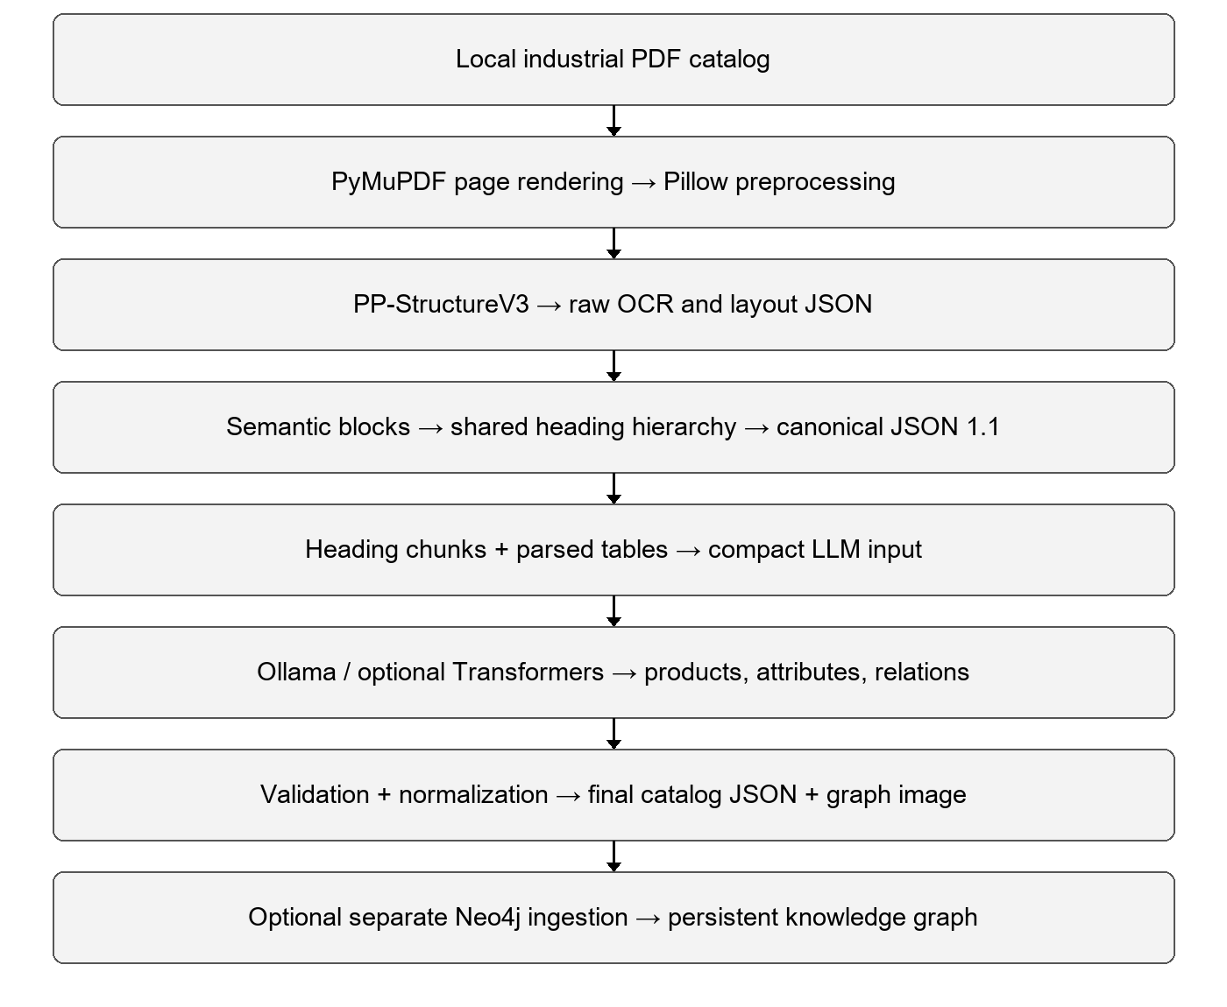
Figure 10.1. Implemented data flow. Raw, canonical and normalized artifacts are saved between stages.
The canonical document separates page geometry from the hierarchy so that OCR need not be rerun to inspect downstream behavior. A shared heading stack survives page transitions. Data stores consist of local JSON and image artifacts; an operational relational database is not implemented.

10.2 Data model and target hierarchy
Other than the schema of pages used within the internal implementation of Stage 1 pipeline, the project has defined a schema for the target portfolio structure which will be created by the pipeline. The schema has been defined according to the hierarchy required by the Dassault Systems problem statement. In the schema of target, each node will be characterized by the type of node, title, description, and identifier since nodes are nested in each other creating hierarchy/portfolio tree. Possible types of nodes in the schema include Product Category (nodes can have other Product Categories and Models), Model (with Sellable Items), Sellable Item (with List Prices and Article Number), and List Price (having Amount, Currency, Location).
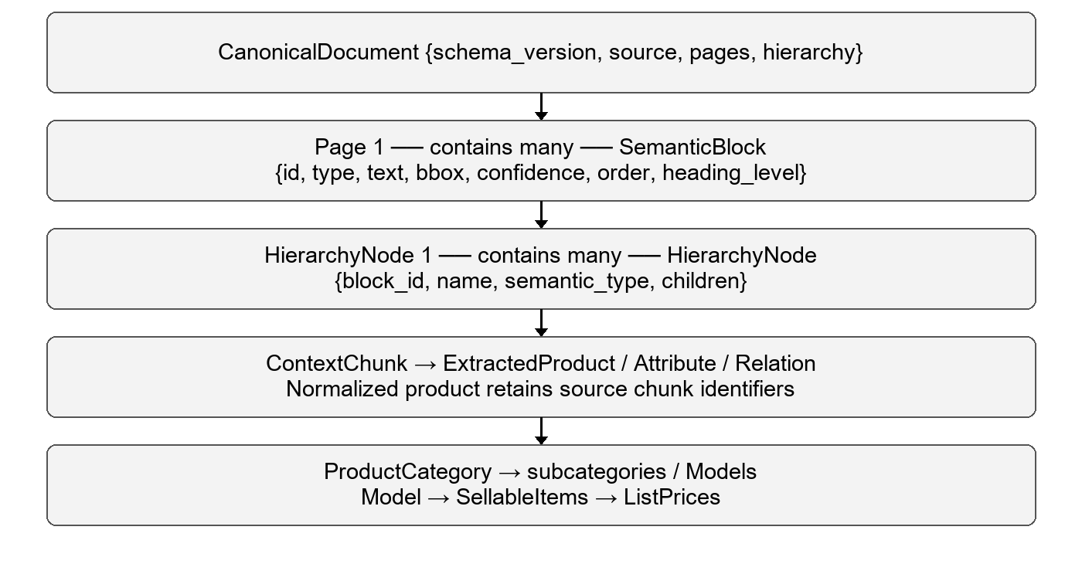
Figure 10.2. Logical entities and containment. Arrows describe processing or containment, not relational foreign keys.
The internal schema is now version 1.1 with total_pages and per-page block lists. The final business schema uses Product Category, Model, Sellable Item and List Price nodes. This exported hierarchy is separate from the document heading tree. Descriptions are requested by the prompt but are not retained in the typed product record.

10.3 Activity and state transitions
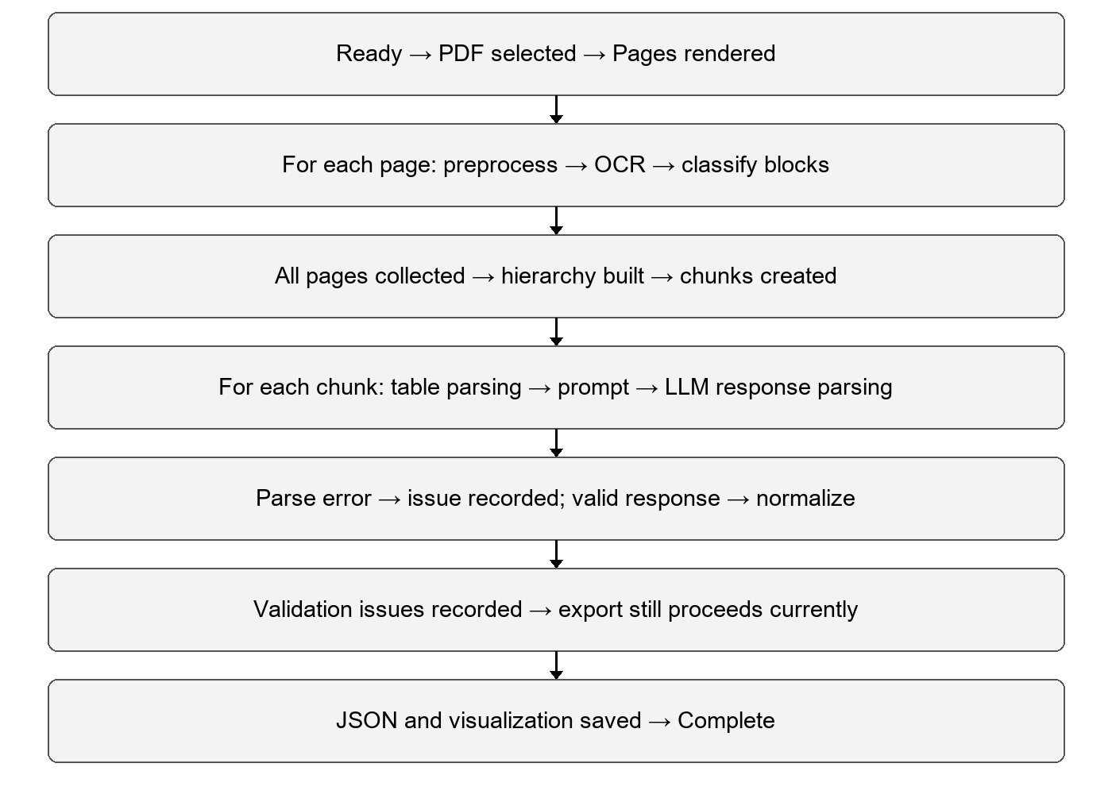
Figure 10.3. Current control flow. A future release should add a validation-failed state that blocks final publication.
The main failure boundaries are missing OCR/model dependencies, malformed LLM responses, empty extraction and invalid business relations. The mock backend is useful for deterministic plumbing tests but returns no products; selecting it must not be interpreted as a successful real extraction.

10.4 Neo4j graph design
Node / relationship | Purpose
Document → HAS_SECTION → Section | Track source sections and document provenance.
Section → CONTAINS → Product | Connect extracted products to source context.
Product → HAS_ATTRIBUTE → Attribute | Represent extracted property values.
Product → BELONGS_TO → Category | Organize products by category.
Product → IS_VARIANT_OF / HAS_MATERIAL | Represent supported product relationships.
Stable identifier + MERGE | Permit repeatable dry-run generation and idempotent database writes.

11. Development Implementation

11.1 Baseline proof of concept
The baseline notebook clones CatalogBank (an industrial catalog dataset containing samples for Thorlabs OptoMechanics and McMaster-Carr), rasterizes a small random selection of catalog PDFs into page images with PyMuPDF, then processes each page using the PP-StructureV3 model from PaddleOCR. In the process, there was also a real-world migration problem: since the previous version 2.x API from PPStructure (which outputted a simple list of type, bbox, and res dictionaries) was no longer compatible with PaddleOCR 3.x the notebook had to be changed to the current PPStructureV3 class with its “predict, savetojson, savetomarkdown, savetoimg” API. Additionally it was observed during development that trying to import paddleocr to ensure it works properly during a quick sanity check before the real pass resulted in PaddleX global model registry being in a semi-initialised state, thus it had been necessary to rearrange the order of the imports in the notebook.

11.2 Modular pipeline
Module | Responsibility
preprocessing/ | PDF page rendering and configurable image preparation.
ocr/ppstructure.py | Thin wrapper around PaddleOCR PP-StructureV3.
semantic/ | Extract candidate blocks; map OCR labels using lookup rules and text heuristics.
hierarchy/ | Sort by reading order, maintain heading stack and attach spatially contained blocks.
schemas/ | Typed semantic blocks, hierarchy nodes and canonical document.
visualization/ | Page overlays and reconstructed hierarchy visualization.
stage2/context_builder.py | Traverse the hierarchy and assemble one context chunk per heading.
stage2/table_parser.py | Parse HTML, Markdown and raw table content.
stage2/llm_input_builder.py | Construct bounded prompts with table and paragraph evidence.
stage2/llm_extractor.py | Backend selection, extraction and response parsing.
stage2 normalization / validation | Typed checks, unit alias normalization and deduplication.
scripts/run_final_pipeline.py | Multi-page integration, extraction, normalization, catalog export and visualization.
scripts/run_stage2_phase_d.py | Separate graph ingestion or dry-run execution.

11.3 CA4 processing algorithm
- Read the selected local PDF and render every page at the configured DPI. Apply requested image preprocessing and persist page images.
- Run PP-StructureV3. Prefer parsing_res_list as the block source to avoid duplicating flat OCR lines. Map each block to one of six semantic classes.
- Give blocks page-specific identifiers. Traverse pages in order using a shared heading stack, then serialize canonical schema 1.1.
- Traverse heading nodes to create context chunks. Parse available table metadata and add bounded text evidence to the master prompt.
- Request structured products, attributes and relations. Use exact model/SKU evidence and parse the returned JSON, including fenced responses.
- Validate and normalize records; merge exact repeated products and retain source chunk references. Build the final category/model/sellable-item structure and save JSON and visualization.
Prompt limits are important implementation constraints: specification text is limited to 400 characters, paragraph evidence to 600 total characters, tables to 20 rows, cells to 80 characters and product-card text to 300 characters. Long catalogs may therefore lose evidence even when all pages are processed. The current Ollama configuration uses temperature 0, a 2,048-token prediction budget and thinking disabled.

11.4 Hierarchy reconstruction pseudocode
for page in pages_in_order:
for block in reading_order(page.blocks):
if block.type == HEADING:
pop headings at same or deeper level
attach block below remaining heading
push block onto shared heading stack
else:
attach using active container / heading rules
serialize pages and shared document hierarchy
The pseudocode summarizes the implemented heading-stack approach. Heading levels use text heuristics rather than typography-based learning. Spatial containment across page boundaries needs explicit regression coverage because page coordinates alone do not establish a valid parent relationship.

11.5 Saved multi-page execution artifacts
Artifact | Observed content
Canonical document | 4 pages; 141 blocks: 92 paragraphs, 13 headings, 12 tables, 19 figures and 5 product cards.
Context and normalized extraction | 13 chunks; 17 products, 35 attributes and 29 relations.
Final catalog | 10 categories; 20 model occurrences, 20 sellable-item occurrences and 19 price records.
Identity check | 16 unique model IDs among 20 occurrences; MS12B and HWKIT5 each occur three times.

The saved multi-page catalog sample contains the output counts above. These describe output structure, not precision or recall; a labeled evaluation is required to measure extraction accuracy.
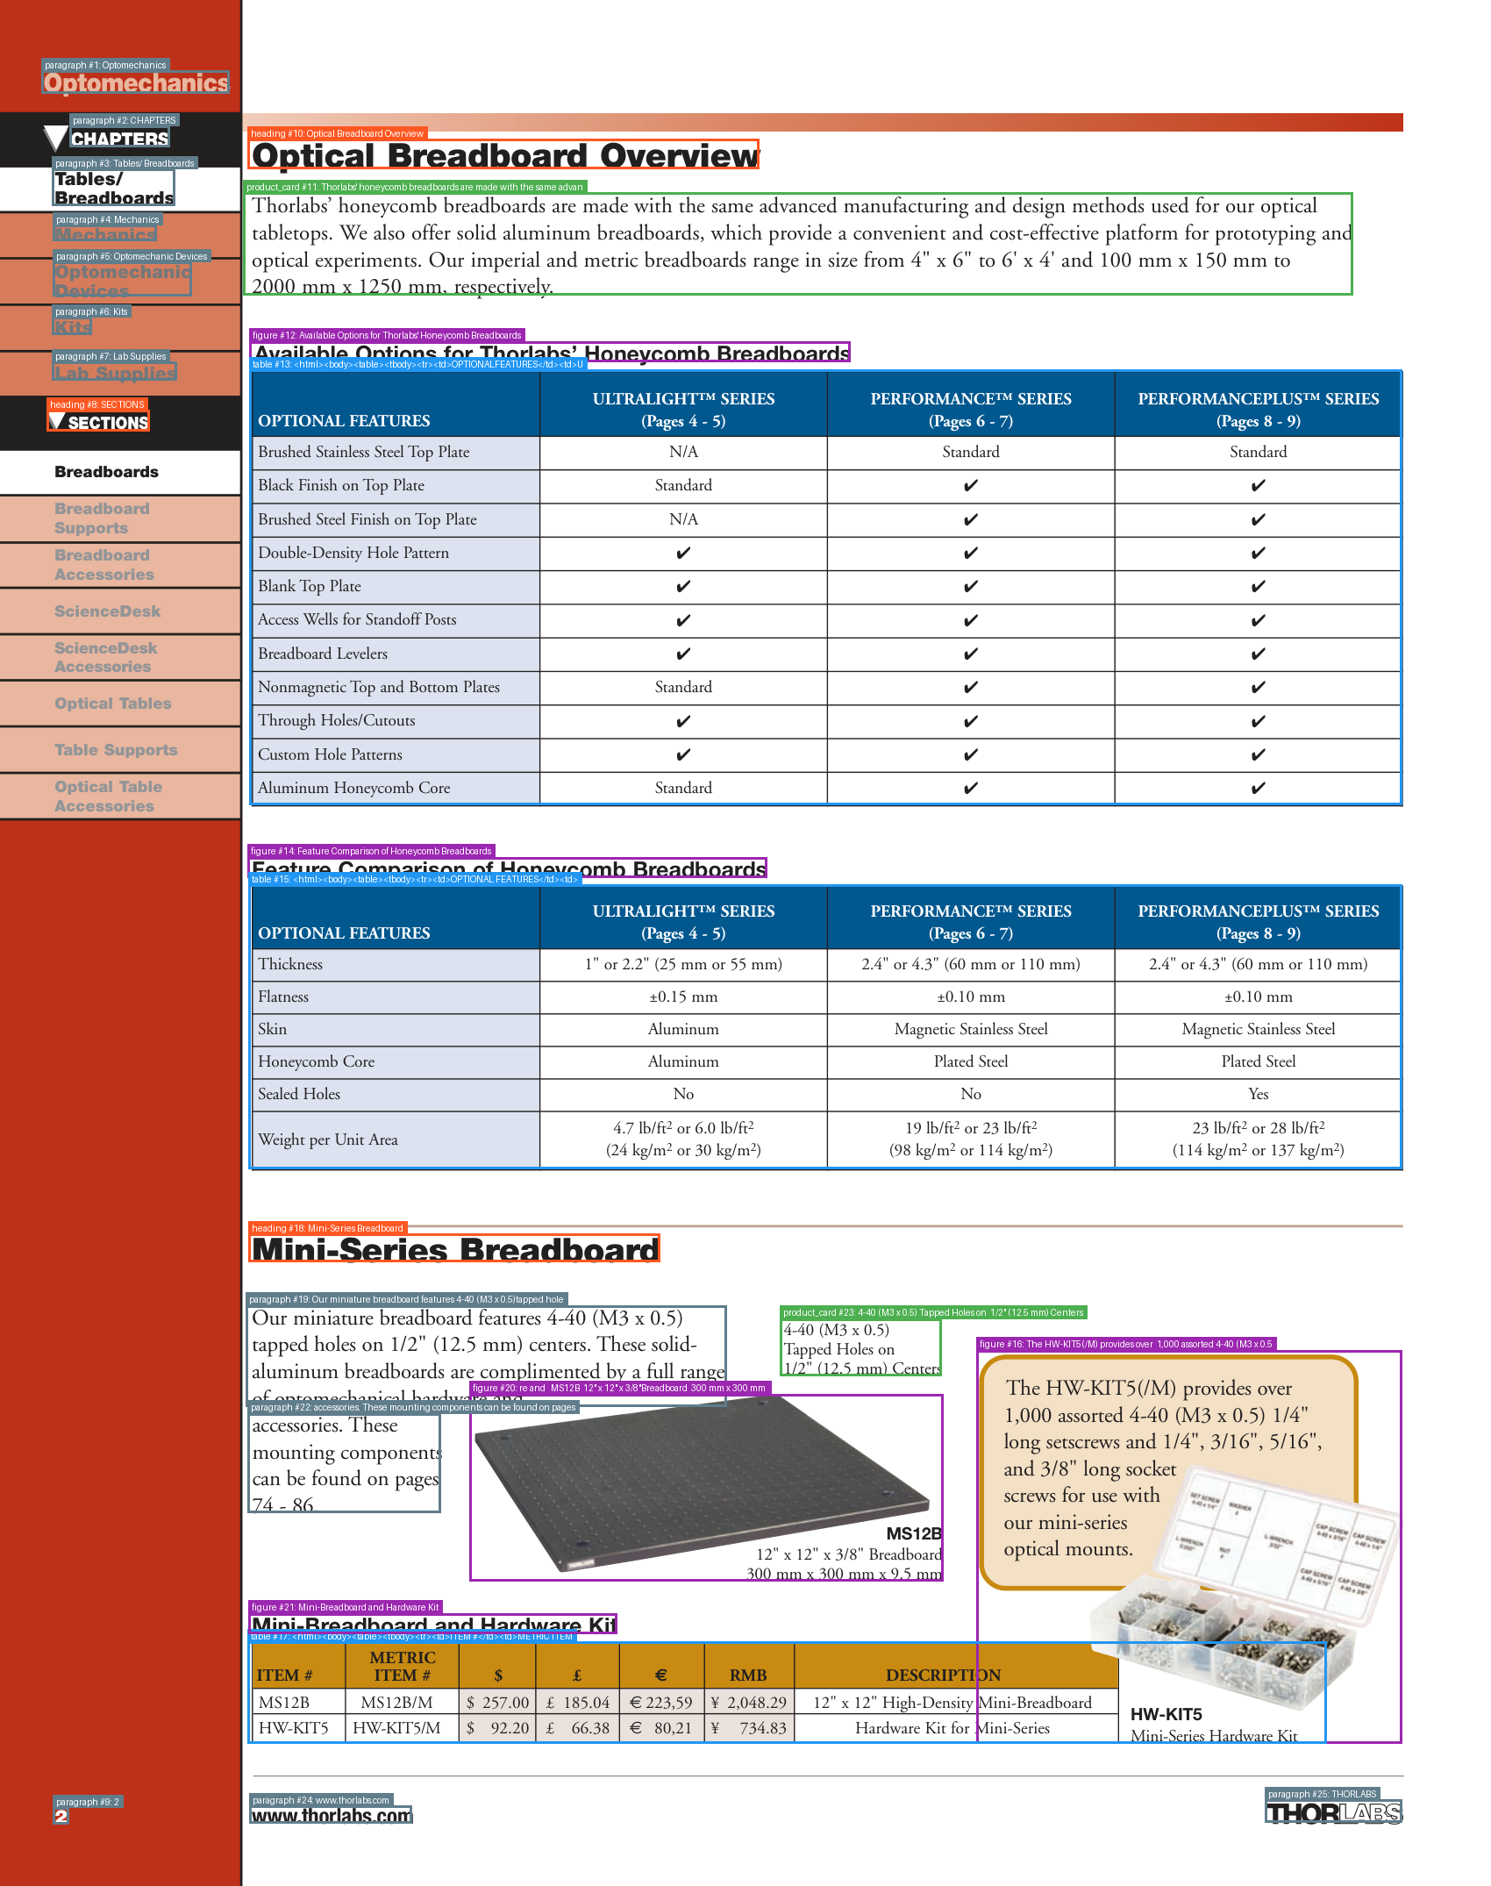
Figure 11.1. Actual saved semantic-block overlay for page 1 of the multi-page catalog sample.

12. Testing and Debugging
There is a suite of automated tests written for the implemented pipeline covering every stage: (conversion of PDF to image, image preprocessing, loading the dataset, checking JSON, semantic block detection, reconstruct the hierarchy, visualization, the CLI entrance point and the pipeline integration test (integrates all the stages). Where possible, the integration test reads the JSON fixture captured previously during real execution-so the entire test suite can run with no OCR engine or GPU being installed-therefore allowing quick feedback. Beyond the automated tests, the group ran into and resolved several practical issues while getting the OCR engine to work reliably:
- The metadata of the package had been broken due to partial upgrading of the CUDA library and required cleanup, after which packages had to be installed without taking their dependencies into account.
- PPStructure 2.x API that provided type/bbox/res dictionaries through structure_engine(img_path) function became outdated in PaddleOCR 3.x and had to be replaced by PPStructureV3 and its predict/save_to_json methods.
- Import of the paddleocr package as a check of the environment before running do inference could cause partial registration of PaddleX models registry; therefore, the import order had to be changed to make sure that the paddleocr package is being imported only once.
- The raw JSON format of the output of the OCR had to be investigated (top-level keys and the whole JSON printing) before starting any normalization, as there was no sense trying to create a block detector on a non-existent schema.
- The duplication issue of the block detector that was causing six times more blocks to be found than necessary had been caused by using a flat OCR lines array instead of parsing_res_list; it had been solved by changing the source of the data.

12.1 CA4 regression execution
On 13 October 2026, the existing Pytest suite collected 41 tests: 28 passed, 13 were skipped and none failed (0.99 seconds). The skipped tests depend on two absent historical raw OCR fixtures. Consequently, a passing run does not establish full fixture-based integration coverage. Live OCR, Ollama inference and a live Neo4j server were not rerun for this report.
Area | Passed | Skipped
CLI | 12 | 0
Dataset loading | 2 | 0
Hierarchy | 1 | 0
Image preprocessing | 1 | 0
Integration and mapping | 5 | 13
JSON schema | 2 | 0
PDF rendering | 2 | 0
Pipeline | 1 | 0
Semantic detection | 1 | 0
Visualization | 1 | 0
Total | 28 | 13

12.2 Focused CA4 test cases and observed results
ID and test | Expected result | Observed result | Status
A01 Cross-page heading continuation | Page 2 content under page 1 heading | Continuation | PASS
A02 html table parsing | One row with SKU A1 | [{'SKU': 'A1', 'Price': '10'}] | PASS
A03 markdown table parsing | One row with SKU A1 | [{'SKU': 'A1', 'Price': '10'}] | PASS
A04 Fenced JSON parsing | One product and no parse error | 1 | PASS
A05 Mock backend | Valid empty extraction | True | PASS
A06 Cross-chunk product deduplication | One product with two source chunks | 1 | PASS
A07 Fraction and unit parsing | 0.375 in | {'value': 0.375, 'unit': 'in', 'raw': '3/8 in'} | PASS
A08 Orphan attribute validation | Orphan issue is reported | [] | FAIL
A09 Neo4j dry-run | Statements generated without connection | 7 | PASS
A10 Saved multi-page block IDs | All 141 IDs unique across 4 pages | 141 | PASS
A11 Final model uniqueness | Each model appears once | 20 occurrences; 16 unique model IDs | FAIL
A12 Product description retention | Description survives extraction and normalization | Absent | FAIL

The focused checks produced 9 passes and 3 failures. They exercise current functions and saved data; they supplement the existing test suite and do not replace a labeled extraction benchmark.

12.3 Defects and debugging plan
Finding | Cause / impact | Planned correction and verification
Orphan attribute accepted | When no products exist, the orphan check is bypassed; unattached attributes can survive. | Validate against an empty product set; rerun A08 and add positive/negative cases.
Duplicate model placement | Final category matching can attach the same model more than once. | Use explicit category membership and globally stable model identity; rerun A11.
Description discarded | Prompt requests description, but typed product parsing does not retain the field. | Carry description through dataclass, normalization and export; rerun A12.
Export despite validation issues | Errors are logged without stopping final export. | Define fatal vs reviewable issues; block invalid final output.
Unstable / incomplete normalization | Category IDs use process-dependent hashing; first-seen attribute values may hide conflicts. | Use stable IDs and preserve conflicting values with source evidence.

12.4 Next acceptance suite
Create a manually annotated, vendor-separated catalog set covering repeated headings, cross-page tables, merged cells, duplicate SKUs, missing currencies and ambiguous accessories. Compare extracted entities, attributes and parent-child links against annotations. Report precision, recall and F1 per task, plus schema validity and duplicate rate. Record wall-clock time, memory, model version, DPI and input hashes. Restore the missing fixtures and test live OCR/LLM/Neo4j integration before final acceptance.

13. Project plan and progress
The project is organized into three phases.
Phase 1: Research and Data Collection
- Understand industrial catalog structure
- Collect and preprocess PDF datasets (CatalogBank, DocLayNet, PubLayNet, FUNSD)
- Study Document AI and LLM techniques through the literature review
- Define the target hierarchy (Portfolio to Family to Model to Variant)
- Design the JSON output schema
Phase 2: AI Pipeline Development
- OCR and text extraction
- Layout detection (headings, tables, figures)
- Product attribute extraction
- LLM-based hierarchy reconstruction
- JSON generation and validation
Phase 3: Integration, Testing and Deployment
- Integrate all pipeline modules
- Test on real industrial catalogs
- Measure extraction accuracy
- Optimize performance
- Deploy a demonstration system

13.1 CA4 progress against the plan
Phase | Current progress | Remaining work
Research and data | Catalog samples, target schema and literature review established. | Ground-truth labeling; held-out vendor split.
AI pipeline | Multi-page OCR, hierarchy, LLM extraction, normalization and catalog export integrated. | Resolve duplicate placement, description loss and validation defects.
Integration and evaluation | Automated tests, saved artifacts and graph dry-run available. | Live database test, extraction benchmark, performance study and deployment.

13.2 Gantt chart
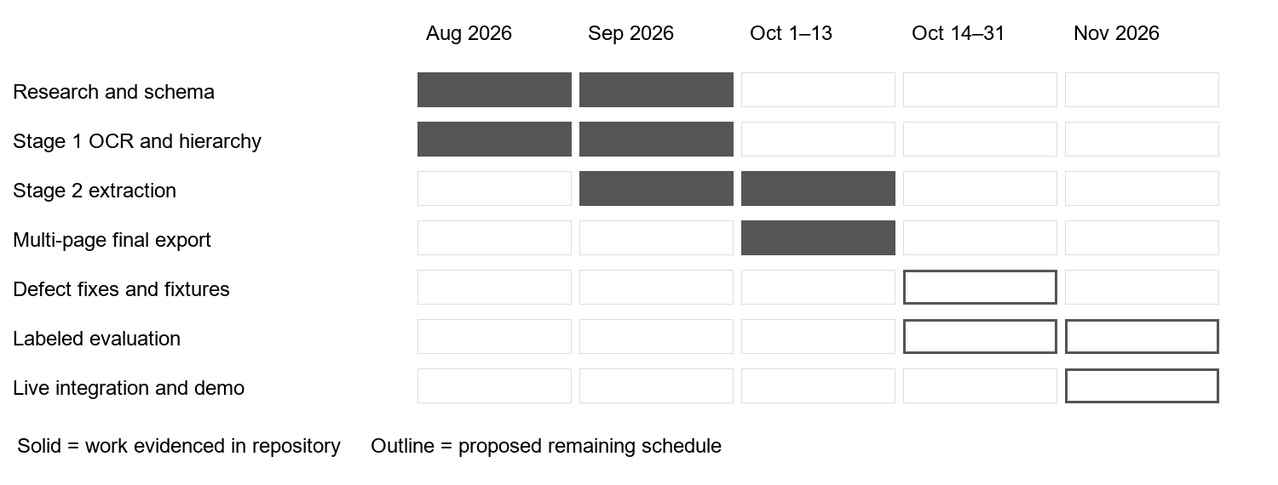
Figure 13.1. Retrospective progress and proposed completion windows.

14. Project Outcome
Planned outcome | Progress and plan to achieve it
Reusable catalog-to-JSON pipeline | Integrated multi-page pipeline available. Resolve validation and identity defects, then freeze schema/versioned configurations.
Correct hierarchical product portfolio | Final category/model/sellable-item export exists. Annotate sample truth and measure parent-child and entity correctness.
Traceable product attributes | Normalized records retain chunk sources. Preserve descriptions, conflicts and page/block evidence through final export.
Queryable knowledge graph | Cypher generation and separate ingestion module exist. Verify live ingestion, repeatability and representative queries.
Evaluated demonstration system | Tests and saved visual artifacts available. Add held-out evaluation, latency/memory results and a reproducible demonstration package.

15. Conclusion
HierarchIQ has progressed from the Stage 1 layout pipeline to an integrated multi-page workflow with local LLM extraction, normalization and final catalog export. The saved four-page example demonstrates the presence of these stages and preserves useful intermediate outputs for debugging.
The current test evidence verifies pipeline mechanics but exposes issues in orphan attribute validation, repeated model placement and description retention. The next milestone is to resolve these defects and evaluate product and hierarchy correctness on annotated catalogs. This will determine whether the structured output meets the original enterprise integration objectives.

16. References
Abdallah, A., Eberharter, D., Pfister, Z., & Jatowt, A. (2024). A survey of recent approaches to form understanding in scanned documents. Artificial Intelligence Review, 57, Article 342. https://doi.org/10.1007/s10462-024-11000-0
Appalaraju, S., Jasani, B., Kota, B. U., Xie, Y., & Manmatha, R. (2021). DocFormer: End-to-end transformer for document understanding. In Proceedings of the IEEE/CVF International Conference on Computer Vision (pp. 993-1003). IEEE. https://openaccess.thecvf.com/content/ICCV2021/html/Appalaraju_DocFormer_End-to-End_Transformer_for_Document_Understanding_ICCV_2021_paper.html
Bank, H. S., & Herber, D. R. (2024). CatalogBank: A structured and interoperable catalog dataset with a semi-automatic annotation tool (DocumentLabeler) for engineering system design. Proceedings of the ACM Symposium on Document Engineering 2024. https://doi.org/10.1145/3685650.3685665
Cui, C., Sun, T., Lin, M., Gao, T., Zhang, Y., Liu, J., Wang, X., Zhang, Z., Zhou, C., Liu, H., Zhang, Y., Lv, W., Huang, K., Zhang, Y., Zhang, J., Zhang, J., Liu, Y., Yu, D., & Ma, Y. (2025). PaddleOCR 3.0 technical report [Preprint]. arXiv. https://doi.org/10.48550/arXiv.2507.05595
Huang, Y., Lv, T., Cui, L., Lu, Y., & Wei, F. (2022). LayoutLMv3: Pre-training for document AI with unified text and image masking. In Proceedings of the 30th ACM International Conference on Multimedia (pp. 4083-4091). Association for Computing Machinery.
Jamieson, L., Moreno-Garcia, C., & Elyan, E. (2024). A review of deep learning methods for digitisation of complex documents and engineering diagrams. Artificial Intelligence Review, 57, Article 136. https://doi.org/10.1007/s10462-024-10779-2
Kim, G., Hong, T., Yim, M., Nam, J., Park, J., Yim, J., Hwang, W., Yun, S., Han, D., & Park, S. (2021). OCR-free document understanding transformer [Preprint]. arXiv. https://doi.org/10.48550/arXiv.2111.15664
Luo, C., Cheng, C., Zheng, Q., & Yao, C. (2023). GeoLayoutLM: Geometric pre-training for visual information extraction. In Proceedings of the IEEE/CVF Conference on Computer Vision and Pattern Recognition (pp. 7092-7101). IEEE.
Mohammed, M., Cakmak, M. C., & Talburt, J. (2026). Engineering queryable industrial product knowledge bases from technical documents: A survey of data, knowledge, and retrieval pipelines. SSRN Electronic Journal. https://doi.org/10.2139/ssrn.6844785
Nassar, A., Livathinos, N., Lysak, M., & Staar, P. (2022). TableFormer: Table structure understanding with transformers [Preprint]. arXiv. https://doi.org/10.48550/arXiv.2203.01017
Pfitzmann, B., Auer, C., Dolfi, M., Nassar, A. S., & Staar, P. W. J. (2022). DocLayNet: A large human-annotated dataset for document-layout analysis [Preprint]. arXiv. https://doi.org/10.48550/arXiv.2206.01062
Shin, J., Park, C., Park, J., Seo, J., & Lim, H. (2025). MultiDocFusion: Hierarchical and multimodal chunking pipeline for enhanced RAG on long industrial documents. In Proceedings of the 2025 Conference on Empirical Methods in Natural Language Processing (pp. 20985-21004). Association for Computational Linguistics. https://doi.org/10.18653/v1/2025.emnlp-main.1062
Wang, D., Raman, N., Sibue, M., Ma, Z., Babkin, P., Kaur, S., Pei, Y., Nourbakhsh, A., & Liu, X. (2024). DocLLM: A layout-aware generative language model for multimodal document understanding. In Proceedings of the 62nd Annual Meeting of the Association for Computational Linguistics (pp. 8529-8548). Association for Computational Linguistics. https://doi.org/10.18653/v1/2024.acl-long.463
Wang, W., Hu, H., Zhang, Z., Li, Z., Shao, H., & Dahlmeier, D. (2025). Document intelligence in the era of large language models: A survey (arXiv:2510.13366). arXiv. https://doi.org/10.48550/arXiv.2510.13366
Xing, H., Cheng, C., Gao, F., Shao, Z., Yu, Z., Bu, J., Zheng, Q., & Yao, C. (2024). A large diverse dataset for document hierarchy parsing. In Proceedings of the 2024 Conference on Empirical Methods in Natural Language Processing (pp. 1129-1142). Association for Computational Linguistics. https://doi.org/10.18653/v1/2024.emnlp-main.65
Zhong, X., Tang, J., & Jimeno Yepes, A. (2019). PubLayNet: Largest dataset ever for document layout analysis. 2019 International Conference on Document Analysis and Recognition (pp. 1015–1022). IEEE. https://doi.org/10.1109/ICDAR.2019.00166

Project evidence
Group 26. (2026). HierarchIQ monthly progress report August 2026 [Unpublished project report]. Symbiosis Institute of Technology, Pune.
Group 26. (2026). Portfolio structure preparation based on product catalog [CA3 project presentation]. Symbiosis Institute of Technology, Pune.
Group 26. (2026). HierarchIQ source code and saved execution artifacts (commit d323c6d, 2 October 2026) [Unpublished software]. Test results reviewed on 13 October 2026.

