Problem Statement:

Create a simple maven project with group id com.in28mins & write a Junit test for the

truncateAInFirst2Positions method by passing a string & add test case & assertEquals run the test without failure & run successful Junit.

Run a test method that includes before, after, before class & after class methods.

Write a mocks example ToDo service management system & create a unit test using a stub to implement the ToDo service.

Write a test mock list get using BDD in a Given, When & Then style add a delete Todo method in the service interface.

Add the ham crest library dependency to porm.xml & use the assert that method & do ham crest matchers test.

Show how to mock the constructor using the combination of power mock & mockito

1. Create a simple maven project with group id com.in28mins & write a Junit test for the

truncateAInFirst2Positions method by passing a string & add test case & assertEquals run the test without failure & run successful Junit.

Run a test method that includes before, after, before class & after class methods.

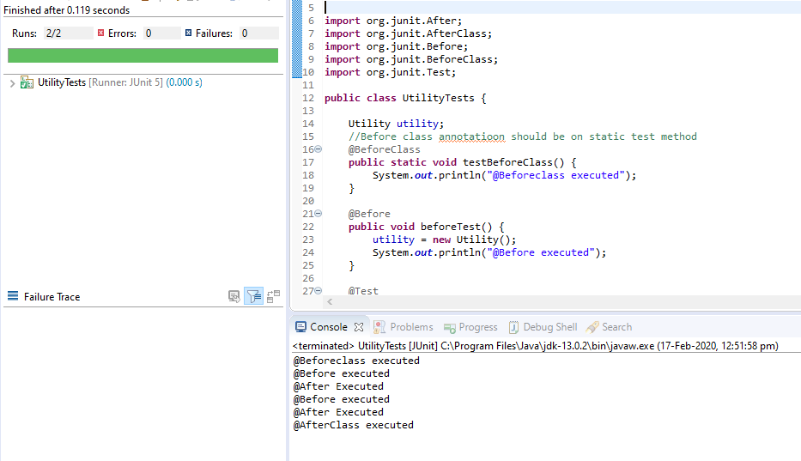

Write a mocks example ToDo service management system & create a unit test using a stub to implement the ToDo service.

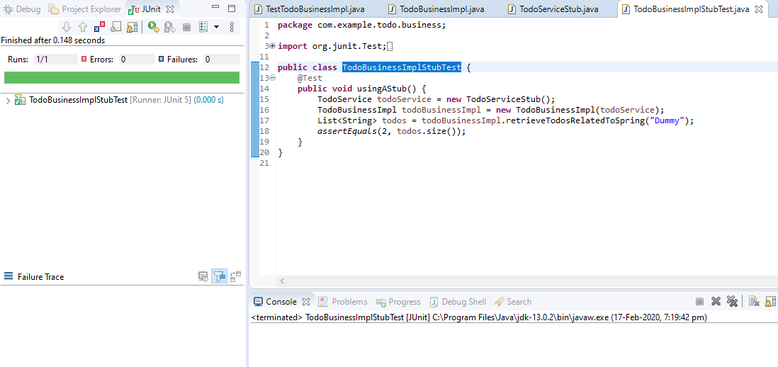

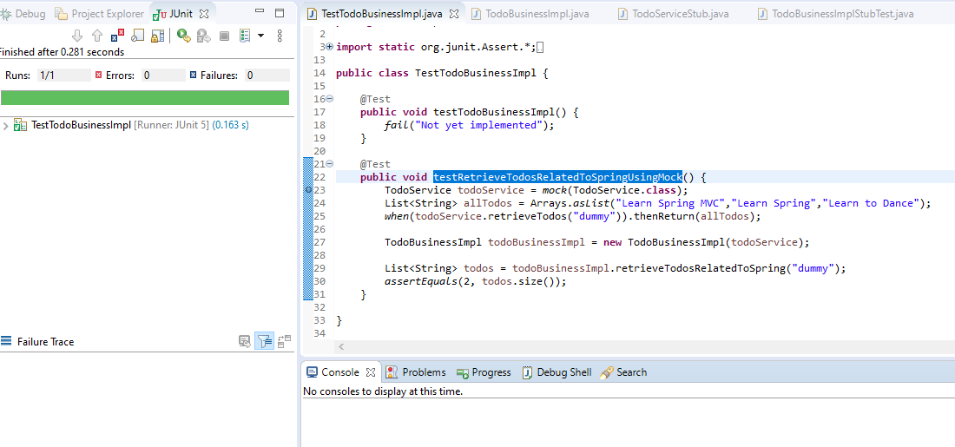

Write a test mock list get using BDD in a Given, When & Then style add a delete Todo method in the service interface.

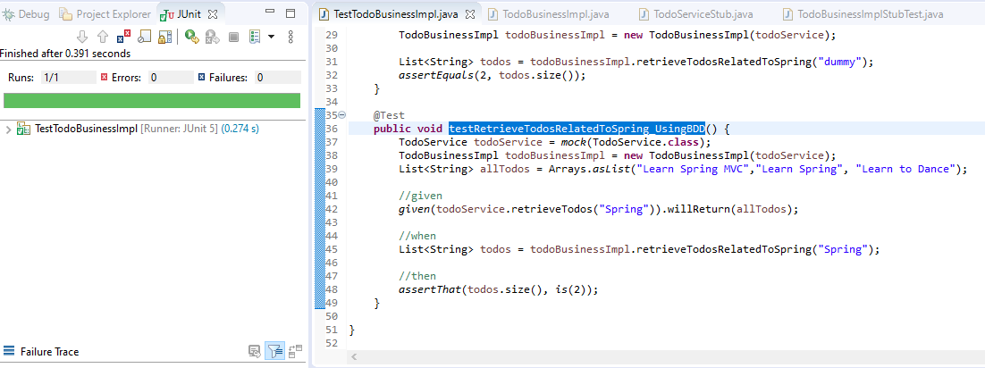

Add the ham crest library dependency to porm.xml & use the assert that method & do ham crest matchers test.