1.Dirty Reads
Cu probleme:
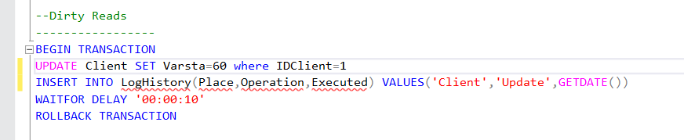
Transaction 1
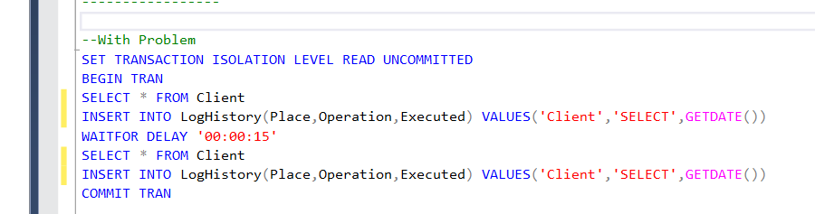
Transaction 2
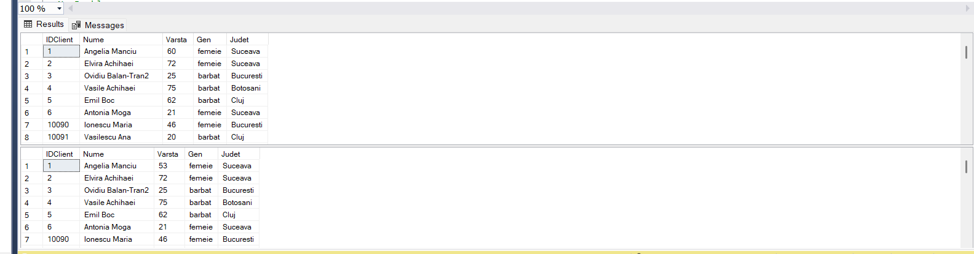

Rezolvare:
--Modificam Transactia 2
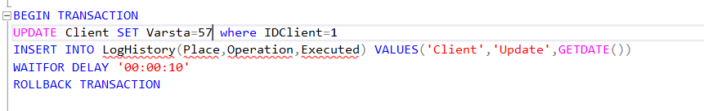
Transaction 1
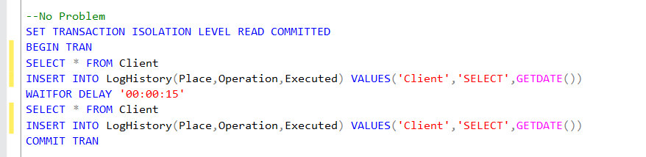
Transaction 2
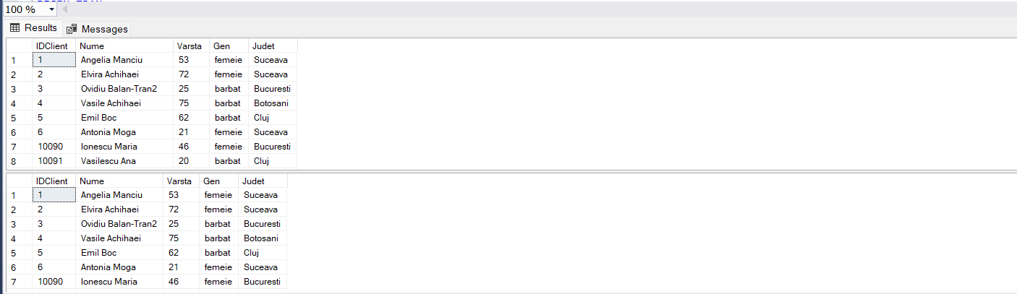
2. Non-repeatable Reads
Cu probleme:
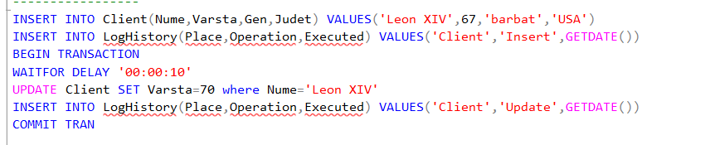
Transaction 1
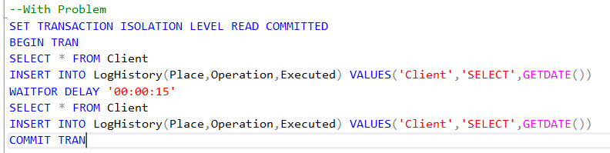
Transaction 2
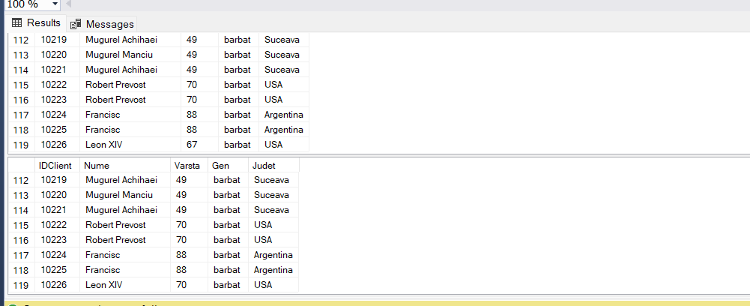
Rezolvare:
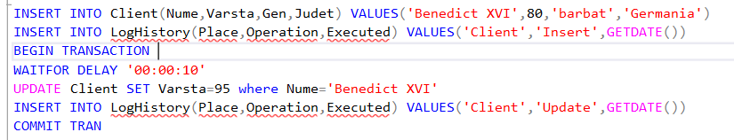
Transaction 1
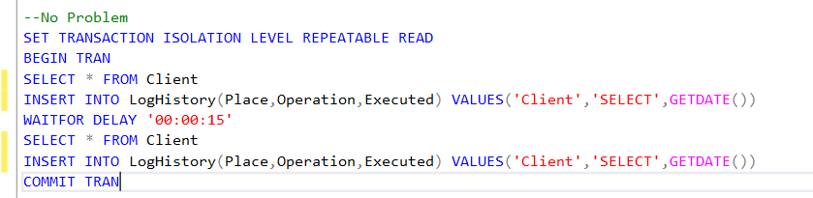
Transaction 2
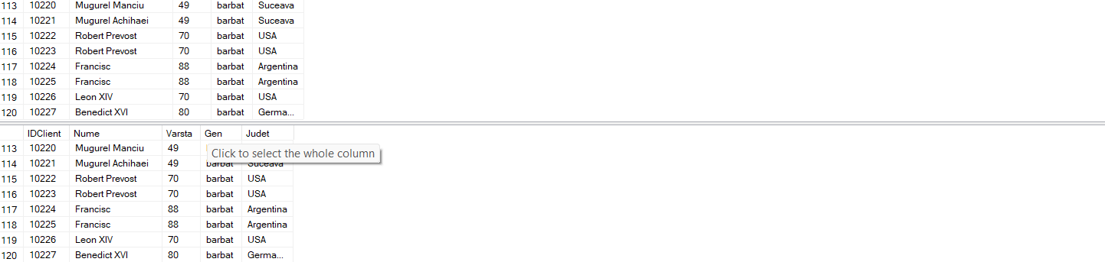
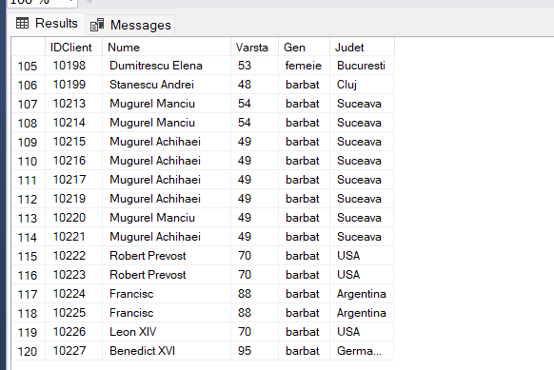
SELECT * FROM CLIENT
3.Phantom Reads
Cu probleme:
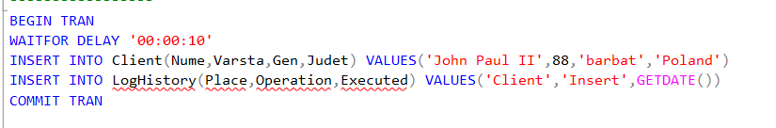
Transaction 1
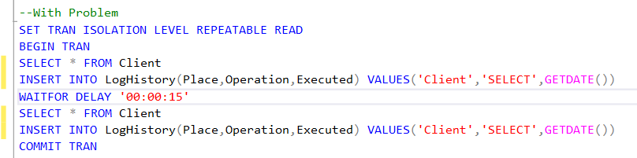
Transaction 2
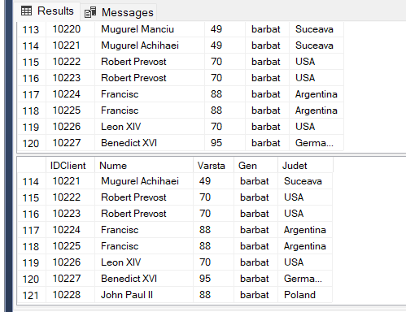
Solutie:
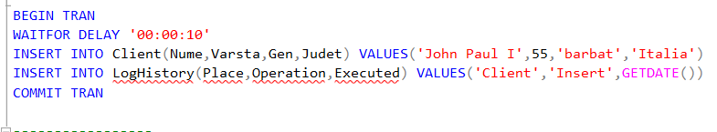
Transaction 1
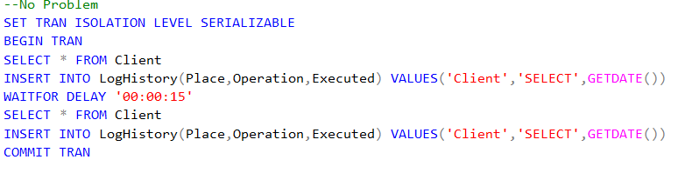
Transaction 2
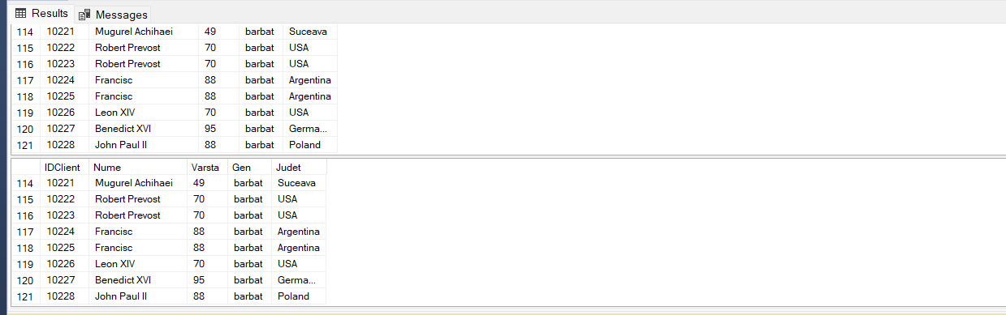
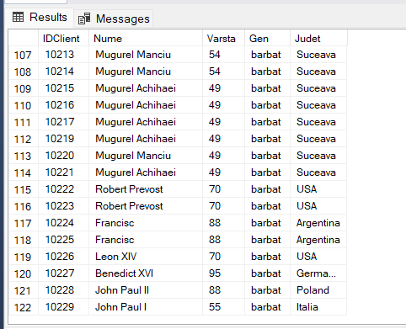
SELECT * FROM CLIENT

