
CMPT 470 Milestone 4 Report
Future Business Majors

Formal Methods-Inspired Static Analysis with Infer

Kylen Morris (gth842)
Darian Rowat (ddr271)
Rylan Curtis (ody435)
Vlad Akulov (onc736)
Kyran McKnight-Woods (zoe821)

March 26th, 2026
Contents
List of Figures 3
List of Tables 3
1. Introduction 3
2. Background 3
3. Experimental Setup 4
3.1 Infer 4
3.2 Operating System 4
3.3 Java 4
3.4 Build tool 4
3.5 Repository 4
4. Results 5
4.2 Experiment 2 5
4.3 Experiment 3 5
4.3.1 Issue A Identification 5
4.3.2 T1. First Feasible Failure Point 6
4.3.3 T2. Infer Assumption 7
4.3.4 T3. Refactoring Robustness 7
4.3.5 Classification 7
4.3.6 Fix Validation 7
4.3.7 Issue B Identification 8
4.4 Experiment 4: Stability Under Small Code Changes 8
4.5 Experiment 5: Comparison with Semgrep 8
5. Discussion 11
6. Lessons Learned 11
7. Conclusion 11

List of Figures
Figure 1: Issue A relevant code snippet 5
Figure 2: Issue A Infer Trace 6
Figure 3: Issue A Fix Validation 8
Figure 4: Issue A Fix Validation Result 8
Figure 5: Stability Test Changes 8
Figure 6: Semgrep Scan Summary 9
Figure 7: Semgrep Errors 10
Figure 8: Issue A File Semgrep Scan 10

List of Tables
Table 1: Experiment 2 results 5
Table 2: Issue A Execution Path Evidence 6
Table 3: Semgrep Comparison summary 11

Introduction
Static analysis tools are often used in modern software engineering to detect bugs, security vulnerabilities, and reliability issues early on before even running the code. This process allows developers to periodically examine code with tools even before it’s in a runnable state. Traditional static analysis tools use a rule-based approach which flags violations of predefined standards or bug patterns. While effective for enforcing best practices, this approach often fails to capture the deeper behavioral issues that could arise in a complex program.
This report explores using Infer, which is a static analysis tool that performs path-sensitive and intraprocedural analysis to construct execution traces leading to potential defects. We will examine how Infer identifies issues, how reliable its findings are, and how stable its results are after small code changes. Additionally, we will also compare Infer with Semgrep, a rule-based static analysis tool to better understand the differences between behavioral reasoning and pattern-based detection.

Background
Static analysis refers to the process of analyzing source code without executing it to identify potential issues. Static analysis tools inherently rely on approximations to analyze all possible program executions. These approximations can lead to false positives where a tool reports an issue that cannot actually occur, and false negatives, where a real defect is missed.
Different tools use different strategies for analyzing code as mentioned earlier. Semgrep operates by matching syntactic or semantic patterns in the code against a predefined set of rules. These tools are typically fast and easy to configure, making them well-suited for detecting common bug patterns, enforcing coding standards, and identifying security vulnerabilities. However, because they do not reason about program execution paths in depth, they often miss issues that depend on complex control flow.
In contrast, Infer uses a bi-abduction approach which breaks down code into smaller pieces and analyzes them independently. After breaking the code into smaller pieces, Infer is able to only review changed parts of code in pull requests when integrated with code review systems. It focusses mostly on null pointer exceptions, memory leaks, resource leaks, and concurrency race conditions.

Experimental Setup

3.1 Infer
- Using the command found at https://fbinfer.com/docs/getting-started/
- Extracting the binary release from https://github.com/facebook/infer/releases/latest
- Verified installation using infer –version showed version 1.2.0

3.2 Operating System
- WSL Ubuntu 22.04.5 LTS and WSL Ubuntu 22.04.3 LTS were both used for the following experiments

3.3 Java
- Java version 21.0.10 was used for the following experiments
- Version 17.0.18 was causing issues which were resolved after updating

3.4 Build tool
- Apache Maven 3.9.12 was used
- Verified by running ./mvnw -version

3.5 Repository
- URL: https://github.com/vavr-io/vavr.git
- Commit hash 598a691
- Using “git ls-files | xargs wc -l” we found 135,018 total lines of code inside the vavr repository, of which 127,257 are pure .java lines, found by adding “-name”*.java””

Results

4.2 Experiment 2
The goal of this experiment was to run Infer using the command “infer run -- ./mvnw clean compile”. The lines of code were found with “find vavr -name "*.java" | xargs wc -l”. Results from this experiment are shown in table 1.
Table 1: Experiment 2 results
Project | LOC | Total Issues | Top Issue Types | Runtime (s)
vavr | 127,257 | 2 | THREAD_SAFETY_VIOLATION (2) | 55.7

4.3 Experiment 3

4.3.1 Issue A Identification
The goal of this experiment was to further analyze 2 specific issue categories. Issue A is the most frequent issue type which was THREAD_SAFETY_VIOLATION. The method handle for the related issue was “public boolean block()” which occurred on line 235 of the following file: vavr/src/main/java/io/vavr/concurrent/FutureImpl.java:235. The relevant code snippet is shown in figure 1 and the Infer trace is shown in figure 2 with a detailed trace explanation in table 2.
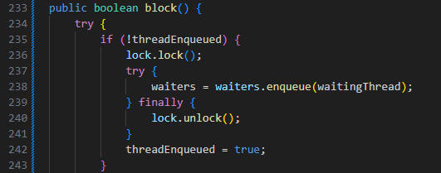
Figure 1: Issue A relevant code snippet
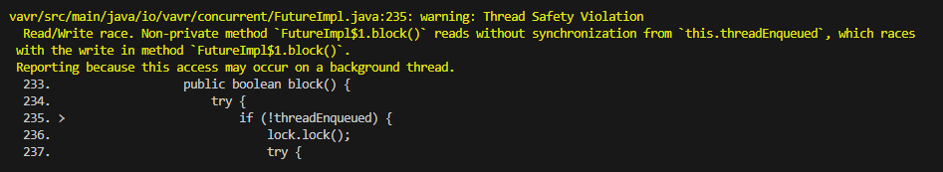
Figure 2: Issue A Infer Trace
Table 2: Issue A Execution Path Evidence
Trace Step | File | Line | Explanation
Value Introduced | vavr/src/main/java/io/vavr/concurrent/FutureImpl.java | 221 | threadEnqueued is initialized to false and becomes mutable state on the anonymous blocker object.
Conditional branch | vavr/src/main/java/io/vavr/concurrent/FutureImpl.java | 235 | The method checks if (!threadEnqueued) before enqueueing, so later behavior depends on this unsynchronized access.
Risky state appears | vavr/src/main/java/io/vavr/concurrent/FutureImpl.java | 242 | The field is written outside synchronization, creating the possible race.
Failure location | vavr/src/main/java/io/vavr/concurrent/FutureImpl.java | 242 | Infer reports the unsynchronized write itself as the violation.

4.3.2 T1. First Feasible Failure Point
File and Line Number: - FutureImpl.java:221
This line represents the first risky state because threadEnqueued is introduced as shared mutable state on the anonymous ManagedBlocker object. After the introduction of threadEnqueued, access to that variable can lead to race conditions if the same blocker instance is accessed by multiple threads.
Infer both the read on line 235 and write at line 242, but the condition for both warnings is the existence and handling of this shared mutable state.

4.3.3 T2. Infer Assumption
The assumption Infer makes is that the ForkJoinPool.ManagedBlocker instance may be accessed by more than one thread. This would cause block() to execute on the same object concurrently in multiple threads. Because block() is a method on an object and Infer cannot prove the object is confined on one thread, it assumes another thread could call that block. With that assumption the read on line 235 and write on line 242 could create a race.

4.3.4 T3. Refactoring Robustness
Since Semgrep is a pattern base static analysis tool and is not path sensitive, it’s unlikely that it would detect this issue. A small refactor on this code would likely only cause Semgrep to detect more issues unless it does not break any of the predefined rules.
Since Infer focusses on the program behaviour, most forms of refactoring such as renaming or extraction would not change the outcome of it’s test. Without proper synchronization or guarding logic, Infer would likely still recognize this potential error and report is as such.

4.3.5 Classification
This issue reported by Infer is likely a false positive. The threadEnqueued variable belongs to a fresh anonymous managed blocker instance created inside an _await() invocation and appears to only be used by the current waiting thread. Since the object does not appear to be shared, the race is likely infeasible at runtime.

4.3.6 Fix Validation
To fix issue A, we can protect threadEnqueued with the same lock on both the read and write as shown in figure 3. After running Infer again we can see the issue is resolved as shown in figure 4.

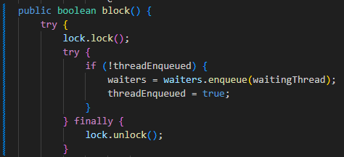
Figure 3: Issue A Fix Validation
Figure 4: Issue A Fix Validation Result

4.3.7 Issue B Identification
Since Infer did not report any other issue types we were unable to examine a second issue type.

Experiment 4: Stability Under Small Code Changes
To verify stability under small code changes, whitespace and a temporary variable were added to the block function discussed earlier. These changes can be seen in figure 5. After this change Infer reported two issues which maintained the THREAD_SAFETY_VIOLATION type. This suggests that path-sensitive design of Infer is not sensitive to these kinds of small changes.
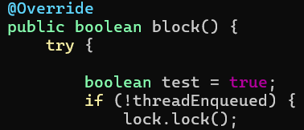
Figure 5: Stability Test Changes

Experiment 5: Comparison with Semgrep
Our results showed zero issues reported by Semgrep. We used the latest version available (1.156.0) but it failed to parse many of the files in the repository. We found that Semgrep seems to have an issue with the @NonNull annotation as it failed to scan 164 files and reported syntax errors on every @NonNull annotation in those files. The results were the same when using just the default ruleset as well as with –config “p/java”. The detailed Semgrep report is shown in figure 6 along with some of the errors in figure 7.
We were able to verify that Semgrep ran successfully on the file containing the issues reported by Infer. Semgrep reported zero errors in this file as shown in figure 8 and a summary of these results are shown in table 3.
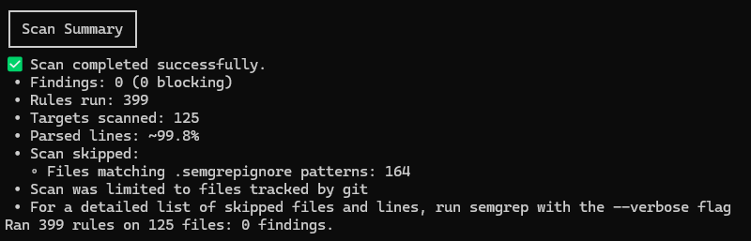
Figure 6: Semgrep Scan Summary
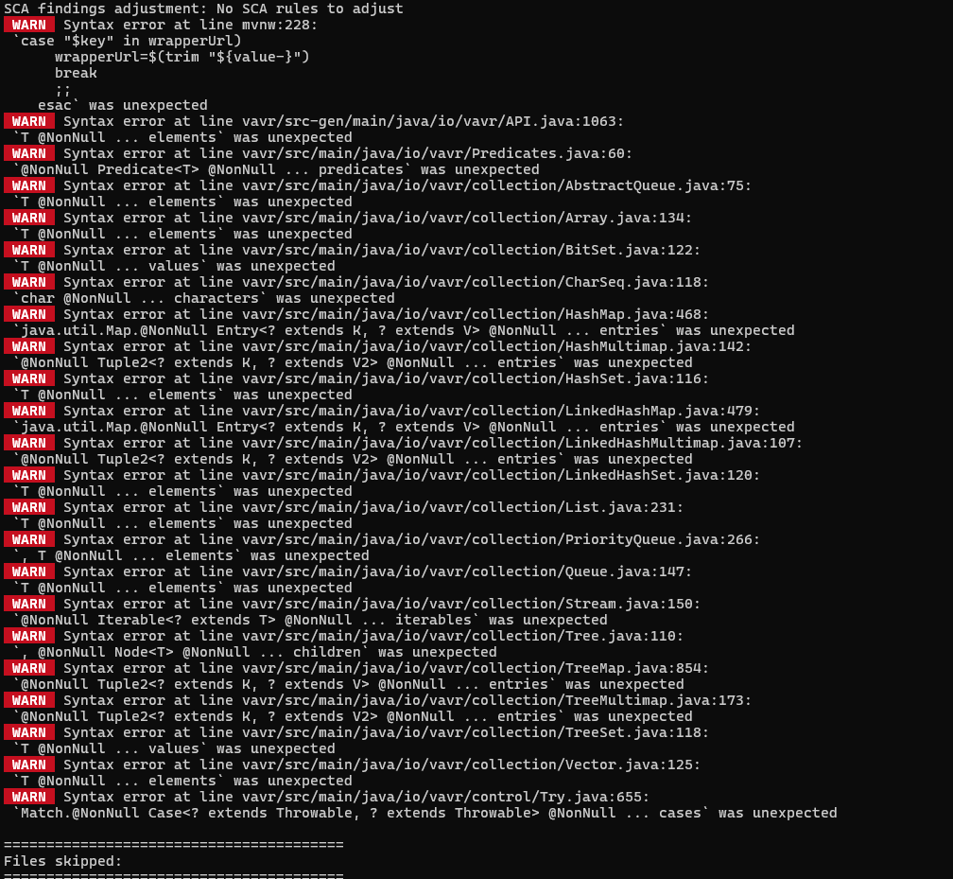
Figure 7: Semgrep Errors
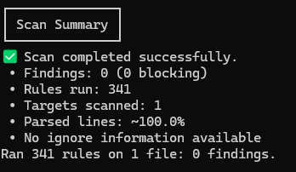
Figure 8: Issue A File Semgrep Scan
Table 3: Semgrep Comparison summary
Tool | Total Findings | Top Issue Types | Runtime (s)
Infer | 2 | THREAD_SAFETY_VIOLATION | 55.7
Semgrep | 0 | N/A | 3

Discussion
Infer was able to detect an interesting and potentially serious issue in this code. The possibility of multiple threads reading at writing data is a serious issue. This highlights the benefits of path-sensitive static analysis tools since simple pattern recognition would not have been able to detect such an issue without very complex rules. Compared to our previous milestone, Infer has done a better job at finding serious potential issues as apposed to simple syntax errors or poor readability/maintainability issues. Although we classified this issue as a false positive, it is clear from this error that Infer is able to understand the flow of the program to a much greater extent than rule-based static analysis tools.
One issue we encountered with Infer was its injection of java version 11 into the projects environment. We noticed that after adding infer to the build Maven was falling back to java 11 for certain parts causing compilation errors. After many failed attempts to fix this issue, we found that adding a “.inferconfig” file to the root /vavr/ directory with the contents “{“java-version”: 21}” and then running Infer with “infer run -- ./mvnw clean compile” fixed the issue.
Our Semgrep results are disappointing since the tool was unable to fully scan the repository with the default ruleset. This suggests that an issue exists with Semgrep, specifically around the @NonNull annotation.

Lessons Learned

Conclusion
In conclusion, our results suggest that Infer is the more reliable static analysis tool. The stability proved impressive while also showing that a genuine fix to the issue solved the reported problem without creating any new issues. Although the primary issue was ultimately classified as a false positive, it still highlighted Infer’s ability to reason about complex execution paths and detect subtle concurrency risks that rule-based tools would likely miss. In contrast, Semgrep’s performance was limited due to parsing issues and its reliance on pattern matching which prevented it from identifying deeper behavioral problems such as the one found by Infer. Overall, these findings reinforce the value of static analysis tools like Infer in improving software reliability while also emphasizing the importance of manual validation when interpreting results.

