**NODE**

**Clear-stergem outputul pe care l vedem (cls)**

**Window object-referinta a browser window**



**Cu process.argv luam input de la tastatura, din linia de comanda**

**Cu yargs(package) vs normal**

**prima e numele comenzii(nu merge modificat), a 2 a descrierea(merge modifica denumirea), a 3 a handler-ul(functia, ce sa faca cand e apelata comanda)**

**demandingOption->inseamna ca campul ala e required(default e pe false)-> adica daca nu vrem required nici nu trb sa l punem**

**type-> obligam ca acel camp sa fie de un anumit tip**

**fara .parse nu putem afisa**

**JSON**

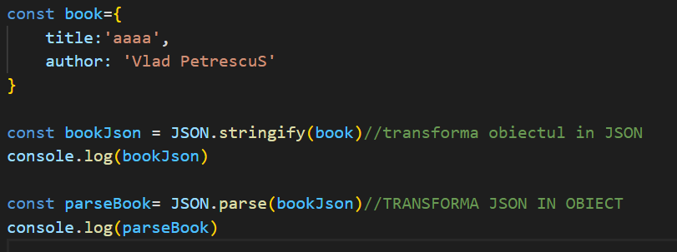

**Putem accesa proprietatea doar pe obiect, nu si pe json (Adica nu merge bookJson.title, dar merge parseBook.title) !!!!!!!!!!!!!**



**Cu readFS->citim fisierul si am stocat in dataBuffer(Buffer inseamna biti si bytes).. trb sa folosim toString ca sa ne afiseze ce trb**

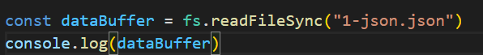

**Add a note**

**Workfow: 1.Fct Load. 2fCT ADD 3.Workfow: 1.Fct Load. 2fCT ADD 3.FCT SAVEWorkfow: 1.Fct Load. 2fCT ADD 3.FCT SAVE**

Arrow function (ES6)

Cu arrow function nu putem referential obiectul cu this.

**Debugg**-

Trb sa punem “debugger” in cod unde vrem

node inspect si continuam comanda normal

Intram pe chrome pe ://inspect

Primele linii sunt cele mai importante.. in a 2 a ne zice exact unde e problema

**WEATHER APP (ASYNC)**

**Call stack->nodeApi-> callback queue**

**Call stack**

Intra pe sus si ca sa iasa trb sa iasa mai intai de sus in jos. Daca nu e vreun setTimeot sau cv sa astepte il afiseaza apoi iese din stack

Daca e-> intra in node api-> poate fie sa se intoarca in stack si sa faca logica sau se duce in queue, iar din queue in stack

**Http requests-**putem sa folosim un modul de node ca sa fie mai usor



Pt challenge folosim positionStack Api(free)

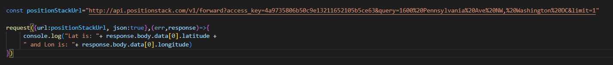

Acelasi sistem de lucru

**CallBack functions**

**Sunt functii pe care le punem ca parametru pt alte functii**

**Apelare:**

**Callback Chaining-> Punem callback in callback**

**OBJECT PROPERTY SHORTHAND**

**Normal**

**SHORTHAND(practice daca au aceeasi denumire putem scrie doar o data)**

**In our app**

**For ex: destructing response from forecast**

**Aveam error, response ca param si peste tot unde am body, inainte aveam response.body…, acum doar body**

**Fara ‘request’**

**Too much work .. easier with request library**

**SECTION 7- WEB SERVERS(EXPRESS)**



**Dynamic pages with templating(hbs)**

**404 pages**

**Section8**

Query strings(= ceva in url)

Prima data pun ?

Si ca sa delimitez query -urile &

Fetch(browser based api): workflow: luam info din url, APOI raspunsul in punem intr un callback

Response.json-> transforma datele in object(erau json)

Cum luam datele din formular si le folosim in js.

Cu querySelector luam datele si in paranteza specificam de unde Apoi adaugam un event pt apasare

**Section 10. MongoDB and Promises**

**Inserting one doc**

**Inserting more docs**

**Cautare dupa id**

**Promises !!!!**

